FVS-HI Koa Growth & Yield Model
Comprehensive Stress Test, CFI Validation, and Survival Refinement
Prepared for: Ben Rice (Midgard Natural Resources), FVS-HI PR #30
Prepared by: Aaron Weiskittel, University of Maine | 2026-06-05
Code basis: HiGy.R v0.2.0 (== koa_prediction_functions_FINAL.R v2, 2026-05-12); harness branch koa-stress-test

1. Executive summary
A comprehensive stress test of the current FVS-HI koa equations confirms the static and increment components are robust and track the manuscript Table 8 trajectories, but the survival component is not safe to ship unguarded. Applied per tree as FVS does, the published survival model collapses real stands.
- The harness reproduces HiGy.R to machine precision (max difference 1e-14 over 3,240 grid points), so these findings apply directly to the shipped code.
- HiGy.R is on the latest equation iteration: it matches koa_prediction_functions_FINAL.R (v2, post-pivot) for every component. The FVS_FINAL README and parameters.csv recommend a different (superseded) form and CFs and should be reconciled.
- Components produce no NaN, Inf, or negative values across 81,000 input combinations and clip cleanly (dDBH at 4 cm/yr, dHT at 2 m/yr).
- Survival is the problem: 67% of the koa-plausible crown-ratio by relative-height domain yields annual survival below 0.90, and survival drops from 0.80 at CR 0.5 to ~0 at CR 0.7. Koa crowns are routinely 0.5 to 0.8.
- On the koa CFI/PSP network (first to last remeasurement), raw survival drives stand basal area and density bias to -99.9% (near-total mortality). A stabilized survival (clamp crown ratio and relative height to the calibration domain, floor annual survival at 0.90) recovers density bias to -9.3%.
- Recommendation: do not ship the raw survival cloglog. Ship the stabilizer as an interim or refit survival for individual-tree use. Keep the rest of the equations. Add an ingrowth submodel. Fix four code issues.

2. Scope and method
Two engines exercise the equations independent of the compiled FVS variant: a stand-level cohort projector (run with the operational guardrails of koa_projection.py, and with them stripped to expose raw behavior) and an individual-tree-list engine that mirrors HIGYOneStand for real plots. Survival is run in three modes: cohort (raw equation floored at 0.50/yr, the koa_projection.py crutch), raw (no floor, the FVS behavior), and stable (covariates clamped to the calibration domain and floored). Port fidelity to HiGy.R is verified in base R against the verbatim function bodies.

3. Equation provenance (which version is current)
The latest finalized code, koa_prediction_functions_FINAL.R (v2, 2026-05-12 post-pivot), uses the NEW increment form, conditional Duan correction factors (1.026 and 1.030), and the published survival fit (intercept 18.133). HiGy.R v0.2.0 in PR #30 matches that file coefficient for coefficient across height, height-to-crown-base, diameter increment, height increment, survival, and the correction factors. The FVS_FINAL README TL;DR (old form, marginal factors) and koa_FVS_FINAL_parameters.csv (M1/S1) reflect a pre-pivot decision that was reversed and are stale. This contradiction is documented in discrepancies.md and should be resolved before release.

4. Component robustness
Each component was evaluated over 81,000 input combinations spanning DBH 0.5 to 110 cm, height 1.4 to 35 m, basal area in larger trees 0 to 80, stand basal area 0.5 to 80, crown ratio 0.05 to 0.95, BYI 0 to 600, and both origins.
Component | NaN | Inf | Negative | Min | Max
Height (m) | 0 | 0 | 0 | 1.37 | 31.94
Height to crown base (m) | 0 | 0 | 0 | 0.08 | 30.40
Diameter increment (cm/yr) | 0 | 0 | 0 | 0.00 | 4.00
Height increment (m/yr) | 0 | 0 | 0 | 0.00 | 2.00
Annual survival | 0 | 0 | 0 | 0.00 | 1.00
No numerical failures. Increment components clip at their documented ceilings. The survival range spanning the full 0 to 1 interval is the first signal of the instability quantified next.

5. Survival instability
The published survival cloglog has very large coefficients and is hypersensitive to crown ratio and BYI. At DBH 15, height 9, relative height 0.5, BYI 264:
Crown ratio | 0.4 | 0.5 | 0.6 | 0.7
Annual survival | 0.99 | 0.80 | 0.02 | 0.00
30-year cumulative | 0.82 | 0.001 | ~0 | ~0
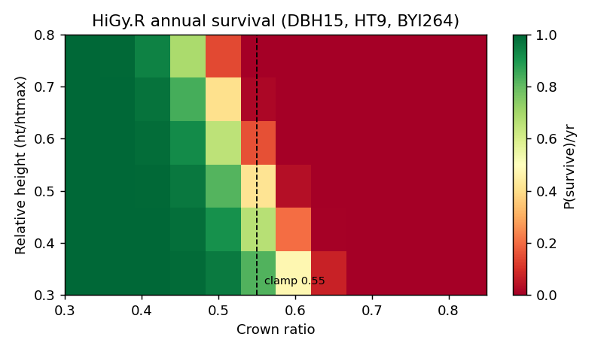
Figure 1. Annual survival across the crown-ratio by relative-height domain. Most of the koa-plausible space (67% of cells) falls below 0.90/yr; survival craters above crown ratio 0.55.
The cohort projector only behaves because it fixes relative height at 0.5, clamps crown ratio at or above 0.20, and floors annual survival at 0.50. FVS applies the raw model with none of these crutches.

6. Long-horizon behavior
Natural-origin cohort QMD (cm) at age 40 (manuscript Table 8 expectation about 42 cm):
BYI | Bounded cohort | Raw unbounded | Stable unbounded
100 | 43.4 | 43.0 | 42.9
264 | 56.9 | 56.3 | 54.9
450 | 57.2 | 52.8 | 42.5
For realistic natural starting densities the increment and height equations track Table 8 and do not run away. Runaway risk is confined to very small initial DBH and dense planted starts, the regime to confirm in true FVS runs.
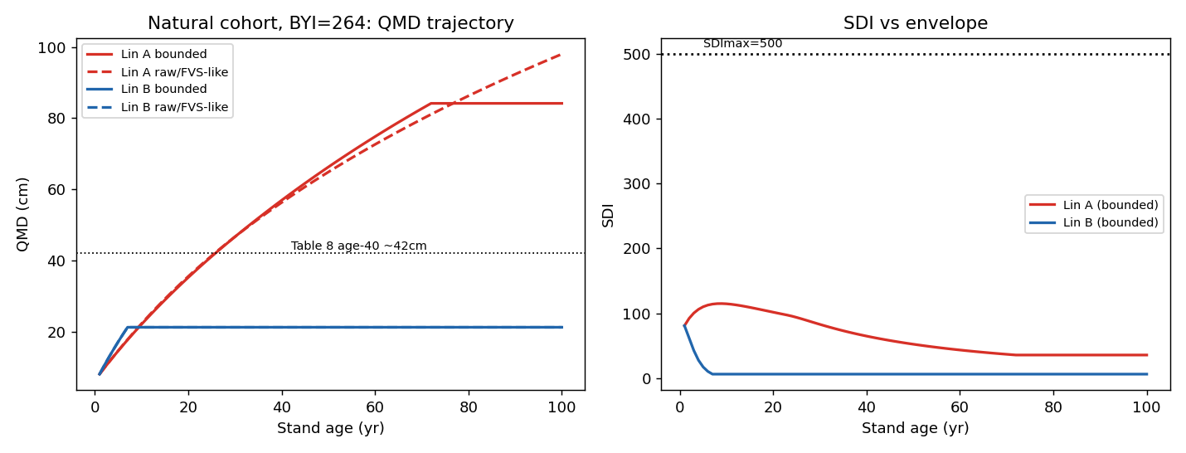
Figure 2. Natural cohort QMD and SDI trajectories (BYI 264). Bounded and raw increment paths are close; SDI stays within the envelope under self-thinning.

7. Out-of-source extrapolation
Four off-distribution points show the survival contrast between raw and stabilized; increment predictions remain bounded.
Case | dDBH | dHT | Survival raw | Survival stable
Kahikinui dry small | 0.84 | 0.30 | 0.96 | 0.96
Wet mature natural | 0.34 | 0.06 | 0.00 | 0.90
Old-growth low-BYI | 0.20 | 0.04 | 0.00 | 0.90
Dense plantation | 2.34 | 0.55 | 0.00 | 0.90
Wherever crown ratio or BYI move off the cohort-average regime, raw survival collapses to zero while the stabilizer holds a defensible floor. (Illustrative dDBH/dHT shown; see extrapolation.csv.)

8. CFI / PSP validation (first to last measurement)
Individual-tree projection of the koa CFI/PSP network (13 plots with usable remeasurements, about 9 to 14 year spans, BYI assumed 264) from first measurement to observed last:
Variable | Survival | Mean bias | Bias % | RMSE
QMD (cm) | raw | -3.2 | -13.3% | 5.4
QMD (cm) | stable | -6.7 | -27.5% | 8.1
Basal area (m2/ha) | raw | -9.0 | -99.9% | 9.7
Basal area (m2/ha) | stable | -6.4 | -71.0% | 7.5
Density (trees/ha) | raw | -186 | -99.9% | 199
Density (trees/ha) | stable | -17 | -9.3% | 170
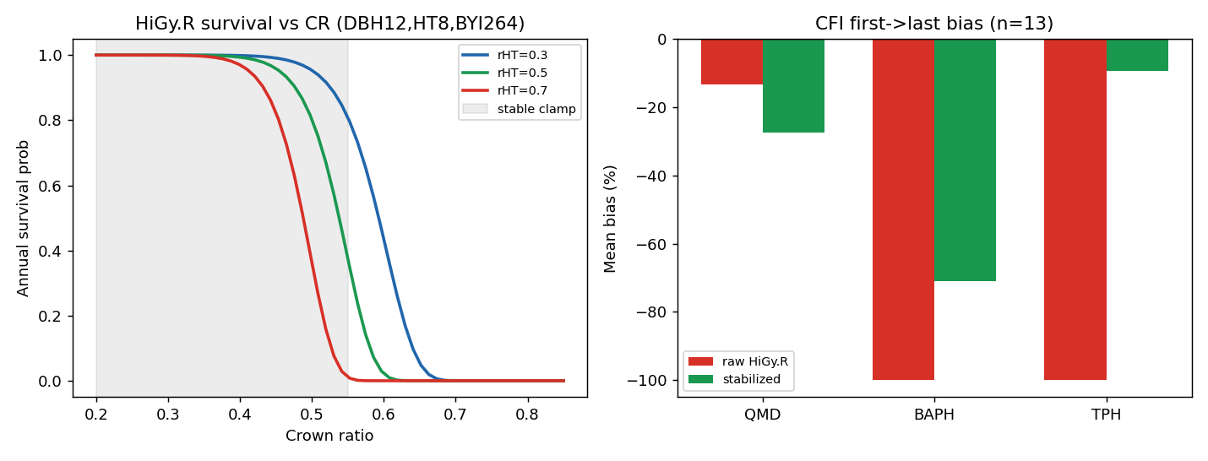
Figure 3. Left: survival versus crown ratio with the stabilizer clamp region. Right: CFI first-to-last bias, raw versus stabilized survival.
Raw survival wipes out the stands. The stabilizer recovers realistic density (bias -9.3%). The residual basal-area shortfall is largely the missing ingrowth submodel: these are young building koa stands where observed basal area and density rise through recruitment that a no-ingrowth projection cannot reproduce.

9. Survival dial-in
Sweeping the stabilizer settings against CFI density bias shows the annual-survival floor is the dominant lever; the crown-ratio clamp ceiling has little effect once the floor is active.
Crown-ratio ceiling | Floor 0.85 | Floor 0.90 | Floor 0.95
0.50 | -35.1% | -9.2% | +29.1%
0.55 | -35.2% | -9.3% | +29.1%
0.60 | -35.2% | -9.3% | +29.1%
Recommended interim setting: clamp crown ratio to [0.20, 0.55] and relative height to [0.30, 0.70], floor annual survival near 0.90 to 0.92. This is an operational stopgap, not a refit; the proper fix is to refit survival for individual-tree application on the current AK.SURV records.

10. Bakuzis / SDI envelope
Across both origins and three site classes, 100% of decade snapshots remain within 110% of the maximum stand density index (500) under self-thinning. The equations respect the self-thinning boundary; they do not push stands above the observed density envelope.

11. Open code issues
- Unit-order bug in the first-cycle crown imputation in customRun_fvsRunHi.R: height is converted to feet before calc_hcb, which expects metres, biasing imputed crown ratios. Compute crown base while metric, convert to feet last.
- Hi.GY() calls AcadianGYOneStand() instead of HIGYOneStand(); latent but should be corrected or the wrapper removed.
- Tree-size cap units: tree.size.cap AK=(90,92) is multiplied by inch-to-cm and foot-to-metre; if 90 was cm the DBH cap is effectively disabled at 228 cm.
- Species scope: only koa is parameterized; ohia and sandalwood map to OT and are held static. Document or add surrogates.

12. Recommendations
- Do not ship the raw survival cloglog unguarded. Ship the stabilizer (clamp plus floor) as an interim, or refit survival for individual-tree use.
- Keep the current height, height-to-crown-base, and increment equations with conditional correction factors (matches the FINAL code and tracks Table 8).
- Add an ingrowth submodel, or document the no-ingrowth limitation; it is the main residual gap in young-stand basal area and density.
- Fix the four code issues in section 11.
- Reconcile the FVS_FINAL README and parameters.csv with the actual FINAL code (see discrepancies.md).
- Validate in true FVS on the dense-planted, small-DBH regime that the equation-level harness cannot fully exercise.

Appendix: reproduce
Branch koa-stress-test, folder fvsOL/inst/extdata/koa_stress_test: Rscript fidelity_check.R (port check); python3 run_stress_comprehensive.py (this report); python3 run_cfi.py (CFI validation). Python needs numpy, pandas, matplotlib; R needs no packages.

