U.S. Department of Labor
Office of Public Affairs
Division of Enterprise Communication


DOL Helpful Utility
(Was this page helpful?)

Release and Deployment Instructions
for
OPA

September 14th 2012

U.S. Department of Labor
Frances Perkins Building
200 Constitution Avenue, NW
Washington, DC 20210

Document History

Version | Date | Author | Comments
1 | 09/13/2012 | Somesham Pisike | Initial Draft
2 | 09/14/2012 | Somesham Pisike | Updated final review comments
3
4
5

Table of Contents

1. Project/Application General Information 4
1.1. Project/Application Owner 4
1.2. Project/Application Overview 4
1.3. Project/Application General Information 4
2. General 4
2.1. Download 4
2.1.1. Step 1 4
3. Database Setup 5
3.1. Database(s) General Information 5
3.1.1. FeedbackScript (Helpful Database) 5
3.2. Deployment Instructions 5
3.2.1. Step 1 5
3.2.2. Step 2 5
3.2.3. Step 3 5
3.2.4. Step 4 5
3.2.5. Step 5 5
3.2.6. Step 6 5
4. Solution (Projects) Setup 6
4.1. Projects Setup Instructions 6
4.1.1. Step 1 6
4.1.2. Step 2 6
4.1.3. Step 3 6
4.1.4. Step 4 6
4.1.5. Step 5 6
4.1.6. Step 6 6
4.1.7. Step 7 6
4.1.8. Step 8 7
4.1.9. Step 9 7
4.1.10. Step 10 8
4.1.11. Step 11 8
4.1.12. Step 12 9

- Project/Application General Information
  - Project/Application Owner
Application Owner: Michael Pulsifer
Client/Agency: OPA
  - Project/Application Overview
The solution begins with the question “Was this page helpful?”, which allows to capture the feedback from the user about the page that is displayed on the browser. This can be easily integrated in all or desired pages as per the need. Once the data is gathered and stored in database, the data can be viewed in different views by supervisor(s) or administrator(s). This solution does not apply to one specific web site, this can be applied to many websites as you desire and connect to one or many database(s). This solution contains the following projects.
- Helpful: This project stores the data that is captured from the user feedback.
- Helpful.Public: This project is a sample project, which demonstrates how to consume the Helpful project and record user feedback.
- FeedbackScript.Admin: This project provides the following Administrative views for supervisor(s)/administrator(s)
  - View of 10 Most Rated, Highest Rated and Lowest Rated DOL Pages
  - View of Summary by Agency
  - View of Custom Search
  - View of User Comments by URL
  - View of Feedback Trends with Graphical interface
  - Project/Application General Information
Application Name: “Was this page helpful?” - Helpful Utility
Release Date: 09/14/2012
Version Control Name (source name(s)): Helpful.git
Developer(s): DOL OPA
Ticket(s): N/A
Application Version: 1.0
Application /Module Type: Web App
Prog. Language: C# / ASP.Net MVC3 and JQuery
Framework/Version: 4.0
MS Tool: Visual Studio 2010
- General
  - Download
    - Step 1
Download and unzip Helpful.Redistribution.zip file into your local machine. This zip file contains the following main folder(s) and file(s).
- DatabaseScript (Database Script Folder)
- FeedbackScript.Admin (Project Folder)
- Helpful (Project Folder)
- Helpful.Public (Project Folder)
- Helpful (solution file)

- Database Setup
  - Database(s) General Information
    - FeedbackScript (Helpful Database)
Name: FeedbackScript
RDBMS: SQL Server 2008 R2
NON SENSITIVE PII/SENSITIVE PII/NON-PII: Non-Sensitive PII
Public User: FeedbackUser Admin User: FeedbackAdmin
Script(s): DatabaseScript\HelpfulDatabaseScript.SQL

  - Deployment Instructions
    - Step 1
Using MS SqlServer Management Studio connect to the database server where the Helpful Database is going to be created.
    - Step 2
From the menu select File->Open->Open File and open the file DatabaseScript\HelpfulDatabaseScript.SQL.
    - Step 3
Change the database (.mdf) and log (ldf) files location to your desired location. Other database parameters can be changed if you desire and they do not impact executing the Helpful utility.
    - Step 4
Run the script by clicking the Execute toolbar icon or pressing F5.
    - Step 5
Change the passwords for FeedbackAdmin and FeedbackUser users.
    - Step 6
Save the modifications for your future reference.

- Solution (Projects) Setup
  - Projects Setup Instructions
    - Step 1
Open MS Visual Studio 2010 in Administrative mode.
    - Step 2
From the menu select File->Open->Project/Solution and open the Helpful solution located at main level. This should open all three projects.
    - Step 3
Open the Web.Config file under FeedbackScript.Admin project and locate the FeedbackScriptConnectionString connection string. Change the values that are in red color as appropriate.
<add name="FeedbackScriptConnectionString" connectionString="Data Source=XXXXX; Initial Catalog=Feedbackscript; User ID=FeedbackAdmin; Password=XXXXX;Persist Security Info=false" providerName="System.Data.SqlClient" />
    - Step 4
Open the Web.Config file under Helpful project and locate the FeedbackScriptConnectionString connection string. Change the value(s) that are in red color as appropriate.
<add name="FeedbackScriptConnectionString" connectionString="Data Source=XXXXX;Initial Catalog=FeedbackScript;Integrated Security=True" providerName="System.Data.SqlClient" />

    - Step 5
Open the properties of Helpful project and note the Auto-assign port number, which is found in Web tab.

    - Step 6
Open the Scripts\W_helpful.js file under Helpful.Public project and locate the TRACKER_URL variable, which should be in the beginning. Replace the 99999 with the value noted in step 5. Then, save the file.
'http://localhost:99999/Data.mvc/Log'

    - Step 7
Set the startup project to Helpful.Public project and hit F5. This should open the following screen in the browser. And, should see the “Was this page helpful?” option on top right side of the screen
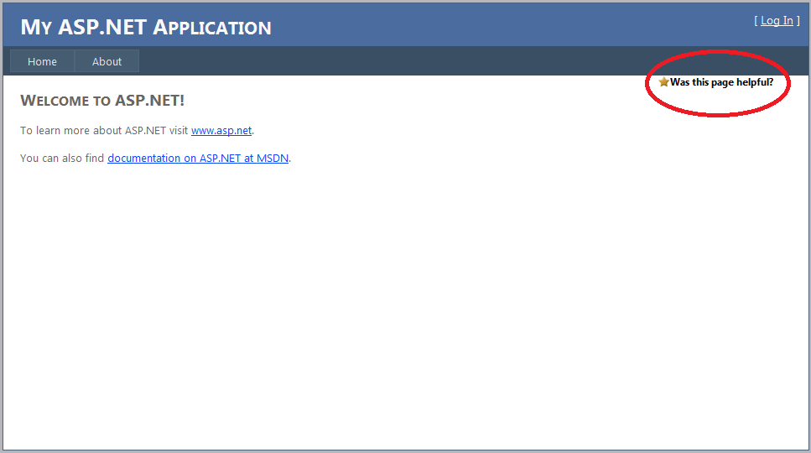

    - Step 8
On click of “Was this page helpful?” option it should change to the following screen.
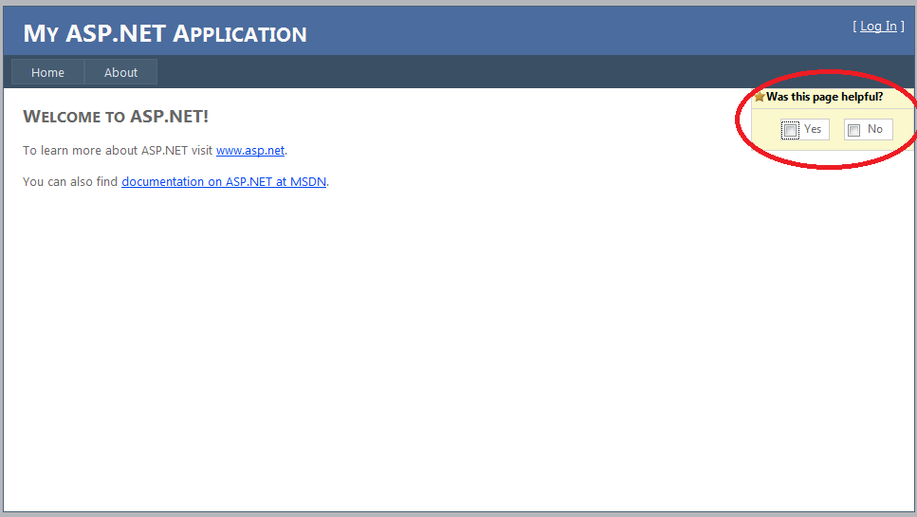

    - Step 9
On click of “Yes” or “No” checkbox it should change to the following screen.

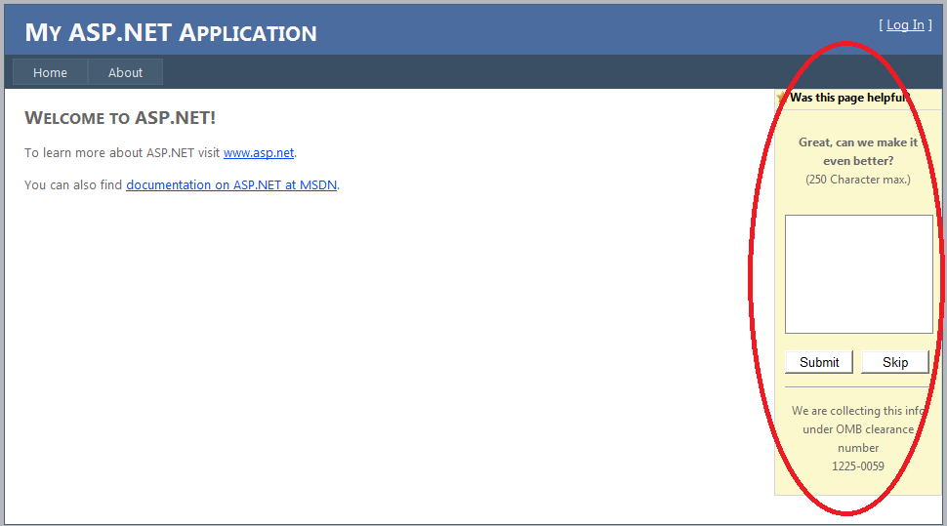

    - Step 10
Enter comments and click Submit button.

    - Step 11
Go back to solution and set the startup project to FeedbackScript.Admin project and hit F5. This should open the following “Top 10 DOL Pages” screen in the browser. Note: The data in the following screen is a sample data.
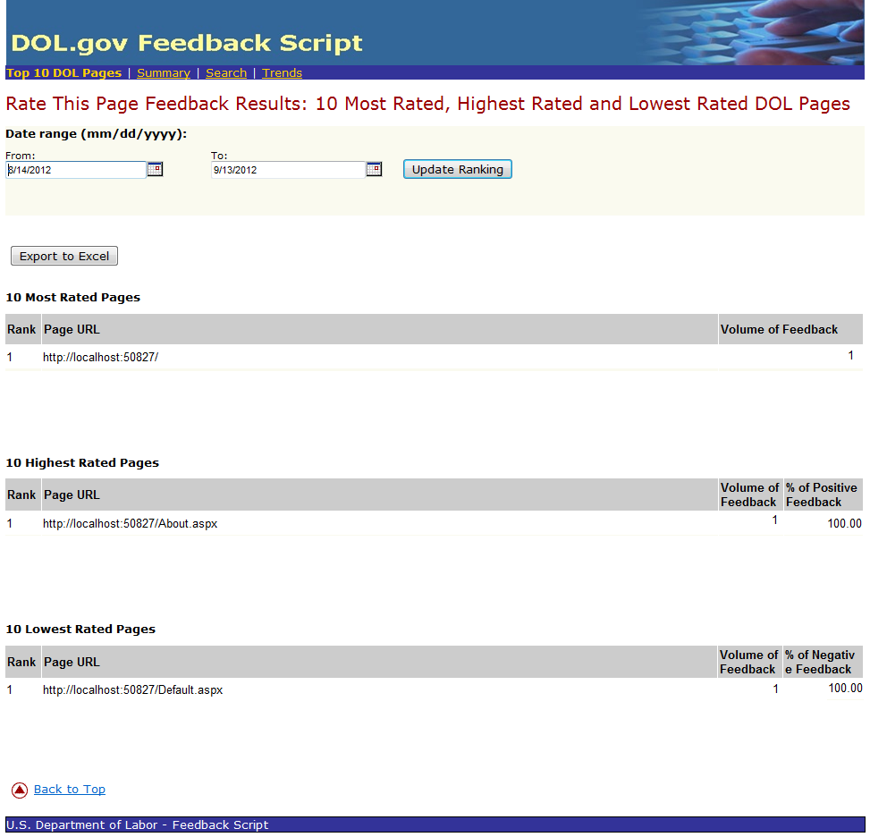

    - Step 12
Navigate to the following links provided on top the page. Each link generates a very comprehensive view based on the data gathered from “Was this page helpful?” option from Helpful.Public project.
- Top 10 DOL Pages
- Summary
- Search
- Trends

