# **WHD Long-term Product Vision and Execution Roadmap v1.0**

# **Background Information**

## Overview of Wage and Hour Division

WHD was created 75 years ago with the enactment of the Fair Labor Standards Act (FLSA). We’re responsible for enforcing the minimum wage, overtime, and child labor provisions of the FLSA. We enforce several other laws including the prevailing wage requirements of the Davis-Bacon and Related Acts (DBRA), the McNamara-O-Hara Service Contract Act (SCA), and the Walsh–Healey Public Contracts Act (PCA). We also determine the prevailing wages under these statutes.

We’re comprised of a nationwide staff of investigators, supervisors, analysts, technicians, and administrative employees. We have approximately 1,800 employees,

of which nearly 1,050 are field investigators. More than half of these investigators speak a language other than English. The agency is headquartered in Washington, D.C.; however, most of our employees are stationed in over 220 field, area, district, and regional offices across the country and in U.S. territories. These offices are in rural, suburban, and urban locations.

Every day, WHD investigators go into workplaces -- ranging from blueberry fields to restaurant kitchens to garment shops -- to conduct investigations to determine if the employer is in compliance with the applicable laws. Investigators use a wide range of techniques to gather evidence. They collect paper and digital payroll and employment records from employers, interview workers and employers and document interview statements, conduct surveillance, observe and document workplace conditions, and then analyze this information to determine whether the employer is in compliance with the applicable laws.

Investigations often require collaboration with teams of investigators, managers, legal counsel, and other government agencies. If we determine there has been a violation of law, the agency will resolve the case by requiring the employer to remedy the situation. Depending on the law in question, employers may be required to pay back wages and other penalties, reinstate employees in their jobs, and put in place new policies and procedures to ensure they remain in compliance. If an investigation reveals that an employer failed to pay proper wages, WHD makes computations, assesses monetary penalties, and supervises the payment of these monies to the U.S. Treasury and/or directly to the underpaid employees. Some cases result in the decision to take legal action in coordination with the Department’s Office of the Solicitor or other law enforcement agencies.

Our enforcement activities can originate with employees coming forward to file a complaint or by WHD initiating an investigation directly because of evidence of a high-rate of non-compliance in a particular industry.

## The Current Legacy System

There are a number of applications that currently support WHD’s mission and business functions, as described above. These applications are divided into two groups: (1) investigative support systems and (2) wage determination systems. See Figure 1 below.

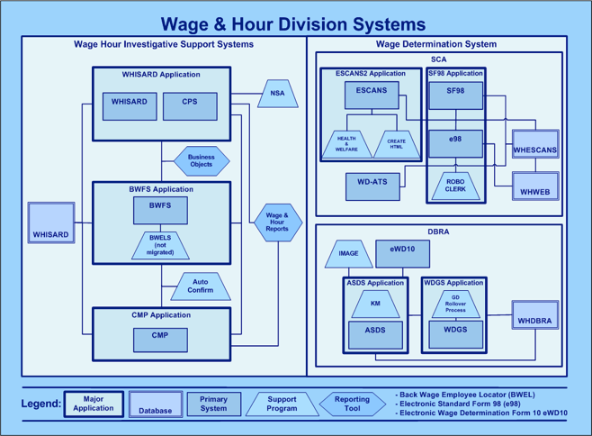

*Figure 1: Wage and Hour Division Systems Conceptual Model*

The Wage Hour Investigative Support Systems support activities related to labor law compliance enforcement for the purpose of protecting workers from wage theft and unfair practices. All the enforcement systems use the same WHISARD database. Key components include:

|  |  |  |
| --- | --- | --- |
| **Component Name** | **Component Type** | **Description** |
| Wage Hour Investigative Support and Reporting Database (WHISARD) | Primary System | WHISARD is an application that stores WHD's investigations and generates information into the WHISARD data store. The WHISARD application supports processing of complaints, assignment, management, and investigation of cases, assistance with outreach, tracking and monitoring of investigator time, tracking case history through narratives and diary entries, and assists in responding to FOIA requests and reporting to management. |
| Certificate Processing System (CPS) | Primary System | CPS is an application that makes it possible for special certificates be issued to allow disabled or student workers to be paid below applicable minimum wages under provisions of Sections 14(b) and 14(c) of the FLSA, and to issue farm labor certificates under MSPA. CPS communicates with WHISARD systems to determine if labor violations exist before issuing a certificate. CPS also provides the functionality to generate online renewal applications, print certificates and report functionality that provides up-to-date data on certification by status, issuance, date, region, and fiscal year. |
| Back Wage Financial System (BWFS) | Primary System | BWFS is designed to collect back wages and liquidated damages from employers and disburse those funds to employees. BWFS allows the transfer of employee funds to the U.S. Treasury when an employee cannot be located after three years. BWFS has the functionality to assess and accrue interest and penalties for delinquent debt, and to transfer those debts to the U.S. Treasury for collection. |
| Civil Money Penalty (CMP) | Primary System | CMP is a system designed to track civil money penalties that are levied against employers who violate certain labor laws in the work place. |
| National System Administration (NSA) | Support Program | NSA support program establishes access and authorization for WHISARD users at the application level and is one of a number of secondary support programs. |

*Table 1: Wage Hour Investigative Support Systems -- Key Components*

{Brief description of Wage Determination System, followed by a table describing the key components. Just like above.}

# **Vision and Strategy**

## Vision

It's time to provide the employees of the U.S. Department of Labor’s Wage and Hour Division (WHD) with the right digital tools so they can better perform their job of helping to protect American workers from unfair and illegal labor practices (e.g., not paying overtime, paying less than minimum wage, violating the Family Medical Leave Act). To meet the needs of our employees and be more adaptive to change (e.g., new labor laws), we are committed to designing and building digital solutions in a user-centered, secure, and flexible way. Our objectives are to:

* Create a well-designed user experience for investigators and managers that improves labor productivity, increases case throughput and effectiveness, and increases job satisfaction.
* Completely replace the legacy two-tier architecture with a three-tier architecture (clean separation between the Presentation, Business Logic, and Persistence Layers) in order to improve flexibility, maintainability, reusability, scalability, and reliability.
* Implement an Application Programming Interface (API)-centric approach that supports: (a) effective automated testing to protect against unintentional regressions when changes are made; (b) greater sharing of data/information with multiple stakeholders (e.g., DOL, government partners, the public) to improve analysis, decision-making, and innovation; and (c) more robust security (e.g., protect privacy of American workers and investigated firms) by exposing only the minimal functionality necessary to authorized users or systems.
* Empower a mobile, distributed workforce by providing web-based and mobile delivery mechanisms for communications, evidence collection, and case management.
* Decrease operations & maintenance (O&M) costs by allowing comprehensive automated unit test suites and deployment practices on a modern technology stack.
* Reduce O&M and increase security by replacing dependence on antiquated third-party software systems.
* Support electronic case files and dynamic case management to improve organization, management, and transmission of investigative evidence (including digital audio files, photos, and scans) gathered by investigators working in a variety of workplace settings across the country.
* Enable relevance ranked, Google-like full-text queries against all cases in order to support legal analysis, discovery of violation patterns and connections, and evaluation of enforcement effectiveness.
* Support the seamless transformation of evidence from original sources (e.g., paper documents) to images to transcribed textual representation as guided by the investigator’s judgement and priority.
* Illuminate linkages between firms (that are in fact part of a larger corporation) in a fissured workplace in order to enforce laws properly.
* Improve the quality and timeliness of wage rates issued by WHD for government contracts, thereby benefiting workers, government contractors, and contracting officers across the government.

## Strategy

To achieve our modernization objectives, we’re implementing an acquisition and technical strategy that embraces a number of modern practices such as [modular contracting](http://www.whitehouse.gov/sites/default/files/omb/procurement/guidance/modular-approaches-for-information-technology.pdf), [agile contracting](https://github.com/WhiteHouse/playbook/blob/gh-pages/_includes/techfar-online.md), [digital services delivery](https://playbook.cio.gov/), and [strangler architecture pattern](http://martinfowler.com/bliki/StranglerApplication.html).

From an acquisition strategy standpoint, we intend to break-up our overall acquisition needs into many independent and potentially parallel contracts from which the government will oversee the integration of the technical outputs. We believe this approach will allow us to:

* Deliver usable, customer-valued functionality early in the overall modernization program and complete the total program as rapidly as possible even in the face of changing requirements and priorities.
* Increase flexibility to adopt emerging technologies incrementally.
* Mitigate overall programmatic risk by spreading it across several independently valuable projects.
* Gain greater visibility into project and contract performance sooner.
* Give contractors the flexibility they need to deliver value to the government.
* Create more opportunities for small business and to utilize vendors using modern and state-of-the-art technologies.
* Mitigate operational lock-in and overdependence on a single supply source.
* Decrease unpleasant surprises late in the schedule.
* "Fail fast" -- terminate an investment with fewer sunk costs when things do not go as planned.
* Incorporate in a componentized fashion proven, commodity IT solutions such as those found in the open source community.

From a technical/architecture standpoint, we intend to transition from our legacy two-tier architecture to a modern three-tier architecture using the strangler architecture pattern.

The first phase of the transition is to test the feasibility of using the strangler architecture pattern while delivering new functionality (Employee Data Entry application and Proof of Payment application) to WHD employees. The diagram below represents a conceptual depiction of where we expect to be at the completion of the first phase.

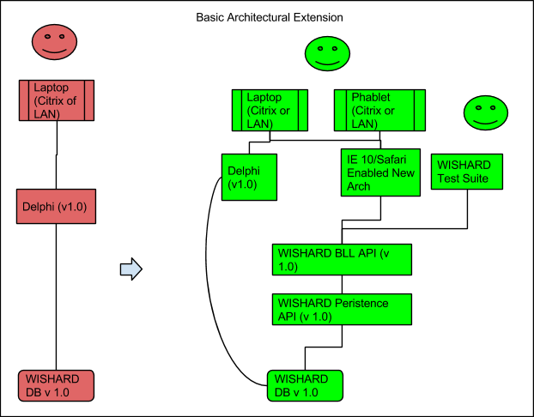

*Figure 2: Phase 1 - Basic Architectural Extension*

*Figure 3: Phase 2 - TBD*

## What Our Strategy Means for the Vendor Community

Given our acquisition and technical strategy, there are a number of implications for those vendors interesting in working with WHD:

* There will be many solicitations of moderate value in this total program. Because we plan to be agile even in our modular contracting, it’s difficult to precisely predict the number, size, and order of these solicitations. Currently, we estimate approximately one dozen solicitations of modest size to modernize the legacy system, in addition to ongoing system sustainment.
* The technical outputs of each contract must be integrated and operate smoothly with the existing legacy system. This makes each step more complicated than simple green-field development, and will consequently entail more cost.
* We decrease risk by moving in a step-wise fashion. However, there is still risk at every step that must be dealt with. Contractors will have to collaborate with each other and the slowly “strangled” legacy system.
* WHD will need engineers and developers who can work with the legacy system environment (e.g., Delphi, DB2 stored procedures) and produce a new system using a modern technology stack. Thus there will be constantly be contracting opportunities for this large system at different levels.

## Planned Solicitations

In order to give vendors who are interested in working with WHD a vision of how we’re currently thinking of modularizing the contracts over time, see Figure X below. Although this diagram represents our good-faith thinking at the time of this writing, we intend to be agile in the construction of the [modular contracts](http://www.whitehouse.gov/sites/default/files/omb/procurement/guidance/modular-approaches-for-information-technology.pdf), so we expect this to change.

The diagram represents the expected complexity -- and therefore potential dollar-size of the contracts -- for each of the currently planned modules. This is of course imprecise, and does not represent our budget. We represent the amounts of the first and second task in the first solicitation as approximately $X. We then represent the expected cost of the other, upcoming solicitations in terms of this amount. This is based on our engineering estimates of the relative complexity and level of effort required to complete the respective functionality.

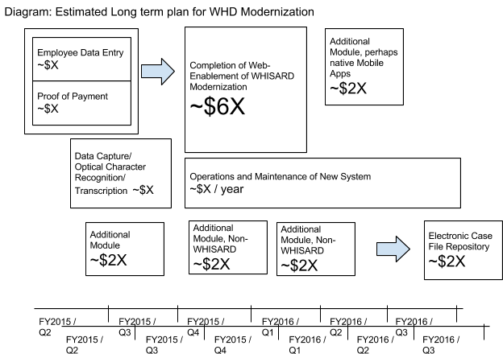

## De-risking Actions Taken To-date

In order to decrease risk and increase your chances of success, we’ve begun in-house development of the user experience design, as well as “spike” solutions to prove the technical feasibility of certain approaches. This work can be found at our public GitHub repos: <https://github.com/18F/consulting-dol-ede-prototype> and <https://github.com/18F/dol-ede-wireframes>.

At the time of this writing (Dec. 7, 2014), these repositories contain:

* Wireframe images of the two tasks in the first planned solicitation -- the Employee Data Entry and the Proof of Payment functionality.
* Initial clickable mockups of these designs to show them realized in HTML and to provide a demonstrable, clickable experience.
* An initial “spike” solution of a Python code making a connection to a DB2 instance with all of the WHISARD schema and stored procedures showing very crude connection to the data. This demonstrates: (a) a prototype website that renders employee names and (b) a Python unit-test suite which exercises the legacy stored procedure to add an employee.

This work is and will remain an evolving and changing exploration even during the execution of the planned solicitations.