How To Use ExpoKids

**Table of Contents:**

Background

ExpoKids Lifestages

Using ExpoKids

**ExpoKids Shiny App Version 1.1**

***Background:***

ExpoKids was first developed as an R-based data visualization tool to help characterize aggregate environmental exposure during childhood, through a collaboration between EPA’s organizations AO-OCHP and ORD-CPHEA. This ExpoKids Shiny app was developed from the ExpoKids R tool. It displays aggregate exposure estimates of chemicals across developmental and adult lifestages for 10 oral media (dust, breastmilk, water, vegetables, <i>etc.</i>). Five ExpoKids graph types can be produced:

1. ADD by lifestage

2. LADD by lifestage

3. ADD for an individual exposure pathway, by lifestage

4. LADD for an individual exposure pathway, by lifestage

5. Percent ADD by lifestage

ExpoKids v. 1.1 is compatible with EPA’s Exposure Factors Interactive Resource for Scenarios Tool ([ExpoFIRST](https://cfpub.epa.gov/ncea/efp/recordisplay.cfm?deid=344928)). ExpoFIRST is a standalone tool which uses the EPA’s Exposure Factors Handbook to provide deterministic potential dose estimates for user-defined average daily doses (ADDs) and lifetime average daily doses (LADDs) by lifestage.

***Sample Data:***

Please see the [Sample Data for ExpoKids](https://github.com/USEPA/ExpoKids/Sample_Data_for_ExpoKids.xlsx) file to see the format of the excel file for inputting your data.

***ExpoKids Lifestages:*** Table 1 provides the lifestage names and corresponding age ranges used in ExpoKids and compares the age ranges to those used in the EPA’s Exposure Factors Handbook.

**Table 1: ExpoKids and Exposure Factors Handbook (EFH) Lifestages Comparison and Total Years in each ExpoKids Lifestage**

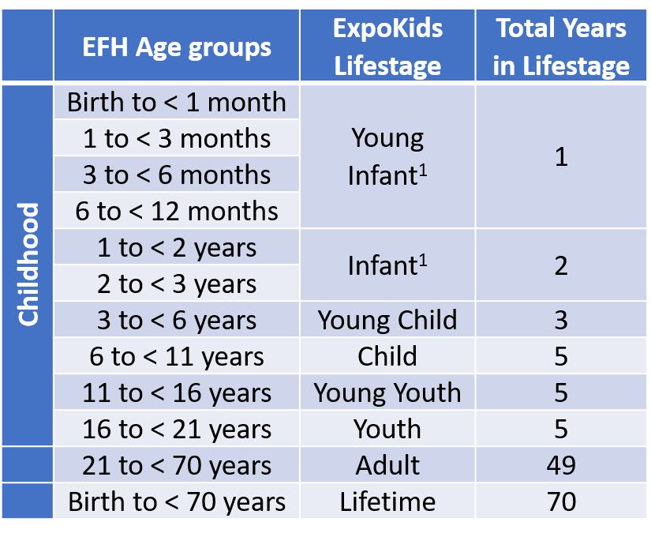

1The young infant and infant lifestages are the only ExpoKids lifestages to combine multiple EFH/ExpoFIRST age groups.

Here is a 508-compliant version of Table 1:

<!DOCTYPE html>

<html>

<head>

</head>

<body>

<table style='border: 2px solid black;'>

<th>

<td style='border: 1px solid black;'>EFH Age Groups</td>

<td style='border: 1px solid black;'>ExpoKids Lifestage</td>

<td style='border: 1px solid black;'>Total Years in Lifestage</td>

</th>

<tr>

<td rowspan='10' style='border: 1px solid black;'><p style='transform: rotate(-90deg);'>Childhood</p></td>

<td style='border: 1px solid black;'>Birth to &lt; 1 month</td>

<td rowspan='4' style='border: 1px solid black;'>Young Infant</td>

<td rowspan='4' style='border: 1px solid black;'>1</td>

</tr>

<tr>

<td style='border: 1px solid black;'>1 to &lt; 3 months</td>

</tr>

<tr>

<td style='border: 1px solid black;'>3 to &lt; 6 months</td>

</tr>

<tr>

<td style='border: 1px solid black;'>6 to &lt; 12 months</td>

</tr>

<tr>

<td style='border: 1px solid black;'>1 to &lt; 2 years</td>

<td rowspan='2' style='border: 1px solid black;'>Infant</td>

<td rowspan='2' style='border: 1px solid black;'>2</td>

</tr>

<tr>

<td style='border: 1px solid black;'>2 to &lt; 3 years</td>

</tr>

<tr>

<td style='border: 1px solid black;'>3 to &lt; 6 years</td>

<td style='border: 1px solid black;'>Young Child</td>

<td style='border: 1px solid black;'>3</td>

</tr>

<tr>

<td style='border: 1px solid black;'>6 to &lt; 11 years</td>

<td style='border: 1px solid black;'>Child</td>

<td style='border: 1px solid black;'>5</td>

</tr>

<tr>

<td style='border: 1px solid black;'>11 to & lt; 16 years</td>

<td style='border: 1px solid black;'>Young Youth</td>

<td style='border: 1px solid black;'>5</td>

</tr>

<tr>

<td style='border: 1px solid black;'>16 to & lt; 21 years</td>

<td style='border: 1px solid black;'>Youth</td>

<td style='border: 1px solid black;'>5</td>

</tr>

<tr>

<td style='border: 1px solid black;'></td>

<td style='border: 1px solid black;'>21 to &lt; 70 years</td>

<td style='border: 1px solid black;'>Adult</td>

<td style='border: 1px solid black;'>49</td>

</tr>

<tr>

<td style='border: 1px solid black;'></td>

<td style='border: 1px solid black;'>Birth to &lt; 70 years</td>

<td style='border: 1px solid black;'>Lifetime</td>

<td style='border: 1px solid black;'>70</td>

</tr>

</table>

</body>

</html>

***Using ExpoKids:***

1) Media-specific exposure data are identified from the literature or other source for a chemical of interest.

2) ExpoFIRST can be used to generate lifestage-specific ADDs and LADDs. Please compile your ADDs and LADDs by media using the format in the attached file called “sample_data_ExpoKids.xlsx”.

3) Scroll past the background information and disclaimer to use the ExpoKids Shiny app. Click the “Upload” button on the top-left corner of the navigation bar on the left side of the page. You will be prompted to select the spreadsheet on your computer from step 2 containing the ADDs and LADDs.

4) Click on the buttons on the left to generate the various graphs. Note that you can switch from “stacked” to “grouped” (and select or deselect media) by clicking on the little circles in the legend of each graph. Note also that, for the Media Graphs, there is one tab for ADD and another tab for LADD.

**More information:**

* EPA ExpoKids website: <https://www.epa.gov/expobox/expokids-data-visualization-tool-aggregate-exposure-lifestage-and-media>
* An article describing the ExpoKids R-tool and its uses, using examples, was published Oct. 5, 2020 in the *Journal of Exposure Science and Environmental Epidemiology (JESEE)*; available online at: [[https://www.nature.com/articles/s41370-020-00265-6](https://gcc01.safelinks.protection.outlook.com/?url=https%3A%2F%2Fwww.nature.com%2Farticles%2Fs41370-020-00265-6&data=02%7C01%7CEuling.Susan%40epa.gov%7C4774d5f23a7c43c54aa208d86b080288%7C88b378b367484867acf976aacbeca6a7%7C0%7C0%7C637377029898794831&sdata=hUHJwQPKgStWpkJ9eP8Vx0k5Y9HcVAlukH3XtumTJSA%3D&reserved=0)](https://www.nature.com/articles/s41370-020-00265-6)
* Exposure Factors Handbook (EFH); available online at: [<https://www.epa.gov/expobox/about-exposure-factors-handbook>](https://www.epa.gov/expobox/about-exposure-factors-handbook)
* EPA’s Exposure Factors Interactive Resource for Scenarios Tool (ExpoFIRST; <https://cfpub.epa.gov/ncea/efp/recordisplay.cfm?deid=344928>)