25 Years of Water Quality Change in Rhode Island Lakes and Ponds

Hollister. J. W. * *1*, Kellogg, D. Q. *2*, Kreakie, B. J. *1*, Shivers, S. *3*, Herron, E. *2*, Green, L. *2*, Gold, A *2*

*1* US Environmental Protection Agency, Office Of Research and Development, Atlantic Ecology Division, Narragansett, RI 02882

*2* University of Rhode Island, Department of Natural Resources Science, Kingston, RI 02881

*3* ORISE, Narragansett, RI 02882

* *corresponding author: [hollister.jeff@epa.gov*](mailto:hollister.jeff@epa.gov*)

The University of Rhode Island’s Watershed Watch Volunteer Monitoring Program has been collecting water quality data on dozens of Rhode Island lakes and ponds for over 25 years, allowing us to explore long-term trends in common water quality parameters. Not all lakes and ponds in the study area were sampled across the full time period and lakes were often added in geographic clusters (e.g. in urbanized northern Rhode Island). Not unlike how long-term temperature records are analyzed, we centered and scaled (i.e., the z-score) water quality measurements on a per-station basis. This provides a robust and commonly scaled measurement to explore this data for long-term trends. State-wide aggregation shows increasing temperature, chlorophyll *a*, and total nitrogen. Interestingly, total phosphorus is showing a decline, perhaps reflecting the management focus on phosphorus reductions. While yearly trends are useful, they do mask month-to-month variability differences across sites. Additionally, while most sites track the yearly trend in decreasing water quality, there are bright spots with some sites improving over the 25 years. Contrary to previously reported analyses that show relatively stable water quality at the regional scale, our analysis shows that long-term water quality trends within Rhode Island show some parameters improving while others are in decline. Importantly, this analysis also points out the incredible value and importance of data from long-term monitoring programs, like the Univeristy of Rhode Island’s Watershed Watch, for identifying trends in environmental condition.

# Introduction

General stuff about long-term trends, monitoring programs and watershed watch details

Given what is known about long term trends in water quality within the broader region of the northeastern United States [1], we were curious if those trends were also present in water quality trends in Rhode Island lakes and ponds. Something about spatial and temporal variability of water quality

The goals of this study were to look at approximately 25 years of lakes and ponds data in Rhode Island. We will answer two particular questions. First, what are the state-wide trends in total nitrogen, total phosphorus, chlorophyll *a*, and lake temperature and second, are water quality trends in Rhode Island similar to regional trends in the northeastern United states. In addition to these goals, this analysis has also been done using open data from the URI Watershed Watch program and the analysis in its entirety is available for independent reproduction at <https://github.com/usepa/ri_wq_trends>.

# Methods

For this study we combined a long-term dataset on water quality of lakes in Rhode Island, with a trend analysis based on centered and scaled water quality values (i.e. z-scores) to find increasing or decreasing annual water quality trends. Details are outlined below.

## Study Area and Data

The study area for this analyis includes data in lakes and ponds in the state of Rhode Island that were collected by the University of Rhode Island’s Watershed Watch (URIWW) program (Figure 1). MORE DETAILS ON RIWW.

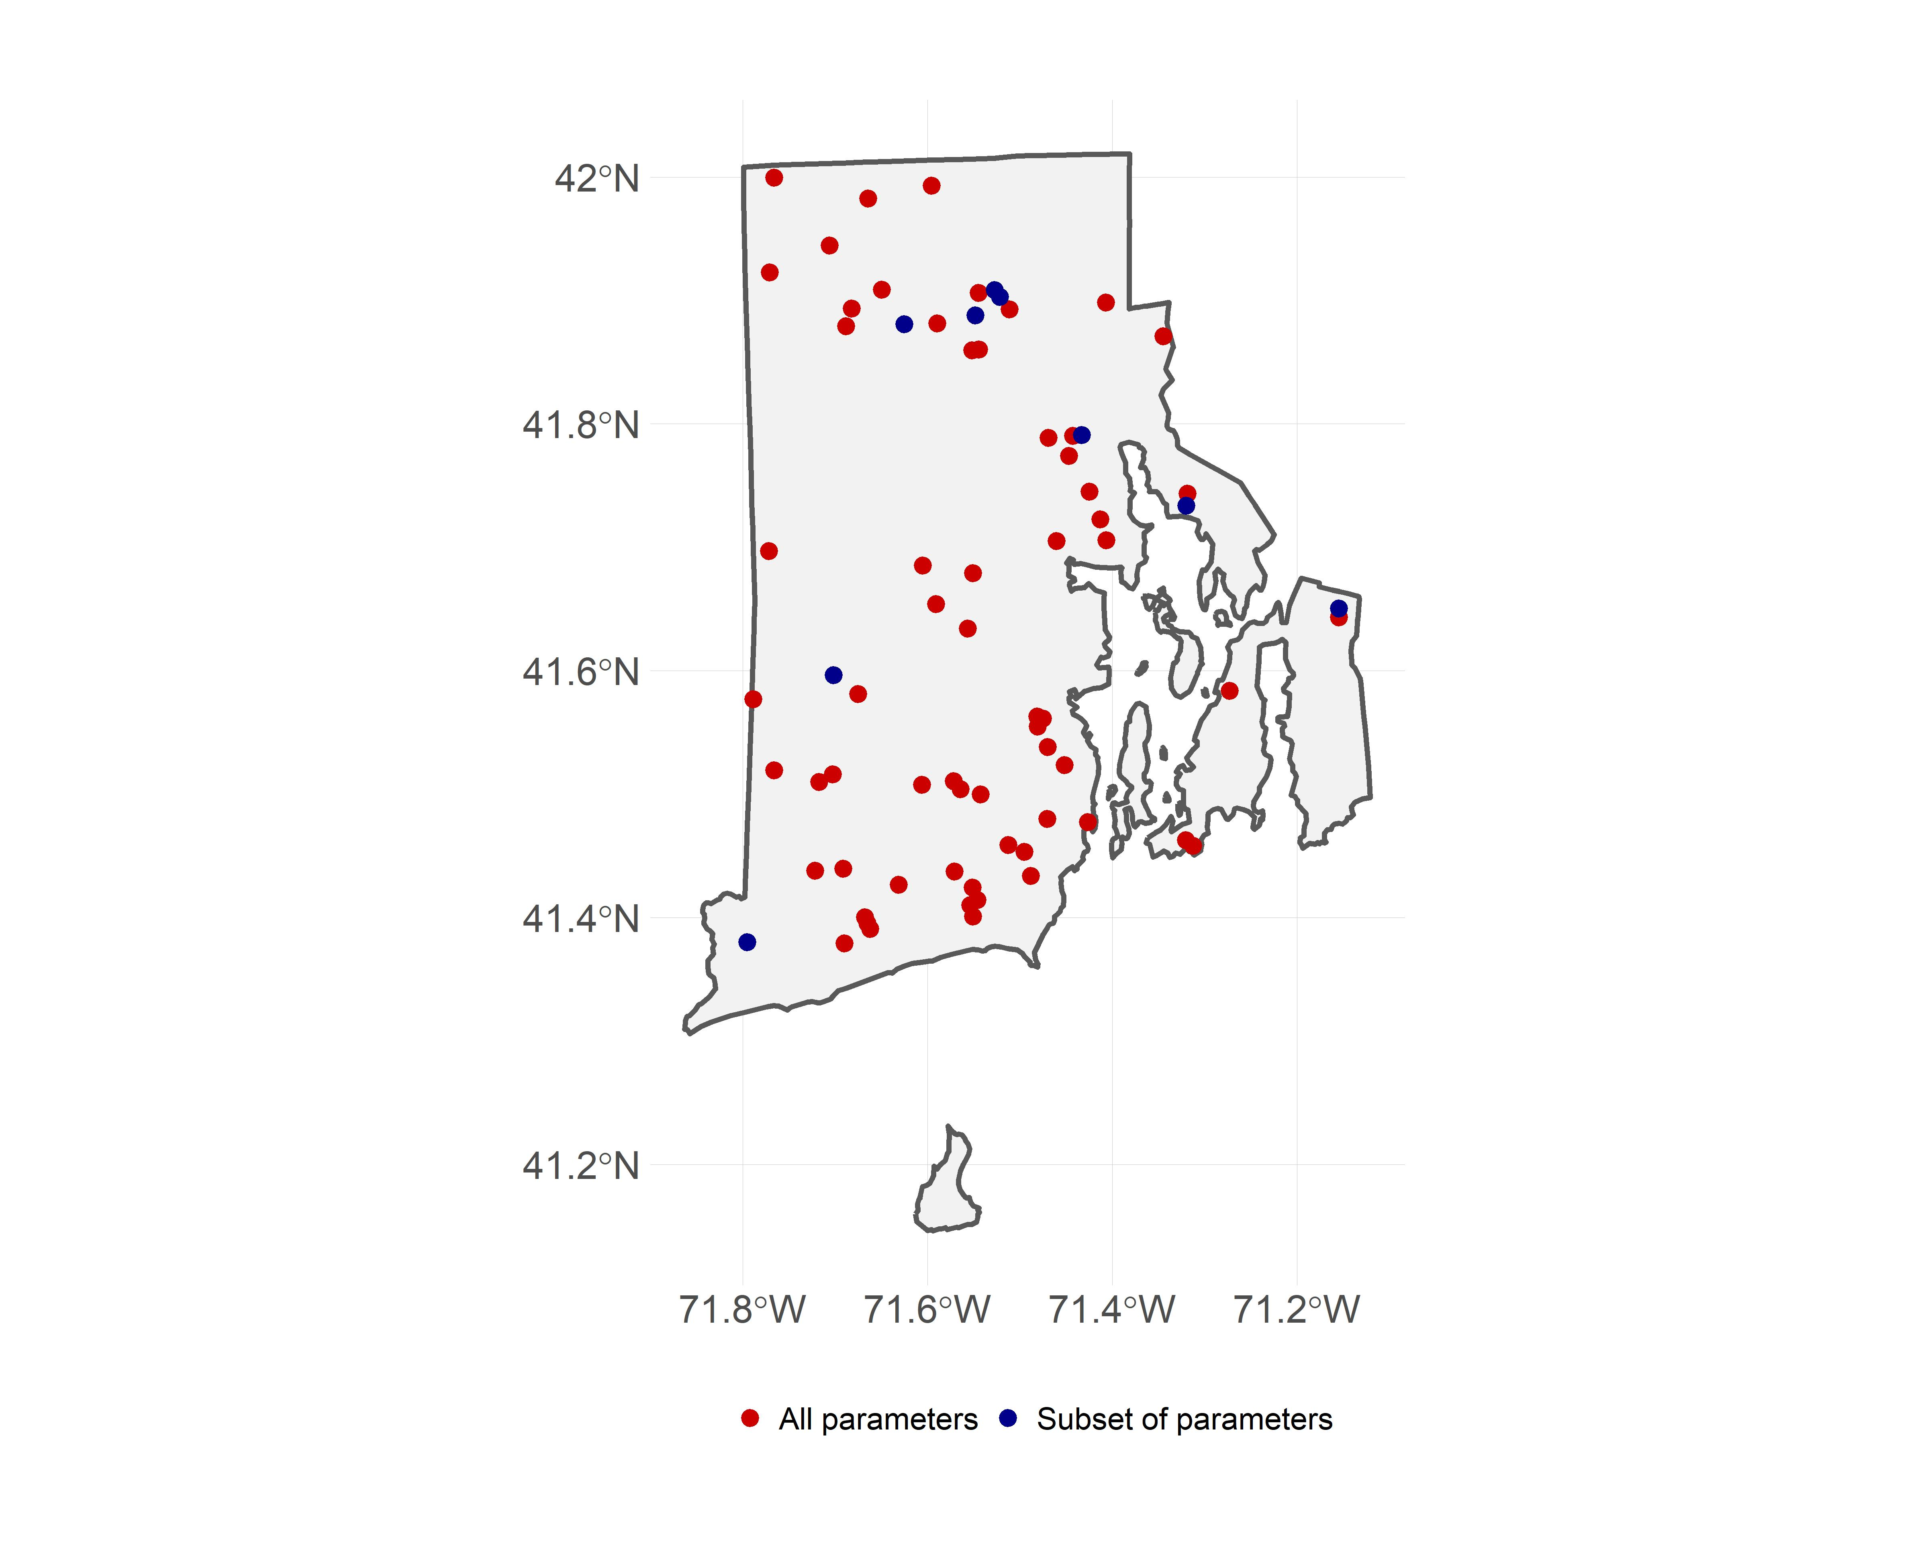

Figure 1: Map of URI Watershed Watch lake and pond sampling sites

In particular we selected data from the RIWW data that matched the following criteria: 1) were sampled between 1990 and 2016, 2) were sampled in May to October, 3) and were sampled at a depth of 2 meters or less. For this analysis we were interested in trends in lake temperature, total nitorgen, total phosphorus, and chlorophyll *a* and for each of these parameters we further filtered the data to select sites that had at least 10 years of data for a given parameter. The final dataset used in our analysis included 72 lakes and ponds which had approximately 70 samples for temperature, 70 samples for chlorophyll *a*, 65 samples for Total Nitrogen (TN), and 69 samples for Total Phosphorus (TP). Of the 72 sampling sites, 63 had data for all 4 parameters.

Additionally, prior studies have looked at water quality trends across a larger region of the Northeastern United states that included 17 states including Minnesota, Wisconsin, Iowa, Missouri, Illinois, Indiana, Michigan, Ohio, Pennsylvania, New York, New Jersey, Connecticut, Massachusetts, Rhode Island, Vermont, New Hampshire, and Maine [1,2]. The authors found little change in water quality trends across this region [1] . We repeated our analysis (see **Trend Analysis** section) with the same dataset used by [1], the LAGOSNE dataset [2–4]. Temperature data were not availble, thus we only examine trends, using our analytical methods, for Total Nitrogren, Total Phosphorus, and Chlorophyll *a* from the LAGOSNE database.

## Trend Analysis

There are many different methods for analyzing time series data for trends. One of the difficulties that is encountered when you have multiple sampling locations is how to identify a trend when you have variation at the scale of the sampling location as well as variation in when a sampling location might have been addedd to a dataset. For instance, if you have long-term data on water quality for several ponds, yet the cleaner ponds wer sampled more frequently in early years then a simple comparison of raw-values over time might show a decrease in water quality. Thus, it is necessary to account for this type of site-specific variation. This is similar to how the long-term temperature trends are analyzed using temperature anomolies [FILL IN GROUP DOING THIS]. The general approach is to calculate site-specific deviations from a long-term mean over pre-determined reference period. This allows all sites to be shifted to a common base line and the deviations, or anomalies, show change relative to the reference period.

### Z-score

The anomaly approach is very useful and is the approach we chose to follow. However, using anomalies works best with a single measure (e.g temperature) or with mulitple measurements that are on the same scale. The water quality parameters that we explored have different scales and thus the anomaly alone is difficult to interpret across metrics. For instance, temperature in Rhode Island lakes during the growing season will range from approximately 15 degrees celsius to a high of 30 degrees celsius, whereas phosphorus might range from near zero ug/l to ~900 ug/l. To standardize these values we used the common approach of dividing each anomlaly by the standard deviation for the reference period. This value is commonly referred to as a Z-score. We use these z-scores to examine each water quality variable for a trend over the time period of 1990 to 2016.

Furthermore, since we are interest in water quality trends over time, we wanted to explore how each site was responding. Thus, our z-scores were calculated over the reference period, 1990-2016, for each site. In other words the long-term mean and standard deviation were calculated on a site-by-site basis.

### Kendall’s Tau

Kendall’s Tau and the Mann-Kendall test are commonly used to test for monotonic trends water quality data [5–7]. We followed these standard procedures to test for postive or negative trends in lake temperature, chlorophyll *a*, total nitrogen, and total phosphorus.

### Comparison of Rhode Island to the Region

Prior studies have shown relatively stable water quality in the lakes of the Northeastern United Sates [1]. The data we used in our analysis, the University of Rhode Island’s Watershed Watch data, was inlcuded in that, but we were curious if regional trends were masking local scale trends in Rhode Island. In addition to the analysis condcuted by Oliver et al. [1], we analyzed the same dataset but using the approach outlined here.

# Results

## State-wide trends in water quality

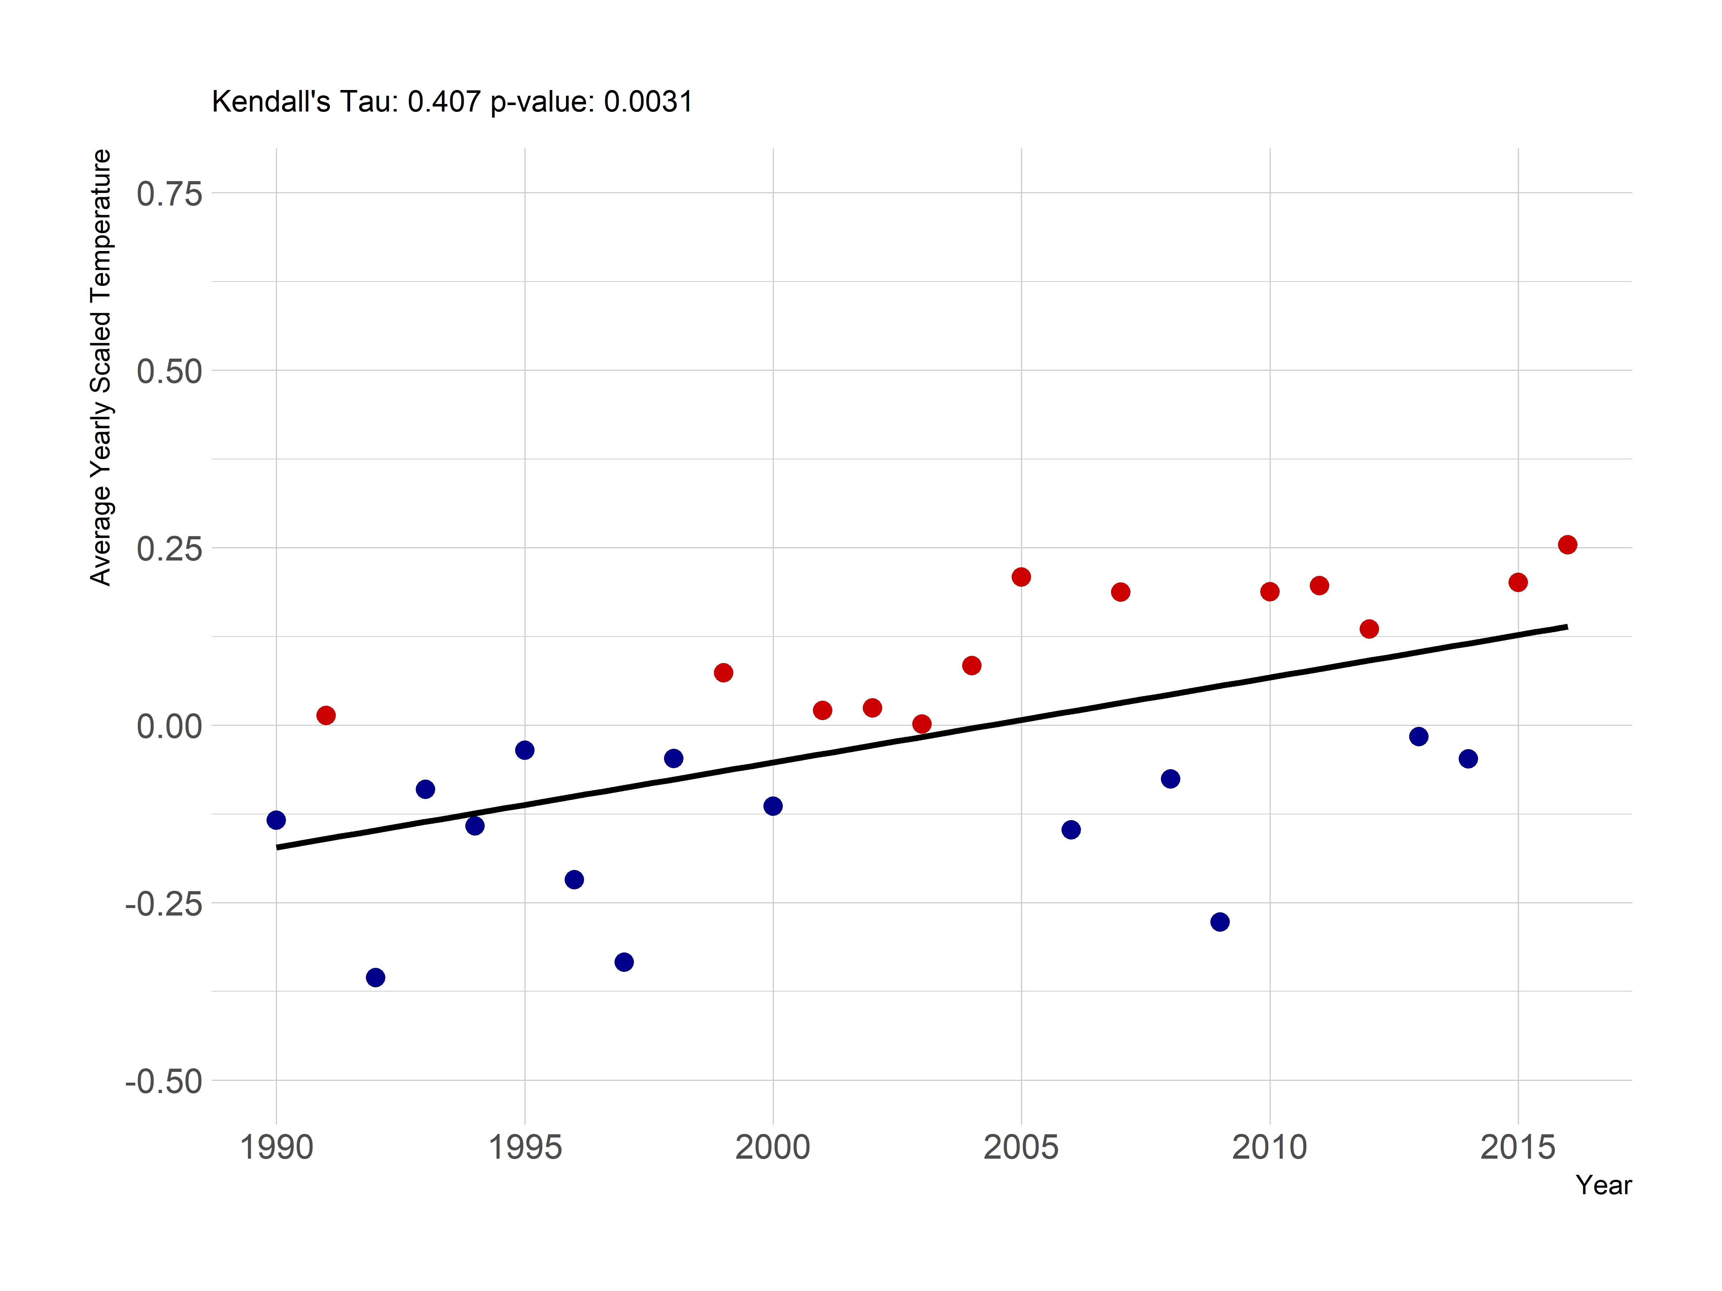

Figure 2: Yearly trend over 20+ years of lake temperature in Rhode Island lakes and ponds.

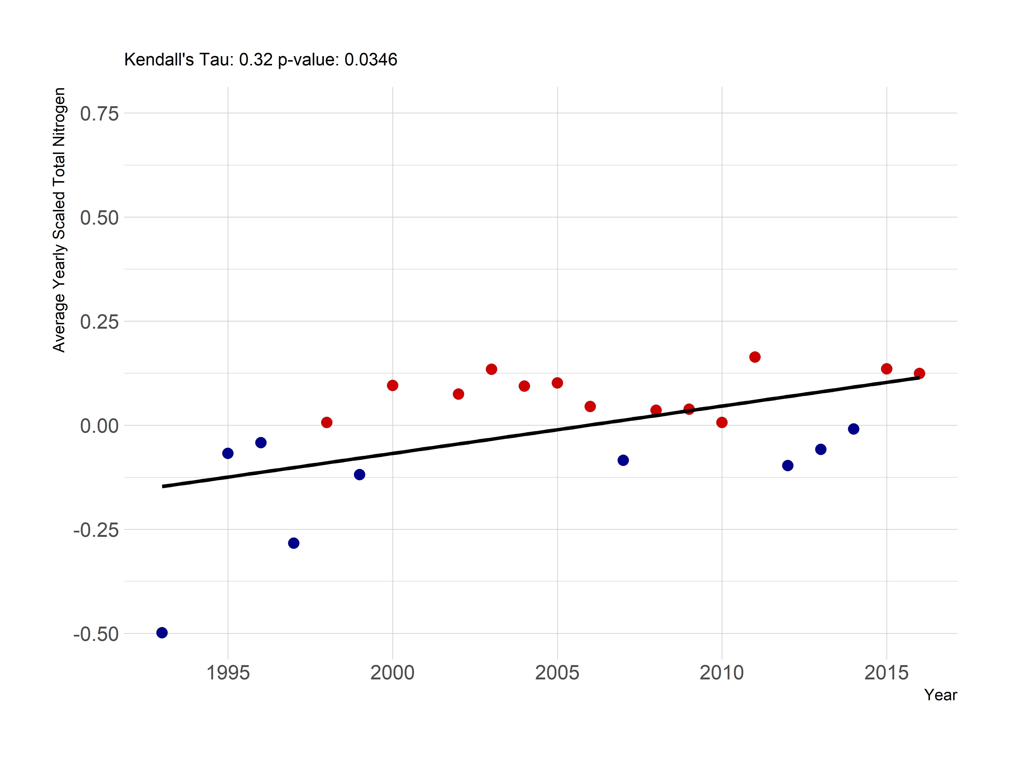

Figure 3: Yearly trend over 20+ years of Total Nitrogen (average z-score) in Rhode Island lakes and ponds.

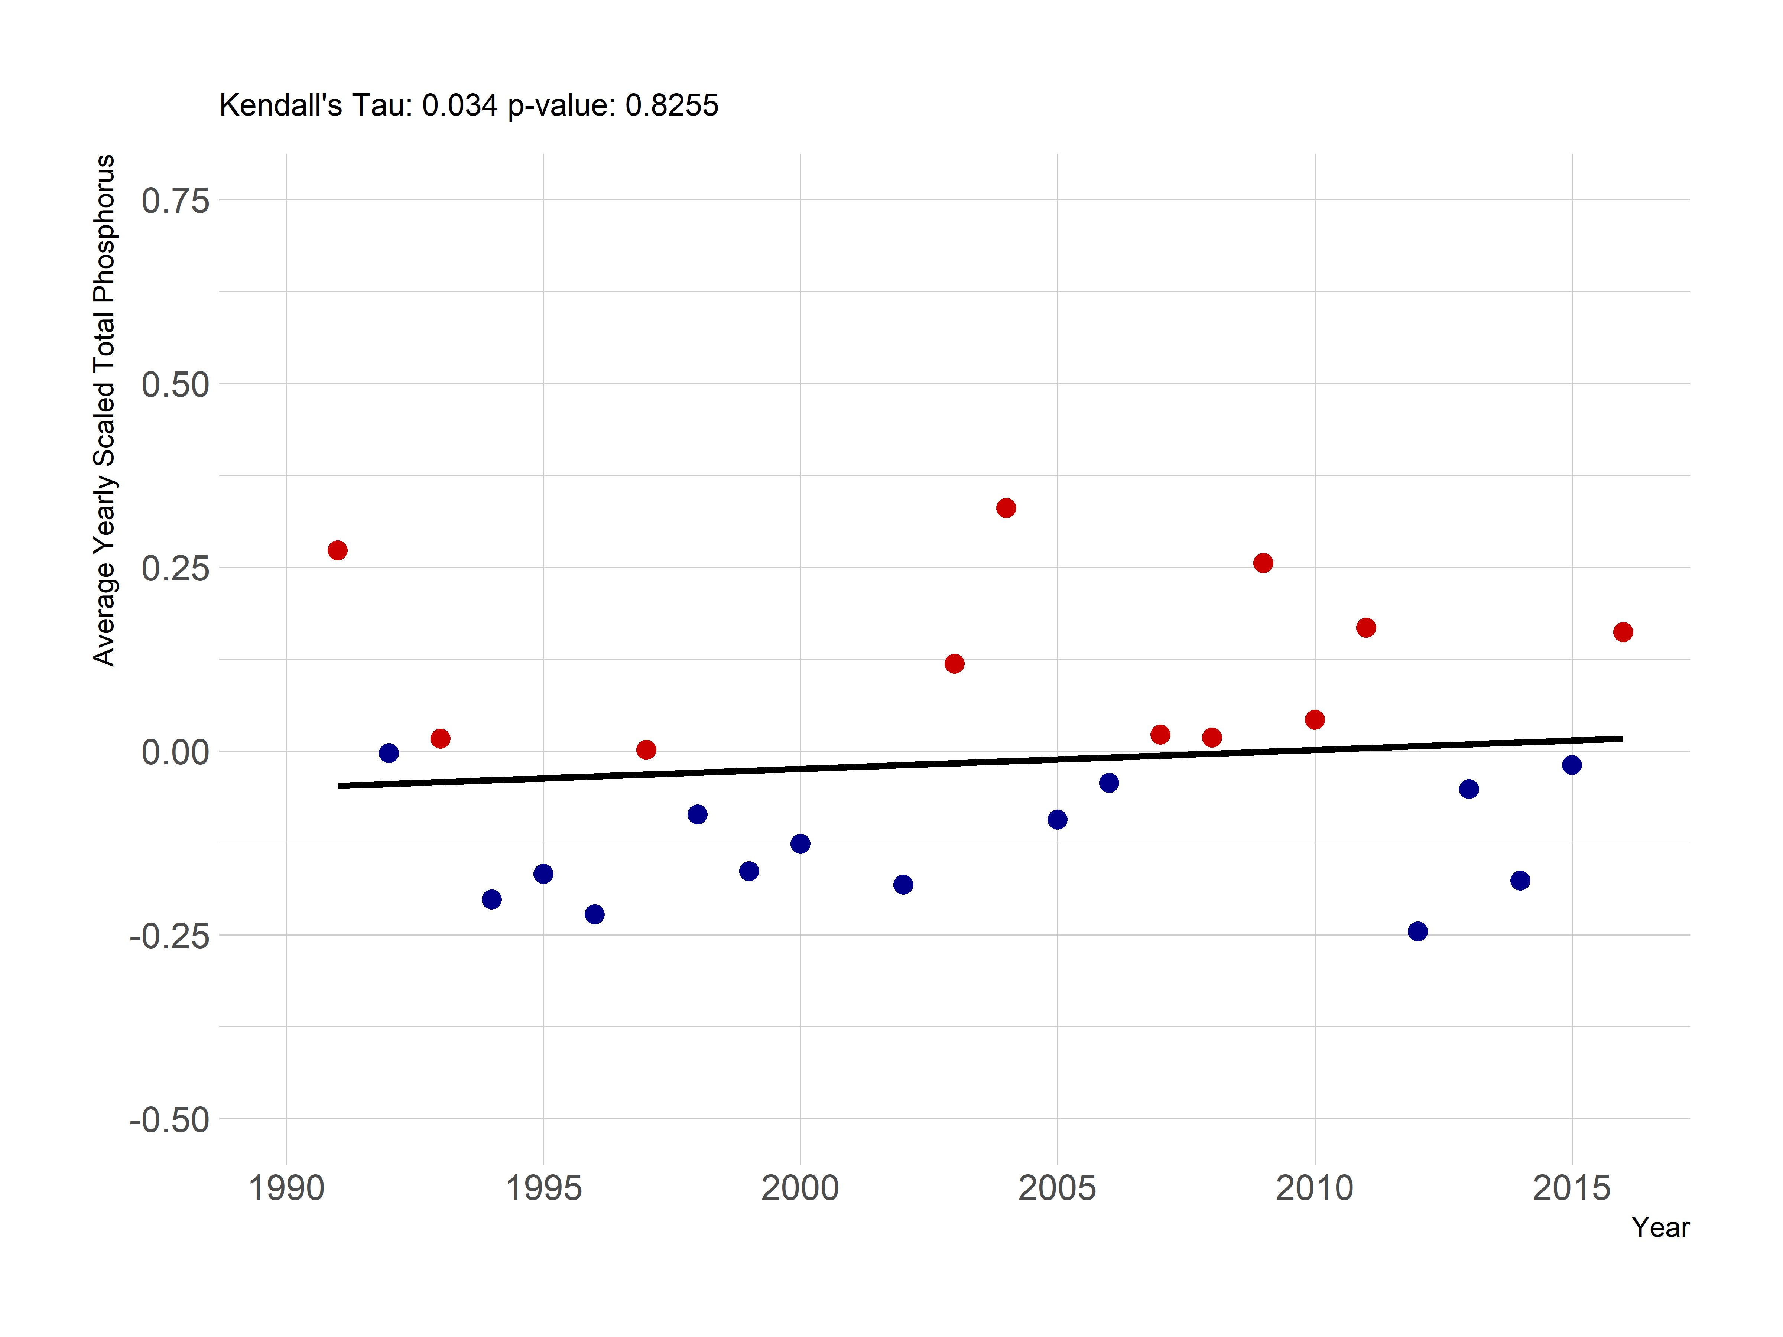

Figure 4: Yearly trend over 20+ years of Total Phosphorus (average z-score) in Rhode Island lakes and ponds.

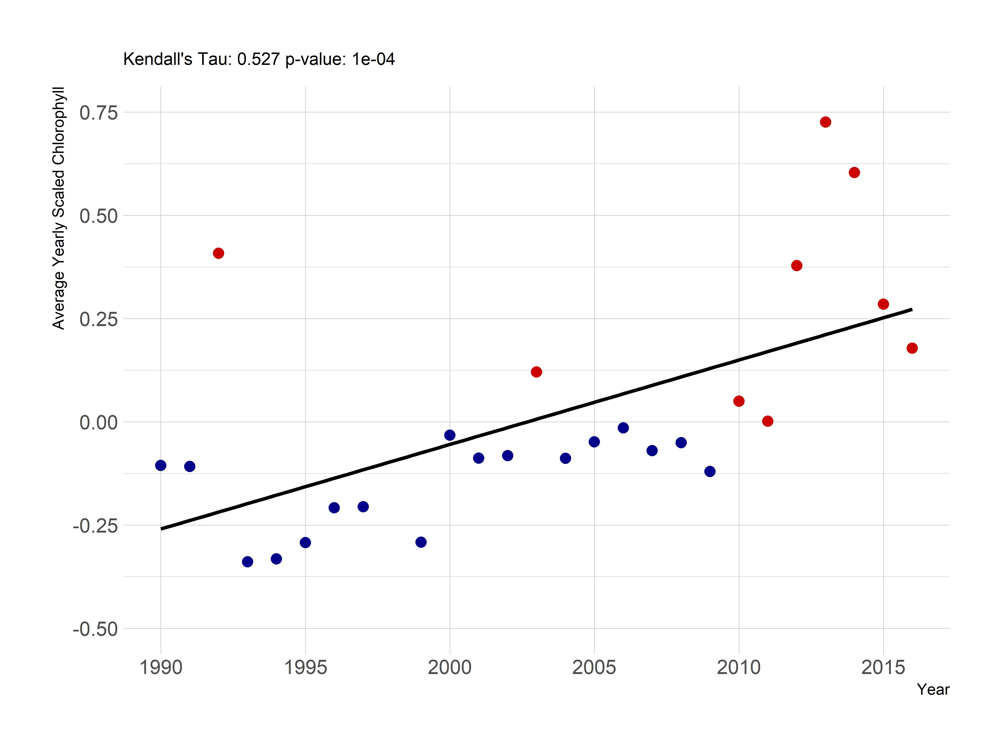

Figure 5: Yearly trend over 20+ years of Chlorphyll *a* (average z-score) in Rhode Island lakes and ponds.

## Regional trends in water quality

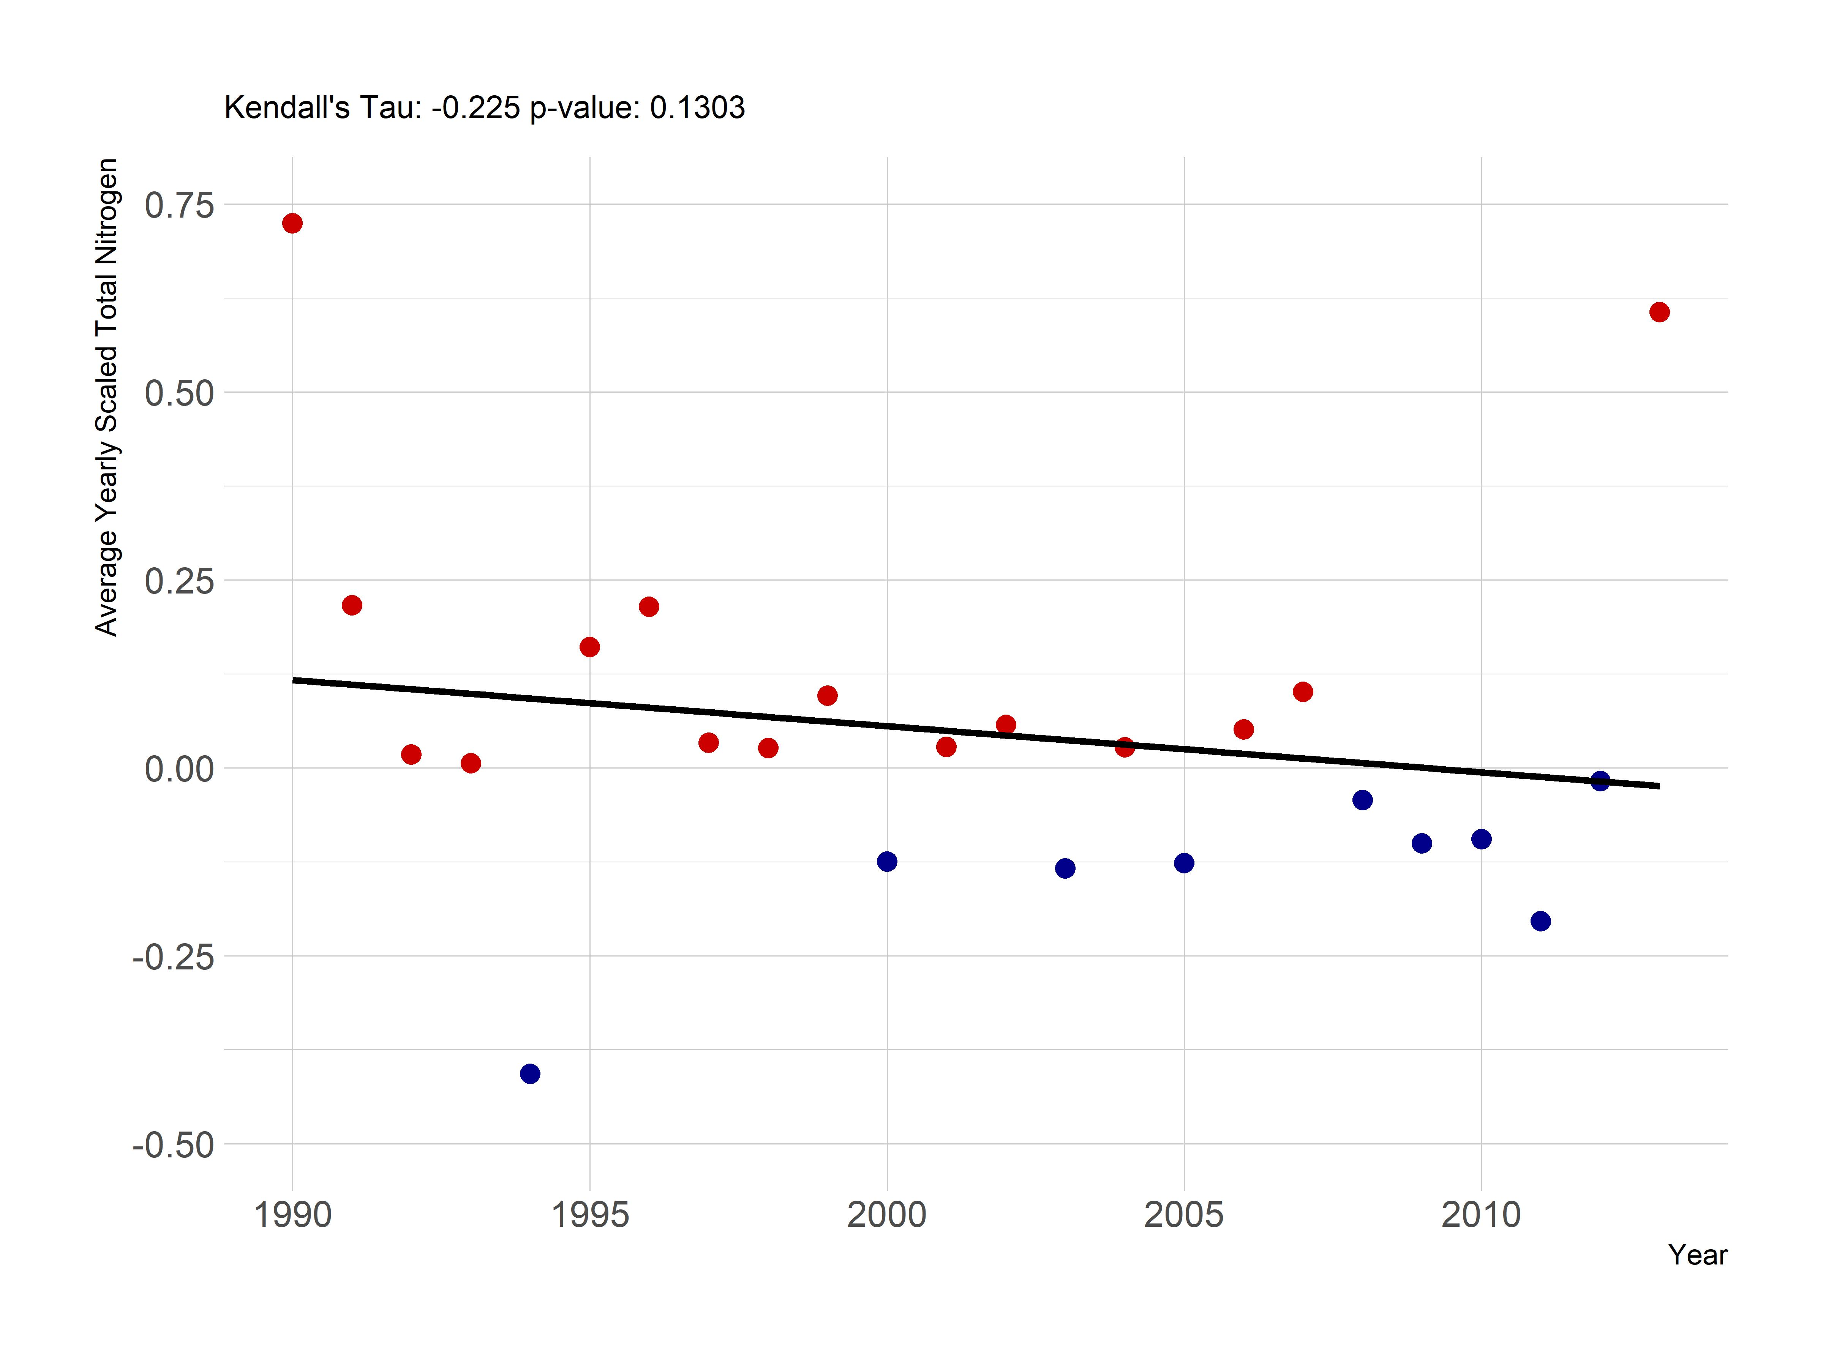

Figure 6: Yearly trend over 20+ years of Total Nitrogen (average z-score) in the LAGOSNE states.

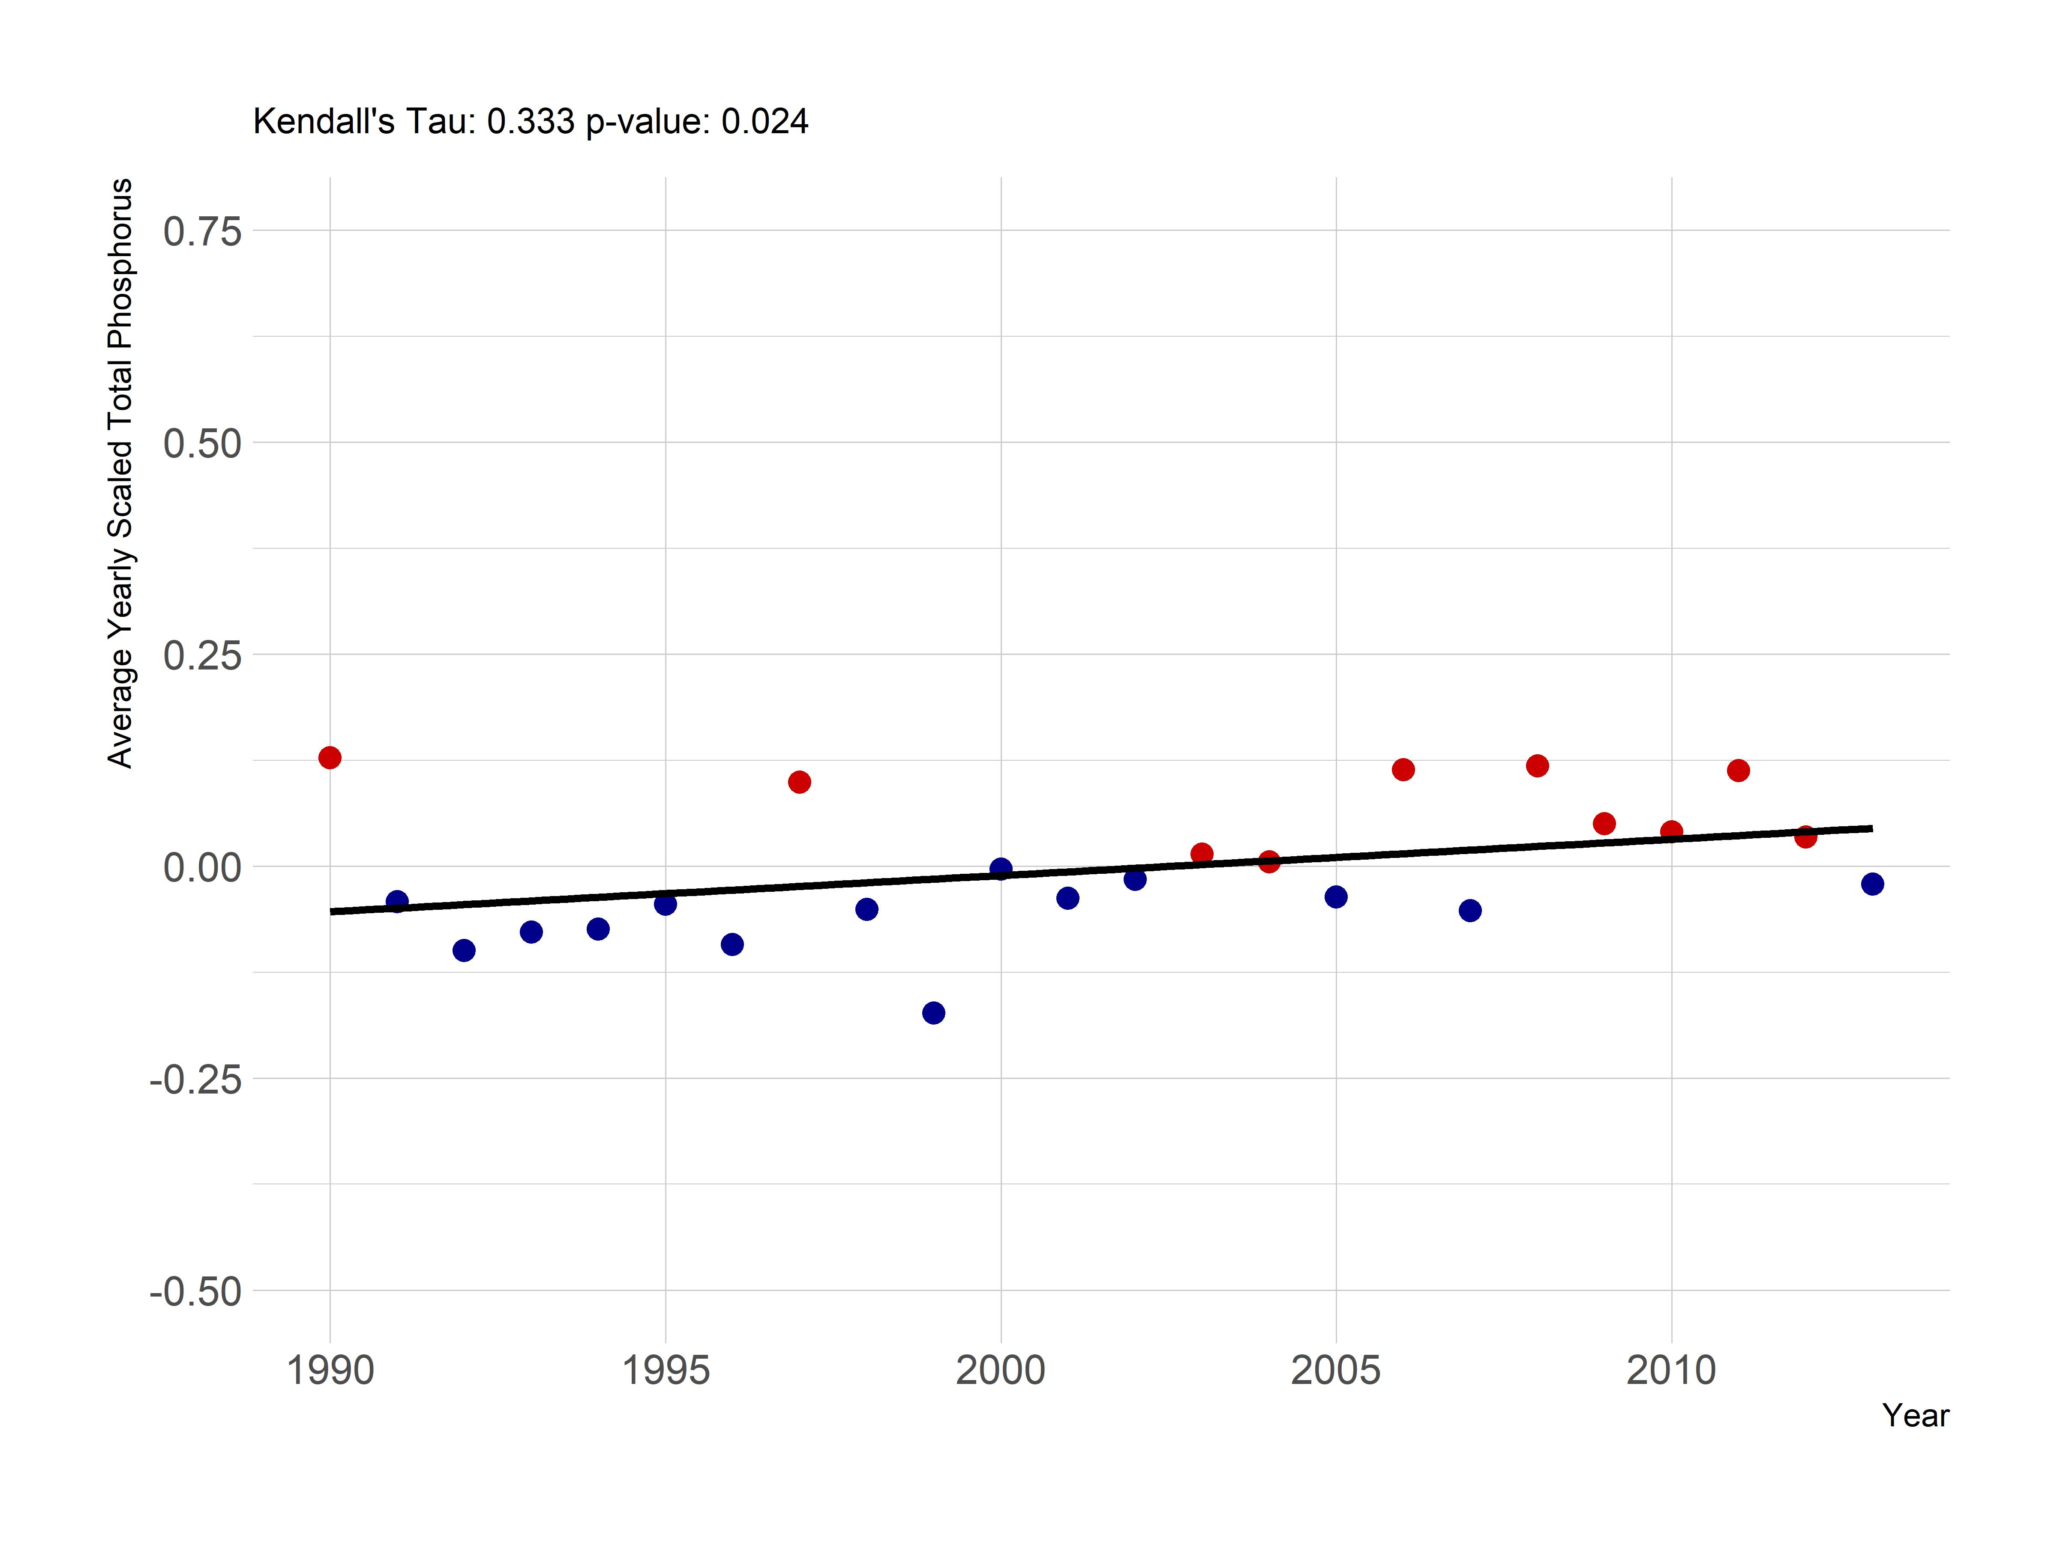

Figure 7: Yearly trend over 20+ years of Total Phosphorus (average z-score) in the LAGOSNE states.

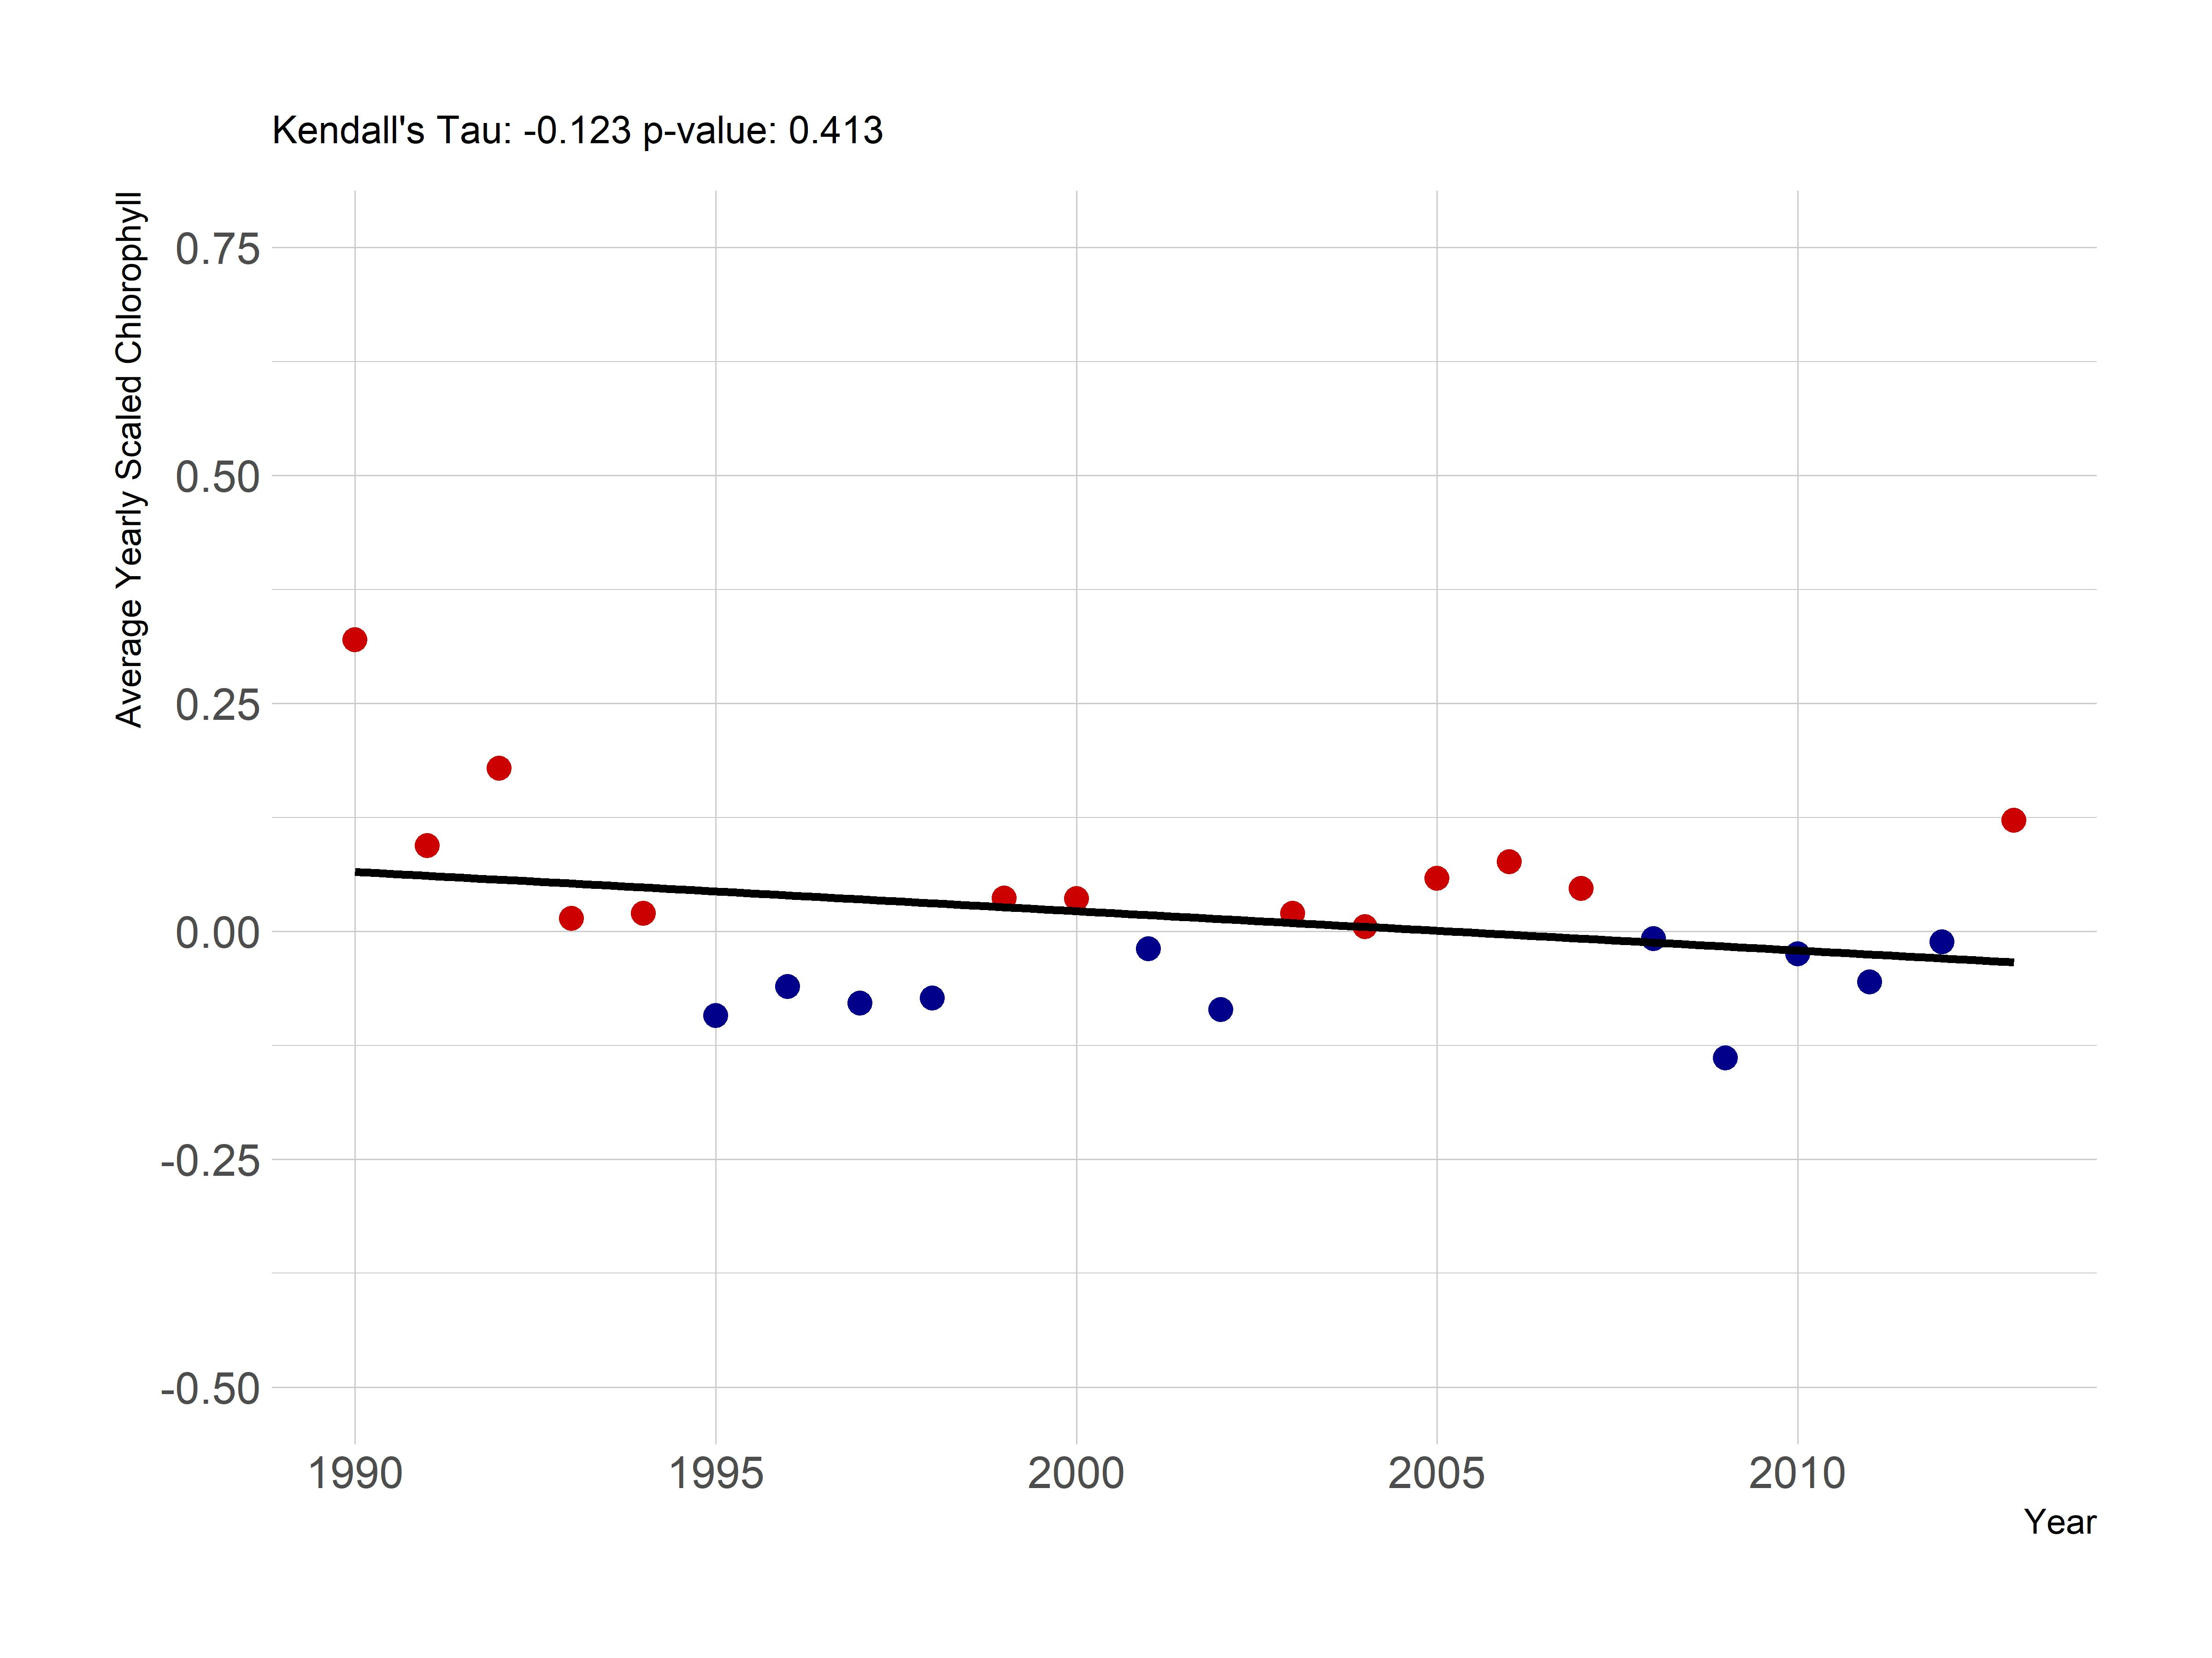

Figure 8: Yearly trend over 20+ years of Chlorophyll *a* (average z-score) in the LAGOSNE states.

# Discussion and conclusions

## Trends

### Local scale vs Regional/Global scale

## Caveats

# Bibliography

1. Oliver SK, Collins SM, Soranno PA, Wagner T, Stanley EH, et al. (2017) Unexpected stasis in a changing world: Lake nutrient and chlorophyll trends since 1990. Global Change Biology 23: 5455–5467. Available: <https://doi.org/10.1111%2Fgcb.13810>.

2. Soranno PA, Bissell EG, Cheruvelil KS, Christel ST, Collins SM, et al. (2015) Building a multi-scaled geospatial temporal ecology database from disparate data sources: Fostering open science and data reuse. GigaScience 4: 28.

3. Stachelek J, Oliver S (2017) LAGOSNE: Interface to the lake multi-scaled geospatial and temporal database. Available: <https://cran.r-project.org/package=LAGOSNE>.

4. Soranno P, Bacon L, Beauchene M, Bednar K, Bissell E, et al. (2017) LAGOS-ne: A multi-scaled geospatial and temporal database of lake ecological context and water quality for thousands of us lakes. Gigascience 6.

5. Mann HB (1945) Nonparametric tests against trend. Econometrica: Journal of the Econometric Society: 245–259.

6. Helsel DR, Hirsch RM (2002) Statistical methods in water resources. US Geological survey Reston, VA, Vol. 323.

7. Hipel KW, McLeod AI (1994) Time series modelling of water resources and environmental systems. Elsevier.