The Advanced Decision-making and Management Tool ADAM 1.0 Beta Version User Guide

### Yicheng Hu*‡*, Victor M. Zavala*‡*, Gerardo Ruiz-Mercado*¶*

*‡* Department of Chemical and Biological Engineering

University of Wisconsin-Madison, 1415 Engineering Dr, Madison, WI 53706, USA

*¶*Center for Environmental Solutions and Emergency Response, U.S. Environmental Protection Agency, 26 West Martin Luther King Drive, Cincinnati, Ohio 45268, USA

[yhu267@wisc.edu](mailto:yhu267@wisc.edu)

US EPA GitHub: https://github.com/USEPA/Advanced-Decision-Making-And-Management

### September 2020

**Contents**

1. Introduction 3

1.1 Background . . . . . . . . . . . . . . . . . . . . . . . . . . . . . . . . . . . . . . . . . . . 3

1.2 Basic Functions and Target Users . . . . . . . . . . . . . . . . . . . . . . . . . . . . . . . 3

1.3 Structure and Modules in ADAM . . . . . . . . . . . . . . . . . . . . . . . . . . . . . . . 4

1. ADAM Tutorial 5

2.1 Structure and Goals . . . . . . . . . . . . . . . . . . . . . . . . . . . . . . . . . . . . . . . 5

2.2 Tutorial Part 1 - Biogas From Waste . . . . . . . . . . . . . . . . . . . . . . . . . . . . . . 7

2.3 Tutorial Part 2 - Custom Model 11

1. User dashboard 13
   1. Overview 13
   2. Registration and User Profile 13
   3. Case Studies 14
   4. Model Management 16
   5. Create a Model 17
   6. Edit a Model - Common Options 17
   7. Edit a Model - Model Type and Time Basis 19
   8. Edit a Model - Supply, Technology and Demand 19
   9. Edit a Model - Transportation 25
   10. Run a Model and Get Results 27
   11. User Support 28
2. Visualization 28
   1. Visualize Model Data and Results 28
   2. Visualize Custom Data 30
3. Developer Guide 32
   1. Become an Admin of ADAM 32
   2. Publish New Case Studies 33
   3. Product and Technology Management 34
   4. Object Management 36
4. Endnotes 38

Appendix 38

ADAM Database 38

# Introduction

## Background

The ADAM (Advanced Decision-Making and Management) is designed for systems-level organic waste management (OWM) problems and has been under development since October 2018. The main principle behind this tool is to use logistic network optimization models to decide optimal feedstock and product transformation and transportation options. In this document, we will summarize the functions of this tool and current accomplishments. At the same time, we will provide a detailed user guide and some notes for future developers and maintainers.

OWM is an important sector in the Food-Energy-Water (FEW) nexus, in which organic waste streams are generated in different stages of anthropocentric activities. For example, in the State of Wisconsin, over 1.2 million lactating cows are generating 29 billion pounds of milk (food) and 23 billion liter of manure (organic waste) annually [1]. Those organic waste streams are usually of low value and highly distributed across many locations, and this makes the processing technologies hard to employ due to the uncertainty raised by the economy of scale and logistics issues. On the other hand, the unprocessed waste streams are usually environmentally unfriendly - they can gen- erate greenhouse gas emissions, nutrient pollution in soil and waterbodies, pathogens and odors, etc. Therefore, proper management strategies are of vital significance to mitigate the economic and environmental risks in organic waste processing.

Logistic network optimization has been proven to be a suitable and comprehensive method for analyzing OWM problems or even biomass conversion problems. A logistic network optimization modeling abstract has been established in [2]. This modeling abstract can be employed in various OWM practices regardless of the study region, waste streams, or processing technologies, as long as proper, corresponding datasets are provided. This modeling abstract forms the core foundation of the mathematical modeling behind ADAM.

In recent years, our research team has been devoted to solving OWM problems from different perspectives, following a similar methodological philosophy. Sampat et al [3] used the developed framework to test the impact of policy incentives, including RINs (Renewable Identification Num- bers), RECs (Renewable Energy Certificates), and hypothetic phosphorus credits. Hu et al [4] con- ducted a techno-economic analysis for novel technologies in OWM, i.e. the recovery of fatty acids using different waste streams. Furthermore, case studies related to technology selection and place- ment [5], energy recovery [6], and nutrient balance [7, 8] are also reported. Those research projects mainly focus on problems appearing in the State of Wisconsin, and the organic waste streams con- sidered mainly involve livestock waste. By developing this tool, we hope that more case studies for different study regions and livestock waste streams will be generated and published to highlight the importance of sustainability throughout the progress of human society.

## Basic Functions and Target Users

The ADAM provides an **automated procedure of logistic network modeling, problem solving, and results visualization**, once users properly define their OWM problems by providing or specifying

corresponding data. Some built-in auxiliary functions are provided, such as a simple, detailed tu- torial of ADAM, and a database system where users can find data of typical organic waste streams, processing technologies, or data packages related to published studies.

Target users of ADAM could include (but not limited to):

* college students and researchers in engineering or any other related fields;
* experimentalists and developers who want to do preliminary tests of their technologies;
* policy makers and stakeholders who want to learn macroscopical information about OWM;
* others who are interested in systems-level OWM problems.

## Structure and Modules in ADAM

The current structure of ADAM is shown below in Figure 1. **Any user from the internet** will have access to the ADAM homepage, where an interactive map is provided to visualize some datasets, e.g., locations of CAFOs (concentrated animal feeding operations) and WWTPs (wastewater treatment plants). At the home page, users can see a navigation bar with different options, including ABOUT, TUTORIAL, DASHBOARD, and CONTACT. The ABOUT section provides a brief overview of ADAM. The TUTORIAL module provides two simple, step-by-step examples for users, which will be discussed in Section 2. And in the CONTACT section, users can send messages to our team. All the aforementioned sections are open to all users.

In the DASHBOARD section (which is only accessible for **registered users**), users can view pub- lished, real case studies, manage their OWM models, and use the visualization tool provided for their model data and corresponding results. This part, including user registration and the use of these modules, will be discussed in Section 3 and 4, respectively.

Any registered user can apply to be an **admin of ADAM**. Admin users will have access to the developer panel, where they can manage the database system behind the scene directly on ADAM, including organic waste processing technologies, organic waste streams, published case studies, etc. This part will be discussed in Section 5.

We note that the structure might be changing as we keep improving ADAM. For example, in an earlier internal version, all users have access to the database system, and they can manage their own, private technology and product items; and we removed that function later considering that it might increase the complexity of this tool for common users.

We hope that after reading and playing around with the interactive map on the home page, users will first go through the TUTORIAL module to get familiar with this tool. And then after registration, users can enter the dashboard, either to make a copy of one published case study to get started or to prepare their data and define a novel problem.

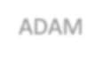

All Users

Home

Biogas from Waste

Tutorial

Custom Model

ADAM

Contact

Case Studies

Case Management

Registered Users

Model Management

Tech Management

Dashboard

Visualization

Prod Management

Admin Users

Developer Panel

General Management (Django Admin)

**Figure 1:** Current structure of ADAM

# ADAM Tutorial

## Structure and Goals

For any users who are new to ADAM, the tutorial module should be the first site to visit. The ADAM tutorial module can be accessed via the button TUTORIAL on the Home page. Currently, ADAM has two simple examples, *Biogas from Waste* and *Custom Model*. The second example is built upon the first one. Each example is decomposed into two preliminary sheets explaining the input and output data, and six steps for establishing the model, including *Model Type, Supply Data, Technology Data, Consumer Data, Transport Data, and Run Model*. We note that in the dashboard when users establish their models, the same steps will be followed.

The first example, *Biogas from Waste*, is a static one where all input data are fixed and presented step-by-step, and pre-solved results are shown in step 6. The second example, *Custom Model*, is a dynamic one, where users can change some input data. The model will be solved instantaneously, which normally takes tens of seconds to several minutes, and users will be redirected to another page to view results after the model is successfully solved.

The current structure of the tutorial module is shown below in Figure 2, as explained. More examples are under development and will be published in the future.

The tutorial is designed to achieve the following goals.

* to present the core functions of ADAM, i.e. the ability to establish, solve and visualize systems OWM problems using logistic network modeling and optimization;

Prelim: input & output data Step1: model type

Step2: supply data Step3: technology data Step4: consumer data



Biogas from Waste

Tutorial

Custom Model

Step5: transportation data Step6: run model & results

Prelim: input & output data Step1: model type

Step2: supply data Step3: technology data Step4: consumer data



Server

Step5: transportation data Step6: run model

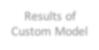

Results of Custom Model

**Figure 2:** Structure of ADAM tutorial

* to get users familiar with the general workflow of defining an OWM problem and related terms used, i.e. the six steps included in each example;
* to make users understand the definitions and differences of two model types supported, design and management models, by reading the preliminary sheets;
* to make users understand the necessary data input for models and realize how the input data might influence results by reading the six steps.
* to present the way of thinking when one assigns data to the model, i.e. to show which part is considered a supply, technology, consumer, and transportation.

After going through the tutorial, we anticipate our users gain the following abilities.

* to understand the key components in defining a systems OWM problem, i.e. to identify which part is a supply, technology, and consumer;
* to understand the results reported by ADAM;
* to understand and make use of the case studies published in their user dashboard to serve their needs;
* to establish a model by correctly preparing and providing data.

## Tutorial Part 1 - Biogas From Waste

The first example in the tutorial module is *Biogas From Waste*. Once users enter this example, the following example outline will be shown (Figure 3).

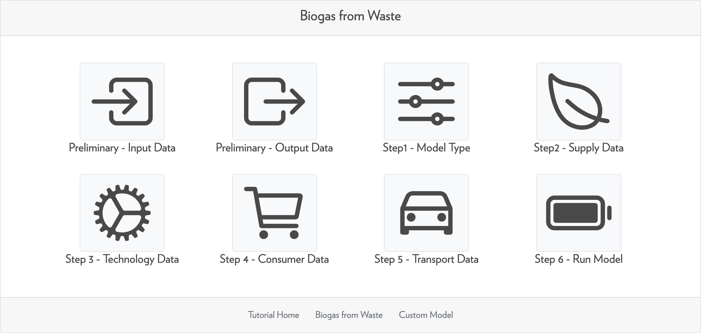

**Figure 3:** Outline of the example 1

This example involves the use of a **logistic network management** model, and the input and out- put data are illustrated first in the two preliminary sheets.

#### Input Data

Here we introduce the input data of this example, including supply data, technology data, consumer data, and transportation data. For each type of data, users need to consider the following aspects:

* supply data, what type organic waste is supplied, where is the supply, what is the capacity of the supplied OW, and what is the price of the supplied OW;
* technology data, what type of technology is installed (or can be installed), where is the technology (candidate), and what is the capacity of that technology;
* consumer data, what type of product can be sold, where is the consumer, what is the capacity of the requested product, and what is the price of the product;
* transportation data, what are the feasible transportation routes for each material in the network.

Users can follow steps 1-4 to learn the data input procedure. Here we illustrate those steps as well as data used again.

In this example, we consider three CAFOs supplying (livestock) waste in the Madison (WI) area. The supply data is summarized in Table 1 and the locations are shown in Figure 4. Note that the

**negative supply price** means the supplier will pay to whoever takes the OW away (while a positive price means the supplier needs to get paid).

|  |  |  |  |  |
| --- | --- | --- | --- | --- |
| No. | Supplied OW | Location (latitude, logitude) | Capacity (tonne per year) | Price (USD per tonne) |
| CAFO1 | Waste | 43*◦* 7’ 35" N, 89*◦* 33’ 5" W | 65000 | -5 |
| CAFO2 | Waste | 43*◦* 12’ 50" N, 89*◦* 28’ 44" W | 35000 | -10 |
| CAFO3 | Waste | 43*◦* 14’ 44" N, 89*◦* 26’ 14" W | 15000 | -15 |

**Table 1:** Supply data of example 1

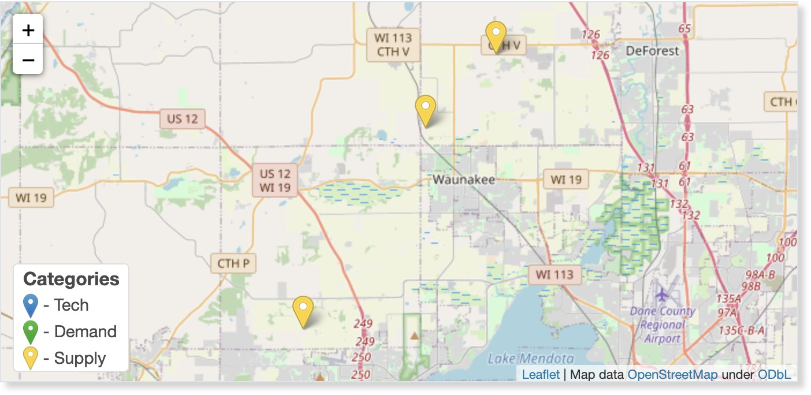

**Figure 4:** Supply locations of example 1

When specifying technology data, users need to first consider what is a proper pathway to pro- cess the OW, and then put technologies in that pathway onto the map as a technology provider. At the provider, the specified technology is already installed for use. In this example, we have two tech- nology providers, providing anaerobic digestion (AD, convert waste into biogas and digestate), and anaerobic digestion plus electricity generation (EG, convert biogas into electricity), respectively. The technology data is summarized in Table 2 and the locations are shown in Figure 5.

|  |  |  |  |
| --- | --- | --- | --- |
| No. | Technology Provided | Location (latitude, logitude) | Capacity (tonne per year) |
| Tech1 | AD | 43*◦* 10’ 22" N, 89*◦* 30’ 13" W | 60000 |
| Tech2 | AD+EG | 43*◦* 11’ 34" N, 89*◦* 24’ 12" W | 60000 |

**Table 2:** Technology data of example 1

The next step is to define consumer data. Consumers can request any materials in the network, including final products, intermediate products, and even raw organic waste (e.g., raw livestock waste can be used as fertilizer sometimes). Please note that if some final product is not requested by any consumer, then the technology which will produce it will be deactivated by default. In this example, we have three consumers, of which one overlaps with one supplier and one requested two materials. The consumer data is summarized in Table 3 and the locations are shown in Figure 6. Note that the **negative demand price** means the consumer will get paid pay by taking the product (such

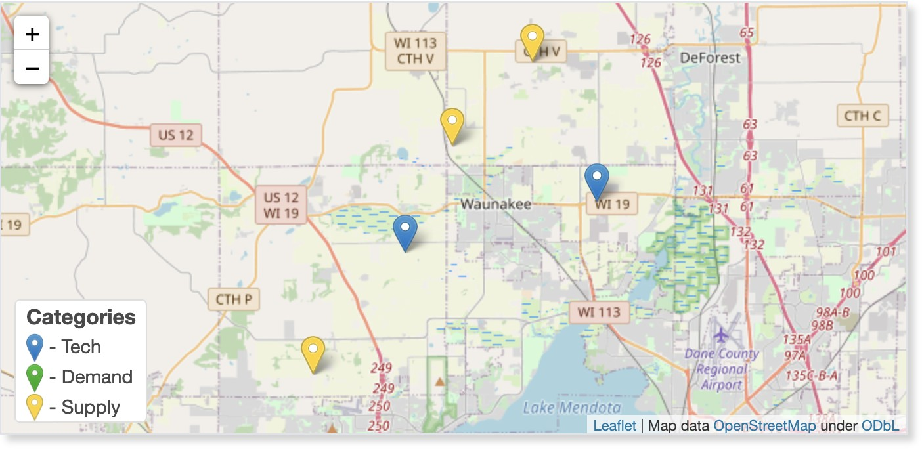

|  |  |  |
| --- | --- | --- |
|  | **Figure 5:** Technology locations of example 1 |  |
| as OW). |  |
| No. | Requested Product Location (latitude, logitude) Capacity (unit per year) | Price (USD per unit) |
| Consumer1 | Biogas 43*◦* 7’ 14" N, 89*◦* 33’ 27" W 2.8e8 (cft) | 2 |
| Consumer2 | Digestate 43*◦* 11’ 10" N, 89*◦* 32’ 42" W 115000 (tonne) | 5 |
| Consumer2 | Waste 43*◦* 11’ 10" N, 89*◦* 32’ 42" W 115000 (tonne) | 0 |
| Consumer3 | Electricity 43*◦* 14’ 44" N, 89*◦* 26’ 14" W 3e6 (kWh) | 1 |

**Table 3:** Demand data of example 1

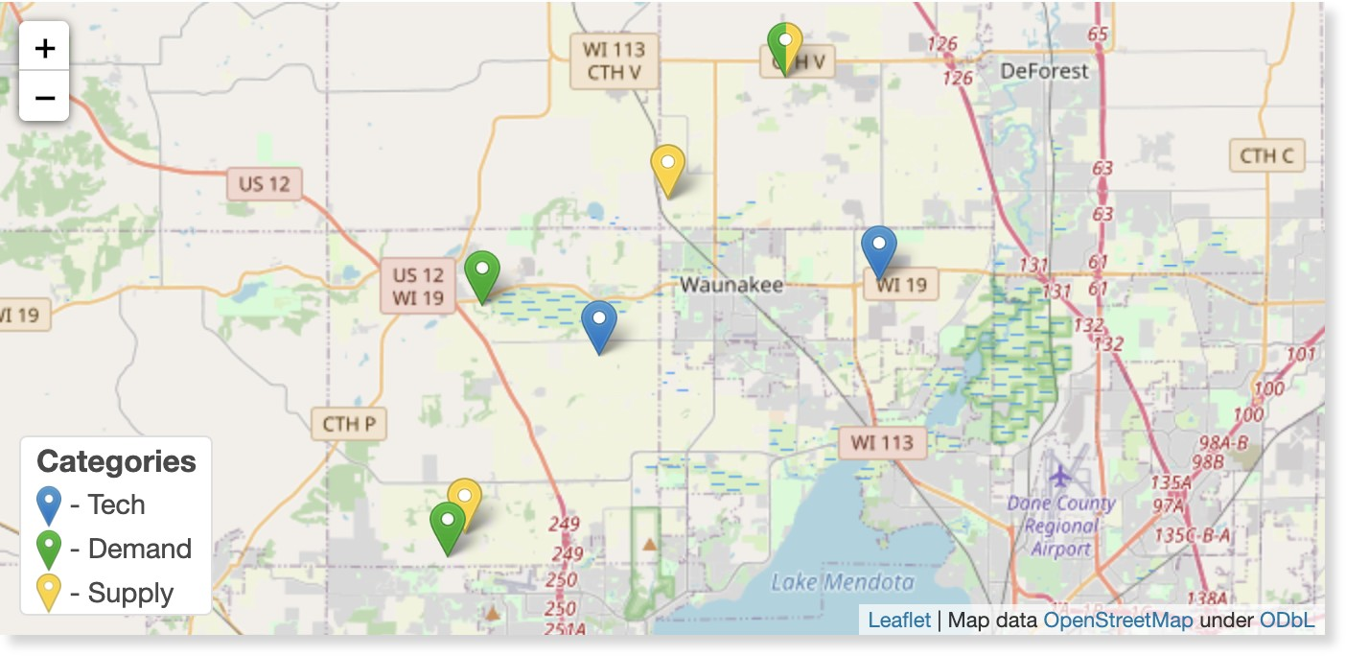

**Figure 6:** Demand locations of example 1

After all the supply, technology, and demand data are provided, all possible transportation routes will be generated automatically in step 5, as shown in Figure 7 below. For this example, we assume all routes are available by default.

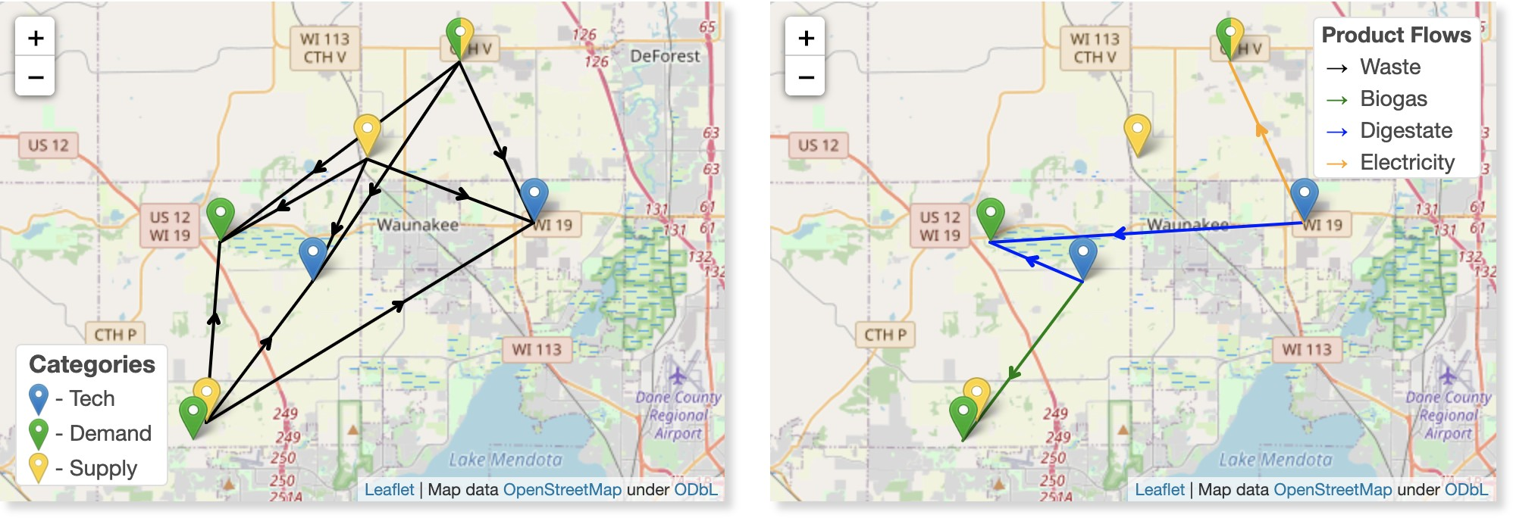

**Figure 7:** Transportation routes of example 1

#### Output Data

This example is pre-solved by finding the most economic solution, and results are displayed in step 6, as shown in Figure 8 below and summarized in Table 4.

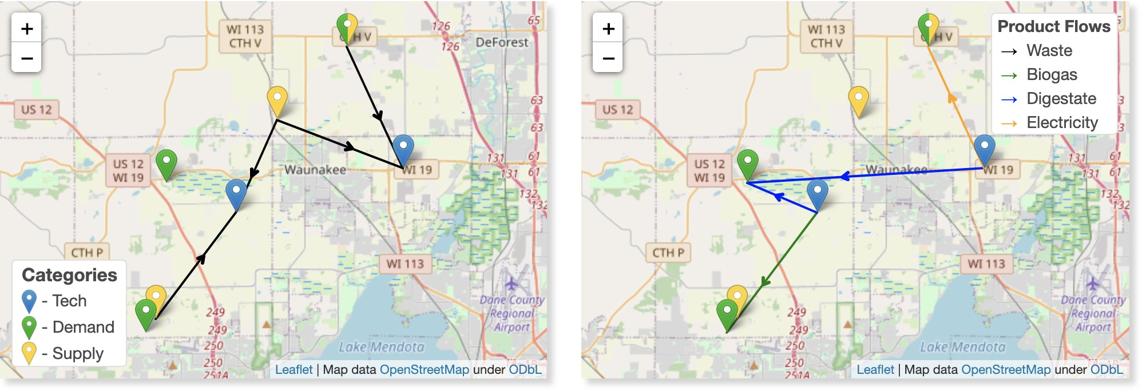

**Figure 8:** Results of example 1

|  |  |  |  |
| --- | --- | --- | --- |
| From | To | Material | Amount (unit per year) |
| CAFO1 | Tech1 | Waste | 45294.12 (tonne) |
| CAFO2 | Tech1 | Waste | 14705.88 (tonne) |
| CAFO2 | Tech2 | Waste | 20294.12 (tonne) |
| CAFO3 | Tech2 | Wate | 15000 (tonne) |
| Tech1 | Consumer1 | Biogas | 9e7 (cft) |
| Tech1 | Consumer2 | Digestate | 57000 (tonne) |
| Tech2 | Consumer2 | Digestate | 33529.41 (tonne) |
| Tech2 | Consumer3 | Electricity | 3e6 (kWh) |

**Table 4:** Results summary of example 1

## Tutorial Part 2 - Custom Model

The second example in the tutorial module is *Custome Model*. This example has the same outline as the first one.

This example involves the use of a **logistic network design** model (please refer to the following section for full mathematical formulation), the input and output data are illustrated first in the two preliminary sheets. The main difference is that users can now specify technology candidates in ad- dition to technology providers, and the model will decide whether it is an economic option to install the technology.

This example is interactive. In each step, users can drag nodes around the map; and when users double click one node, some parameters can be modified (e.g., capacity, price, etc.). But all default data is consistent with the previous example. The following Figure 9 shows that users can modify the supplied capacity and price of livestock waste in CAFO2.

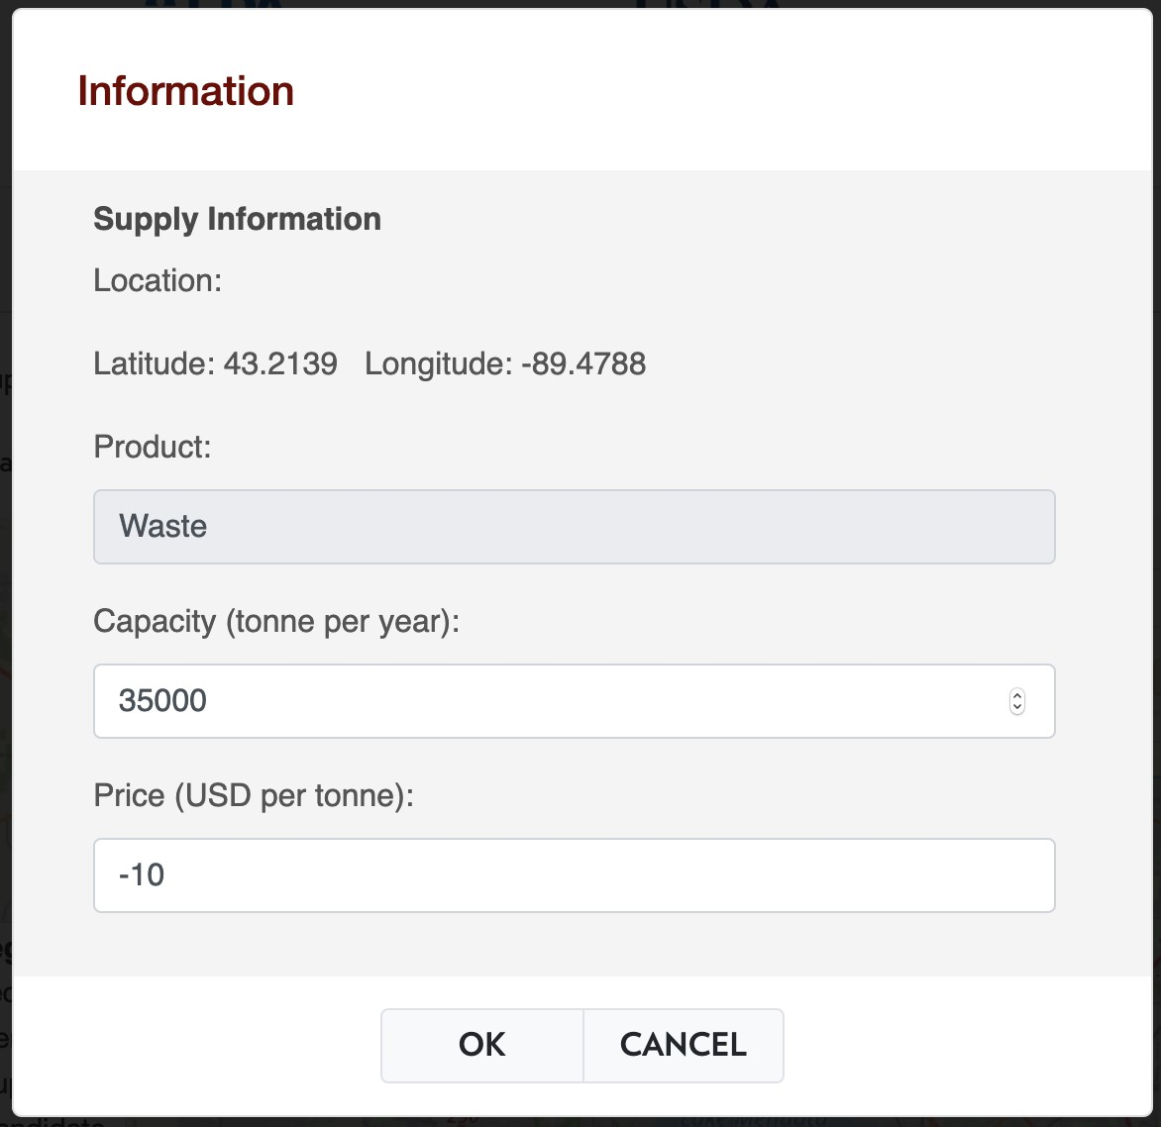

**Figure 9:** Input data in example 2

This example is built upon the first one. In addition to the preinstalled AD and AD+EG, now we have a technology candidate for AD and biomethane production technology set, as shown in Figure 10 below (default location). This new technology can convert waste into biomethane and digestate). After users go through steps 1-5 as guided and modify some of the data, the model can be solved instantaneously in step 6, as shown in Figure 11. Once the Run the Model button is clicked, a popup will show up on the page, and users should not refresh or close the current page, or go back

to the previous page. All the model data is then packed and sent to the server for use.

The model solving procedure for this example should take tens of seconds to several minutes under normal internet conditions. Once it is solved, results will be packed and users will be redi- rected to another page where results are visualized. The following Figure 12 shows the results of this example under the default data. The results will be eliminated as long as users leave the result page.

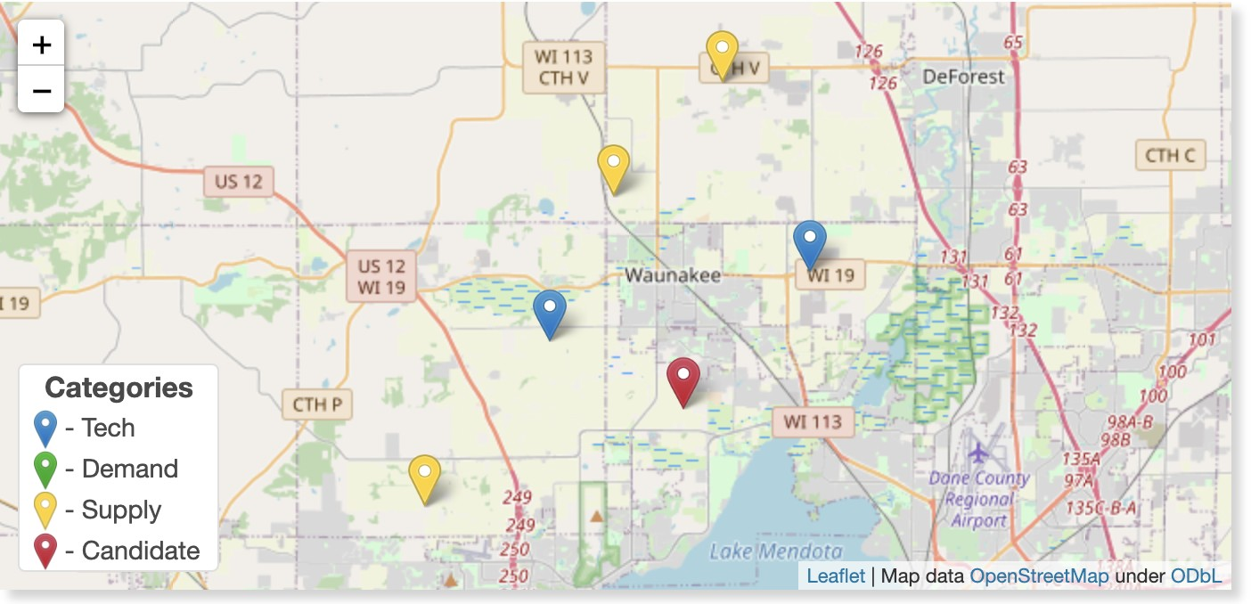

**Figure 10:** Default technology locations of example 2

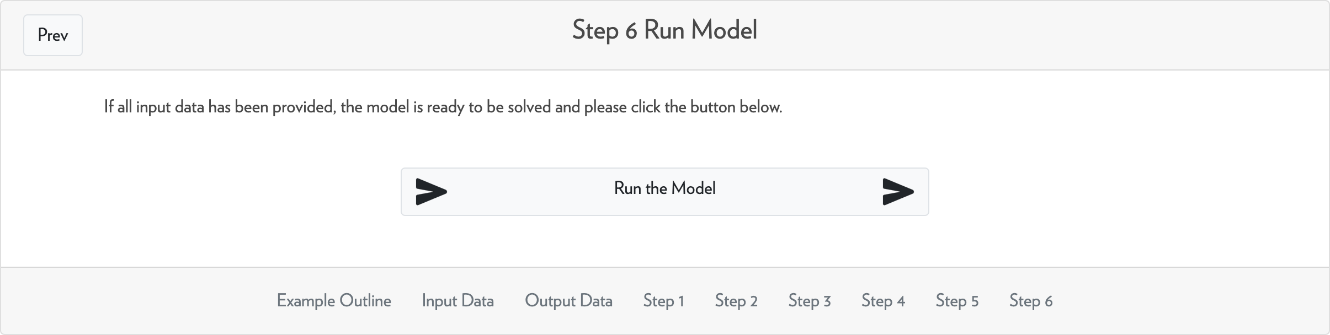

**Figure 11:** Solve model in example 2

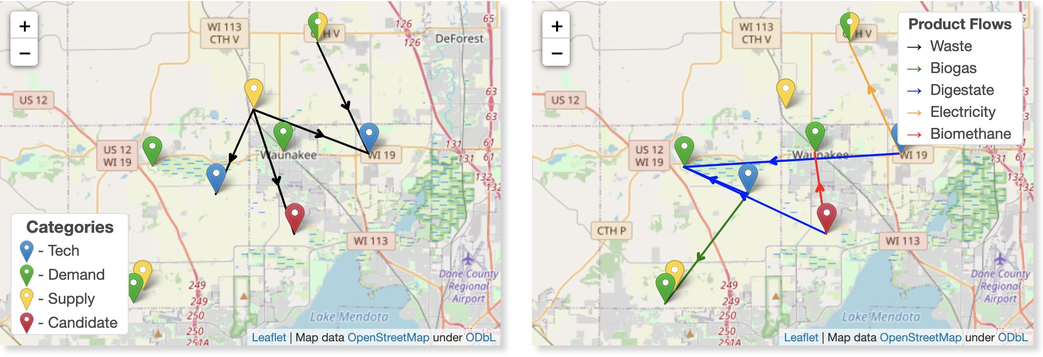

**Figure 12:** Results of example 2

# User dashboard

## Overview

The dashboard is a platform for registered users to **view published case studies, establish person- alized models and visualization**. The dashboard can be accessed via the DASHBOARD button on the home page. Users will usually be directed into a login page, and after login, the dashboard will be displayed.

There are three main modules on the DASHBOARD: Case Studies, which will be introduced in Section 3.3, Manage Models, which will be introduced in Section 3.4-3.10, and Visualization, which will be introduced separately in Section 4.

In the Case Studies module, a list of pre-solved cases provided by the developer team as well as other users are provided. Inside each case study, usually more than one scenarios are included for parametric studies. In the Manage Models module, a list of user-defined models are listed, and one can build and edit their models for specific problems.

## Registration and User Profile

For users who want to access the user dashboard in ADAM, a registration is necessary. The registra- tion can be accessed when click DASHBOARD and then Register HERE. Following information will be requested:

* Username for login use, must be unique;
* E-mail for receiving notifications, must be unique;
* Password for login use;
* First name and last name;
* Organization.

All the information will be used for academic use only and will be secured in our server. Once the registration is successful, one can access the login page by clicking DASHBOARD again and enter the username and password.

Currently, if one user forgets his/her user account information and is blocked from login, the only way to correct that is to describe the situation and send us a message through CONTACT module. The automatic account retrieving function is still under development.

To modify any information, users can go to My Profile once logged in, a button at the upper right corner on the dashboard as shown in Figure 13 and 14. Users can then change any of their information except the username.

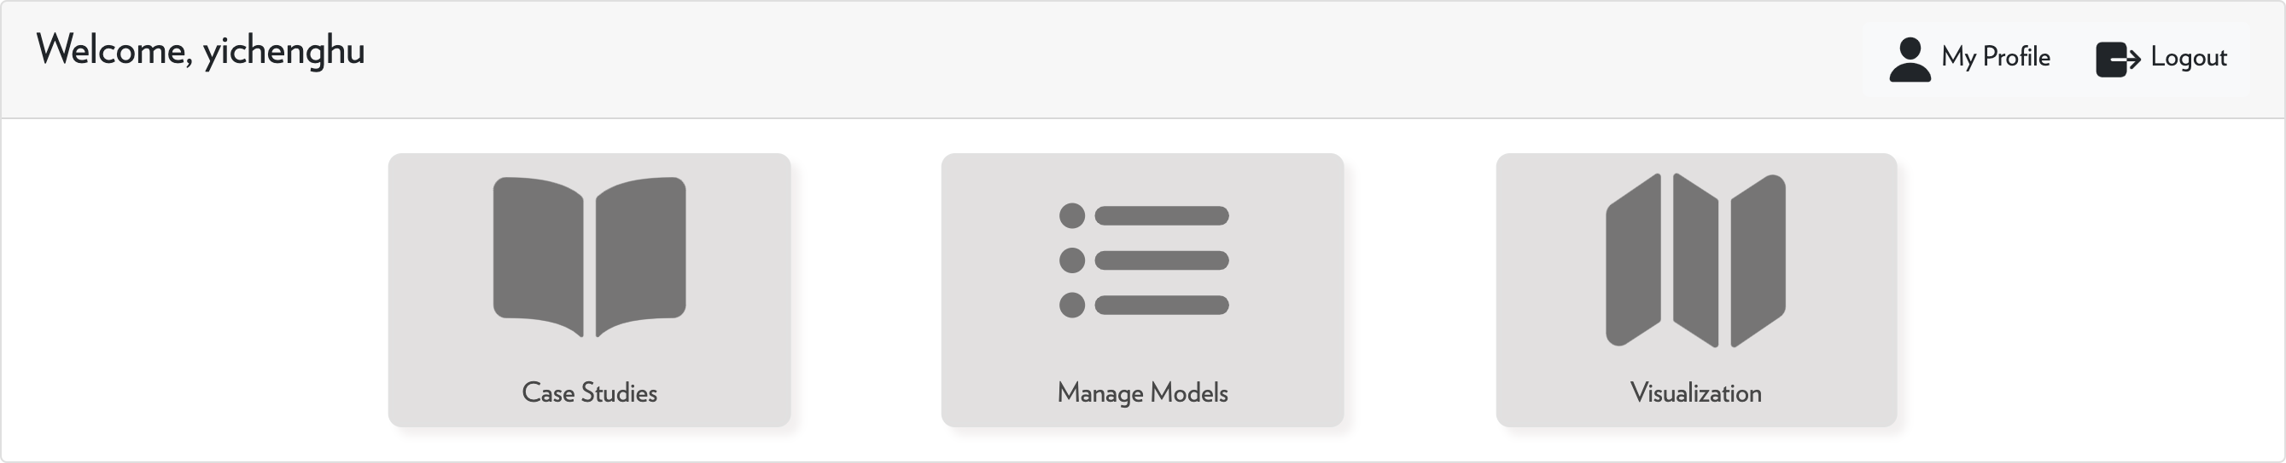

**Figure 13:** My profile button on dashboard

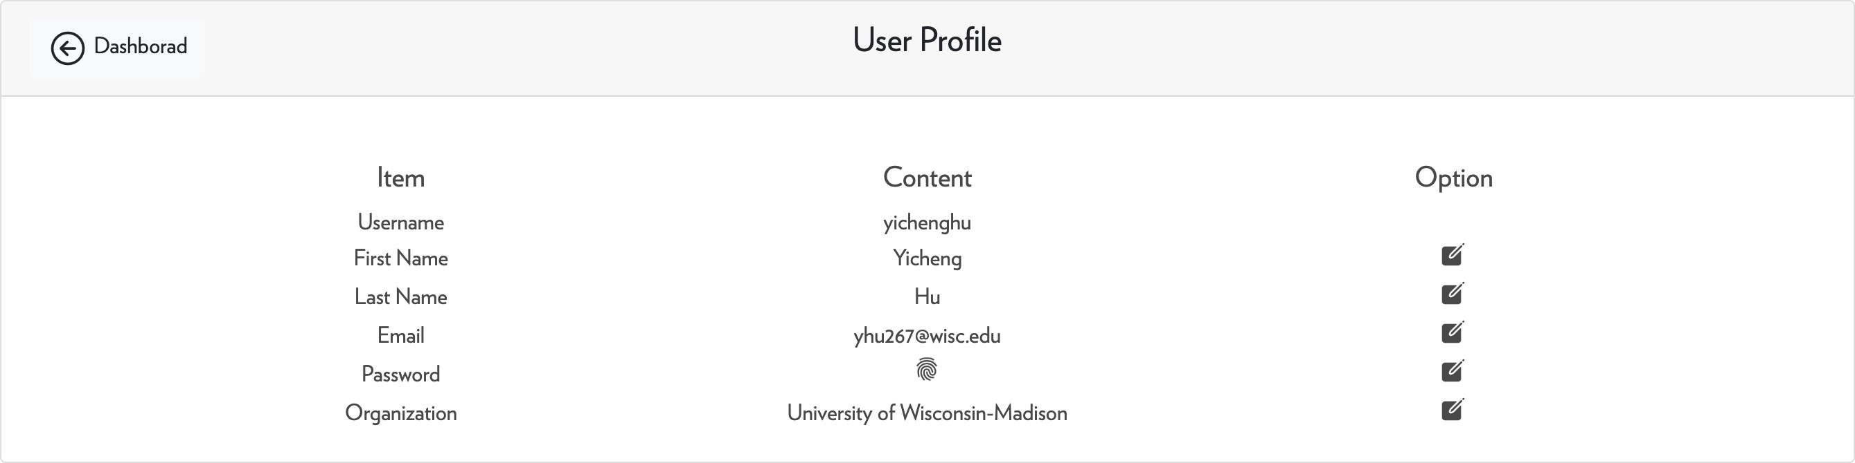

**Figure 14:** User profile

## Case Studies

In ADAM Dashboard, we provide a series of developed case studies, most of which are simplified versions of peer-reviewed case studies in research publications.

Each case study in ADAM contains several scenarios; users can compare each scenario to do parametric studies. There are three main options for each scenario:

* Make a Copy
* Show/Hide Results
* Download Documentation

By clicking the Make a Copy button, users can make a deep copy of the scenario and it will appear as a ready-to-go user-defined model in the list of Manage Models module.

#### Revisit Example 1 in ADAM Tutorial

The first case study we provide is a revisit of Example 1 in Tutorial. In this example, we use the exact set up of supply, demand, and technology site, but with more accurate data on cost and product price.

Three scenarios are included with different electricity prices: 0.08, 0.2, and 0.8 USD/kWh. With the same supply and demand price, biogas and electricity technology is not competitive until the electricity is increased by almost 10 times.

#### Nutrient Balance in Upper Yahara Watershed

The second case study we provide is the nutrient balance (phosphorus balance) in Upper Yahara Watershed in WI. We include around 200 beef and dairy farms in the region, which supply livestock waste to the system. For technology sites, it is assumed that the largest 20 farms are equipped with solid-liquid separation technologies, and the largest 3 farms are equipped with granulation technolo- gies.

For the demand side, we consider around 80 nodes to represent crop area in this watershed. Each demand is a technology site for a pseudo-technology, P release, for each land-applicable waste stream to represent the natural degradation and the release of nutrients. For each cropland node, the nutrient capacity is pre-calculated as the demand capacity of P with price 0, meaning the organic waste can be applied freely if the total P is below the capacity. For each crop node, there is also a second demand item for P and with unlimited capacity, but with negative price, representing that the waste stream can still be applied if total P is above the threshold, but it will cause some economic loss due to potential nutrient pollutions. The negative price here is defined as the phosphorus value of service. We also have a customer at the city of Madison who collects value-added products, including solid manure and pellets.

We tested four scenarios for this case study, with different phosphorus values of service: 0, 0.5, 2.5, 10 USD per kg of excess P in the system. With this example, we noticed that with 0 value of service, the system is purely economic driven and there is excess P in the system. As we increase the value of service, transportation will be first used to coordinates waste flows to reduce excess phosphorus. With a large value of service, the technologies will be used to make nutrient products from the system to avoid over application.

#### Renewable Energy Credits (REC) Analysis in Upper Rock Watershed

The third case study we provide is the REC analysis in Upper Rock Watershed in WI. 24 farms with more than 1000 animal units are considered in this case study. Each farm is a technology candidate for the anaerobic digestion and electricity generation technology. Each farm is also a customer for the electricity generated, for raw livestock waste and digestate by assuming they can be applied on land near those farms.

The role of REC comes into play as we generate electricity from biogas due to its sustainable attribute, and it can be implemented by adjusting the demand price of electricity in the system. We tested three scenarios with different RECs: 0, 0.08, and 0.14 USD/kWh. We found that without any incentives, no technology will be used. With 0.08-0.14 USD/kWh of incentive, the biogas and electricity generation technologies will be installed.

As we continue to improve ADAM and expand the database system, more case studies will be provided.

## Model Management

The model management can be accessed by the Manage Models module on the user dashboard. A list of user-defined models will be shown here if the user has any. A sample format is shown in Figure 15. On this page, the user can conduct the following actions:

* View the name, creation date, model type, and status of a model directly in the model list;
* View the description of the model by hovering on the note icon in Options column;
* Edit the model description by clicking that icon;
* Delete a model by click the trash icon in Options column;
* Create new models, either blank model or a copied one, by the button on the top;
* Enter the model home page by clicking the model name.

The model name and description will be entered by the user when a model is created. The model type will be defined when editing a model, in step 1 specifically, and will be illustrated later. The cre- ation date of a model is generated automatically when a new model is created, and it is Coordinated Universal Time by default.

The Status column shows the status of models. There can be four types of status :

* Data Required: once a model is created, this is the default status, meaning the model still needs data input before it can run;
* Data Complete: the model has all required input data and is ready for running;
* Complete: the model has finished running and results are ready;
* Error: the model encounters an error during running and is interrupted; this is usually caused by ill input data.

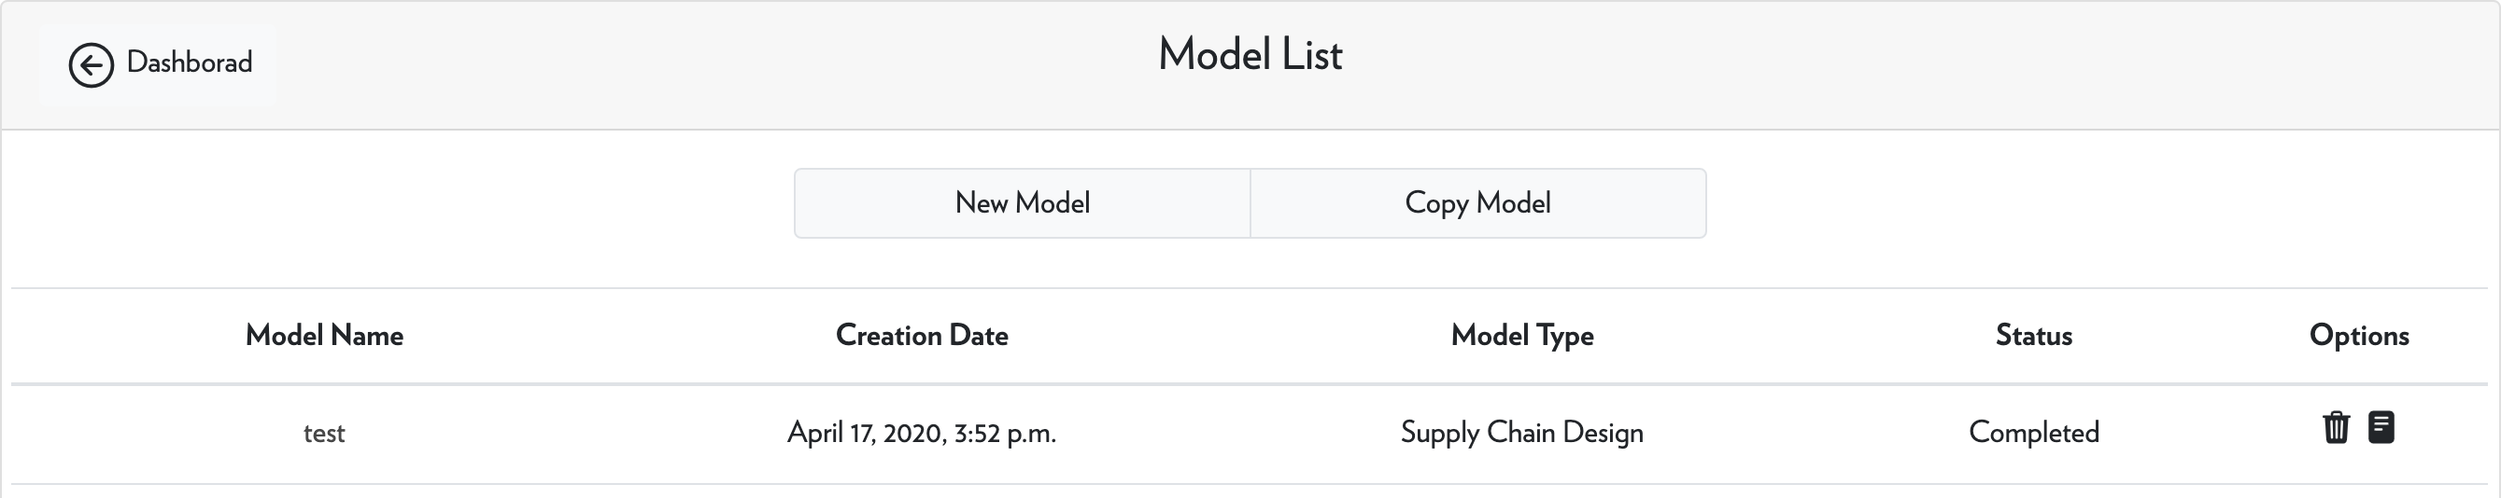

**Figure 15:** Model management

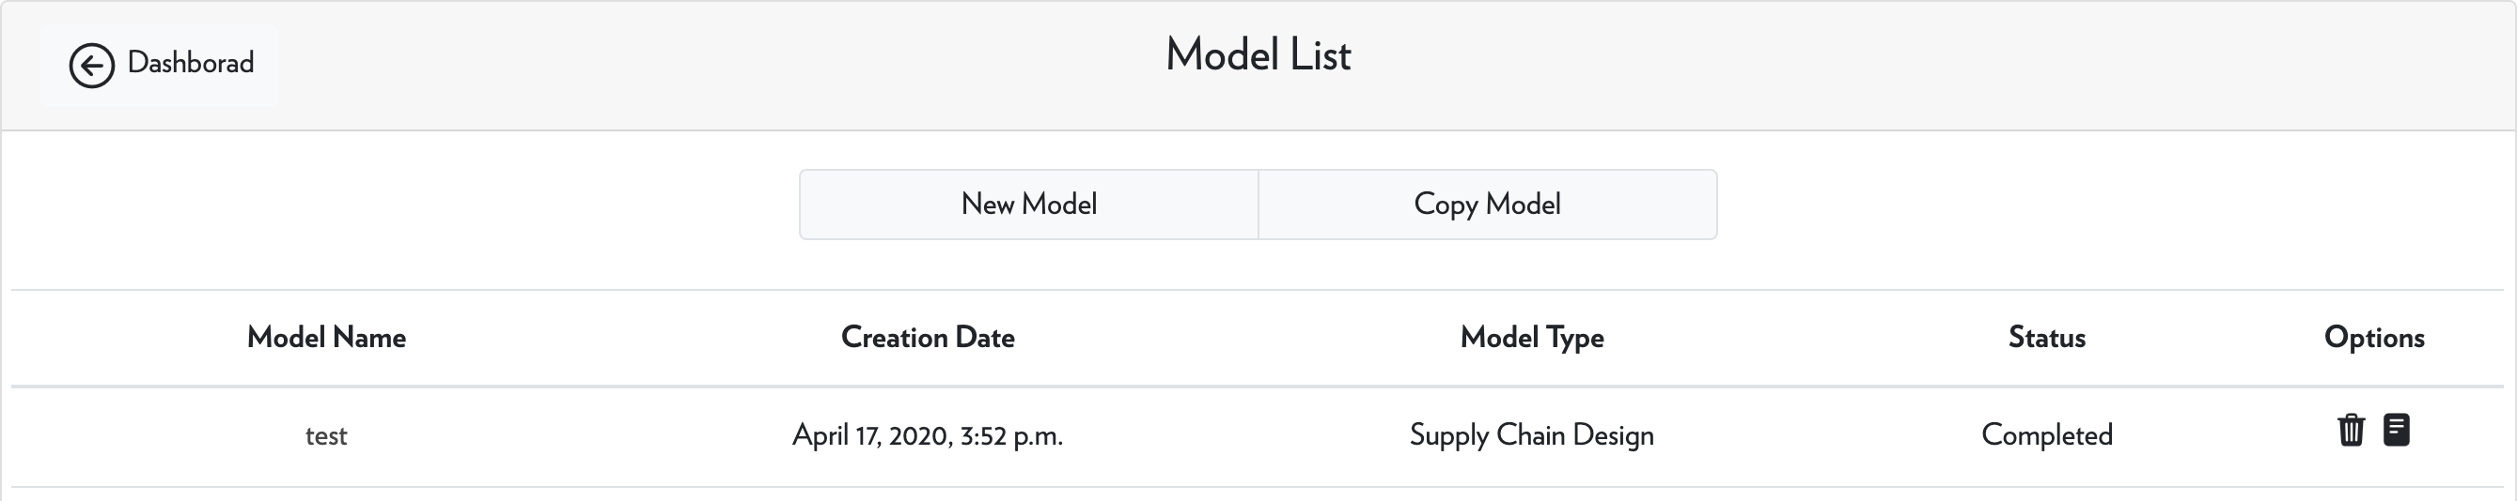

**Figure 16:** Create a model

## Create a Model

To create a new model, user can click on New Model button or Copy Model button on the top of the model management page, as shown in Figure 16.

The difference here is that, for the first option, New Model, the user needs to enter only a name and a description of the model, as shown in Figure 17. While for the other option, Copy Model, the user can make a copy of an existing model or a published case study with a specified name and model description, as shown in Figure 18. We also note that to make a copy of one published case study, the user can also go to the Case Studies module, select a scenario from a case study, and then click the Make a Copy button.

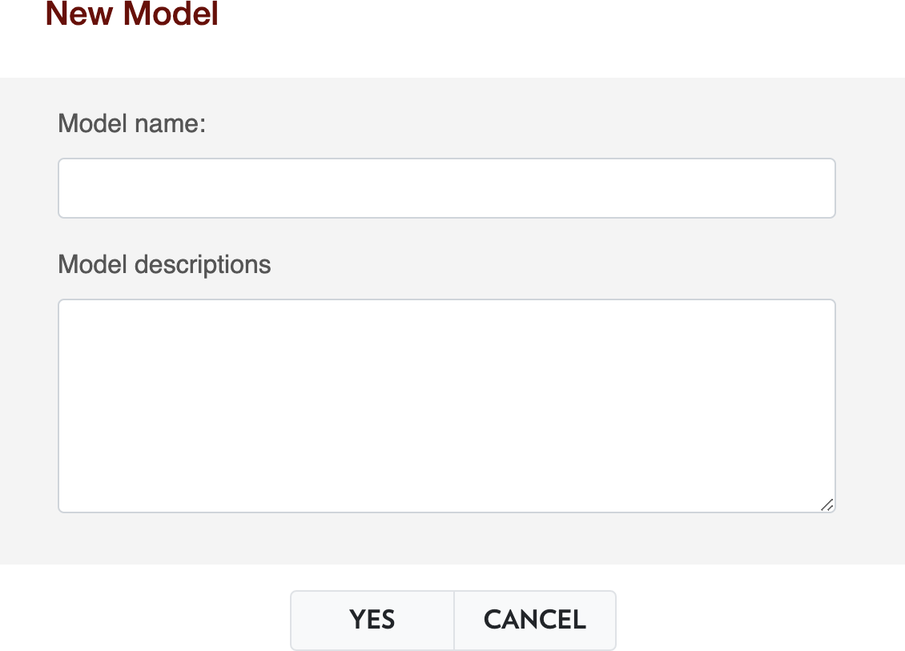

**Figure 17:** Create a blank model

## Edit a Model - Common Options

Once a model is created, it will be listed on the Manage Models page. To view the detailed status of this model, the user can click on the model name. Figure 19 below shows an example of how the model home page looks like.

This page will display the current status of the model, the progress of model specification, and other options available on the model. The progress is decomposed into six steps, which is the same

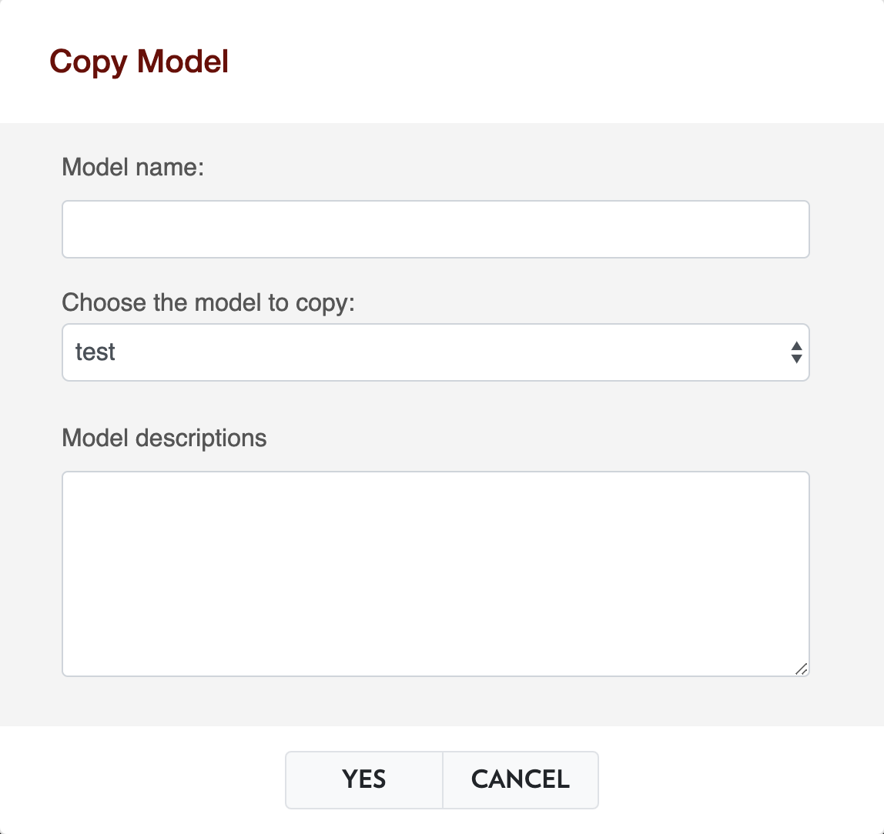

**Figure 18:** Make a copy of existing model

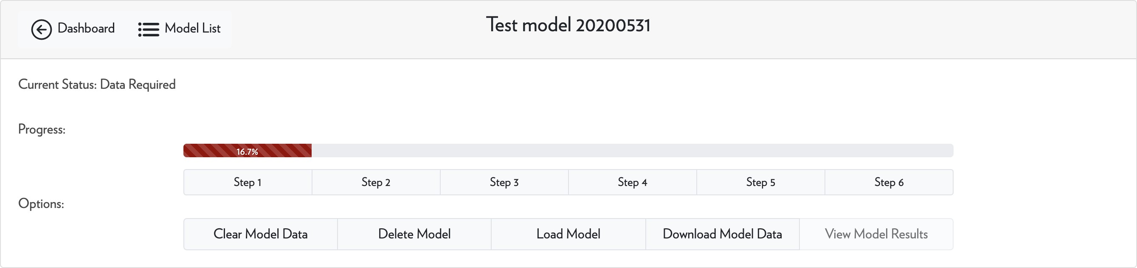

**Figure 19:** Example of model home page

as the tutorial. The six steps are:

* Step 1: specify model type (design or management) and time basis (year, month or day);
* Step 2: specify supply data;
* Step 3: specify technology data;
* Step 4: specify demand data;
* Step 5: generate and edit transportation data;
* Step 6: run the model.

The details of the six steps will be illustrated in the following sections. And the five possible options are:

* Clear Model Data: clean up all assigned data of this model and reinitialize it;
* Delete Model: delete this model permanently;
* Load Model: clean up all assigned data of this model first, then copy data from a specified model or case study to this model;
* Download Model Data: organize selected data of this model as csv files, zip those files and down- load; the csv files can be directly uploaded to a new model.
* View Model Results: view a summary of model results once the status of this model is complete.

## Edit a Model - Model Type and Time Basis

To define the type and time basis of a model, the user can access through the Step 1 page at the model home page. The two types available are **logistic network management** and **logistic network design**. The following table displays a comparison between the two types of models.

So a rule of thumb here is that, if one user wants to test the performance of **exsisting technologies** on some organic waste sources, then a management model is suggested; on the other hand, if one user wants to **select technologies to be installed** in the region, then a design model is recommended.

The time basis can also be selected in this step, where possible options are **year, month, day**. All input data, output data, and the model will be set on a time basis.

## Edit a Model - Supply, Technology and Demand

First of all we want to explain what is a supply, technology, or demand in an OWM problem.

* A supply is used to add a feedstock into the whole system. To define a supply, the user needs to define its name, geographical location, supplied product, price, and capacity.

|  |  |  |
| --- | --- | --- |
| **Item** | **Management** | **Design** |
|  | Input Data |  |
| Supply Data | Needed | Needed |
| Technology Site Data | Needed | Optional |
| Technology Candidate Data | Not Applicable | Needed |
| Consumer Data | Needed | Needed |
|  | Output Data |  |
| Transportation Results | Available | Available |
| Technology Processing Results | Available | Available |
| Technology Installation Results | Not Available | Available |
| Supply and Demand Results | Available | Available |
| Price of Materials | Available | Not Available |
|  | Other Information |  |
| Mathematical Model | Linear Programming | Mixed-Integer Linear Programming |
| Solver | Clp | Cbc |
| Suggested Problem Size | < 200 Nodes | < 50 Nodes |

**Table 5:** Comparison of management and design Model

* A technology is used to convert one or more feedstocks into one or more products. To define a technology, the user needs to define its name, geographical location, the technology used, and capacity.
* A demand is used to take a product out of the whole system. To define a demand, the user needs to define its name, geographical location, demanded product, price, and capacity.

Here we want to emphasize that, the supply is for providing a feedstock from somewhere outside of the system to the system. It is different from the products generated in technologies, which are converted from some feedstocks in the system. And similarly, the demand is to take products from the system to somewhere outside and is different from the feedstock in technologies.

To define the supply, technology, and demand of a model, the user can access through the Step 2, Step 3, and Step 4 page at the model home page. The interface is shown in Figure 20. In each step, the user can have similar options, including:

* Upload Data: to add a list of data to the model by uploading a csv file following a certain format;
* Manual Entry: to add one data point to the model by manually filling out a form;
* Load From Model: to add a list of data to the model by copying data from another model;
* Clear Data: clean up data for this step;
* Look for a feedstock/technology/product: to look for information on a feedstock, technology, or product.

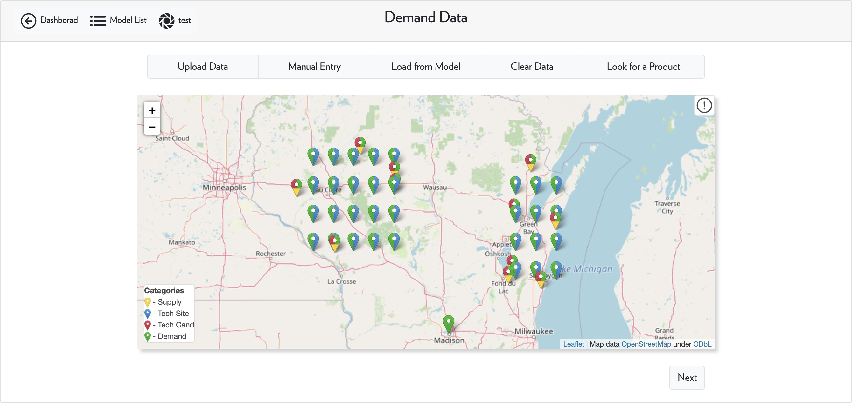

**Figure 20:** Interface of step 4

**Upload Data** User can upload a csv file to define a model’s supply, technology site, technology can- didate, or demand data. This method is recommended when dealing with problems with **medium or large sizes**. A template csv file is given in each step and the user only needs to populate their data items in that file. The screenshot of the uploading supply data window is shown below in Figure 21. For example, the template of a supply data file is shown below in Table 6. To populate the sup- ply data file, the user will first need to identify the sources of the suppliers of OW, then enter their information in the csv files, including names of suppliers, geographical coordinates (latitude and lon- gitude), feedstock ID (which can be looked up), supply price and supply capacity. Multiple suppliers

can be overlapped or identical, depending on the need of the user.

Sup Latitude Longitude Feed ID Price Capacity

s1 56.1234 87.6543 p1 10 10000

*· · · · · · · · · · · · · · · · · ·*

**Table 6:** Template for supply data

To define technology and demand data, similar csv files need to be generated by users. Once done and on clicking the UPLOAD button, the data file will transfer to the server and the content will be analyzed and tested. if there is no error, then the data will be sent back to be visualized on the map. Users can continue working on those data by dragging a marker around or double-clicking a marker. If there is an error, the server will notify the user where the error message and the user should correct the data and resubmit it. This workflow is shown in Figure 22.

The server will mainly check the following aspects of a data file:

* If a file can be open - only csv files are suitable for uploading;

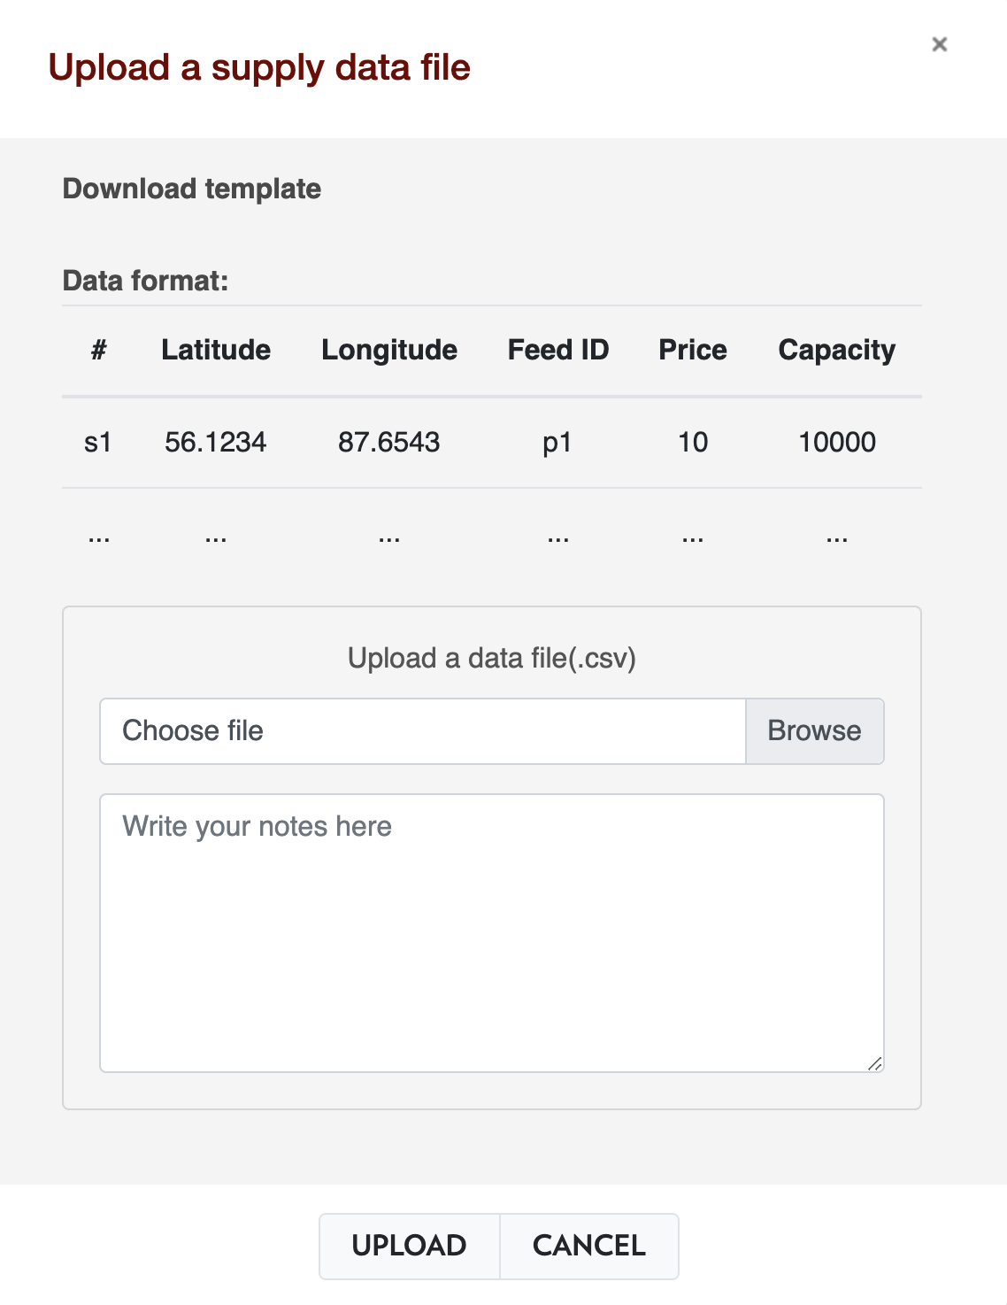

**Figure 21:** Upload supply data



Enter Step 2/3/4

Click Upload Data

Download Template

Fill Data File

Upload Data File

Further Editing/Next Step

Correct Error and Resubmit

User Side

Error

Send back Error Msg

Pass

Send Data Back

Check Format

Read Data File

Server Side

Save Data File

**Figure 22:** Example of model home page

* If a file has enough columns specified - e.g., a supply data file should have the first six columns defined as the template;
* If a cell has correct data format - e.g., geographical coordinates should be float numbers (decimal);
* If the data in a cell has the correct physical meaning - e.g., the supply capacity should be non- negative;
* If the data in a cell is consistent - e.g., the feedstock, technology, and product ID should be valid.

If there is an error, then our server will tell the user the exact line where the error occurs so that the user can correct the error and resubmit the file.

Usually for a model, if its assigned data pass our data check tool on the server-side, the model is well defined. However, sometimes the model can still raise some problems - e.g., a model can be infeasible, meaning there is no single solution for the model; or a model is unbounded, meaning there can be a solution making an infinite profit. Both of them can be caused by some ill-defined data, but they cannot be discovered until the model is solved.

**Manual Entry** This method is usually for small-size problems or adding several points in medium or large-size problems. To trigger the manual entry function, the first option is to click the Manual Entry button on the top, then a window will pop up for users to enter data. A screenshot of manually entering supply data is shown below in Figure 23. As in the previous method, the user needs to specify the supplier name, geographical coordinates, feedstock ID (selected from database), supplied price, and capacity.

The second option to trigger the manual entry function here is to right-click on the map. In the use of this method, the map engine will automatically extract the geographical coordinates and fill in the blanks in the form.

**Load from Model** This method is to extract the supply, consumer, or technology data from another model or case study and add them to this model. Please note that usually, the data from another model is very specific - for example, the technology data of one model is dependent on the supply data of that model, and the technologies might not be suitable in processing the supplied OW in a new model, which can result in a trivial solution. Therefore this method is only recommended when a user wants to make a **deep copy** of an existing model or case study.

Here we note that for all three methods in defining supply, technology, or consumer data, the data is not assigned to the model until the user clicks on the Next button and confirms to Save the defined data.

**A Note on Technology Data** In step 3, for a **design** model, the technology data is categorized as **technology site** data and **technology candidate** data. The technology site data specifies the locations where some technologies have already been installed; while the technology candidate data specifies the locations to install new technologies. For a **management** model, however, only technology site data can be defined.

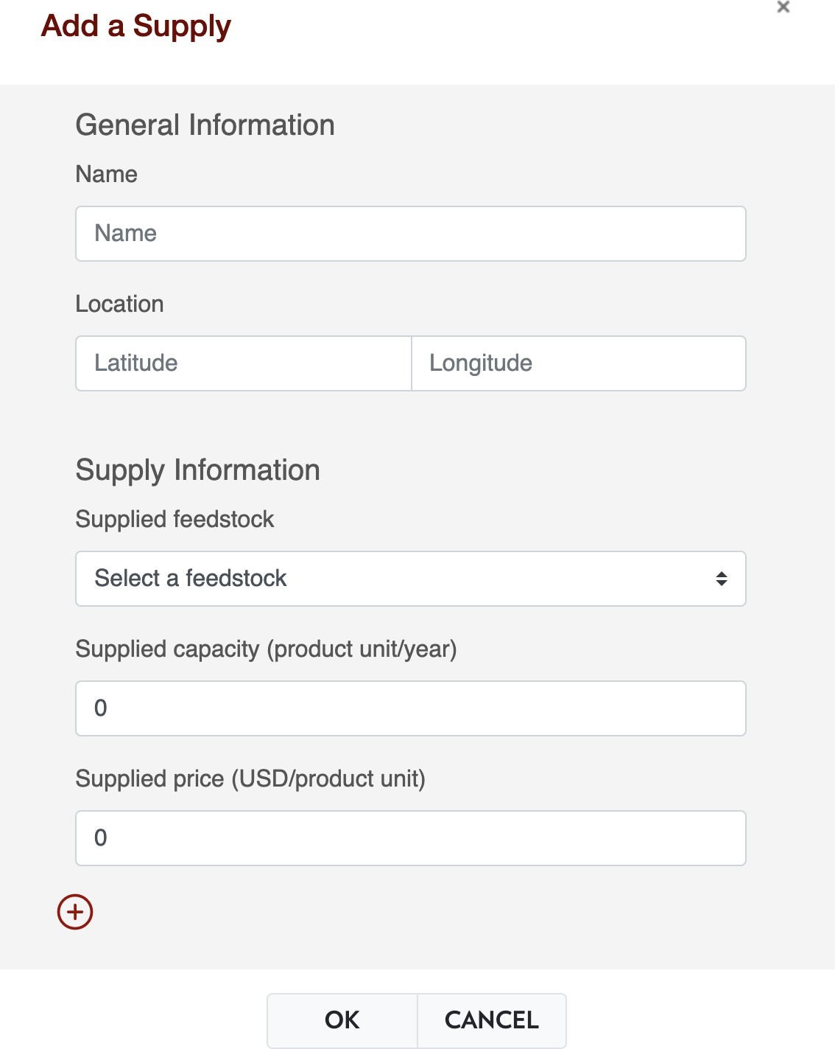

**Figure 23:** Manual entry of supply data

**Clear Data** The clear data function here is to clean up all the data associated with this step. How- ever, this function is not finalizing until the user clicks on the Next button and confirms to Save the step.

**Look for a Feedstock/Technology/Product** Here user can see a list of all available feedstocks, tech- nologies, and products in ADAM. On the selection of feedstocks and products, the user can get the name, unit, transportation cost, and a list of related technologies with its role (feedstock or product). On the selection of technologies, users can get the name, capacity range, cost information, and a list of involved feedstocks/products with their transformation coefficients.

In step 3, technology data specification, some technologies will be marked by a star sign, meaning that the technology is recommended based on the supplied OW defined in the previous step. In step 4, consumer data specification, some products will be marked by a star sign, meaning that this product is recommended based on the technology data specified in the previous step.

## Edit a Model - Transportation

Once the user specifies the supply, technology, and demand data, step 5, transportation data will be available for users. The interface is shown in Figure 24. Here we provide five editing options:

* Skip: do not modify transportation data and assume that any link between pair of nodes is avail- able;
* Generate Transportation Routes: based on the defined data in previous steps, generate all possible transportation routes for all products;
* Read Transportation Data: if the user has modified transportation data before, read those data from stored files on the server;
* Recover all Routes: abandon all changes made to the transportation data;
* Distance Filter: apply a filter to filt transportation routes based on the distance.

**Skip** The skip function is usually recommended when there is no specific reason (e.g., transporta- tion between a certain pair of nodes is not realistic) to delete any of the routes. Another situation is that, for large problems (with more than 200 nodes on the map and more than 10 feedstocks/prod- ucts in the problem), generating and loading transportation data can be time-consuming, and other operations, such as distance filter, can also be computationally heavy for common browsers.

**Generate Transportation Data** Based on the supply, technology, and consumer data defined in pre- vious steps, all possible transportation routes are generated for all products automatically. Basically, for a specific product, if one node can supply that product or to generate that product from some tech- nology, and another node can demand that product or to consume that product in some technology, then there should be a possible transportation route between this pair of nodes. Those transportation data are written in the form of a series of matrices in csv files.

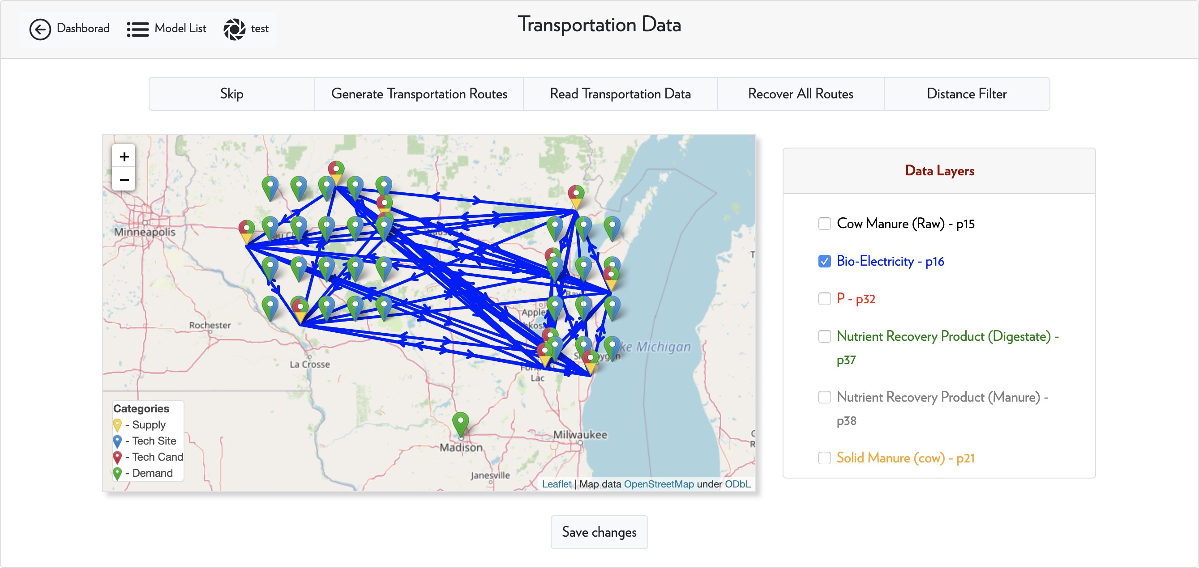

**Figure 24:** Interface of transportation data

**Read Transportation Data** If the user has generated and modified the transportation data before, using this option can quickly reload the saved transportation matrix from the server. This option is disabled if there is no transportation data available on the server.

**Recover All Routes** This is to redo any operations the user has conducted after generating or read- ing transportation data.

**Distance Filter** A distance filter is provided for users to remove any routes that are beyond empir- ical realistic distances. When clicking on this option, ADAM will quickly extract the information of those **visible routes** on the map and make a slider, as shown in Figure 25. The user can either move the slide bars or enter the range of transportation distance in the input boxes. The routes on the map will be removed or added instantaneously. Then, the user needs to click on the red Filt button on the right to confirm to make the filtration.

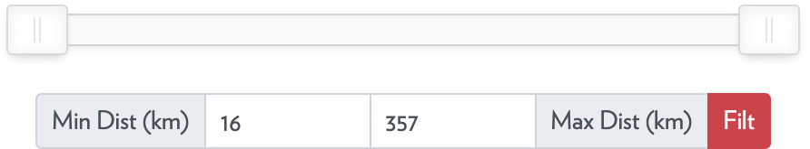

**Figure 25:** Distance filter

**Remove a Single Route** To remove a single route from the map, the user can right-click on that route and then delete that route.

We note that all modifications will not be transferred to the server until clicking the Save changes

button and confirm.

## Run a Model and Get Results

So up to now, all input data of a model has been defined and the status of the model will be changed to Data Complete automatically. In the step 6, the button Run the Model will also be activated, as shown in Figure 26. To run the model, the user only needs to click that button and an email will be sent to notify the user when a model starts to run. The server will reorganize all the assigned data and feed them into a Julia language based model builder. Then an optimization solver will be called to solve the problem. Once the problem is solved and all results are generated, our server will send another email to the user. The workflow here is shown below in Figure 27

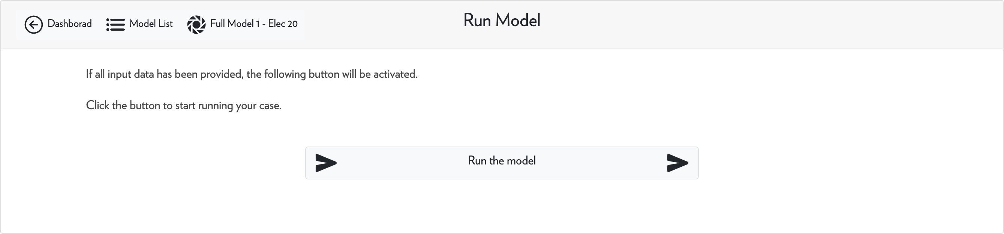

**Figure 26:** Run the model



Reorganize Model Data

Send Email to User

Build Model in Julia

Server Side

Call Optimization Solver

Output Results

Send Email to User

User Side

Enter Step 6

Click Run Button

**Figure 27:** Run the model

Once the user receives the email indicating that the model is solved, the model status will be changed to Complete and the View Model Results button on the model home page will be avail- able. The results include a quick summary of the solved model, including the overall social welfare (defined by revenue by selling products to demanders - supply cost - transportation cost - technology cost) and some other detailed economic metrics. All results files are also available for download - the user can get detailed information about demand, supply, technology, and product transportation.

Those results can also be displayed on the map directly if click on the Go button in the visualization part.

## User Support

To get support from researchers in our team, the user is recommended to send us messages through the CONTACT function on the navigation bar. The interface is shown below in Figure 28, where the user needs to provide their name, email, subject, and description of problems.

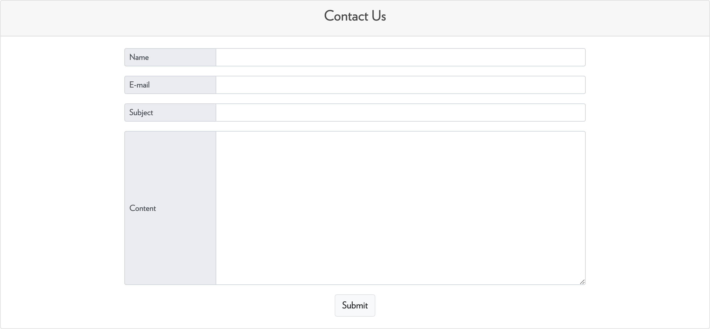

**Figure 28:** Contact form

# Visualization

The Visualization module can be accessed by clicking on the Visualization button on the user dashboard. Here we provide two basic functions, visualization of models and visualization of cus- tomized data.

## Visualize Model Data and Results

To visualize model data and results, the user needs to select a model in the model list and then click on the Go button below, as indicated in Figure 29.

After that, the user will be directed to the model visualization page with an empty map displayed, as shown in Figure 30.

Two options are provided here, including

* Visualize Model Data: to plot the supply, technology, and demand **input data** onto the map;

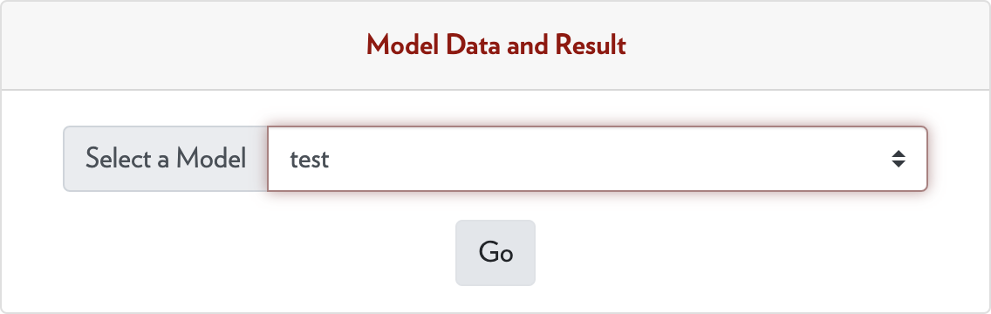

**Figure 29:** Select a model

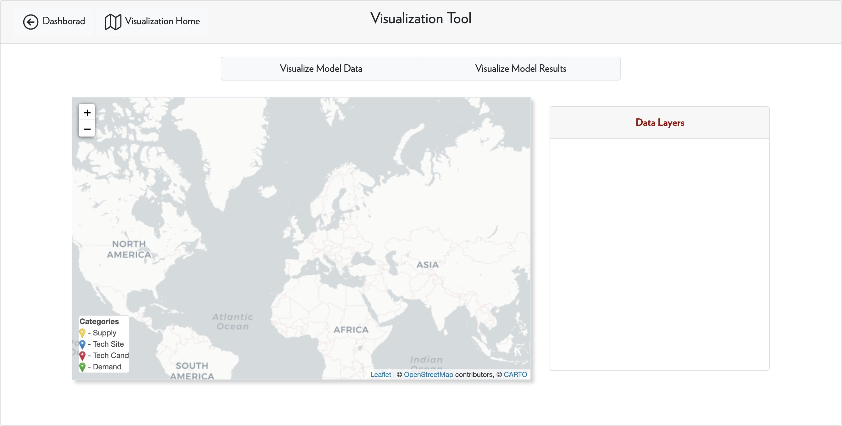

**Figure 30:** Model visualization

* Visualize Model Results: to plot the supply, technology, demand, product transportation, and product prices (if available) results onto the map.

By clicking the Visualize Model Data button, ADAM will load data from the model and plot onto the map. Figure 31 below shows an example of the visualization of model data. Users can double click on each marker to get information about input data settings.

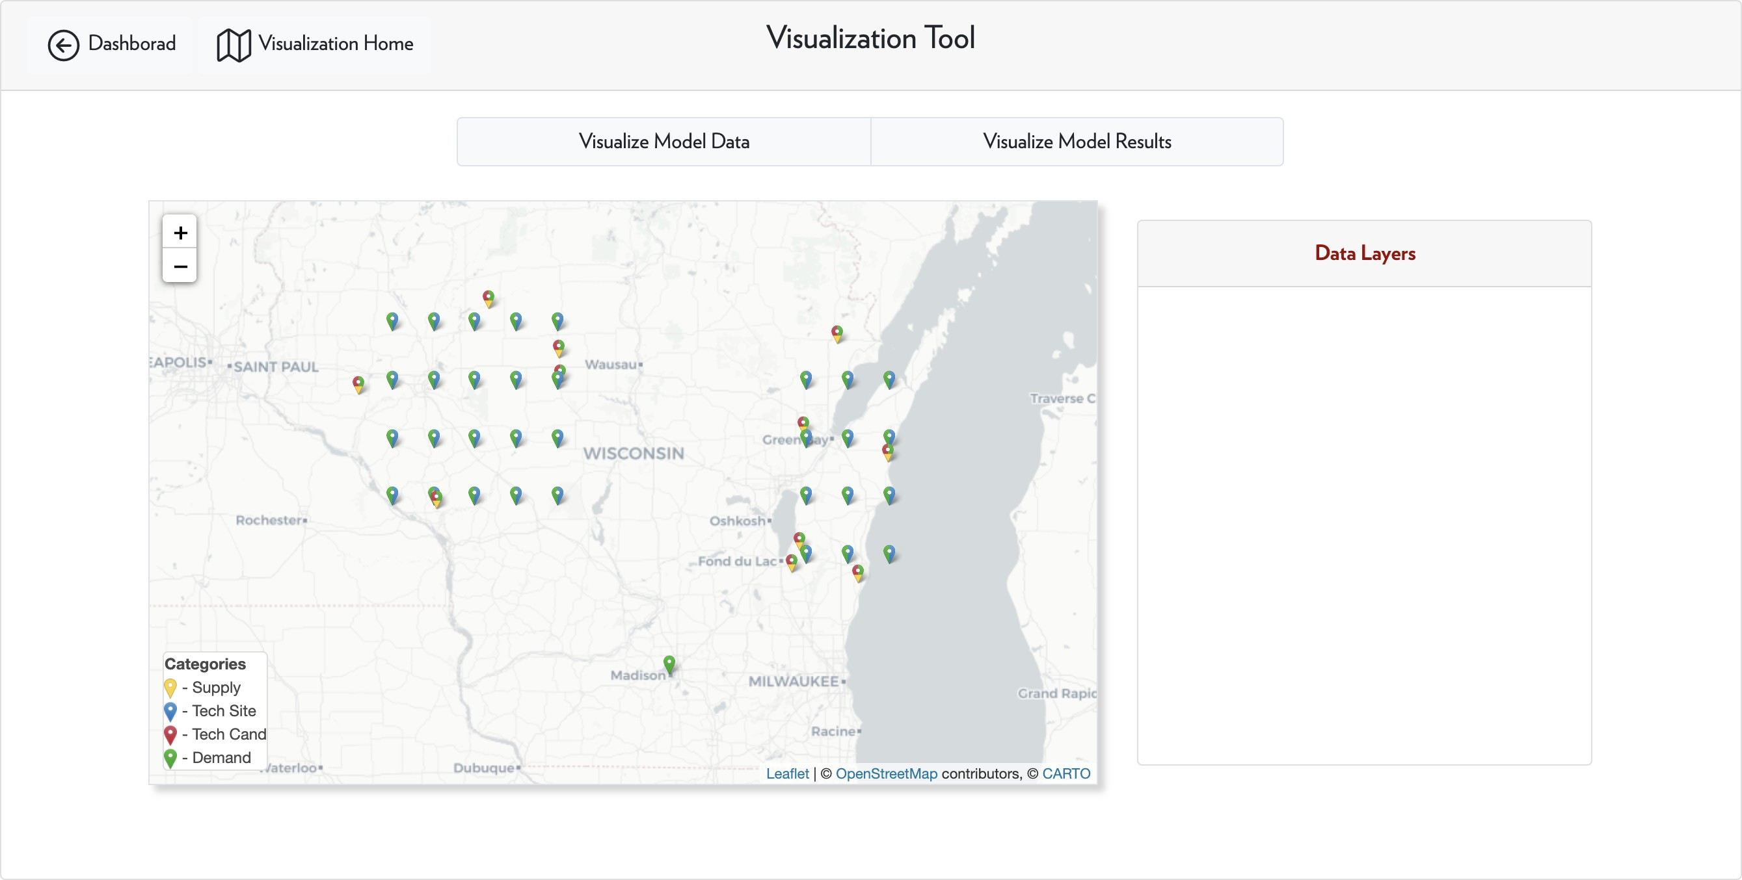

**Figure 31:** Visualization of model data

By clicking the Visualize Model Results button, ADAM will load the results of this model and plot onto the map if there is any available result; otherwise, an error message will pop up. Users can double click on each marker to get information about supply, demand, and technology results. If a node is gray, it means that the ode does not participate in the network. When hover on product transportation flows, information including the amount of transported product and corresponding cost will show up. And for management models, users can also visualize the distribution of products or feedstocks over the study area. Examples of transportation results and price results are shown in Figure 32 and 33, respectively.

With the above two functions, users can change the map back and forth to compare the input data with outcomes.

## Visualize Custom Data

We also provide a function to visualize users’ custom data. User can directly click the Go button in the Uploading New Data card.

In this function, once the user clicks on the Upload Data File button on the top, the user can upload a geographical location csv file with an optional flow data file defining the transportation flows, as shown in Figure 34.

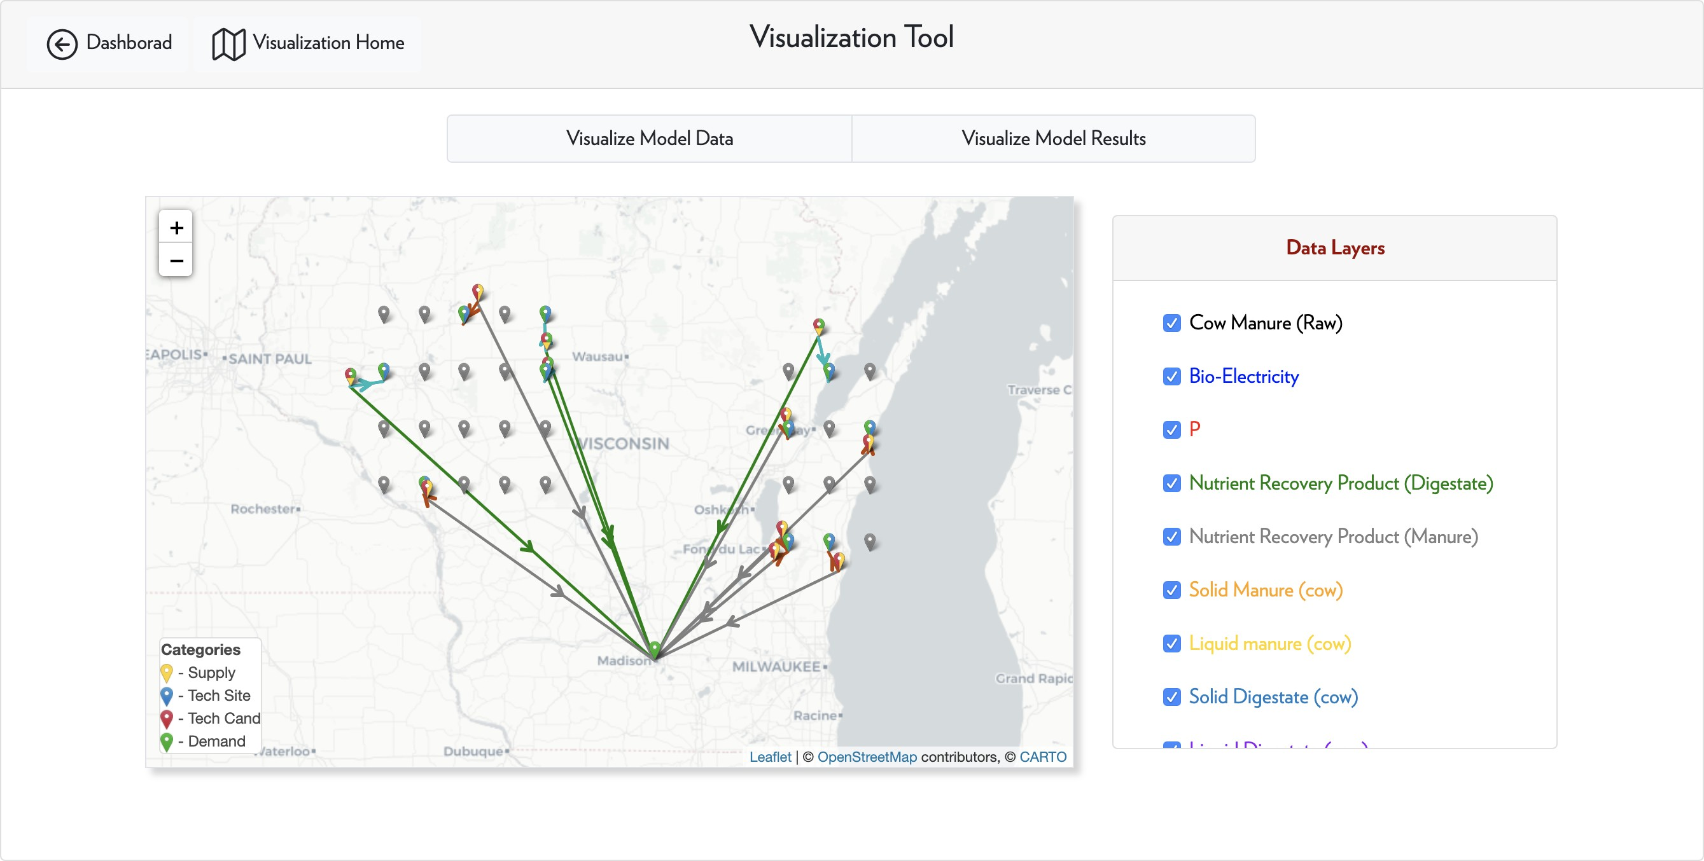

**Figure 32:** Visualization of model results - product flows

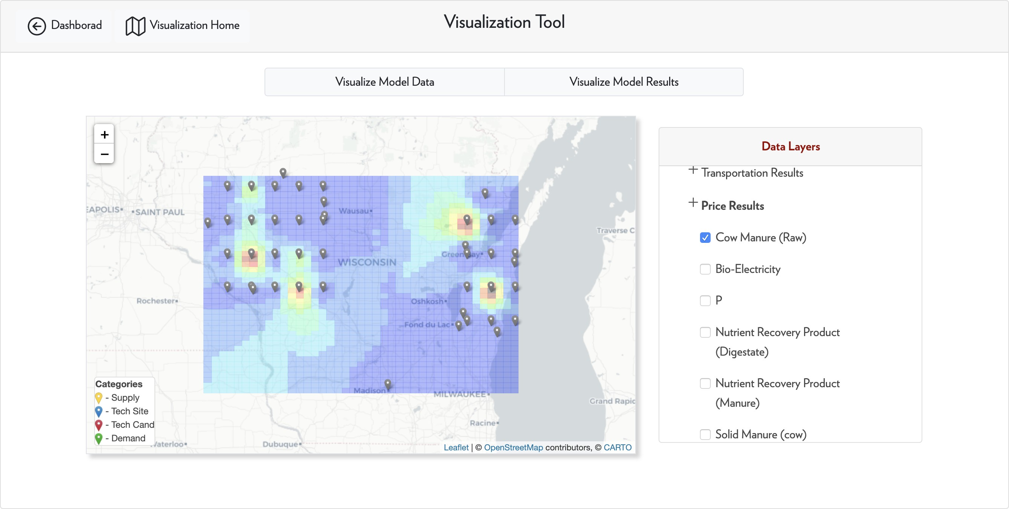

**Figure 33:** Visualization of model results - product prices

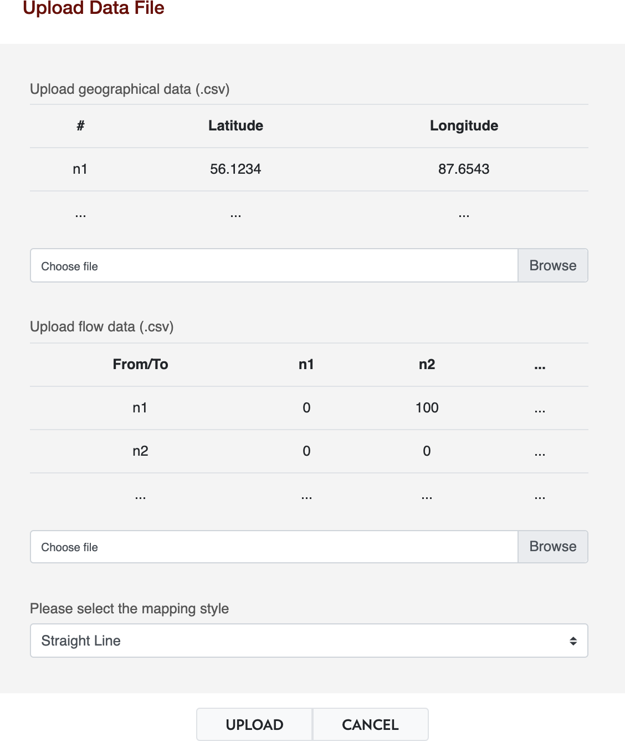

**Figure 34:** Uploading data and visualization

In the uploading window, the data format is given: for geographical locations, the user only needs to provide names and geographical coordinates of those locations. For flow data, the user needs to provide a matrix defining the transportation flow amount between each pair of nodes (any flow larger than zero will be plotted onto the map).

For flow data, we provide three types of mapping style:

* Straight Line: use straight lines to connect node pairs between which product flow is positive;
* Routing: to show GIS road paths between node pairs;
* Hybrid: to plot straight lines first, and the GIS road will show up when the user clicks on the straight line.

# Developer Guide

## Become an Admin of ADAM

In ADAM, registered users can apply to become a member of admin users by sending us a message in the contact form. Admin users will have the following privileges:

* To build and publish new case studies;
* To manage the user’s own, private feedstock, product, and technology database to define problems with more possibilities;
* To add new public feedstock, product, and technology for other users;
* To access the Django admin site to manage all other data and objects behind the scene. And at the same time, the admin users should keep the following rules:
* To maintain the quality, including reasonable model setup and clear documentation, of published case studies;
* To maintain the quality, including data accuracy, simple and clear descriptions, accurate name, etc., of public product and technology items;
* To help deal with users’ requests about modifications of other server-side files and objects;
* To avoid to modify any other users’ data without explicit permission.

In the following sessions, we will briefly introduce the workflow of making new case studies, managing products and technologies, and managing other objects. We will provide another guide for ADAM maintainers to maintain ADAM from the server side.

## Publish New Case Studies

The case study management site can be accessed by admin users via Dashboard-Case Studies- Manage Cases. Each case study in ADAM should contain one or more scenarios. Each scenario is essentially a model defined by users. A good case study should provide users with insights and inspirations by properly grouping several scenarios. Examples could be

* Sensitivity analysis of some parameters, e.g., product price;
* Comparison of different availability of technologies in the same region;
* Comparison of using the same set of technologies in different study regions;
* More potential case study setups.

To define a case study, the admin user needs to first generate scenarios from model objects in ADAM by clicking the Generate Scenario from Model button. Then the scenario name as well we the model to be copied needs to be specified. For now, any admin user can have access to models defined by any other users, but we may change that in the future.

Once a scenario is generated, it will be listed on the Manage Cases page. By checking the sce- narios and then click on the Group Scenarios button, a case study can be constructed. The new case study will also be listed on the same page. The admin user can choose to edit the case study, options include:

* Delete this Case Study: remove it from the case list;
* Rename: change the name of this case study;
* Publish/Unpublish: make this case study accessible (or not accessible) to other users;
* Add/Remove Scenarios: to add a scenario to this case study or to remove a scenario from this case study.
* Upload Document: to assign a document to the case study to illustrate the background and model setups.

Once a case study is published, any registered user in ADAM will have access to it via the Case Studies button on the dashboard. All registered users will have full access to the case study data, results, and documentation, and they can easily duplicate a scenario from the case study for their own purposes.

## Product and Technology Management

To manage products (feedstocks) and technologies in ADAM, an admin user needs to go to Dashboard- Developer Panel-Manage technologies/Products. We note that in ADAM, we do not dif- ferentiate a feedstock with a product because a product in one problem can be a feedstock in another problem. For simplicity, we use products to refer to the union of all possible materials in ADAM.

For adding a product, the admin user can click on the Add Product on top of the Manage Products module. As shown in Figure 35, the admin needs to provide following information for a new product:

* Product Name;
* Unit;
* Default transportation cost in USD/unit/km;
* A brief description of this product;
* If public.

For an admin user, if he/she wants to define a private product for its own purpose then the public option should not be checked. Any public products should be evaluated by researchers in the field to make sure the content and data are reasonable. The admin user can edit his or her own private products here, but cannot edit a public product.

For adding a technology, the admin user can click on the Add Technology on top of the Manage Technologies module. As shown in Figure 36, the admin needs to first define how many inflow and outflow streams the technology has and then provide following information for a new technol- ogy as shown in Figure 37:

* Technology Name;
* If public;

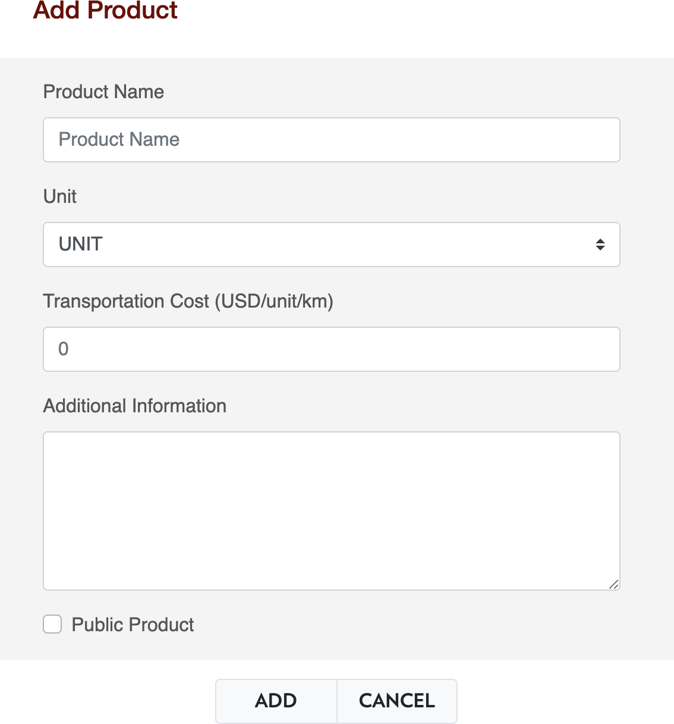

**Figure 35:** Add a product

* Data of input/output streams, feedstocks/products, transformation coefficients, and if it is the reference stream;
* Capacity Ranges in unit of reference stream per year;
* Operational cost coefficients;
* Investment cost coefficients;
* A brief description of this technology.

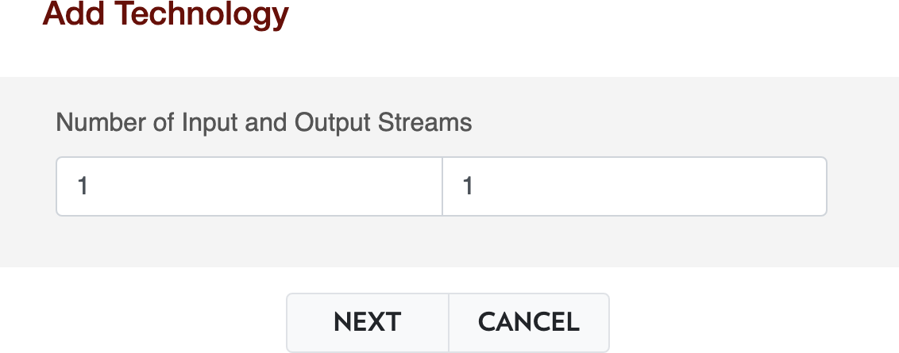

**Figure 36:** Specify number of input and output streams

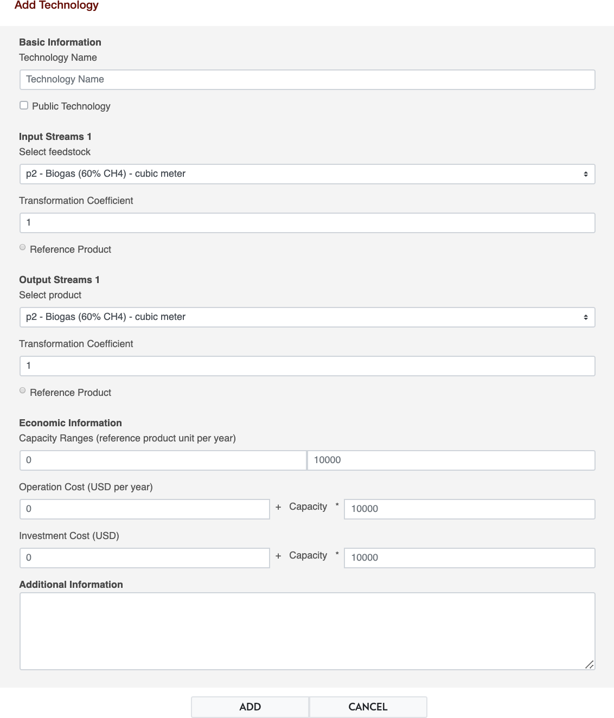

**Figure 37:** Add a technology

Similar to products, usually we recommend admin users add private technology items unless the data and content have been peer-reviewed by researchers in the field. For both the operational and in- vestment cost of technologies, the admin user needs to provide the **fixed cost** as well as **proportioanl cost** part.

## Object Management

This part should only be used upon **user’s request** or there is **severe error** for items in the database. To manage the objects, the admin user needs to click on the Admin System on the Developer Panel. The default Django admin website is used, where different objects can be managed and modified, such as models, products, technologies, etc., as shown in Figure 38.

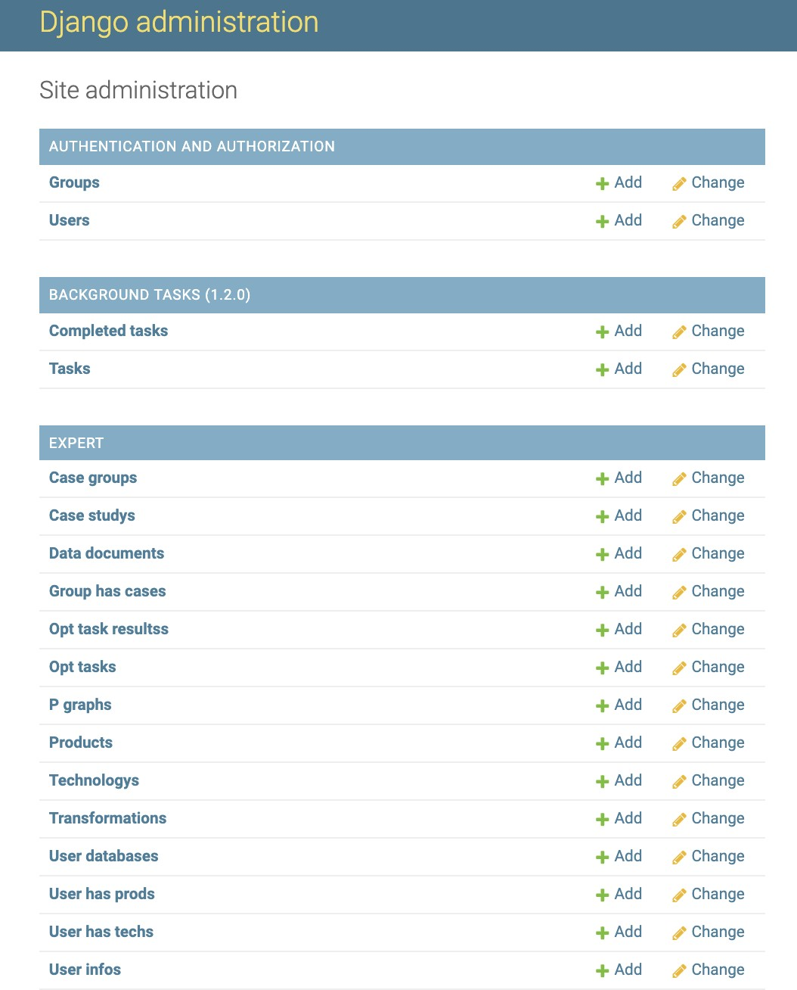

**Figure 38:** Django admin site

# Endnotes

In this document, we have included some detailed guidance of using ADAM, especially for defining new models in the user dashboard module. Our team is continuously working on improving the performance and functionalities of ADAM. Future functionalities might include:

* Enhance the modeling capability (environmental components, dynamic models, etc.);
* Allow users to define more customized models;
* Provide database for geographical information (e.g. waste source);
* Continue to expand our case study library and product/technology database.

# Appendix

## ADAM Database

Currently, ADAM has the following technologies in the database system; some combined technolo- gies are also included for modeling convenience.

* Anaerobic digestion of raw cow manure
* Dilution and sand recovery of raw cow manure
* Anaerobic digestion of diluted cow manure
* Electricity generation from biogas
* Solid-liquid separation of raw cow, beef, and heifer manure
* OSTARA technology of cow manure for nutrient recovery
* Multiform technology of cow manure for nutrient recovery
* Crystalactor technology of cow manure for nutrient recovery
* NuReSys technology of cow manure for nutrient recovery
* MAPHEX technology of cow manure for nutrient recovery
* PROC technogy of cow manure for nutrient recovery
* Granulation technology of solid cow, beef, and heifer manure
* Phosphorus release (pseudo technology) of land applicable waste streams

All related materials and products are in the database system as well. As as continue to develop ADAM, more items will be added into the database.

# A*c*knowledgment

We acknowledge support from the U.S. Department of Agriculture (grant 2017-67003-26055), from the National Science Foundation (grant CBET-1604374), and from the U.S. EPA (contract number EP-18-C-000016).

**Disclaimer**: The views expressed in this document are those of the authors and do not necessarily reflect the views or policies of the U.S. Environmental Protection Agency. Mention of trade names, products, or services does not convey, and should not be interpreted as conveying, official U.S. EPA approval, endorsement, or recommendation.

**References**

1. D. C. López-Díaz, Y. Hu, W. Chan, J. M. Ponce-Ortega, and V. M. Zavala, “Systems-level analysis of phosphorus flows in the dairy supply chain,” *ACS Sustainable Chemistry & Engineering*, vol. 7, no. 20, pp. 17074–17087, 2019.
2. A. M. Sampat, E. Martin, M. Martin, and V. M. Zavala, “Optimization formulations for multi- product supply chain networks,” *Computers & Chemical Engineering*, vol. 104, pp. 296–310, 2017.
3. A. M. Sampat, G. J. Ruiz-Mercado, and V. M. Zavala, “Economic and environmental analysis for advancing sustainable management of livestock waste: A wisconsin case study,” *ACS sustainable chemistry & engineering*, vol. 6, no. 5, pp. 6018–6031, 2018.
4. Y. Hu, M. Scarborough, H. Aguirre-Villegas, R. A. Larson, D. R. Noguera, and V. M. Zavala, “A supply chain framework for the analysis of the recovery of biogas and fatty acids from organic waste,” *ACS Sustainable Chemistry & Engineering*, vol. 6, no. 5, pp. 6211–6222, 2018.
5. A. M. Sampat, E. Martín-Hernández, M. Martín, and V. M. Zavala, “Technologies and logistics for phosphorus recovery from livestock waste,” *Clean Technologies and Environmental Policy*, vol. 20, no. 7, pp. 1563–1579, 2018.
6. E. Martín-Hernández, A. M. Sampat, V. M. Zavala, and M. Martín, “Optimal integrated facility for waste processing,” *Chemical Engineering Research and Design*, vol. 131, pp. 160–182, 2018.
7. A. M. Sampat, Y. Hu, M. Sharara, H. Aguirre-Villegas, G. Ruiz-Mercado, R. A. Larson, and V. M. Zavala, “Coordinated management of organic waste and derived products,” *Computers & Chemi- cal Engineering*, vol. 128, pp. 352–363, 2019.
8. Y. Hu, A. M. Sampat, G. J. Ruiz-Mercado, and V. M. Zavala, “Logistics network management of livestock waste for spatiotemporal control of nutrient pollution in water bodies,” *ACS Sustainable Chemistry & Engineering*, vol. 7, no. 22, pp. 18359–18374, 2019.