# upplementary Information

**Drinking Water Buffer Intensity Simulator (BIS): Development and Practical Simulations**

David G. Wahman1*, Michael R. Schock2, and Darren A. Lytle1

1 United States Environmental Protection Agency, Office of Research & Development, Cincinnati, OH 45268

2 Retired, Cincinnati, Ohio 45230

*Corresponding author, mailing address: USEPA, 26 W. Martin Luther King Dr., Cincinnati, OH 45268. Phone: (513) 569–7733. E–mail: [wahman.david@epa.gov](mailto:wahman.david@epa.gov)

**Table of Contents**

Supplementary Information S-1

Instructions for Acquiring and Running BIS R Code S-3

Graphical User Interface Description S-6

Header Area S-7

User-Selected Simulated Condition Inputs Area S-7

Buffer Intensity Plot Area S-7

Simulated Condition Summary Tables Area S-8

List of Figures

Figure S1 Buffer intensity simulator schematic with major areas highlighted. S-9

Figure S2 Screenshot of user-selected simulated condition inputs area with default conditions shown. S-10

Figure S3 Screenshots of alternative simulated condition inputs to estimate ionic strength from total dissolved solids (A) or electrical conductivity (B). S-11

Figure S4 Screenshot of alternative simulated condition input option to estimate dissolved inorganic carbon from a total alkalinity water sample. S-12

Figure S5 Screenshot of buffer intensity simulated plot area. Plot options are in the upper right area denoted with the yellow box. S-13

Figure S6 Screenshot of simulated condition summary tables area. S-14

**List of Tables**

Table S1 Summary of software and packages used to develop the BIS R code. S-6

Table S2 Summary of columns in downloaded buffer intensity plot simulation data file where each row represents a plot data point. S-14

## Instructions for Acquiring and Running BIS R Code

The following are the general steps to acquire and run the BIS R code:

1. Download and install R for the desired operating system: <https://cran.r-project.org/>

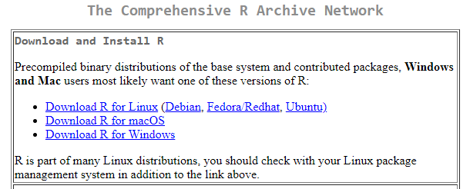

1. Download and install the free, open-source edition of RStudio Desktop (Windows link shown; other operating systems are available at the link as well): <https://posit.co/download/rstudio-desktop/>

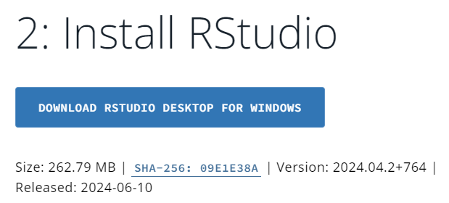

1. If not already installed, RStudio may prompt to install packages, or you may manually install the required packages as follows. Using RStudio Desktop, install the following five packages from a CRAN repository (Tools à Install Packages): DT, plotly, shiny, shinyWidgets, tidyverse

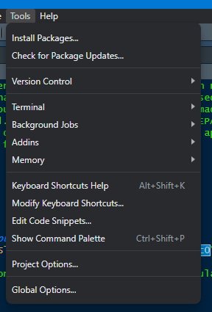

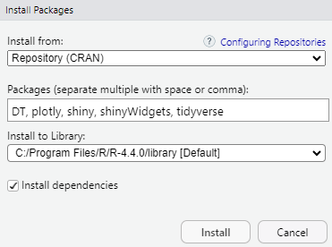

1. Download and save the BIS R code file (app.R) located at GitHub on your local machine from <https://github.com/USEPA/BIS>
2. Open the BIS R code file (app.R) from within RStudio (File à Open File…)

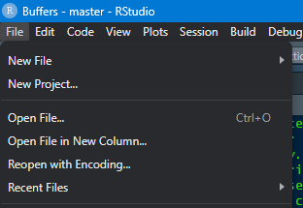

1. Once app.R loads, select the “Run App” button (yellow box) from within RStudio Desktop to run the BIS R code which will open the graphical user interface

For reference, the version of R, RStudio, and associated R packages used in developing the BIS R code are summarized in Table S1 along with relevant reference information.

Table S1 Summary of software and packages used to develop the BIS R code.

|  |  |  |  |
| --- | --- | --- | --- |
| **Item** | **Description** | **Version** | **Reference** |
| R | Free, open-source language and environment for statistical computing and graphics | 4.4.0 | 1 |
| RStudio | Free, open-source integrated development environment (IDE) for R | 2024.04.2 Build 764 | 2 |
| DT | R package, allows creation of tables | 0.33 | 3 |
| plotly | R package, allows creation of interactive plots | 4.10.4 | 4 |
| scales | R package, control appearance of axes on plots | 1.3.0 | 5 |
| shiny | R package, allows creation of interactive web applications | 1.8.1.1 | 6 |
| shinyWidgets | R package, adds custom widgets to enhance shiny applications | 0.8.6 | 7 |
| tidyverse | R package, a set of packages that share common data representations | 2.0.0 | 8 |
| 1R Core Team, 2024. R: A Language and Environment for Statistical Computing. R Foundation for Statistical Computing, Vienna, Austria. <https://cran.r-project.org/>  2 <https://posit.co/products/open-source/rstudio/>  3 Xie, Y., Cheng, J., and Tan, X., 2024. *DT: A Wrapper for the Javascript Library ‘DataTables’, R package version 0.33*. <https://CRAN.R-project.org/package=DT>  4 Sievert, C, 2020. *Interactive Web-Based Data Visualization with R, plotly, and shiny*. Chapman and Hall/CRC, Florida. <https://plotly-r.com>  5 Wickham H., Pedersen T., and Seidel D., 2023. *scales: Scale Functions for Visualization. R package version 1.3.0.* <https://CRAN.R-project.org/package=scales>.  6 Chang, W., Cheng, J., Allaire, J., Sievert, C., Schloerke, B., Xie, Y., Allen, J., McPherson, J., Dipert, A., and Borges, B., 2024. *shiny: Web Application Framework for R. R package version 1.8.1.1*. <https://CRAN.R-project.org/package=shiny>  7 Perrier, V., Meyer, F., and Granjon, D., 2024. *shinyWidgets: Custom Inputs Widgets for Shiny, R package version 0.8.6*. <https://CRAN.R-project.org/package=shiny>  8 Wickham et al., 2019. Welcome to the tidyverse. *Journal of Open Source Software*, 4(43), 1686. <https://doi.org/10.21105/joss.01686> | | | |

## Graphical User Interface Description

Running the BIS R code provides an interactive Shiny application for the user to simulate buffer intensity curves. The graphical user interface general layout (Figure S1) consists of a single page with four main areas: (1) header, (2) user-selected simulated condition inputs, (3) buffer intensity plot, and (4) simulated condition summary tables.

Header Area**.** The header area displays the version of the BIS R code and the last time the BIS R code was updated. Also, a general description of the application along with a disclaimer is in the header area.

User-Selected Simulated Condition Inputs Area**.** The user-selected simulated condition inputs area provides sliders to select buffer intensity simulation conditions (Figure S2). Specifically, the pH range of interest is selected along with the temperature (5-35° C) and ionic strength of the water (0-100 mM). Finally, the concentrations of the chemical constituents that provide buffer intensity are selected in typically measured units: dissolved inorganic carbon (0-100 mg C/L), total dissolved orthophosphate (0-10 mg PO4/L), free ammonia (0-10 mg N/L), free bromine (0-10 mg Cl2/L), free chlorine (0-10 mg Cl2/L), and total dissolved orthosilicate (0-50 mg SiO2/L).

In addition to directly entering known ionic strength and dissolved inorganic carbon concentrations, alternative input options are available. The requested inputs will change based on the selected input option for ionic strength (Figure S3) and dissolved inorganic carbon (Figure S4). Ionic strength may be estimated from total dissolved solids or electrical conductivity (Figure S3), and the dissolved inorganic carbon concentration may be estimated from a total alkalinity water sample (Figure S4).

Buffer Intensity Plot Area**.** A dynamic buffer intensity plot (Figure S5) will generate per the user-selected simulated condition inputs (Figures S2-S4). In addition to the total buffer intensity, the plot displays the contribution from each of the individual weak acids (carbonate, free ammonia, free chlorine, free bromine, orthophosphate, and orthosilicate) and water. Using the bar located in the upper right portion of the plot, the generated plot is interactive and allows zooming, panning, and scaling. Information on the plotted data also appears upon hovering over the generated curves. Furthermore, individual weak acids can be toggled on and off by clicking on them in the legend. Two buttons are also provided to (1) download the data associated with the simulated plot as a comma-seperated variable (.csv) file (Table S2) and (2) download the simulated plot as a portable network graphic (.png) file. Finally, an area below the plot provides a slider where the user may select two pH values, and based on the total buffer intensity curve, the required addition of strong acid or strong base to change the water between the two selected pH values is calculated and reported in milliequivalent/L (see also manuscript section *Strong acid or strong base addition to change pH*).

Simulated Condition Summary Tables Area**.** Two dynamic tables (Figure S6) are generated below the buffer intensity plot that summarize (1) the selected simulated conditions associated with the generated buffer intensity plot and (2) the negative base 10 logarithms of (i) the standard equilibrium constants at 25 °C (298.15 K) and 0 M ionic strength and (ii) the concentration-based temperature corrected equilibrium constants used for the simulated buffer intensity plot based on user inputs. A button is provided to download each table as a comma-seperated variable (.csv) file.

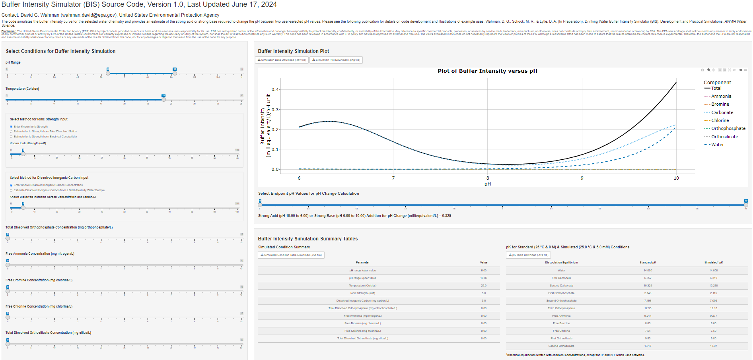

**Simulated Condition Summary Tables**

**Buffer Intensity Plot**

**User-Selected**

**Simulated**

**Condition Inputs**

**Header**

Figure S1 Buffer intensity simulator schematic with major areas highlighted.

Figure S2 Screenshot of user-selected simulated condition inputs area with default conditions shown.

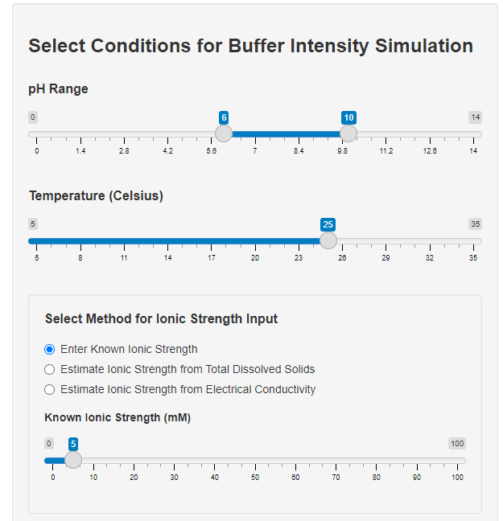

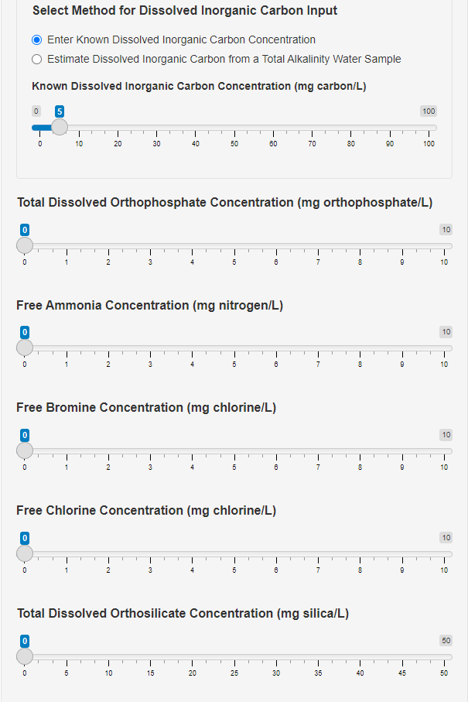

Figure S3 Screenshots of alternative simulated condition inputs to estimate ionic strength from total dissolved solids (A) or electrical conductivity (B).

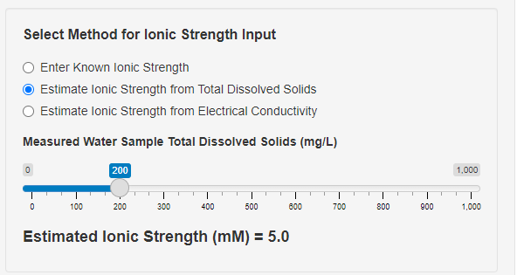

**A**

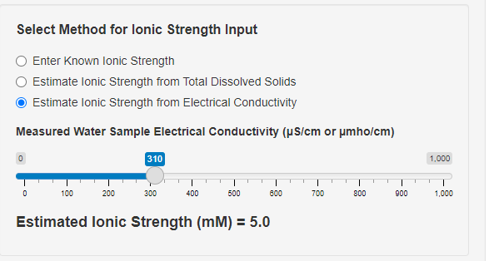

**B**

Figure S4 Screenshot of alternative simulated condition input option to estimate dissolved inorganic carbon from a total alkalinity water sample.

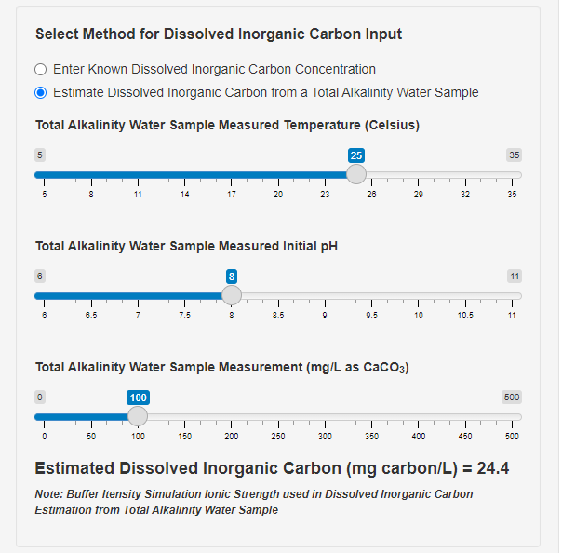

Figure S5 Screenshot of buffer intensity simulated plot area. Plot options are in the upper right area denoted with the yellow box.

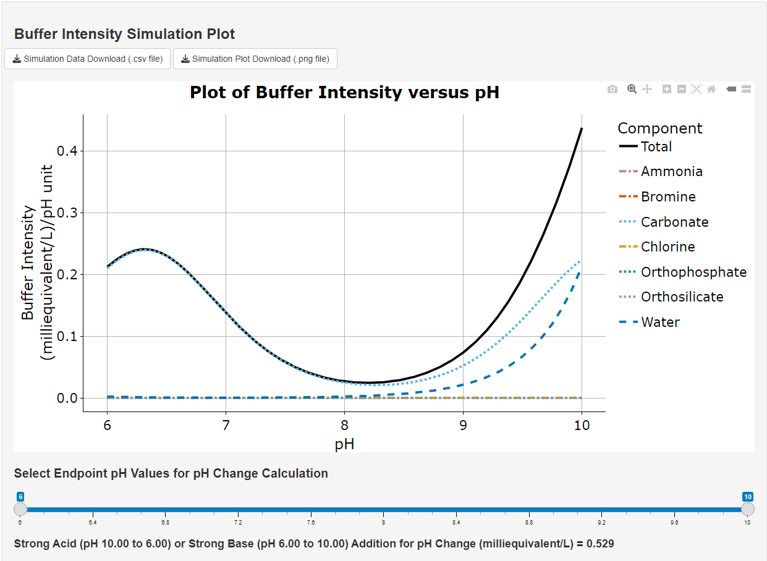

Table S2 Summary of columns in downloaded buffer intensity plot simulation data file where each row represents a plot data point.

|  |  |  |  |  |
| --- | --- | --- | --- | --- |
|  | pH | buffer | buffer_intensity_M | buffer_intensity_mM |
| Row number | Simulated condition pH | Denotes component of simulated buffer intensity: *Total*, *Ammonia*, *Bromine*, *Carbonate*, *Chlorine*, *Orthophosphate*, *Orthosilicate*, or *Water* | Component simulated buffer intensity in molar equivalents per liter per pH unit | Component simulated buffer intensity in milliequivalents per liter per pH unit |

Figure S6 Screenshot of simulated condition summary tables area.

