# Modeling Summary

## Dataset

|  |  |  |
| --- | --- | --- |
| Dose | N | Incidence |
| 0 | 5 | 0 |
| 0.5 | 5 | 3 |
| 1 | 5 | 5 |

## Maximum Likelihood Approach

|  |  |  |  |  |  |  |  |  |
| --- | --- | --- | --- | --- | --- | --- | --- | --- |
| Model | BMDL | BMD | BMDU | *P*-Value | AIC | Scaled Residual at Control | Scaled Residual near BMD | Recommendation and Notes |
| Logistica | 0.159 | 0.451 | 0.491 | 1. | 8.73 | -0. | -0. | **Recommended - Lowest AIC** lowest dose/BMDL ratio > 3.0 |
| Probit | 0.151 | 0.416 | 0.49 | 1. | 10.73 | -0. | <0.001 | **Viable** lowest dose/BMDL ratio > 3.0 |

a BMDS recommended best fitting model

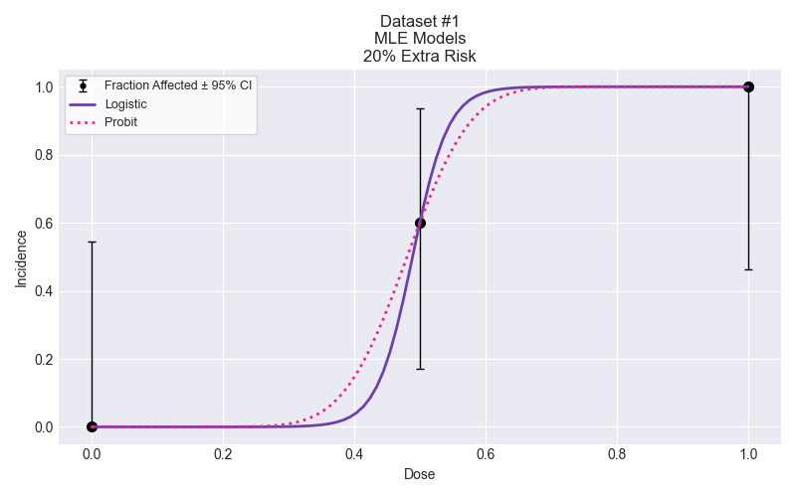

## Selected Model

No model was selected as a best-fitting model.

# Modeling Summary

## Dataset

|  |  |  |
| --- | --- | --- |
| Dose | N | Incidence |
| 0 | 5 | 0 |
| 0.33 | 5 | 0 |
| 0.67 | 5 | 4 |
| 1 | 5 | 5 |

## Maximum Likelihood Approach

|  |  |  |  |  |  |  |  |  |
| --- | --- | --- | --- | --- | --- | --- | --- | --- |
| Model | BMDL | BMD | BMDU | *P*-Value | AIC | Scaled Residual at Control | Scaled Residual near BMD | Recommendation and Notes |
| Logistic | 0.329 | 0.574 | 0.626 | 1. | 7.006 | -0. | <0.001 | **Viable** |
| Probita | 0.317 | 0.576 | 0.631 | 1. | 7.004 | 0 | <0.001 | **Recommended - Lowest AIC** |

a BMDS recommended best fitting model

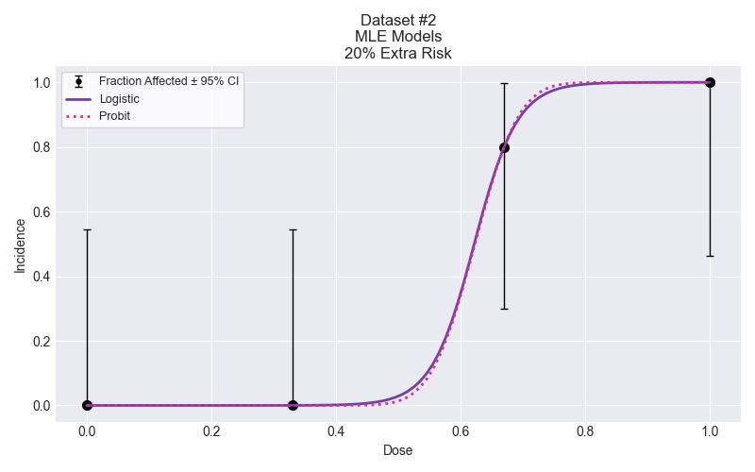

## Selected Model

No model was selected as a best-fitting model.

# Recommended citation

Please adapt as appropriate; the citations below capture the package version and timestamps for easier reproducibility of the analysis.

pybmds. (Version 24.1a0; Model Library Version 2023.10a1) [Python package]. Available from https://pypi.org/project/bmds/. Executed on May 21, 2024.