# Modeling Summary

## Dataset

|  |  |  |
| --- | --- | --- |
| Dose | N | Incidence |
| 0 | 20 | 0 |
| 25 | 20 | 1 |
| 75 | 20 | 7 |
| 125 | 20 | 15 |
| 200 | 20 | 19 |

## Maximum Likelihood Approach

|  |  |  |  |  |  |  |  |  |
| --- | --- | --- | --- | --- | --- | --- | --- | --- |
| Model | BMDL | BMD | BMDU | *P*-Value | AIC | Scaled Residual at Control | Scaled Residual near BMD | Recommendation and Notes |
| Logistic | 32.588 | 44.884 | 59.2 | 0.666 | 70.176 | -0.731 | -0.241 | **Viable** |
| LogLogistic | 25.63 | 40.699 | 55.23 | 0.828 | 69.094 | -0.001 | 0.681 | **Viable** |
| Probit | 30.363 | 41.863 | 55.949 | 0.605 | 70.259 | -0.649 | -0.244 | **Viable** |
| LogProbit | 24.848 | 37.801 | 50.504 | 0.741 | 69.463 | -0.001 | 0.691 | **Viable** |
| Quantal Lineara | 8.916 | 11.64 | 15.467 | 0.142 | 74.757 | -0.001 | -0.001 | **Recommended - Lowest BMDL** |
| Multistage 2 | 18.234 | 35.93 | 42.103 | 0.98 | 68.456 | -0.001 | <0.001 | **Viable** |
| Multistage 3 | 16.215 | 35.93 | 50.62 | 0.98 | 68.456 | -0.001 | <0.001 | **Viable** |
| Gamma | 22.22 | 37.501 | 51.773 | 0.964 | 68.547 | -0.001 | 0.307 | **Viable** |
| Weibull | 20.811 | 35.515 | 50.623 | 0.981 | 68.452 | -0.001 | -0.026 | **Viable** |
| Hill | 25.63 | 40.699 | 55.23 | 0.828 | 69.094 | -0.001 | 0.681 | **Viable** |

a BMDS recommended best fitting model

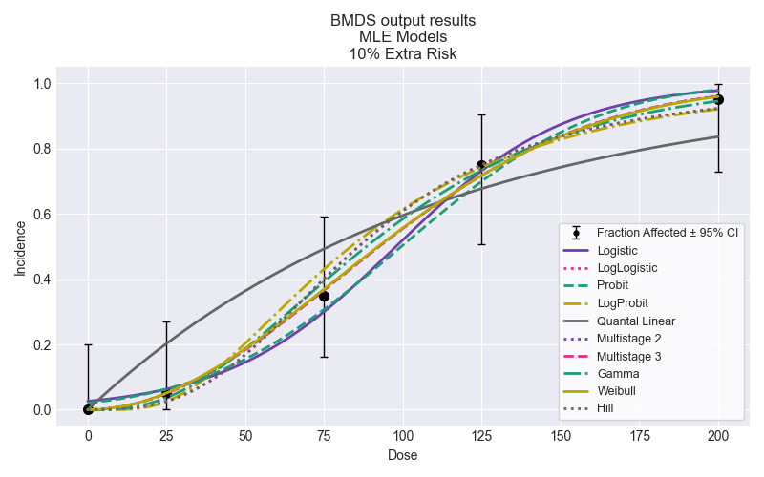

## Selected Model

No model was selected as a best-fitting model.

# Recommended citation

Please adapt as appropriate; the citations below capture the package version and timestamps for easier reproducibility of the analysis.

pybmds. (Version 24.1a0; Model Library Version 2023.10a1) [Python package]. Available from https://pypi.org/project/bmds/. Executed on May 21, 2024.