**Collect Equity Data**

## Purpose

To explore publicly available data sources to help communities identify populations in their community that may be more impacted by climate change and disasters. This data can help identify where there are disparities in factors such as income, housing, and health, as well as consider the needs of populations that have been made more vulnerable to climate risk and other disasters.

## What you will need

**Who:** one or more members of the core team

**Where:** meetings and asynchronous data collection

**How long will it take:** depends on familiarity with the data sources

**Materials:** internet access

## Instructions

Download and review detailed information for your community and compare to state and federal data. There are several sources of information and data tools that combine demographic and environmental indicators to better understand your community’s population and potential vulnerability.

Think about what you heard in the storytelling workshop and adjust filters or add other population groups you would like more information about.

Check to see if a local organization or university has produced any reports or information about equity issues in your community.

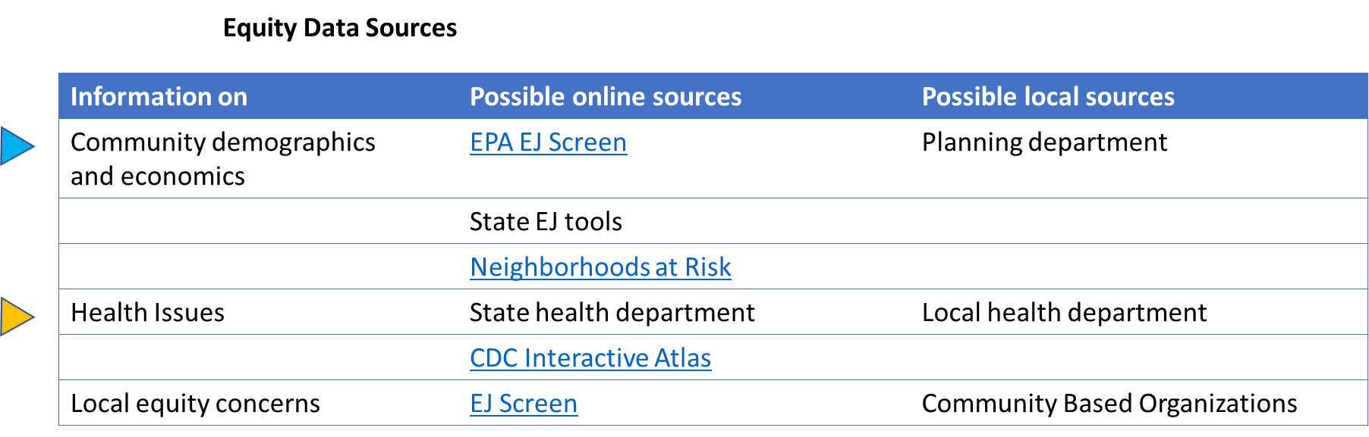

Equity Data Table: Fill out this table to include relevant data at the census-tract, state, and federal level for your community.

|  |  |  |  |
| --- | --- | --- | --- |
| Population | Community % | State % | National % |
| Black |  |  |  |
| Hispanic |  |  |  |
| White |  |  |  |
| Indigenous |  |  |  |
| Other cultural/ ethnic groups |  |  |  |
| Low-income |  |  |  |
| Renters |  |  |  |
| Foreign-born |  |  |  |
| Elderly |  |  |  |
| Disability |  |  |  |
| Select your own |  |  |  |
| Select your own |  |  |  |

Debrief with the team and answer some of the discussion prompts below. Then

1. Which population groups do the data tools identify as at risk of climate-related or environmental risks? How does it compare to state or federal level data?
2. Does this information align with what you understand about your community or what you have learned through storytelling and community engagement?
3. How will you use this information? Are there gaps where you might need more information?
4. How does this information inform what issues do you want to prioritize in the mapping activity? What base maps do you need to print for your workshop?

## What to do next

Return to the ERB tool to answer Question 3 on the Key Takeaways Form on Assessment. The next page is on Resilient Systems Data.