**Scoping Information Gathering**

**Overview**

**Objective**

To provide some suggestions for data sources and guiding questions to determine how much capacity you have for gathering data and information.

## Preparation

**Who will be involved:** core team

**Where:** in-person or virtual meeting, or asynchronous discussion

**Suggested activity length:** 1.5 hours

**Materials:** internet access

**Output**

A data collection table to compile information on hazards equity measures.

**Next Steps**

After completion, return to the ERB and begin the next step: **Gather Data**.

**Example of Data Collection Table**

|  |  |  |  |  |
| --- | --- | --- | --- | --- |
| Topic | Local sources | Online sources | How might you use this? | Core team point person |
| **Hazards** |  |  |  |  |
| **Climate change** | Hazard Mitigation Plan | [Climate Explorer](https://crt-climate-explorer.nemac.org/) | HMP risk analysis |  |
| **Pollution/toxic sites** |  | [EJ Screen](https://www.epa.gov/ejscreen)  [My Environment](https://enviro.epa.gov/myenvironment/) |  |  |
| **Disasters** |  | [FEMA National Risk Index](https://www.fema.gov/flood-maps/products-tools/national-risk-index) |  |  |
|  |  |  |  |  |
| **Equity** |  |  |  |  |
| **Community demographics** |  | [Neighborhoods at Risk](https://nar.headwaterseconomics.org/?_ga=2.99205406.1689028597.1678843534-1326411450.1677528176&_gl=1*1o416r9*_ga*MTMyNjQxMTQ1MC4xNjc3NTI4MTc2*_ga_4GZ7QHJZ4N*MTY3ODg0MzUzNC4yLjAuMTY3ODg0MzUzNC4wLjAuMA..) |  |  |
| **Health concerns** | Local health department | [CDC Interactive Atlas](https://www.cdc.gov/dhdsp/maps/atlas/index.htm) |  |  |
| **Food security** | Food pantries |  |  |  |
| **Housing** | Housing office |  |  |  |
|  |  |  |  |  |

In this example, we’ve pre-populated potential online and local sources. Your table may have more or less information.

**Scoping Information Gathering**

## Instructions

Use the following prompts to discuss and determine your information needs and capacity:

1. Revisit the Key Takeaways Form on Assessment from Workshop 1. Which topics would you like to explore further?
2. Revisit Part II of the Project Plan on goals. Do you have specific information needs for achieving your goals?
3. Look over the potential data sources listed below. Which are you already familiar with? You can add other sources of information, as well.

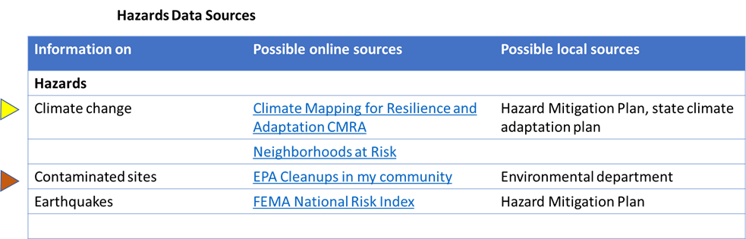

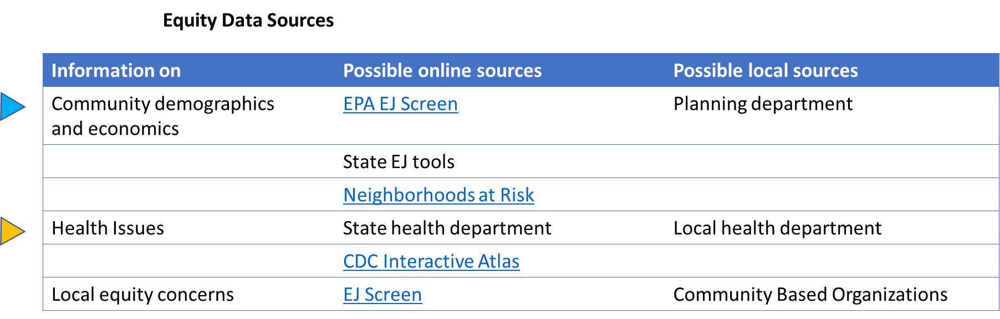

1. Discuss how much time and capacity the core team has to collect information. Refer to parts I and IV of the Project Plan on how the team will work together. Consider: Are there other ongoing planning activities that could be leveraged? Are other organizations tracking or managing relevant data? Are there opportunities to partner with community organizations, universities or local agencies that can help?
2. Complete the table on the next page to organize data collection.

After you’ve considered your capacity and looked at the data sources, you might decide:

* The team has limited time and capacity, or already has the data needed, so you are not going to gather any additional information at this time. You will do workshop activities (storytelling, mapping, action evaluation) to get input from community members.
* The team has some time and capacity and will gather some data on hazards, equity, and/ or resilience using local and online sources and by doing workshop activities.
* The team has enough time and capacity or has support from technical experts and will gather all the relevant data available to support the resilience plan.

## Data Collection Table:

Now that you understand your capacity to collect data, fill out the table below as a core team to map out how and where to collect relevant data and information in your community. Highlight what information/data needs to be collected for hazards equity, what source the data will come from, and how this data will be used. Refer to the lists above for potential data sources. Additionally, appoint a core team member to collect each area of data.

|  |  |  |  |  |
| --- | --- | --- | --- | --- |
| Topic | Local sources | Online sources | How might you use this? | Core team point person |
| **Hazards** |  |  |  |  |
| **Climate change** |  |  |  |  |
| **Pollution/toxic sites** |  |  |  |  |
| **Disasters** |  |  |  |  |
|  |  |  |  |  |
| **Equity** |  |  |  |  |
| **Community demographics** |  |  |  |  |
| **Health concerns** |  |  |  |  |
| **Food security** |  |  |  |  |
| **Housing** |  |  |  |  |
|  |  |  |  |  |