**Indicator Activity Worksheet**

In this activity workshop, participants will arrange the indicator cards to assess which are most or least resilient and most or least equitable. ​We will learn where systems and topics fall on resilience and equity continuums.

First divide into breakout groups for each of the resilience systems (built, natural, and social). Make sure the indicator cards in your group correspond to the same resilience system. Then, follow the steps below to sort the indicator cards according to their resilience and equity in your community.

**Step 1. As a group, arrange cards along the horizontal line from least to most resilient**.​

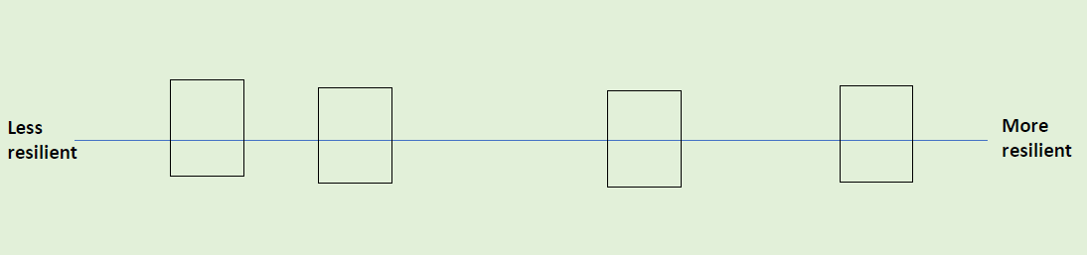​

Definitions

Less resilient – Very vulnerable/susceptible to damage or disruption and would likely take a long time to recover from a shock. ​

More resilient – Minimally vulnerable/susceptible to damage or disruption and would likely be able to withstand shocks or recover quickly.

**Step 2. Now as a group, move the cards you just placed on the resilience line up or down to indicate how equitable each indicator is.**​

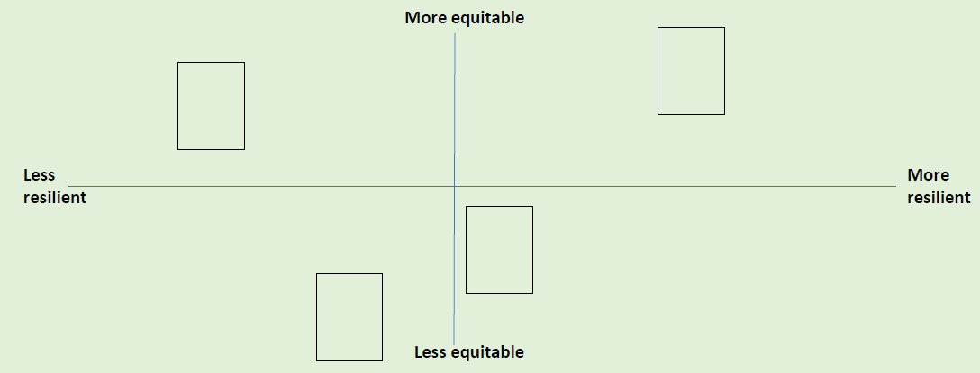

Definitions

Less equitable – There are substantial differences in how different groups of people or neighborhoods are affected by this indicator which cause greater harm or risks for some groups.   ​

More equitable – There are minimal differences in how different groups of people or neighborhoods are affected by this indicator or if there are differences, they do not cause greater harm or risk for a particular group.

Example

For the indicator “Number of homes in FEMA floodplain”, there could be a low number of homes in floodplains (more resilient), but the homes in the floodplains belong to low-income families or persons over 65 (less equitable).

**Step 3. Have each breakout group share their results and discuss patterns you see. ​Draw squares around the 4 quadrants on the board and add labels as in the example below. ​**

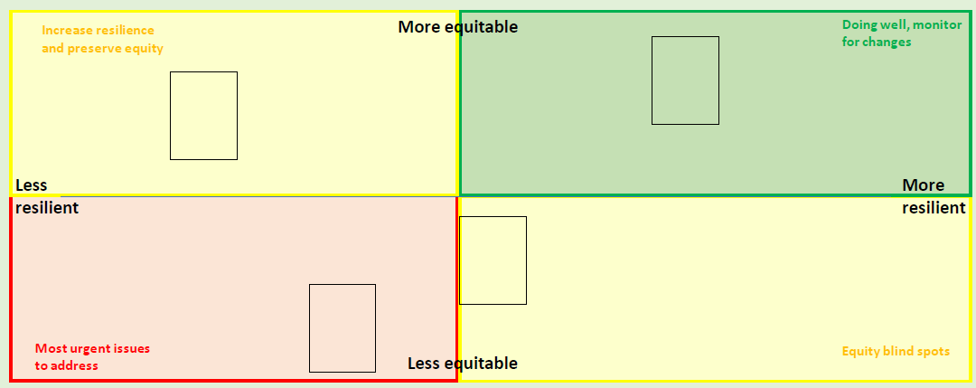​

**Discussion questions:​**

Which quadrants have the most cards? Do you feel this is an accurate picture of the overall resilience and equity of the community? ​

Are there certain systems that show up more often as more or less resilient, or more or less equitable? ​

Are there certain hazards that present a greater risk for the community than others? Are there certain systems that are more vulnerable to specific hazards (as discussed during the hazard mapping activity)?