Indicator Activity Instructions

## Purpose

To assess which indicators are most or least resilient and most or least equitable, and where systems and topics fall on resilience and equity continuums.

## What you’ll Need

**Who:** Workshop Participants, Facilitators

**Where:** In-person or virtual workshop

**How long will it take:** 1-2 hours

**Materials:** Printed indicator cards (in-person) or populated indicator cards (virtual), large tables (in-person)

## Instructions

1. **(Core team)**: Present the indicator cards you chose to assess your community’s resilience and equity. Run through the data and information on each card to make sure the participants understand the indicator and what it represents within their community.
2. **(Community members):** Divide into breakout groups for each of the resilience systems (built, natural, and social). Make sure the indicator cards in your group correspond to the same resilience system.
3. **(Breakout groups)**: As a group, arrange cards along a horizontal line for least to most resilient as shown in the image below.
   1. Less resilient: Very vulnerable/susceptible to damage or disruption and would likely take a long time to recover from a shock.
   2. More resilient: Minimally vulnerable/susceptible to damage or disruption and would likely be able to withstand shocks or recover quickly.

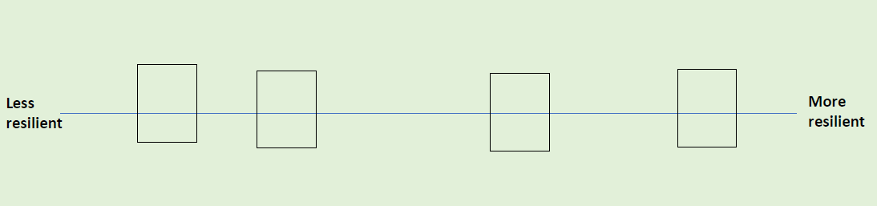

*Cards Sorted by Resilience: An example of how the indicator cards should be sorted horizontally from less resilient to more resilient.*

1. **(Breakout groups)**: Now as a group, move the cards you just placed on the resilience line up or down to indicate how equitable each indicator is as shown in the image below.
   1. Less equitable: There are substantial differences in how different groups of people or neighborhoods are affected by this indicator which cause greater harm or risks for some groups.
   2. More equitable: There are minimal differences in how different groups of people or neighborhoods are affected by this indicator or if there are differences, they do not cause greater harm or risk for a particular group.
   3. Example: For the indicator “Number of homes in FEMA floodplain”, there could be a low number of homes in floodplains (more resilient), but the homes in the floodplains belong to low-income families or persons over 65 (less equitable).

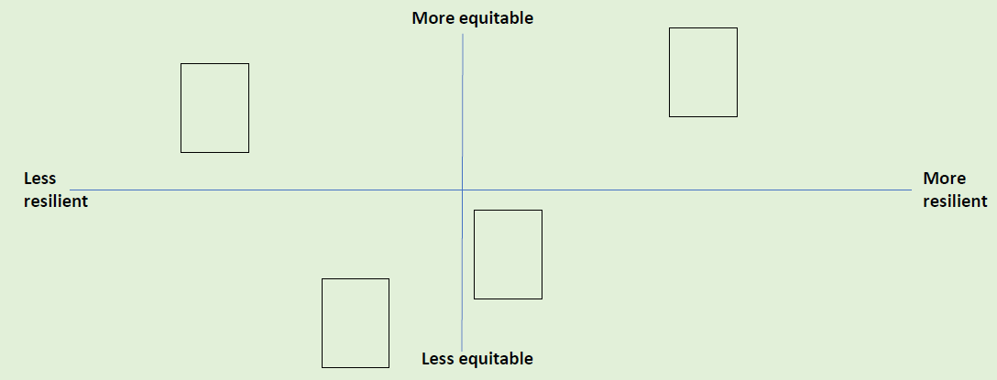

*Cards Sorted by Equity: An example of how the indicator cards should be sorted vertically from less equitable to more equitable after sorted based on resilience.*

1. **(Core Team)**: Have each breakout group share their results and discuss as a group the patterns you see. This can be done with tape or sticky notes on a wall, projector, or table. Draw squares around the 4 quadrants on the board and add labels as in the example below.

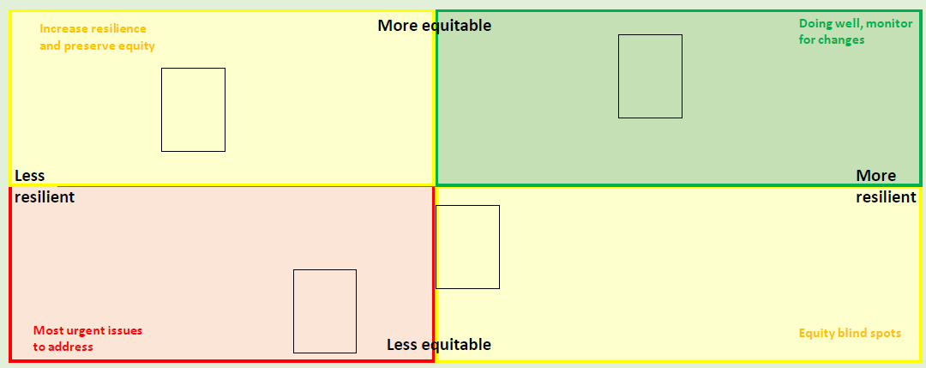

*Cards in Quadrants: An example of fully sorted indicator cards from all systems. Quadrants are labeled as a group after breakout groups have sorted their cards.*

## Large Group Discussion Prompts

1. Which quadrants have the most cards? Do you feel this is an accurate picture of the overall resilience and equity of the community?
2. Are there certain systems that show up more often as more or less resilient, or more or less equitable?
3. Are there certain hazards that present a greater risk for the community than others? Are there certain systems that are more vulnerable to specific hazards (as discussed during the hazard mapping activity)?

## What to do next

Return to the ERB tool to input your Key Takeaways from this activity. Then, move on to the next activity: Discuss Equity.