**Scoping Information Gathering**

## Purpose

To provide some suggestions for data sources and guiding questions to determine how much capacity you have for gathering data and information.

## What you will need

**Who:** core team

**Where:** in-person or virtual meeting, or asynchronous discussion

**How long will it take:** 1.5 hours

**Materials:** internet access

## Instructions

Use the following prompts to discuss and determine your information needs and capacity:

1. Revisit the Key Takeaways Form on Assessment from Workshop 1. Which topics would you like to explore further?
2. Revisit Part II of the Project Plan on goals. Do you have specific information needs for achieving your goals?
3. Look over the potential data sources listed below. Which are you already familiar with? You can add other sources of information, as well.

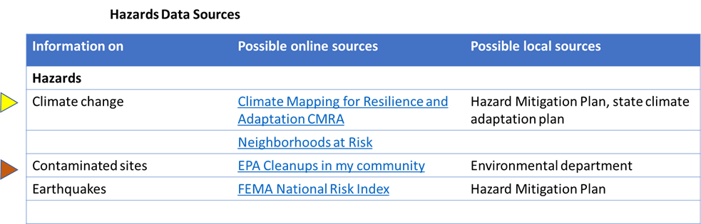

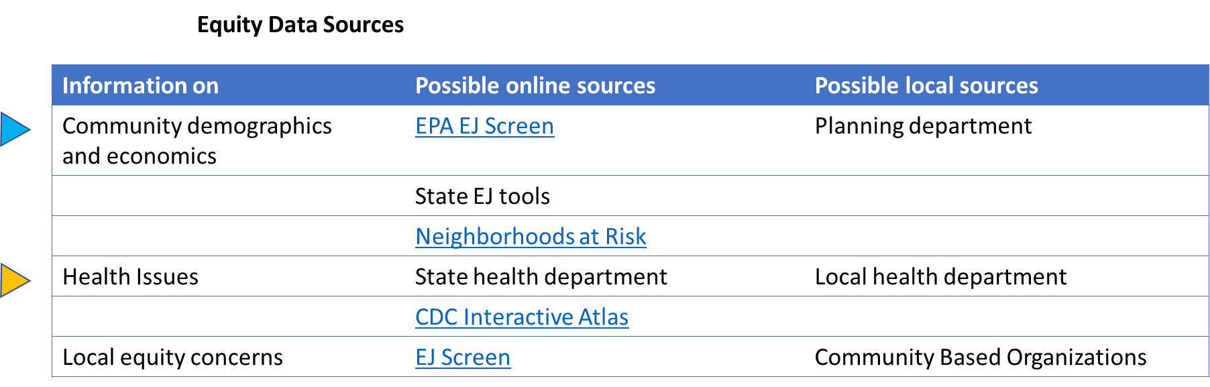

1. Discuss how much time and capacity the core team has to collect information. Refer back to parts I and IV of the Project Plan on how the team will work together. Consider: Are there other ongoing planning activities that could be leveraged? Are other organizations tracking or managing relevant data? Are there opportunities to partner with community organizations, universities or local agencies that can help?
2. Complete the table on the next page to organize data collection.

After you’ve considered your capacity and looked at the data sources, you might decide:

* The team has limited time and capacity, or already has the data needed, so you are not going to gather any additional information at this time. You will do workshop activities (storytelling, mapping, action evaluation) to get input from community members.
* The team has some time and capacity and will gather some data on hazards, equity, and/ or resilience using local and online sources and by doing workshop activities.
* The team has enough time and capacity or has support from technical experts and will gather all the relevant data available to support the resilience plan.

Data Collection Table: Fill out the table below on what information/data needs to be collected for hazards equity, what source the data will come from, how this data will be used, and the which team member is the point person. Refer to the lists above for potential data sources.

|  |  |  |  |  |
| --- | --- | --- | --- | --- |
| **Topic** | **Local sources** | **Online sources** | **How might you use this?** | **Core team point person** |
| **Hazards** |  |  |  |  |
| **Climate change** | Hazard Mitigation Plan | [Climate Explorer](https://crt-climate-explorer.nemac.org/) | HMP risk analysis |  |
| **Pollution/toxic sites** |  | [EJ Screen](https://www.epa.gov/ejscreen)  [My Environment](https://enviro.epa.gov/myenvironment/) |  |  |
| **Disasters** |  | [FEMA National Risk Index](https://www.fema.gov/flood-maps/products-tools/national-risk-index) |  |  |
|  |  |  |  |  |
| **Equity** |  |  |  |  |
| **Community demographics** |  | [Neighborhoods at Risk](https://nar.headwaterseconomics.org/?_ga=2.99205406.1689028597.1678843534-1326411450.1677528176&_gl=1*1o416r9*_ga*MTMyNjQxMTQ1MC4xNjc3NTI4MTc2*_ga_4GZ7QHJZ4N*MTY3ODg0MzUzNC4yLjAuMTY3ODg0MzUzNC4wLjAuMA..) |  |  |
| **Health concerns** | Local health department | [CDC Interactive Atlas](https://www.cdc.gov/dhdsp/maps/atlas/index.htm) |  |  |
| **Food security** | Food pantries |  |  |  |
| **Housing** | Housing office |  |  |  |
|  |  |  |  |  |

## What to do next

Now that you understand your capacity to collect data, fill out the table above as a core team to map out how and where to collect relevant data and information in your community. Additionally, appoint a core team member to collect each area of data. Some examples have been filled out in the table above, but feel free to add any data types or sources that you’d like to collect. Next, return to the ERB and begin the next step: Gather Data.