**Ch. 5 Template- Evaluating Resilience Building Actions**

As you look through your group's list of actions, or hear the actions the other groups are presenting, think about where they fall on a spectrum of

1. Equity. Which actions will benefit the greatest number of people, and/or have the greatest benefit for those most vulnerable, and/or the lowest likelihood of unintended, negative social consequences?
2. Feasibility. Which actions are accomplishable in the short, medium, or long term? What might it cost, and who would need to pay? Does it seem politically viable?
3. Hazard impact. Does this action have the potential to build resilience to more than one hazard- including hazards most likely to affect your community, and/or hazards that might be lower probability but higher consequence?

Equity

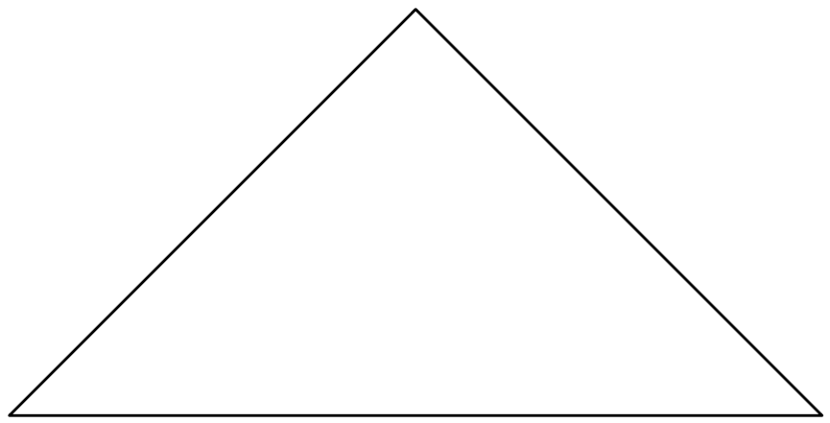Feasibilityê

Hazards Impact