Develop a Community Engagement Plan

Activity1: Determine the scope of engagement

**Objectives:**Determine how and in what ways community members will be engaged in the ERB process. ​

**Why:**  Before reaching out more broadly in your community, consider the type of engagement that is appropriate for your project. Different types of engagement have different levels of involvement by community members and different expectations for the impact of that involvement on decision making, as shown in table to the right. More intensive engagement may require more time and effort, however, that effort can pay off with improved trust and relationships and more actionable results.  ​

**Who:** Core team

​

**Time needed:** 2 hour session​

**Materials needed:** Community Connections Table, Community Connections Diagram

**Directions:**

1. Bring the core team together. Refer to the figure below that illustrates the different goals of engagement. You will use this figure to determine your goals of engagement for each group/individual you plan to engage.

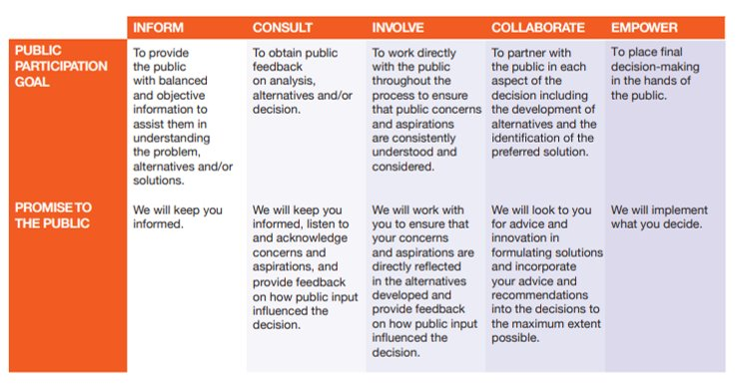

 International Association for Public Participation. 2021. IAP2 Spectrum. ​

1. Discuss specific considerations of underrepresented groups in your community and how you might invite them to the table. In particular, think about groups in your community that might be exposed to greater risks from hazards and threats. Record notes from this discussion.  ​

3. Next, look through the ERB activities associated with the opportunities for engagement listed in the table below. (We’ve filled out the table below to provide an example.) Consider your team’s engagement goals and determine how each audience will be engaged throughout the ERB process. Go back to your Community Connections Table and fill out column “E,” noting what type of engagement you will carry out. Include which audiences will be informed, consulted, and invited to participate in the activity.

|  |  |  |  |
| --- | --- | --- | --- |
| Opportunities for Engagement | Key Participants | Important Actors | Public |
| Chapter 3: Hazards, Disasters, and Threats Storytelling Activity | Collaborate on preparation for workshop, invited to participate, consulted on feedback | Invited to participate, consulted on feedback | Invited to participate |
| Chapter 3: Mapping Vulnerabilities | Invited to participate | Informed on progress |  |
| Chapter 3: Social Vulnerability Assessment | Invited to participate | Informed on progress |  |
| Chapter 4: Indicator Analysis Workshop | Invited to participate | Consulted on feedback | Informed on progress |
| Chapter 5: Action Planning Workshop | Collaborate on preparation for workshop, invited to participate, consulted on feedback | Invited to participate | Consulted on feedback |

* For example, key participants may be invited to all the activities, updated on the planning processes, and consulted for feedback throughout the process. Key stakeholders may include actors like the mayor, leaders of trusted organizations, or other stakeholders heavily involved in resilience planning. Important actors may be consulted or updated throughout the process more than the public, but it isn’t feasible to invite all actors to participate in all the workshops. The audience levels are a suggestion and can be adapted for your community. ​
* Try to plan some engagement activities that go beyond a town hall or public meeting. Examples are:
  + Have an info booth at a local store/restaurant
  + Create an “open office hour” at a local café or coffee shop where community members can sit and talk with you informally
  + Give a talk at a local school and encourage students to ask questions

4. Establish norms for community empowerment. Discuss what steps the team can take to ensure that participants are empowered to participate, and their decisions can be implemented. Take notes on this discussion and use these norms to inform your plan in the next activity below.

​

**Activity 2: Write the plan**​

**Objectives:** Plan the preparation, execution, and reflection necessary for the community engagement activities.

**Why:**  Planning your engagement strategy ahead of time can ensure that you continually and effectively build relationships with your community. Having a plan helps you to center equity and empowerment at the heart of your approach.

**Who:** Core team

​

**Time needed:** 2-3 hour session​

**Materials needed:** Community Connections Table, Community Connections Diagram

**Directions:** Refer to your Community Connections Table, Community Connections Diagram and discussion notes thus far. Fill out the community engagement plan below. (We’ve provided an example row already filled out.) When planning, consider:​

​

* How you will invite and communicate with participants (utilizing multiple outreach methods for best results)​
* Accommodations to help participants overcome potential barriers (childcare, transportation, internet access, etc)​
* Scheduling the activity and sending invitations, as well as scheduling pre-planning and reflection sessions with the core team. ​
* Preparing for the tangible needs of the activity (materials, financial, meeting space)​

|  |  |  |  |  |  |  |  |  |
| --- | --- | --- | --- | --- | --- | --- | --- | --- |
| Engagement Activity | Time allotted: | Date: | Audience(s) invited: | Venue Details | Accommodations | Materials and Budget | Communication Plan: | Timeline (include pre-planning and reflection) |
| Example: Chapter 3: Hazards, Disasters, and Threats Storytelling Activity | 4 hours | 12/1 | Public | City Hall | -Translators for Spanish and ASL  -Childcare provided  -Printed agenda and instructions | -Sticky notes, whiteboard, templates printed  -$XX for translation and childcare | 10/1- Announcement on social media  10/1- Post on Nextdoor Facebook group  10/1- Distribute flyer to key stakeholders and important actors  10/15- Speak at XYZ meeting and invite participants  11/15- Reminder post on social media | 9/1- Initial meeting to plan communications and prepare workshop objectives (Core team + key participants)  11/15- Meeting to complete Ch 3 step 1 and 2 (core team and key participants)  12/1- Public Workshop  12/3-Reflection meeting (core team + key participants), feedback form sent to important actors |
| Chapter 3: Hazards, Disasters, and Threats Storytelling Activity |  |  |  |  |  |  |  |  |
| Chapter 3: Mapping Vulnerabilities |  |  |  |  |  |  |  |  |
| Chapter 3: Social Vulnerability Assessment |  |  |  |  |  |  |  |  |
| Chapter 4: Indicator Analysis Workshop |  |  |  |  |  |  |  |  |
| Chapter 5: Action Planning Workshop |  |  |  |  |  |  |  |  |