**Equitable Resilience Concepts Worksheet**

As planners and practitioners prepare for increased environmental hazards and climate risks, care must be taken to ensure that adaptation and resilience measures do not inadvertently add to disproportionate burdens. Local leaders are increasingly recognizing that deliberate attention to rectifying historic inequities is required to improve adaptive capacity and support *equitable resilience.*

**Equitable resilience** describes the capacity to withstand, respond, adapt, and transform in the face of climate change and disasters in ways that are culturally appropriate, participatory, and enhances the resilience of the *community,* not just individual resilience. Equitable resilience acknowledges deeply rooted social forces that affect how community members are made vulnerable to disaster and climate risk, may experience cascading consequences of incidents, and bear disproportionate benefits burdens of actions to increase resilience.

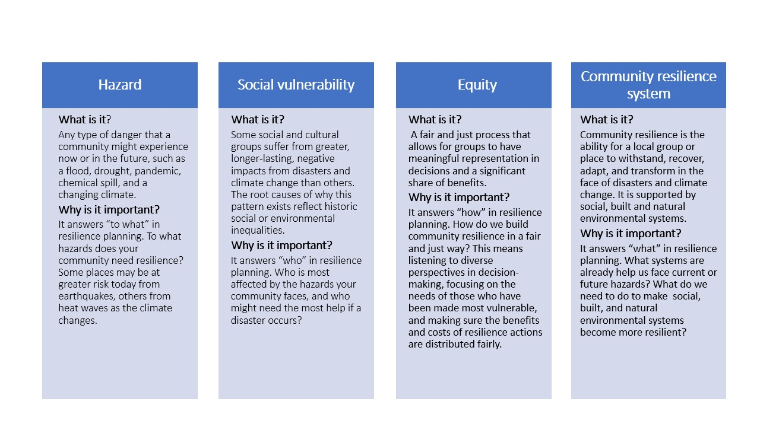

**Chapter 3 & 4 ERB activities, outputs, and impacts on community resilience**

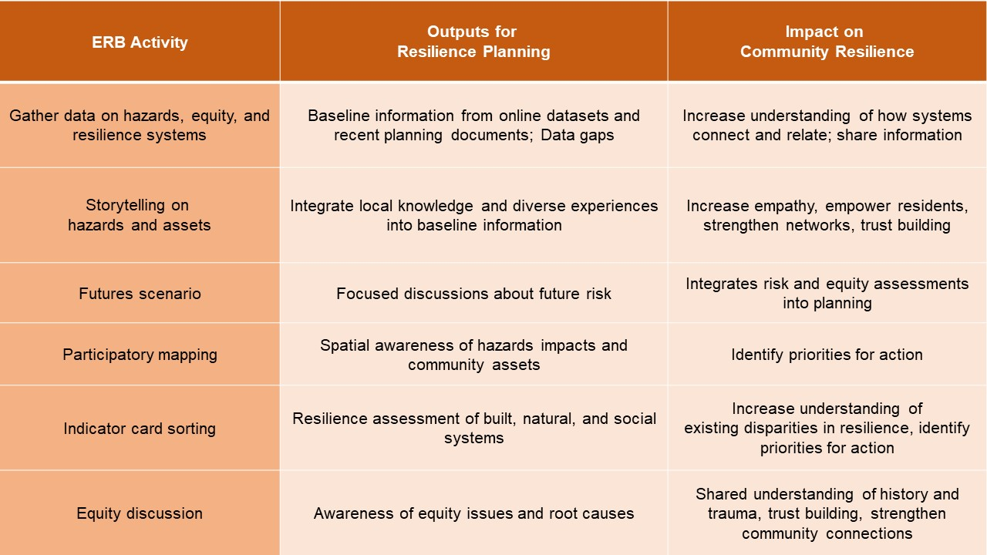

**How do communities benefit from using the ERB tool?**

* ***Relationships***​
  + A stronger network of community organizations and agencies to share information and resources​
* ***Recognition***​
  + Facilitation guides for holding workshops in trauma-informed ways​
  + Activity guides for soliciting community perspectives​
  + Local knowledge is valued and utilized alongside scientific data​
* ***Information***​
  + Data and maps on hazards, equity, and resilient community systems​
  + Locally meaningful and measurable indicators to measure future change in built, natural, and social environment systems​
* ***Action***​
* A collaboratively prioritized set of actions and next steps for strengthening community resilience in an equitable way

**Equitable Resilience Builder focuses on three systems**

