**Indicator Cards Template**

Before the community workshop, the core team will need to integrate the indicator data gathered into printable indicator cards.​ The indicators for each system can be used to assess how well that system is doing relative to its potential for supporting equitable resilience.​

**Prepare an indicator card** for each indicator selected based on the template below.  Print out completed indicator cards to use in the community workshop card sorting activity.​

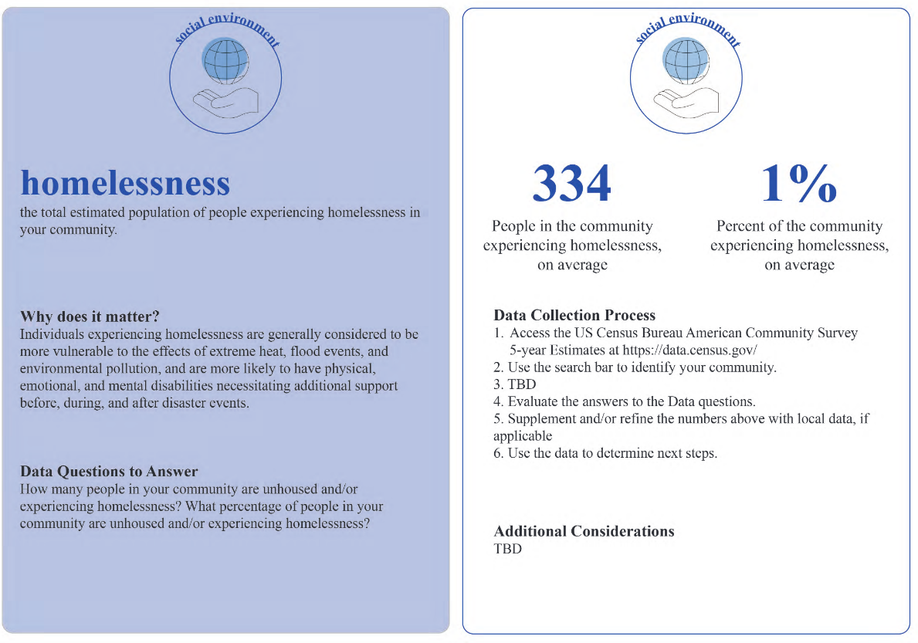

​

**Where to get the information for each indicator card?**Some indicators may have an existing dataset you can link to, while others you may need to consult with a representative of a municipal, county, or state agency. ​You can find recommended data sources and the full list of indicators on the **Master Indicators List.**