**Chapter 4 instructions for assessing equity and resilience in your community**

Let’s dig into your community’s resilience and equity!

In this chapter, your core team and community constituencies will work with a set of indicators to assess how resilient and equitable community’s built, natural, and social support systems currently are.

When you finish, you will have reviewed and sorted indicators by their relative resilience and equity, producing a 4-quadrant diagram. This information will help you identify your community's greatest needs for equitable actions to build resilience to hazards and disasters.  In Chapter 5, you will use the results of this assessment to identify and prioritize the most urgent areas for action.

**Objectives:**

* + Assess how resilient and equitable your community's built, natural, and social environment systems are to disasters and climate change, using key indicators.
  + Convene discussions about equitable resilience with your core team and community constituencies.

**Who?** The project core team and any additional community members. If you have any questions about who to invite, refer to Chapter 2 (network analysis).

**Where: In person** or virtual meetings

**Time needed**:

1. Kickoff meeting with the core team and community members to discuss Chapter 4 objectives and select indicators that are relevant to where you live (2 hours for meeting).
2. Prepare for the indicators workshop. Gather data and information to help you complete the indicator cards for each selected indicator (hours may vary).
3. Host indicators workshop where you will sort indicators by their relative resilience and equity into a 4-quadrant diagram and discuss the results of the assessment (2 hours for the workshop).
4. Reflect on the workshop accomplishments and discuss next steps (1 hour).

**Materials will you need:** easel pad, sticky notes, and markers (alt: whiteboard and dry erase pens, virtual whiteboard); Chapter 2 network analysis; printed (individual) indicator cards; large posterboard to create 4-quadrant diagram.

**Steps:**

1. Kickoff meeting to review and select built, natural, and social environment indicators that are relevant to your community.
2. Prepare for the indicators workshop and gather indicator data.
3. Host the indicators workshop.
4. Reflect on the workshop accomplishments and discuss next steps.

**Step 1. Kickoff meeting to review and select built, natural, and social environment indicators that are relevant to your community.**

1. **Review the indicators for each system and topic** listed here (indicators workbook). Print out or share the workbook with your core team.
2. **Core team holds kickoff meeting** to discuss objectives for Chapter 4 and reflect on any concerns expressed in Chapter 3 (for certain population groups or particular HDTs). Select indicators from the workbook to use to assess how resilient and equitable the community’s built, natural, and social support systems are. Review the list of recommended indicators for each system and topic. Select the indicators that are most relevant for your community. Refer to your resilience goals from Ch. 1 if you’re having difficulty deciding. Please note the following:
   1. In the[indicators workbook](https://teams.microsoft.com/l/file/82F0B8A7-FB6C-4919-95B3-8BCAD99085F0?tenantId=88b378b3-6748-4867-acf9-76aacbeca6a7&fileType=xlsx&objectUrl=https%3A%2F%2Fusepa.sharepoint.com%2Fsites%2FMETRO-CERIResilienceandsocialvulnerabilityteam%2FShared%20Documents%2FHCD%2FERB%20chapter%20content%2FERB%20Chapter4_Indicators%20Workbook_Template_Draft_13Dec2021.xlsx&baseUrl=https%3A%2F%2Fusepa.sharepoint.com%2Fsites%2FMETRO-CERIResilienceandsocialvulnerabilityteam&serviceName=teams&threadId=19:25b46df5ad8d4428902bd6a4f8c2c1c1@thread.skype&groupId=a0311f5e-b32f-4504-a8ca-129e1d2e365c), there are about 10 to 15 indicators per topic that represent important aspects of an equitable, resilient community (reflected in the functional statements listed in the workbook).
   2. Consider these questions when selecting indicators:

Is the indicator relevant to a hazard your community faces?

Does the indicator reflect an equity priority in your community?

1. **Assign responsibilities among your core team for collecting data and information for each indicator**. Establish a date for gathering this information, allowing enough time for any data preparation ahead of the indicators workshop. Each indicator card has an “indicator question” and suggested data sources, which range from asking the local recreation department to examining U.S. census data. On each card, the assigned core team member should fill in an answer to the indicator question and identify the data source(s). If available, the core team member should gather the data in preparation for the workshop.
2. **Optional!** If there’s anything you want to know that is not represented by the recommended indicators in the workbook, feel free to add indicators that are especially relevant for your situation. Note: When adding an additional indicator, be sure that it represents key aspects of the resilience of the system as realistically and objectively as possible (refer back to the functional statements). Being as transparent as possible will help build trust within the community. Selecting indicators that only yield a positive or negative picture of resilience will undermine the confidence in the results. If you identify any critical gaps, please note them in the Data Parking Lot to consider addressing in the future.

*For more information:

***What are indicators of equitable resilience?***

*Indicators are pieces of information that measure the state of a community, nation, waterway, or other system. They give insights into conditions (past, present, future) that help you make a decision about what to do.*

*The indicators in this chapter cover built, natural, and social environment systems in a community. Each system contains several topics (e.g., food, water, shelter; waste management; energy and fuel). There are also two topics that cut across systems (equity, governance and planning). For each topic, we provide a description about what resilience looks like (functional statement), which serves as the reference point for measuring resilience. To learn more how scientists developed the indicators, click here.*

|  |  |  |
| --- | --- | --- |
| **Built Environment** | **Natural Environment** | **Social Environment** |
| Food, water, shelter | Air, Water, and Soil | Society & Culture |
| Waste Management | Biodiversity | Economy |
| Energy and Fuel |  | Health & Well-being |
| Information and Communications |  |  |
| Transportation |  |  |
| Cross-cutting issues | | |
| Equity | | |
| Governance and planning | | |

**Step 2. Prepare for the indicators workshop**

1. **Core team plans the indicators workshop** to identify and invite key community members who will engage in sorting the selected indicators to classify their degree of resilience and equity for the community.
2. **Before the workshop, gather indicator information and data. Fill in and print out completed indicators cards** for workshop participants to use. Plan for breakout groups based on expertise. See What to expect with indicator cards (below).

*For more information:

***What to expect with indicator cards***

*The indicators for each sector can be used to assess how well that sector is doing relative to its potential for supporting equitable resilience (which we call a sector’s functional statement).*

*Prepare an indicator card for each indicator selected in Step 1. Print out completed indicator cards to use in the workshop you hold in Step 3.*

***Where to get the information for each indicator card?*** *Some indicators may have an existing dataset you can link to, while others you may need to consult with a representative of a municipal, county, or state agency.*

*For the full list of indicators, refer to the* ***indicators workbook****.*

*Indicator Card Example:*

Indicator of: Sense of Belonging

Question to Answer: Each neighborhood has a community gathering space (e.g., recreation center, library, plaza, playground)

Your answer: ____________

Where to look for data: ___________

System: Social Environment

Sector: Society and Culture

Functional statement: A resilient society is one in which people are connected, included, respected, supported, and cultures are valued.

**Step 3. Hold the indicators workshop**

1. **At the workshop, divide into breakout groups for each system (or topic) depending on how many people you have. Have the breakout groups sort the indicator cards** into Least Resilient, Moderately Resilient, and Most Resilient. Next, within each category, order the cards from Least Equitable to Moderately Equitable to Highly Equitable.

*Think back to Chp. 3 stories:*

* *In what aspects/areas did you hear about least/greatest resiliency?*
* *In what aspects/areas did you hear about least/greatest equity?*
* *How might these stories change/inform your indicator sorting?*

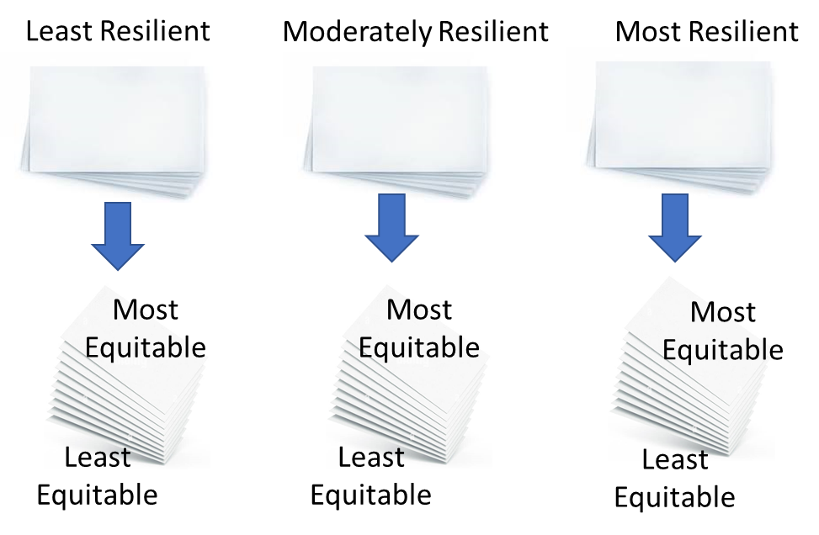

2. **Lay your cards on the table**

Have each breakout group take the indicator cards they sorted and lay them on the table. Divide each group’s posterboard into four quadrants (see depiction below), placing the indicator cards into quadrant positions based on their relative degree of resilience and equity in their community. The quadrants are: **(a)** more resilient and more equitable, **(b)** less resilient and less equitable, **(c)** more resilient and less equitable, **(d)** less resilient and more equitable. This allows you to visually compare across systems and topics.

Interact with the visualization to explore patterns. What are the most and least equitable sectors? Which hazards appear to have the most impact? Where are potential problem areas and where are we doing well?

As time permits, breakout groups can rotate to review and provide feedback to other breakout groups on their placement of cards.

Use this visualization and your discussion to **identify 4-5 topics as potential action areas to discuss further in Chapter 5.** 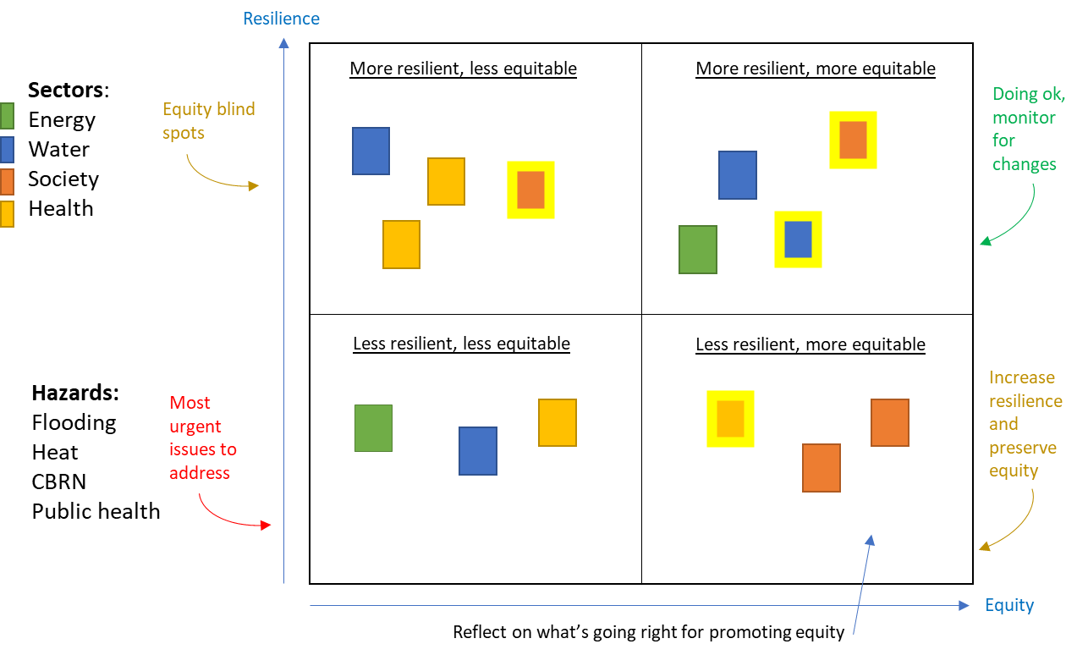

**Step 4. Reflect on the workshop accomplishments and discuss next steps**

Congrats, you made it to the end of Chapter 4!

Take a minute to think about what you accomplished in this chapter:

* Selected which indicators to use
* Gathered data and answered indicator questions
* Collectively identified where your community is doing well, and where systems could use some help

Possible next steps

* Discuss the 4-quadrant diagram with your team, note any surprises or insights
* Share the results of the resilience assessment using your communications plan developed in Chapter 2

Now you’re ready for the next and final chapter – Taking Action!