Diagram Community Connections

**Purpose**

Use this activity to create a diagram of the social connections in your community at a moment in time. The diagram will help you identify where trust might already exist and where it needs to strengthen, as well as the flow of information and resources.

**What You Will Need**

**Who:** core team

**Where:** in-person or virtual meeting

**How long will it take:** 1-2 hours

**Materials:** white board or paper, and any already existing lists of stakeholders/community groups/contacts, or your recently completed Community Connections Table

**Directions**

1. Take the actors from the *Community Connections Table*, or any previously existing list of contacts/key informants/stakeholders you might have and write them on your white board or paper in circles. Each actor is in its own circle. Use different colors for each circle according to the sectors they belong to (e.g., government, non-governmental agency (NGO), religious group). They can have more than one colored circle. ​**Don’t forget to add your agency/group as an actor!**
2. Draw arrows between the actors that often communicate with each other, share/give resources, and/or collaborate on projects. Point the arrows in the direction of each type of flow; use a two-way arrow to indicate two-way communication or other type of bi-directional relationship. You might also use different colors of arrows to indicate different types of flows (e.g., red for information flows, black for resource flows).
3. Once your team has finished adding actors and arrows, reflect and discuss the patterns you see in what you’ve drawn.

* Which actors have the most connections? What types of connections are they (e.g., resources, communication)?
* Are there any actors that are central in your diagram?
* Which actors are currently disconnected from other actors? Why might that be?
* Are any actors missing?
* Do you see any patterns related to the type of actor (more of one color circle than others)?

1. Discuss how your community connection diagram can help you target certain groups for engagement, and which connections might need more attention.

* How could you connect with groups that are currently disconnected? ​
* Which groups might be the hardest to reach?
* Are there certain actors that can help build more connections? How can you partner with them or bring them into the ERB process?

**Example**

See below for an example diagram for your reference.

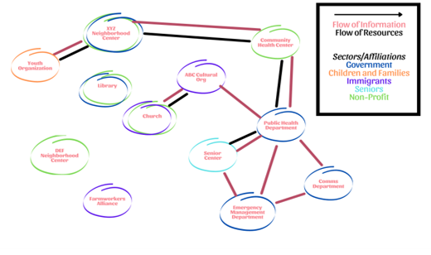

**What to Do Next**

Apply the conclusions you discussed in this activity to generate your community engagement plan (the next activity). You might want to add to the diagram as you progress through the rest of the ERB process, to show new connections that have built through resilience planning.