**Indicator Activity Instructions**

## Purpose

To assess which indicators are most or least resilient and most or least equitable, and where systems and topics fall on resilience and equity continuums.

## What you will need

**Who:** workshop participants, facilitators

**Where:** in-person or virtual workshop

**How long will it take:** 1-2 hours

**Materials:** completed indicator cards (printed or virtual, see instructions on the “Read Me” tab of the Indicator List spreadsheet to prepare cards), large tables (in-person)

*Note: We recommend that teams begin with a small set of indicators the first time using the ERB tool. This initial set of indicators should be selected based on topics brought up in previous community storytelling exercises. Indicators can be added at any time as capacity to address new topics emerges.*

## Instructions

**In-person workshop:**

1. **(Core team)**: Present the indicator cards you chose to assess your community’s resilience and equity. Run through the data and information on each card to make sure the participants understand the indicator and what it represents within their community. Make sure participants know they do not have to use the qualitative and quantitative components of each indicator. They can choose what to use based on capacity and information available to them – e.g., they could use just the qualitative component, if that's all that is available.
2. **(Community members):** Divide into breakout groups for each of the resilience systems (built, natural, and social). Make sure the indicator cards in your group correspond to the same resilience system.
3. **(Breakout groups)**: As a group, arrange cards along a horizontal line for least to most resilient as shown in the image below.
   1. Less resilient: Very vulnerable/susceptible to damage or disruption and would likely take a long time to recover from a shock.
   2. More resilient: Minimally vulnerable/susceptible to damage or disruption and would likely be able to withstand shocks or recover quickly.

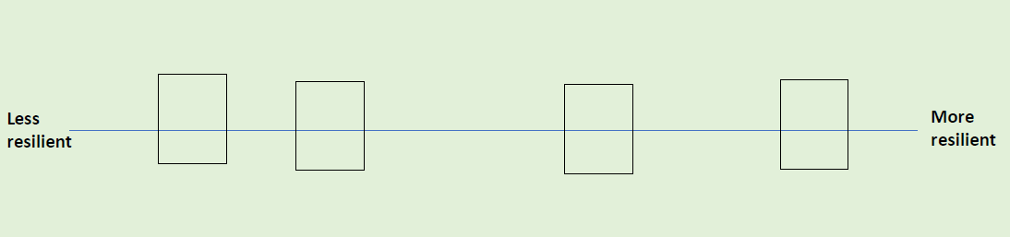

Indicator Diagram with Cards Sorted by Resilience: An example of how the indicator cards should be sorted horizontally from less resilient to more resilient.

1. **(Breakout groups)**: Now as a group, move the cards you just placed on the resilience line up or down to indicate how equitable each indicator is as shown in the image below.
   1. Less equitable: There are substantial differences in how different groups of people or neighborhoods are affected by this indicator which cause greater harm or risks for some groups.
   2. More equitable: There are minimal differences in how different groups of people or neighborhoods are affected by this indicator or if there are differences, they do not cause greater harm or risk for a particular group.
   3. Example: For the indicator “Number of homes in FEMA floodplain”, there could be a low number of homes in floodplains (more resilient), but the homes in the floodplains belong to low-income families or persons over 65 (less equitable).

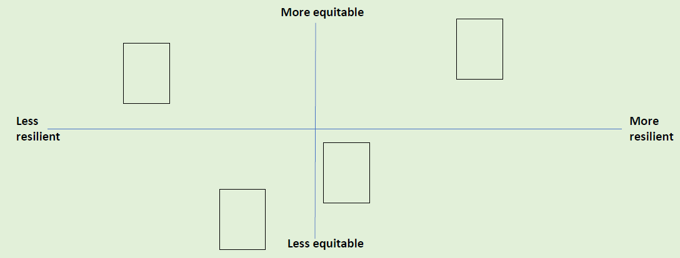

Indicator Diagram with Cards Sorted by Equity: An example of how the indicator cards should be sorted vertically from less equitable to more equitable after sorted based on resilience.

1. **(Core team)**: Have each breakout group share their results and discuss as a group the patterns you see. This can be done with tape or sticky notes on a wall, projector, or table. Draw squares around the 4 quadrants on the board and add labels as in the example below.

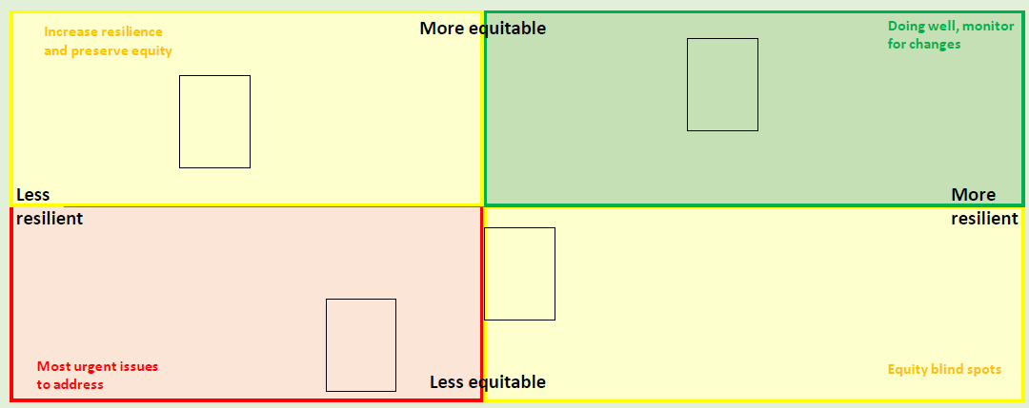

*Indicator Diagram with Cards in Quadrants: An example of fully sorted indicator cards from all systems. Quadrants are labeled as a group after breakout groups have sorted their cards.*

## Large group discussion prompts

1. Which quadrants have the most cards? Do you feel this is an accurate picture of the overall resilience and equity of the community?
2. Are there certain systems that show up more often as more or less resilient, or more or less equitable?
3. Are there certain hazards that present a greater risk for the community than others? Are there certain systems that are more vulnerable to specific hazards (as discussed during the hazard mapping activity)?

**Virtual workshop:**

*All participants call into a single virtual meeting space (such as Zoom or Teams). Ideally, all participants have the ability to turn on their cameras and microphones to join in group active, real-time discussion. One core team member has the ERB Tool open on their computer and is in charge of following all instructions below directed at working in the tool in real-time while participants observe.*

1. Share your screen with workshop participants and display the Indicator Resilience Ranking page of the ERB Tool (this page is found by navigating through the indicator selection process from the Indicator Center).
2. Present each indicator card that you chose to assess your community’s resilience and equity to the group assembled online. Click on each indicator card on the left to display more information; run through the data and information on each card to make sure the participants understand the indicator and what it represents within their community.

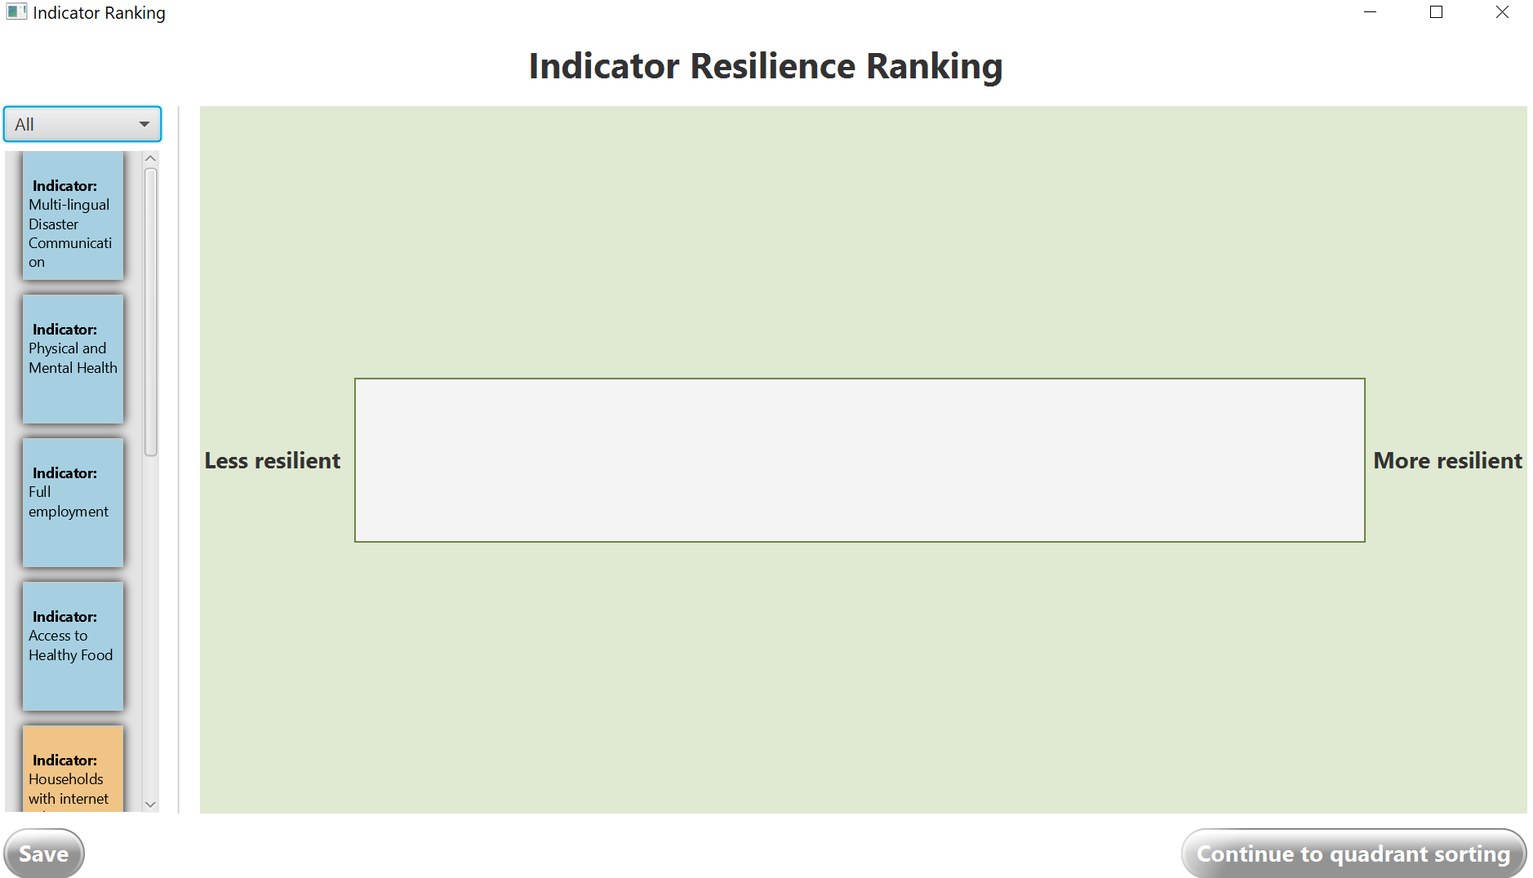

View of the Indicator Resilience Ranking activity page in the ERB Tool

1. Facilitate a discussion with workshop participants to hear about their views on each indicator. Ask them where they would place each card along a spectrum from more to less resilient. Begin placing the cards on the ERB Tool Indicator Resilience Ranking page in response to participant comments by dragging-and-dropping cards from the lefthand side of the screen into the white box to the right. As a group, arrange cards along a horizontal line from least to most resilient as shown in the image below.
   1. Less resilient: Very vulnerable/susceptible to damage or disruption and would likely take a long time to recover from a shock.
   2. More resilient: Minimally vulnerable/susceptible to damage or disruption and would likely be able to withstand shocks or recover quickly.

**NOTE:** *Cards can only be ranked relative to one another and cannot occupy the same spot on the spectrum in this part of the exercise. In the next exercise, cards can be adjusted to more accurately reflect their resilience ranking in need be.*

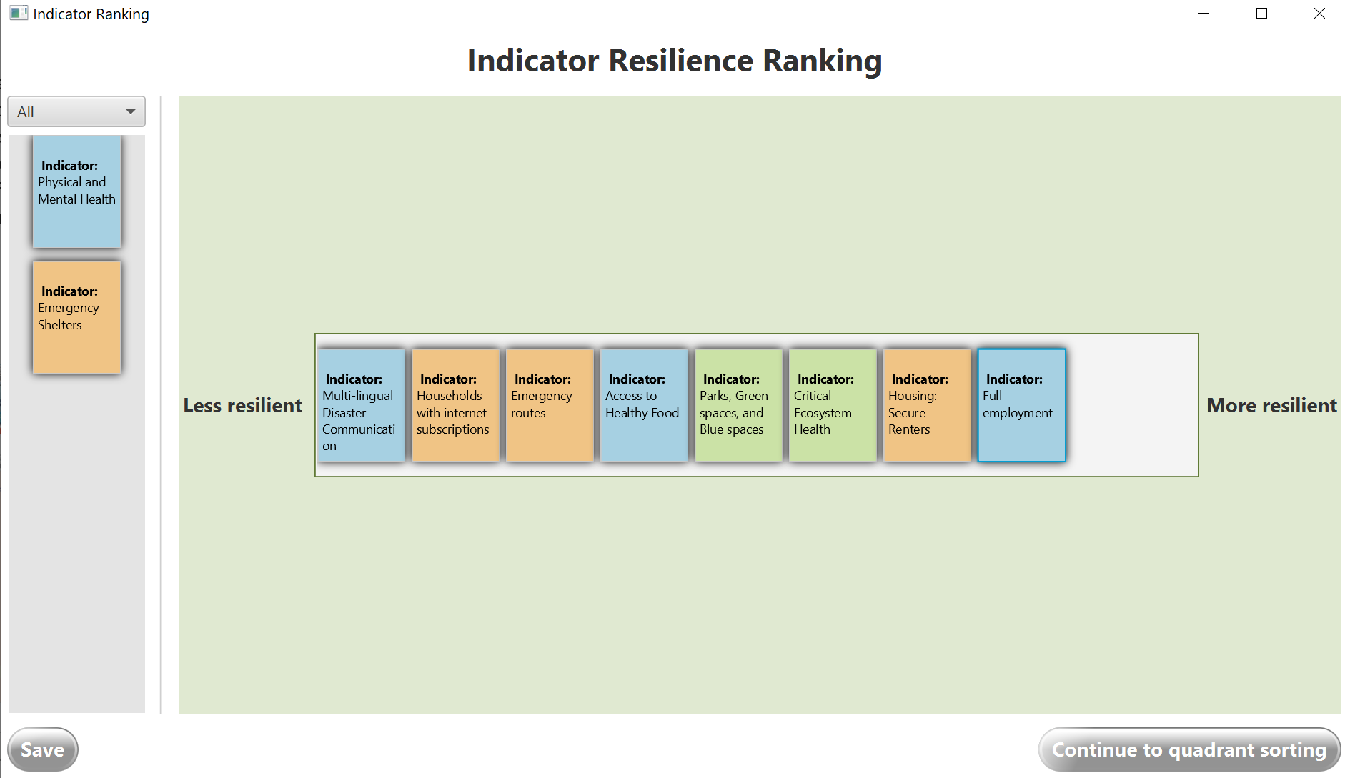

Indicator Diagram with Cards Sorted by Resilience: An example of how the indicator cards could be sorted horizontally from less resilient to more resilient.

1. Once there is consensus regarding the ranking of each indicator card, click the “Continue to quadrant sorting” button at the bottom of your screen.

**NOTE:** *Some cards may not be sorted because they are not of interest to the group; only cards that are dragged over to the resilience spectrum will be brought into the next part of the exercise.*

1. Now, as a group, begin to discuss how equitable each indicator is in your community. It may be helpful to review and re-read the “Local Concerns” section of each card to the group to begin this discussion. Drag-and drop cards from the top of the page to the grey boxes below to correspond with the comments of the participants.
   1. Less equitable: There are substantial differences in how different groups of people or neighborhoods are affected by this indicator which cause greater harm or risks for some groups.
   2. More equitable: There are minimal differences in how different groups of people or neighborhoods are affected by this indicator or if there are differences, they do not cause greater harm or risk for a particular group.
   3. Example: For the indicator “Number of homes in FEMA floodplain”, there could be a low number of homes in floodplains (more resilient), but the homes in the floodplains belong only to low-income families or persons over 65 (less equitable).

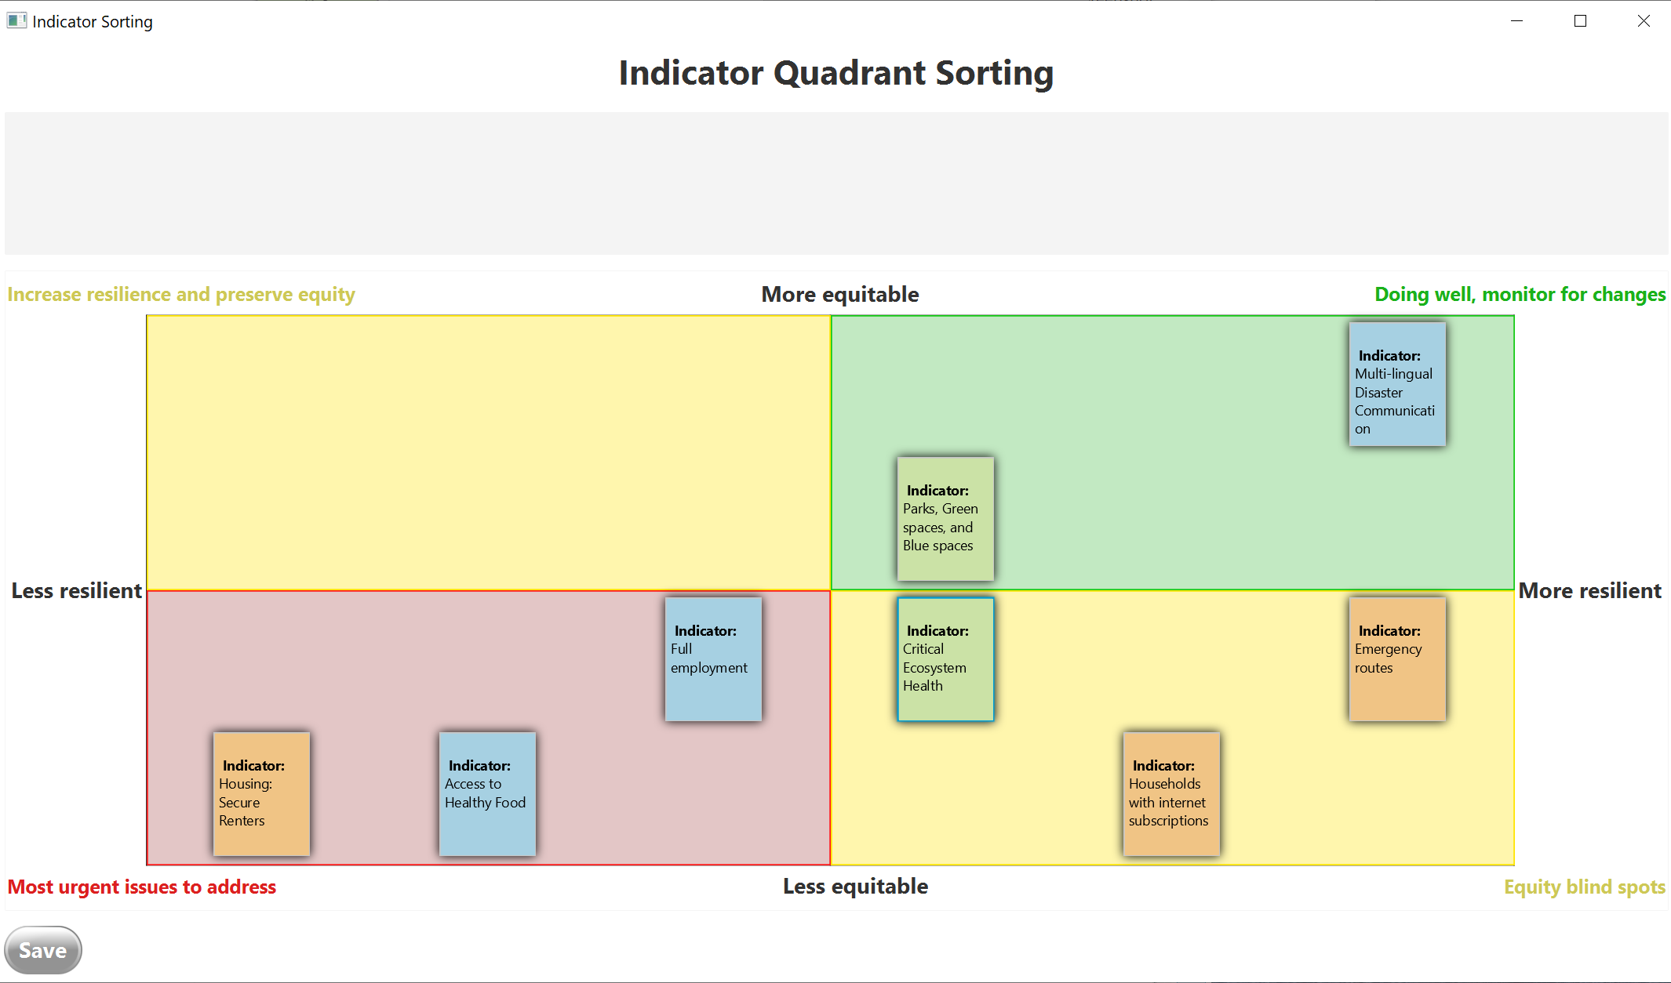

Indicator Diagram with Cards Sorted by Equity: An example of how the indicator cards will appear after sorting vertically from less equitable to more equitable (after sorting based on resilience.)

1. Next, examine each of the 4 quadrants of cards separately (2 yellow, 1 green, and 1 red quadrant). Use the large group discussion prompts listed in the next section to facilitate a discussion with participants about what each of these quadrants means for actions moving forward. As a group, discuss and write down a unique label for each quadrant that has local relevance.

## Large group discussion prompts

1. Which quadrants have the most cards? Do you feel this is an accurate picture of the overall resilience and equity of the community?
2. Are there certain systems that show up more often as more or less resilient, or more or less equitable?
3. Are there certain hazards that present a greater risk for the community than others? Are there certain systems that are more vulnerable to specific hazards (as discussed during the hazard mapping activity)?

## What to do next

Return to the ERB tool and use the discussion notes from this activity to answer Questions 7 and 8 on the “Key Takeaways: Assess” form. Then, move on to the next activity in the workshop: Equity Discussion.