Equitable Resilience Handout

## Purpose

As planners and practitioners prepare for increased environmental hazards and climate risks, care must be taken to ensure that adaptation and resilience measures do not inadvertently add to disproportionate burdens. Local leaders are increasingly recognizing that deliberate attention to rectifying historic inequities is required to improve adaptive capacity and support equitable resilience.

## Definitions and Importance

## Equitable resilience describes the capacity to withstand, respond, adapt, and transform in the face of climate change and disasters in ways that are culturally appropriate, participatory, and enhances the resilience of the community, not just individual resilience. Equitable resilience acknowledges deeply rooted social forces that affect how community members are made vulnerable to disaster and climate risk, may experience cascading consequences of incidents, and bear disproportionate benefits burdens of actions to increase resilience.

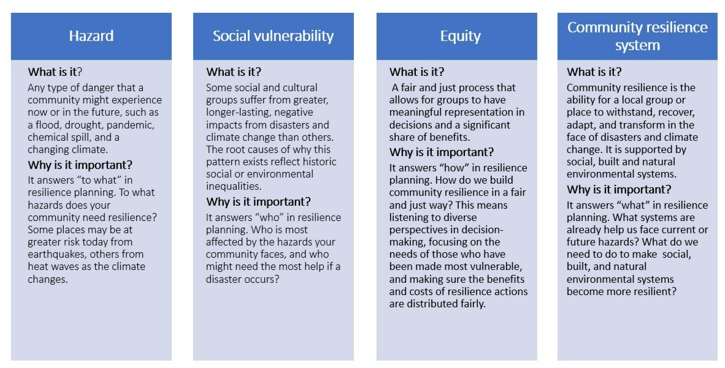

*Key Terms: Definitions of key terms (hazard, social vulnerability, equity, and community resilience system) which are used in the ERB process.*

**ERB Activity Table: Chapter 3 and 4 ERB activities, outputs, and impacts for community resilience**

|  |  |  |
| --- | --- | --- |
| **ERB Activity** | **Outputs for Resilience Planning** | **Community Building Around Resilience** |
| **Gather data on hazards, equity, and resilience systems** | Baseline information from online datasets and recent planning documents; close data gaps | Increase understanding of how systems connect and relate; share information |
| **Storytelling on**  **hazards and assets** | Integrate local knowledge and diverse experiences into baseline information | Empower residents, strengthen networks, build empathy and trust |
| **Futures scenario** | Focused discussions about future risks people might not have thought about | Integrate risk and equity assessments into planning |
| **Participatory mapping** | Spatial awareness of hazard impacts and community assets, integrate local knowledge and diverse experiences into baseline information | Identify priorities for action |
| **Indicator card sorting** | Resilience assessment of built, natural, and social systems, including existing disparities, integrate local knowledge into baseline information | Empower residents, identify priorities for action |
| **Equity discussion** | Awareness of root causes for who might experience hazards differently, how and why, and equity considerations to address when designing resilience actions | Shared understanding of history and trauma, trust building, strengthen community connections, identify priorities for action |

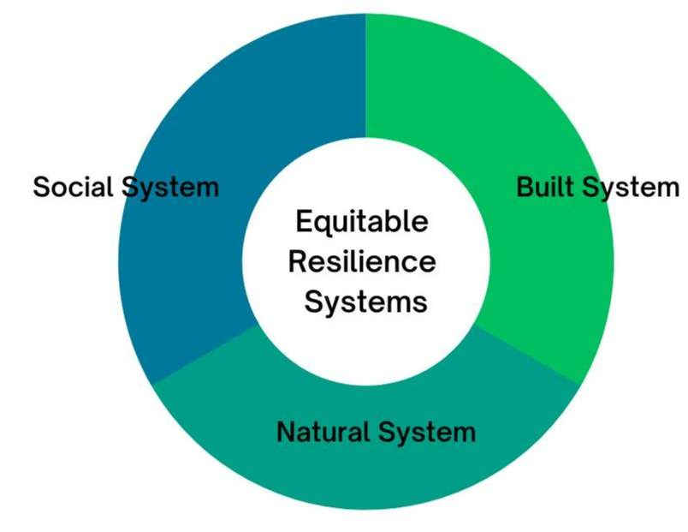  
*Equitable Resilience Systems: The three resilience systems (social, built, and natural) that the ERB focuses on.*

## How do communities benefit from the tool?

* Relationships: A stronger network of community organizations and agencies to share information and resources
* Recognition: Facilitation guides for holding workshops in trauma-informed ways, activity guides for soliciting community perspectives, and local knowledge is valued and utilized alongside scientific data
* Information: Data and maps on hazards, equity, and resilient community systems, and locally meaningful and measurable indicators to measure future change in built, natural, and social environment systems
* Action: A collaboratively prioritized set of actions and next steps for strengthening community resilience in an equitable way