Empirical Evaluation of *In Vitro* Disposition Models

Meredith Scherer, Madison Feshuk, Katie Paul Friedman, John Wambaugh

Likely: Jon Arnot, James Armitage, Nynke Kramer

Target Journal: Environmental Science & Technology? (would need to combine results and discussion section)

# ****Abstract:­­****

Cell-based *in vitro* chemical toxicology observes cellular perturbations caused by increasing the concentration of test chemical. The aim of toxicological *in vitro* to *in vivo* extrapolation (IVIVE) is to predict whole animal effects from perturbations observed *in vitro*. However, reliance on the nominal concentration of chemical introduced *in vitro* can result in an inaccurate estimate of the dose causing any perturbations that might be observed. This is because nominal (tested) concentration does not account for chemical distribution. Binding can occur between the test compound and other, non-cellular, elements of the *in vitro* assay system. These elements include the cell culture media and the walls of the test well. Distribution of chemical to non-cellular elements of the *in vitro* assay system reduces the free concentration available to cause any observed cellular effect. However, there are limited experimental data available to characterize the difference between cellular and nominal concentration. 118 experimental intracellular concentration measurements of 28 chemicals, along with parameters describing measurement conditions, were curated from the scientific literature. Among the literature data, the median difference between nominal and cellular concentration was 10-fold, ranging between nominal concentration being 10-fold higher than cellular (Omeprazole) to cellular concentration being 268-fold higher than nominal (Tamoxifen). In the absence of measured cellular concentration there are mathematical, chemical property-based partitioning models for predicting cellular concentration. In this study we evaluated two of these *in vitro* disposition models: Armitage et al., 2014 and Kramer et al., 2010 using the experimentally derived intracellular concentration measurements. The Armitage model’s predictions were more accurate and precise (root mean squared log10 error or RMSLE = 1.48) than the Kramer model (RMSLE = 1.61). Among the chemicals examined, the Armitage model also had greater accuracy than using the nominal concentration (RMSLE = 2.58). Although limited by the amount of available measurement data, these results indicate that mathematical modeling of *in vitro* distribution may improve the accuracy of IVIVE.

# ****Introduction****

With 86,000+ chemicals currently listed in the Toxic Substances Control Act inventory and new ones being added every 6 months, chemical hazard characterization and risk assessment is a priority. To establish toxicity reference values, risk assessments require reliable methods with well-characterized uncertainty. Despite *in silico* advances, the majority of testing is being carried out in *in vivo* and *in vitro* systems.

The field of next generation risk assessment is moving away from *in vivo* animal testing (Coecke et al., 2013). One way that this is being accomplished is by using mathematical models to perform *in vitro* to *in vivo* extrapolation (IVIVE) to translate observed cellular responses to whole organisms (Wambaugh et al., 2015). IVIVE informs quantitative dose-response using mathematical modeling and in vitro bioactivity assay data.

It is the current practice that IVIVE studies use the in vitro nominal concentration as proxy for the free concentration in blood plasma. These two concentrations are not necessarily equivalent as chemical disposition within the assay reduces the free concentration (Blaauboer, 2010). In vitro disposition is an important part of IVIVE and refers to the way that a given chemical partitions within the in vitro system via binding to the plate wall, media, proteins, cells, and volatilization to air. The disposition of a chemical dictates the difference between the nominal and bioavailable chemical concentration that causes any observed effects. Chemical disposition varies across chemicals as a function of both inherent chemical properties and in vitro test conditions.

Given that *in vitro* bioactivity screening has been performed across large chemical libraries (for example, ToxCast and Tox21), there is a critical need to accurately predict *in vitro* disposition for many chemicals. There are several such models as described in Proenca et al, including the Armitage and Kramer models (2011, (Armitage et al., 2014), (Kramer, 2010)). These static models are designed for a cell monolayer in a culture media with or without serum. The chemicals can be volatile or not and both can handle neutral chemicals while Kramer is also designed to evaluate polar chemicals (Proença et al., 2021). The aim of this paper is to evaluate the accuracy and applicability of these two models.

# ****Methods****

**Models and data used in this analysis were added to** R package “httk” (Pearce, Setzer, Strope, et al., 2017) version 2.X.0, implemented in the free, open-source R statistical language (*R: A Language and Environment for Statistical Computing*). Supporting information including scripts for generating figures and data tables are available from Github at: <https://github.com/USEPA/comptox-expocast-invitrodist>

1. *In Vitro* Disposition Modeling

As shown in Figure 1, disposition of chemical to various elements of the in vitro test system can be considered. The concentration of chemical in each of these elements might be described mathematically as separate compartments. We consider two equilibrium, mass-balance models that assume that each compartment comes instantaneously to chemical equilibrium. Therefore, key parameters of the models are the equilibrium partition coefficients (that is the ratio of concentration in one compartment to another after sufficient time to reach equilibrium). The models make different assumptions about how physico-chemical properties relate to the equilibrium partition coefficients. Both models consider plastic, headspace, bovine serum albumin, and cell lipid. The first, from Kramer et al. (2010) also considers the Cfree in medium. The second, from Armitage et al. (2014) considers the following compartments in addition: serum lipid, dissolved organic matter, insoluble and soluble Cfree.

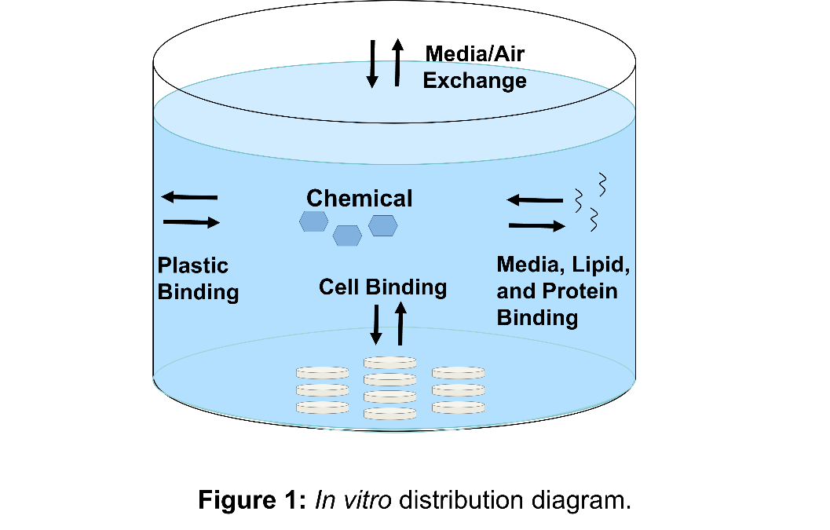

Both models have been implemented as part of the R package “httk” for high throughput in vitro-in vivo extrapolation. The Armitage et al. (2014) model was implemented in the function httk::armitage_eval() by Honda et al. (2018) (we thank James Armitage for providing a detailed, Microsoft Excel-based version of the model). The model in “httk” builds upon the Armitage et al. (2014) model with the addition of 1) updated cell composition to include water, bulk proteins, and storage and membrane lipids, 2) plastic vessel wall included in the mass balance equation, 3) alternate approach to estimate cellular membrane concentrations, and 4) well plate characterization values (e.g., surface areas, total well plate volumes, typical cell seeding densities and mass per cell) to improve parameterization accuracy. The Kramer et al. (2010) model was implemented in the function httk:kramer_eval() for this work (we thank Nynke Kramer for providing a R-based version of the model).

Both models have been modified to account for chemical ionization due to the advent of open-source prediction of ionization equilibria (that is, pKa) (Mansouri et al., 2019). We use httk:calc_ionization() (Pearce, Setzer, Davis, et al., 2017) to estimate the neutral fraction of chemical via the Henderson-Hasselbach equation (Po & Senozan, 2001). We then assume that only the neutral fraction of chemical in the in vitro system is available for partitioning into the compartments of the system. We note that Armitage et al. (2021) similarly updated the Armitage et al. (2010) model to account for chemical ionization.

1. Curation of data from the scientific literature

The available literature was evaluated to find studies that reported experimentally derived intracellular concentrations from *in vitro* tests. The requirements for data selection are as follows: 1) single exposure or only sampling points prior to the second dose used, 2) cell monolayers grown in a standard well plate (i.e. no transwell plates, sandwich layers, etc), 3) concentrations with significant cytotoxicity were omitted, and 4) if multiple samples were taken, only the final exposure was used (both models assume instantaneous equilibrium).

The chemicals identified and source data references are listed in Table 1. Much of this data was in the form of graphs, rather than raw data. WebPlotDigitizer (Drevon et al., 2017) was used to extract the numerical data from image files. Both the measured data and the parameters describing the test conditions such that corresponding predictions could be made with the IVD models are provided in Supplemental Table S1.

**Table 1.** Physicochemical properties of test chemicals and Ccell/Cnominal ratios from each reference.

|  |  |  |  |  |  |  |  |  |
| --- | --- | --- | --- | --- | --- | --- | --- | --- |
| **Compound** | **DTXSID** | **logP** | **Henry's Law** | **Ionization @ pH 7.4** | **pKa** | **Median Ccell:Cnom ratio** | **n** | **Reference** |
| 3-Methylcholanthrene | 0020862 | 5.97 | 1.07E-07 | Neutral | n/a | 80.50 | 1 | Steve Ferguson |
| Acetaminophen | 2020006 | 0.32 | 3.16E-10 | Acid | 9.4 | 0.80 | 3 | Dimitrijevic |
| 0.40 | 1 | Tox21 |
| Atrazine | 9020112 | 2.47 | 2.95E-09 | Base | 3.79 | 1.66 | 6 | Tox21 |
| Bisphenol A | 7020182 | 3.18 | 3.98E-11 | Acid | 9.46 | 16.87 | 2 | Dimitrijevic |
| Caffeine | 0020232 | -0.21 | 1.12E-11 | Base | 2.43 | 0.52 | 3 | Dimitrijevic |
| Chenodeoxycholic Acid | 2020260 | 2.87 | 1.58E-11 | Acid | 5.66 | 10.80 | 1 | Steve Ferguson |
| Colchicine | 5024845 | 1.16 | 1.20E-10 | Base | 7.16 | 3.03 | 3 | Dimitrijevic |
| Cyclosporine A | 0020365 | 2.78 | 9.77E-13 | Base | 7.08 | 9.18 | 4 | Bellwon 2015a |
| Fenarimol | 2032390 | 3.45 | 6.92E-09 | Acid | 1.04, 11.58 | 28.86 | 3 | Dimitrijevic |
| Flusilazole | 3024235 | 3.56 | 1.26E-08 | Acid | 2.32, 9.56 | 35.07 | 8 | Tox21 |
| Flutamide | 7032004 | 3.21 | 5.62E-07 | Acid | 8.15 | 5.48 | 3 | Dimitrijevic |
| Genistein | 5022308 | 2.82 | 4.07E-10 | Acid | 9.34 | 4.11 | 3 | Dimitrijevic |
| Ketoconazole | 7029879 | 4.21 | 5.01E-08 | Acid | 3.69,  6.75, 7.97 | 36.67 | 3 | Dimitrijevic |
| Methyltosterone | 1033664 | 3.22 | 3.39E-08 | Acid | 10.3 | 6.17 | 3 | Dimitrijevic |
| N-Phenyl-1,4-benzenediamine | 7025895 | 2.26 | 1.78E-11 | Base | 2.24 | 8.20 | 2 | Tox21 |
| Omeprazole | 6021080 | 2.09 | 6.31E-09 | Base | 2.41, 10.6 | 5.75 | 2 | Steve Ferguson |
| 2.33 | 4 | Tox21 |
| PBDE 153 | 4030047 | 7.76 | 1.62E-06 | Neutral | n/a | 31.99 | 4 | Kodavanti 2005 |
| PBDE 47 | 3030056 | 6.67 | 1.15E-05 | Neutral | n/a | 89.23 | 14 | Mundy 2004 |
| 34.95 | 4 | Kodavanti 2005 |
| PBDE 99 | 9030048 | 7.17 | 5.25E-06 | Neutral | n/a | 36.39 | 4 | Kodavanti 2005 |
| Phenobarbitol | 5021122 | 1.33 | 8.32E-13 | Acid | 7.71 | 6.45 | 1 | Steve Ferguson |
| Rifampicin | 6021244 | 2.99 | 1.05E-12 | Acid | 5.91, 6.90, 8.25, 9.87 | 8.06 | 6 | Steve Ferguson |
| 5.53 | 3 | Tox21 |
| Ritonavir | 1048627 | 3.76 | 6.76E-08 | Acid | 6.22 | 72.18 | 4 | Steve Ferguson |
| Rosiglitazone | 7037131 | 0.88 | 2.57E-09 | Acid | 5.91, 6.90,  8.25,  9.87 | 0.78 | 2 | Tox21 |
| Tamoxifen | 1034187 | 6.96 | 2.69E-06 | Base | 9.77 | 186.45 | 3 | Dimitrijevic |
| Thiacloprid | 7034961 | 1.12 | 9.77E-09 | Base | 0.75 | 2.35 | 6 | Tox21 |
| Trenbolone | 0034192 | 2.41 | 3.72E-10 | Acid | 11.28 | 3.37 | 3 | Dimitrijevic |
| Triphenyl phosphate | 1021952 | 4.45 | 1.00E-06 | Neutral | n/a | 60.88 | 6 | Tox21 |
| Warfarin | 5023742 | 2.56 | 3.39E-08 | Acid | 4.74 | 2.07 | 3 | Dimitrijevic |

1. Annotation of in vitro Assay Parameters

EPA’s toxicity forecaster (ToxCast) project is an ongoing high throughput in vitro screening project that has tested thousands of chemicals across more than a thousand assay-endpoint combinations (Feshuk et al., 2023) (Richard et al., 2016). Each in vitro assay potentially varies with respect to the parameters described by in vitro disposition models (Figure 1). For the ToxCast assays a table of in vitro disposition model parameters has been created (httk::invitro.assay.params) that is indexable by ToxCast assay-endpoint identifier (AEID) or assay-endpoint name (AENM). The function parameterize_ivd() takes as arguments both a chemical identity and an assay identity to produce the needed parameters for the Armitage or Kramer models depending on both the chemical tested and the in vitro assay system being tested. Httk::invitro.assay.params was developed by…

1. Data analysis

In vitro assay descriptors for the measurements in Table S1 were added as additional assays into httk:invitro.assay.params using the AENM “IVD” + Author + Year (that is, Smith et al. (2000) would be AENM “IVDSmith2000”. Information characterizing the experimental conditions was input to the Armitage et al. (2014) and the Kramer et al. (2010) *in vitro* disposition models. Finally, R was used to calculate the root mean square log10 error (RMSLE) and coefficient of determination (r2) for each chemical-model combination (R Core Team, 2023).

Results

One hundred eighteen experimentally derived intracellular concentrations of twenty-eight chemicals were curated from the public scientific literature covering a variety of assays and cell types (**Table S1**). The in vitro systems analyzed consisted of 6-, 24-, 96-, and 384-well plates and 60 cm2 petri dishes with Rat Neocortical cells, Primary Human Hepatocytes, HepaRG, HepG2, Caco-2, and Balb/c 3T3 cells. The nominal comparison (i.e. assumption that nominal = Cfree) resulted in an underprediction of Ccell while the Armitage model resulted in a slight over prediction of Ccell. The Kramer model had the greatest spread but most evenly over and underpredicted Ccell (Figure 2). 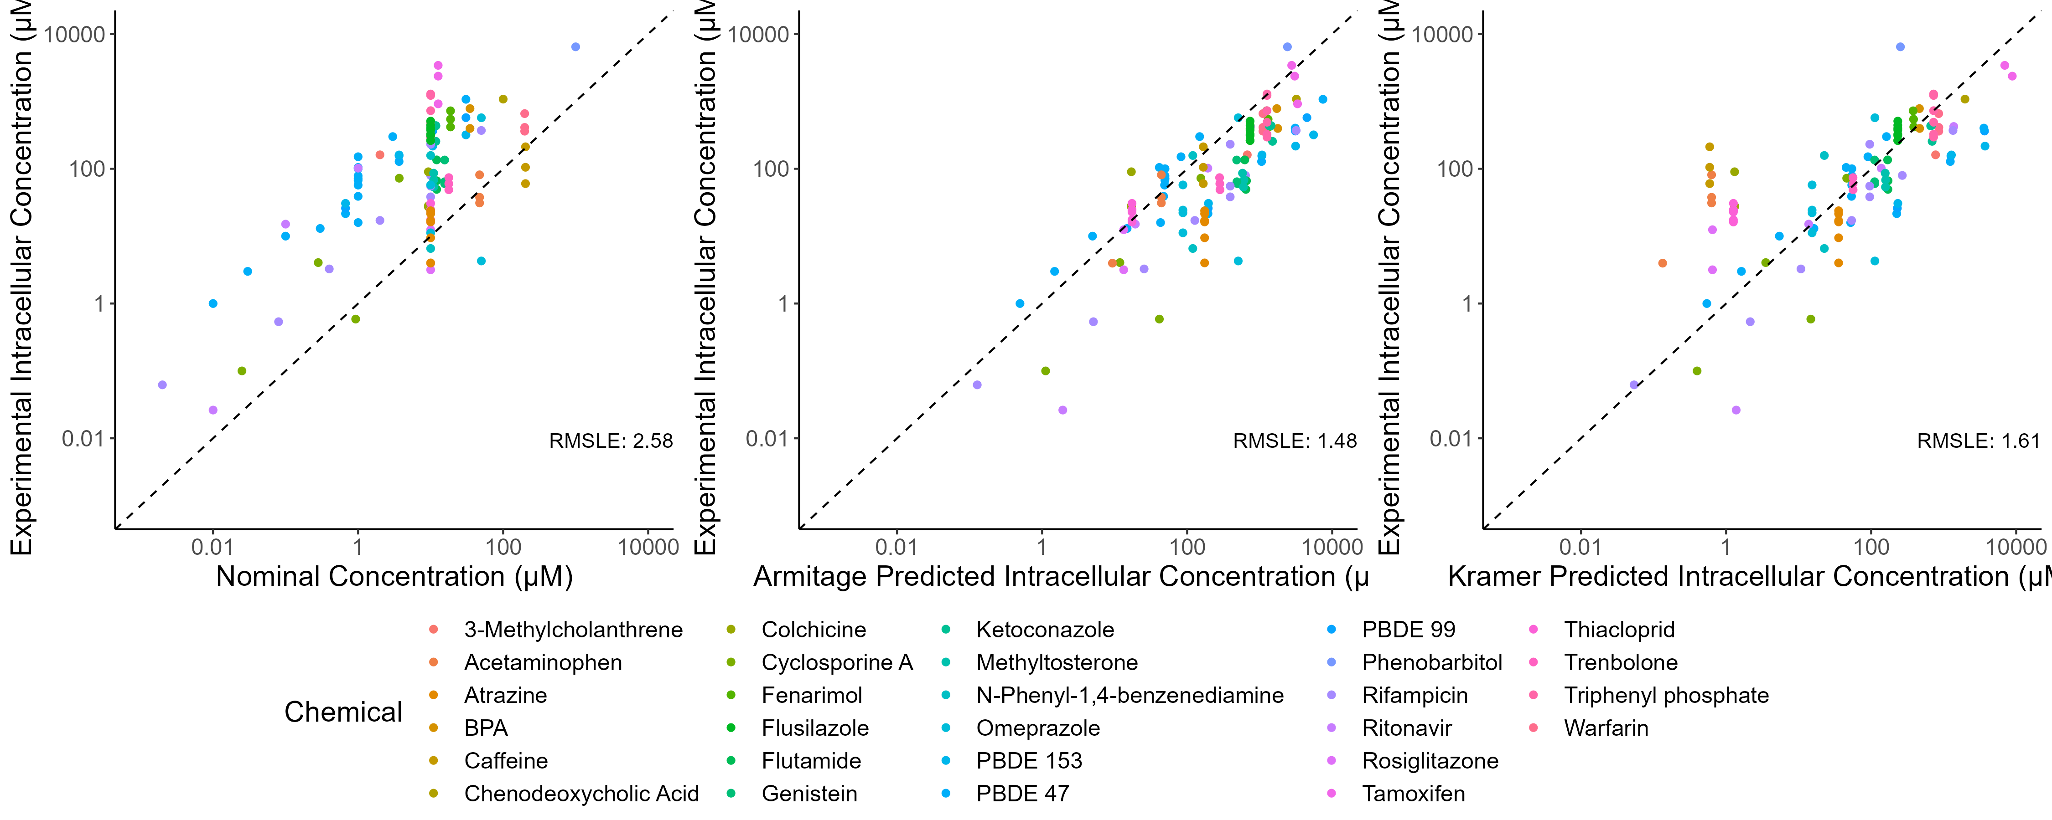

**Figure 2.** Predicted and experimental intracellular concentrations from the Nominal = Cfree (left panel), Armitage (middle panel), and Kramer (right panel) models. Dashed line shows unity.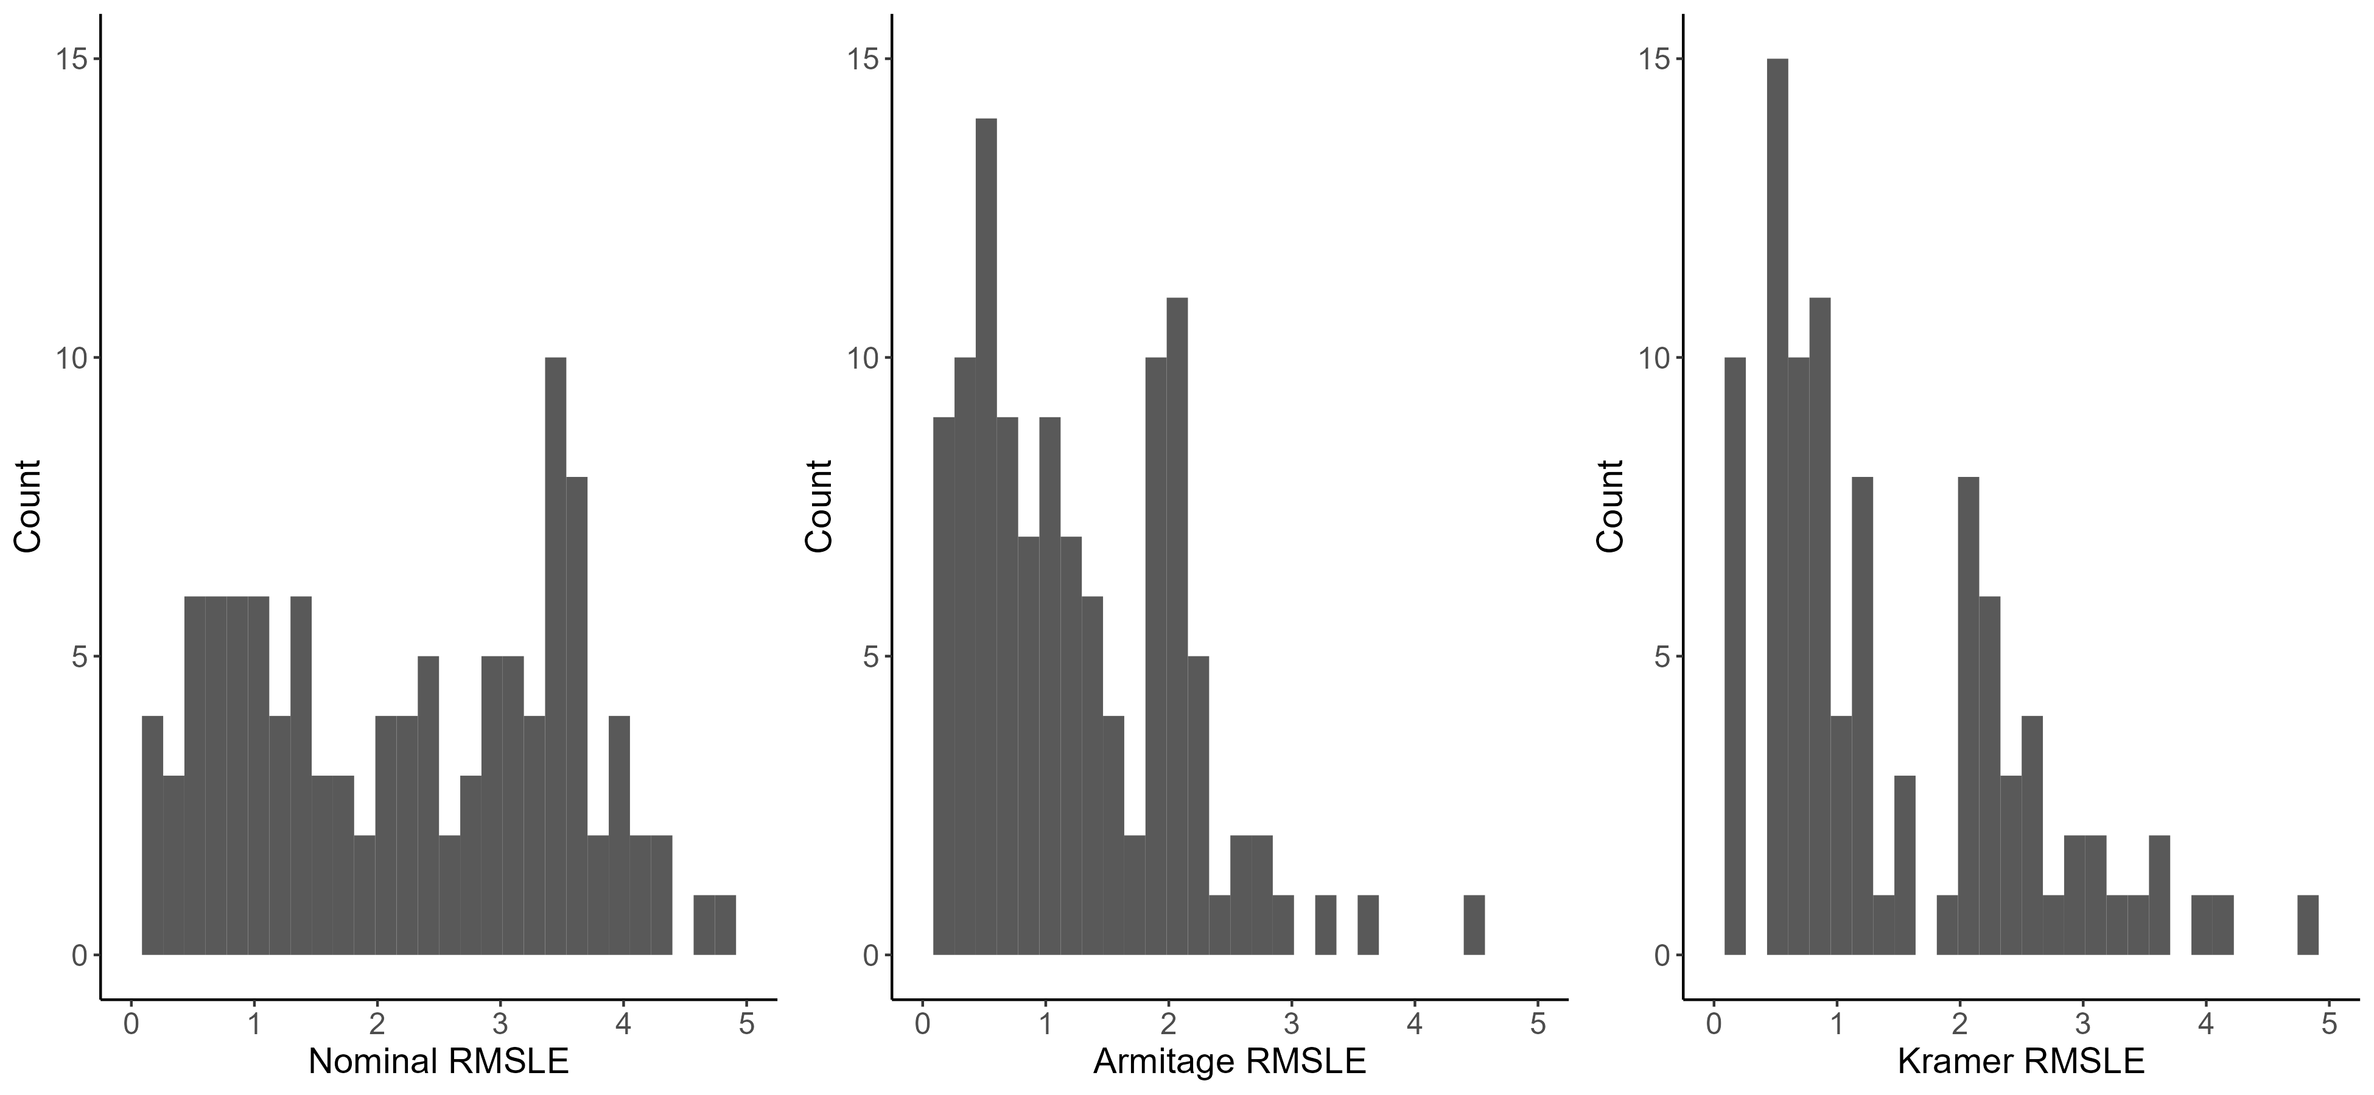

**Figure 3.** Histogram showing chemical-specific RMSLE for Observed Ccell vs. Cnominal, Armitage Ccell vs Observed Ccell, and Kramer Ccell vs Observed Ccell.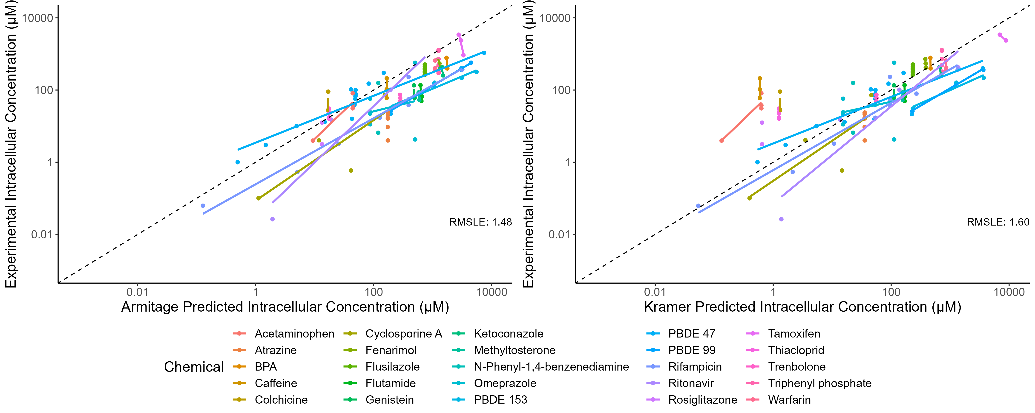

**Figure 4.** Predicted and experimental intracellular concentrations from the Armitage (left panel) and Kramer (right panel) models for the twenty-five chemicals with multiple observations. Dashed line shows unity.

**Table 2.** Root mean squared log error (RMSLE) and coefficient of determination (r2) for the chemicals with multiple observations. Note: Atrazine, Flusilazole, N-Phenyl-1,4-benzenediamine, Rosiglitazone, Thiacloprid, and Triphenyl phosphate each only reflect two data points.

|  |  |  |  |  |
| --- | --- | --- | --- | --- |
|  | Armitage | | Kramer | |
| Chemical | RMSLE | r2 | RMSLE | r2 |
| Acetaminophen | 0.51 | 0.52 | 3.02 | 0.52 |
| Atrazine | 2.55 | 0 | 1.08 | 0 |
| BPA | 1.2 | 1 | 0.39 | 1 |
| Caffeine | 0.65 | 0.83 | 4.28 | 0.83 |
| Colchicine | 1.01 | 0.47 | 2.96 | 0.47 |
| Cyclosporine A | 1.78 | 0.94 | 1.18 | 0.9 |
| Fenarimol | 0.9 | 0.99 | 0.42 | 0.99 |
| Flusilazole | 0.77 | 0 | 0.47 | 0 |
| Flutamide | 2.16 | 0.72 | 0.9 | 0.73 |
| Genistein | 1.83 | 0.58 | 0.49 | 0.58 |
| Ketoconazole | 1.4 | 0.68 | 0.67 | 0.66 |
| Methyltosterone | 2.17 | 0.44 | 0.85 | 0.45 |
| N-Phenyl-1,4-benzenediamine | 1.97 | 0 | 1.57 | 0 |
| Omeprazole | 2.17 | 0.36 | 1.53 | 0.36 |
| PBDE 153 | 2.36 | 0.91 | 2.68 | 0.82 |
| PBDE 47 | 1.09 | 0.92 | 1.16 | 0.93 |
| PBDE 99 | 2.03 | 0.99 | 2.38 | 0.91 |
| Rifampicin | 1.74 | 0.77 | 0.93 | 0.73 |
| Ritonavir | 0.68 | 1 | 0.74 | 0.98 |
| Rosiglitazone | 0.87 | 0 | 1.62 | 0 |
| Tamoxifen | 0.77 | 0.99 | 1.69 | 1 |
| Thiacloprid | 0.31 | 0 | 2.34 | 0 |
| Trenbolone | 1.54 | 1 | 0.18 | 1 |
| Triphenyl phosphate | 0.93 | 0 | 0.61 | 0 |
| Warfarin | 0.91 | 0 | 0.67 | 0.64 |

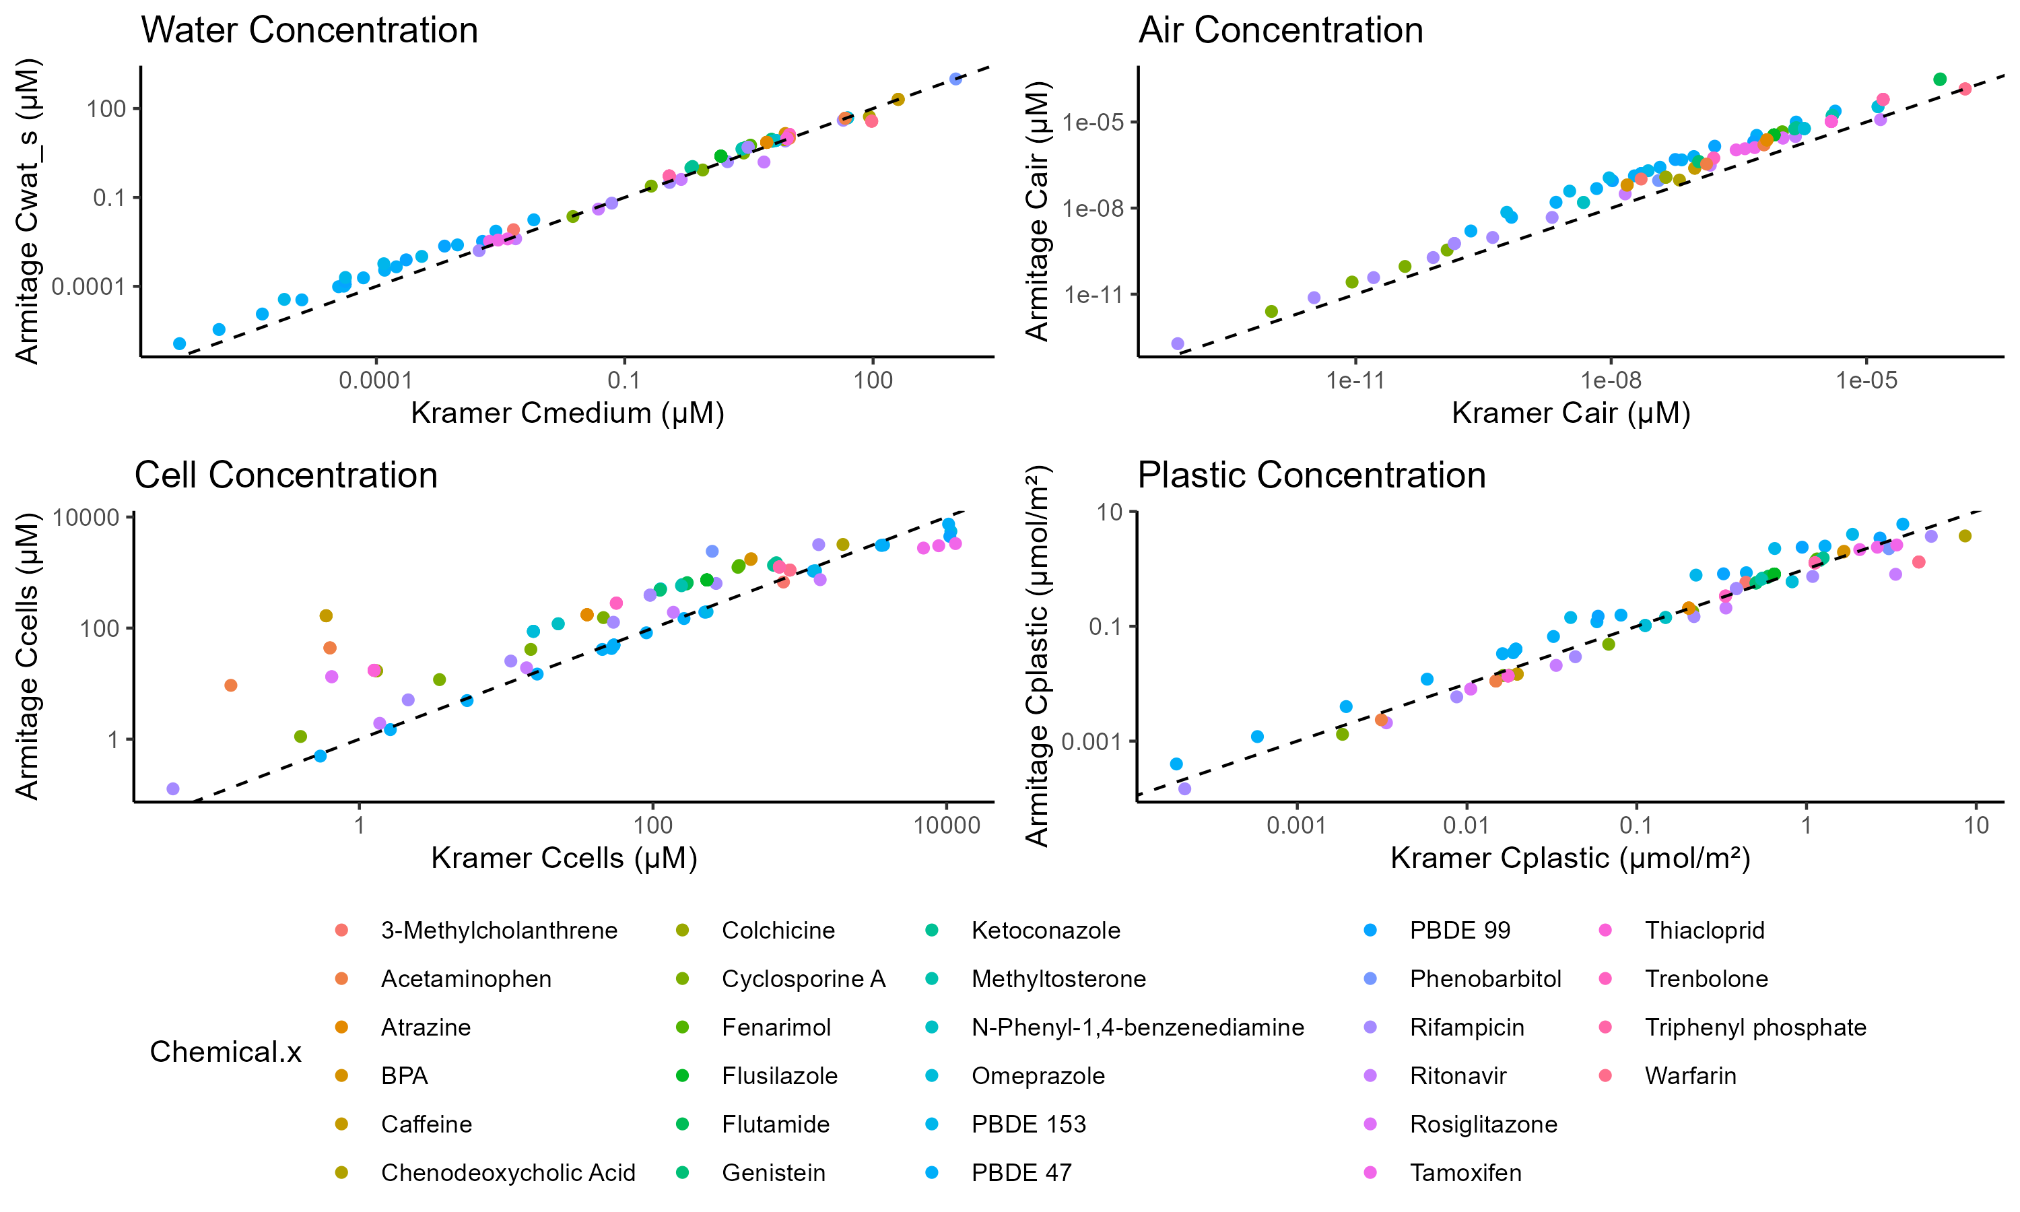

**Figure 5.** Chemical partitioning into water, air, cell, and plastic compartments for the Armitage and Kramer models. Dashed line shows unity.

Results (continued):

Overall, the Armitage model is more accurate than the Kramer model, with a smaller RMSLE and a larger r2 (Table 2). Within chemicals with more than one observation, this pattern deviates for fifteen of the chemicals, which Kramer predicts with a smaller RMSLE (Figure 4, Table 2). Within each model tested, Armitage most accurately predicts neutral and basic chemicals while Kramer is most accurate for acids (Table S2). Of the chemicals tested, Kramer is most accurate with moderately lipophilic chemicals (log Kow 2.59−3.36) and Armitage is most accurate for hydrophilic chemicals (log Kow −0.07−1.30). Neither model is more accurate at predicting chemicals with certain physicochemical properties (Kow, Kaw, etc.).

The models’ predictions for chemical partitioning into the different compartments (water, air, cell, and plastic) are very similar with the greatest differences in the cell and plastic compartments (Figure 5). The intracellular concentration predictions by the Armitage model were larger for Caffeine, Acetaminophen, Colchicine, and Thiacloprid compared to the Kramer model. The Armitage and Kramer model's plastic concentrations are roughly equal however the Armitage plastic concentrations are larger for PBDE 47, PBDE 99, and PBDE 153.

# Discussion/Conclusion:

While the Kramer model is more accurate than using the nominal concentration, it misses out on crucial variables that reduce precision. The Armitage model is more complex than the Kramer model, including binding to serum lipids, dissolved organic matter, and predicting whether the chemical has reached saturation. These additional parameters mean that Armitage model is more accurate and precise in its predictivity.

Since the Armitage model is currently in use in the R package “httk”, other models relying on these predictions are receiving accurate information regarding in vitro distribution. As mentioned by Armitage et al. (2021), the lack of data is a critical factor limiting the accuracy of these in vitro distribution models. This analysis was conducted using 118 data points (experimentally derived intracellular concentrations) from a variety of assays and cell types (**Table S1**). Due to this relatively small amount of data, the ability to fully test these models is limited.

New methods for calculating *in vitro* distribution parameters are constantly being developed that could further improve the accuracy of both models. For example, the updated Armitage et al. (2021) model includes distinguishing sorption to anionic and neutral phospholipids for ionized organic chemicals and simulating lysosomal sequestration for basic ionized organic chemicals. Standardizing *in vitro* test protocols, reducing the number of studies using nominal concentrations, and generating more data for charged IOCs and volatile neutral organics would increase the confidence in the currently available *in vitro* distribution models. The data could also be used to adapt or build new, more robust models to address the current shortcomings in the field. Better predictions of *in vitro* distribution are essential for the fields of risk assessment and policy making as they move away from animal testing.

# Supplement:

**Table S1.** Results of the literature review. (separate file)

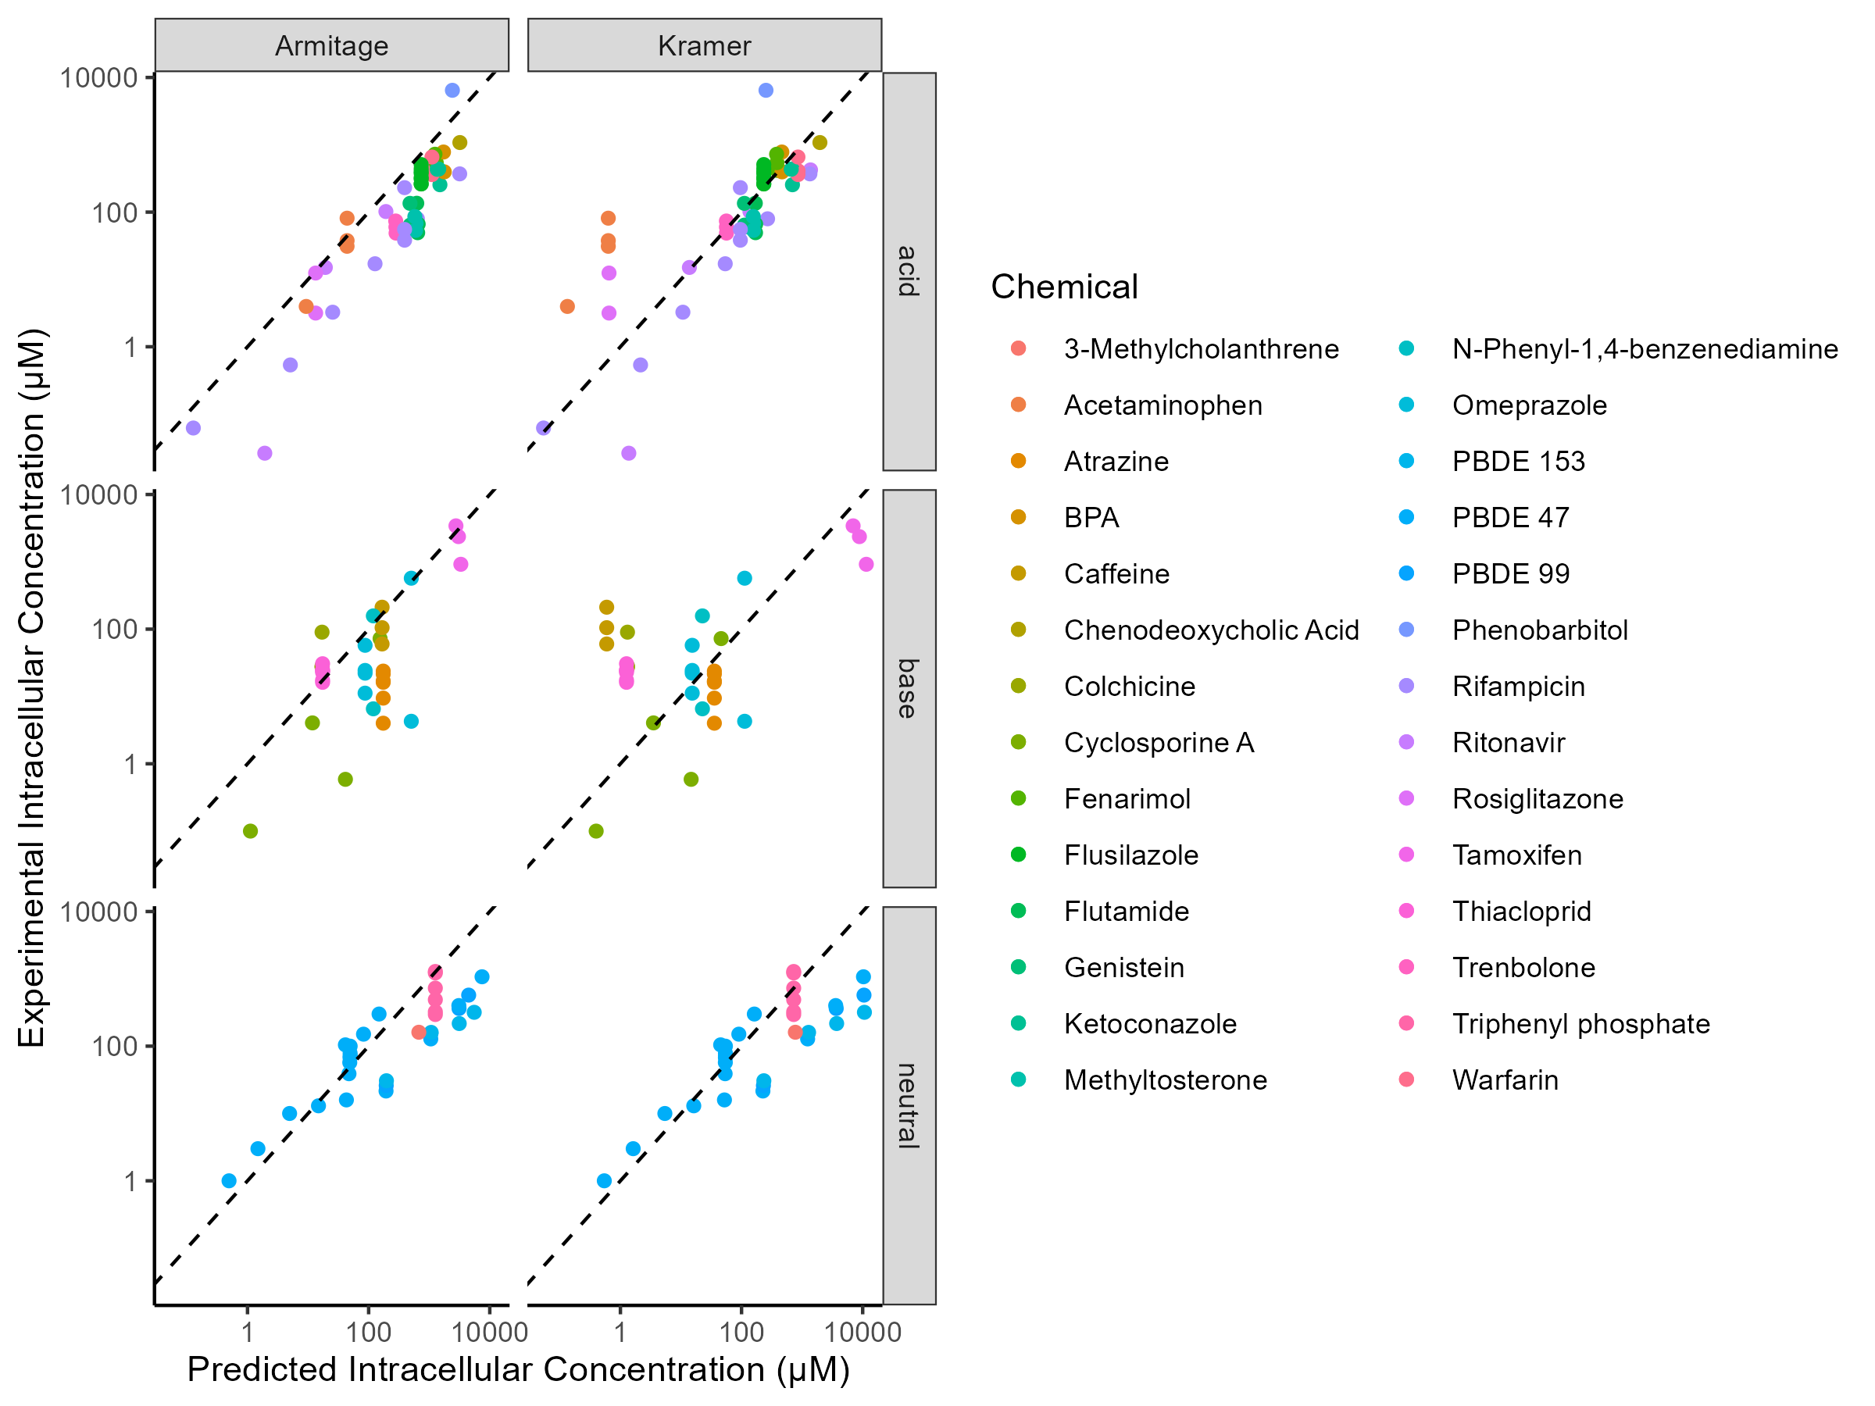

**Figure S1:** Predicted intracellular concentrations of acids, bases, and neutral chemicals by the Armitage and Kramer models.

**Table S2:** RMSLE and r^2 for acids and bases.

|  |  |  |  |  |
| --- | --- | --- | --- | --- |
|  | Armitage Model | | Kramer Model | |
| Ionization | RMSLE | r2 | RMSLE | r2 |
| neutral | 1.43 | 0.30 | 1.56 | 0.16 |
| acid | 1.37 | 0.73 | 1.19 | 0.03 |
| base | 1.69 | 0.72 | 2.16 | 0.60 |

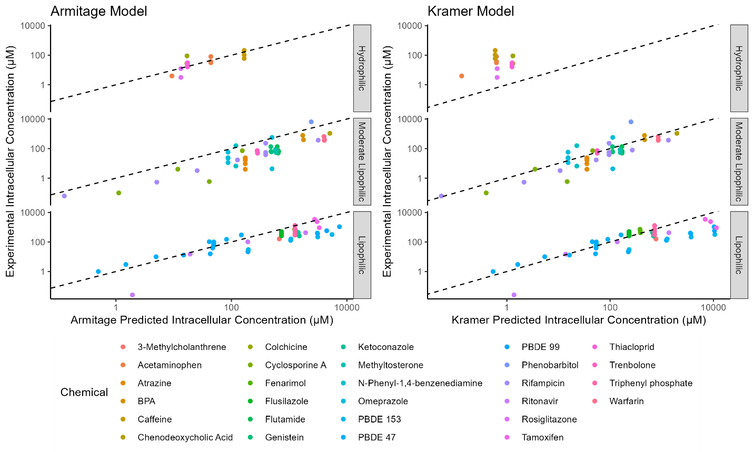

**Figure S2.** Predicted intracellular concentrations of lipophilic (log Kow >3.60), moderately lipophilic (log Kow 2.59−3.36), and hydrophilic (log Kow −0.07−1.30) chemicals by the Armitage and Kramer models.

**Table S3.**

|  |  |  |
| --- | --- | --- |
| Lipophilicity: | Armitage RMSLE | Kramer RMSLE |
| Lipophilic | 1.25 | 1.32 |
| Moderate Lipophilic | 1.91 | 1.11 |
| Hydrophilic | 0.65 | 2.94 |

Citations:

Armitage, J.M., Wania, F., Arnot, J.A., Application of Mass Balance Models and the Chemical Activity Concept To Facilitate the Use of in Vitro Toxicity Data for Risk Assessment. Environmental Science & Technology. 2014; 48(16), 9770-9779. doi.org/10.1021/es501955g

Armitage JM, Sangion A, Parmar R, Looky AB, Arnot JA. Update and Evaluation of a High-Throughput In Vitro Mass Balance Distribution Model: IV-MBM EQP v2.0. *Toxics.* 2021; 9(11):315. <https://doi.org/10.3390/toxics9110315>

Bas J. Blaauboer (2010) Biokinetic Modeling and *in Vitro*–*in Vivo* Extrapolations, Journal of Toxicology and Environmental Health, Part B, 13:2-4, 242-252, DOI: [10.1080/10937404.2010.483940](https://doi.org/10.1080/10937404.2010.483940)

Coecke, 2013: Toxicokinetics as a key to the integrated toxicity risk assessment based primarily on non-animal approaches

Kramer, 2010. Measuring, Modeling, and Increasing the Free Concentration of Test Chemicals in Cell

Assays. Utrecht University. ----model citation from proenca paper

Pearce, R. G., Setzer, R. W., Strope, C. L., Sipes, N. S., & Wambaugh, J. F. (2017). httk: R Package for High-Throughput Toxicokinetics. *Journal of Statistical Software*, *79*(4), 1–26. https://doi.org/10.18637/jss.v079.i04

R: A Language and Environment for Statistical Computing. R Foundation for Statistical Computing,

Vienna, Austria. <https://www.R-project.org/>

John F. Wambaugh, Barbara A. Wetmore, Robert Pearce, Cory Strope, Rocky Goldsmith, James P. Sluka, Alexander Sedykh, Alex Tropsha, Sieto Bosgra, Imran Shah, Richard Judson, Russell S. Thomas, R. Woodrow Setzer, Toxicokinetic Triage for Environmental Chemicals, Toxicological Sciences, Volume 147, Issue 1, September 2015, Pages 55–67, <https://doi.org/10.1093/toxsci/kfv118>

Armitage, J. M., Wania, F., & Arnot, J. A. (2014). Application of Mass Balance Models and the Chemical Activity Concept To Facilitate the Use of in Vitro Toxicity Data for Risk Assessment. *Environmental Science & Technology*, *48*(16), 9770-9779. <https://doi.org/10.1021/es501955g>

Coecke, S., Pelkonen, O., Leite, S. B., Bernauer, U., Bessems, J. G., Bois, F. Y., Gundert-Remy, U., Loizou, G., Testai, E., & Zaldívar, J. M. (2013). Toxicokinetics as a key to the integrated toxicity risk assessment based primarily on non-animal approaches. *Toxicol In Vitro*, *27*(5), 1570-1577. <https://doi.org/10.1016/j.tiv.2012.06.012>

Drevon, D., Fursa, S. R., & Malcolm, A. L. (2017). Intercoder Reliability and Validity of WebPlotDigitizer in Extracting Graphed Data. *Behav Modif*, *41*(2), 323-339. <https://doi.org/10.1177/0145445516673998>

Feshuk, M., Kolaczkowski, L., Dunham, K., Davidson-Fritz, S. E., Carstens, K. E., Brown, J., Judson, R. S., & Paul Friedman, K. (2023). The ToxCast pipeline: updates to curve-fitting approaches and database structure. *Front Toxicol*, *5*, 1275980. <https://doi.org/10.3389/ftox.2023.1275980>

Kramer, N. (2010). *Measuring, Modeling, and Increasing the Free Concentration of Test Chemicals in Cell*

*Assays* Utrecht University].

Mansouri, K., Cariello, N. F., Korotcov, A., Tkachenko, V., Grulke, C. M., Sprankle, C. S., Allen, D., Casey, W. M., Kleinstreuer, N. C., & Williams, A. J. (2019). Open-source QSAR models for pKa prediction using multiple machine learning approaches. *J Cheminform*, *11*(1), 60. <https://doi.org/10.1186/s13321-019-0384-1>

Pearce, R. G., Setzer, R. W., Davis, J. L., & Wambaugh, J. F. (2017). Evaluation and calibration of high-throughput predictions of chemical distribution to tissues. *J Pharmacokinet Pharmacodyn*, *44*(6), 549-565. <https://doi.org/10.1007/s10928-017-9548-7>

Pearce, R. G., Setzer, R. W., Strope, C. L., Wambaugh, J. F., & Sipes, N. S. (2017). httk: R Package for High-Throughput Toxicokinetics. *J Stat Softw*, *79*(4), 1-26. <https://doi.org/10.18637/jss.v079.i04>

Po, H. N., & Senozan, N. M. (2001). The Henderson-Hasselbalch Equation: Its History and Limitations. *Journal of Chemical Education*, *78*(11), 1499. <https://doi.org/10.1021/ed078p1499>

Proença, S., Escher, B. I., Fischer, F. C., Fisher, C., Grégoire, S., Hewitt, N. J., Nicol, B., Paini, A., & Kramer, N. I. (2021). Effective exposure of chemicals in in vitro cell systems: A review of chemical distribution models. *Toxicology in Vitro*, *73*, 105133. <https://doi.org/https://doi.org/10.1016/j.tiv.2021.105133>

*R: A Language and Environment for Statistical Computing*.In. <https://www.R-project.org/>

Richard, A. M., Judson, R. S., Houck, K. A., Grulke, C. M., Volarath, P., Thillainadarajah, I., Yang, C., Rathman, J., Martin, M. T., Wambaugh, J. F., Knudsen, T. B., Kancherla, J., Mansouri, K., Patlewicz, G., Williams, A. J., Little, S. B., Crofton, K. M., & Thomas, R. S. (2016). ToxCast Chemical Landscape: Paving the Road to 21st Century Toxicology. *Chem Res Toxicol*, *29*(8), 1225-1251. <https://doi.org/10.1021/acs.chemrestox.6b00135>

Wambaugh, J. F., Wetmore, B. A., Pearce, R., Strope, C., Goldsmith, R., Sluka, J. P., Sedykh, A., Tropsha, A., Bosgra, S., Shah, I., Judson, R., Thomas, R. S., & Setzer, R. W. (2015). Toxicokinetic Triage for Environmental Chemicals. *Toxicol Sci*, *147*(1), 55-67. <https://doi.org/10.1093/toxsci/kfv118>