Untitled

Christopher Cook

3/9/2022

## R Markdown

This is an R Markdown document. Markdown is a simple formatting syntax for authoring HTML, PDF, and MS Word documents. For more details on using R Markdown see <http://rmarkdown.rstudio.com>.

When you click the **Knit** button a document will be generated that includes both content as well as the output of any embedded R code chunks within the document. You can embed an R code chunk like this:

summary(cars)

## speed dist   
## Min. : 4.0 Min. : 2.00   
## 1st Qu.:12.0 1st Qu.: 26.00   
## Median :15.0 Median : 36.00   
## Mean :15.4 Mean : 42.98   
## 3rd Qu.:19.0 3rd Qu.: 56.00   
## Max. :25.0 Max. :120.00

## Including Plots

You can also embed plots, for example:

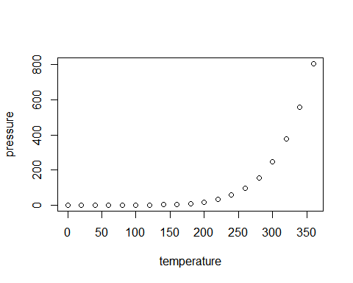

Note that the echo = FALSE parameter was added to the code chunk to prevent printing of the R code that generated the plot.

# References

Boxenbaum, Harold G., Sidney Riegelman, and Robert M. Elashoff. 1974. “Statistical Estimations in Pharmacokinetics.” *Journal of Pharmacokinetics and Biopharmaceutics* 2 (2): 123–48. <https://doi.org/10.1007/BF01061504>.

Cox, D. R., and D. V. Hinkley. 1979. *Theoretical Statistics*. CRC Press.

Dovi, V. G., O. Paladino, and A. P. Reverberi. 1991. “Some Remarks on the Use of the Inverse Hessian Matrix of the Likelihood Function in the Estimation of Statistical Properties of Parameters.” *Applied Mathematics Letters* 4 (1): 87–90. <https://doi.org/https://doi.org/10.1016/0893-9659(91)90129-J>.

Kamiya, Yusuke, Kentaro Handa, Tomonori Miura, Junya Ohori, Makiko Shimizu, Masato Kitajima, Fumiaki Shono, Kimito Funatsu, and Hiroshi Yamazaki. 2021. “An Updated in Silico Prediction Method for Volumes of Systemic Circulation of 323 Disparate Chemicals for Use in Physiologically Based Pharmacokinetic Models to Estimate Plasma and Tissue Concentrations After Oral Doses in Rats.” *Chemical Research in Toxicology* 34 (10): 2180–3. <https://doi.org/10.1021/acs.chemrestox.1c00249>.

Kamiya, Yusuke, Shohei Otsuka, Tomonori Miura, Manae Yoshizawa, Ayane Nakano, Miyu Iwasaki, Yui Kobayashi, et al. 2020. “Physiologically Based Pharmacokinetic Models Predicting Renal and Hepatic Concentrations of Industrial Chemicals After Virtual Oral Doses in Rats.” *Chemical Research in Toxicology* 33 (7): 1736–51. <https://doi.org/10.1021/acs.chemrestox.0c00009>.

Kudo, Naomi, Masanori Katakura, Yasunori Sato, and Yoichi Kawashima. 2002. “Sex Hormone-Regulated Renal Transport of Perfluorooctanoic Acid.” *Chemico-Biological Interactions* 139 (3): 301–16. <https://doi.org/10.1016/s0009-2797(02)00006-6>.

Nash, John C. 2014. “On Best Practice Optimization Methods in R.” *Journal of Statistical Software* 60 (2): 1–14. <https://doi.org/10.18637/jss.v060.i02>.

Nash, John C., and Ravi Varadhan. 2011. “Unifying Optimization Algorithms to Aid Software System Users: optimx for R.” *Journal of Statistical Software* 43 (9): 1–14. <https://doi.org/10.18637/jss.v043.i09>.

O’Flaherty, E. J. 1981. *Toxicants and Drugs: Kinetics and Dynamics*. John Wiley & Sons.

Sayre, Risa R., John F. Wambaugh, and Christopher M. Grulke. 2020. “Database of Pharmacokinetic Time-Series Data and Parameters for 144 Environmental Chemicals.” *Scientific Data* 7 (1): 122. <https://doi.org/10.1038/s41597-020-0455-1>.

Sheiner, L. B. 1985. “Analysis of Pharmacokinetic Data Using Parametric Models. II. Point Estimates of an Individual’s Parameters.” *Journal of Pharmacokinetics and Biopharmaceutics* 13 (5): 515–40. <https://doi.org/10.1007/BF01059333>.

Thorne, W. Brent. 2019. *Posterdown: An R Package Built to Generate Reproducible Conference Posters for the Academic and Professional World Where Powerpoint and Pages Just Won’t Cut It*. <https://github.com/brentthorne/posterdown>.

Wakefield, Jon, Leon Aarons, and Amy Racine. 1999. “The Bayesian Approach to Population Pharmacokinetic/Pharmacodynamic Modeling.” <https://doi.org/10.1007/978-1-4612-1502-8_4>.

Wambaugh, John F., Michael F. Hughes, Caroline L. Ring, Denise K. MacMillan, Jermaine Ford, Timothy R. Fennell, Sherry R. Black, et al. 2018. “Evaluating in Vitro-in Vivo Extrapolation of Toxicokinetics.” *Toxicological Sciences : An Official Journal of the Society of Toxicology* 163 (1): 152–69. <https://doi.org/10.1093/toxsci/kfy020>.

World Health Organization. 2010. “Characterization and Application of Physiologically Based Pharmacokinetic Models in Risk Assessment.” WHO Document Production Services, Geneva, Switzerland.