Widespread nitrous oxide undersaturation in U.S. lakes and reservoirs

28 March, 2023

<<<<<<< HEAD

## Introduction

## Results and Discussion

### N2O undersaturation extent

In this study we present the first national-scale survey of N2O concentrations and emissions from lakes, reservoirs, and ponds, hereafter referred to as waterbodies, in the conterminous U.S. (CONUS). A generalized random-tessellation survey design (Stevens and Olsen, 2004) was used to select a spatially-balanced and representative sample of 1090 **[weird, I have 1090, but NLA17 report says 1,005?]** sites from CONUS waterbodies that are least 1 hectare in area, at least 1 meter deep, have at least 0.1 hectare of open water, and have a minimum residence time of one week (Figure 1). Sample sites were distributed across all nine major CONUS ecoregions and varied widely in water chemistry, morphometry, watershed land-use, and climate (See NLA website for all data?). 72.9 percent of the sampled waterbodies were undersaturated in N2O and were therefore functioning as N2O sinks (Figure 1). We modeled the data using a bayesion hierchical approach and predicted the dissolved N2O concentration for all 224,916 CONUS waterbodies in the target population. At the population level, 72.5 percent (95% CI: 72.3 - 72.7) of CONUS waterbodies were functioning as N2O sinks. The Western Mountains ecoregion had the smallest proportion of waterbodies functioning as N2O sinks (mean = 65.5%, 95% CI: 64.8 - 66.2), the Northern Plains had the greatest (mean = 76.8%, 95% CI: 76.3 - 77.3), and >65% of the waterbodies in every ecoregion were undersaturated (Table 1).

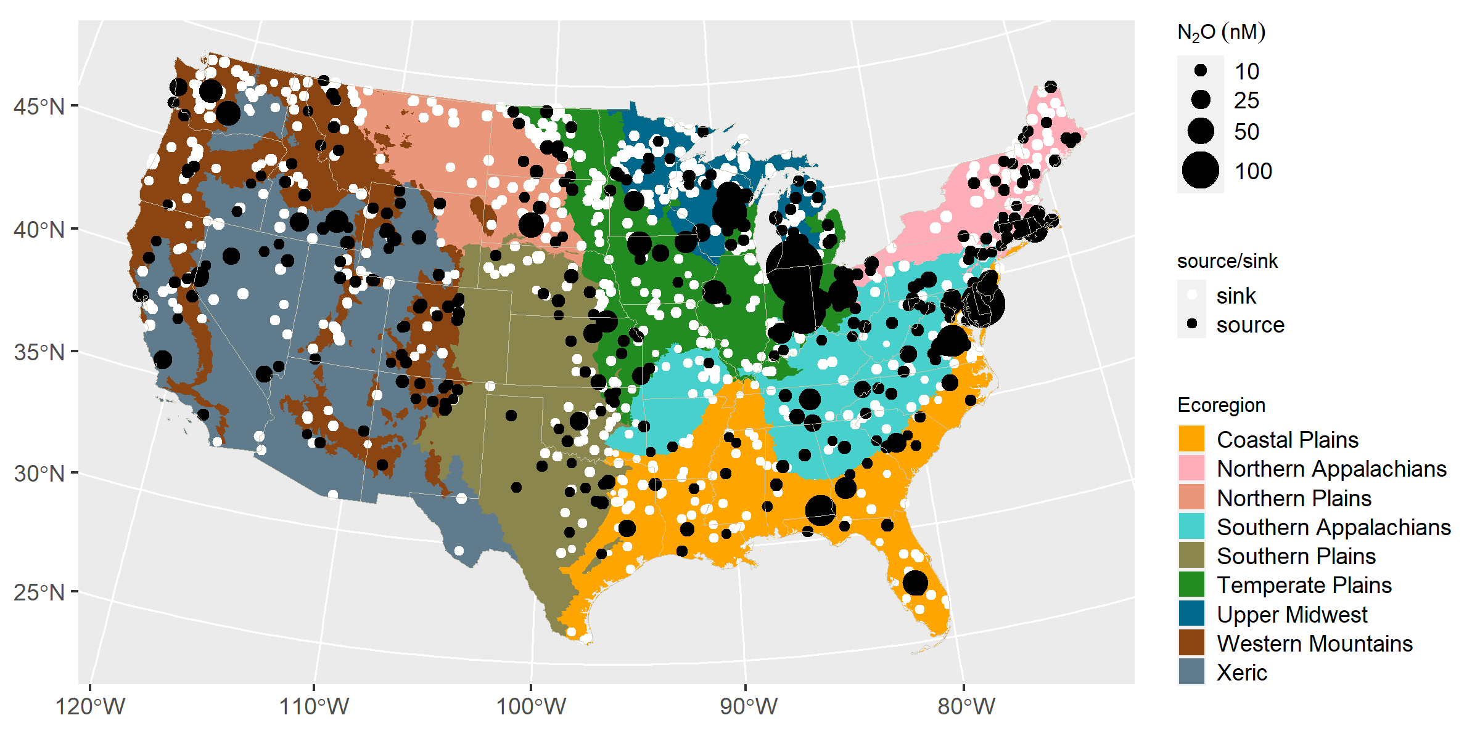

Location of sampling sites. Color of the points indicates whether the waterbody was functioning as a source or sink of nitrous oxide (N2O). Point size indicates the dissolved N2O concentration.

The extent of N2O undersaturation in CONUS waterbodies is surprisingly high, particularly for waterbodies in nitrogen rich ecoregions that are managed for agricultural production. This finding runs counter to the long standing paradigm that nitrogen rich surface waters are a source of N2O to the atmosphere (Mosier et al. 1998) and joins other recent reports that lentic waterbodies can function as an N2O sink. Webb et al. (2019) found that 67% of sampled reservoirs in an agricultural region of Canada were undersaturated with N2O during the summer months and Soued et al (2015) report that 40% of rivers, lakes, and ponds sampled during the summer in a boreal region of Quebec, Canada were functioning as N2O sinks. While these latter surveys were conducted at regional scales, the national-scale results presented here provide the strongest evidence to date that most lentic waterbodies function as N2O sinks during the summer months. This pattern holds across all 9 major ecoregions in the CONUS, despite the tremendous variation in climate, geology, waterbody morphology, and land use across the continental U.S..

Mean and 95% confidence interval of N2O undersaturation extent, saturation ratio, and emission rate at the national and ecoregional scales

| spatial domain | N2O undersaturation extent | N2O saturation ratio | N2O emission rate |
| --- | --- | --- | --- |
| national | 72.5 (72.3-72.7) | 1.11 (1.1-1.11) | 0.025 (0.023-0.027) |
| CPL | 73.5 (73.2-73.8) | 1.2 (1.18-1.21) | 0.045 (0.041-0.049) |
| NAP | 73.5 (73-74) | 0.98 (0.97-0.98) | -0.006 (-0.008–0.004) |
| NPL | 76.8 (76.3-77.3) | 0.93 (0.92-0.93) | -0.021 (-0.023–0.019) |
| SAP | 69.7 (69.1-70.2) | 1.14 (1.12-1.15) | 0.03 (0.026-0.034) |
| SPL | 71.1 (70.5-71.7) | 1.1 (1.08-1.12) | 0.029 (0.024-0.035) |
| TPL | 73.3 (72.8-73.9) | 1.15 (1.13-1.17) | 0.038 (0.033-0.042) |
| UMW | 73.2 (72.7-73.6) | 1 (0.99-1.01) | 0.001 (-0.001-0.002) |
| WMT | 65.5 (64.8-66.2) | 1.02 (1.01-1.03) | 0.005 (0.003-0.008) |
| XER | 70.4 (69.5-71.2) | 1.07 (1.05-1.08) | 0.016 (0.011-0.021) |

Here is a citation example: Multilevel models are useful for survey inference (Kennedy and Gelman 2021). This paper by Kennedy and Gelman (2021) provides a nice worked example.

### N2O saturation ratio

#### Distribution

Despite widespread N2O undersaturation in CONUS waterbodies, the mean N2O saturation ratio (ratio of measured to equilibrium concentration) was equal to or greater than 1 in seven of the nine ecoregions (Table 1, Figure 2), suggesting that, on average, waterbodies in these ecoregions were supersatured with N2O and therefore functioning as a source of N2O. The apparent contradiction between widespread N2O undersaturation throughout the CONUS and average dissolved N2O concentrations that exceed equilibrium in most ecoregions can be attributed to the distribution of dissolved N2O concentrations across the population of CONUS waterbodies (Figure 2). Across the CONUS, and within each of the nine major ecoregions, the distribution of N2O saturation ratios had median values that were less than 1, indicating undersaturation, but a long right tail composed of relatively rare waterbodies with levels of N2O supersaturation that are sufficiently high to drive the population mean to values close to, or even greater than 1. Thus most waterbodies in the CONUS are functioning as N2O sinks, but a few function as strong N2O sources.

### Controls on N2O saturation

N2O saturation was related to waterbody size in several ecoregions, but the direction of the relationship varied. For example, N2O saturation increased with waterbody size in the Northern Plains, Upper Midwest, Northern Appalachians, and Western Mountain ecoregions, but decreased with increasing size in the Coastal and Southern Plains (Figure 3). A pattern common to many of the ecoregions, regardless of the direction of the relationship between N2O saturation and waterbody size, is that N2O saturation deviates from equilibrium most strongly in the smallest waterbody size class. When pooled across all ecoregions, the absolute magnitude of the difference beween the measured and equilibrium N2O concentration, known as delta N2O

# References

Kennedy, Lauren, and Andrew Gelman. 2021. “Know Your Population and Know Your Model: Using Model-Based Regression and Poststratification to Generalize Findings Beyond the Observed Sample.” Journal Article. *Psychological Methods* 26 (5): 547–58. <https://psycnet.apa.org/doi/10.1037/met0000362>.