Surface Aeration - Rating Mode
The following problem will be used to show sample calculations for surface aeration. In addition, a sample program run of ASAP™ will be used to verify that the program is correctly duplicating the results of the sample calculations.

Problem Statement
The city of Anytown, USA recently discovered that one of its wells was contaminated with the compounds listed in Table 1. In order for them to continue using the well, they were required to remove these compounds below their MCLs, also shown in Table 1. During normal pumping operations, the well produces about 2000 gpm, the water temperature is 10°C, and the barometric pressure is 1 atm.
A surface aeration system consisting of three surface aeration tanks operating in series was designed to remove all the VOCs below their MCLs. The tanks each have a volume of 400 m³. Physical and chemical properties for the design were retrieved from StEPP™.
Power input to the system has an efficiency of 80 percent. The power input per unit volume is 65.0 W/m³.
Now that the system is under full operation, the performance of the system must be evaluated. This can be accomplished using the ASAP’s™ program rating mode for surface aeration. Show a calculation of the effluent concentration for TCE from each tank. Present a table showing influent concentration, treatment objective, mass transfer coefficient, and effluent concentration from each tank for each component.
Table 1 - Influent Concentrations and Treatment Objectives (MCLs)
Compound | Concentration Discharged, C₀ | MCL, C_{TO}
 | (μg/L) | (μg/L)
Trichloroethylene (TCE) | 200.0 | 5.0
Tetrachloroethylene (PCE) | 150.0 | 5.0
Vinyl Chloride | 60.0 | 1.0
Ethylbenzene | 30.0 | 5.0
Toluene | 80.0 | 5.0
1,1-Dichloroethene (1,1-DCE) | 85.0 | 7.0

Note Regarding Comparison of Sample Calculation Values to Sample Program Run
In certain cases, the numbers that appear in the sample calculations are slightly different from the values displayed in the sample program run. These variations can be attributed to rounding.

Sample Rating Mode Calculation of Effluent Concentration for Trichloroethylene as the Design Compound Including Supplementary Parameter Calculations

Liquid Phase Effluent Concentration from Tank Number i
The liquid phase effluent concentration from tank number i, 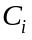, can be calculated using the following relationships:
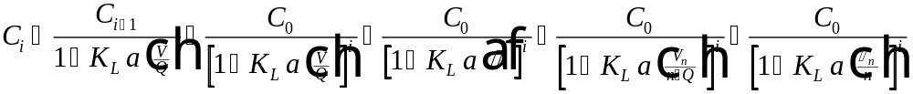
Eq. 1
The parameters required to calculate in Eq. 1 can be found as follows:
Parameter Location
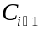 Calculated value
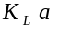 See design mode calculations
See design mode calculations
Given in problem statement
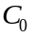 Table 1
User-specified
See design mode calculations
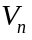 Eq. 4
Given in problem statement
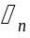 Eq. 6

Liquid Phase Effluent Concentration from Tank Number 1
The liquid phase effluent concentration from tank number 1, 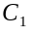, can be found using Eq. 2:
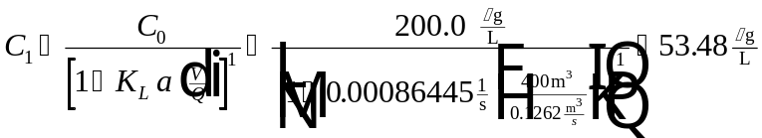
Eq. 2
The parameters required to calculate in Eq. 2 can be found as follows:
Parameter Location
See design mode calculations
Table 1
Given in problem statement
See design mode calculations

Liquid Phase Effluent Concentration from Tank Number 2
Liquid phase effluent concentration from tank number 2 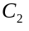, is found with Eq. 3
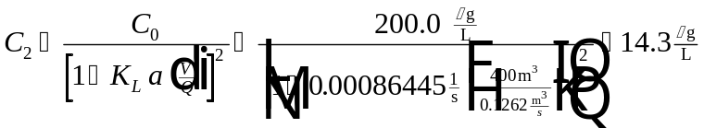
Eq. 3
The parameters required to calculate in Eq. 3 can be found as follows:
Parameter Location
See design mode calculations
Table 1
Given in problem statement
See design mode calculations

Liquid Phase Effluent Concentration from Tank Number 3
Liquid phase effluent concentration from tank number 3,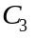, can be found using Eq. 4:
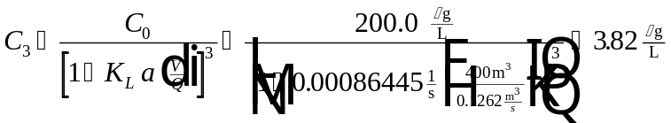
Eq. 4
The parameters required to calculate in Eq. 4 can be found as follows:
Parameter Location
See design mode calculations
Table 1
Given in problem statement
See design mode calculations

Total Power Input
The total power input to the system, , can be found using the following:
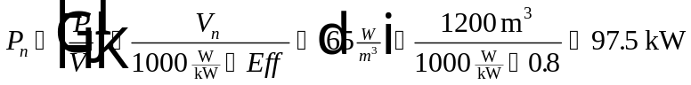
Eq. 5
The parameters required to calculate in Eq. 5 can be found as follows:
Parameter Location
 Given in problem statement
Eq. 7
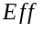 Given in problem statement

Power Input per Tank
The power input per tank, , is calculated using Eq. 6 as follows:
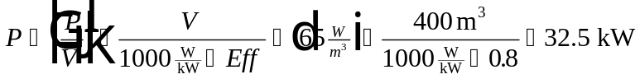
Eq. 6
The parameters required to calculate in Eq. 6 can be found as follows:
Parameter Location
Given in problem statement
Given in problem statement
Given in problem statement

Note Regarding Calculation of , , , and
In rating a surface aeration system, one of the parameters listed above can be specified and then the other three calculated. Sample calculations are presented here.

Case 1: Specify , Calculate , , and

Total Volume of System
The total volume of all of the aeration tanks, , can be calculated as follows:
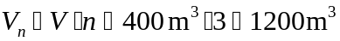
Eq. 7
The parameters required to calculate in Eq. 7 can be found as follows:
Parameter Location
User-specified
Given in problem statement

Hydraulic Retention Time
Hydraulic retention time for one aeration tank, , is calculated as follows:
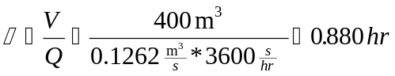
Eq. 8
The parameters required to calculate in Eq. 8 can be found as follows:
Parameter Location
User-specified
Given in problem statement

Total Hydraulic Retention Time
The total hydraulic retention time for the system, , can be found using Eq. 9:
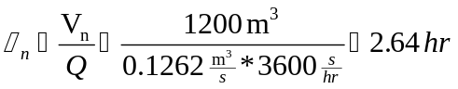
Eq. 9
The parameters required to calculate in Eq. 9 can be found as follows:
Parameter Location
Eq. 7
Given in problem statement

Case 2: Specify , Calculate , , and

Volume of One Aeration Tank
The volume of one of the aeration tanks, , can be calculated as follows:
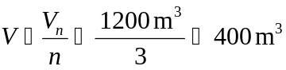
Eq. 10
The parameters required to calculate in Eq. 10 can be found as follows:
Parameter Location
User-specified
Given in problem statement

Hydraulic Retention Time
The hydraulic retention time, , can be calculated using the following relationship:
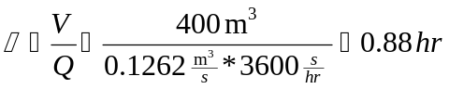
Eq. 11
The parameters required to calculate in Eq. 11 can be found as follows:
Parameter Location
Eq. 10
Given in problem statement

Total Hydraulic Retention Time
The total hydraulic retention time for the system, , is calculated as follows:
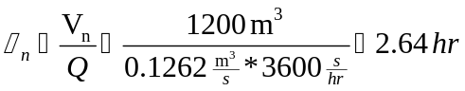
Eq. 12
The parameters required to calculate in Eq. 12 can be found as follows:
Parameter Location
User-specified
Given in problem statement

Case 3: Specify , Calculate , , and

Volume of One Aeration Tank
The volume of one of the aeration tanks, , can be calculated as follows:
Eq. 13
The parameters required to calculate in Eq. 13 can be found as follows:
Parameter Location
User-specified
Given in problem statement

Total Volume of System
The total volume of all of the aeration tanks, , can be calculated using Eq. 14:
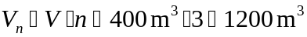
Eq. 14
The parameters required to calculate in Eq. 14 can be found as follows:
Parameter Location
Eq. 13
Given in problem statement

Total Hydraulic Retention Time
The total hydraulic retention time for the system, , is calculated using the equation below:
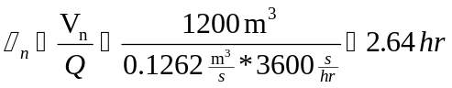
Eq. 15
The parameters required to calculate in Eq. 15 can be found as follows:
Parameter Location
Eq. 14
Given in problem statement

Case 4: Specify , Calculate , , and

Hydraulic Retention Time
The hydraulic retention time, , is found using Eq. 16:
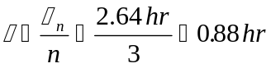
Eq. 16
The parameters required to calculate in Eq. 16 can be found as follows:
Parameter Location
User-specified
Given in problem statement

Volume of One Aeration Tank
The volume of one of the aeration tanks, , can be calculated using Eq. 17
Eq. 17
The parameters required to calculate in Eq. 17 can be found as follows:
Parameter Location
Eq. 16
Given in problem statement

Total Volume of System
The total volume of all of the aeration tanks, , can be calculated as follows:
Eq. 18
The parameters required to calculate in Eq. 18 can be found as follows:
Parameter Location
Eq. 17
Given in problem statement

Effluent Results for All Components
Table 2 - Effluent Results for All Compounds
Concentration | Compound
 | TCE | PCE | Vinyl Chloride | Ethylbenzene | Toluene | 1,1-DCE
(μg/L) | 200 | 150.0 | 60.0 | 30.0 | 80.0 | 85
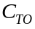 (μg/L) | 5 | 5.0 | 1.0 | 5.0 | 5.0 | 7
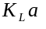 (1/s) | 0.000864 | 0.000855 | 0.00104 | 0.000760 | 0.000795 | 0.000977
(μg/L) | 53.48 | 40.43 | 13.99 | 8.8 | 22.72 | 20.74
(μg/L) | 14.3 | 10.9 | 3.26 | 2.58 | 6.46 | 5.06
(μg/L) | 3.82 | 2.94 | 0.76 | 0.757 | 1.83 | 1.24

Sample Program Run of ASAP™ to Verify Sample Calculations for Surface Aeration in Rating Mode
To start the ASAP™ program, double click on the ASAP™ icon in the ETDOT Programs group in windows. The screen shown in Figure 1 will appear.
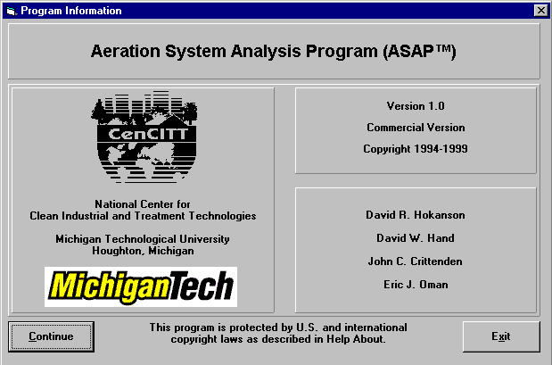
Figure 1 - ASAP™ Title Window
Click on the Continue button on the screen shown in Figure 1 and the menu shown in Figure 2 will appear.

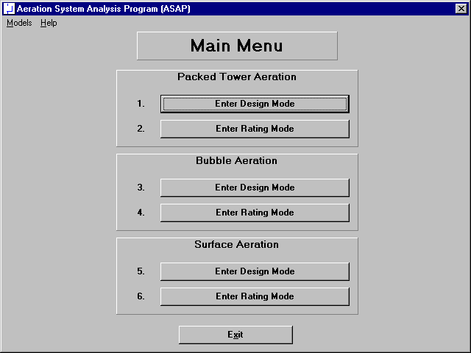
Figure 2 - Main Menu Window in ASAP™

Click on the Enter Rating Mode button for Surface Aeration (option 6 in Figure 2) and the rating mode screen for surface aeration shown in Figure 3 will appear.

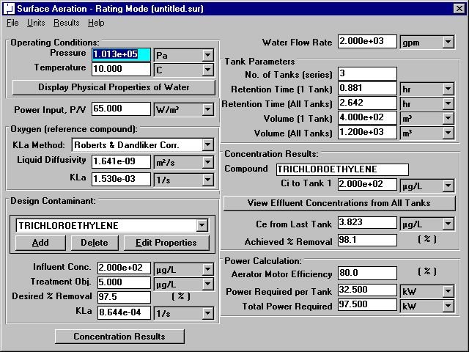
Figure 3 - Rating Mode Window for Surface Aeration

Physical Properties of Water
Specify pressure and temperature in the upper left-hand corner of the window shown in Figure 3. This portion of the surface aeration rating mode window is shown in Figure 4.
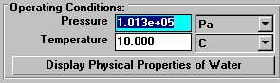
Figure 4 - Operating Conditions Portion of Rating Mode Window
Click on the Display Physical Properties of Water button in Figure 3 (and highlighted in Figure 4) to show the properties of water at the specified temperature and pressure (101325 Pa and 10°C). Figure 5 shows the water properties window for this case.
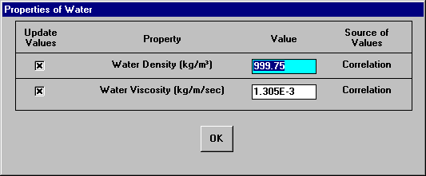
Figure 5 - Water Properties Window
The properties shown in Figure 5 are by default calculated from correlations so the user should not have to change his values. In the rare case that the user would like to enter a value for any of these properties instead of using the correlations, it is possible to do so on the window shown in Figure 5. Click on the OK button shown in Figure 5 to close the window.

Oxygen (reference compound)
The mass transfer coefficient for the design contaminant is calculated using its relationship to the mass transfer coefficient of oxygen under similar conditions. The mass transfer coefficient of oxygen is estimated using the Roberts & Dandlike Correlation. This portion of the design mode window is shown in Figure 3 (and highlighted in Figure 6).
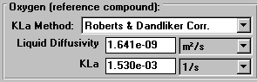
Figure 6 - Oxygen Section of Rating Mode Window
The mass transfer coefficient of oxygen at 10°C is calculated by the program as 1.530E-03 1/s. This agrees with the value from the sample calculations of the design mode section for surface aeration (see Eq. 4).

Chemical Properties
Chemical properties for each of the six components can be retrieved from StEPP™. When the screen shown in Figure 3 loads, the properties of the six contaminants load as a default rating situation. Before retrieving the chemical properties of the six chemicals required in the current rating situation, it is necessary to delete the six default chemicals shown in the Design Contaminant list box on the bottom of the left-hand column shown in Figure 3. This portion of the rating mode window is in Figure 3 (and highlighted in Figure 7).
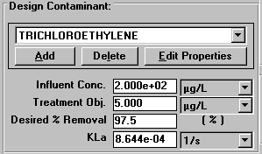
Figure 7 - Contaminant Selection Portion of Rating Mode Window
It can be seen that the value for the mass transfer coefficient of trichloroethylene calculated by the program to be 8.644E-04 1/s agrees with the sample calculations of the design mode section (see Eq. 3).
To delete each chemical click on the Delete button located in between the Add and Edit Properties buttons shown in Figure 3 (and highlighted in Figure 7). Click the Delete button once for each chemical until all chemicals have been deleted from the Design Contaminant list box.

Transferring Properties from StEPP™ to ASAP™
ASAP™ has the capability of transferring the physical properties of contaminants from Software to Estimate Physical Properties (StEPP™). There are two options for transferring data from StEPP™ into ASAP™: (a) Create Export File for AdDesignS/ASAP and (b) Copy to Clipboard for AdDesignS/ASAP. Both choices are available in the Options menu within StEPP™. The StEPP™ main window highlighting the Options menu is shown in Figure 8. Figure 8 shows the main StEPP™ window after the chemicals for this design have been selected at 10° C (see StEPP™ manual for how to get to this stage).
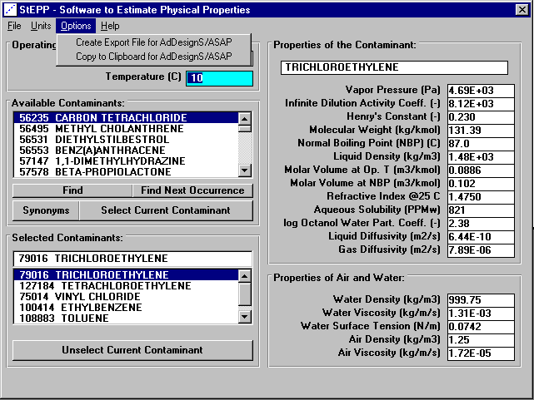
Figure 8 – StEPP™ Main Window
After the contaminants have been selected in StEPP™ and their properties calculated at the proper temperature and pressure, they can be transferred from StEPP to ASAP using either of two options, which are described below: (a) Create Export File for AdDesignS/ASAP and (b) Copy to Clipboard for AdDesignS/ASAP.

Transferring Chemical Properties from StEPP™ to ASAP™ Using the Create Export File for AdDesignS/ASAP Option
To create an export file within StEPP™ for use in ASAP™, click on the Create Export File for AdDesginS™/ASAP™ in the StEPP™ Options menu. This option is shown in Figure 8. After clicking this option, the Save StEPP™ Export File window shown in Figure 9 appears. Give the export file a .exp extension (the default), such as surf10.exp, and the file will be readily importable into ASAP™, as described below.
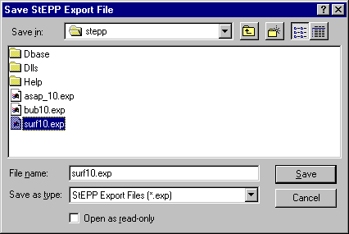
Figure 9 - Save StEPP™ Export File Window
To import the StEPP™ export file described above (surf10.exp), click on the Add button shown on the bottom left-hand corner of the window shown in Figure 3 (and highlighted in Figure 7). Figure 10 shows the window that will appear.
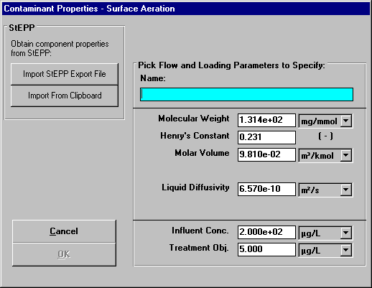
Figure 10 - Contaminant Properties Input Window
Click on the Import StEPP™ Export File button shown in Figure 10. The window shown in Figure 11 will appear.
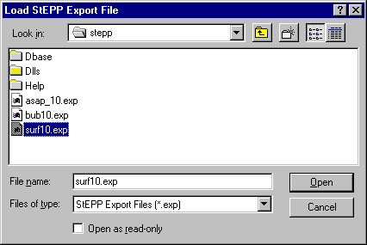
Figure 11 - Load StEPP™ Export File Window
Select the file surf10.exp that was created earlier and the chemicals selected in StEPP™ for the given design will be imported into ASAP™. Figure 12 appears after the import and shows a successful import was achieved.
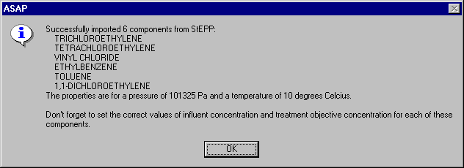
Figure 12 - Successful StEPP™ Property Retrieval Indication Window

Transferring Chemical Properties from StEPP™ to ASAP™ Using the Copy to Clipboard for AdDesignS/ASAP Option
To copy selected StEPP™ data to the Windows clipboard for export into ASAP™, select Copy to Clipboard for AdDesignS/ASAP from the Options menu within StEPP™. The message box shown in Figure 13 will appear, verifying that all of the StEPP™ data is now stored in the Windows clipboard.
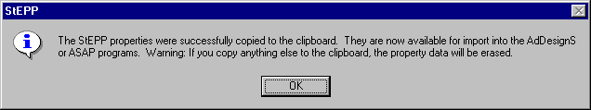
Figure 13 – Successful Copy to Clipboard from StEPP™ Message Box
To import the chemicals and their physical properties to ASAP™ from the data on the clipboard, click on the Add button in the Component Properties block of the ASAP™ main window. The Component Properties window shown in Figure 14 will appear.

Figure 14 - Component Properties window (adding new components)
To import the StEPP™ data from the Windows clipboard, click the Import from Clipboard button on the Component Properties window. The window shown in Figure 15 will appear, showing that the properties have been successfully transferred into ASAP.
Figure 15 – Successful Import from StEPP™ Window

Manipulation of Data Required after Transferring Properties from StEPP™ to ASAP™
Click on the OK button to continue. Figure 3 appears. As shown in Figure 12 or Figure 15, it is necessary to input influent concentrations and treatment objectives for each of the six components retrieved. To do so, select each contaminant one at a time in the Design Contaminant list box shown in the lower left-hand corner of Figure 3. Then click on the Edit Properties button. Figure 16 shows the window that appears for trichloroethylene.
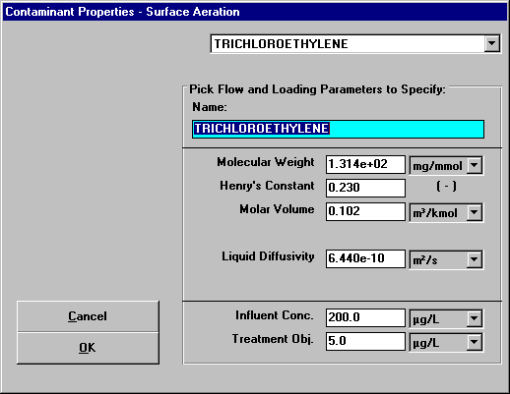
Figure 16 - Specify Contaminant Properties Window for Trichloroethylene
The properties molecular weight, Henry’s constant, molar volume, and liquid diffusivity are already correct since they were retrieved from StEPP™. The influent concentration and treatment objective shown at the bottom of the screen must be input since they will vary from case to case. These properties shown in Figure 16 already reflect the values for the current design case. It is seen that the properties shown in Figure 16 agree with the trichloroethylene properties shown in Tables 1 and 2.
Figure 17 shows the Specify Contaminant Properties window for tetrachloroethylene. It can be seen that the properties shown in Figure 17 agree with the properties of tetrachloroethylene shown in Tables 1 and 2.
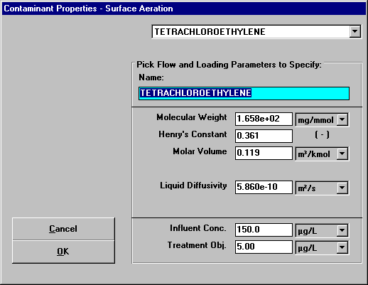
Figure 17 - Specify Contaminant Properties Window for Tetrachloroethylene
Figure 18 shows the Specify Contaminant Properties window for vinyl chloride. It can be seen that the properties shown in Figure 18 agree with the properties of vinyl chloride shown in Tables 1 and 2.
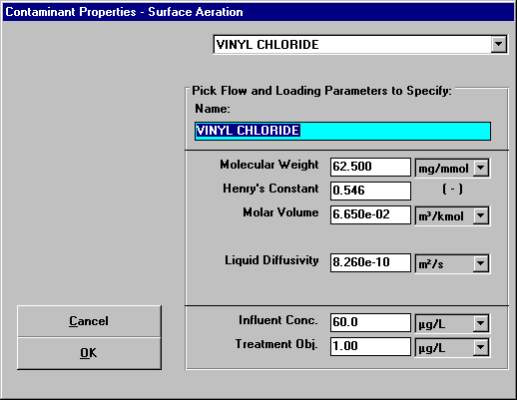
Figure 18 - Specify Contaminant Properties Window for Vinyl Chloride
Figure 19 shows the Specify Contaminant Properties window for ethylbenzene. It can be seen that the properties shown in Figure 19 agree with the properties of ethylbenzene shown in Tables 1 and 2.
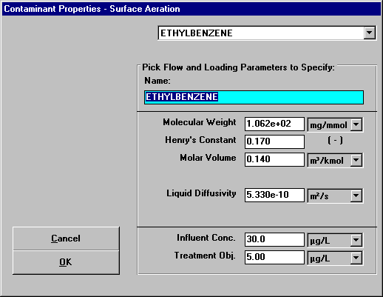
Figure 19 - Specify Contaminant Properties Window for Ethylbenzene
Figure 20 shows the Specify Contaminant Properties window for toluene. It can be seen that the properties shown in Figure 20 agree with the properties of toluene shown in Tables 1 and 2.
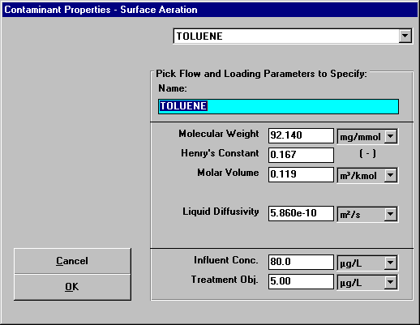
Figure 20 - Specify Contaminant Properties Window for Toluene
Figure 21 shows the Specify Contaminant Properties window for 1,1-dichloroethene. It can be seen that the properties shown in Figure 21 agree with the properties of 1,1-dichloroethene shown in Tables 1 and 2.
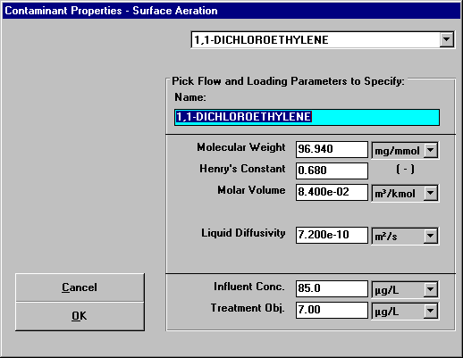
Figure 21 - Specify Contaminant Properties Window for 1,1-Dichloroethene

Flow Parameters
The flow is shown in the upper right-hand side of Figure 3. This portion of Figure 3 is reproduced here as Figure 22.

Figure 22 - Flow Rate in Rating Mode Window
The water flow rate of 2000 gpm is given in the problem statement.

Tank Parameters
The tank parameters are shown at the top of the right-hand column of the rating mode window shown in Figure 3. This portion of the window is highlighted as Figure 23.
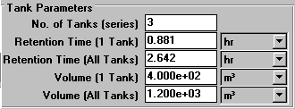
Figure 23 - Tank Parameters Section of Rating Mode Window
The values of the tank parameters shown in Figure 3 (and highlighted in Figure 23) agree with the sample calculations of the design mode section. The number of tanks in the series is given in the problem statement. Any one of the other parameters in this section may be specified and the program will calculate the remainder. Case 1 of the sample calculations allows for specification of the volume of one tank. The retention time of 0.88 hr calculated by the program agrees with the sample calculations performed in this case (see Eq. 8). The total retention time for the system determined by the program to be 2.64 hr corresponds to the value calculated in the sample calculations (see Eq. 9). The volume of the entire system calculated as 1200 m³ by the program agrees with the sample calculations performed previously (see Eq. 5).

Concentration Results for Trichloroethylene
The effluent concentrations of the liquid phase and the achieved percent removal are found in the middle of the right-hand column of the rating mode window as shown in Figure 3 (and highlighted in Figure 24).
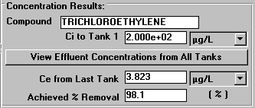
Figure 24 - Concentration Results Portion of Rating Mode Window

Click on the View Effluent Concentrations from All Tanks button shown in Figure 3 (and highlighted in Figure 24) to see the effluent concentrations of the liquid of the contaminant from each tank. The window that appears is shown in Figure 25.
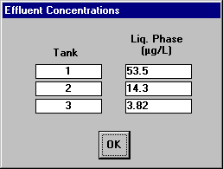
Figure 25 - Effluent Concentrations from Each Tank
It can be seen that the values calculated by the program for the liquid phase effluent concentrations; 53.5 μg/L from tank 1 (see Eq. 2), 14.3 μg/L from tank 2 (see Eq. 3), and 3.82 μg/L from tank 3 (see Eq. 4), match the values shown in the sample calculations.
Click the OK button shown in Figure 25 to return to the rating mode window shown in Figure 3.

Concentration Results for Other Compounds
Figure 26 - Figure 30 shows the ASAP™ main window with the effluent concentrations for each tank window for the other components. It is seen from the figures that the values calculated by the program match the results given in Table 2.

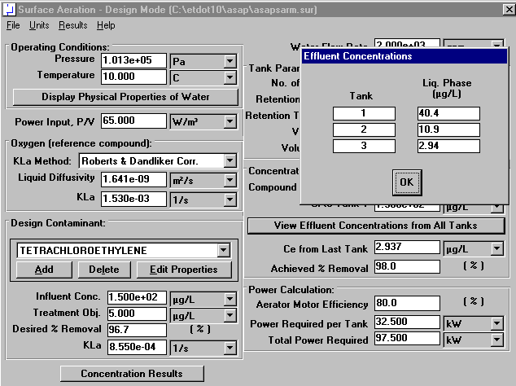
Figure 26 - Concentration Results for Tetrachloroethylene
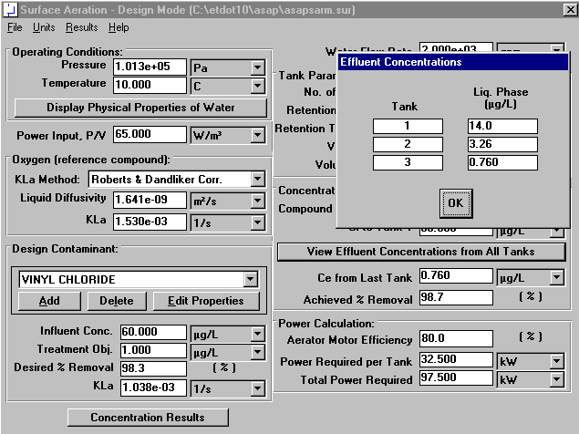
Figure 27 - Concentration Results for Vinyl Chloride
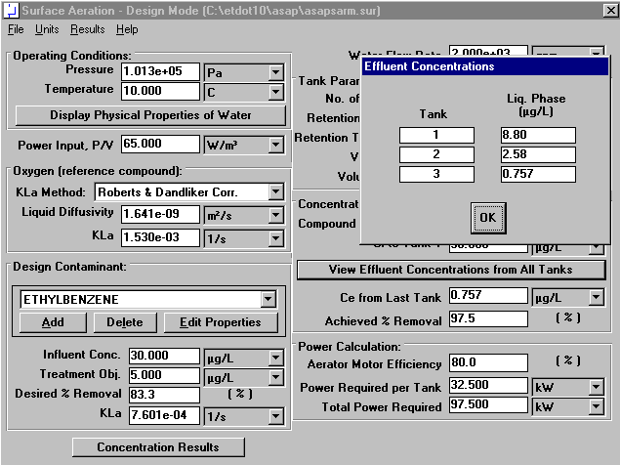
Figure 28 - Concentration Results for Ethylbenzene
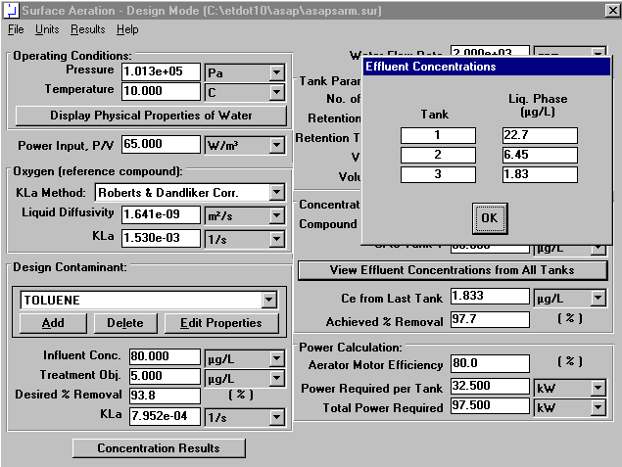
Figure 29 - Concentration Results for Toluene
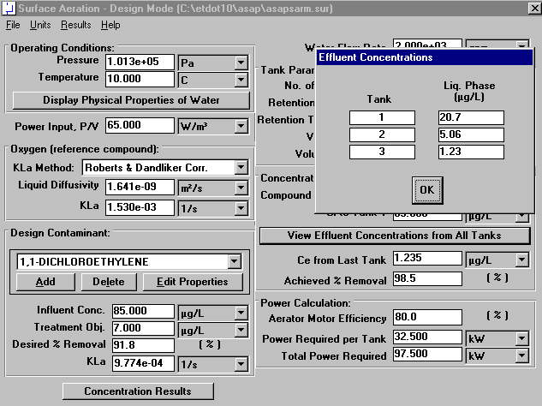
Figure 30 - Concentration Results for 1,1-Dichloroethene

Power Input
The power input to the system is displayed in middle of the left-hand column of the rating mode window as shown in Figure 3 (and highlighted in Figure 31). This value is specified by the user.

Figure 31 - Power Input Portion of Rating Mode Window

Power Calculations
Other power parameters can be viewed in the lower right-hand corner of the rating mode window as shown in Figure 3 (and highlighted in Figure 32). A value is chosen for the aerator motor efficiency by the user. The power required per tank is calculated by the program as 32.5 kW which agrees with the sample calculations (see Eq. 6). The total power required is also calculated by the program and found to be 97.5 kW which again agrees with the sample calculations (see Eq. 5).
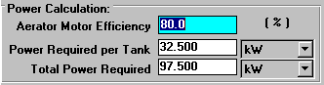
Figure 32 - Power Calculation Section of Rating Mode Window

Viewing Effluent Concentration Results for All Contaminants
For the current design, it is useful to see what the effluent concentrations of all contaminants on the same window. ASAP provides a convenient method for seeing these results.
By clicking on the Concentration Results button in the lower left-hand corner of the surface aeration – rating mode window shown in Figure 3, the user will see the concentration results for all contaminants using the given design (see Figure 33).
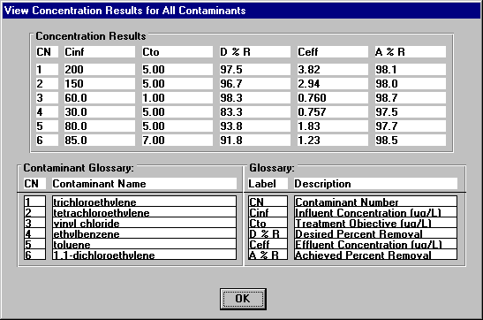
Figure 33 – View Concentration Results for All Contaminants Window
This window provides a quick method to see whether the given design will meet the treatment objectives for all contaminants.

