Development of Process Design Equations for Packed Tower Aeration

Development
This development is for a single compound in packed tower aeration. All liquid phase concentrations, gas phase concentrations, and mass transfer coefficients specified in the development are relevant to a specific generic compound. The development presented is for a single tower. The model development for the countercurrent packed tower aeration process is well established in the literature (Ball, et al, 1981; Roberts, et al, 1985; Singley, et al, 1981; Kavanaugh and Trussell, 1981; Gross and TerMaath, 1985; Sherwood and Hollaway, 1940; Umphres, et al, 1983; McKinnon and Dyksen, 1984; Cummins and Westrick, 1983; Roberts and Levy, 1985; Treybal, 1980; Hand, et al, 1986; Hand and Crittenden, 1986; Ball and Edwards, 1992; Dzombak, et al, 1993).

Operating Line Equation
The first step is to develop the operating line equation for packed tower aeration. Assumptions incorporated into the development of the operating line equation include: (1) steady state conditions prevail in the tower, (2) air flow rate and water flow rate are constant along the column, (3) concentration of organics in both streams is small, and (4) no reaction occurs. Figure 1 shows a schematic of a packed tower.
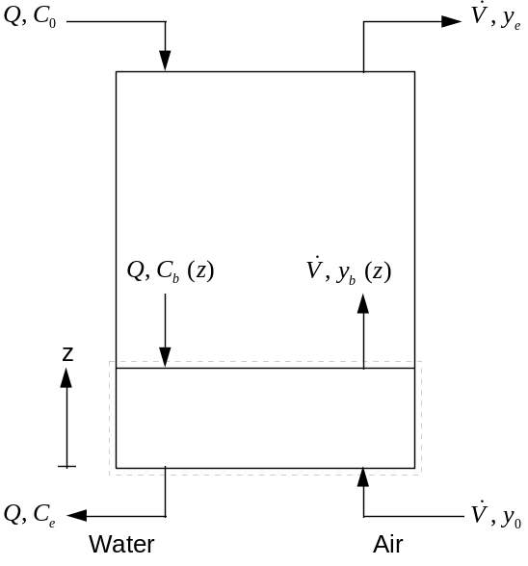
Figure 1 - Schematic of a Packed Tower
Taking a mass balance around the lower part of the column, which is surrounded by a dashed box in Figure 1, results in:
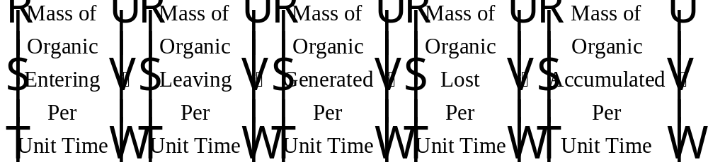
Eq. 1
After some rearrangement, Eq. 1 can be written as:
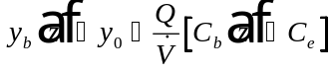
Eq. 2
This is the operating line equation for packed tower aeration. A plot showing the operating line for packed tower aeration is given in Figure 2.
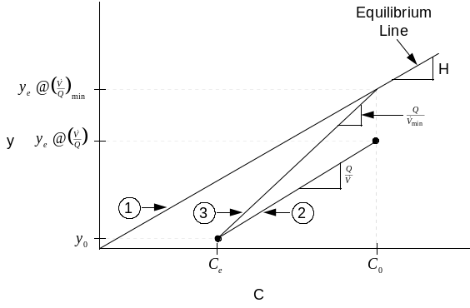
Figure 2 - Operating Line Diagram for a Packed Tower
Equilibrium between the air and water phases in packed tower aeration is governed by Henry’s Law. Line 1 in Figure 2 is the equilibrium line for packed tower aeration. The equation of the equilibrium line is given below:
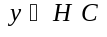
Eq. 3
Line 2 in Figure 2 is the operating line equation for packed tower aeration that was derived above and shown in Eq. 2. Using the operating line (Line 2) in Figure 2, it is possible to determine the effluent concentration in the gas phase, , that will be achieved for a given air to water ratio, , gas phase influent concentration, (which is typically assumed to be zero for packed tower aeration), and treatment objective, 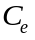. Line 3 in Figure 2 represents a special case of the operating line equation. For Line 3, the influent water is in equilibrium with the exiting air (i.e. 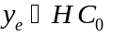). The slope of Line 3 represents the inverse of the minimum air to water ratio that can be used to meet the treatment objective. Rearranging Eq. 2 to describe this situation results in:
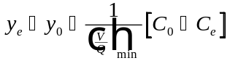
Eq. 4
Substituting and applying the assumption that equals zero for pure influent air, Eq. 4 can be written as follows after solving for :
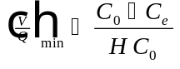
Eq. 5
The minimum air to water ratio, , represents the minimum air to water ratio that can be applied for a packed tower to meet its treatment objective, . If the air to water ratio applied is less than the minimum air to water ratio, it will not be possible to design a packed tower capable of meeting the treatment objective. Hand, et al (1986) determined that operating at an air to water ratio approximately 3.5 times the minimum air to water ratio minimized both the volume and power requirements for a full-scale packed tower.

Design Equation
The next step is to develop the design equation used to calculate the tower length for packed tower aeration. Assumptions incorporated into the development of the design equation include: (1) steady state conditions prevail in the tower, (2) air flow rate and water flow rate are constant along the column, and (3) no reaction occurs.
Figure 3 shows a schematic of a packed tower that is used to develop the design equation for packed tower aeration.
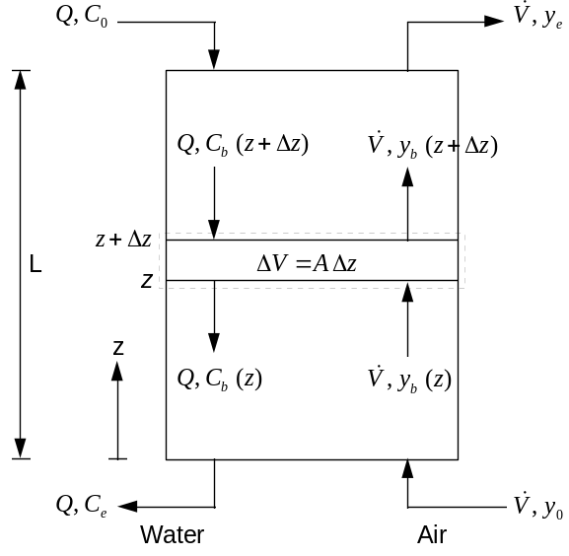
Figure 3 - Schematic of a Packed Tower Used in Development of Design Equation
It is necessary to take a liquid phase mass balance around the differential element surrounded by a dashed box in Figure 3. Figure 4 shows a schematic of the differential element applicable to the case of a liquid side mass balance.
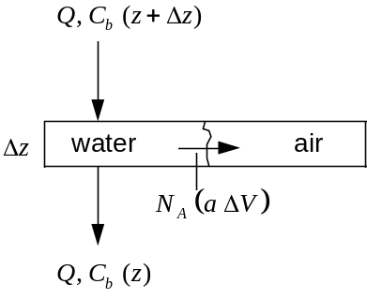
Figure 4 - Schematic of Differential Element in Packed Tower Used for Liquid Phase Mass Balance
The liquid phase mass balance around the differential element is written below:
Eq. 6
The term 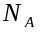 in Eq. 6 represents the mass flux lost from the liquid phase (and entering the air phase). is proportional to a concentration driving force for mass transfer. The proportionality constant is referred to as the mass transfer coefficient and is denoted by 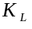. The concentration driving force for packed tower aeration is the difference between the bulk liquid phase concentration, 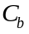, and the liquid phase concentration at the air-water interface, 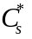. The equation for mass flux can be represented as:
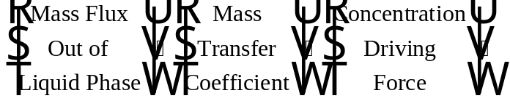
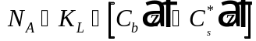
Eq. 7
Applying this relationship and the fact that the volume of the differential element is equal to the cross-sectional area of the tower times the height of the differential element (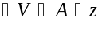) to Eq. 6 results in:
Eq. 8
The term in Eq. 6 and Eq. 8 is defined as the area available for mass transfer divided by the vessel volume. The term does not vary with contaminant in packed tower aeration. Therefore, the term is typically lumped together with the liquid phase mass transfer coefficient term, , and the combined term is referred to as the overall liquid phase mass transfer coefficient, 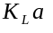. Eq. 8 can be written in terms of as:
Eq. 9
Eq. 10
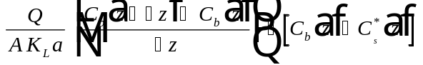
Eq. 11
Taking the limit as approaches zero results in:
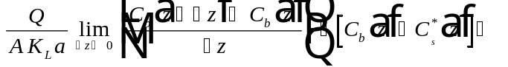
Eq. 12
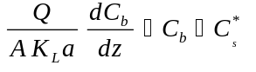
Eq. 13
Integrating Eq. 13 results in:
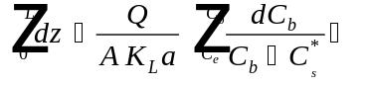
Eq. 14
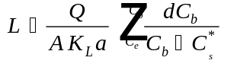
Eq. 15
In order to solve the integral on the right-hand side of Eq. 15, it is useful to examine the operating line diagram for packed tower aeration, which is shown below in Figure 5.
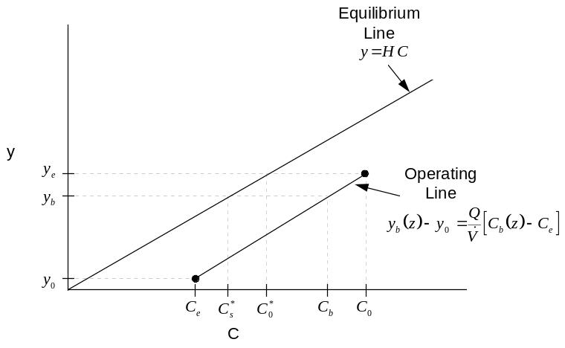
Figure 5 - Operating Line Diagram Used in Development of Design Equation for Packed Tower Aeration
From Figure 5, it is clear that the liquid phase concentration at the air-water interface, , that is in equilibrium with the bulk air phase concentration, , can be represented by the following relationship:
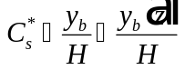
Eq. 16
Substituting in the equation for the operating line that was developed earlier (Eq. 2) and that is shown in Figure 5 results in:
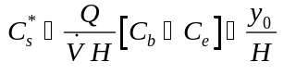
Eq. 17
Substituting Eq. 17 into Eq. 15 results in the following:
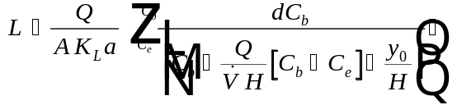
Eq. 18
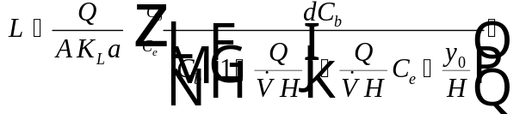
Eq. 19
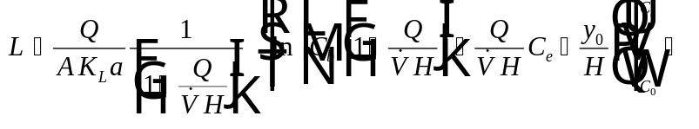
Eq. 20
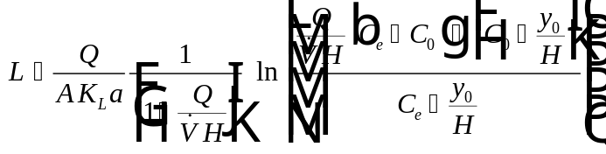
Eq. 21
Eq. 21 can be further simplified after examining the operating line diagram and equation shown in Figure 5. Solving the operating line equation (Eq. 2) for at the point where 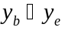 and 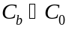 then dividing both sides of the resultant equation by results in:
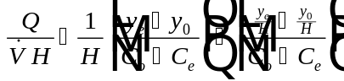
Eq. 22
By looking at the operating line diagram in Figure 5, it is clear that the variable 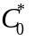 is defined as the liquid phase concentration that is in equilibrium with the exiting gas phase concentration, . That is, 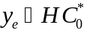. Substituting into Eq. 22 results in:
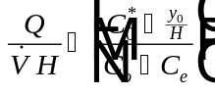
Eq. 23
By rearranging Eq. 23, it is possible to show that the following relationship holds true:
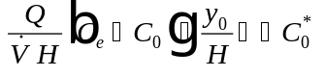
Eq. 24
Subtracting Eq. 23 from 1 results in the following:
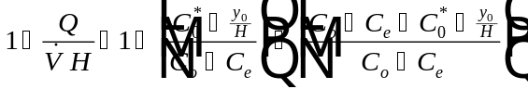
Eq. 25
Substituting Eq. 24 and Eq. 25 into Eq. 21 results in an expression for tower length, :

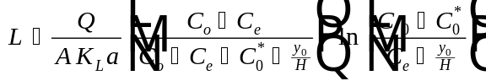
Eq. 26
For a packed tower, it is typically assumed that the incoming air phase concentration is approximately equal to zero (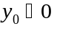). Making this assumption, Eq. 26 simplifies to:
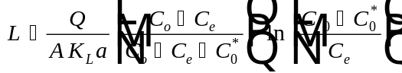
Eq. 27
In packed tower aeration, the tower length is often defined as the product of the height of a transfer unit (or HTU) and the number of transfer units (or NTU). The following two equations define HTU and NTU:
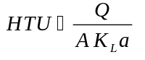
Eq. 28
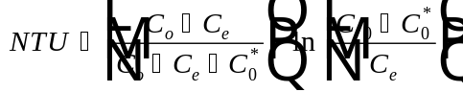
Eq. 29
Substituting Eq. 28 and Eq. 29 into Eq. 27 results in:
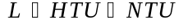
Eq. 30
The parameters required to determine tower height using Eq. 27 are described below:
Water flow rate (L³/T). This parameter is user-specified.
Cross-sectional area of the packed tower (L²). This parameter is calculated based on the desired pressure drop in the tower. The method is shown later.
Overall liquid phase mass transfer coefficient (1/T). This parameter is calculated based on the Onda correlation, which is described in detail later.
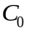 Influent liquid phase concentration (M/L³). This parameter is user-specified.
Effluent liquid phase concentration (M/L³). In Eq. 27, this parameter represents the treatment objective, which is user-specified.
Liquid phase concentration in equilibrium with the exiting gas phase concentration, (M/L³). This parameter can be found by rearranging Eq. 24 with the assumption that : 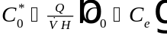.
Henry’s Law constant which describes the equilibrium between the air and water phases in a packed tower (dimensionless). This value is available from Software to Estimate Physical Properties (StEPP™) and from various literature sources (Ashworth, et. al., 1988; Gossett, 1987).
Inverse of air to water ratio, , which is user-specified.

Design Mode

In design mode, it is desired to size a packed tower in order to exactly meet the treatment objective, 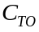. Substituting 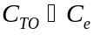 into Eq. 27 results in the design equation for packed tower aeration:
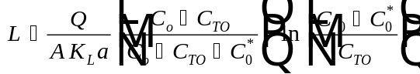
Eq. 31
Substituting 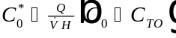 into Eq. 31 and introducing the stripping factor, 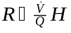, results in a way that the design mode equation is often written:
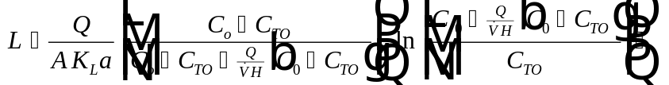
Eq. 32
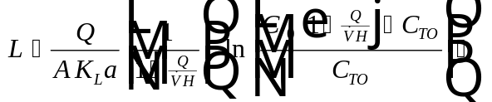
Eq. 33
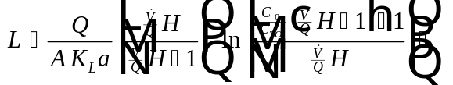
Eq. 34
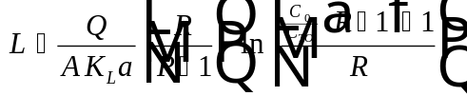
Eq. 35
Estimation of mass transfer coefficient, and cross-sectional area, , for packed tower aeration are described in detail later.

Rating Mode
In rating mode, it is possible to determine effluent concentration of various compounds for an existing tower. In rating mode, the following variables are specified: (1) tower height, (2) tower diameter, (3) type of packing, (4) water flow rate, (5) air flow rate, (6) pressure, (7) temperature, (8) influent concentration, and (9) mass transfer coefficient. Knowing these variables, it is possible to determine effluent concentration and gas pressure drop for the tower. The effluent concentration is found by rearranging Eq. 27 and solving for effluent concentration, (recalling that 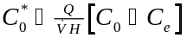):
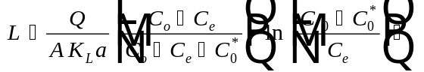
Eq. 36
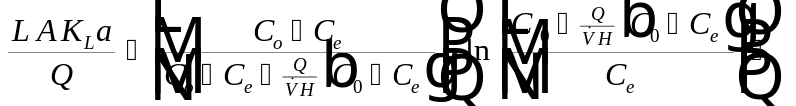
Eq. 37
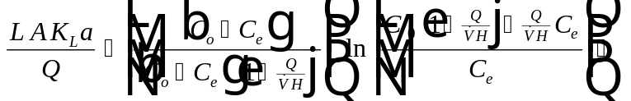
Eq. 38
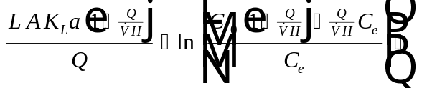
Eq. 39
Eq. 40
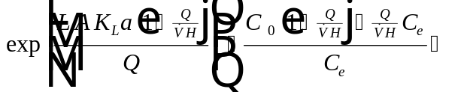
Eq. 41
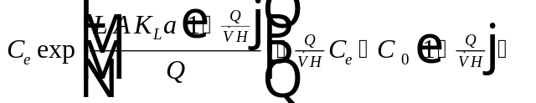
Eq. 42
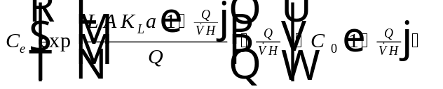
Eq. 43
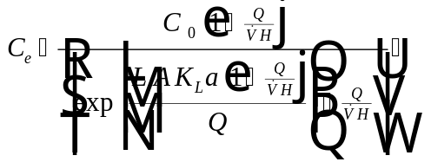 Divide top and bottom by 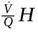
Eq. 44
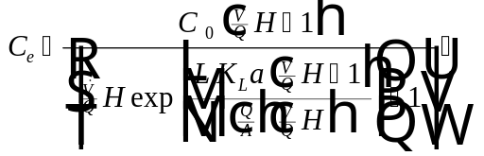
Eq. 45
The term in Eq. 45 is stripping factor, . Substituting into Eq. 45 results in:
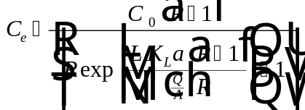
Eq. 46
In rating mode, the pressure drop for the tower can be calculated using an iterative method based on the Eckert pressure drop curves. This process is described in detail later.

Nomenclature
Area available for mass transfer divided by vessel volume (L²/L³)
Cross-sectional area of the packed tower (L²)
,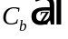 Bulk liquid phase concentration at axial position along tower (M/L³)
Effluent liquid phase concentration (M/L³)
Influent liquid phase concentration (M/L³)
Liquid phase concentration in equilibrium with exiting gas phase concentration, (M/L³)
,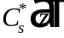 Liquid phase concentration at air-water interface, which is in equilibrium with bulk air (M/L³)
Treatment objective (M/L³)
Henry’s Law constant (dimensionless)
Height of a transfer unit (L)
Liquid phase mass transfer coefficient (L/T)
Overall liquid phase mass transfer coefficient (1/T)
Packed tower height (L)
Mass flux leaving the liquid phase and entering the gas phase (M/L²/T)
Number of transfer units (dimensionless)
Water flow rate (L³/T)
Stripping factor (L³/L³)
Volume of packed tower (L³)
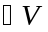 Volume of a differential element in a packed tower (L³)
Air flowrate (L³/T)
Air to water ratio (L³/L³)
Minimum air to water ratio that will allow a packed tower to meet the treatment objective for a contaminant (L³/L³)
,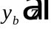 Bulk gas phase concentration at axial position along tower (M/L³)
Effluent gas phase concentration (M/L³)
Influent gas phase concentration (M/L³)
Axial position in the tower (L)
Width of a differential element in packed tower aeration (L)

References
Ashworth, R. A., G. B. Howe, M. E. Mullins, and T. N. Rogers, “Air--Water Partitioning Coefficients of Organics in Dilute Aqueous Solutions,” Journal of Hazardous Materials, 18, 25-36 (1988).
Ball, W. P., M. D. Jones, and M. C. Kavanaugh, “Mass Transfer of Volatile Organic Compounds in Packed Towers,” Journal WPCF, 56, 127 (1984).
Ball, B. R. and M. D. Edwards, “Air Stripping VOCs from Groundwater: Process Design Considerations,” Environmental Progress, 11, 1, 39-48 (1992).
Cummins, M.D. and J.J. Westrick, Proc. ASCE Env. Engrg. Conf., Boulder, CO (1983).
Dzombak, D. A., S. B. Roy, and H. J. Fang, “Air-Stripper Design and Costing Computer Program,” Journal AWWA, 85, 10, 63-72 (1993).
Gossett, J. M., “Measurement of Henry’s Law Constants for C₁ and C₂ Chlorinated Hydrocarbons,” Environ. Sci. Technol., 21, 202-208 (1987).
Gross, R. L. and S. G. TerMaath, “Packed Tower Aeration Strips Trichloroethene from Groundwater,” Environmental Progress, 4, 2 (1985).
Hand, D. W., J. C. Crittenden, J. L. Gehin, and Benjamin W. Lykins, Jr., “Design and Evaluation of an Air-Stripping Tower for Removing VOCs from Groundwater,” Journal AWWA, 78, 9, 87-97 (1986).
Hand, D. W. and J. C. Crittenden, “Design of Packed Tower Aeration Systems,” Association of Environmental Engineering Professors Computer Software Manual (J. C. Crittenden, Editor), Michigan Technological Univ. (1986).
Kavanaugh, M. C. and R. R. Trussell, “Design of Aeration Towes to Strip Volatile Contaminants from Drinking Water,” Journal AWWA, 72, 12, 684 (1980).
McKinnon, R. J. and J. E. Dyksen, “Removal of Organics from Groundwater Using Aeration Plus Carbon Adsorption,” Journal AWWA, 76, 5, 42 (1984).
Roberts, P. V., G. D. Hopkins, C. Munz, and A. H. Riojas, “Evaluating Two-Resistance Models for Air Stripping of Volatile Organic Contaminants in a Countercurrent, Packed Column,” Environ. Sci. Technol., 19, 164-173 (1985).
Roberts, P. V. and J. A. Levy, “Energy Requirements for Air Stripping Trihalomethanes,” Journal AWWA, 77, 4, 138 (1985).
Sherwood, T. K. and F. A. Hollaway, “Performance of Packed Towers - Liquid Film Data for Several Packings,” Trans. Amer. Inst. Chem. Engrs., 36, 39 (1940).
Singley, et al, “Trace Organics Removal by Air Stripping,” Supplementary Rept. to AWWARF, Denver, Colorado (1981).
Treybal, R. E., Mass Transfer Operations. Chem. Engrg. Series, McGraw-Hill Book Co., New York, 3rd Ed. (1980).
Umphres, M. D., C. H. Tate, M. C. Kavanaugh, and R. R. Trussell, “A Study of THM Removal by Packed Tower Aeration,” Journal AWWA, 75, 8, 414 (1983).

