Development of Process Design Equations for Surface Aeration

Development
This development is for a single compound in surface aeration. All liquid phase concentrations, gas phase concentrations, and mass transfer coefficients specified in the development are relevant to a specific generic compound, which could be anything.

Single Tank
Figure 1 shows a schematic of a surface aeration system for a single tank. Model development for surface aeration has been described in the literature (Matter-Müller, et al, 1981; Roberts and Dändliker, 1983; Roberts, et al, 1984; Roberts and Levy, 1985; Munz and Roberts, 1989). This development of process design equations for surface aeration incorporates the following assumptions: (1) completely mixed liquid phase, (2) the gas phase concentration in the tank equals zero, and (3) the process is at steady state.
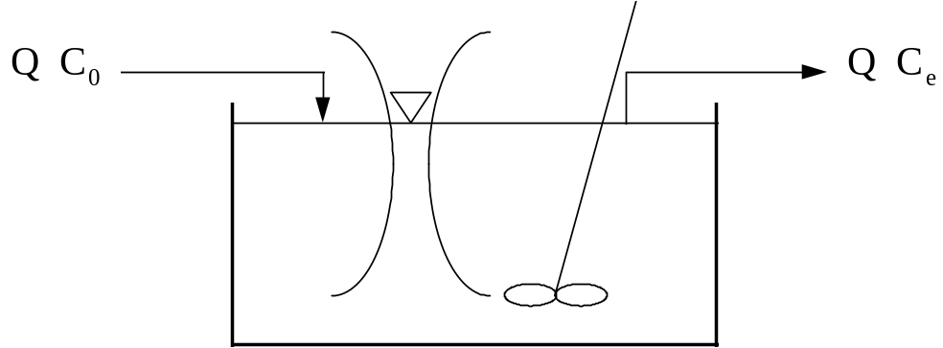
Figure 1 - Schematic of Surface Aeration Configuration
An overall mass balance around the tank is given below:
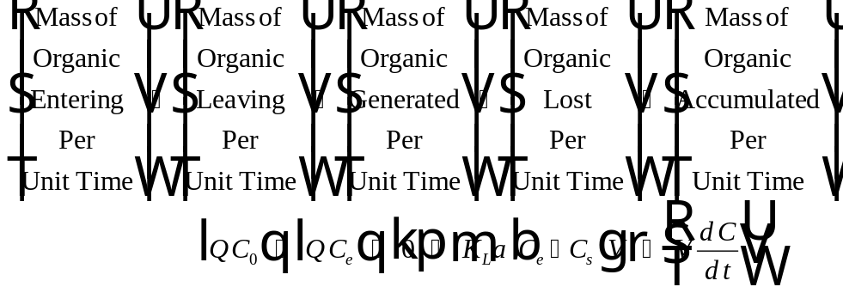
Eq. 1
With the assumption of steady-state conditions, Eq.1 simplifies to:
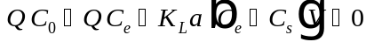
Eq. 2
In surface aeration, it is assumed that the gas phase concentration in the tank, , is equal to zero. As a result of this assumption, it is shown that the liquid phase concentration at the air-water interface, 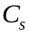, is also equal to zero based on the following relationship:
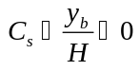
Eq. 3
Substituting Eq. 3 into Eq. 2 results in:
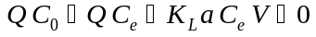
Eq. 4

Design Mode
In design mode, it is desirable to size the surface aeration system (i.e., determine the minimum tank volume that will allow for meeting the treatment objective). This is done by solving Eq. 4 for the volume, V. For design mode, the achieved effluent concentration, C_{e}, is the treatment objective, C_{TO}, so the substitution, C_{e} = C_{TO} is made into Eq. 4.
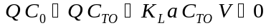
Eq. 5
Solving Eq. 5 for results in the minimum tank volume, , required for a single tank in order to meet the treatment objective in surface aeration:
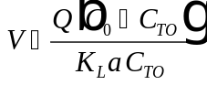
Eq. 6
The design equation for a single surface aeration tank may alternatively be written in terms of the hydraulic retention time of the tank, , where 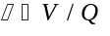. Substituting this relationship into Eq. 6 results in the following expression:
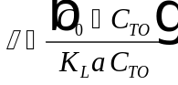
Eq. 7

Rating Mode
The purpose of rating mode is to predict the removal of a given contaminant for an existing tank (i.e. is known and it is desired to find 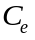). This is accomplished by solving Eq. 4 for , as shown below:
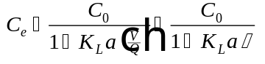
Eq. 8

Tanks in Series
Process performance can often be improved significantly (i.e., less total volume requirements) by configuring the surface aeration system as tanks in series. Figure 2 shows a schematic of a surface aeration system operated with a tanks in series configuration. The derivation of process design equations provided below is for the general case of n tanks in series. Assumptions in the development of the tanks in series equations for surface aeration include: (1) liquid phase behaves as a completely mixed flow reactor, (2) the gas phase concentration of the contaminant in the tank equals zero, (3) the process is at steady state, and (4) each tank will be equally sized with volume, .
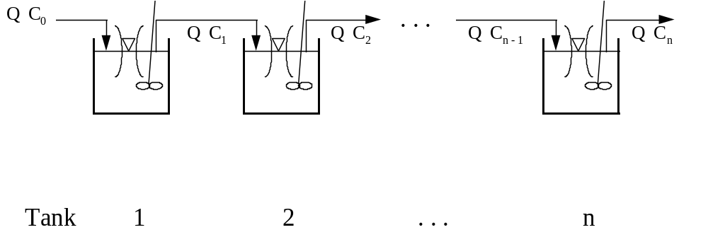
Figure 2 - Schematic of Surface Aeration Tanks in Series Configuration
Mass Balance on Tank 1:
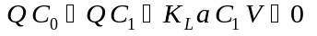
Eq. 9
Solving for the effluent concentration from tank 1, 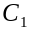:
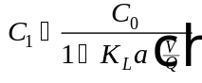
Eq. 10
Similarly, a mass balance around Tank 2 results in:
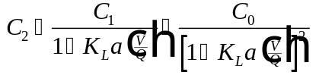
Eq. 11
A mass balance around tank results in:
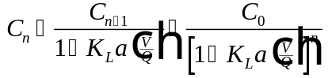
Eq. 12
Taking a closer look at Eq. 10 - Eq. 12, it is possible to write a general formula for the effluent concentration from tank number in surface aeration:
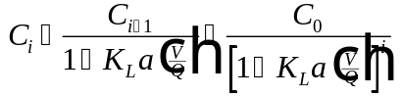
Eq. 13

Design Mode
To solve for the volume of each tank required to meet a specified treatment objective, 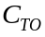, given n tanks, it is necessary to set 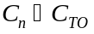 in Eq. 12 and solve for :
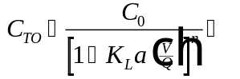
Eq. 14
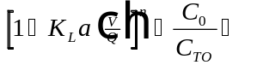
Eq. 15
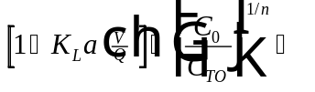
Eq. 16
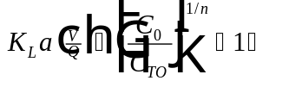
Eq. 17
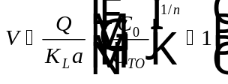
Eq. 18
It is also possible to solve for the hydraulic retention time of each individual tank, , by making the substitution 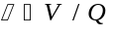 in Eq. 18. The resultant equation is:
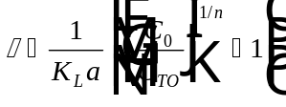
Eq. 19
The volume of all tanks required for a tanks in series configuration consisting of n tanks, 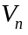, is found by multiplying in Eq. 18 by the number of tanks, . The result is:
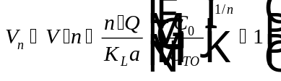
Eq. 20
Likewise, the total hydraulic retention time required for a tanks in series configuration consisting of tanks, 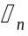, is obtained by multiplying in Eq. 19 by :
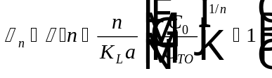
Eq. 21
Examination of Eq. 19 and Eq. 20 reveals that the following relationship holds true:
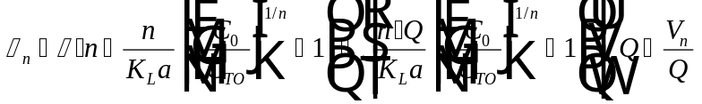
Eq. 22
It should be noted that for surface aeration in design mode, the quantities 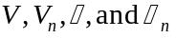 are not independent variables. Calculation of one value allows for determination of the other three parameters using Eq. 18 - Eq. 22. The procedure is to find 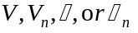 using Eq. 18, Eq. 19, Eq. 20, or Eq. 21, respectively. Once any one quantity is known, it is possible to find the other three quantities using the relationships:
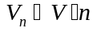
Eq. 23
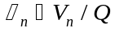
Eq. 24
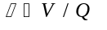
Eq. 25

Rating Mode
The equation to predict the liquid phase effluent concentration for an existing tank in a tanks in series configuration has already been specified above in Eq. 13, which is repeated here. Note that 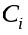 represents the liquid phase effluent concentration from tank number i.
Eq. 26
For surface aeration in rating mode, the user may specify any of the following properties: . Calculation of each of the other properties for each of the four cases will be explained below:
Case 1 - Specify V
Calculate , , and using the following relationships:
Eq. 27
Eq. 28
Eq. 29
Case 2 - Specify
Calculate , , and using the following relationships:
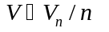
Eq. 30
Eq. 31
Eq. 32
Case 3 - Specify τ
Calculate , , and using the following relationships:
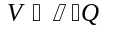
Eq. 33
Eq. 34
Eq. 35
Case 4 - Specify
Calculate , , and using the following relationships:
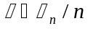
Eq. 36
Eq. 37
Eq. 38

Nomenclature
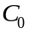 Influent liquid phase concentration to the first surface aeration tank (M/L³)
Effluent liquid phase concentration from tank number 1 for a tanks in series configuration for surface aeration (M/L³)
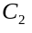 Effluent liquid phase concentration from tank number 2 for a tanks in series configuration for surface aeration (M/L³)
Effluent liquid phase concentration from one surface aeration tank (M/L³)
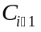 Effluent liquid phase concentration from tank number i-1 for a tanks in series configuration for surface aeration (M/L³)
Effluent liquid phase concentration from tank number i for a tanks in series configuration for surface aeration (M/L³)
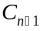 Effluent liquid phase concentration from tank number n-1 for a tanks in series configuration for surface aeration (M/L³)
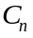 Effluent liquid phase concentration from tank number n for a tanks in series configuration for surface aeration (M/L³)
Liquid phase concentration at the air-water interface in surface aeration (M/L³), which is equal to zero
Treatment objective (M/L³)
Henry’s Law constant (dimensionless)
Number of a given tank in a tanks in series configuration in surface aeration
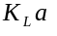 Overall mass transfer coefficient (1/T)
Total number of tanks in series used in a surface aeration configuration
Water flowrate (L³/T)
Volume of an individual surface aeration tank (L³)
Total volume of all surface aeration tanks in a tanks in series configuration (L³)
Concentration in the bulk gas phase, which is assumed to be in equilibrium with the liquid phase concentration at the air-water interface, (M/L³).
Greek Letters
Stanton number (dimensionless)
Hydraulic retention time of an individual surface aeration tank (T)
Total hydraulic retention time of all surface aeration tanks in a tanks in series configuration (T)

References
Matter-Müller, C., W. Gujer, and W. Giger, “Transfer of Volatile Substances from Water to the Atmosphere,” Water Research, 15, 1271-1279 (1981).
Munz, C. and P. V. Roberts, “Gas- and Liquid-Phase Mass Transfer Resistances of Organic Compounds during Mechanical Surface Aeration,” Water Research, 23, 5, 589-601 (1989).
Roberts, P. V. and P. G. Dändliker, “Mass Transfer of Volatile Organic Contaminants from Aqueous Solution to the Atmosphere during Surface Aeration,” Environ. Sci. Technol., 17, 8, 484-489 (1983).
Roberts, P. V., C. Munz, and P. Dändliker, “Modeling Volatile Organic Solute Removal by Surface and Bubble Aeration,” Journal WPCF, 56, 2, 157-163 (1984).
Roberts, P. V. and J. A. Levy, “Energy Requirements for Air Stripping Trihalomethanes,” Journal AWWA, 77, 138-146 (1985).

