Packed Tower Aeration - Nomenclature
Tower area (m²)
Area available for mass transfer divided by vessel volume (m²/m³)
Specific surface area of packing (m²/m³)
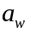 Wetted surface area of packing which is equal to a for a packed tower (m²/m³)
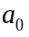 Empirical parameter (dimensionless)
Empirical parameter (dimensionless)
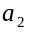 Empirical parameter (dimensionless)
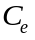 Effluent Concentration (μg/L)
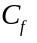 Packing factor (dimensionless)
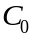 Concentration discharged (μg/L)
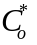 Liquid phase concentration in equilibrium with exiting gas (μg/L)
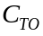 Treatment objective concentration (μg/L)
Tower diameter (m)
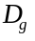 Gas diffusivity (m²/s)
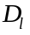 Liquid diffusivity (m²/s)
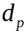 Nominal diameter of packing material (m)
Empirical parameter (dimensionless)
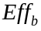 Blower efficiency (expressed as decimal), which is a net efficiency accounting for both the fan and motor on the blower
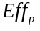 Pump efficiency (expressed as decimal)
Empirical parameter (dimensionless)
Froude number (dimensionless)
Gravitational constant (m/s²) = 9.81
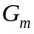 Gas mass loading rate (kg/m²/s)
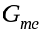 Mass flow rate of air (kg/s)
Henry’s constant (dimensionless)
Gas phase mass transfer coefficient (m/s)
Liquid phase mass transfer coefficient (m/s)
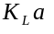 Design mass transfer coefficient (1/s)
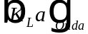 Onda mass transfer coefficient (1/s)
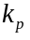 Constant used to estimate gas pressure drop in tower for losses other than that in the tower packing (N s²/m⁴) = 275
Packing height (m)
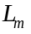 Liquid mass loading rate (kg/m²/s)
Empirical parameter (dimensionless)
Molecular weight (kg/kmol)
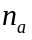 Constant used in determining blower brake power = 0.283 for air
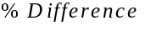 Percent difference between 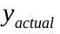 and 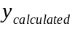 for a trial pressure drop per unit length, 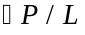
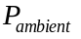 Ambient air pressure (N/m²)
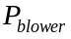 Blower brake power (kW)
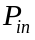 Inlet air pressure to packed tower (bottom of tower) (N/m²)
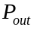 Outlet air pressure from packed tower (top of tower) (N/m²)
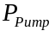 Pump brake power (kW)
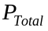 Total power requirement for packed tower aeration (kW)
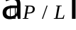 Pressure drop per unit length (N/m²/m)
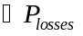 Pressure drop through the demister, packing support plate, duct work, inlet and outlet of the tower (N/m²)
Water flowrate (m³/s)
Stripping Factor (dimensionless)
Reynolds number (dimensionless)
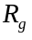 Universal gas constant (J/kg/K) = 286.7
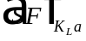 Safety factor (dimensionless)
Operating temperature (K)
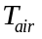 Air temperature (K)
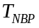 Normal boiling point temperature (° C)
Tower volume (m³)
Air flowrate (m³/s)
Air to water ratio (dimensionless)
 Minimum air to water ratio (dimensionless)
 User-specified air to water ratio (dimensionless)
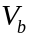 Molar volume (m³/kmol)
Weber number (dimensionless)
Actual value of the y-axis on the Eckert curve for rating mode
Calculated value of the y-axis on the Eckert curve for rating mode based on a trial pressure drop per unit length value,
Greek Letters
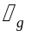 Air viscosity (kg/m/s)
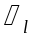 Water viscosity (kg/m/s)
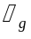 Air density (kg/m³)
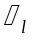 Water density (kg/m³)
Water surface tension (N/m)
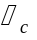 Critical surface tension of packing (N/m)

