Packed Tower Aeration - Rating Mode
The following problem will be used to show sample calculations for packed tower aeration in rating mode. In addition, a sample program run of ASAP™ will be used to verify that the program is correctly duplicating the results of the sample calculations.

Problem Statement
The city of Anytown, USA recently discovered that one of its wells was contaminated with the compounds listed in. In order for them to continue using the well, they were required to remove these compounds below their MCLs, also shown in Table 1. During normal pumping operations, the well produces about 2000 gpm and the water temperature is 10°C.
A packed tower aeration system was designed to remove all the VOCs below their MCLs. Physical and chemical properties for the design were retrieved from StEPP™. The following packing material was used in design: 3.5 inch plastic tripacks. The air to water ratio is 14.8 m³/m³. A safety factor of 0.6 (Design K_{L}a/ Onda K_{L}a) was applied to the mass transfer coefficient calculated from the Onda correlations in the design mode calculations. The tower was designed to have a height of 15.5 m. and a diameter of 2.10m (Note that a 15.5 m [equals 50.9 ft] packing height may not be practical. This manual was written to illustrate the use of the software. In order to design a practical tower size, the user may want to increase the air to water ratio [or air flow rate], but that activity is beyond the scope of this manual.).
Determine the effluent concentrations and tower pressure drop given influent concentrations from Table 1. Show a sample calculation of the effluent concentration for TCE. Show a sample calculation for pressure drop. Present a table showing the influent concentration, treatment objective, design mass transfer coefficient, stripping factor, and effluent concentration for each component.

Table 1 - Contaminants - Influent Concentrations
Compound | Concentration Discharged, C₀ | MCL, C_{TO}
 | (μg/L) | (μg/L)
Trichloroethylene (TCE) | 200.0 | 5.0
Tetrachloroethylene (PCE) | 150.0 | 5.0
Vinyl Chloride | 60.0 | 1.0
Ethylbenzene | 30.0 | 5.0
Toluene | 80.0 | 5.0
1,1-Dichloroethene (1,1-DCE) | 85.0 | 7.0

Properties Needed to Perform Sample Calculations and Program Run
Table 2 shows the chemical properties retrieved from StEPP™ required for packed tower aeration at 10°C and 1 atm.
Table 2 - Chemical Properties from StEPP™ at 10° C and 1 atm
Compound | MW | H | V_{b} | T_{NBP} | D_{l} | D_{g}
 | (kg/kmol) | (-) | (m³/kmol) | (°C) | (m²/s) | (m²/s)
Trichloroethylene | 131.39 | 0.230 | 0.1020 | 87.0 | 6.44E-10 | 7.89E-06
Tetrachloroethylene | 165.84 | 0.361 | 0.1190 | 121.0 | 5.86 E-10 | 7.13 E-06
Vinyl Chloride | 62.50 | 0.546 | 0.0665 | -13.9 | 8.26 E-10 | 1.08E-05
Ethylbenzene | 106.17 | 0.170 | 0.1400 | 136.0 | 5.33 E-10 | 6.88 E-06
Toluene | 92.15 | 0.167 | 0.1190 | 111.0 | 5.86 E-10 | 7.57 E-06
1,1-Dichloroethene | 96.95 | 0.680 | 0.0840 | 31.6 | 7.20 E-10 | 9.05 E-06

Table 3 shows the physical properties of air and water retrieved from StEPP™ at 10°C and 1 atm.
Table 3 - Physical Properties from StEPP™ at 10° C and 1 atm
Property | Units | Value
Water Density, 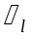 | kg/m³ | 999.75
Water Viscosity, 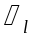 | kg/m/s | 0.00131
Water Surface Tension, | N/m | 0.0742
Air Density, 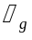 | kg/m³ | 1.25
Air Viscosity, 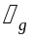 | kg/m/s | 1.72E-05

Table 4 shows the packing properties for 3.5 inch plastic tripacks.
Table 4 - Packing Properties for 3.5 Inch Plastic Tripacks
Property | Units | Value
Nominal Diameter of Packing, 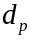 | m | 0.0889
Packing Factor, 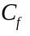 | (-) | 12.0
Specific Surface Area of Packing, | m²/m³ | 124.7
Critical Surface Tension of Packing, 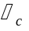 | N/m | 0.033

Note Regarding Comparison of Sample Calculation Values to Sample Program Run
In certain cases, the numbers that appear in the sample calculations are slightly different from the values displayed in the sample program run. These variations can be attributed to rounding.

Sample Rating Mode Calculation of Effluent Concentration for Trichloroethylene as the Design Compound Including Supplementary Parameter Calculations

Effluent Concentration
The calculation of effluent concentration, 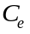, of TCE is shown in Eq. 1.
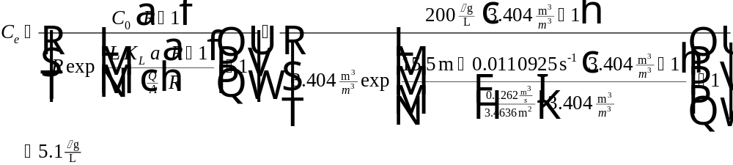
Eq. 1
The parameters required to calculate in Eq. 1 can be found as follows:
Parameter Location
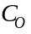 Table 1
Eq. 2
Given in problem statement
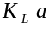 Eq. 10
Given in problem statement
Eq. 18

Stripping Factor
Calculation of stripping factor, , required in Eq. 1 is given in Eq. 2:
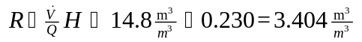
Eq. 2
The parameters required to find R in Eq. 2 can be found as follows:
Parameter Location
3 Possible Cases (see next section)
Table 2

Air Flow Rate (), Water Flow Rate (), Air to Water Ratio (), Liquid Mass Loading Rate (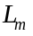), and Air Mass Loading Rate (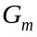)
In packed tower aeration rating mode, it is possible to specify either and , and , or and with the other three parameters calculated. For the rating case presented in the problem statement, and are given as shown in Case 1.
Case 1: Specify and , Calculate , , and
Air Flow Rate
The air flow rate, , through the tower can be calculated by the following relationship:
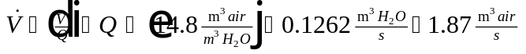
Eq. 3
The parameters required to calculate in Eq. 3, can be found as follows:
Parameter Location
Given in problem statement
Given in problem statement
Water Loading Rate
The water mass loading rate, , can be calculated by the following equation:
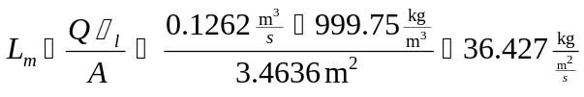
Eq. 4
The parameters required to calculate in Eq. 4 can be found as follows:
Parameter Location
Given
Table 3
Eq. 18
Air Loading Rate
The air mass loading rate, , can be calculated by the following relationship:
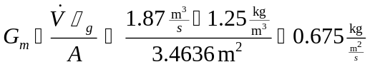
Eq. 5
The parameters required to calculate in Eq. 5 can be found as follows:
Parameter Location
Eq. 3
Table 3
Eq. 18
Case 2: Specify and , Calculate, , and
Air to Water Ratio
The air to water ratio, , can be calculated using the following equation:
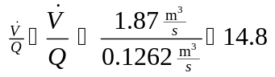
Eq. 6
The parameters required to calculate in Eq. 6 can be found as follows:
Parameter Location
User-specified
User-specified
Water Loading Rate
The water loading rate, , through the tower can be calculated using Eq. 4 shown above.
Air Loading Rate
The air loading rate, , can be calculated from Eq. 5 given above.
Case 3: Specify and , Calculate , , and
Water Flow Rate
The water flow rate, , is calculated by the following equation:
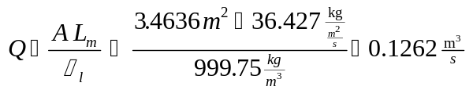
Eq. 7
The parameters required to calculate in Eq. 7 can be found as follows:
Parameter Location
Eq. 18
User-specified
Table 3
Air Flow Rate
The air flow rate, , is found by the following relationship:
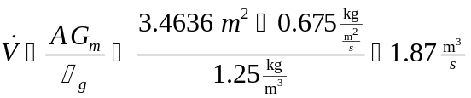
Eq. 8
The parameters required to calculate in Eq. 8 can be found as follows:
Parameter Location
Eq. 18
User-specified
Table 3
Air to Water Ratio
The air to water ratio, , can be calculated using the following equation:
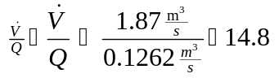
Eq. 9
The parameters required to calculate in Eq. 9 can be found as follows:
Parameter Location
Eq. 8
Given

Actual Mass Transfer Coefficient
The mass transfer coefficient is calculated using the following relationship:
Eq. 10
The parameters required to calculate in Eq. 10 can be found as follows:
Parameter Location
 Eq. 11
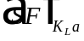 Given in problem statement

Onda Mass Transfer Coefficient
The Onda mass transfer coefficient is found using Eq. 11:
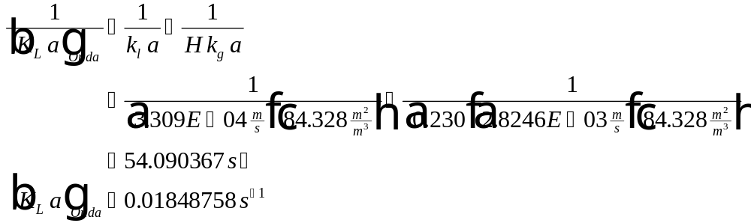
Eq. 11
The parameters required to calculate in Eq. 11 can be found as follows:
Parameter Location
Eq. 12
Eq. 13
Table 2
Eq. 17
Liquid Phase Mass Transfer Coefficient
The liquid phase mass transfer coefficient is calculated by the following relationship:
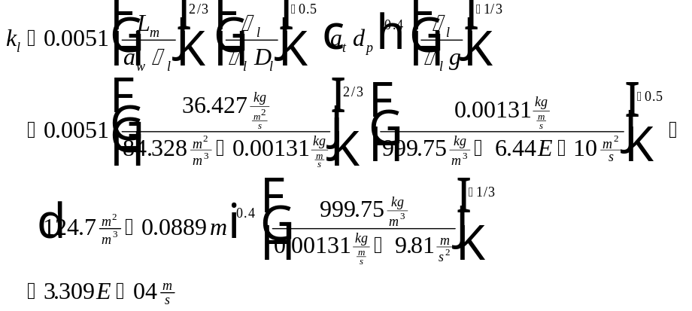
Eq. 12
The parameters required to calculate in Eq. 12 can be found as follows:
Parameter Location
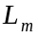 Eq. 4
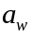 Eq. 13
Table 3
Table 3
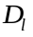 Table 2
Table 4
Table 4
Constant - Known = 9.81 m/s²
Area Available for Mass Transfer Divided by Vessel Volume
The area available for mass transfer divided by the vessel volume, , required in Eq. 12 is calculated in the following equation:
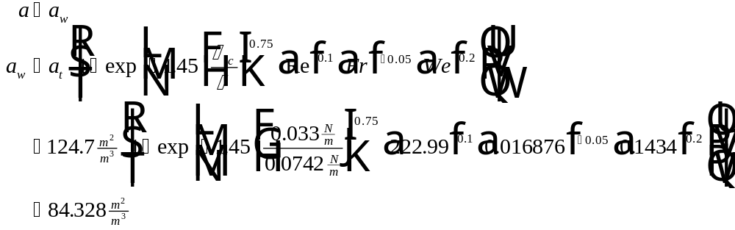
Eq. 13
The parameters required to calculate in Eq. 13 can be found as follows:
Parameter Location
Table 4
Table 4
Table 3
Eq. 14
Eq. 15
Eq. 16
Reynolds Number
The Reynolds Number, Re, needed for the calculation of is defined by:
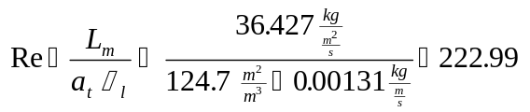
Eq. 14
The parameters required to calculate Re in Eq. 14 can be found as follows:
Parameter Location
Eq. 4
Table 4
Table 3
Froude Number
The Froude Number, Fr, is calculated using the equation below:
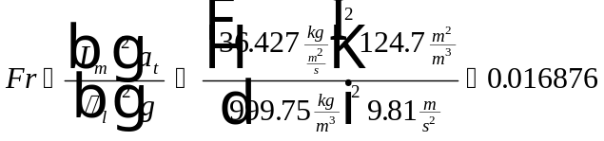
Eq. 15
The parameters required to calculate Fr in Eq. 15 can be found as follows:
Parameter Location
Eq. 4
Table 4
Table 3
Constant - Known = 9.81 m/s²
Weber Number
The Weber Number, We, used to find is found by the following:
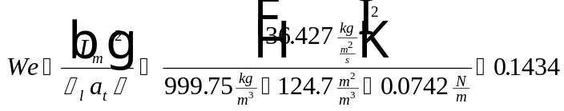
Eq. 16
The parameters required to calculate in Eq. 16 can be found as follows:
Parameter Location
Eq. 4
Table 3
Table 4
Table 3
Gas Phase Mass Transfer Coefficient
The gas phase mass transfer coefficient, , used in the calculation of is found by using the equation below:
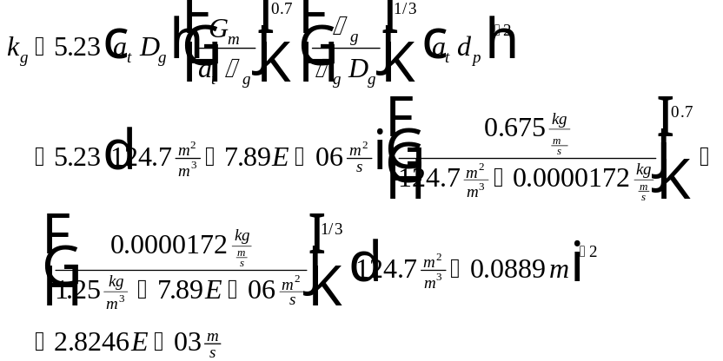
Eq. 17
The parameters required to calculate in Eq. 17 can be found as follows:
Parameter Location
Table 4
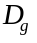 Table 2
Eq. 5
Table 3
Table 3
Table 4

Sample Rating Mode Calculations of Cross-Sectional Area and Volume

Tower Cross-Sectional Area
The cross-sectional area, , of the tower can be calculated from the tower diameter given in the problem statement using the following relationship:
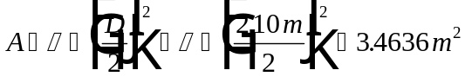
Eq. 18
The parameters required to calculate in Eq. 18 can be found as follows:
Parameter Location
Given in problem statement

Tower Volume
Tower volume, V, is calculated from design area and tower height using Eq. 19:
Eq. 19
The parameters required to calculate in Eq. 19 can be found as follows:
Parameter Location
Given in problem statement
Eq. 18

Sample Power Calculation for Packed Tower Aeration Rating Mode
This calculation is the same as for design mode and will not be repeated here.

Sample Pressure Drop Calculation for Packed Tower Aeration Rating Mode
The pressure drop is calculated by an iterative process, described below. In rating mode, all the parameters necessary to calculate the value of the y-axis on the Eckert curves are known. The value of the y-axis on the Eckert curves, 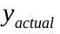, can be calculated from the following equation. Note that the relationships involved are empirical so the input units must be as shown here but the output units are not meaningful.
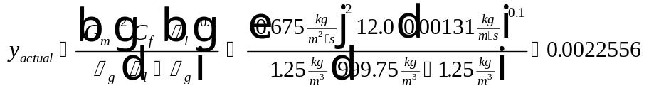
Eq. 20
The parameters required to determine in Eq. 20 as follows:
Parameter Location
Eq. 5
Table 4
Table 3
Table 3
Table 3
Once is known, it is necessary to iterate the value of pressure drop until the calculated value of the y-axis on the Eckert curve, 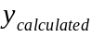, matches the actual value, within 1 %. Pressure drop per packing height is usually iterated between the values of 50 and 1200 N/m²/m since that is the region for which the correlations were developed. In the program, the pressure drop is iterated from 1 to 1200 N/ m²/m. The pressure drop iteration step is initially set to 1.0 N/m²/m. If convergence is not achieved between 1 and 1200 N/ m²/m, the step is lowered to 0.1 N/m²/m. If convergence is not achieved between 0.1 and 1200 N/ m²/m, then the step is lowered to 0.01 N/m²/m. If convergence is still not achieved, then the process ends and the user is alerted that the program is unable to converge on a pressure drop per unit length value. If convergence is achieved for a value less than 50 N/m²/m, a warning message will be displayed saying that the convergent pressure drop is outside the range for which the correlation was developed. The iteration process is described below. For the sample calculations here, the process will be shown for a pressure drop per unit length that does not achieve convergence (40 N/m²/m) and then for the convergent pressure drop per unit length value (50 N/m²/m).
Iteration Process to Calculate Pressure Drop:
(1) Calculate the parameter, E:

Eq. 21
The parameters required to calculate in Eq. 21 can be found as follows:
Parameter Location
Eq. 5
Table 4
Table 3
Table 3
Table 3
(2) Specify a pressure drop, 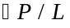, in N/m²/m = 40
(3) Calculate the parameter, :
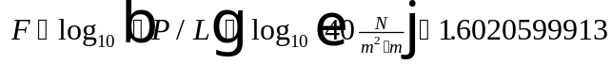
Eq. 22
(4) Calculate the parameters, 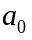, , and 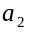:
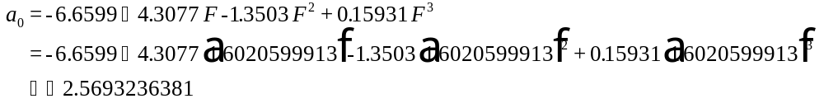 Eq. 23
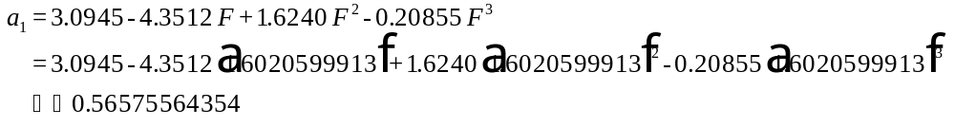 Eq. 24
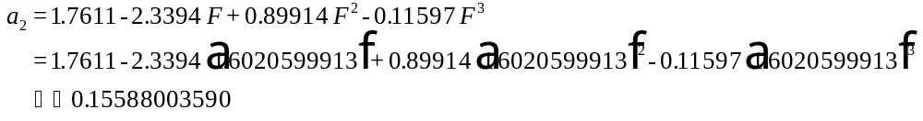
Eq. 25
(5) Determine the value of from the following equation:
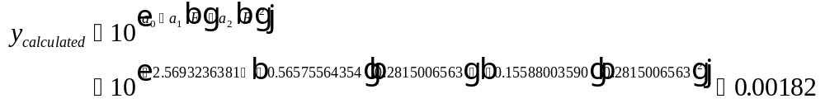
Eq. 25
(6) Calculate the percent difference between and :
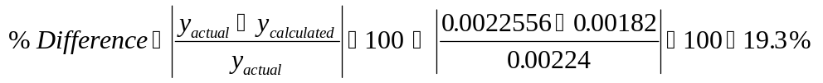
Eq. 26
Since is not within 1 % of then pressure drop is set equal to the next iterative value and the process returns to step (2) above. Here we will skip to the correct pressure drop and show how the process is complete.
(2) Specify a pressure drop, , in N/m²/m = 50
(3) Calculate the parameter, :
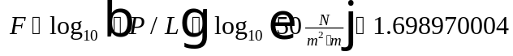
Eq. 27
(4) Calculate the parameters, , , and :
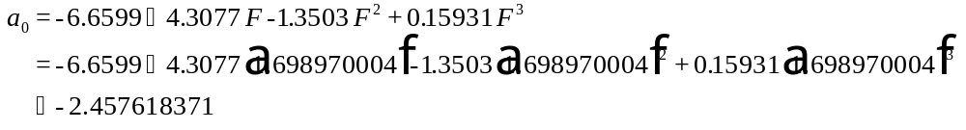 Eq. 28
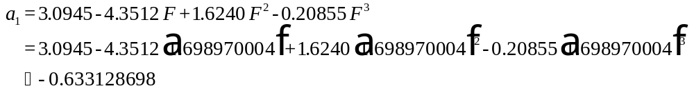 Eq. 29
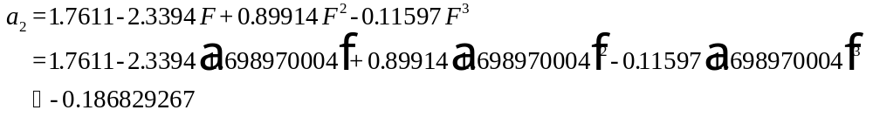 Eq. 30
(5) Determine the value of from the following equation:
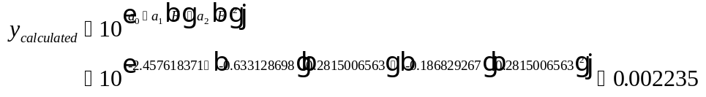
Eq. 31
(6) Calculate the percent difference between and :
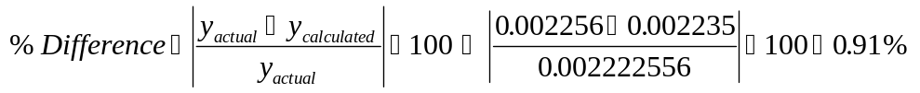
Eq. 32
Since is within 1 % of , the iterative process is complete and pressure drop per unit length is equal to the value specified in step (2) = 50 N/m²/m.

Results for All Compounds
Table 5 below shows the effluent concentration results for all contaminants for this sample rating mode case of packed tower aeration. The calculation of parameters shown in Table 5 is done using the methods shown above for TCE.
Table 5 - Results for All Contaminants in Rating Mode
Compound | 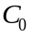 | 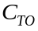 | 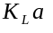
 | (μg/L) | (μg/L) | (1/s) | (-) | (μg/L)
Trichloroethylene (TCE) | 200.0 | 5.0 | 0.01109 | 3.404 | 5.1
Tetrachloroethylene (PCE) | 150.0 | 5.0 | 0.0120 | 5.3428 | 1.9
Vinyl Chloride | 60.0 | 1.0 | 0.0158 | 8.0808 | 0.14
Ethylbenzene | 30.0 | 5.0 | 0.00903 | 2.516 | 1.9
Toluene | 80.0 | 5.0 | 0.00946 | 2.4716 | 4.5
1,1-Dichloroethene (1,1-DCE) | 85.0 | 7.0 | 0.0152 | 10.064 | 0.23

Sample Program Run of ASAP™ to Verify Sample Calculations for Packed Tower Aeration in Rating Mode
To start the ASAP™ program, double click on the ASAP™ icon in the ETDOT Programs group in windows. The screen shown in Figure 1 will appear.
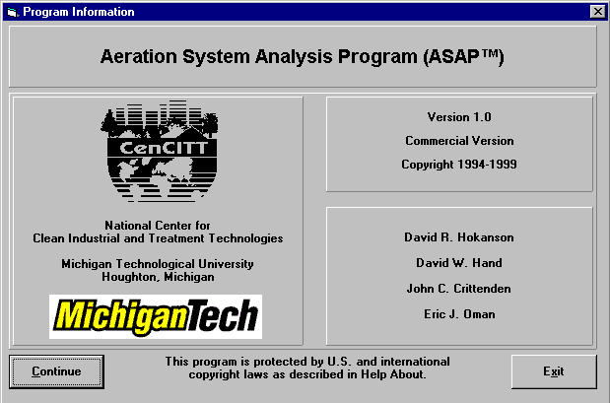
Figure 1 - ASAP™ Title Window
Click on the Continue button on the screen shown in Figure 1 and the menu shown in Figure 2 will appear.

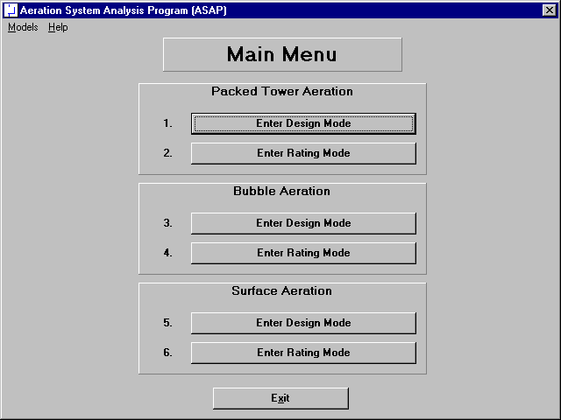
Figure 2 - Main Menu Window in ASAP™
Click on the Enter Rating Mode button for Packed Tower Aeration (option 2 in Figure 2) and the rating mode screen for packed tower aeration shown in Figure 3 will appear.
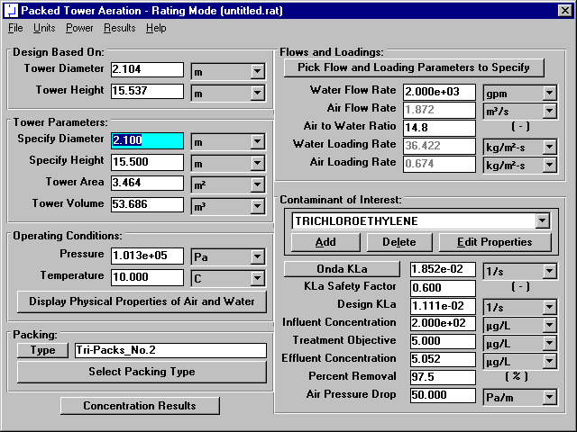
Figure 3 - Rating Mode Window for Packed Tower Aeration

Tower Parameters
The tower parameters can be found in the middle of the left-hand column of the rating mode window as shown in Figure 3 (and highlighted in Figure 4).
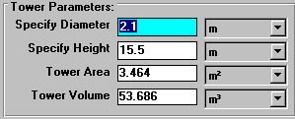
Figure 4 - Tower Parameters Portion of Rating Mode Window
The tower parameters used in this rating situation are those previously calculated in the design mode case for packed tower aeration. The tower diameter used in this case is 2.10m . The tower height is 15.5 m. The tower area calculated by the program as 3.46 m² agrees with the sample calculations (see Eq. 18). The tower volume determined by the program to be 53.7 m³ is also in agreement with the sample calculations (see Eq. 19).

Physical Properties of Air and Water
Specify pressure and temperature in the lower left-hand corner of the window shown in Figure 3. This portion of the packed tower aeration rating mode window is shown in Figure 5.
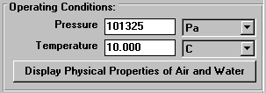
Figure 5 - Operating Conditions Portion of Rating Mode Window
Click on the Display Physical Properties of Air and Water button in Figure 3 (and highlighted in Figure 5) to show the properties of air and water at the specified temperature and pressure (101325 Pa and 10°C). Figure 6 shows the air and water properties window for this case.
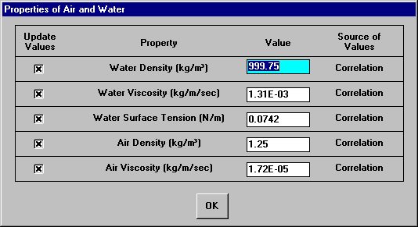
Figure 6 - Air and Water Properties Window
The properties shown in Figure 6 are by default calculated from correlations so the user should not have to change their values. In the rare case that the user would like to enter a value for any of these properties instead of using the correlations, it is possible to do so on the window shown in Figure 6. Click on the OK button shown in Figure 6 to close the window.
It can be seen that the air and water properties shown in Figure 3 agree with the properties shown in Table 3.

Packing Properties
The next step is to choose the appropriate packing. Packing selection is located on the bottom of the left-hand side of the design mode window shown in Figure 3. This portion of Figure 3 is highlighted in Figure 7.
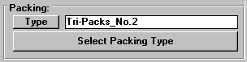
Figure 7- Packing Selection Portion of Rating Mode Window
Click on the Select Packing Type button shown in Figure 3 (and highlighted in Figure 7). The packing database window shown in Figure 8 will appear.

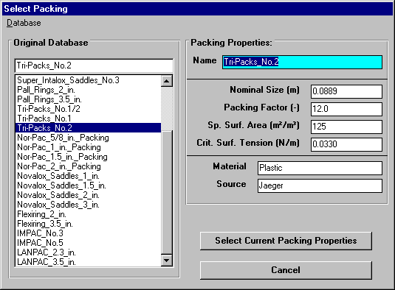
Figure 8- Select Packing Type Window
ASAP™ contains a database of packing properties available from vendor data. The packing properties used in development of the product are shown in Figure 8. The left-hand side of the packing database window shown in Figure 9 contains a listing of available packings. The item called “Tripacks No. 2” in the list is the 3.5 inch plastic tripacks requested in the problem statement. Click on this item in the list as shown in Figure 8 so that this item is selected. Then select the properties of this packing for use in the design by clicking on the Select Current Packing Properties button shown in Figure 8.
It is also possible for the user to enter properties of additional packings. It is not possible for the user to modify the list of packings from vendor data supplied with the program (called the “Original Database”). However, there is a separate database of packing properties from user input available with the software. An alternative method to enter the properties of 3.5 inch plastic tripacks is as follows. Click on the Select Packing Type button in the window shown in Figure 3 (and highlighted in 8). The window shown in Figure 8 will appear again. In the Database menu shown in Figure 9, it is seen that currently the “Original Database” option is selected.
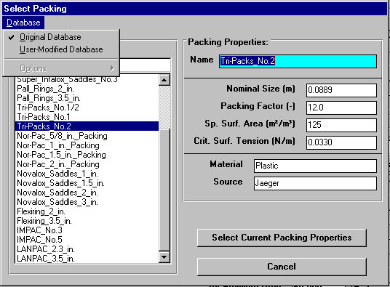
Figure 9- Database Menu in Select Packing Type Window
To input data, the user must click on the “User Modified Database” item in the menu shown in Figure 9. Then the Select Packing Type window will show a database of user input packing parameters, as shown in Figure 10.
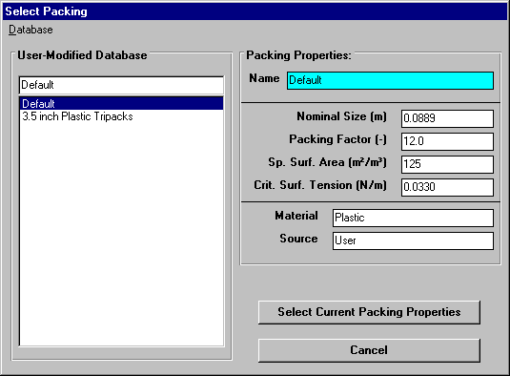
Figure 10- User Modified Database in Select Packing Type Window
On the screen shown in Figure 10, it is possible to input values for all packing properties. Figure 10 shows the screen after the properties of 3.5 inch plastic tripacks have been input. To select these properties for use in the current design, click on the Select Current Packing Properties button shown in Figure 10.

Flow and Loading Parameters
Flow and loading parameters are shown in the upper right-hand side of Figure 3. This portion of Figure 3 is reproduced here as Figure 11.

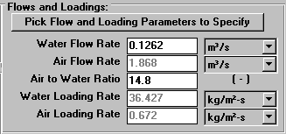
Figure 11 - Flow and Loading Parameters
Explanation of the origin of the values for the properties shown in Figure 11 is provided here. The water flow rate of 2000 gpm which converts to 0.1262 m³/s was specified in the problem statement. The air to water ratio used in this rating case is 14.8. The air flow rate was calculated in the program as 1.87 m³/s. This value agrees with the sample calculations section (see Eq. 3). The air loading rate was calculated by the program as 0.67 kg/m²/s. This value agrees with the sample calculations section (see Eq. 5). The water loading rate was calculated by the program as 36.4 kg/m²/s. This number agrees with the sample calculations section (see Eq. 4).
Click on the Pick Flow and Loading Parameters to Specify button to view the window shown in Figure 12.
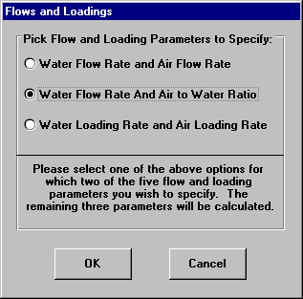
Figure 12 - Flows and Loadings Parameter Specification Window
This window allows the user to chose which flow and loading parameters are specified for design rating. The calculations for the flows and loadings shown above in Figure 4 (and highlighted in Figure 11) will be based on whichever option is selected here. Click on the OK button to return to the rating mode window.

Chemical Properties
Chemical properties for each of the six components can be retrieved from StEPP™. When the screen shown in Figure 3 loads, the properties of six contaminants load as a default rating situation. Before retrieving the chemical properties of the six chemicals required in the current rating situation, it is necessary to delete the six default chemicals shown in the Contaminant of Interest list box in the middle of the right-hand column shown in Figure 3. This portion of the rating mode window is highlighted in Figure 13.
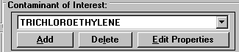
Figure 13 - Contaminant Selection Portion of Rating Mode Window
To delete each chemical click on the Delete button located in between the Add and Edit Properties buttons shown in Figure 3 (and highlighted in Figure 13). Click the Delete button once for each chemical until all chemicals have been deleted from the Contaminant of Interest list box.
It is now possible to add the chemicals required for the current design. To do so, click on the Add button shown on the bottom left-hand corner of the window shown in Figure 3 (and highlighted in Figure 13). Figure 14 shows the window that will appear.
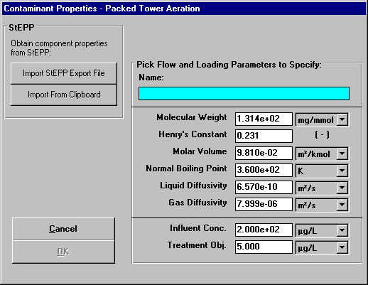
Figure 14 - Contaminant Properties Input Window
The following properties (with their default units in parentheses) are required for each component:
- Name
- Molecular weight (mg/mmol)
- Henry’s constant (dimensionless)
- Molar volume at the normal boiling point temperature (m³/kmol)
- Normal boiling point (K)
- Liquid diffusivity (m²/s)
- Gas diffusivity (m²/s)
- Initial (influent) concentration (mg/L)
- Treatment objective (mg/L)
The user can input data by clicking on a text box and typing in the corresponding value. By pressing the Enter key, the Tab key or clicking on another text box or button, the data is updated. The default units can be changed in the pull-down menus to the right of the text boxes.

Transferring Properties from StEPP™ to ASAP™
ASAP™ has the capability of transferring the physical properties of contaminants from Software to Estimate Physical Properties (StEPP™). There are two options for transferring data from StEPP into ASAP: (a) Create Export File for AdDesignS/ASAP and (b) Copy to Clipboard for AdDesignS/ASAP. Both choices are available in the Options menu within StEPP. The StEPP™ main window highlighting the Options menu is shown in Figure 15.
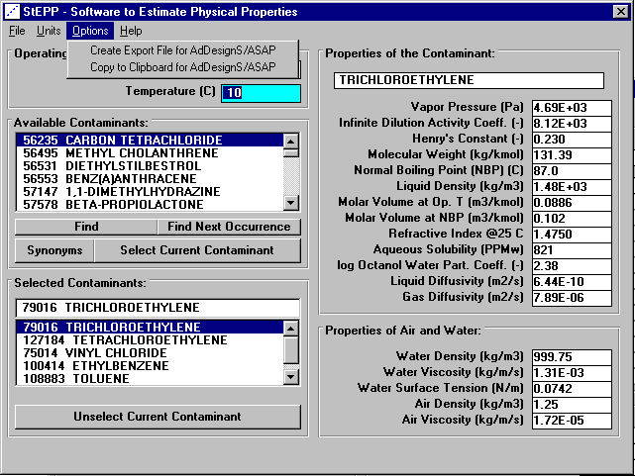
Figure 15 - StEPP™ Main window
The operating temperature and pressure, with units of degrees Celsius and Pascals respectively, must be entered. Chemicals can be selected using the scroll bar on the Available Contaminants block or the Find, Find Next Occurrence, or Synonyms buttons, highlighting the chemical, and clicking on the Select Current Contaminant button. Repeat this process for all contaminants of interest. After the contaminants have been selected in StEPP™ and their properties calculated at the proper temperature and pressure, they can be transferred from StEPP to ASAP using either of two options, which are described below: (a) Create Export File for AdDesignS/ASAP and (b) Copy to Clipboard for AdDesignS/ASAP.

Transferring Chemical Properties from StEPP™ to ASAP™ Using the Create Export File for AdDesignS/ASAP Option
To create a StEPP™ export file, select Create Export File for AdDesignS/ASAP™ from the Options menu. The window shown in Figure 16 will appear. Enter a file name to save the export file. This file will be available for use in ASAP™.
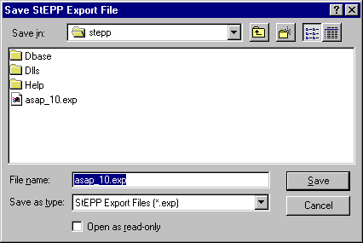
Figure 16 - Save StEPP™ Export File window
To import the chemicals and their physical properties to ASAP™ from the StEPP™ export file, click on the Add button in the Component Properties block of the ASAP™ main window. The Component Properties window shown in Figure 17 will appear.
Figure 17 - Component Properties window (adding new components)
To open the StEPP™ export file, click the Import StEPP™ export file button on the Component Properties window. The Load StEPP™ Export File window shown in Figure 18 will appear.

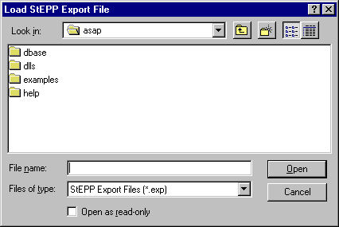
Figure 18 - Load StEPP™ Export File window
The file which was previously saved in StEPP™ can be selected in this window. The window shown in Figure 19 announcing the successful import of the components will appear. To return to the ASAP™ main window, click on OK.
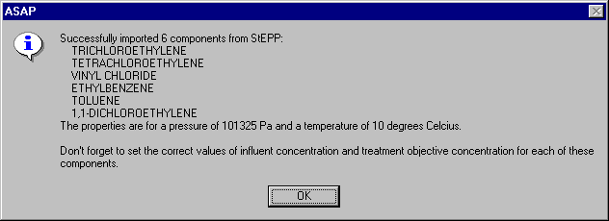
Figure 19 - Successful Import of Components from StEPP™ window

Transferring Chemical Properties from StEPP™ to ASAP™ Using the Copy to Clipboard for AdDesignS/ASAP Option
To copy selected StEPP™ data to the Windows clipboard for export into ASAP™, select Copy to Clipboard for AdDesignS/ASAP from the Options menu within StEPP™. The message box shown in Figure 20 will appear, verifying that all of the StEPP™ data is now stored in the Windows clipboard.
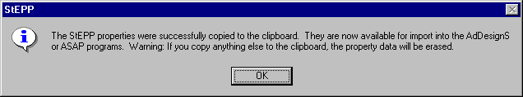
Figure 20 – Successful Copy to Clipboard from StEPP™ Message Box
To import the chemicals and their physical properties to ASAP™ from the data on the clipboard, click on the Add button in the Component Properties block of the ASAP™ main window. The Component Properties window shown in Figure 21 will appear.

Figure 21 - Component Properties window (adding new components)
To import the StEPP™ data from the Windows clipboard, click the Import from Clipboard button on the Component Properties window. The window shown in Figure 22 will appear, showing that the properties have been successfully transferred into ASAP.

Figure 22 – Successful Import from StEPP™ Window

Manipulation of Data Required after Transferring Properties from StEPP™ to ASAP™
The following properties will be transferred to ASAP™ from StEPP™, unless they are not available:
- Molecular weight (mg/mmol)
- Henry’s constant (dimensionless)
- Molar volume at the normal boiling point temperature (mL/gmol)
- Normal boiling point (Celsius)
- Liquid diffusivity (m²/s)
- Gas diffusivity (m²/s)
The name of the chemical will also be transferred. If any of the properties above are not available in StEPP™ for a selected chemical, the chemical with missing properties will not be imported and a warning message will be displayed.
Click on the OK button to continue. Figure 3 appears. As shown in Figure 19 or Figure 22, it is necessary to input influent concentrations and treatment objectives for each of the six components retrieved. To do so, select each contaminant one at a time in the Design Contaminant list box shown in the lower right-hand corner of Figure 3. Then click on the Edit Properties button. Figure 23 shows the window that appears for trichloroethylene.
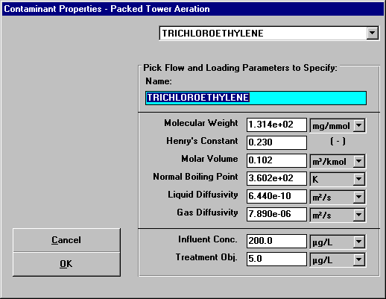
Figure 23 - Specify Contaminant Properties Window for Trichloroethylene
The properties molecular weight, Henry’s constant, molar volume, normal boiling point, liquid diffusivity, and gas diffusivity are already correct since they were retrieved from StEPP™. The influent concentration and treatment objective shown at the bottom of the screen must be input since they will vary from case to case. These properties shown in Figure 23 already reflect the values for the current design case. It is seen that the properties shown in Figure 23 agree with the trichloroethylene properties shown in Tables 1 and 2.
Figure 24 shows the Specify Contaminant Properties window for tetrachloroethylene. It can be seen that the properties shown in Figure 24 agree with the properties of tetrachloroethylene shown in Tables 1 and 2.
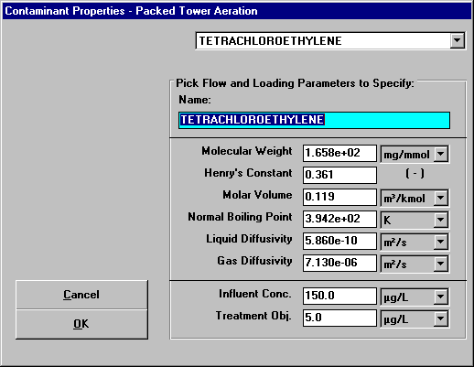
Figure 24 - Specify Contaminant Properties Window for Tetrachloroethylene
Figure 25 shows the Specify Contaminant Properties window for vinyl chloride. It can be seen that the properties shown in Figure 25 agree with the properties of vinyl chloride shown in Tables 1 and 2.
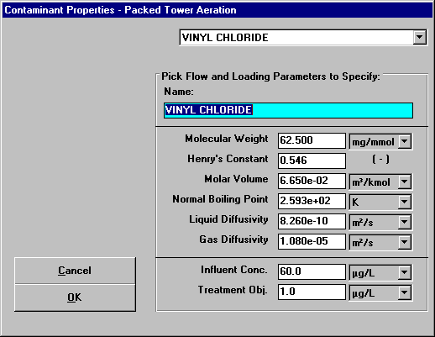
Figure 25 - Specify Contaminant Properties Window for Vinyl Chloride
Figure 26 shows the Specify Contaminant Properties window for ethylbenzene. It can be seen that the properties shown in Figure 25 agree with the properties of ethylbenzene shown in Tables 1 and 2.
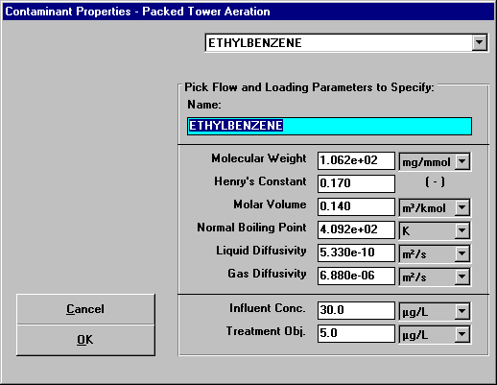
Figure 26 - Specify Contaminant Properties Window for Ethylbenzene
Figure 27 shows the Specify Contaminant Properties window for toluene. It can be seen that the properties shown in Figure 25 agree with the properties of toluene shown in Tables 1 and 2.
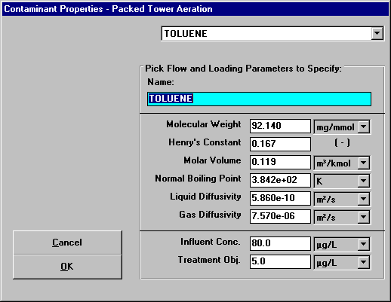
Figure 27 - Specify Contaminant Properties Window for Toluene
Figure 28 shows the Specify Contaminant Properties window for 1,1-dichloroethene. It can be seen that the properties shown in Figure 25 agree with the properties of 1,1-dichloroethene shown in Tables 1 and 2.
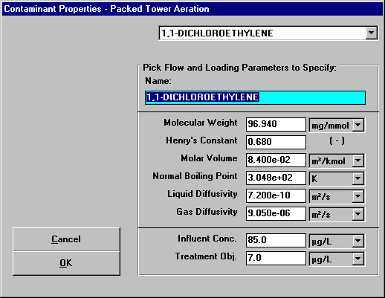
Figure 28 - Specify Contaminant Properties Window for 1,1-Dichloroethene

Mass Transfer Parameters and Effluent Results
The mass transfer parameters and effluent results are shown on the lower right-hand corner of the rating mode window shown in Figure 3. This portion of the window is highlighted in Figure 29.
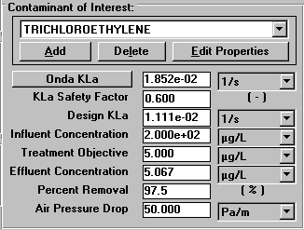
Figure 29 - Mass Transfer Parameters and Effluent Results for Trichloroethylene
This section of the rating mode window lists various parameters for rating mode calculations of the effluent concentrations such as the Onda K_{L}a, K_{L}a safety factor, design K_{L}a, influent concentration, treatment objective and air pressure drop. The Onda K_{L}a and design K_{L}a values match the values for the sample calculations (see Eq. 10 and Eq. 11, respectively). The effluent concentration calculated by the program is 5.1 μg/L, which agrees with the sample calculations (see Eq. 1). This reflects a percent removal of 97.5. The air pressure drop calculated by the program for this rating mode case is 50.0 Pa/m, which matches the sample calculations (see Eq. 20 - Eq. 32).
The mass transfer parameters and effluent results portion of the main window is shown for the other components in Figure 30 - Figure 34. The mass transfer parameters and effluent results for each component shown in the figures match the values given in the sample calculations (see Table 5).
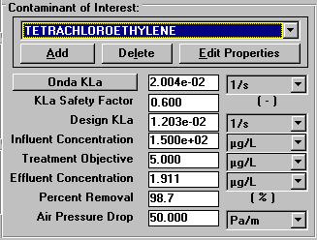
Figure 30 - Mass Transfer Parameters and Effluent Results for Tetrachloroethylene
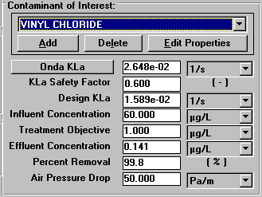
Figure 31 - Mass Transfer Parameters and Effluent Results for Vinyl Chloride
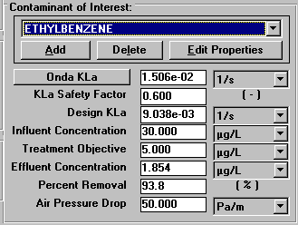
Figure 32 - Mass Transfer Parameters and Effluent Results for Ethylbenzene
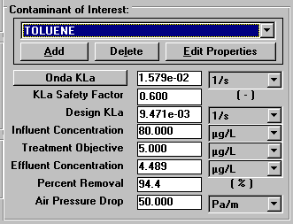
Figure 33 - Mass Transfer Parameters and Effluent Results for Toluene
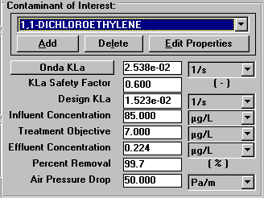
Figure 34 - Mass Transfer Parameters and Effluent Results for 1,1-Dichloroethylene

Power Parameters
By clicking on the Perform Power Calculations option in the Power menu shown in Figure 3, the power calculations for this rating case are made. The resultant window is shown in Figure 35. The sample power calculations were given in the design mode case and not repeated for rating mode so there are no values for comparison available.
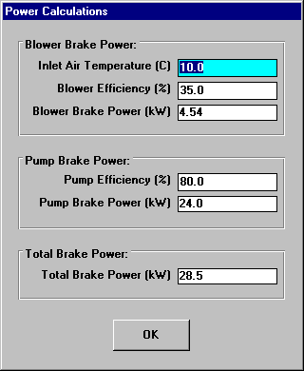
Figure 35 - Power Parameters

Viewing Effluent Concentration Results for All Contaminants
For the current design, it is useful to see what the effluent concentrations of all contaminants on the same window. ASAP provides a convenient method for seeing these results.
By clicking on the Concentration Results button in the lower left-hand corner of the packed tower aeration – rating mode window shown in Figure 3, the user will see the concentration results for all contaminants using the given design (see Figure 36).
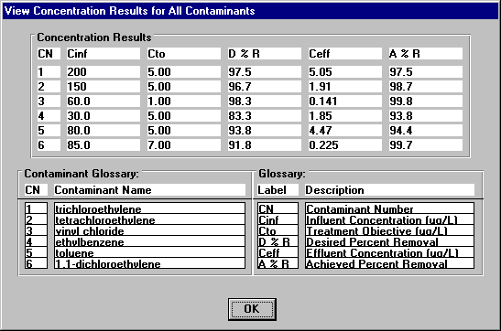
Figure 36 – View Concentration Results for All Contaminants Window
This window provides a quick method to see whether the given design will meet the treatment objectives for all contaminants.

