Bubble Aeration - Rating Mode
The following problem will be used to show sample calculations for bubble aeration in rating mode. In addition, a sample program run of ASAP™ will be used to verify that the program is correctly duplicating the results of the sample calculations.

Problem Statement
The city of Anytown, USA recently discovered that one of its wells was contaminated with the compounds listed in Table 1. In order for them to continue using the well, they are required to remove these compounds below their MCLs, also shown in Table 1. During normal pumping operations, the well produces about 2000 gpm, the water temperature is 10°C, and the barometric pressure is 1 atm. An air to water ratio of 11 should be used. Tank volume for one tank is 600 m³ and the system consists of three tanks in series. Will the system be able to remove all the components below their MCLs?
Show a sample calculation of effluent concentrations in each tank in both the liquid and gas phase for Trichloroethylene. Present a table showing the influent concentration, treatment objective, Stanton number, and effluent concentrations from each tank in each phase for all components. Show that the sample calculations match the results of using ASAP™ for bubble aeration in rating mode.
Power calculations and mass transfer coefficient calculations are the same as for the design mode case presented in Appendix B.4 and need not be shown again. Mass transfer coefficients obtained in design mode which are also applicable to this rating mode case are shown in Table 3.
Table 1 - Contaminant Influent Concentrations and Treatment Objectives (MCLs)
Compound | Concentration Discharged, C₀ | MCL, C_{TO}
 | (μg/L) | (μg/L)
Trichloroethylene (TCE) | 200.0 | 5.0
Tetrachloroethylene (PCE) | 150.0 | 5.0
Vinyl Chloride | 60.0 | 1.0
Ethylbenzene | 30.0 | 5.0
Toluene | 80.0 | 5.0
1,1-Dichloroethene (1,1-DCE) | 85.0 | 7.0

Properties Needed to Perform Sample Calculations and Program Run
Table 2 shows the Henry’s constants retrieved from StEPP™ required for bubble aeration at 10°C and 1 atm.
Table 2 - Henry’s Constants from StEPP™ at 10° C and 1 atm
Compound | H
 | (-)
Trichloroethylene | 0.230
Tetrachloroethylene | 0.361
Vinyl Chloride | 0.546
Ethylbenzene | 0.170
Toluene | 0.167
1,1-Dichloroethene | 0.680

Table 3 - Mass Transfer Coefficients (KLa) from Design Mode Calculations
Compound | K_{L}a
 | (1/s)
Trichloroethylene | 0.001582
Tetrachloroethylene | 0.001518
Vinyl Chloride | 0.001882
Ethylbenzene | 0.001392
Toluene | 0.001471
1,1-Dichloroethene | 0.001739

Note Regarding Comparison of Sample Calculation Values to Sample Program Run
In certain cases, the numbers that appear in the sample calculations are slightly different from the values displayed in the sample program run. These variations can be attributed to rounding.

Sample Rating Mode Calculation of Effluent Concentration for Trichloroethylene as the Design Compound Including Supplementary Parameter Calculations

Liquid Phase Effluent Concentration from Tank Number i
The calculation of liquid phase effluent concentration from tank number i, 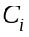, of a bubble aeration system with tanks in series is shown in Eq. 1.
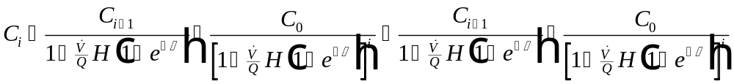
Eq. 1
The parameters required to calculate in Eq. 1 can be found as follows:
Parameter Location
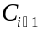 Calculated value
User-specified
Table 2
Eq. 2
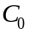 Table 1
User-specified

Stanton Number,
Stanton number, , is calculated using the following relationship:
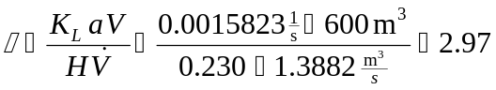
Eq. 2
The parameters required to find in Eq. 2 can be found as follows:
Parameter Location
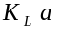 Table 3
Given
Table 2
Eq. 3

Liquid Phase Effluent Concentration from Tank Number 1
Calculation of 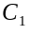 from Eq. 1 is given in Eq. 3:
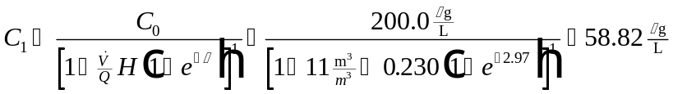
Eq. 3
The parameters required to find in Eq. 3 can be found as follows:
Parameter Location
User-specified
Table 2
Eq. 2
Table 1

Liquid Phase Effluent Concentration from Tank Number 2
Calculation of the liquid phase effluent concentration from tank number 2 in the series of tanks forming the bubble aeration system, 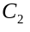 from Eq. 1 is given in Eq. 4:
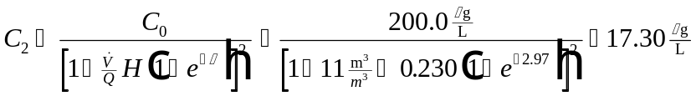
Eq. 4
The parameters required to find in Eq. 4 can be found as follows:
Parameter Location
User-specified
Table 2
Eq. 2Eq. 2
Table 1

Liquid Phase Effluent Concentration from Tank Number 3
The liquid phase effluent concentration from tank number 3 in the series, 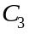 is calculated in Eq. 5:
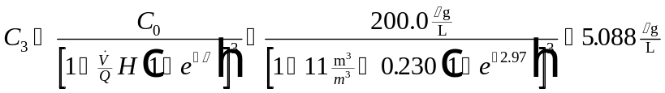
Eq. 5
The parameters required to find in Eq. 5 can be found as follows:
Parameter Location
User-specified
Table 2
Eq. 2
Table 1

Gas Phase Effluent Concentration from Tank Number i
The gas phase effluent concentration, , corresponding to the liquid phase effluent concentrations for each tank calculated above can be found using Eq. 6:
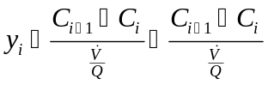
Eq. 6
The parameters required to find in Eq. 6 can be found as follows:
Parameter Location
Eq. 1
Eq. 1
User-specified

Gas Phase Effluent Concentration from Tank Number 1
Gas phase effluent concentration, , from tank 1 is calculated using Eq. 7:
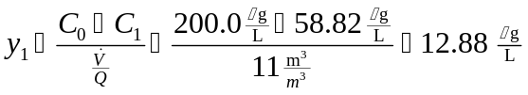
Eq. 7
The parameters required to find in Eq. 7 can be found as follows:
Parameter Location
Table 1
Eq. 3
User-specified

Gas Phase Effluent Concentration from Tank Number 2
Gas phase effluent concentration, , from tank 2 is calculated using Eq. 8:
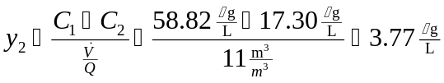
Eq. 8
The parameters required to find in Eq. 8 can be found as follows:
Parameter Location
Eq. 3
Eq. 4
User-specified

Gas Phase Effluent Concentration from Tank Number 3
Gas phase effluent concentration, , from tank 3 is calculated using Eq. 9:
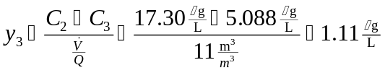
Eq. 9
The parameters required to find in Eq. 9 can be found as follows:
Parameter Location
Eq. 4
Eq. 5
User-specified

Note Regarding Calculation of , 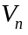, , and 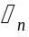
In rating a bubble aeration system, it is possible to specify one of the parameters listed above and then calculate the other three. Sample calculations for the four cases are presented here.

Case 1: Specify , Calculate , , and

Total Volume of System
The total volume of all of the aeration tanks, , can be calculated as follows:
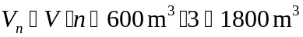
Eq. 10
The parameters required to calculate in Eq. 10 can be found as follows:
Parameter Location
User-specified
Given in problem statement

Hydraulic Retention Time
The hydraulic retention time for one of the aeration tanks, , is found as:
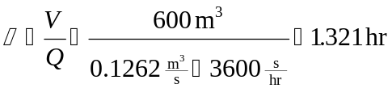
Eq. 11
The parameters required to calculate in Eq. 11 can be found as follows:
Parameter Location
User-specified
Given in problem statement

Total Hydraulic Retention Time
The total hydraulic retention time for the system, , can be found using Eq. 12:
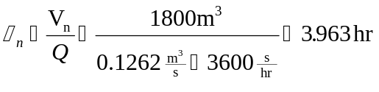
Eq. 12
The parameters required to calculate in Eq. 12 can be found as follows:
Parameter Location
Eq. 10
Given in problem statement

Case 2: Specify , Calculate , , and

Volume of One Aeration Tank
The volume of one of the aeration tanks, , can be calculated as follows:
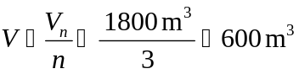
Eq. 13
The parameters required to calculate in Eq. 13 can be found as follows:
Parameter Location
User-specified
Given in problem statement

Hydraulic Retention Time
The hydraulic retention time, , can be calculated using the following relationship:
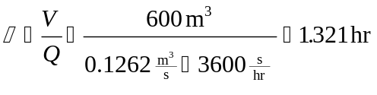
Eq. 14
The parameters required to calculate in Eq. 14 can be found as follows:
Parameter Location
Eq. 13
Given in problem statement

Total Hydraulic Retention Time
The total hydraulic retention time for the system, , is calculated using the following relationship:
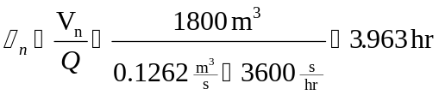
Eq. 15
The parameters required to calculate in Eq. 15 can be found as follows:
Parameter Location
User-specified
Given in problem statement

Case 3: Specify , Calculate , , and

Volume of One Aeration Tank
The volume of one of the aeration tanks, , can be calculated using the following:
Eq. 16
The parameters required to calculate in Eq. 16 can be found as follows:
Parameter Location
User-specified
Given in problem statement

Total Volume of System
The total volume of all of the aeration tanks can be calculated using Eq. 17:
Eq. 17
The parameters required to calculate in Eq. 17 can be found as follows:
Parameter Location
Eq. 16
Given in problem statement

Total Hydraulic Retention Time
The total hydraulic retention time for the system, , is calculated as follows:
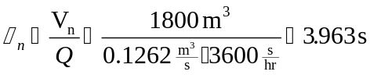
Eq. 18
The parameters required to calculate in Eq. 18 can be found as follows:
Parameter Location
Eq. 17
Given in problem statement

Case 4: Specify , Calculate , , and

Hydraulic Retention Time
The hydraulic retention time, , is found using Eq. 19:
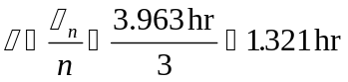
Eq. 19
The parameters required to calculate in Eq. 19 can be found as follows:
Parameter Location
User-specified
Given in problem statement

Volume of One Aeration Tank
The volume of one of the aeration tanks, , can be calculated using Eq. 20:
Eq. 20
The parameters required to calculate in Eq. 20 can be found as follows:
Parameter Location
Eq. 19
Given in problem statement

Total Volume of System
The total volume of all of the aeration tanks, , can be calculated using the following relationship:
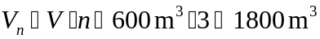
Eq. 21
The parameters required to calculate in Eq. 21 can be found as follows:
Parameter Location
Eq. 20
Given in problem statement

Table Showing Effluent Results for All Components
Table 4shows the effluent results for all components for this rating mode case. The calculation of the values for trichloroethylene (TCE) was shown earlier. Calculation of values for the other components follows exactly the same method and is thus not shown.
Table 4 - Effluent Results for All Components
Concentration | Compound
 | TCE | PCE | Vinyl Chloride | Ethylbenzene | Toluene | 1,1-DCE
(μg/L) | 200 | 150.0 | 60.0 | 30.0 | 80.0 | 85
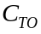 (μg/L) | 5.0 | 5.0 | 1.0 | 5.0 | 5.0 | 7.0
 | 2.97 | 1.82 | 1.49 | 3.54 | 3.81 | 1.11
(μg/L) | 58.82 | 34.7 | 10.60 | 10.7 | 28.60 | 14.2
(μg/L) | 17.30 | 8.02 | 1.88 | 3.78 | 10.20 | 2.36
(μg/L) | 5.088 | 1.85 | 0.332 | 1.34 | 3.66 | 0.393
(μg/L) | 12.88 | 10.5 | 4.49 | 1.76 | 4.67 | 6.44
(μg/L) | 3.77 | 2.42 | 0.794 | 0.625 | 1.67 | 1.07
(μg/L) | 1.11 | 0.560 | 0.141 | 0.222 | 0.597 | 0.179

Sample Program Run of ASAP™ to Verify Sample Calculations for Bubble Aeration in Rating Mode
To start the ASAP™ program, double click on the ASAP™ icon in the ETDOT Programs group in windows. The screen shown in Figure 1 will appear.
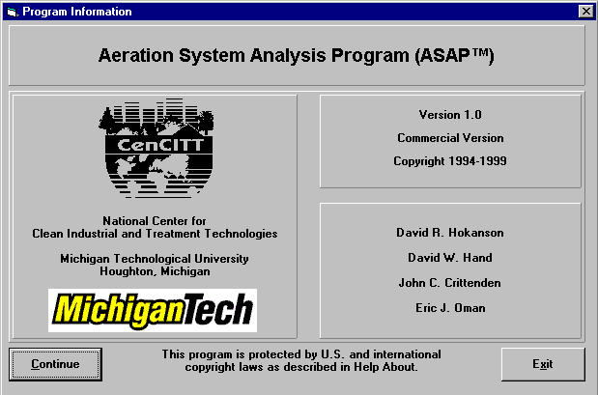
Figure 1 - ASAP™ Title Window
Click on the Continue button on the screen shown in Figure 1 and the menu shown in Figure 2 will appear.
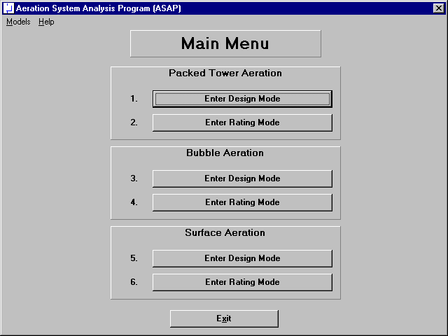
Figure 2 - Main Menu Window in ASAP™

Click on the Enter Rating Mode button for Bubble Aeration (option 4 in Figure 2) and the rating mode screen for bubble aeration shown in Figure 3 will appear.

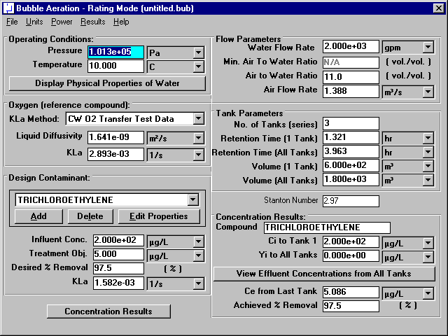
Figure 3 - Rating Mode Window for Bubble Aeration

Physical Properties of Water
Specify pressure and temperature in the upper left-hand corner of the window shown in Figure 3. This portion of the bubble aeration rating mode window is shown in Figure 4.
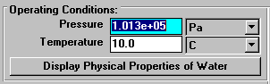
Figure 4 - Operating Conditions Portion of Rating Mode Window
Click on the Display Physical Properties of Water button in Figure 3 (and highlighted in Figure 4) to show the properties of water at the specified temperature and pressure (101325 Pa and 10°C). Figure 5 shows the water properties window for this case.
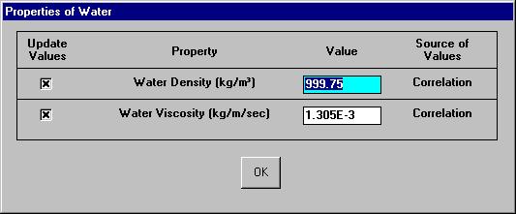
Figure 5 - Water Properties Window
The properties shown in Figure 5 are by default calculated from correlations so the user should not have to change his values. In the rare case that the user would like to enter a value for any of these properties instead of using the correlations, it is possible to do so on the window shown in Figure 5. Click on the OK button shown in Figure 5 to close the window.

Oxygen (reference compound)
The mass transfer coefficient for the design contaminant is calculated using its relationship to the mass transfer coefficient of oxygen under similar conditions. The mass transfer coefficient of oxygen is estimated using clean water oxygen transfer test data. This portion of the rating mode window is shown in Figure 6.
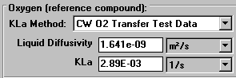
Figure 6 - Oxygen Section of Rating Mode Window
The mass transfer coefficient of oxygen at 10°C is calculated by the program as 2.89E-03 1/s. This agrees with the value from the sample calculations of the design mode section. To view additional information regarding the calculation of the mass transfer coefficient of oxygen by this method, click on the  button to display a choice between CW O2 Transfer Test Data and User Input. Click on CW O2 Transfer Test Data button to obtain the window shown in Figure 3 (and highlighted in Figure 7).
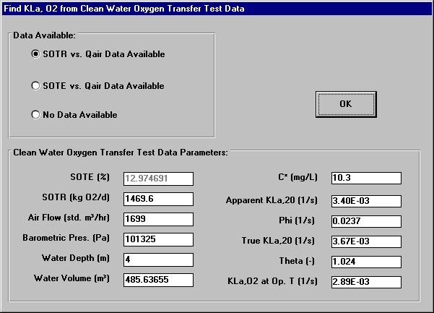
Figure 7 - Mass Transfer Coefficient of O₂ from Clean Water Oxygen
Transfer Test Data
The dissolved oxygen surface saturation concentration, apparent K_{L}a at 20°C, oxygenation coefficient, and true K_{L}a at 20°C calculated by the program are shown by the sample calculations of the design mode section.
Additional parameters shown in Figure 7 were either specified in the problem statement of the design mode case or chosen for the purposes of the design.

Chemical Properties
Chemical properties for each of the six components can be retrieved from StEPP™. When the screen shown in Figure 3 loads, the properties of the six contaminants load as a default rating situation. Before retrieving the chemical properties of the six chemicals required in the current rating mode case, it is necessary to delete the six default chemicals shown in the Design Contaminant list box on the bottom of the left-hand column shown in Figure 3. This portion of the rating mode window is highlighted in Figure 8.
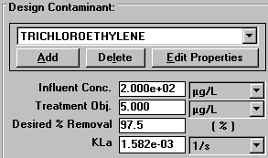
Figure 8 - Contaminant Selection Portion of Rating Mode Window
The value for the mass transfer coefficient of trichloroethylene calculated by the program, 1.58E-03 1/s, agrees with the sample calculations of the design mode section.
To delete each chemical click on the Delete button located in between the Add and Edit Properties buttons shown in Figure 3 (and highlighted in Figure 8). Click the Delete button once for each chemical until all chemicals have been deleted.

Transferring Properties from StEPP™ to ASAP™
ASAP™ has the capability of transferring the physical properties of contaminants from Software to Estimate Physical Properties (StEPP™). There are two choices available in the Options menu within StEPP for transferring data from StEPP into ASAP: (a) Create Export File for AdDesignS/ASAP and (b) Copy to Clipboard for AdDesignS/ASAP. The StEPP™ main window highlighting the Options menu is shown in Figure 9. Figure 9 shows the main StEPP™ window after the chemicals for this design have been selected at 10° C (see StEPP™ manual for how to get to this stage).
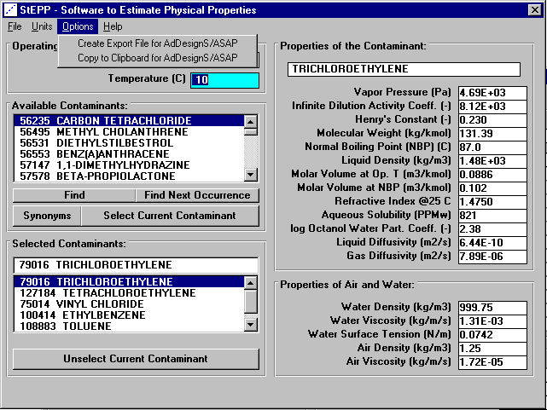
Figure 9 - StEPP™ Main Window for This Design
After the contaminants have been selected in StEPP™ and their properties calculated at the proper temperature and pressure, they can be transferred from StEPP to ASAP using either of two options, which are described below: (a) Create Export File for AdDesignS/ASAP and (b) Copy to Clipboard for AdDesignS/ASAP.

Transferring Chemical Properties from StEPP™ to ASAP™ Using the Create Export File for AdDesignS/ASAP Option
To create an export file within StEPP™, for use in ASAP™, click on the Create Export File for AdDesignS™/ASAP™ in the StEPP™ Options menu. This option is shown in Figure 9. After clicking this option, the Save StEPP™ Export File window shown in Figure 10 appears. Give the export file an .exp extension (the default), such as bub10.exp, and the file will be readily importable into ASAP™, as described below.
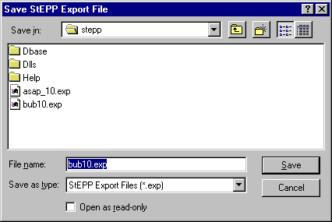
Figure 10 - Save StEPP™ Export File Window
To import the StEPP™ export file described above (bub10.exp), click on the Add button shown on the bottom left-hand corner of the window shown in Figure 3 (and highlighted in Figure 8). Figure 11 shows the window that will appear.
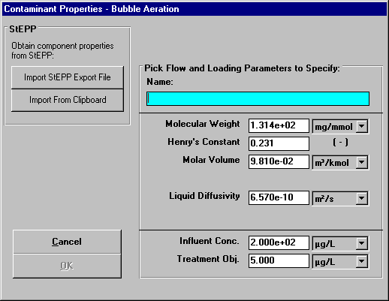
Figure 11 - Contaminant Properties Input Window
Click on the Import StEPP™ Export File button shown in Figure 11. The window shown in Figure 12 will appear.
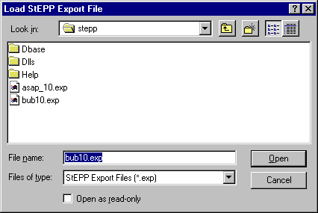
Figure 12 - Load StEPP™ Export File Window
Select the file bub10.exp that was created earlier and the chemicals selected in StEPP™ for the given design will be imported into ASAP™. Figure 13 appears after the import and shows a successful import was achieved.
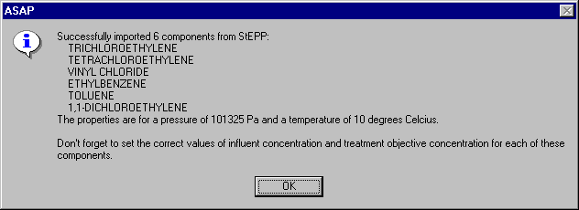
Figure 13 - Successful StEPP™ Property Retrieval Indication Window

Transferring Chemical Properties from StEPP™ to ASAP™ Using the Copy to Clipboard for AdDesignS/ASAP Option
To copy selected StEPP™ data to the Windows clipboard for export into ASAP, select Copy to Clipboard for AdDesignS/ASAP from the Options menu within StEPP. The message box shown in Figure 14 will appear, verifying that all of the StEPP data is now stored in the Windows clipboard.
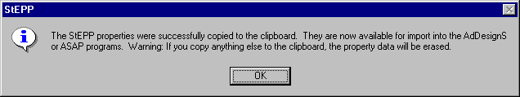
Figure 14 – Successful Copy to Clipboard from StEPP™ Message Box
To import the chemicals and their physical properties to ASAP™ from the data on the clipboard, click on the Add button in the Component Properties block of the ASAP™ main window. The Component Properties window shown in Figure 15 will appear.
Figure 15 - Component Properties window (adding new components)
To import the StEPP™ data from the Windows clipboard, click the Import from Clipboard button on the Component Properties window. The window shown in Figure 16 will appear, showing that the properties have been successfully transferred into ASAP.
Figure 16 – Successful Import from StEPP™ Window

Manipulation of Data Required after Transferring Properties from StEPP™ to ASAP™
Click on the OK button to continue. Figure 3 appears. As shown in Figure 13 or Figure 16, it is necessary to input influent concentrations and treatment objectives for each of the six components retrieved. To do so, select each contaminant, one at a time, in the Design Contaminant list box shown in the lower left-hand corner of Figure 3. Then click on the Edit Properties button. Figure 17 shows the window that appears for trichloroethylene.
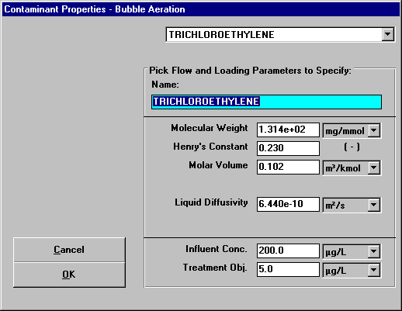
Figure 17 - Specify Contaminant Properties Window for Trichloroethylene
The properties molecular weight, Henry’s constant, molar volume, and liquid diffusivity are already correct since they were retrieved from StEPP™. The influent concentration and treatment objective shown at the bottom of the screen must be input since they will vary from case to case. These properties shown in Figure 17 already reflect the values for the current design case. It is seen that the properties shown in Figure 17 agree with the trichloroethylene properties shown in Tables 1 and 2.
Figure 18 shows the Specify Contaminant Properties window for tetrachloroethylene. It can be seen that the properties shown in Figure 18 agree with the properties of tetrachloroethylene shown in Tables 1 and 2.
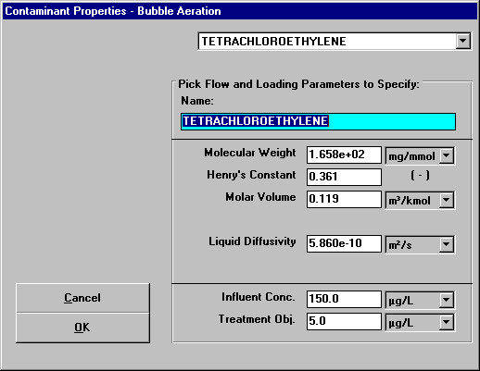
Figure 18 - Specify Contaminant Properties Window for Tetrachloroethylene
Figure 19 shows the Specify Contaminant Properties window for vinyl chloride. It can be seen that the properties shown in Figure 19 agree with the properties of vinyl chloride shown in Tables 1 and 2.

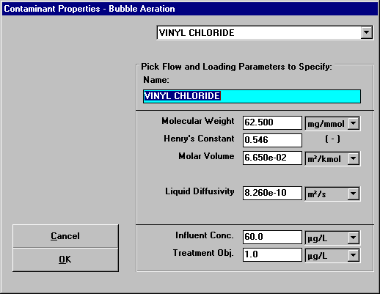
Figure 19 - Specify Contaminant Properties Window for Vinyl Chloride
Figure 20 shows the Specify Contaminant Properties window for ethylbenzene. It can be seen that the properties shown in Figure 20 agree with the properties of ethylbenzene shown in Tables 1 and 2.
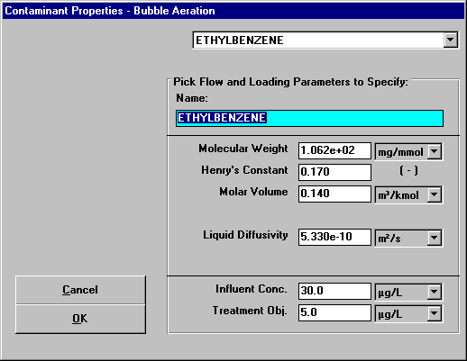
Figure 20 - Specify Contaminant Properties Window for Ethylbenzene
Figure 21 shows the Specify Contaminant Properties window for toluene. It can be seen that the properties shown in Figure 21 agree with the properties of toluene shown in Tables 1 and 2.

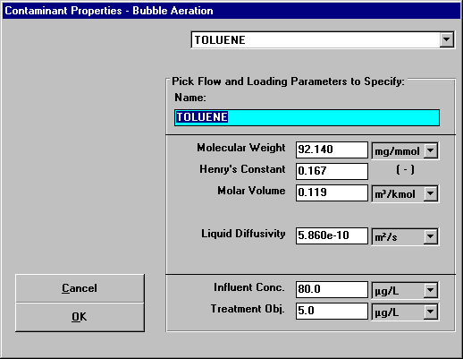
Figure 21 - Specify Contaminant Properties Window for Toluene
Figure 22 shows the Specify Contaminant Properties window for 1,1-dichloroethene. It can be seen that the properties shown in Figure 22 agree with the properties of 1,1-dichloroethene shown in Tables 1 and 2.
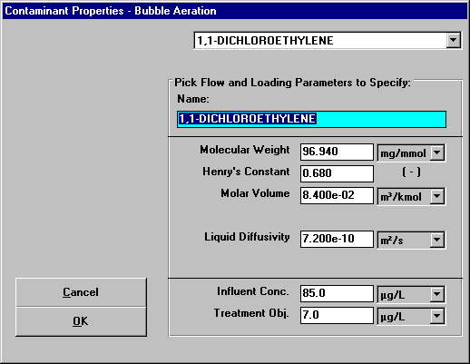
Figure 22 - Specify Contaminant Properties Window for 1,1-Dichloroethene

Flow Parameters
Flow parameters are shown in the upper right-hand side of Figure 3. This portion of Figure 3 is reproduced here as Figure 23.
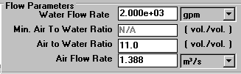
Figure 23 - Flow Parameters of Rating Mode Window
Explanation of the origin of the values for the properties shown in Figure 23 is provided here. The water flow rate of 2000 gpm is given in the problem statement. An air to water ratio of 11 is used as it was calculated by the program in the design mode for this case and agreed with the value calculated in the sample calculations for this design case (see Eq. 3 in the sample calculations section of the design mode). An air flow rate of 1.39 m³/s was calculated as the product of 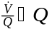.

Tank Parameters
The tank parameters are shown in the middle of the right-hand column of the design mode window shown in Figure 3. This portion of the window is highlighted as Figure 24.
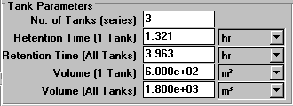
Figure 24 - Tank Parameters Section of Design Mode Window
The values of the tank parameters shown in Figure 3 (and highlighted in Figure 24) were taken from the design calculations performed for the design mode run of this program and corresponding sample calculations. The number of tanks in series is given in the problem statement. In rating mode, one of the other parameters can be specified with the program calculating the remainder. Case 1 of the sample calculations shows the specification of the tank volume as 6.00E+02 m³. The retention time of 1.32 hr calculated by the program agrees with the sample calculations (see Eq. 11). The total retention time for the system determined by the program to be 3.963 hr corresponds to the value calculated in the sample calculations (see Eq. 12). The volume of 1.800E+03 m³ calculated by the program agrees with the sample calculations performed previously (see Eq. 10).

Stanton Number for Trichloroethylene
The Stanton number used in the calculation of the liquid phase effluent concentrations is located beneath the tank parameters in the middle of the right-hand column as shown in Figure 3 (and highlighted in Figure 25).
Figure 25 - Stanton Number Section of Rating Mode Window
The Stanton number calculated by the program is 2.97 and can be seen in the sample calculations (see Eq. 2).

Concentration Results for Trichloroethylene
The effluent concentrations of both the liquid phase and the gas phase of the contaminant as well as the achieved percent removal are found in the lower right-hand corner of the rating mode window as shown in Figure 3 (and highlighted in Figure 26).
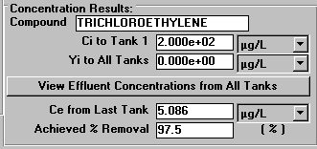
Figure 26 - Concentration Results Portion of Rating Mode Window
Click on the View Effluent Concentrations from All Tanks button shown in Figure 3 (and highlighted in Figure 26) to see the effluent concentrations of both the liquid phase and the gas phase of the contaminant from each tank. The window that appears is shown in Figure 27.
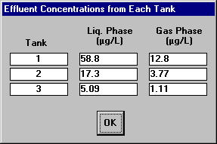
Figure 27 - Effluent Concentrations from Each Tank
It can be seen that the values calculated by the program for the liquid phase effluent concentrations; 58.82 μg/L from tank 1 (see Eq. 3), 17.30 μg/L from tank 2 (see Eq. 4), and 5.088 μg/L from tank 3 (see Eq. 5); and the gas phase concentrations; 12.9 μg/L from tank 1 (see Eq. 7), 3.77 μg/L from tank 2 (see Eq. 8), and 1.11 μg/L from tank 3 (see Eq. 9), match the values shown in the sample calculations.
Click the OK button shown in Figure 27 to return to the rating mode window shown in Figure 3.

Concentration Results for Other Components
Figure 28 - Figure 32 show the main window with the effluent concentrations for each tank window for the other components. It is seen from the figures that the values calculated by the program match the results given in Table 4.
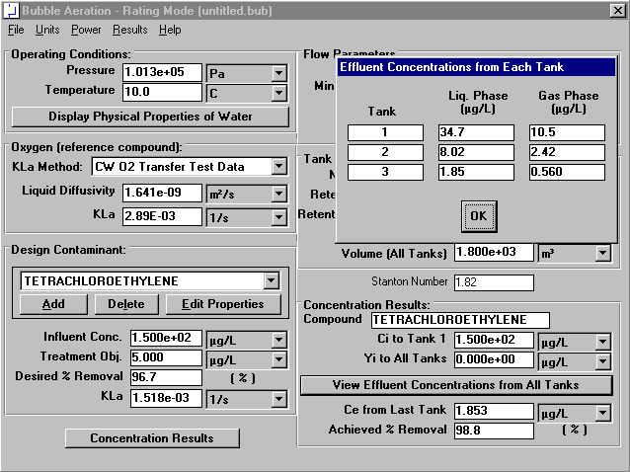
Figure 28 - Concentration Results for Tetrachloroethylene
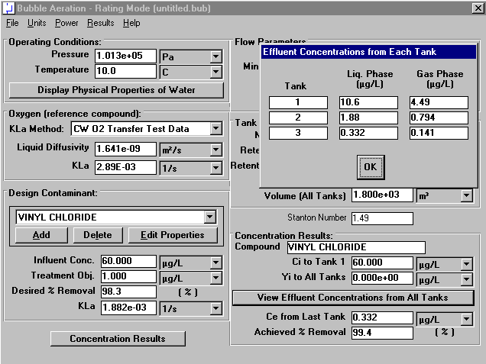
Figure 29 - Concentration Results for Vinyl Chloride
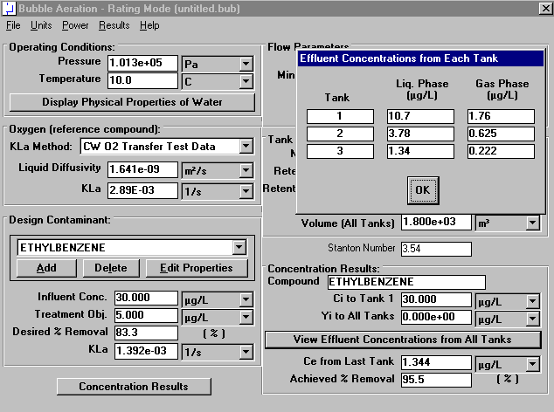
Figure 30 - Concentration Results for Ethylbenzene
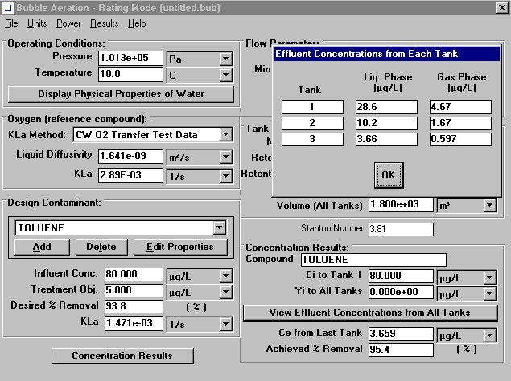
Figure 31 - Concentration Results for Toluene
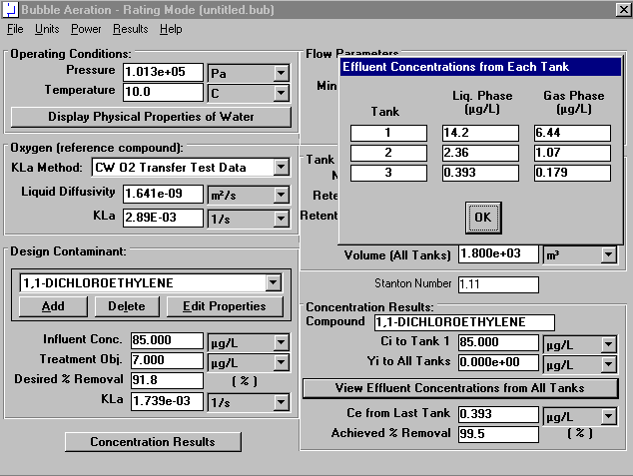
Figure 32 - Concentration Results for 1,1-Dichloroethylene

Power Results
The power calculations for rating mode are identical to those for design mode. To view the power window for this rating mode case, click the Perform Power Calculations options in the Power menu shown in Figure 3. Then the power window will appear:
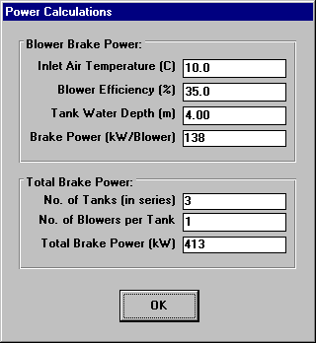
Figure 33 - Power Window

Viewing Effluent Concentration Results for All Contaminants
For the current design, it is useful to see what the effluent concentrations of all contaminants on the same window. ASAP provides a convenient method for seeing these results. By clicking on the Concentration Results button in the lower left-hand corner of the bubble aeration – rating mode window shown in Figure 3, the user will see the concentration results for all contaminants using the given design (see Figure 34).
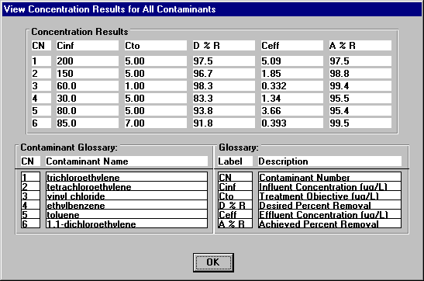
Figure 34 – View Concentration Results for All Contaminants Window
This window provides a quick method to see whether the given design will meet the treatment objectives for all contaminants.

