Bubble Aeration - Nomenclature

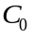 Liquid phase influent concentration of contaminant, (μg/L)
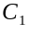 Liquid phase effluent concentration of contaminant discharged from tank number 1, (μg/L)
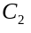 Liquid phase effluent concentration of contaminant discharged from tank number 2, (μg/L)
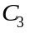 Liquid phase effluent concentration of contaminant discharged from tank number 3, (μg/L)
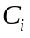 Liquid phase effluent concentration of contaminant discharged from tank number i, (μg/L)
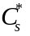 Tabulated value of dissolved oxygen surface saturation concentration at 20°C, (μg/L)
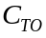 Treatment objective concentration of contaminant, (μg/L)
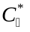 Dissolved oxygen saturation concentration attained at infinite time, (μg/L)
Effective saturation depth, (m)
Tank water depth, (m)
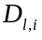 Liquid diffusivity of contaminant at 10°C, (m²/s)
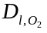 Diffusivity of Oxygen at 10°C, (m²/s)
gravitational constant (m/s²) = 9.81
Henry’s constant, (dimensionless)
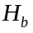 Water depth (m)
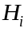 Henry’s constant of the contaminant, (dimensionless)
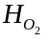 Henry’s constant of oxygen, (mg/L*atm)
Tank number, (dimensionless)
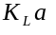 Design mass transfer coefficient, (1/s)
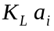 Design mass transfer coefficient of contaminant at 10°C, (1/s)
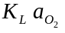 Mass transfer coefficient of Oxygen at 10°C, (1/s)
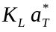 True mass transfer coefficient for oxygen at temperature, T, (1/s)
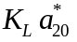 True mass transfer coefficient for oxygen at 20°C, (1/s)
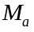 Molecular weight of air, (amu)
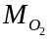 Molecular weight of oxygen, (amu)
Number of tanks operating in series, (dimensionless)
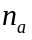 constant used in determining blower brake power = 0.283
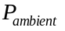 ambient pressure (N/m²)
Barometric pressure, (N/m²)
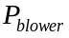 Blower brake power (kW)
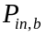 Inlet air pressure to bubble aeration tank (N/m²)
Barometric pressure under standard conditions, (N/m²)
Vapor pressure of water at 20°C, (N/m²)
Water flowrate, (m³/s)
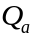 Volumetric air flow rate, (m³/s)
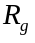 Universal gas constant (L*atm/(mol*K)) = 0.08205
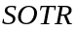 Standardized oxygen transfer rate, (kg/d)
Operating temperature (K)
Volume of each tank in series, (m³)
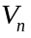 Total volume of system, (m³)
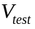 Clear water oxygen test volume (m3)
Air flowrate, (m³/s)
Air to water ratio, (dimensionless)
 Minimum air to water ratio, (dimensionless)
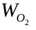 Rate of oxygen supply by the diffuser, (kg/s)
Gas phase effluent concentration of contaminant discharged from tank number 1, (μg/L)
Gas phase effluent concentration of contaminant discharged from tank number 2, (μg/L)
Gas phase effluent concentration of contaminant discharged from tank number 3, (μg/L)
Gas phase effluent concentration of contaminant discharged from tank number i, (μg/L)
Greek Letters
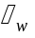 Weight density of water, (N/m³)
Parameter used for temperature correlation
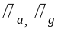 Air density at 20°C, (kg/m³)
Hydraulic retention time of one tank in series, (hr)
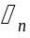 Total hydraulic retention time of system, (hr)
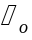 Oxygenation coefficient, (1/sec)

