Theoretical Development of ASAP

Estimating the Mass Transfer Coefficient in Air Stripping Processes

Development
Mass transfer between the air and liquid phases can be described using two film theory (Lewis and Whitman, 1924). Figure 1 shows a diagram illustrating the equilibrium between the air and water phases for two film theory.
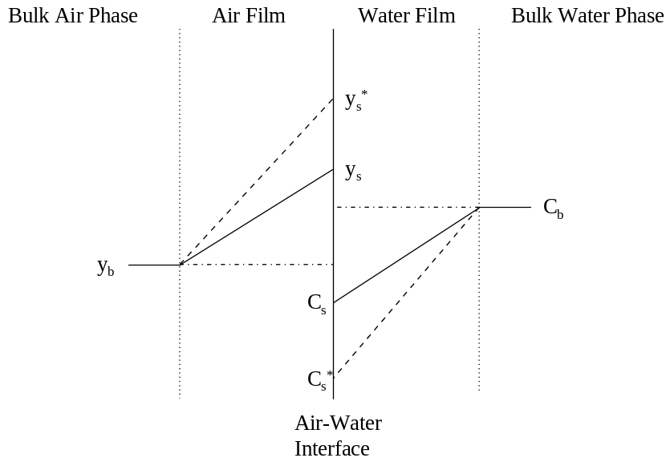
Figure 1 - Diagram Describing Equilibrium between Air and Liquid Phases Using Two Film Theory
Definitions of variables shown in Figure 1 are provided here:
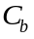 Aqueous phase concentration in the bulk solution (M/L³)
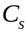 Aqueous phase concentration at air-water interface (M/L³)
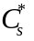 Equilibrium aqueous phase concentration assuming no concentration gradient in the air phase (M/L³)
Gas phase concentration in the bulk (M/L³)
Gas phase concentration at air-water interface (M/L³)
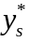 Equilibrium gas phase concentration assuming no concentration gradient in the liquid phase (M/L³)
Equilibrium between the air and water phases can be described using Henry’s Law. At the air-water interface, local equilibrium exists. Because of this, the following relationships hold true:
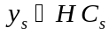
Eq. 1
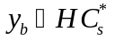
Eq. 2
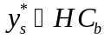
Eq. 3
Fick’s Law states that the flux across the air-water interface, 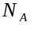, is proportional to concentration gradient. Mathematically, , is described by:
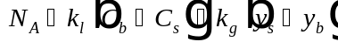
Eq. 4
Assuming all resistance to mass transfer is on the liquid side allows for the calculation of an overall mass transfer coefficient, K_{L}, based on a liquid phase driving force. It should be noted that this development accounts for both liquid and gas phase resistance to mass transfer. An expression for the flux based on a liquid phase driving force is given as:
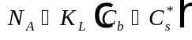
Eq. 5
Equating Eq. 4 and Eq. 5 results in:
Eq. 6
Noting the following relationship:
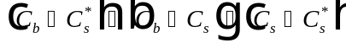
Eq. 7
Substituting 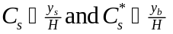 into Eq. 7:
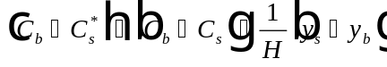
Eq. 8
Combining Eq. 6 and Eq. 8:
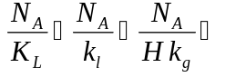
Eq. 9
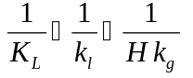
Eq. 10
Eq. 10 can also be written as:
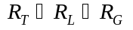
Eq. 11
where: 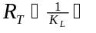 Overall resistance to mass transfer (T/L)
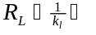 Liquid side resistance to mass transfer (T/L)
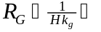 Gas side resistance to mass transfer (T/L)
It is clear from Eq. 11 that the expression for overall mass transfer coefficient based on a liquid phase driving force, 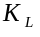, accounts for both liquid phase and gas phase resistance to mass transfer, as stated above.
Introducing a new variable, , which is constant for all compounds and defined as the area available for mass transfer divided by the vessel volume, it is possible to rewrite Eq. 10 as:
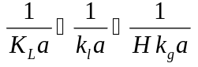
Eq. 12
Eq. 12 represents the general equation for determining the mass transfer coefficient in an aeration process, such as packed tower aeration, bubble aeration, or surface aeration.

Nomenclature
Area available for mass transfer divided by the vessel volume (L²/L³)
Name of compound
Aqueous phase concentration of A in the bulk solution (M/L³)
Aqueous phase concentration of A at air-water interface (M/L³)
Equilibrium aqueous phase concentration of A assuming no concentration gradient in the air phase (M/L³)
Henry’s Law constant describing equilibrium between the air and water phases (dimensionless)
Gas phase mass transfer coefficient (L/T)
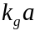 Gas phase mass transfer coefficient for compound i (1/T)
Liquid phase mass transfer coefficient (L/T)
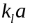 Liquid phase mass transfer coefficient for compound i (1/T)
Overall mass transfer coefficient based on a liquid phase driving force (L/T)
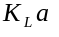 Overall mass transfer coefficient for compound i (1/T)
Flux across the air-water interface (M/L²/T)
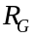 Gas side resistance to mass transfer (T/L)
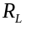 Liquid side resistance to mass transfer (T/L)
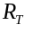 Overall resistance to mass transfer (T/L)
Gas phase concentration of A in the bulk (M/L³)
Gas phase concentration of A at air-water interface (M/L³)
Equilibrium gas phase concentration of A assuming no concentration gradient in the liquid phase (M/L³)

References
Lewis, W. K. and W. E. Whitman, “Principles of Gas Absorption,” Ind. Engng. Chem., 16, 1215-1220 (1924).

