Determination of Flows and Loadings for Packed Tower Aeration (Rating Mode)

Development
In rating mode, the user has three flow and loading specification options:
(1) Specify water flow rate and air flow rate
Calculate air to water ratio, water loading rate, and air loading rate
(2) Specify water flow rate and air to water ratio
Calculate air flow rate, water loading rate, and air loading rate
(3) Specify water loading rate and air loading rate
Calculate water flow rate, air flow rate, and air to water ratio
The equations used for the calculations in each of the three cases are given below.
Case (1) Specify water flow rate and air flow rate
Calculate air to water ratio, water loading rate, and air loading rate
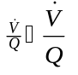
Eq. 1
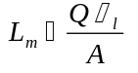
Eq. 2
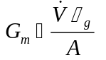
Eq. 3
Case (2) Specify water flow rate and air to water ratio
Calculate air flow rate, water loading rate, and air loading rate
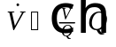
Eq. 4
Eq. 5
Eq. 6
Case (3) Specify water loading rate and air loading rate
Calculate water flow rate, air flow rate, and air to water ratio
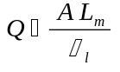
Eq. 7
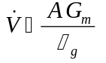
Eq. 8
Eq. 9

Nomenclature
Cross-sectional area of tower (L²)
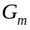 Air mass loading rate (M/L²/T)
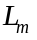 Water mass loading rate (M/L²/T)
Water flow rate (L³/T)
Air flow rate (L³/T)
Air to water ratio (L³/L³)
Greek Letters
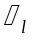 Water density (M/L³)
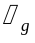 Air density (M/L³)

