Power Requirements in Packed Tower Aeration

Development
The total operating power for packed tower aeration is the sum of the blower and pump brake power requirements. The blower brake power was found from the following relationship (Metcalf & Eddy, 1991):
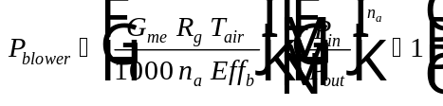
Eq. 1
Hand, et al (1986) discussed the application of Eq. 1 in packed tower aeration. The term 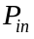 refers to the pressure at the bottom of the tower, which is the inlet for the gas stream. is calculated as the sum of the ambient pressure and the pressure drop caused by the packing media, demister, packing support plate, duct work, inlet and outlet of the tower.
The equation used to find is:
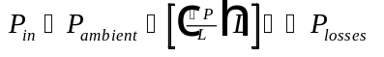
Eq. 2
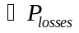 is found from the following:
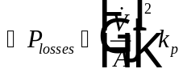
Eq. 3
Note that Eq. 3 represents the pressure drop through the demister, packing support plate, duct work, inlet and outlet of the tower. It is assumed that turbulent flow conditions prevail and most of the losses occur in the tower (i.e. in the packing support plate and the demister).
The pump brake power for packed tower aeration is given by (note that this expression only accounts for the pressure loss resulting from the head required to pump the water to the top of the tower):
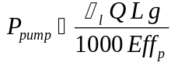
Eq. 4

Nomenclature
Tower cross-sectional area (L²)
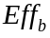 Blower efficiency (expressed as decimal), which is a net efficiency accounting for both the fan and motor on the blower
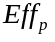 Pump efficiency (expressed as decimal)
Gravitational constant (L/T²)
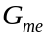 Mass flow rate of air (M/T) = 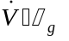
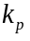 Constant used to estimate gas pressure drop in tower for losses other than that in the tower packing (M/L³) = 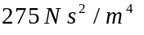 (Hand, et al, 1986)
Packing height (L)
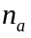 Constant used in determining blower brake power = 0.283 for air
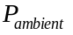 Ambient air pressure (M L/T²/L²)
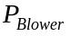 Blower brake power (M L² / T² / T)
Inlet air pressure to packed tower (bottom of tower) (M L/T²/L²)
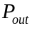 Outlet air pressure from packed tower (top of tower) (M L/T²/L²) =
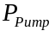 Pump brake power (M L² / T² / T)
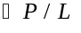 Gas pressure drop per unit length of packing (M L/T²/L²/L)
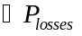 Pressure drop through the demister, packing support plate, duct work, inlet and outlet of the tower (M L/T²/L²)
Water flow rate (L³/T)
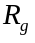 Universal gas constant
Absolute water temperature
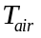 Absolute air temperature, which is typically assumed equal to
Air volumetric flow rate (L³/T)

Greek Letters
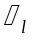 Liquid density (M/L³)
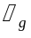 Gas density (M/L³)

References
Hand, D.W., J.C. Crittenden, J.L. Gehin, and B.W. Lykins, Jr., “Design and Evaluation of an Air-Stripping Tower for Removing VOCs from Groundwater,” Journal AWWA, 78, 9, 87-97 (1986).
Metcalf and Eddy Inc., Wastewater Engineering, 3rd Ed., New York: McGraw-Hill (1991).

