Determination of Mass Transfer Coefficient in Bubble and Surface Aeration

Development
The general equation for estimating mass transfer coefficient, 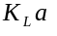, for an aeration process was derived earlier as:
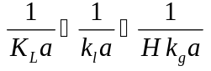
Eq. 1
For bubble and surface aeration, it is difficult to determine the overall mass transfer coefficient for a compound from Eq. 1 because the quantities 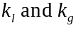 vary greatly from system to system and are difficult to measure. In order to determine the overall mass transfer coefficient of a compound for these systems, it is necessary to relate the mass transfer coefficient of a given compound, 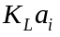, to the mass transfer coefficient of a reference compound, 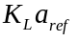. The procedure for doing so is shown below.
Eq. 1 can be written for compound i as:
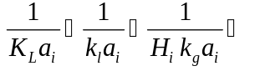
Eq. 2
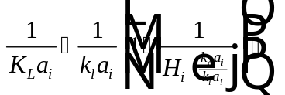
Eq. 3
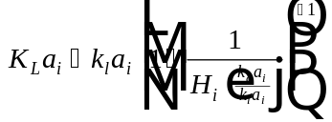
Eq. 4
It should be noted that the term 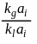 is relatively constant for a given device and does not depend on the compound, i. The following simplification can be made:
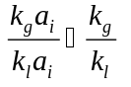
Eq. 5
Substituting Eq. 5 into Eq. 4 results in:
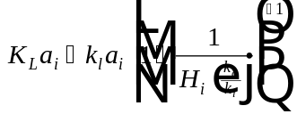
Eq. 6
Eq. 6 can be written for a reference compound as:
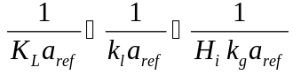
Eq. 7
A good choice for reference compound is a compound that has all resistance to mass transfer on the liquid side. Such a compound is oxygen since the liquid side controls mass transfer. For oxygen, the gas phase mass transfer resistance is negligible and Eq. 7 simplifies to:
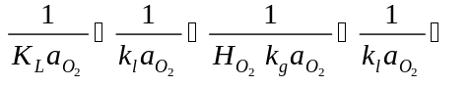
Eq. 8
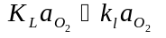
Eq. 9
Relating mass transfer coefficient of a given compound, i, to the mass transfer coefficient for oxygen as a reference compound results from dividing Eq. 6 by Eq. 9:
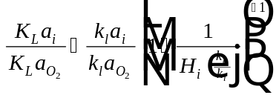
Eq. 10
The quantity 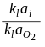 in Eq. 10 can be determined using the Sherwood number, 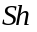, which is defined by the following equation:
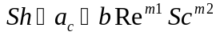
Eq. 11
The constant in Eq. 11 is a term accounting for natural convection. This term is negligible in most engineered systems compared to the term, 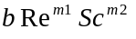, which is a term accounting for flow. Making this assumption, Eq. 11 can be rewritten as:

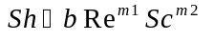
Eq. 12
Taking the ratio of the Sherwood number of a given compound, i, to the Sherwood number for oxygen results in:
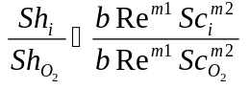
Eq. 13
The values for the constants and 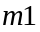 and the Reynolds number, , in Eq. 13, are dependent only on the system and not on the compound. Knowing this, Eq. 13 can be simplified to:
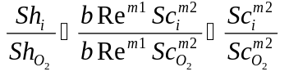
Eq. 14
The Sherwood number of a compound i is defined as:
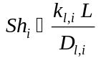
Eq. 15
Likewise, the Sherwood number for oxygen can be represented by:
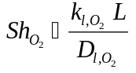
Eq. 16
The Schmidt numbers for a compound i and for oxygen are defined as:
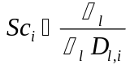
Eq. 17
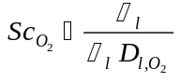
Eq. 18
Substituting the definitions given in Eq. 15 - Eq. 18 into Eq. 14 results in:
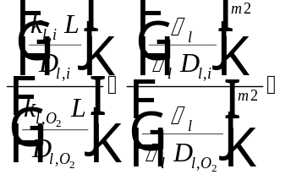Multiplying top and bottom of left side by
Eq. 19
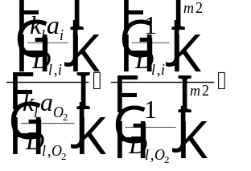
Eq. 20
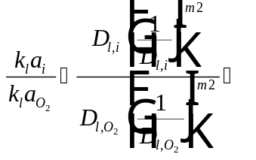
Eq. 21
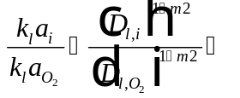
Eq. 22
Noting that 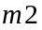 is a constant depending on the type of boundary in the range 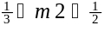, a variable 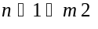 can be substituted into Eq. 22, where is in the range 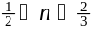:
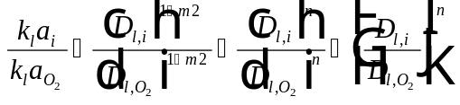
Eq. 23
Substituting Eq. 23 into Eq. 10 results in the equation for determining the mass transfer coefficient of any compound, i, using oxygen as a reference compound:
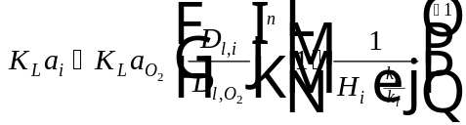
Eq. 24
Eq. 24 represents the general formula for estimating the mass transfer coefficient of a compound in bubble and surface aeration. A few comments on each of the variables needed to calculate the mass transfer coefficient of a compound i:
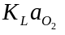 Overall mass transfer coefficient for oxygen (1/T).
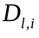 Liquid diffusivity of compound i (L²/T). This parameter is available in StEPP™.
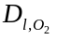 Diffusivity of oxygen (L²/T). This parameter can be determined from a correlation presented by Holmén and Liss (1984). The correlation was obtained from a best fit of literature values and is described in detail below.
Constant depending on the type of boundary. In water, there is typically a boundary layer and n is closer to 1/2. In air, there is typically no boundary layer and n is closer to 2/3.
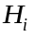 Henry’s Law constant for component i
This ratio tends to be relatively constant for a given device. The range of values for this parameter is approximately 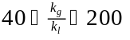, depending on the device. This parameter does not depend on the compound of interest.

Estimating the Diffusivity of Oxygen
This parameter can be determined from a correlation presented by Holmén and Liss in 1984. The correlation was obtained from a best fit of literature values:
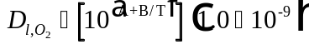
Eq. 25
Parameters used in the correlation are:
Diffusivity of oxygen (m²/s)
Fitting parameter = 3.15
Fitting parameter = -831.0
Absolute temperature (K)

Nomenclature
Area available for mass transfer divided by the vessel volume (L²/L³)
Constant accounting for natural convection in the equation for Sherwood number
Fitting parameter in diffusivity of oxygen equation
Constant in the equation for Sherwood number that depends on the system
Fitting parameter in diffusivity of oxygen equation
Liquid diffusivity of compound i (L²/T)
Liquid diffusivity of oxygen (L²/T)
Henry’s Law constant describing equilibrium between the air and water phases (dimensionless)
Henry’s Law constant for compound i (dimensionless)
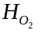 Henry’s Law constant for oxygen (dimensionless)
Name of compound of interest
Gas phase mass transfer coefficient (L/T)
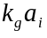 Gas phase mass transfer coefficient for compound i (1/T)
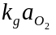 Gas phase mass transfer coefficient for oxygen (1/T)
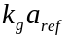 Gas phase mass transfer coefficient for a reference compound (1/T)
This ratio tends to be relatively constant for a given device. The range of values for this parameter is approximately , depending on the device. This parameter does not depend on the compound of interest.
Liquid phase mass transfer coefficient (L/T)
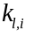 Liquid phase mass transfer coefficient for compound i (L/T)
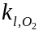 Liquid phase mass transfer coefficient for oxygen (L/T)
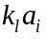 Liquid phase mass transfer coefficient for compound i (1/T)
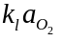 Liquid phase mass transfer coefficient for oxygen (1/T)
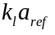 Liquid phase mass transfer coefficient for a reference compound (1/T)
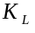 Overall mass transfer coefficient based on a liquid phase driving force (L/T)
Overall mass transfer coefficient for compound i (1/T)
Overall mass transfer coefficient for oxygen (1/T)
Overall mass transfer coefficient for a reference compound (1/T)
Length term (L)
Constant in the equation for Sherwood number that depends on the type of flow
Constant in the equation for Sherwood number that depends on the type of boundary
Constant depending on the type of boundary in the range . In water, there is typically a boundary layer and n is closer to 1/2. In air, there is typically no boundary layer and n is closer to 2/3.
Reynolds number (dimensionless)
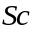 Schmidt number (dimensionless)
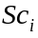 Schmidt number for compound i (dimensionless)
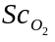 Schmidt number for oxygen (dimensionless)
Sherwood number (dimensionless)
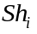 Sherwood number for compound i (dimensionless)
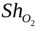 Sherwood number for oxygen (dimensionless)
Absolute temperature (K)
Greek Letters
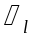 Viscosity of liquid water (M/L/T)
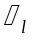 Density of liquid water (M/L³)

Reference
Holmén, Kim, and Peter Liss, “Models for Air-Water Gas Transfer: An Experimental Investigation,” Tellus, 36B, 92-100 (1984).

