Estimating the Mass Transfer Coefficient for Bubble Aeration

Development
It was shown previously that the general formula for estimating the mass transfer coefficient of a compound in an air stripping process is:
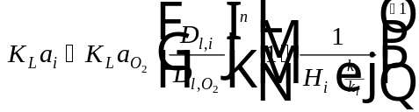
Eq. 1
Methods for obtaining each of the parameters in Eq. 1 are described below:
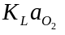 For bubble aeration, the overall mass transfer coefficient for oxygen can be estimated using clean water oxygen transfer test data. The procedure for doing so is described in detail below.
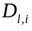 Liquid diffusivity of compound i (L²/T). This parameter can be calculated by the Hayduk & Laudie correlation (1974) for small molecules in water.
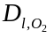 Diffusivity of oxygen (L²/T). This parameter can be determined from a correlation presented by Holmén and Liss (1984). The correlation was obtained from a best fit of literature values.
Diffusivity exponent (dimensionless). For bubble aeration, this value will be set equal to 0.6. This is based on an evaluation of literature values performed by Holmén and Liss (1984) in which the mean value of n was found to be approximately 0.6 for air-water gas transfer. It should be noted that the range of n values shown in the various literature studies was 0.1 < n < 0.8.
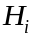 Henry’s constant of compound, i (dimensionless). This value is available from StEPP™ and from various literature sources (Ashworth, et al, 1988; Gossett, 1987)
Munz and Roberts (1989) point out that a constant value of 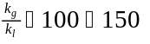 has become widely used in air-water mass transfer. For this reason, a constant value of 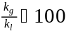 will be used as a conservative estimate in bubble aeration. Munz and Roberts also point out that the assumption of a constant may over-simplify matters since could depend on operating conditions and/or temperature.
Therefore, the equation used to estimate the mass transfer coefficient of a compound, i, in bubble aeration is given below:
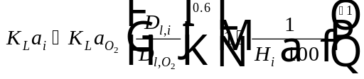
Eq. 2

Estimating the Mass Transfer Coefficient for Oxygen for Bubble Aeration
For bubble aeration, the mass transfer coefficient for oxygen can be estimated using clean water oxygen transfer test data (Brown and Baillod, 1982; Baillod, et al, 1986). The procedure to find 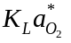 is as follows:
True mass transfer coefficient for oxygen at 20 °C, 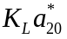, is calculated based on the observed mass transfer coefficient for oxygen at 20 °C, 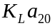, and a parameter, :
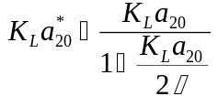
Eq. 3
The observed mass transfer coefficient for oxygen at 20 °C, , can be determined from the standardized oxygen transfer rate, 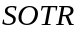, the water volume in the tank, , and the dissolved oxygen saturation concentration attained at infinite time, 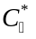. Further explanation on finding the will be provided in the next section.
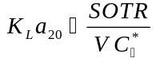
Eq. 4
The dissolved oxygen saturation concentration attained at infinite time can be found from the following relationship:
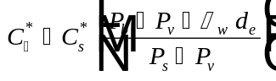
Eq. 5
The parameter, , needed to solve Eq. 3 is defined by the following expression:
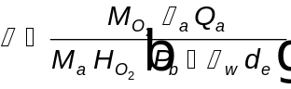
Eq. 6
Once the mass transfer coefficient for oxygen at 20 °C, , is known, it is possible to estimate the mass transfer coefficient at other temperatures using the relationship:
Eq. 7
This value, 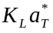, is the mass transfer coefficient for oxygen, , referred to in the calculation of the mass transfer coefficient of a given compound, 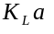, in bubble aeration.

Determination of the Standardized Oxygen Transfer Rate
is defined as the rate of oxygen transfer in clean water at zero dissolved oxygen and a specified temperature, usually 20°C (68°F). One possible method for retrieving a value for for an aeration tank at a given sidewall depth, is by obtaining a rating curve showing SOTR versus air flow rate in SCFM. Such information should be available from operating data for a given tank. An example of such a curve is shown in Figure 1.

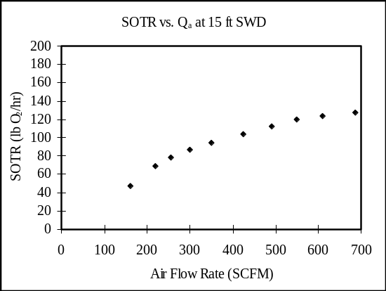
Figure 1 - Rating Curve Showing SOTR vs. Air Flow Rate in SCFM for a Given Aeration Tank
At times, oxygen transfer data will be reported in terms of standardized oxygen transfer efficiency, 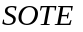, rather than in terms of . Given a value for in %, can be calculated from the following relationships:
SI Units
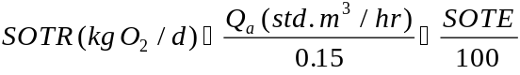
Eq. 8
English Units
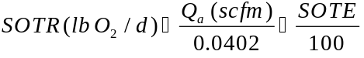
Eq. 9
It should be noted that the and are by definition reported at 20°C (68°F), 1 atm pressure, and 36% relative humidity.
For completeness, derivations of Eq. 8 and Eq. 9 are provided.
Derivation to Calculate SOTR in terms of SOTE for SI Units
Problem: Find relationship between 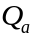 (std. m³ / hr) and (kg/d).
Solution:
Standard Conditions → 20°C, 1 atm Pressure, 36% Relative Humidity (r.h.)
Composition of Dry Air → 21.0% O₂, 78.0% N₂, 1.0% Ar

Using the Ideal Gas Law:

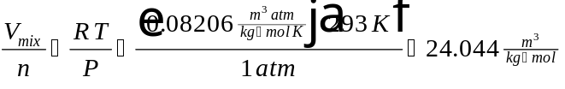
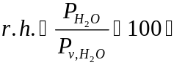
At 20°C, 100% r.h., vapor pressure of water, 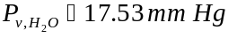
At 20°C, 36% r.h., partial pressure of water, 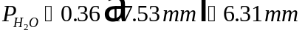

At 760 mm total pressure and 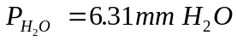, the pressure at the dry air is:
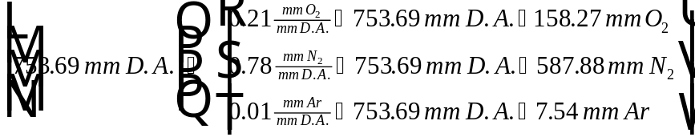

Assume 1 kg-mol mixture:
Wet Air Mixture Mol Fraction, MF Mol. Wt., MW 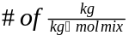
(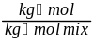) (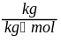) ()

H₂O 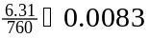 18.0 0.1494
O₂ 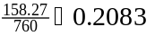 32.0 6.6656
N₂ 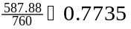 28.0 21.6580
Ar 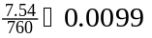 40.0 0.3960

Average Molecular Weight = 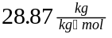

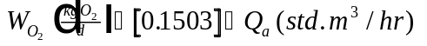
Eq. 10
By definition:
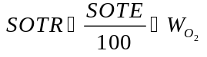
Eq. 11
Solving Eq. 10 for 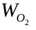 and substituting into Eq. 11 results in:
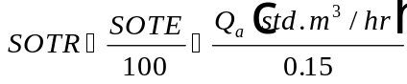
Eq. 12
Eq. 12 matches Eq. 8, meaning the derivation of Eq. 8 is complete.
Derivation to Calculate SOTR in terms of SOTE for English Units

Problem: Find relationship between (scfm) and (lb/d).
Solution:
Standard Conditions → 68°F, 1 atm Pressure, 36% Relative Humidity (r.h.)
Composition of Dry Air → 21.0% O₂, 78.0% N₂, 1.0% Ar

Using the Ideal Gas Law:

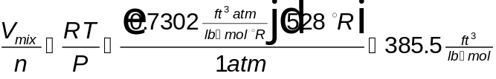
At 20°C, 100% r.h., vapor pressure of water,
At 20°C, 36% r.h., partial pressure of water,

At 760 mm total pressure and , the pressure at the dry air is:

Assume 1 lb-mol mixture:
Wet Air Mixture Mol Fraction, MF Mol. Wt., MW 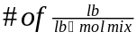
(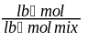) (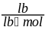) ()

H₂O 18.0 0.1494
O₂ 32.0 6.6656
N₂ 28.0 21.6580
Ar 40.0 0.3960

Average Molecular Weight = 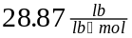

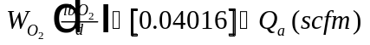
Eq. 13
By definition:
Eq. 14
Solving Eq. 13 for and substituting into Eq. 14 results in:
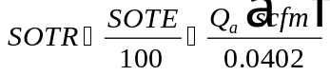
Eq. 15
Eq. 15 matches Eq. 9, meaning the derivation of Eq. 9 is complete.

Nomenclature
Dissolved oxygen saturation concentration attained at infinite time (M/L³)
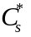 Tabulated value of dissolved oxygen surface saturation concentration at 20°C (M/L³) = 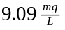 (Metcalf & Eddy, 1991)
Effective saturation depth (L) = 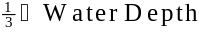
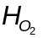 Henry’s constant for oxygen (M/L³)/(M L/T²/L²) = 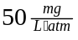
True mass transfer coefficient for oxygen at 20°C (1/T)
True mass transfer coefficient for oxygen at temperature, T (1/T)
Apparent observed mass transfer coefficient for oxygen at 20°C (1/T)
Mass transfer coefficient for oxygen at temperature, T (1/T) =
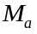 Molecular weight of air (amu) = 28.0
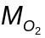 Molecular weight of oxygen (amu) = 32.0
Number of moles of gas in ideal gas law
Barometric pressure (M L/T²/L²)
Barometric pressure under standard conditions (M L/T²/L²) = 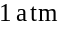
Vapor pressure of water at 20°C (M L/T²/L²) = 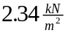 (Metcalf & Eddy, 1991)
Volumetric air flow rate (L³/T)
Universal gas constant
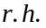 Relative humidity (%)
Standardized oxygen transfer efficiency (%)
Standardized oxygen transfer rate (M/T)
Absolute temperature
Water volume (L³)
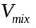 Volume of wet air mixture (L³)
Rate of oxygen supply by the diffuser (M/T)
Greek Letters
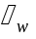 Weight density of water = 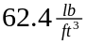
Oxygenation coefficient (1/T)
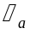 Density of air at 20°C = 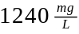
Parameter used for temperature correlation = 1.024

References
Ashworth, R. A., G. B. Howe, M. E. Mullins, and T. N. Rogers, “Air-Water Partitioning Coefficients of Organics in Dilute Aqueous Solutions,” Journal of Hazardous Materials, 18, 25-36 (1988).
Baillod, C. R., W. L. Paulson, J. J. McKeown, and H. J. Campbell, Jr., “Accuracy and Precision of Plant Scale and Shop Clean Water Oxygen Transfer Tests,” Journal WPCF, 58, 4 (1986).
Brown, L.C. and C.R. Baillod, “Modeling and Interpreting Oxygen Transfer Data,” J. Environ. Eng. Div. Proc. Am. Soc. Civ. Eng., 108, EE4, 607 (1982).
Gossett, J. M., “Measurement of Henry’s Law Constants for C₁ and C₂ Chlorinated Hydrocarbons,” Environ. Sci. Technol., 21, 202-208 (1987).
Hayduk, W. and H. Laudie, “Prediction of Diffusion Coefficients for Non-electrolytes in Dilute Aqueous Solutions,” Jour. AIChE, 28, 611 (1974).
Holmén, Kim, and Peter Liss, “Models for Air-Water Gas Transfer: An Experimental Investigation,” Tellus, 36B, 92-100 (1984).
Metcalf & Eddy, Inc., Wastewater Engineering: Treatment, Disposal, and Reuse, Third Edition, New York: McGraw Hill (1991).
Munz, C. and P. V. Roberts, “Gas- and Liquid-Phase Mass Transfer Resistances of Organic Compounds during Mechanical Surface Aeration,” Wat. Res., 23, 5, 589-601 (1989).

