Power Requirements in Bubble Aeration

Development
The total operating power for bubble aeration is equal to the blower brake power requirement for each tank times the number of tanks times the number of blowers per tank. The blower brake power was found from the following relationship (Metcalf & Eddy, 1991):
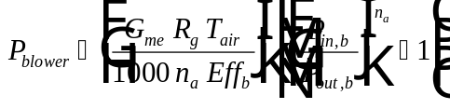
Eq. 1
The term 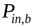 refers to the pressure at the top of the tank, which represents the sum of the ambient pressure and the head required to raise the water to the inlet of the tank. The equation used to find is:
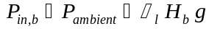
Eq. 2
The pressure head, 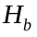, is assumed equal to the water depth in the tank, 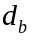.

Nomenclature
Water depth in bubble aeration tank (L)
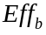 Blower efficiency (%)
Gravitational constant (L/T²)
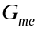 Mass flow rate of air (M/T)
Pressure head required to raise water to top of tank (L) =
Packing height (L)
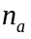 Constant used in determining blower brake power = 0.283 for air
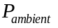 Ambient air pressure (M L/T²/L²)
Inlet air pressure to bubble aeration tank (bottom of tower) (M L/T²/L²)
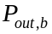 Outlet air pressure from bubble aeration tank (top of tower) (M L/T²/L²) =
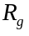 Universal gas constant
Absolute water temperature
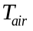 Absolute air temperature, which is typically assumed equal to absolute water temperature
Greek Letters
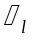 Liquid density (M/L³)

Reference
Metcalf and Eddy Inc., Wastewater Engineering, 3rd Ed., New York: McGraw-Hill (1991).

