Estimation of the Pressure Drop across a Packed Tower (Rating Mode)

Development
In rating mode, the pressure drop across a packed tower is estimated based on the generalized pressure drop curves developed by Eckert (1961), which are shown in Treybal (1980) and reprinted with permission in Hand, et al (1986). The Eckert pressure drop curves were fit by Cummins and Westrick (1983) in order to develop correlations capable of predicting gas loading rate and tower area. The process to estimate pressure drop for rating mode based on the Eckert curves is described below. Note that in some cases it is not possible to attain convergence.
In rating mode, all the parameters necessary to calculate the value of the y-axis on the Eckert curves are known. The value of the y-axis on the Eckert curves, 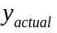, can be calculated from the following equation:
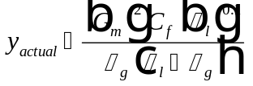
Eq. 1
Once is known, it is necessary to iterate the value of pressure drop using the process shown below until the calculated value of the y-axis on the Eckert curve, 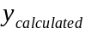, matches the actual value, . Pressure drop per packing height is usually iterated between the values of 50 and 1200 N/m²/m since that is the region for which the correlations were developed.

Iteration Process to Calculate Pressure Drop
(1) Calculate the parameter, E:
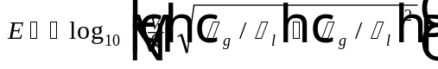
Eq. 2
(2) Specify a pressure drop, 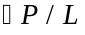, in N/m²/m.
(3) Calculate the parameter, :
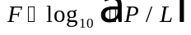
Eq. 3
(4) Calculate the parameters, 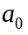, , and 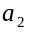:
Eq. 4
Eq. 5
Eq. 6
(5) Determine the value of from the following equation:

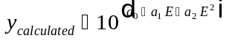
Eq. 7
(6) If is within 1 % of then pressure drop is set equal to the value specified in step (2) above and the iterative process is complete. Otherwise, return to step (2) and perform the iterative process again, remembering that pressure drop is generally iterated between 50 and 1200 N/m²/m.

Nomenclature
, , Calculated empirical parameters
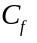 Packing factor (dimensionless)
, Calculated empirical parameter
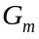 Gas mass loading rate (M/L²/T)
Calculated empirical parameter
Pressure drop gradient (F/L²/L)
Water flow rate (L³/T)
Air to water ratio (L³/L³)
Greek Letters
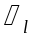 Liquid viscosity (M/L/T)
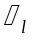 Liquid density (M/L³)
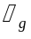 Gas density (M/L³)

References
Cummins, M. D. and J. J. Westrick, Proc. ASCE Envir. Engrg. Conf., Boulder, Colorado (July 1983).
Eckert, J. S., “Design Techniques for Sizing Packed Towers,” Chem. Eng. Prog., 57, 9 (1961).
Hand, D. W., J. C. Crittenden, J. L. Gehin, and Benjamin W. Lykins, Jr., “Design and Evaluation of an Air-Stripping Tower for Removing VOCs from Groundwater,” Journal AWWA, 78, 9, 87-97 (1986).
Treybal, R. E., Mass Transfer Operations, Chem. Engrg. Series, McGraw-Hill Book Co., New York, 3rd Ed. (1980).

