Estimation of the Mass Transfer Coefficient in Packed Tower Aeration

Development
The general equation for calculating an overall mass transfer coefficient, 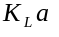, in aeration processes was derived earlier based on the two-film theory of mass transfer:

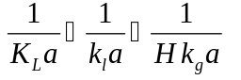
Eq. 1
It should be noted that Eq. 1 accounts for both liquid- and gas-phase resistances to mass transfer. For packed tower aeration, the liquid phase mass transfer coefficient (), gas phase coefficient (), and specific interfacial area () are determined based on the following correlations, which were developed by Onda, et al (1968).
The specific interfacial area, , is equivalent to the wetted surface area of the packing, 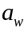, which is calculated as follows:
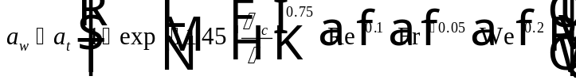
Eq. 2
The parameter refers to the specific surface area of the packing. The parameters 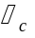 and refer to the critical surface tension of the packing and the surface tension of water, respectively. The parameters Re, Fr, and We refer to the Reynolds number, Froude number, and Weber number, respectively, which are defined by the following equations:
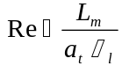
Eq. 3
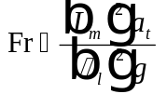
Eq. 4
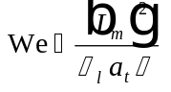
Eq. 5
The liquid phase mass transfer coefficient, , can be calculated as follows:
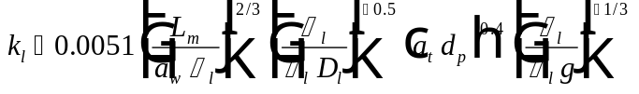
Eq. 6
Eq. 6 is valid for liquid loading rates between 1.1 and 63 gpm/ft² (0.8 and 43 kg/m²/s).
The gas phase mass transfer coefficient, , can be calculated as follows:
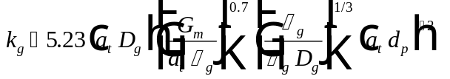
Eq. 7
Eq. 7 is valid for gas loading rates between 2.206 and 267.9 cfm (0.014 and 1.7 kg/m²/s). Eq. 2, Eq. 6, and Eq. 7 were correlated for nominal packing sizes up to 2 in. (0.0508 m).

Applicability and Limitations of the Onda Model
Roberts, et. al. (1985) and Cummins and Westrick (1983) showed that for several VOCs, obtained from the Onda correlations compared favorably to pilot plant data. Lamarche and Droste (1989) evaluated available mass transfer models for packed tower aeration (Onda, 1968; Sherwood and Holloway, 1940; and Shuman, et al, 1955) and determined that the Onda model gives the best predictions of mass transfer coefficient. Recent studies (Staudinger, et al, 1990; Lenzo, et al, 1990; Thom and Byers, 1993; Djebbar and Narbaitz, 1995) have identified some considerations that must be addressed when applying the Onda mass transfer model in packed tower aeration. Staudinger, et al (1990) evaluated the Onda model using 10 literature studies consisting of 11 VOCs and 4 packing materials for the following areas of concern: interactions and concentrations of compounds, prediction of gas-phase resistance, variations of performance between packing materials, extreme column operating conditions and temperature effects. The packing materials studied were both small (≤ 1 in.) and large (> 1 in.). While the study concluded that the Onda correlation provides an acceptable method for predicting the mass transfer coefficient in packed tower aeration, it also pointed out that the Onda correlation tended to underestimate performance for larger packings (2 in. nominal size). Lenzo, et al (1990) took mass transfer data from over 90 pilot- and full-scale air stripping tower studies and compared the experimental data to the mass transfer coefficients predicted by the Onda correlation. The study consisted of both large and small packings. The evaluation (which was limited to 596 data points collected for three different compounds) found that the Onda correlation overestimated in 75 % of the situations examined by an average of 37 %. It should be noted that Staudinger’s study was included in Lenzo’s evaluation. The overestimation of would result in an undersized tower failing to remove contaminants to the desired levels. Based on these findings, the study recommends a safety factor be applied on to reduce its value and increase the size of the tower. The evaluation found that a safety factor of 0.75 (Actual / Onda ) would account for 99 % of the data evaluated.
Application of such a safety factor in all cases will be costly for designers since the degree of overestimation will differ from case to case. Djebbar and Narbaitz (1995) seek to address this issue by correlating the mass transfer coefficient predicted by the Onda model to nominal packing size. The Onda model was developed by correlating nominal packing sizes up to 2 in. Current packing sizes used in the field often are higher, in the range from 2 in. through 6 in. It is for these larger nominal packing sizes that the Onda model tends to produce the most error. The Djebber study accounts for larger packing sizes (up to 6 in.) than any of the previous studies. Based on data for these larger packings used in full-scale operations, Djebbar and Narbaitz concluded that the average overestimation in was 40 % and that a safety factor of 0.68 (Actual / Onda ) would be required to account for 68 % of the data. Because the error in the Onda tends to increase with nominal packing size, Djebbar and Narbaitz developed a correlation to predict the actual achieved as a function of Onda and nominal packing size, 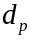. The correlation was created by regressing the full-scale data and is presented below:

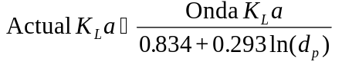
Eq. 8
The correlation presented in Eq. 8 is applicable to nominal packing sizes greater than 1 inch. The error in was reduced to 22 %, with the application of Eq. 8 to the studies of three different researchers for nominal sizes of 1.5”,2”, and 2”. The greatest source of error in the Onda model appears to be in the equation for wetted surface area of the packing, . It should be noted that Djebbar and Narbaitz’s evaluation considered both the Lenzo and Staudinger studies. Djebbar and Narbaitz also found that may vary along the packed column, which would contradict the previous assumptions that is constant with depth.
Thom and Byers (1993) point out that there are additional concerns besides the ones described above that can result in an inappropriate estimation of . In pilot-scale tests where conditions are carefully controlled by researchers, predictions of by the Onda correlation tend to closely match operating data. In the field, variation in design and construction details may lead to significantly different results between model predictions and packed tower performance. Important design and construction details include liquid distribution, packing materials, and adherence to the limitations and restrictions of the air stripping model used. Less likely to cause performance problems are factors such as Henry’s Law data, fouling, chemical reactions, and end effects. Paying close attention to design and construction details is essential in designing a packed tower that will match predicted results.
Based on the above discussion, it is recognized that the Onda correlation tends to overestimate mass transfer coefficients for larger packings. Researchers are in the process of developing correlations to account for the deviations. At the present time, there is no correlation that will correct the to an error of 10 % for larger packings. For this reason, based on the literature cited above, it is recommended that a safety factor of 0.6 (Actual / Onda ) be applied for nominal packing sizes > 1” in order to provide a conservative estimate of packing height required.

Nomenclature
Specific interfacial area, which is the area available for mass transfer divided by the vessel volume (L²/L³)
Total specific surface area of the packing material (L²/L³)
Wetted surface area of the packing, which is equal to (L²/L³)
Nominal diameter of the packing material (L)
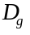 Gas diffusivity (L²/T)
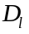 Liquid diffusivity (L²/T)
Froude number (dimensionless)
Gravitational Constant (L/T²)
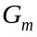 Gas mass loading rate (M/L²/T)
Henry’s Law constant (dimensionless)
Gas phase mass transfer coefficient (L/T)
Liquid phase mass transfer coefficient (L/T)
Overall liquid phase mass transfer coefficient (1/T)
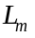 Liquid mass loading rate (M/L²/T)
Reynolds number (dimensionless)
Weber number (dimensionless)
Greek Letters
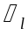 Liquid viscosity (M/L/T)
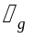 Gas viscosity (M/L/T)
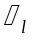 Liquid density (M/L³)
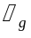 Gas density (M/L³)
Surface tension of liquid water (M/T²)
Critical surface tension of the packing material (M/T²)

References
Cummins, M. D. and J. J. Westrick, Proc. ASCE Envir. Engrg. Conf., Boulder, Colorado (July 1983).
Djebbar, Y. and R. M. Narbaitz, “Mass Transfer Correlations for Air Stripping Towers,” Environmental Progress, 14, 3, 137-145 (1995).
Lamarche, P. and R. L. Droste, “Air-Stripping Mass Transfer Correlations for Volatile Organics,” Journal AWWA, 81, 1, 78-89 (1989).
Lenzo, F.C., T. J. Frielinghaus, and A. W. Zienkiewicz, “The Application of the Onda Correlation to Packed Column Air Stripper Design: Theory Versus Reality,” Proceedings of the AWWA Annual Conference, Cincinnati, Ohio (1990).
Onda, K., H. Takeuchi, and Y. Okumoto, “Mass Transfer Coefficients between Gas and Liquid Phases in Packed Columns,” Jour. Chem. Engrg. Japan, 1, 1, 56-62 (1968).
Roberts, P.V., G. D. Hopkins, C. Munz, and A. H. Riojas, “Evaluating Two-Resistance Models for Air Stripping of Volatile Organic Contaminants in a Countercurrent, Packed Column,” Environ. Sci. Technol., 19, 2, 164-173 (1985).
Sherwood, T. K. and F. A. L. Holloway, “Performance of Packed Towers-Liquid Film Data for Several Packings,” Trans. Amer. Inst. Chem. Engrs., XXXVI:39 (1940).
Shulman, H. L., C. F. Ullrich, and N. Wells, “Performance of Packed Columns. I. Total, Static, and Operating Holdups,” Amer. Inst. Chem. Engrs. Jour., 1, 2, 247 (June 1955).
Staudinger, J., W. R. Knocke, and C. W. Randall, “Evaluating the Onda Mass Transfer Correlation for the Design of Packed-Column Air Stripping,” Journal AWWA, 82, 1, 73-79 (1990).
Thom, J. E. and W. D. Byers, “Limitations and Practical Use of a Mass Transfer Model for Predicting Air Stripper Performance,” Environmental Progress, 12, 1, 61-66 (1993).

