Development of Process Design Equations for Bubble Aeration

Development
This development is for a single compound in bubble aeration. All liquid phase concentrations, gas phase concentrations, and mass transfer coefficients specified in the development are relevant to a specific generic compound, which could be anything.

Single Tank
Figure 1 shows a schematic of a bubble aeration system for a single tank. Model development for bubble aeration has been described in the literature (Matter-Müller, et al, 1981; Munz and Roberts, 1982; Roberts, et al, 1984). The development of the process design equations for bubble aeration incorporates the following assumptions: (1) completely mixed liquid phase, (2) plug flow gas phase, (3) the process is at steady state, and (4) the inlet gas concentration is zero.
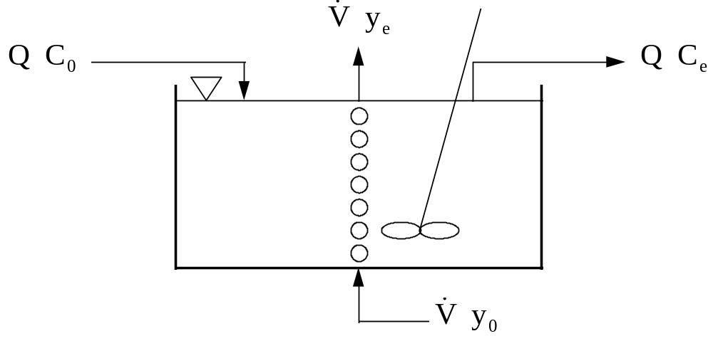
Figure 1 - Schematic of Bubble Aeration Configuration
1. Find minimum air to water ratio needed to achieve an effluent concentration of 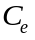 in the tank.
Mass Balance around the tank:
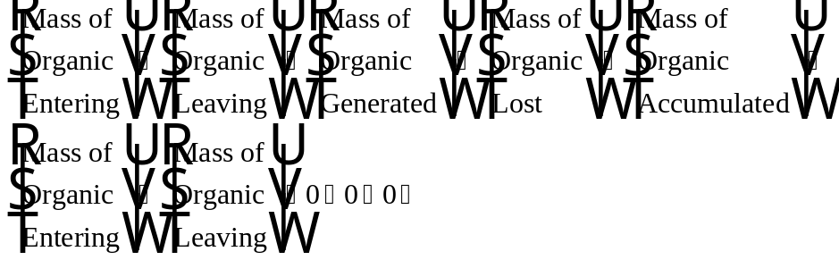
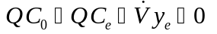
Eq. 1
Assume: Exiting air in equilibrium with bulk liquid →
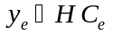
Eq. 2
Substituting Eq. 2 into Eq. 1 yields the following:
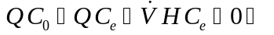
Eq. 3
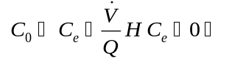
Eq. 4
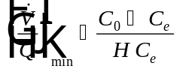
Eq. 5
Note that for air to water ratio values, , less than the minimum air to water ratio, , it will not be possible to achieve the desired effluent concentration from the tank, .
Now the derivation will be continued by eliminating the assumption made above that the exiting air is in equilibrium with the bulk liquid. Plug flow conditions will be assumed for the gas bubble. Figure 2 shows a schematic of a gas bubble in the tank.
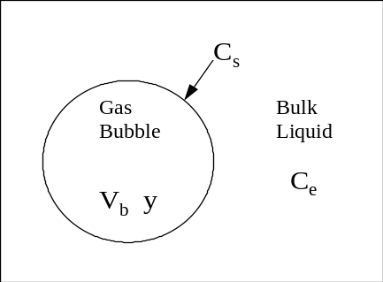
Figure 2 - Schematic of a Gas Bubble
Mass balance around a gas bubble:
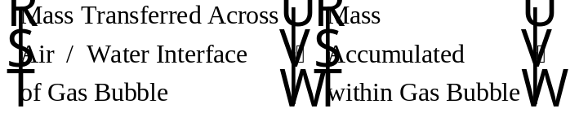
Eq. 6
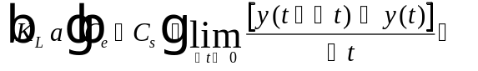
Eq. 7
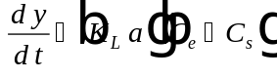
Eq. 8
Based on Henry’s Law, the equilibrium between the gas and liquid phases can be described using Henry’s constant as follows:
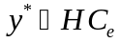
Eq. 9
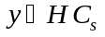
Eq. 10
Substituting Eq. 9 and Eq. 10 into Eq. 8 results in the following:
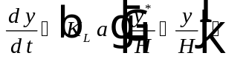
Eq. 11
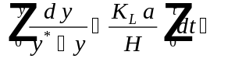
Eq. 12
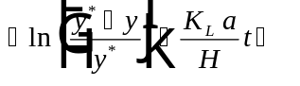
Eq. 13
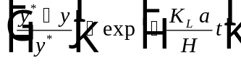
Eq. 14
Note that for the case of plug flow gas, t is equal to the bubble retention time in the tank, as defined by:
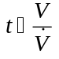
Eq. 15
Substituting Eq. 15 into Eq. 14 results in the following:
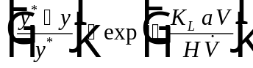
Eq. 16
In order to simplify the equation, a new term called the Stanton number, , will be defined as:
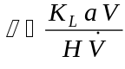
Eq. 17
Substituting Eq. 17 into Eq. 16 yields:
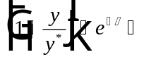
Eq. 18
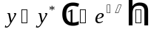
Eq. 19
Substituting Eq. 9 into Eq. 19 results in the following:
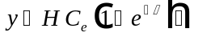
Eq. 20
Noting that 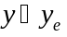 and substituting Eq. 20 into Eq. 1 allows for the solution of the design and rating mode cases for bubble aeration:
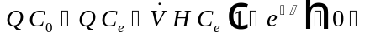
Eq. 21

Design Mode
In design mode, it is desirable to size the bubble aeration system (i.e., determine the minimum tank volume that will allow for meeting the treatment objective). This is done by solving Eq. 21 for the volume, V, that appears in the φ term. For design mode, the achieved effluent concentration, C_{e}, is the treatment objective, C_{TO}, so the substitution, C_{e} = C_{TO} is made.
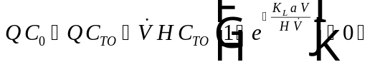
Eq. 22
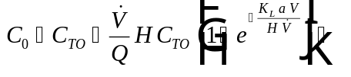
Eq. 23
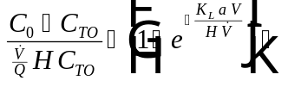
Eq. 24
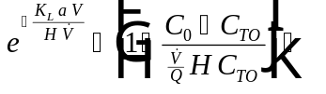
Eq. 25
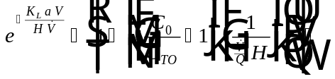
Eq. 26
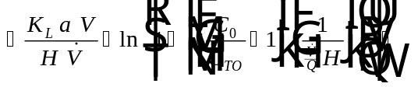
Eq. 27
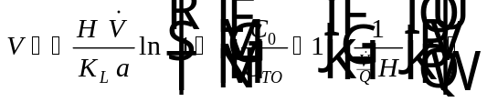
Eq. 28
In order for the bubble aeration tank to meet the treatment objective, the air to water ratio specified, , must be greater than or equal to the minimum air to water ratio that was defined in Eq. 5:
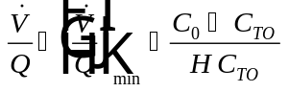
Eq. 29
The gas phase concentration out of the tank can be calculated by solving Eq. 1 for and substituting 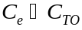. The gas phase effluent concentration, , is given as:
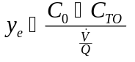
Eq. 30

Rating Mode
The purpose of rating mode is to predict the removal of a given contaminant for an existing tank (i.e., is known and it is desired to find . This is accomplished by solving Eq. 21 for , as shown below:
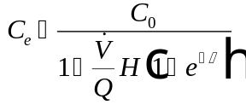
Eq. 31
The equation for gas phase concentration of a contaminant out of a bubble aeration tank is the same as Eq. 30, except that for rating mode, , is the actual effluent concentration achieved out of the tank, as opposed to the treatment objective that was achieved in design mode:
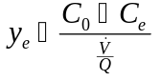
Eq. 32

Tanks in Series
Process performance can often be improved significantly (i.e., less total volume requirements) by configuring the bubble aeration system as tanks in series. Figure 3 shows a schematic of a bubble aeration system operated with a tanks in series configuration. The derivation of process design equations provided below is for the general case of n tanks in series. Assumptions in the development of the tanks in series equations for bubble aeration include: (1) liquid phase behaves as a completely mixed flow reactor, (2) plug flow conditions prevail in the gas phase, (3) the process is at steady state, (4) the volumetric gas flow rate to each tank is the same, , (5) each tank will be equally sized with volume, , and (6) the inlet gas concentration to each tank is equal to zero.

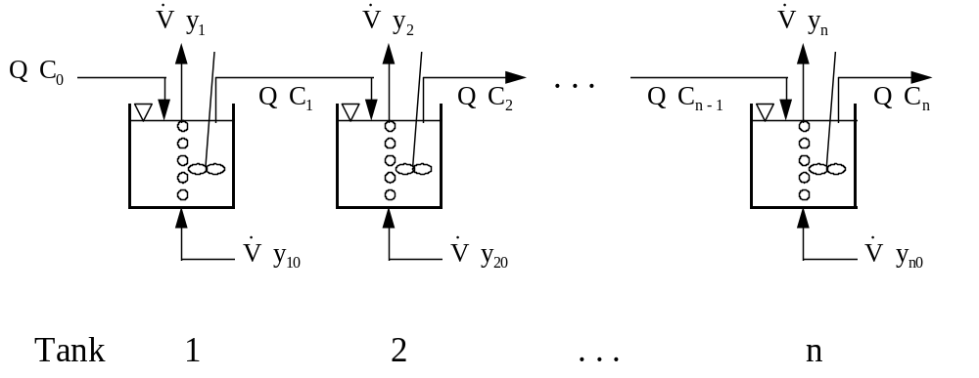
Figure 3 - Schematic of Bubble Aeration Tanks in Series Configuration
Mass Balance on Tank 1:
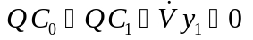
Eq. 33
By the same method shown above for a single tank, it is found that:
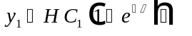
Eq. 34
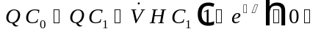
Eq. 35
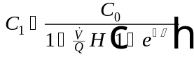
Eq. 36
A mass balance around tank 2 produces a similar result:
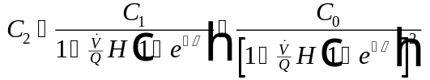
Eq. 37
From mass balances around tanks 3, n-1, and n, respectively:
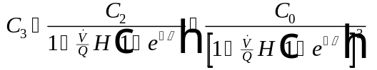
Eq. 38
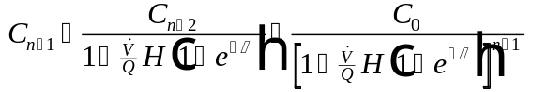
Eq. 39
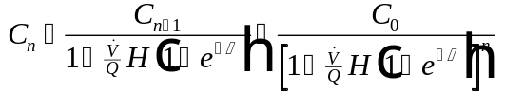
Eq. 40
Taking a closer look at Eq. 36 - Eq. 40, it is possible to write a general expression for Tank i as:
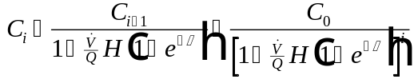
Eq. 41

Design Mode
To solve for the volume of each tank required to meet a specified treatment objective, 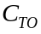, given n tanks, it is necessary to set 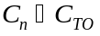 in Eq. 40 and solve for :
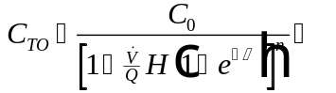
Eq. 42
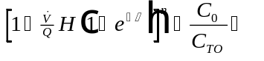
Eq. 43
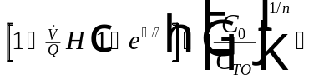
Eq. 44
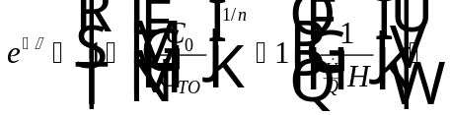
Eq. 45
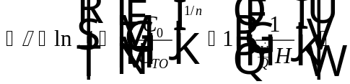
Eq. 46
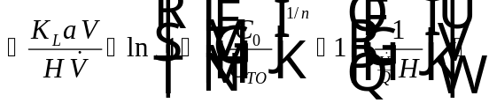
Eq. 47
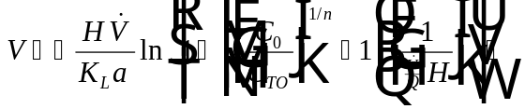
Eq. 48
As for the case of the single tank, the air to water ratio for the tanks in series configuration must exceed the minimum air to water ratio for tanks in series in order to achieve the treatment objective. The minimum air to water ratio for tanks in series is found by assuming the exiting gas in equilibrium with the bulk liquid for each tank, or equivalently, that 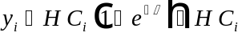, where i denotes any tank. Making this assumption, Eq. 42 simplifies to:
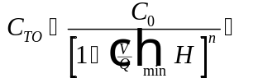
Eq. 49
Solving this equation for results in the minimum air to ratio for tanks in series:
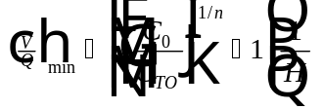
Eq. 50
In order for V to achieve the treatment objective in Eq. 48, the following condition must hold true:
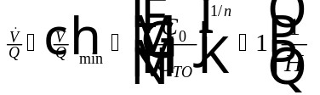
Eq. 51

Rating Mode
The equation to predict the liquid phase effluent concentration for an existing tank in a tanks in series configuration has already been specified above in Eq. 41, which is repeated here. Note that 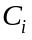 represents the liquid phase effluent concentration from tank number i.
Eq. 52
Once the liquid phase effluent concentration from each tank has been calculated from Eq. 52, it is possible to calculate the gas phase effluent concentration. The gas phase effluent concentration from any tank i is specified by the following equation, which is analogous to the single tank case (see Eq. 32):
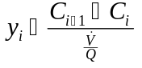
Eq. 53

Nomenclature
Water flowrate (L³/T)
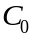 Influent liquid phase concentration to the first bubble aeration tank (M/L³)
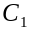 Effluent liquid phase concentration from tank number 1 for a tanks in series configuration for bubble aeration (M/L³)
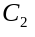 Effluent liquid phase concentration from tank number 2 for a tanks in series configuration for bubble aeration (M/L³)
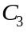 Effluent liquid phase concentration from tank number 3 for a tanks in series configuration for bubble aeration (M/L³)
Effluent liquid phase concentration from a single bubble aeration tank (M/L³)
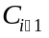 Effluent liquid phase concentration from tank number i-1 for a tanks in series configuration for bubble aeration (M/L³)
Effluent liquid phase concentration from tank number i for a tanks in series configuration for bubble aeration (M/L³)
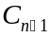 Effluent liquid phase concentration from tank number n-1 for a tanks in series configuration for bubble aeration (M/L³)
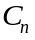 Effluent liquid phase concentration from tank number n for a tanks in series configuration for bubble aeration (M/L³)
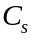 Liquid phase concentration at the air-water interface in bubble aeration (M/L³)
Treatment objective (M/L³)
Henry’s Law constant (dimensionless)
Number of a given tank in a tanks in series configuration in bubble aeration
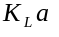 Overall mass transfer coefficient (1/T)
Total number of tanks in series used in a bubble aeration configuration
Bubble retention time in the tank (T)
Volume of a bubble aeration tank (L³)
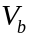 Volume of a single gas bubble in a bubble aeration tank (L³)
Air flowrate (L³/T)
Air to water ratio (L³/L³)
Minimum air to water ratio (L³/L³)
Inlet gas phase concentration to a single bubble aeration tank (M/L³), a quantity whose value is assumed equal to zero
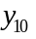 Inlet gas phase concentration to tank number 1 in a tanks in series configuration for bubble aeration (M/L³), a quantity whose value is assumed equal to zero
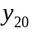 Inlet gas phase concentration to tank number 2 in a tanks in series configuration for bubble aeration (M/L³), a quantity whose value is assumed equal to zero
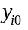 Inlet gas phase concentration to tank number i in a tanks in series configuration for bubble aeration (M/L³), a quantity whose value is assumed equal to zero
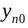 Inlet gas phase concentration to tank number n in a tanks in series configuration for bubble aeration (M/L³), a quantity whose value is assumed equal to zero
Outlet gas phase concentration from tank number 1 for a tanks in series configuration for bubble aeration (M/L³)
Outlet gas phase concentration from tank number 2 for a tanks in series configuration for bubble aeration (M/L³)
Outlet gas phase concentration from tank number i for a tanks in series configuration for bubble aeration (M/L³)
Outlet gas phase concentration from tank number n for a tanks in series configuration for bubble aeration (M/L³)
Outlet gas phase concentration from a single bubble aeration tank (M/L³)
Gas phase concentration in a gas bubble, which is assumed to be in equilibrium with the liquid phase concentration at the air-water interface, (M/L³)
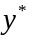 Gas phase concentration in equilibrium with the liquid phase effluent concentration, (M/L³)
Greek Letters
Stanton number (dimensionless)

References
Matter-Müller, C., W. Gujer, and W. Giger, “Transfer of Volatile Substances from Water to the Atmosphere,” Water Research, 15, 1271-1279 (1981).
Munz, C. and P. V. Roberts, “Mass Transfer and Phase Equilibria in a Bubble Column,” Proc. AWWA Annual Conference, 633-640 (1982).
Roberts, P. V., C. Munz, and P. Dändliker, “Modeling Volatile Organic Solute Removal by Surface and Bubble Aeration,” Journal WPCF, 56, 2, 157-163 (1984).

