` 

Manual
Fate of Volatile Organics Software (FaVOr)

Version 1.00
Copyright © 1994-1997
Michigan Technological University
All Rights Reserved

Michigan Technological University
1400 Townsend Drive
Houghton, MI 49931

Copyright © 1997 Michigan Technological University

All rights reserved.

No part of this publication may be reproduced, stored in a retrieval system, or transmitted, in any form or by any means, electronic, mechanical, photocopying, recording, or otherwise, without written permission of the author.

Getting Started

Requirements

To use Fate of Volatile Organics Software, you need:

- Any IBM-compatible machine a 80486 processor or higher (Pentium or equivalent)
- A math co-processor
- A 3.5-inch floppy disk drive, or CD-ROM drive if installation is on CD-ROM
- A hard disk with at least 15 megabytes of free disk space
- A graphic display VGA or SVGA
- At least 4 megabytes of RAM
- MS-DOS version 3.1 or later, and Microsoft Windows 3.1 or later in enhanced mode
- A Microsoft compatible mouse (or any compatible pointing device) is also recommended

The enhanced mode for Windows is the default mode if you are using a 80386 processor (or higher) and at least 1 megabyte of RAM.

Installing Fate of Volatile Organics Software

To install Fate of Volatile Organics Software on your computer, you must have the nine installation disks or the CD-ROM installation disc labeled “ETDOT Environmental Technologies Design Options Tools”. The installation program will copy files from the installation disk to your hard drive. Be sure to have the necessary 15 megabytes of free disk space before starting the installation. However, if anything goes wrong during the installation, you will always be able to quit the setup program and run it again. If a previous release of Fate of Volatile Organics Software was installed, install the new release in a different directory or uninstall the old release of Fate of Volatile Organics Software prior to installation.

To install Adsorption Simulation Software:
- Start Microsoft Windows in enhanced mode.
- Insert the disk labeled “ETDOT Environmental Technologies Design Options Tools - Disk 1 of 9” in the 3.5-inch drive A (or B) or the CD-ROM in the CD-ROM drive.
- From the File Menu in Program Manager, choose Run.
- Type a:\setup (or b:\setup) if using a floppy disk, or z:\disk1\setup if using a CD-ROM (replace z with the letter of the CD-ROM drive).
- Press ENTER.
- Follow the setup instructions on the screen.

Note: Steps 3, 4 and 5 are equivalent to double-clicking on the setup.exe program icon in File Manager.

The installation program will prompt you to specify the directory where you want to install the program. The default directory is C:\ETDOTS\ADSIM. You can change this by entering your own path. If this directory does not exist, it will be created automatically. Next you are shown a screen which displays all the available tools to install. Click on AdSim and then the button pointing to the center of the screen where the “To Install” listbox shows all programs to be installed. This will only install the AdSim program. Then click the “Next” button and the installation program will copy all the necessary files to your hard drive. Actually, the setup program decompresses files from the floppy disks (or CD-ROM) to the hard disk. For more details about the files that are installed, refer to Appendix H.

The Adsorption Simulation Software icon will be installed in the group ETDOT Beta Programs in the Program Manager. To run the software, double click the AdSim icon.

If the software does not work correctly after the installation, you can reach Dr. David W. Hand at (906) 487-2777.

IMPORTANT: If you are running the program under Windows 3.1, you need to have the SHARE program running. The SHARE program is needed to access databases from a Visual Basic application. This program may have already been installed by another application. To check if it has previously been installed, edit your autoexec.bat file which is located in your root directory (C:\). If SHARE.EXE appears in a line it means that the program is automatically loaded when you start your computer and you do not need to modify anything. If not, add the following line at the beginning of the file:
C:\DOS\SHARE.EXE /L:500
or if you want to load it into high memory:
LH C:\DOS\SHARE.EXE /L:500
Then save the autoexec.bat file and restart your computer.

If you are using Windows for Workgroup 3.11 you do not need to install the SHARE program since this release of Windows has its own sharing program.

Introduction to Fate of Volatile Organics Software

In the past, the fate of volatile organic contaminants (VOCs) at wastewater treatment facilities has been considered with respect to the liquid effluent. The Clean Water Act (CWA) regulates the discharge of conventional pollutants and VOCs in the effluent. Consequently, VOC monitoring in the liquid effluent has been necessary. The difference in VOC concentration between the influent and effluent was previously attributed solely to biodegradation. We now know that biodegradation is not the only mechanism responsible for VOC removal from wastewater. VOCs are released from wastewater treatment facilities in pathways other than the liquid effluent in both gas and solid phases. If all removal pathways are not identified, VOC concentrations in the liquid effluent can not be predicted correctly.

VOC discharge from a treatment facility can occur by sorption onto solids or by stripping/volatilization. VOCs sorb onto the sewage sludge that is wasted from the primary and secondary clarifiers. Removal by stripping/volatilization can occur in several ways. Stripping can occur in the aeration basin by diffused bubble or surface aeration, or by mechanical mixing at weirs and drops. Volatilization can occur at any air-liquid interface open to the atmosphere. The importance of each removal mechanism depends on the conditions and the design of the treatment facility. Therefore, both the air above the treatment facility and the sludge removed from it must be considered potential repositories of VOCs not destroyed by biodegradation or accounted for in the liquid effluent. The Clean Air Act (CAA) currently regulates air toxicants which are harmful to human health by setting National Emissions Standards for Hazardous Air Pollutants (NESHAPS). Sludge residuals from waste water treatment facilities are regulated by the CWA and the Resource Conservation and Recovery Act (RCRA).

Mathematical modeling is an inexpensive relatively easy way to simulate VOC fate that allows for a high degree of flexibility. A mathematical model capable of predicting the fate of VOCs in a conventional activated sludge treatment plant would allow for evaluation of emissions in all phases at existing plants.

An ideal model to predict contaminant fate should have several characteristics (Baillod et al., 1990):
1) Conceptually Correct: the model should operate in conjunction with a biological process model which could provide process parameters derived from substrate kinetics, stoichiometry and rigorous material balances.

2) Complete: the model should include fate mechanisms and unit operations such as weirs or grit chambers in addition to aeration basins and clarifiers.

3) Flexible: the model should be flexible enough to allow for different plant configurations and have a large chemical database.

4) Plug Flow Capability: the model should be capable of simulating the aeration system as a series of CSTRs to simulate various degrees of plug flow.

5) Realistic: the model should consider operational variable such as variations in temperature, atmospheric pressure, or differences in influent wastewater characteristics.

6) Technical Support and Documentation: there should be sufficient technical documentation explaining how theory has been applied to the specific operations. Documentation of the model code and variables should also be included to allow for easy code modification if necessary.

Fate of Volatile Organics software was developed as a physical property resource tool for the Clean Process Advisory System (CPASTM) to aid the conceptual process design engineer in furthering the goal of pollution prevention (Radecki et. al., 1994). FaVOr is designed to be used with another CPAS resource tool, Software to Estimate Physical Properties (StEPP) (Hokanson et. al., 1996; Hokanson et al., 1995; Hokanson, 1996). StEPP is designed to provide FaVOr with the physical and chemical properties needed to evaluate emissions from a wastewater treatment facility. Over 600 organic contaminants are contained in the StEPP database which is also supplemented by various parameter estimation methods. The properties provided by StEPP include; vapor pressure, infinite dilution activity coefficient, liquid diffusivity, gas diffusivity, water density, water viscosity, water surface tension, air density, and air viscosity.

The FaVOr software is designed for the Microsoft Windows™ environment with a graphical user interface (GUI) in order to maximize user-friendliness. Making use of the Microsoft Windows interface, with its built-in file and hardware control features, frees the engineer from concerns over printer drivers and other “machine” issues and allows the user to give more attention to the computational algorithms. The GUI consists of a front-end shell written in Visual Basic™ that calls FORTRAN subroutines to perform the calculations.

This manual presents a description of the FaVOr software capabilities including theoretical development and model descriptions. The manual also presents a description of the windows in the software and an example problem in order to aid the user.

References to specific commercial product, processes, or services by trademark, manufacturer, or otherwise does not necessarily constitute or imply endorsement/recommendation by the authors or the respective organizations under which the software was developed.

Development of FaVOr

Fate of Volatile Organics Software is designed to be used in conjunction with the Single Sludge Processes (SSSP) biological treatment simulation model developed by Bidstrup (1988). The unit operations and conceptual removal mechanisms modeled for each operation are shown in Figure 1.

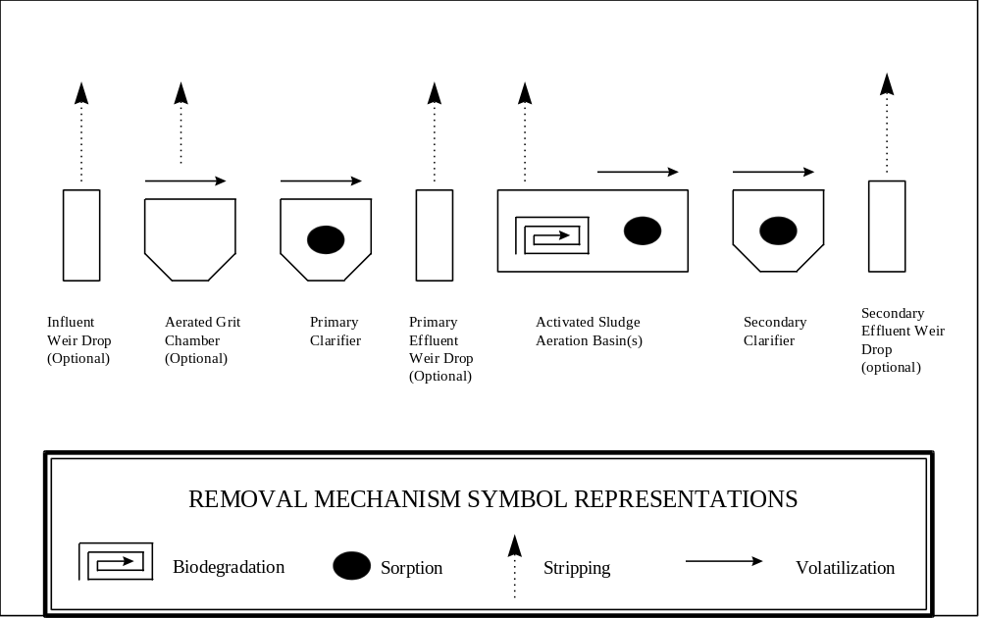

Figure 1: Removal Mechanisms Modeled for each Unit Operation

Unit Operations

VOCs can be removed from the wastewater of an activated sludge treatment plant by several mechanisms. Four mechanisms are considered in this work; biodegradation, stripping, sorption, and volatilization. Volatilization is represented as wind induced, while stripping is considered to occur through surface aeration, diffused bubble aeration or weirs and drops. Other mechanisms such a photolysis, hydrolysis, or other abiotic reactions are considered to be minor (Mihelcic et al., 1993). The role of these mechanisms in the unit operations of a conventional wastewater treatment plant are described below.

Weirs and Drops

At weirs and drops, stripping is modeled as occurring by either plug flow gas/completely mixed liquid or completely mixed gas/plug flow liquid. Weirs and drops are optional at the plant influent, after the primary clarifier, and after the secondary clarifier.
Weirs are commonly found at the treatment plant influent and at clarifier discharge points. As the wastewater falls it provides an escape for contaminants by stripping or volatilization. The contaminant is either assumed to be stripped into the air as the liquid flows over the drop, before it contacts the basin water surface, or into the rising entrained bubbles caused by the turbulence of the water flow entering the receiving basin (Mihelcic et al., 1993). Emission of contaminants at weirs can be modeled by two different mechanisms: the Nappe model and the Pool model. The mass balance for weirs and drops is given by equation

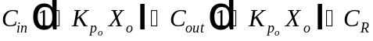 Eq.

where
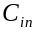 = rate of concentration going into the unit operation in the liquid stream
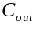= rate of concentration leaving the unit operation in the liquid stream
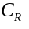 = rate of concentration removal by stripping
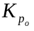=
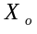 = influent solids concentration

Nappe Model with Nakasone / Pincince Calculations

The Nappe model assumes plug flow conditions for the liquid, completely mixed conditions for the gas. Nakasone (1987) developed correlations describing oxygen transfer at weirs. All mass transfer is assumed to occur in the liquid stream as it falls to the surface. Stripping caused by entrained bubbles in the receiving basin is ignored (Pincence, 1991). For a clarifier weir, the fraction of contaminant emitted is given by equation .

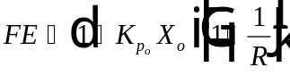 Eq.

where
= fraction emitted [-]
= ration of upstream contaminant concentration to downstream concentration [-]

Note: Assume flow rates do not change across weirs.

Equations and can be derived from an oxygen balance on the liquid stream. By combining these two equations, equation can be derived. The ratio of mass transfer coefficients can be estimated by the diffusivities of oxygen and the contaminant.

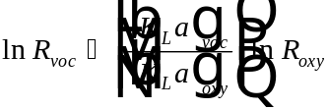 Eq.

where
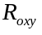= ratio of upstream to downstream oxygen deficit ratio [-]

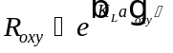 Eq.

where
(residence time) = liquid stream volume divided by flow rate.

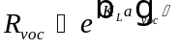 Eq.

Note: 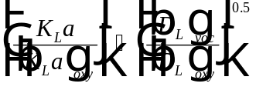where 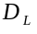 is the liquid diffusivity [m³/s] for VOCs with H > 0.1.

Equations and are the calibrated equations representing the oxygen deficit for primary and secondary clarifiers, respectively. Nakasone (1987) indicated that downstream receiving basin depth was not an important factor and that only unit discharge and height difference need be considered.

For primary clarifier:
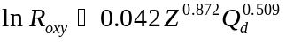 Eq.
where
= distance between water levels above and below weir [m]
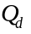 = discharge per unit length of weir [m³/ms]

For secondary clarifier:
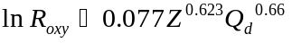 Eq.

Pool Model

The Pool model assumes plug flow conditions for the gas, and completely mixed conditions for the liquid (Mihelcic et al., 1993). It considers only mass transfer into the entrained bubbles as they rise through the pool. Stripping that occurs before the stream contacts the water surface is not considered. Applying a mass balance to the rising bubble yields equations and . These two equations can be combined to give equation which is needed to calculate the fraction emitted by using 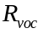 the same way as in the previous model. Work by Ballogh (1993) indicates that the plug flow gas/completely mixed liquid model is more accurate at depicting VOC emissions at weirs and drops.

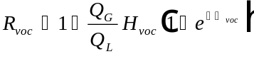 Eq.

where
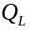 = liquid flow rate per unit length of weir [L³/TL]
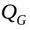 =flow rate of gas leaving the tailwater per length of weir [L³/TL]
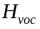 = Henry’s constant of VOC

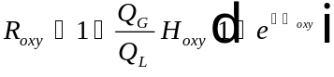 Eq.

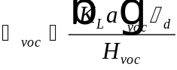 Eq.

where
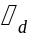 = residence time of entrained gas in liquid [T]
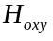 = Henry’s constant of oxygen

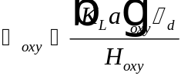 Eq.

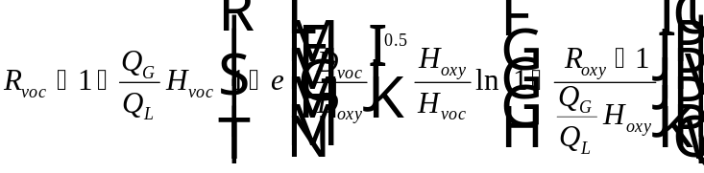 Eq.

Aerated Grit Chamber

In an aerated grit chamber three removal mechanisms can occur; sorption, stripping, and volatilization, although only stripping and volatilization are modeled. Sorption was not modeled due to lack of data for a correlation to predict the solid/liquid partition coefficient. The correlations used for sorption in the clarifiers would not be valid due to the different nature of the sludge. Solids settling in the grit chamber are more inorganic in nature and will allow for less sorption of VOCs. The grit chamber is modeled using diffused bubble aeration and wind induced volatilization.

The mass balance for the aerated grit chamber is given in equation .
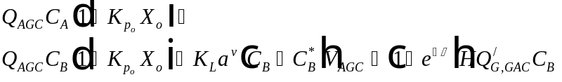 Eq.

where
= plant flow rate
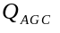 = 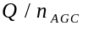 [L/day]
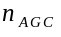 = number of parallel AGC
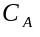 = influent VOC concentration (effluent from 1° weir) [mg/L]
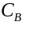 = effluent VOC concentration [mg/L]
= influent solids partitioning coefficient 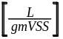
= influent solids concentration (neglecting grit) 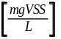
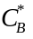 = gas phase concentration in AGC headspace [mg/L]
H = Henry’s constant [dimensionless]
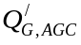 = 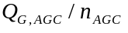 = total aeration flow rate [L/min]
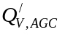 = 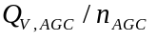= total ventilation flow rate [L/min]
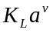 = volatilization mt. [1/sec]

Covered Basin

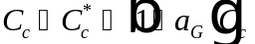 Eq.

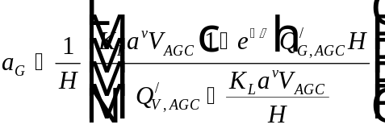 Eq.

where
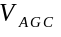 = volume of aerated grit chamber [L]

Note: If the basin is uncovered 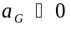.

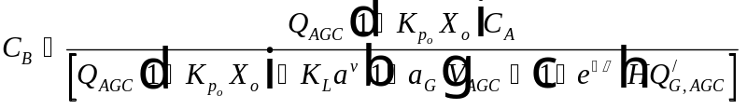 Eq.

Clarifiers

Clarifiers usually precede and follow the aeration basin. Sorption and volatilization are the removal mechanisms that occur here. Although the wastewater leaves the aeration basin and enters the secondary clarifier, the biological activity does not stop immediately, but it is negligible compared to the other removal mechanisms.

Primary Clarifier

In the primary sedimentation tank, two removal mechanisms occur; sorption and volatilization. Research by Dobbs et. al.(1989) suggests that sorption kinetics are rapid and that solid/liquid equilibrium exists in raw wastewater entering the facility. Sorbed contaminants leave the primary clarifier in the primary sludge wastage stream. Wind induced volatilization at the air water interface is also modeled. The mass balance for the primary clarifier is given in equation .

Eq.

where
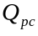 = 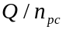 [L/day]
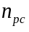 = number of primary clarifiers in parallel
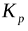 = sorption coefficient in the influent
= solids concentration in the influent
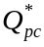 = 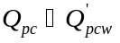 [L/day]
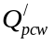 = 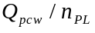 [L/day]
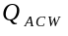 = total PC wastage rate [L/day]
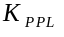 = sorption coefficient in PC
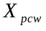 = solids concentration in PC
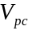 = volume of the PC [L]
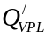 = 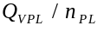 [L/min]
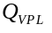 = total ventilation flow rate [L/min]

Secondary Clarifier

The secondary clarifier is modeled with the aeration basin. The mass balance for the secondary clarifier is shown in equation .

Eq.

where
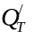 = flow rate entering SC [L/day]
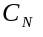 = concentration entering SC [mg/L]
= solid/liquid partitioning coefficient in SC influent 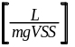
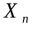 = biomass concentration in SC influent
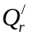 = recycle flow rate [L/day]
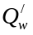 = wastage flow rate [L/day]
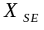 = solids concentration in SC effluent
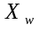 = solids concentration in the SC wastage
= mass time rate coefficient for volatilization [1/day or 1/sec]
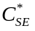 = concentration in equilibrium w/gas phase in headspace [mg/L]
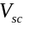 = volume of secondary clarifier [L]

Aeration Basin

In the aeration basin, all four removal mechanisms must be considered, however, the degree of biodegradation for a particular organic can only be a rough estimate. This uncertainty is due to the biodegradation rate constant needed to predict the amount of biodegradation. Also, by utilizing equation ,three potential biological mechanisms are ignored: VOC inhibitory effects on biological processes, synergistic effects of multiple VOCs, and production of VOCs as biodegradation by-products. Surface of diffused bubble aeration may be modeled. Volatilization occurs at the air/water interface due to the fact that the basin is open to the atmosphere. Sorption occurs on the biomass.

The aeration basin can be modeled as a series of CSTRs to simulate various degrees of plug flow. For example, if an aeration basin is long and narrow, it would be more accurate to track the contaminant concentration as it moves through the plant rather than basing all calculations on the influent concentration at the beginning of the basin. The volume and air flow rate for each basin can be independently specified. This allows for accurate representations of different aeration zones within a basin. For example, an oxidation ditch could be modeled by specifying CSTRs with high and low aeration rates.
The secondary clarifier is not modeled independently, but it is included in the overall secondary treatment mass balance (Bidstrup, 1988). Because this model was designed to work in conjunction with the Simulation of Single Sludge Processes (SSSP), the same conceptual approach for mass balances in secondary treatment was used. SSSP models each CSTR as wasting sludge directly. Although this approach is different conceptually, it makes a negligible difference on the overall mass balance (Bidstrup, 1988).

If the activated sludge aeration basin is modeled as a series of CSTRs, more than one mass balance equation is needed. For example, if the basin is modeled as one CSTR, the CSTR influent is the primary treatment effluent and the CSTR effluent is the plant effluent, but if the CSTR is the first of many, the primary treatment effluent is still the influent, but the CSTR effluent is the influent for the next CSTR. If the aeration basin is modeled as more than one CSTR, the feed stream can be modeled to be distributed in any proportion to any reactor. This flexibility allows for contact stabilization or various step feed configurations to be modeled.

The mass balance for aeration basins with one CSTR is given by equation .
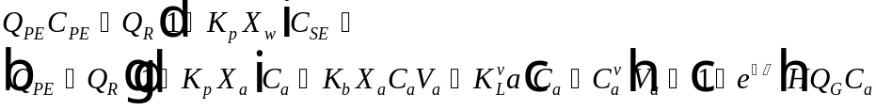 Eq.

where

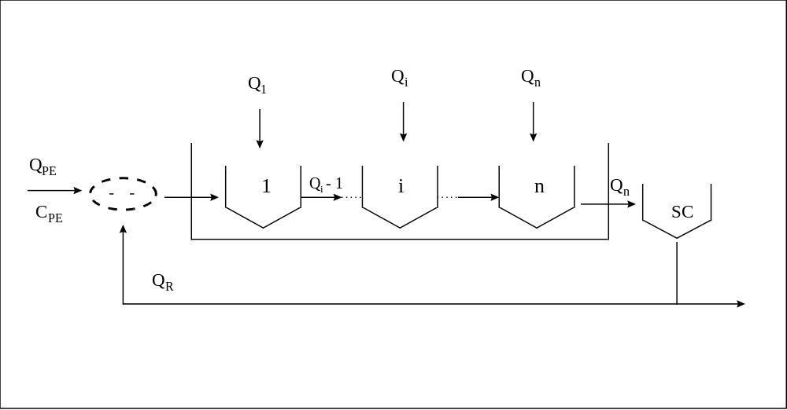

CSTRS

Removal Mechanisms

Biodegradation

Biodegradation in wastewater treatment usually is modeled using the Monod equation. The rate of disappearance according to the Monod equation is given by equation . However, VOCs are usually present in low concentrations at the treatment plants. If it is assumed that the VOC concentration is significantly less than 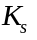, then the Monod equation can be reduced to equation , which is first order with respect to the contaminant. No inhibitory effects on VOCs on the biological process are considered.

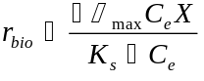 Eq.

where
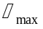= maximum growth rate [1/T]
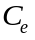 = contaminant concentration [M/L³]
= biomass concentration [M/L³]
= half saturation constant [M/L³]

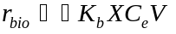 Eq.

where
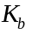= biodegradation rate constant [L³/MT]
= biomass concentration [M/L³]
= contaminant concentration [M/L³]
= aeration tank volume [L³]

Sorption

Sorption is modeled as an equilibrium process and various relationships are available to describe the tendency of a compound to adhere to the suspended solids including linear, Freundlich and Langmuir isotherms. Sorption of organics onto solids in wastewater is usually represented by a linear isotherm ( Dobbs, 1989, Matter-Muller, 1980). The amount of VOCs leaving the plant depends on the sludge wasting rate and the concentration of the contaminant on the suspended solids, q. The variable q is a function of the sorption partition coefficient and the liquid phase contaminant concentration as shown by equation . The sorption partition coefficient can be related to the octanol/water partition coefficient. Dobbs (1989) reported the relationship of 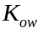 to 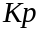 by equation . Equation is a correlation developed by Matter-Muller (1980).

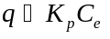 Eq.

where
= amount of contaminant sorbed per mass of suspended solid [M/M]
= solid liquid partition coefficient [L³/M]
= contaminant concentration [M/L³]

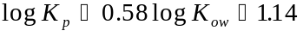 Eq.

where
= octanol water coefficient [L³/L³]
= solid liquid partition coefficient [L/kg]

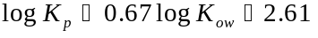 Eq.

where
= solid liquid partition coefficient [L/kg]

The VOC removal rate due to sorption is then given by equation .

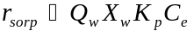 Eq.

where
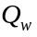= wastage sludge rate [L³/T]
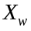= fraction of biomass in the sludge [M/L⁻³]

Volatilization

VOCs can be removed from the wastewater treatment facility by wind induced volatilization into the atmosphere from the surface of an open body of water. The amount removed is small compared to the amount stripped in the aeration basin but is significant enough to model independently. The rate of volatilization is given by equation . Equation can be simplified to give equation if the air above the basin is assumed to have negligible contaminant concentration.

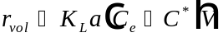 Eq.

where
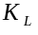 = overall mass transfer coefficient [L/T]
= interfacial area [1/L]
= contaminant concentration [M/L³]
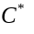 = contaminant concentration in the air above the treatment plant [M/L³]
= tank volume [L³]

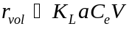 Eq.

For a basin of uniform depth, the interfacial area is equal to the reciprocal of the basin depth. If it is assumed that the concentration of the contaminant above the basin is negligible, the rate of removal due to volatilization is given by equation .

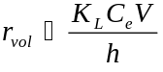 Eq.

where
= overall mass transfer coefficient [L/T]
= contaminant concentration [M/L ³]
= tank volume [L³]
= basin depth [L]

The overall mass transfer coefficient can be calculated from the liquid and gas phase mass transfer coefficients and the Henry’s law constant. This relationship is shown in equation .

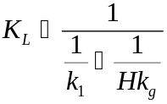 Eq.

where
= overall mass transfer coefficient [L/T]
= liquid phase mass transfer coefficient [L/T]
= gas phase mass transfer coefficient [L/T]
H = Henry’s constant [-]

Mackay and Yeun (1983)

The gas and liquid mass transfer coefficient can be calculated from correlations developed by Mackay and Yeun (1983). The correlations depend on the wind speed 10 meters above the water surface, and the gas and liquid phase Schmidt numbers. The correlations are given in equations through . Equation is the correlation for a friction velocity less that 10 m/s. Equation should be used for a friction velocity greater that 10 m/s. Equation is used to calculate the friction velocity utilized in equations through .

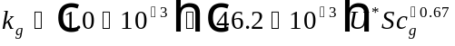 Eq.

where
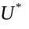 = friction velocity [m/s]
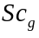 = gas phase Schmidt number [-]

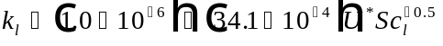 Eq.

where
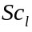= liquid phase Schmidt number [-]

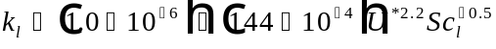 Eq.

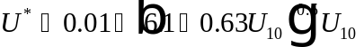 Eq.

where
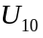= wind velocity 10m above the plant [m/s]

Dobbs-Cohn et. al

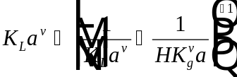 Eq.

where
= 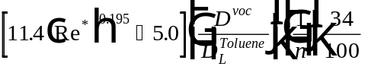
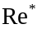 = 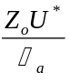 = roughness Reynolds number
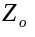 = roughness height [cm]
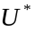 = friction velocity [cm/s]
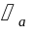 = 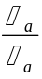 = kinematic viscosity of air [cm²/s]
= liquid diffusivity
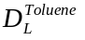 = 6.88 x 10⁻⁶ @ 12°C (Hayduk-Laudie)
= basin depth [m]
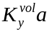 = 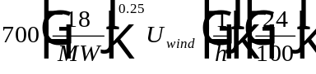
= molecular weight of VOC
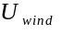 = [m/s]

Roberts (1984)

The liquid and gas mass transfer coefficients can be modeled a different way for known diffusivity, basin depth, molecular weight and wind velocity. The overall mass transfer coefficient for oxygen by volatilization must also be known. The liquid and gas mass transfer coefficient correlations are given in equations (Roberts, 1984) and . The overall mass transfer coefficient can then be calculated using equation . Equations and are different in that equation includes the interfacial area. After the overall mass transfer coefficient has been calculated, it can be applied to equation . For oxygen 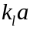 is assumed to be equal to 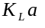.

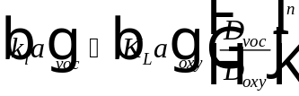 Eq.
where
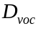= contaminant diffusivity [L²T⁻¹]
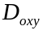= oxygen diffusivity [L²T⁻¹]

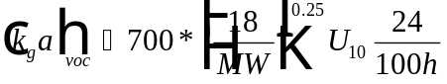 Eq.

where
= Wind velocity [L/T]
= Contaminant molecular weight [g/gmole]
= Basin depth [L]

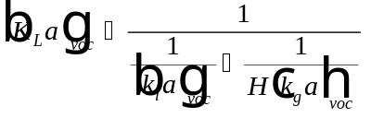 Eq.

Stripping - Surface aeration

Stripping in wastewater treatment facilities occurs when a gas phase is introduced to the process water. In this work stripping is defined as contaminant removal due to water agitation or air bubbles that are mechanical in origin. This mechanism differs form volatilization which is wind induced. For the purpose of this work, stripping can occur by one of three methods; surface aeration in the activated sludge aeration basin, bubble aeration in the activated sludge aeration basin, or by stripping at weirs.

If the aeration basin is assumed to uncovered, the rate of removal can be given by equation . The general form of the removal equations for volatilization, surface aeration and bubble aeration is the same. The differences lie in the mass transfer coefficients. The mass transfer coefficient for oxygen when surface aerators are utilized is given in equation .

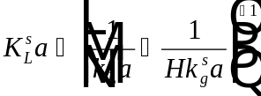 Eq.

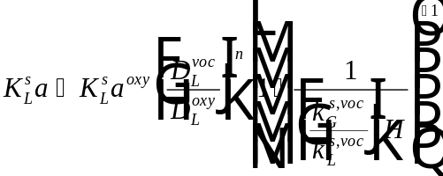

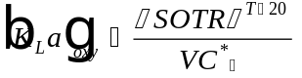

where
= process water correction actor [-]
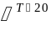 = temperature correction [-]
= temperature [°C]
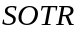 = standard oxygen transfer rate [kg/hr]
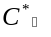 = dynamic saturation variable for oxygen [mg/L]

Once the of oxygen is known, equation is used to calculate the mass transfer coefficient for the contaminant.

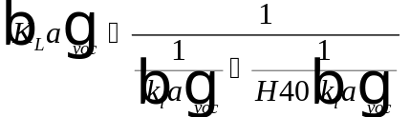 Eq.

Munz and Roberts (1989) reported the value of n for volatile organics for surface aerators to be approximately 0.5. Munz and Roberts also report that semivolatile compounds with a Henry’s constant of less than 0.1 (dimensionless) should not be estimated based on SOTR. In this situation, the ratio of mass transfer coefficients is influenced by the gas phase mass transfer coefficient and the Henry’s constant for both oxygen and the contaminant in addition to the diffusivity ratio. However, for VOCs with a Henry’s constant of less than 0.1 , stripping is not an important mechanism anyway. Munz and Roberts (1989) reported that the average power input for wastewater treatment plants range from 8 to 60 watts/m³. The gas phase mass transfer coefficient can become more important for compounds with a Henry’s constant greater than 0.1 if the power is greater than 70 watts/m³ and the Henry’s constant is less than 0.55.

Stripping - Diffused Bubble Aeration

For diffused bubble aeration, the rate of contaminant removal is given by equation . The product of the VOC liquid concentration and the Henry’s Constant is the exiting air VOC concentration represented by Henry’s Law, equation . When the exiting air concentration is multiplied by the air flow rate per volume of the aeration tank, the total amount of contaminant removed can be calculated. The term 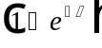 is a correction factor for the fraction equilibrium achieved between VOC concentrations in the liquid and gas phase. Compounds that have high values of , such as oxygen, may require at least 30 m of tank depth to achieve equilibrium. However, VOCs with values of 0.2 can achieve equilibrium after the entrained bubble rises 0.8 m (Matter-Muller, 1981). Unless the Henry’s constant is very large, should be close to 1 (Mihelcic et al., 1993).

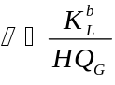 = equilibrium correction term (dimensionless)

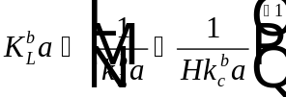

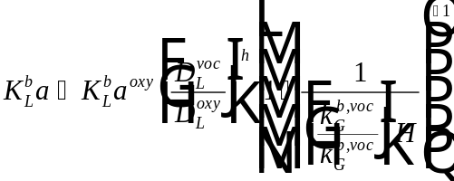

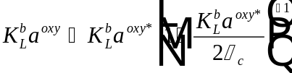
where
= aeration basin gas flow rate [L/min]
= Henry’s constant [-]
= contaminant concentration term [M/L³]
= equilibrium correction term [-]

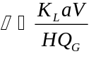 Eq.

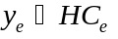 Eq.

where
= gas phase contaminant concentration [M/L³]
The mass transfer coefficient for oxygen can be modeled using equation . Equation gives the apparent and not the true due to the nature of the unsteady state clean water oxygen transfer test used to calculate SOTR. During the unsteady state test, the oxygen concentration is assumed to be constant and equal to the average saturation concentration of oxygen at infinite time. This assumption will lead to biased estimates of . True must be used for estimation of stripping losses (Baillod, 1986). True is related to apparent by equation .

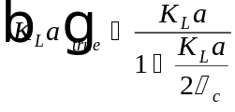 Eq.

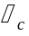 is a correction term defined by equation .

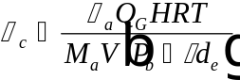 Eq.

where
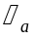 = density of air [ML³]
= aeration basin gas flow rate [L³/T]
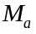 = molecular weight of air [-]
= aeration tank volume [L³]
= Universal gas constant
= temperature
= barometric pressure
= specific weight of water
= effective depth

Lastly, the effective depth must be known to calculate . The effective depth relationship is given in equation .

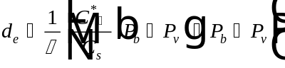 Eq.

where
= vapor pressure of water
= standard pressure

Biological Treatment

As previously mentioned, the SSSP model is used to simulate conventional biological treatment as a chain of completely mixed reactors in an activated sludge system. Carbon oxidation, nitrification, and denitrification are modeled. The user may specify plant configuration; reactor sizes; influent, recycle, and recirculation flow rates, the desired solids retention time; the kinetic parameters; and the time dependent patterns of influent flows and concentrations.

Rigorous mass balances from SSSP incorporating process kinetics, stoichiometry, and multiple substrate classifications, provide two important process parameters for accurate VOC fate modeling; biomass concentration for each reactor and sludge wastage rates for each reactor. The biomass concentration can affect the amount of removal due to sorption. Therefore, an accurate representation of both variables is important. The interaction of SSSP with FaVOr is conceptually illustrated in Figure 2.

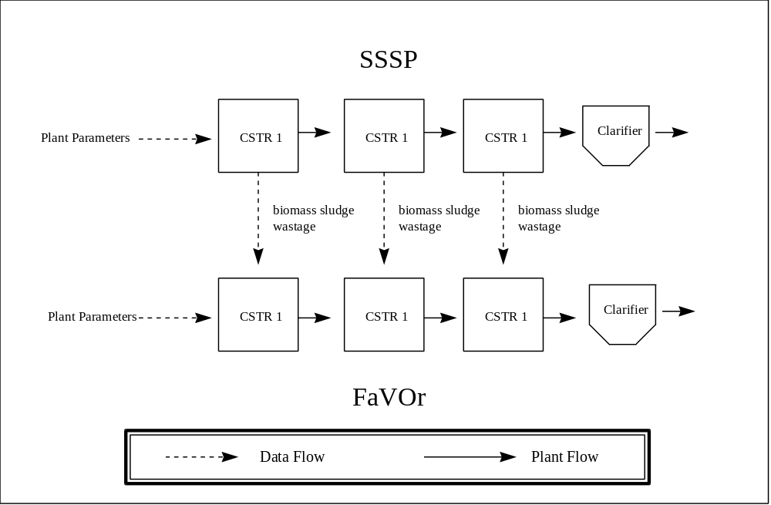

Figure 2: Diagram of SSSP and FaVOr Interaction

Several assumptions must be made to use SSSP in conjunction with FaVOr. First, the VOC concentration in the wastewater stream must be assumed to be negligible compared to other substrate concentrations so that VOC concentrations will have no effect on the normal activated sludge process. Second, the VOCs must be assumed to have no toxic or inhibitory affects on the biomass that could affect the normal activated sludge process.

