

Manual
Software to Estimate Physical Properties (StEPP™)

Copyright © 1994-1999
Michigan Technological University
All Rights Reserved

David R. Hokanson
Tony N. Rogers
David W. Hand *
Michael D. Miller
John C. Crittenden

Michigan Technological University
1400 Townsend Drive
Houghton, MI 49931

Copyright © 1994-1999 Michigan Technological University

All rights reserved.

No part of this publication may be reproduced, stored in a retrieval system, or transmitted, in any form or by any means, electronic, mechanical, photocopying, recording, or otherwise, without written permission of the author.
Table of Contents

I. Getting Started
A. Requirements
B. Installing StEPP™
II. Introduction to Software to Estimate Physical Properties
III. Description of Properties
A. Note on UNIFAC
1. General References for UNIFAC
2. General Information on UNIFAC 6
B. Vapor Pressure 7
1. Sources Available and Hierarchy 7
2. References
a) AIChE/DIPPR®
b) Carl L. Yaws’ book and data compilation (1992)
c) EPA Superfund Public Health Evaluation Manual (1986)
3. Detailed Information on the Sources Available 8
a) AIChE/DIPPR® 8
b) Carl L. Yaws’ book and data compilation (1992) 9
c) EPA Superfund Public Health Evaluation Manual (1986) 10
C. Infinite Dilution Activity Coefficient 10
1. Sources Available and Hierarchy 10
2. References 10
3. Detailed Information on the Sources Available 10
D. Henry’s Constant 10
1. Sources Available and Hierarchy 10
2. References 11
a) Regression of data points 11
b) UNIFAC fit with a data point 11
c) UNIFAC at the operating temperature 11
d) Database 11
e) UNIFAC at database temperatures 11
3. Detailed Information on the Sources Available 11
a) Regression of data points 11
b) UNIFAC fit with a data point 15
c) UNIFAC at the operating temperature 17
d) Database 17
e) UNIFAC at database temperatures 18
E. Molecular Weight 18
1. Sources Available and Hierarchy 18
2. References 18
a) AIChE/DIPPR® 18
b) Group Contribution Method 18
3. Detailed Information on the Sources Available 19
a) AIChE/DIPPR® 19
b) Group Contribution Method 19
F. Normal Boiling Point 19
1. Sources Available and Hierarchy 19
2. References 19
a) AIChE/DIPPR® 19
3. Detailed Information on the Source Available 19
a) AIChE/DIPPR® 19
G. Liquid Density 20
1. Sources Available and Hierarchy 20
2. References 20
a) AIChE/DIPPR® 20
b) Group Contribution Method 20
3. Detailed Information on the Sources Available 20
a) AIChE/DIPPR® 20
b) Group Contribution Method 21
H. Molar Volume at Operating Temperature 23
1. Sources Available and Hierarchy 23
2. References 23
a) AIChE/DIPPR® 23
b) Group Contribution Method 23
3. Detailed Information on the Sources Available 23
a) AIChE/DIPPR® 23
b) Group Contribution Method 24
I. Molar Volume at Normal Boiling Point 24
1. Sources Available and Hierarchy 24
2. References 24
a) Modified Schroeder group contribution method 24
3. Detailed Information on the Sources Available 24
a) Modified Schroeder group contribution method 24
J. Refractive Index 25
1. Sources Available and Hierarchy 25
2. References 25
a) AIChE/DIPPR® 25
3. Detailed Information on the Sources Available 25
a) AIChE/DIPPR® 25
K. Aqueous Solubility 25
1. Sources Available and Hierarchy 25
2. References 25
a) UNIFAC fit with a data point 25
b) UNIFAC at the operating temperature 26
c) Database 26
d) UNIFAC at database temperature 26
3. Detailed Information on the Sources Available 26
a) UNIFAC fit with a data point 26
b) UNIFAC at the operating temperature 28
c) Database 28
d) UNIFAC at database temperature 28
L. Octanol Water Partition Coefficient (log K_{ow}) 28
1. Sources Available and Hierarchy 28
2. References 29
a) UNIFAC at the operating temperature 29
b) Database 29
c) UNIFAC at database temperature 29
3. Detailed Information on the Sources Available 29
a) UNIFAC at the operating temperature 29
b) Database 29
c) UNIFAC at database temperature 30
M. Liquid Diffusivity 30
1. Sources Available and Hierarchy 30
2. References 30
a) Hayduk and Laudie Correlation 30
b) Wilke-Chang Correlation 30
c) Method of Polson 31
3. Detailed Information on the Sources 31
a) Hayduk and Laudie Correlation 31
b) Wilke-Chang Correlation 31
c) Method of Polson (1950) 32
N. Gas Diffusivity 33
1. Sources Available and Hierarchy 33
2. References 33
a) Wilke-Lee Modification of Hirschfelder-Bird-Spotz Equation 33
3. Detailed Information on the Sources Available 33
a) Wilke-Lee Modification of Hirschfelder-Bird-Spotz Equation 33
O. Water Density 35
1. Sources Available and Hierarchy 35
2. Reference 36
3. Detailed Information on the Source Available 36
P. Water Viscosity 37
1. Sources Available and Hierarchy 37
2. Reference 37
3. Detailed Information on the Source Available 37
Q. Water Surface Tension 38
1. Sources Available and Hierarchy 38
2. Reference 38
3. Detailed Information on the Source Available 38
R. Air Density 38
1. Sources Available and Hierarchy 38
2. Reference 38
3. Detailed Information on the Sources Available 38
S. Air Viscosity 39
1. Sources Available and Hierarchy 39
2. Reference 39
3. Detailed Information on the Source Available 39
IV. Sample Run of StEPP 40
A. Running StEPP™ 40
B. Sample Program Run 41
C. Windows in StEPP™ 46
1. Main StEPP™ 47
2. Vapor Pressure 48
3. Infinite Dilution Activity Coefficient 50
4. Henry’s Constant 51
5. Molecular Weight 52
6. Normal Boiling Point 54
7. Liquid Density 55
8. Molar Volume at the Operating Temperature 56
9. Molar Volume at the Normal Boiling Point 57
10. Refractive Index 58
11. Aqueous Solubility 59
12. Octanol Water Partition Coefficient 61
13. Liquid Diffusivity 63
14. Gas Diffusivity 64
15. Water Density 65
16. Water Viscosity 66
17. Water Surface Tension 67
18. Air Density 68
19. Air Viscosity 69
V. Exporting StEPP™ Data to Other ETDOT Applications 70
A. Export Method 1: Create Export File for AdDesignS/ASAP 71
B. Export Method 2: Copy to Clipboard for AdDesignS/ASAP 73
Appendix A 74

Getting Started

Requirements

To use Software to Estimate Physical Properties (StEPP™), you need:

- An English-language version of Windows 95, Windows 98, or Windows NT 4.0. In the case of Windows NT 4.0, Service Pack 3 or more recent is required.
- At least 50 megabytes of hard drive space
- At least 32 megabytes of RAM is recommended
- A graphic VGA or more recent video display
- A CD-ROM drive, which is used to install the software
- A Pentium or more recent processor is recommended.
- A Windows compatible mouse (or any compatible point device) is recommended

Installing StEPP™

To install StEPP™ on your computer, you must have the CD-ROM installation disk labeled “ETDOT Programs”. The installation program will copy files from the installation disk to your hard drive. The installation program will cancel the process if you do not have sufficient hard drive space. If anything goes wrong during the installation, you will always be able to quit the install program and run it again. If a previous release of StEPP™ was installed, you should install the new version on top of the old version; this is done by installing to the same directory that the original version was installed to.

- Log in to Windows normally.
- Insert the CD-ROM labeled “ETDOT Programs” in the CD-ROM drive.
- From the Start menu, choose Run.
- Type z:\setup (replace z with the letter of the CD-ROM drive).
- Press ENTER.
- Follow the setup instructions on the screen.

Note: Steps 3, 4 and 5 are equivalent to double-clicking on the setup.exe program icon in Explorer or File Manager.

If the software does not work correctly after the installation, you can reach Dr. David W. Hand at (906) 487-2777.

Introduction to Software to Estimate Physical Properties

In the process of modeling a treatment system, the most difficult task often involves accurately predicting the physical and chemical properties of the contaminants present in the system. For many treatment and control technologies, such as adsorption and packed tower aeration, models are available that can simulate such processes. However, the effectiveness of such models is severely limited when the properties of the contaminants in the system cannot be accurately determined.
Software to Estimate Physical Properties (StEPP™) was designed to act as a physical property resource tool and seeks to alleviate this problem by providing the capability to easily obtain many of the properties necessary to model chemical and environmental processes. StEPP™ consists of a database of over 600 organic contaminants from which certain properties are available. Table 1 shows a sampling of the classes of compounds for which properties are available in StEPP™. The StEPP™ database consists of critically evaluated property values available in the literature. Because of the lack of quality data in the literature for other properties, StEPP™ provides various parameter estimation methods to supplement the database. Dependence on temperature is included for those properties that vary strongly with temperature. Table 2 shows the properties available from the StEPP™ database and the properties available from parameter estimation methods. Temperature-dependent properties are indicated in Table 2 by an asterisk (*).

Table 1 - Sample Classes of Compounds Available in StEPP™
alkanes | aromatics | nitriles
cycloalkanes | carboxylic acids | dioxins
alkenes | ethers | PCBs
cycloalkenes | esters | ketones
alkynes | thiols | aldehydes
amines | alcohols | epoxides

Table 2 - Properties Available from StEPP™
Property | Available  from  Database | Available  from  Parameter Estimation Methods
Vapor Pressure | Yes* | No
Infinite Dilution Activity Coefficient | No | Yes*
Henry’s Constant | Yes* | Yes*
Molecular Weight | Yes | Yes
Normal Boiling Point | Yes | No
Liquid Density | Yes* | Yes*
Molar Volume at Operating Temperature | Yes* | Yes*
Molar Volume at Normal Boiling Point | No | Yes
Refractive Index | Yes | No
Aqueous Solubility | Yes | Yes*
Octanol Water Partition Coefficient | Yes | Yes*
Liquid Diffusivity | No | Yes*
Gas Diffusivity | No | Yes*
Water Density | No | Yes*
Water Viscosity | No | Yes*
Water Surface Tension | No | Yes*
Air Density | No | Yes*
Air Viscosity | No | Yes*
* - Denotes temperature-dependent property

StEPP™ was developed as a physical property resource tool for the Clean Process Advisory System (CPAS™) to aid the conceptual process design engineer in furthering the goal of pollution prevention (Radecki, et al., 1994). StEPP™ is intended for widespread use in air and water treatment. For example, in a packed tower aeration design, the engineer needs to know the following contaminant properties: molecular weight, Henry's constant, normal boiling point, molar volume at the normal boiling point, liquid diffusivity, and gas diffusivity. StEPP™ is designed to provide accurate values for these properties for a wide variety of organic contaminants. StEPP™ is designed both as a stand-alone software package to estimate physical and chemical properties and as a tool that may be directly linked to other CPAS models, such as air stripping and adsorption, in order to provide physical and chemical properties.
StEPP™ is designed for the Microsoft Windows™ environment with a graphical user interface (GUI) in order to maximize user-friendliness. Making use of the Microsoft Windows interface, with its built-in file and hardware control features, frees the programmer from concerns over printer drivers and other "machine" issues and allows more attention to the computation algorithms themselves. The GUI consists of a front-end shell written in Visual Basic™ that calls FORTRAN subroutines in order to perform calculations. The database of over 600 organic contaminants is designed using a relational database engine (Microsoft Access™ 2.0) to allow unprecedented manipulation and display of the results.
This manual is designed to present a description of the properties available in StEPP™, including methods, references, and sample calculations where applicable. The manual also presents a sample program run and description of the windows in the software in order to aid the user.

Description of Properties

Note on UNIversal quasichemical Functional group Activity Coefficient (UNIFAC)
Several properties (e.g., activity coefficient, Henry’s constant, aqueous solubility, and octanol water partition coefficient) have estimations based on this method. Therefore, the references and detailed information that is common to all properties will be described here rather than in every property that makes use of it.

General References for UNIFAC
Arbuckle, W.B., "Estimating Activity Coefficients for Use in Calculating Environmental Parameters," Environ. Sci. Technol., 17:9, 537-542 (1983).
Arbuckle, W.B., "Using UNIFAC to Calculate Aqueous Solubilities," Environ. Sci. Technol., 20:10 (1986).
Derr, E.L. and C.H. Deal, "Analytical Solutions of Groups: Correlation of Activity Coefficients through Structural Group Parameters," I. Chem. E. Symposium Series, No. 32, 3:40-3:51 (1969).
Fredenslund, Aa., R.L. Jones, and J.M. Prausnitz, "Group-Contribution Estimation of Activity Coefficients in Nonideal Liquid Mixtures," AICHE Journal, 31, 1086-1099 (1975).
Gmehling, J., P. Rasmussen, and Aa. Fredenslund, "Vapor-Liquid Equilibria by UNIFAC Group Contribution. Revision and Extension. 2,” Ind. Eng. Chem., Process Des. Dev., 21:1:118-127 (1982).
Hansen, H.K. et al., "Vapor-Liquid Equilibria by UNIFAC Group Contribution. 5. Revision and Extension," Ind. Eng. Chem. Res., 30:10, 2352-2355 (1991).
Kikic, I., P. Alessi, P. Rasmussen, and Aa. Fredenslund, "On the Combinatorial Part of the UNIFAC and UNIQUAC Models,” The Canadian Journal of Chemical Engineering, 58, 253-258 (April 1980).
Macedo, E.A., U. Weidlich, J. Gmehling, and P. Rasmussen, "Vapor-Liquid Equilibria by UNIFAC Group Contribution. Revision and Extension. 3,” Ind. Eng. Chem. Process Des. Dev., 22:4, 676-678 (1983).
Magnussen, T., et. al., "UNIFAC Parameter Table for Prediction of Liquid-Liquid Equilibria," Ind. Eng. Chem. Process Des. Dev., 20:2, 331-339 (1981).
Pierotti, G.J., C.H. Deal, and E.L. Derr, "Activity Coefficients and Molecular Structure," Industrial and Engineering Chemistry, 51:1, 95-102 (1959).
Rogers, T.N., et al., "Henry's Law Constants for Environmental Applications," Presented at the Second International Conference on Thermodynamics of Aqueous Systems with Industrial Applications, Sponsored by the Design Institute for Physical Property Data (DIPPR®) of the American Institute of Chemical Engineers (AIChE), the National Bureau of Standards (NBS), and the National Science Foundation (NSF), Warrenton, VA (May 1987).
Rogers, T.N., “Predicting Environmental Physical Properties from Chemical Structure Using a Modified UNIFAC Model,” Ph.D. Dissertation, Michigan Technological University (1994).
Skjold-Jorgensen, S., B. Kolbe, J. Gmehling, and P. Rasmussen, "Vapor- Liquid Equilibria by UNIFAC Group Contribution. Revision and Extension,” Ind. Eng. Chem., Process Des. Dev., 18:4, 714-722 (1979).
Tiegs, D. and J. Gmehling, "Vapor-Liquid Equilibria by UNIFAC Group Contribution. 4. Revision and Extension,” Ind. Eng. Chem. Res., 26:1, 159-161 (1987).
Wilson, G.M. and C.H. Deal, "Activity Coefficients and Molecular Structure," Industrial & Engineering Chemistry Fundamentals, 1:1, 20-23 (1962).

General Information on UNIFAC

The StEPP™ computer software builds upon the algorithms presented by Arbuckle (1983, 1986) for calculating thermodynamic properties associated with environmental partitioning and phase equilibrium. The infinite dilution activity coefficient, an environmental parameter of key importance in thermodynamics, is related fundamentally to several major properties and also correlates empirically with many others (Arbuckle, 1983; Arbuckle, 1986). Within StEPP™, the UNIFAC model developed by Fredenslund et al. (1975) is used to predict all properties involving vapor-liquid and liquid-liquid equilibria. UNIFAC can be used with a few simple thermodynamic relationships to predict environmental quantities such as Henry's constant, aqueous solubility, water solubility in a chemical solvent, and octanol water partition coefficient. Because it is rooted in thermodynamics and accounts for the effect of temperature, this approach has advantages over other purely empirical models. Its group contribution emphasis makes UNIFAC applicable to a large number of chemicals and environmental problems (Pierotti, et al., 1959; Wilson and Deal, 1962; Derr and Deal, 1969).

The original UNIFAC parameter sets for vapor-liquid (e.g. UNIFAC-VLE [Hansen, et al., 1991]) and liquid-liquid (e.g., UNIFAC-LLE [Magnussen, et al., 1981]) equilibria are available to the StEPP™ user in addition to a new UNIFAC parameter set (e.g., UNIFAC-ENV (Rogers, et al., 1987)) developed especially for dilute aqueous mixtures. A set of FORTRAN routines, based on the parameter sets described above, forms the core of StEPP’s partitioning and equilibrium property calculations. Listed below are the recommendations within StEPP™, in order of decreasing preference, for selecting the "best" UNIFAC parameter set in a given situation:
- Infinite Dilution Activity Coefficient: UNIFAC-ENV, VLE, LLE, user choice
- Henry's Law Constant: UNIFAC-ENV, VLE, LLE
- Aqueous Solubility: UNIFAC-LLE, ENV, VLE
- Octanol-Water Partition Coefficient: UNIFAC-LLE, VLE, (ENV not possible)
Because none of the UNIFAC parameter sets contain interaction values for all possible functional group pairs, the StEPP™ algorithm follows the above order until the options are exhausted, at which time an error message is displayed. At any time, the user can override the automatic choice of the parameter set. The following paragraphs review the application of UNIFAC to specific partitioning and equilibrium calculations within StEPP™ that are used to determine Henry's constant, aqueous solubility, and octanol water partition coefficient.

Vapor Pressure

Sources Available and Hierarchy
The vapor pressure can be determined in StEPP™ from the following;
- AIChE/DIPPR® - American Institute of Chemical Engineers/Design Institute for Physical Property Data
- Carl L. Yaws’ book and data compilation (1992)
- EPA Superfund Public Health Evaluation Manual (1986)
Only one of the three sources will be available for a given chemical. If vapor pressure data was available from (1) then it is in the database. If no data was available from (1), then data from (2) is in the database. If no data was available from (1) or (2) then data from (3) is in the database.

References

AIChE/DIPPR®
Daubert, T.E., R.P. Danner, H.M. Sibul, and C.C. Stebbins, Physical and Thermodynamic Properties of Pure Chemicals: Data Compilation, Extant 1995, Taylor & Francis, Bristol, Pennsylvania (1995).

Carl L. Yaws’ book and data compilation (1992)
Yaws, C.L., Thermodynamics and Physical Property Data, Houston: Gulf Publishing Company (1992).

EPA Superfund Public Health Evaluation Manual (1986)
EPA Superfund Public Health Evaluation Manual, U.S. Environmental Protection Agency, Office of Emergency and Remedial Response, Washington, D.C., EPA/540/1-86/060 (October 1986).

Detailed Information on the Sources Available

AIChE/DIPPR®
This source provides a correlation that requires temperature input. The correlation used is:
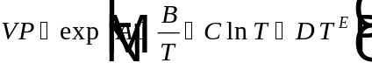 in the range 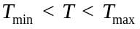
where:
= Vapor pressure (Pa)
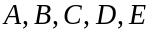 = Empirical coefficients
= Temperature (K)
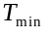 = Minimum temperature for which correlation applies (K)
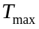 = Maximum temperature for which correlation applies (K)
From the AIChE/DIPPR® data compilation, for Trichloroethylene:
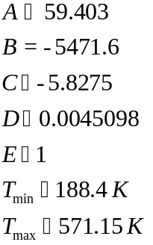
Sample Calculation for Trichloroethylene at :
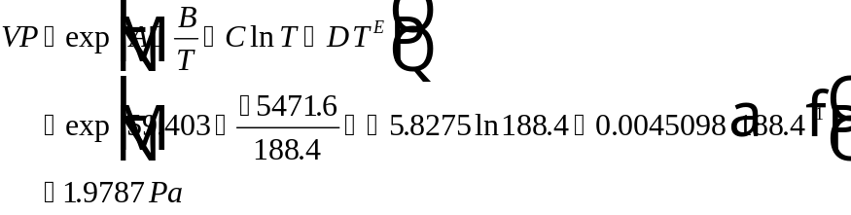
This result agrees with the value reported in Daubert, et al. (1995).

Sample Calculation for Trichloroethylene at 10° C:
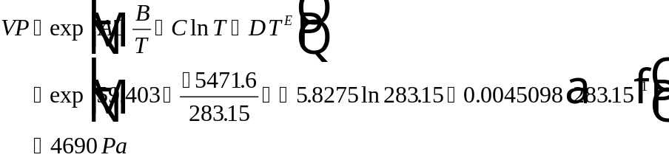

Carl L. Yaws’ book and data compilation (1992)
This source provides a correlation that requires temperature input. The correlation used is Antoine’s equation:
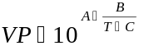 in the range
where:
= Vapor pressure (mm Hg)
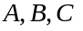 = Empirical coefficients
= Temperature (C)
= Minimum temperature for which correlation applies (C)
= Maximum temperature for which correlation applies (C)
From Yaws (1992) for Trichloroethylene:
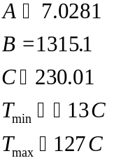
Sample Calculation for Trichloroethylene at :
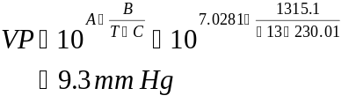
This result agrees with the value reported in Yaws (1992). Converting to Pa to be consistent with units reported in StEPP™, results in vapor pressure equals 1240 Pa.

EPA Superfund Public Health Evaluation Manual (1986)
This source contains discrete vapor pressure data.

Infinite Dilution Activity Coefficient

Sources Available and Hierarchy
The infinite dilution activity coefficient is available in StEPP™ from:
- UNIFAC

References
See the section titled “Note on UNIFAC”.

Detailed Information on the Sources Available
See the section titled “Note on UNIFAC”. A sample application on the method is provided in the following reference:
Lyman, W.J., W.F. Reehl, and D.H. Rosenblatt, Handbook of Chemical Property Estimation Methods: Environmental Behavior of Organic Compounds, New York: McGraw-Hill Book Company (1982).

Henry’s Constant

Sources Available and Hierarchy
Henry’s constant is available in StEPP™ from the following:
- Regression of data points
- UNIFAC fit with a data point
- UNIFAC at the operating temperature
- Database
- UNIFAC at database temperatures
The preferential order of the methods in StEPP™ for determining Henry’s law constant is the ordering given above.

References

Regression of data points
None.

UNIFAC fit with a data point
See below for obtaining the UNIFAC values. No references for the fit.

UNIFAC at the operating temperature
See the “Note on UNIFAC” section for general references on UNIFAC.
Carroll, J.J., "What Is Henry's Law?," Chemical Engineering Progress (September 1991).

Database
Ashworth, R.A., G.B. Howe, M.E. Mullins, and T.N. Rogers, "Air-Water Partitioning Coefficients of Organics in Dilute Aqueous Solutions," Journal of Hazardous Materials, 18, 25-36 (1988).
Yaws, C.L., J.W. Miller, P.N. Shah, G.R. Schorr, and P.M. Patel,"Correlation Constants for Chemical Compounds," Chem. Eng., 83:25, 153-162 (1976).
EPA Superfund Public Health Evaluation Manual, U.S. Environmental Protection Agency, Office of Emergency and Remedial Response, Washington, D.C., EPA/540/1-86/060 (October 1986).

UNIFAC at database temperatures
Same as for UNIFAC at operating temperature.

Detailed Information on the Sources Available

Regression of data points
When more than one discrete data value is available, interpolation and extrapolation to other temperatures are done preferentially from the raw data. For Henry’s constant, this extrapolation is performed by assuming a constant enthalpy change of volatilization in the Van’t Hoff equation, which implies a linear relationship between 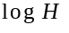 and 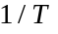 (where H = Henry’s constant and T = absolute temperature). Therefore, a linear regression is performed on data points when more than one data point for a given compound is in the database. Note this is only the case with RTI data. The regression performed is of ln H (atm) vs. 1/T (K) data.

A summary of the regression technique is as follows:
Calculate the sums:
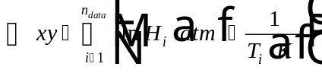
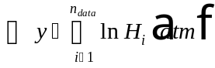
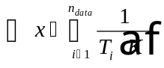
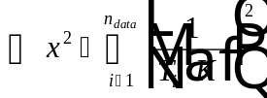

Calculate the means, slope, and intercept:
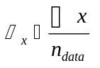
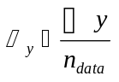
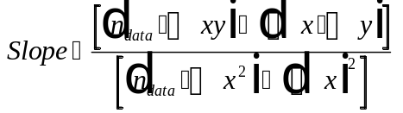
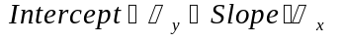

Calculate ln H as a function of temperature:
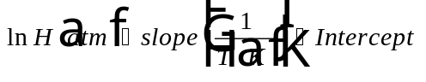
Using this relationship, it is possible to estimate H at any given temperature. Note that the valid temperature range for the correlation encompasses the temperature range of the data.

Sample Calculation for Henry’s Constant of Trichloroethylene at 17° C
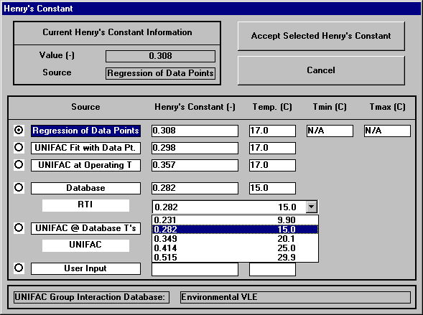
Figure 1 - Henry's Constant Window (TCE, 17° C) Highlighting Data Available
From Figure 1, properties needed to do the regression are Henry’s constants at various temperatures from RTI data, which are shown in Table 1.
Table 1 - Henry's Constant Data for TCE Available in StEPP™ (Source: RTI)
Temperature (C) | Henry’s Constant (-) | Henry’s Constant (atm)
9.9 | 0.231 | 297.7610445
15.0 | 0.282 | 370.0500544
20.1 | 0.349 | 466.0754075
25.0 | 0.414 | 562.1185211
29.9 | 0.515 | 710.7457273

Note: In Table 1, dimensionless Henry’s constants are converted to units of atm by the following relationship:

Calculate the sums using data from Table 1:
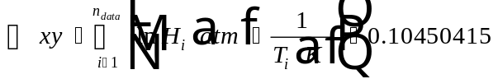
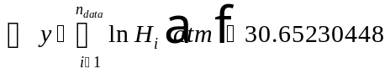
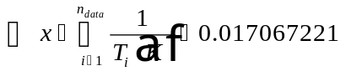
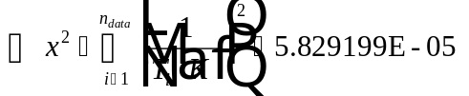

Calculate the means, slope, and intercept:
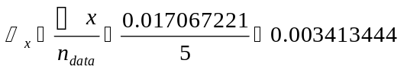
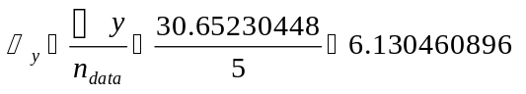
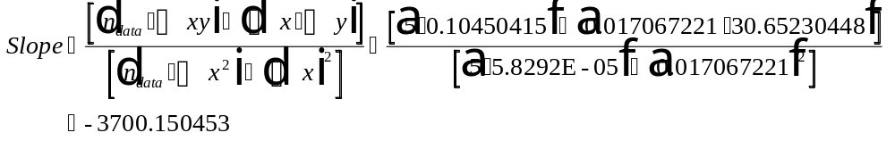

Calculate ln H as a function of temperature:
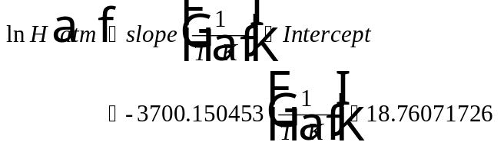
Find H at 17° C:
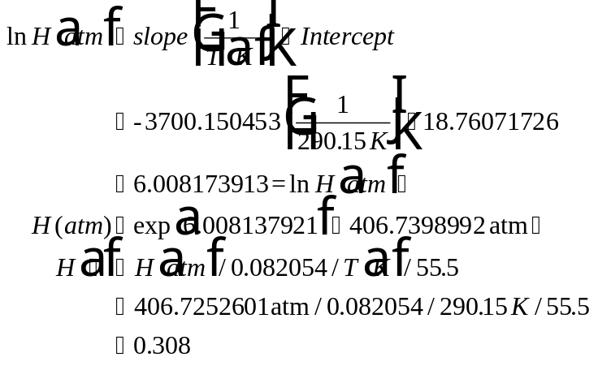

This result agrees with the “Regression of Data” result shown in Figure 1.

UNIFAC fit with a data point
For the special case in which the user desires a property value for Henry's constant at a temperature different from a single discrete value in the database, UNIFAC is used as an extrapolation tool (see the “Note on UNIFAC” section for a detailed discussion of UNIFAC). A UNIFAC estimate at the database temperature is first used to calculate the "offset" between the UNIFAC prediction and the data point. This offset is then applied at the temperature of interest to correct the UNIFAC estimate to be consistent with the given data value (i.e., the UNIFAC property-versus-temperature curve is forced through the discrete database value). This extrapolation technique takes advantage of the linear relationship between ln of Henry’s constant in atm and 1/Temperature. Elsewhere in this paper and in StEPP™, this procedure is referred to as "UNIFAC Fit with Data Point."
Sample Calculation to Estimate Henry’s Constant of TCE at 17° C
Figure 2 shows the Henry’s constant window from StEPP™ for TCE at 17° C.
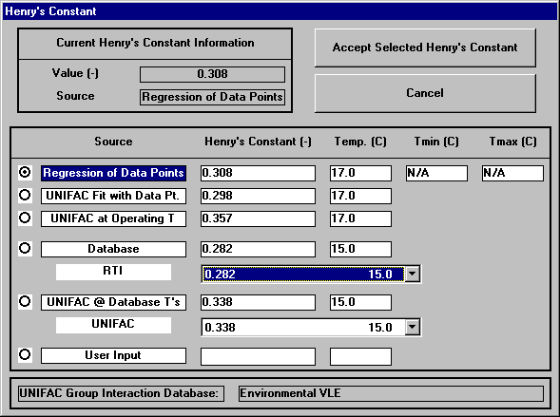
Figure 2 - Henry's Constant Window for Trichloroethylene at 17° C

From Figure 2, the nearest temperature at which a data point is available is 15° C. From Figure 2, the database value of Henry’s constant at 15° C is 0.282 and the UNIFAC value at 15° C is 0.335. Using these values, the program calculates the offset value at this temperature in the following manner.

Henry’s constant values must first be converted to units of atmospheres:
Then to obtain the UNIFAC fit with a data point at 17° C, this offset is applied to the UNIFAC value obtained at that temperature (0.355) as follows:

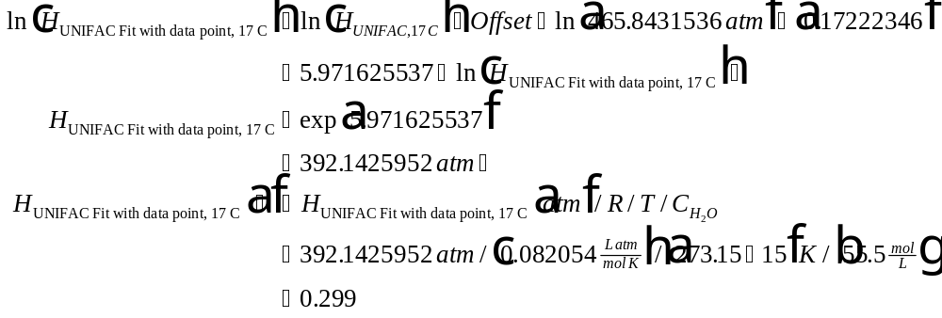
This result is in agreement with the “UNIFAC Fit with Data Point” value shown in Figure 2.

UNIFAC at the operating temperature
The section entitled “Note on UNIFAC” provides general information on properties that are available from UNIFAC. Information specific to Henry’s constant is given here. By definition, Henry's constant is equal to the product of the Lewis-Randall infinite dilution activity coefficient and the pure component vapor pressure. In StEPP™, Henry's constant is estimated by multiplying the infinite dilution activity coefficient estimated by UNIFAC by the solute's pure component vapor pressure calculated from a temperature-dependent correlation in the StEPP™ database. Equilibrium air-water partitioning of a chemical solute obeys Henry's Law only when the liquid mixture is very dilute in the solute (Carroll, 1991).

Database
The StEPP™ database contains discrete Henry’s constant data available from the following:
- Research Triangle Institute (RTI)/U.S. Air Force/U.S. EPA experimental measurements (Ashworth, et al., 1988)
- Yaws (1992)
- EPA Superfund Public Health Evaluation Manual (1986)
The data from source (1) is available for several compounds at several temperatures (typically from 10° to 30°C). The data for sources (2) and (3) is available at a single discrete temperature. The StEPP™ database contains data from (1) if it is available. If no data is available from source (1) then it will contain data from source (2) if it is available. If no data is available from (1) or (2) then the database contains data from source (3).

UNIFAC at database temperatures
For comparison purposes, StEPP™ calculates UNIFAC values for Henry’s constant at temperatures corresponding to those for which data is available in the StEPP™ database. Details on the UNIFAC determination of Henry’s constants is given in the “UNIFAC at Operating Temperature” section above.

Molecular Weight

Sources Available and Hierarchy

Molecular weight is available in StEPP™ from the following:
- AIChE/DIPPR®
- Group Contribution Method

References

AIChE/DIPPR®

Daubert, T.E., R.P. Danner, H.M. Sibul, and C.C. Stebbins, Physical and Thermodynamic Properties of Pure Chemicals: Data Compilation, Extant 1995, Taylor & Francis, Bristol, Pennsylvania (1995).

Group Contribution Method
Partington, J., “An Advanced Treatise on Physical Chemistry,” Vol. I, Fundamental Principles: The Properties of Gases, Longmans, Green, New York (1949).

Detailed Information on the Sources Available

AIChE/DIPPR®
Molecular weight is available for all chemicals in the AIChE/DIPPR® data compilation.

Group Contribution Method
For this method, the molecular weight is determined based on atomic structure via the method of Schroeder. The application of this method is discussed in the following secondary sources:
Lyman, W.J., W.F. Reehl, and D.H. Rosenblatt, Handbook of Chemical Property Estimation Methods: Environmental Behavior of Organic Compounds, New York: McGraw-Hill Book Company (1982).
Reid, R.C., J.M. Prausnitz, and B.E. Poling, The Properties of Gases and Liquids, 4th Ed., New York: McGraw-Hill Book Company (1987).

Normal Boiling Point

Sources Available and Hierarchy

- AIChE/DIPPR®

References

AIChE/DIPPR®

Daubert, T.E., R.P. Danner, H.M. Sibul, and C.C. Stebbins, Physical and Thermodynamic Properties of Pure Chemicals: Data Compilation, Extant 1995, Taylor & Francis, Bristol, Pennsylvania (1995).

Detailed Information on the Source Available

AIChE/DIPPR®

Normal boiling point is available as discrete data from this source.

Liquid Density

Sources Available and Hierarchy
- AIChE/DIPPR®
- Group Contribution Method
The order listed above is the preferential order for selection of the calculation methods.

References

AIChE/DIPPR®
Daubert, T.E., R.P. Danner, H.M. Sibul, and C.C. Stebbins, Physical and Thermodynamic Properties of Pure Chemicals: Data Compilation, Extant 1995, Taylor & Francis, Bristol, Pennsylvania (1995).

Group Contribution Method
Partington, J., “An Advanced Treatise on Physical Chemistry,” Vol. I, Fundamental Principles: The Properties of Gases, Longmans, Green, New York (1949).

Detailed Information on the Sources Available

AIChE/DIPPR®
This source provides a correlation that requires temperature input. The correlation used is:
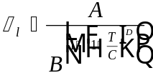 in the range
where:
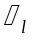 = Liquid density (kmol/m³)
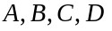 = Empirical coefficients
= Temperature (K)
= Minimum temperature for which correlation applies (K)
= Maximum temperature for which correlation applies (K)
From the AIChE/DIPPR® data compilation, for Trichloroethylene:
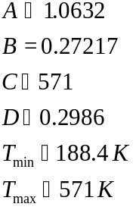

Sample Calculation for Trichloroethylene at :
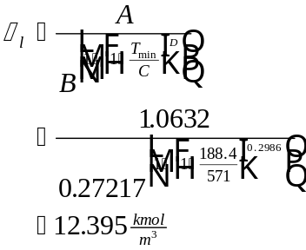
This result agrees with the value reported in Daubert, et al. (1995). The units in StEPP™ for liquid density are kg/m³ and this result converted to those units is 1630 kg/m³.

Sample Calculation for Trichloroethylene at 10° C:
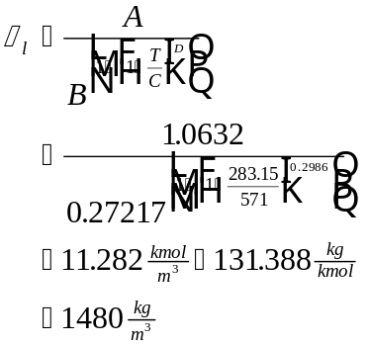

Group Contribution Method
This liquid density is calculated from modified Schroeder group contribution method. It is calculated using the molar volume at the normal boiling point and referenced to water to account for the effect of temperature.

The equation used is shown below:
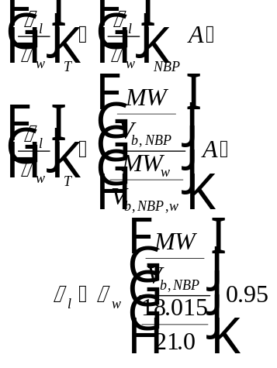
where:
= Liquid density of compound at the temperature of interest (kg/m³)
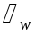 = Water density at temperature of interest (g/cm³)
= Molecular weight of compound (g/mol)
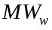 = Molecular weight of water (g/mol)
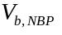 = Molar volume at the normal boiling point of compound (cm³/mol)
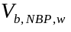 = Molar volume at the normal boiling point of water (cm³/mol)
= Empirical factor designed to represent temperature dependency of compound’s liquid density referenced to water. It was found to equal 0.95 in limited tests over several classes of compounds.
Sample Calculation for Trichloroethylene at 10° C

From StEPP™:
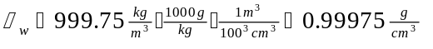
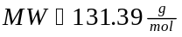

Solving the equation given above, which has been rearranged slightly:
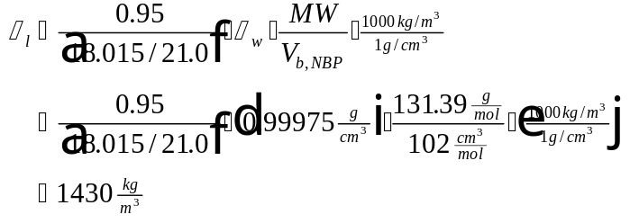

Molar Volume at Operating Temperature

Sources Available and Hierarchy
The sources available are:
- AIChE/DIPPR®
- Group Contribution Method
The molar volumes at the operating temperature given above are calculated as the inverse of liquid density multiplied by molecular weight. The order listed above is the preferential order for selection of the calculation methods.

References

AIChE/DIPPR®
Same as for liquid density.

Group Contribution Method
Same as for liquid density.

Detailed Information on the Sources Available
Molar volumes at the operating temperature for both methods are calculated from the following relationship:
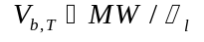
where:
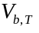 = Molar volume at the operating temperature (m³/kmol)
= Molecular weight (kg/kmol)
= Liquid density (kg/m³)

AIChE/DIPPR®
Sample Calculation for TCE at 10° C
From StEPP™:
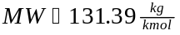
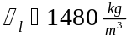
Calculating molar volume at the operating temperature:
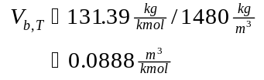

Group Contribution Method
Sample Calculation for TCE at 10° C
From StEPP™:
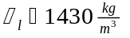
Calculating molar volume at the operating temperature:
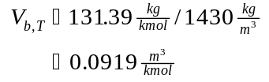

Molar Volume at Normal Boiling Point

Sources Available and Hierarchy
Molar volume is available in StEPP™ from:
- Modified Schroeder group contribution method

References

Modified Schroeder group contribution method
Partington, J., “An Advanced Treatise on Physical Chemistry,” Vol. I, Fundamental Principles: The Properties of Gases, Longmans, Green, New York (1949).

Detailed Information on the Sources Available

Modified Schroeder group contribution method
The application of this method is discussed in the following secondary sources:
Lyman, W.J., W.F. Reehl, and D.H. Rosenblatt, Handbook of Chemical Property Estimation Methods: Environmental Behavior of Organic Compounds, New York: McGraw-Hill Book Company (1982).
Reid, R.C., J.M. Prausnitz, and B.E. Poling, The Properties of Gases and Liquids, 4th Ed., New York: McGraw-Hill Book Company (1987).

Refractive Index

Sources Available and Hierarchy
The refractive index is available in StEPP™ from:
- AIChE/DIPPR®

References

AIChE/DIPPR®
Daubert, T.E., R.P. Danner, H.M. Sibul, and C.C. Stebbins, Physical and Thermodynamic Properties of Pure Chemicals: Data Compilation, Extant 1995, Taylor & Francis, Bristol, Pennsylvania (1995).

Detailed Information on the Sources Available

AIChE/DIPPR®
Discrete data for refractive index is available from this source.

Aqueous Solubility

Sources Available and Hierarchy
The available data in StEPP™ is from:
- UNIFAC fit with a data point
- UNIFAC at the operating temperature
- Database
- UNIFAC at database temperature
The ordering given above is the preferential order for selection of aqueous solubilities in StEPP™.

References

UNIFAC fit with a data point
See below for obtaining the UNIFAC values. No references for the fit.

UNIFAC at the operating temperature
See the section “Note on UNIFAC” for the general references on UNIFAC. A discussion of this calculation is given in Appendix A.3 of Rogers (1994).

Database
Yaws, C.L., J.W. Miller, P.N. Shah, G.R. Schorr, and P.M. Patel, "Correlation Constants for Chemical Compounds," Chem. Eng., 83:25, 153-162 (1976).
EPA Superfund Public Health Evaluation Manual, U.S. Environmental Protection Agency, Office of Emergency and Remedial Response, Washington, D.C., EPA/540/1-86/060 (October 1986).

UNIFAC at database temperature
See the section “Note on UNIFAC” for the general references on UNIFAC.

Detailed Information on the Sources Available

UNIFAC fit with a data point
For the special case in which the user desires a property value for aqueous solubility at a temperature different from a single discrete value in the database, UNIFAC is used as an extrapolation tool (see the “Note on UNIFAC” section for a detailed discussion of UNIFAC). A UNIFAC estimate at the database temperature is first used to calculate the "offset" between the UNIFAC prediction and the data point. This offset is then applied at the temperature of interest to correct the UNIFAC estimate to be consistent with the given data value (i.e., the UNIFAC property-versus-temperature curve is forced through the discrete database value). This extrapolation technique takes advantage of the linear relationship between aqueous solubility and temperature. Elsewhere in this paper and in StEPP™, this procedure is referred to as "UNIFAC Fit with Data Point."
Sample Calculation to Estimate Aqueous Solubility of TCE at 17° C

Figure 3 shows the aqueous solubility window from StEPP™ for TCE at 17° C.
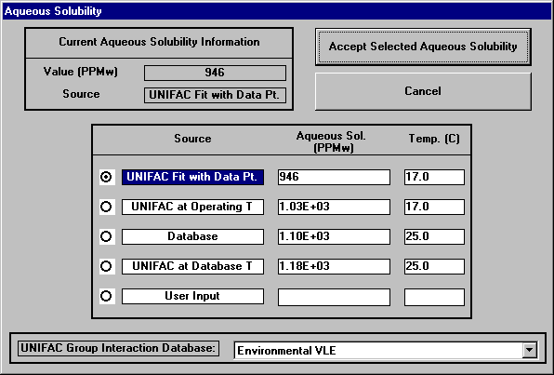
Figure 3 - Aqueous Solubility Window for TCE at 17° C
From Figure 3, the following values are used in the calculation of the offset:
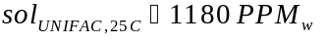
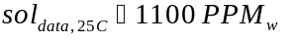
From these values, an offset to apply at other temperatures is calculated as:
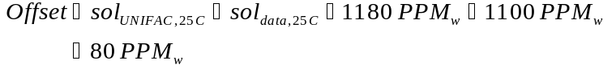

Then aqueous solubilities at other temperatures can be estimated from:
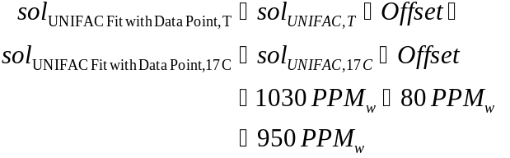

This value agrees with that reported in Figure 3 for “UNIFAC Fit with Data Point”.

UNIFAC at the operating temperature
The section entitled “Note on UNIFAC” provides general information on properties that are available from UNIFAC. Information specific to aqueous solubility is given here. At the saturation composition, adding an additional differential amount of solute to an aqueous mixture will form a second solute-rich phase containing an equilibrium trace amount of water. The mutual miscibility of a chemical with water can be calculated rigorously from solution thermodynamics and UNIFAC activity coefficient estimates. Phase equilibrium relationships are set up and solved within StEPP™ to predict the organic and water compositions (i.e., solubility limits) of the equilibrium liquid phases. The solubility limit of the organic in the water-rich phase is displayed in StEPP™ as the aqueous solubility.

Database
The StEPP™ database contains discrete aqueous solubility data available from the following:
- Yaws (1992)
- EPA Superfund Public Health Evaluation Manual (1986)
The data for both sources is available at a single discrete temperature. The StEPP™ database contains data from (1) if it is available. If no data is available from source (1) then the database will contain data from source (2) if it is available.

UNIFAC at database temperature
For comparison purposes, StEPP™ calculates a UNIFAC value for aqueous solubility at the temperature corresponding to that for which data is available in the StEPP™ database. Details on the UNIFAC determination of aqueous solubilities is given in the “UNIFAC at Operating Temperature” section above.

Octanol Water Partition Coefficient (log Kow)

Sources Available and Hierarchy
The available data in StEPP™ is from:
- UNIFAC at the operating temperature
- Database
- UNIFAC at database temperature
The ordering given above is the preferential order for selection of octanol water partition coefficients in StEPP™.

2. References

UNIFAC at the operating temperature
See the section “Note on UNIFAC” for the general references on UNIFAC. A discussion of this calculation is presented in Appendix A.4 of Rogers (1994).

Database
EPA Superfund Public Health Evaluation Manual, U.S. Environmental Protection Agency, Office of Emergency and Remedial Response, Washington, D.C., EPA/540/1-86/060 (October 1986).

UNIFAC at database temperature
See the section “Note on UNIFAC” for the general references on UNIFAC.

3. Detailed Information on the Sources Available

UNIFAC at the operating temperature
The section entitled “Note on UNIFAC” provides general information on properties that are available from UNIFAC. Information specific to the octanol water partition coefficient is given here. The octanol water partition coefficient is calculated from the UNIFAC activity coefficient model by a series of steps. First, the user selects a temperature of interest and StEPP™ performs a binary octanol-water equilibrium calculation according to the rigorous solution of phase equilibrium relationships. Because the two components are almost immiscible in each other, two phases are predicted: an octanol-rich phase containing dissolved water, and a water-rich phase containing dissolved octanol. Once the composition of each phase has been calculated, infinite dilution activity coefficients for a third component in each phase are then determined. The octanol/water partition coefficient is directly proportional to the ratio of the infinite dilution activity coefficients for a third component distributed between the water-rich and octanol-rich phases.

Database
The StEPP™ database contains discrete octanol water partition coefficient data available from the following:
- EPA Superfund Public Health Evaluation Manual (1986)
The data is available at a single discrete temperature.

UNIFAC at database temperature
For comparison purposes, StEPP™ calculates a UNIFAC value for the octanol water partition coefficient at the temperature corresponding to that for which data is available in the StEPP™ database. Details on the UNIFAC determination of octanol water partition coefficients is given in the “UNIFAC at Operating Temperature” section.

Liquid Diffusivity

Sources Available and Hierarchy
Property estimation methods available in StEPP™ for liquid diffusivity include:
- Hayduk and Laudie correlation
- Wilke-Chang correlation
- Method of Polson
The above ordering is the hierarchy for the case where molecular weight is less than 1000. When molecular weight is greater than 1000, the hierarchy of estimation methods for liquid diffusivity becomes (1) Method of Polson; (2) Hayduk and Laudie correlation, and (3) Wilke-Chang correlation.

2. References

Hayduk and Laudie Correlation
Hayduk, W. and H. Laudie, "Prediction of Diffusion Coefficients for Non-electrolytes in Dilute Aqueous Solutions," Jour. AIChE, 28, 611 (1974).

Wilke-Chang Correlation
Wilke, C.R. and P.C. Chang, "Correlation of Diffusion Coefficients in Dilute Solutions," J. AIChE, 1 (1955).
A discussion of the application of this method is provided in:
Reid, R.C., J.M. Prausnitz, and B.E. Poling, The Properties of Liquids and Gases, 4th ed., New York: McGraw-Hill Book Company (1987).

Method of Polson
Polson, A., "Some Aspects of Diffusion in Solution and a Definition of a Colloidal Particle," Jour. Phys. Coll. Chem., 54, 649 (1950).

3. Detailed Information on the Sources

Hayduk and Laudie Correlation
This correlation is a modification of the Wilke-Chang Correlation and can be used for small molecules in water.
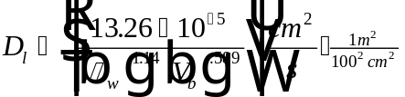
Where:
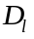 = Liquid diffusivity of compound (m²/s)
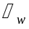 = Viscosity of water (cp = 0.01 g/cm/s)
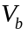 = Molar volume of solute at normal boiling point (cm³/gmol)
Sample Calculation for Trichloroethylene at 10° C

Retrieving properties of Trichloroethylene required for the calculation from StEPP™:
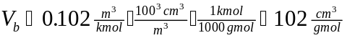
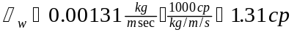
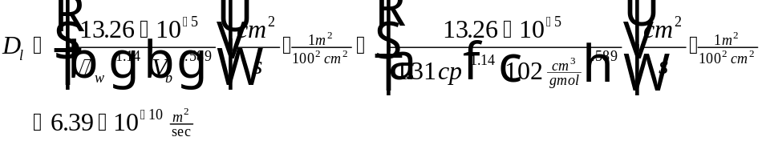

Wilke-Chang Correlation
This correlation is based on the Stokes-Einstein Equation. For background on the Wilke-Chang correlation, see Treybal (1980). To calculate the liquid diffusivity of a compound in water, the equation takes the following form:
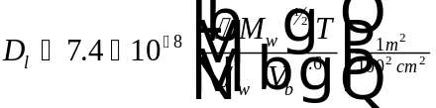

Where:
= Liquid diffusivity of compound (m²/s)
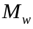 = Molecular weight of water
= Temperature (K)
= Viscosity of water (cp = 0.01 g/cm/s)
= Molar volume of solute at normal boiling point (cm³/gmol)
= Association parameter of water (dimensionless) = 2.26
Sample Calculation for Trichloroethylene at 10° C

Retrieving properties of Trichloroethylene required for the calculation from StEPP™:
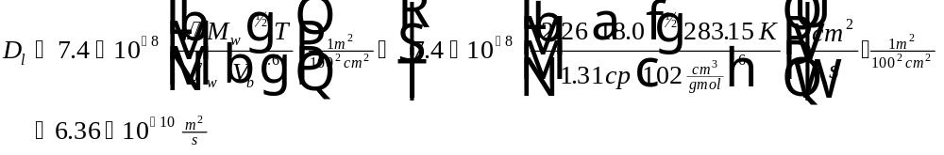

Method of Polson (1950)
This method is only applicable for large molecular weight compounds (> 1000). The equation for the calculation of liquid diffusivity is:
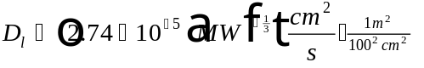
Where:
= Liquid diffusivity of compound (m²/s)
= Molecular weight of compound

Sample Calculation for Trichloroethylene
From StEPP™, MW for Trichloroethylene equals 131.39 (note the correlation would not apply to this compound but the numerical calculation can still be checked).
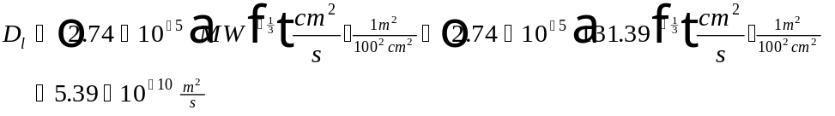

Gas Diffusivity

Sources Available and Hierarchy
Property estimation methods available in StEPP™ for gas diffusivity include:
- Wilke-Lee Modification of Hirschfelder-Bird-Spotz Equation

References

Wilke-Lee Modification of Hirschfelder-Bird-Spotz Equation
Wilke, C.R. and C.Y. Lee, Ind. Eng. Chem., 47, 1253 (1955).
Hirschfelder, J.O., R.B. Bird, and E.L. Spotz, Trans. ASME, 71, 921 (1949); Chem. Rev., 44, 205 (1949).
A discussion of the application of the method is provided in:
Treybal, R.E., Mass-Transfer Operations, 3rd ed., New York: McGraw-Hill Book Company (1980).

Detailed Information on the Sources Available

Wilke-Lee Modification of Hirschfelder-Bird-Spotz Equation
This correlation can be used to calculate the diffusivity of an organic compound in the gas-phase. Background information on the correlation is provided in Treybal (1980).
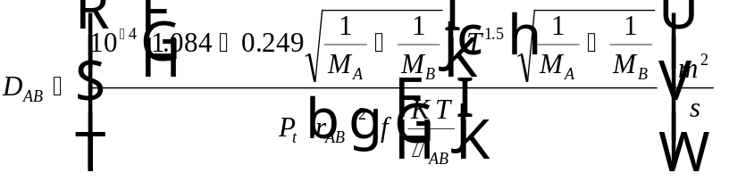
Where:
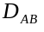 = Gas diffusivity of organic compound A in stagnant gas B (m²/s)
= Absolute temperature (K)
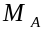 = Molecular weight of A
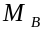 = Molecular weight of B
= Absolute pressure (N/m²)
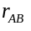 = Molecular separation at collision (nm) = 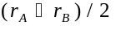
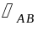 = Energy of molecular attraction = 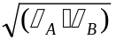
= Boltzman’s constant
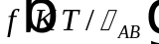 Collision function
See page 33 of Treybal (1980) for estimating some of the above parameters. Given below are the necessary parameter estimation correlations using air as the stagnant gas, B.
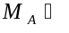Molecular weight of organic compound A
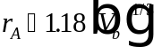
= Molar volume of A at normal boiling point (m³/kmol)
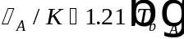
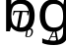 = Normal boiling point of A (K)
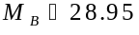
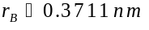
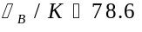
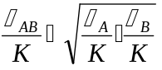
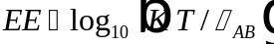
= Operating Temperature (K)
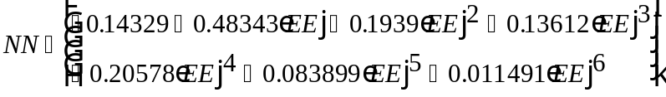
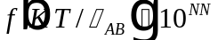
Sample Calculation for Trichloroethylene in Air at 10° C and 101325 Pa
Determination of Required Parameters

= Trichloroethylene = Air
= 131.39 kg/kmol (from StEPP™)
= 0.102 m³/kmol (from StEPP™)
= 360.15 K
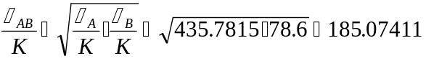
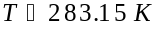
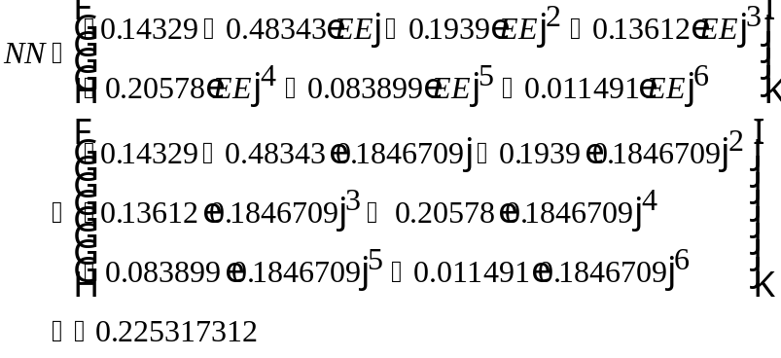

Calculation of Gas Diffusivity:
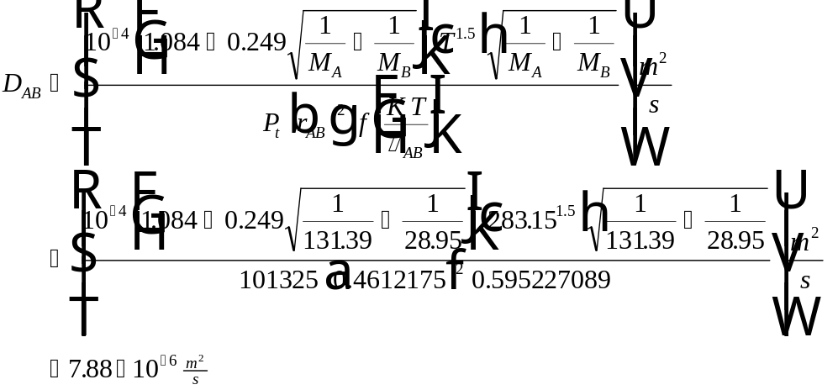

Water Density

Sources Available and Hierarchy
Water density is estimated in StEPP™ from:
- Correlation developed from polynomial fit of data from McCabe and Smith (1976).

Reference
McCabe, W.L. and J.C. Smith, Unit Operations of Chemical Engineering, 3rd ed., New York: McGraw-Hill Book Company (1976).

Detailed Information on the Source Available
The correlation used to calculate water density is given below:
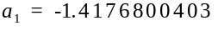
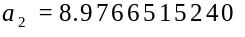
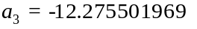
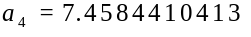
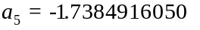
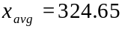
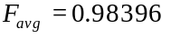
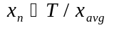
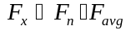
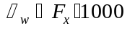
where:
= Water density (kg/m³)
= Temperature (K)
Sample Calculation at 10° C
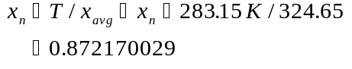
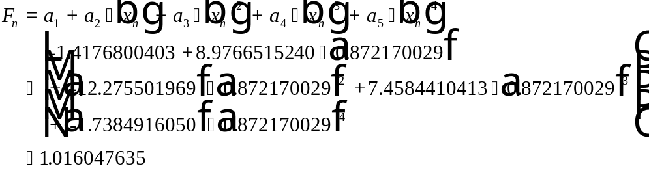
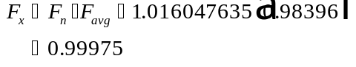
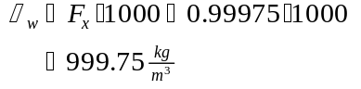

Water Viscosity

Sources Available and Hierarchy
Water viscosity is available in StEPP™ from:
- Correlation presented in Yaws et al. (1976)

Reference
Yaws, C.L., J.W. Miller, P.N. Shah, G.R. Schorr, and P.M. Patel, "Correlation Constants for Chemical Compounds," Chem. Eng., 83:25, 153-162 (1976).

Detailed Information on the Source Available
The correlation used to calculate water viscosity is shown below:
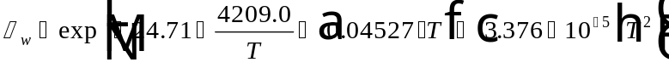
where:
= Water viscosity (kg/m/s)
= Temperature (K)
Sample Calculation at 10° C
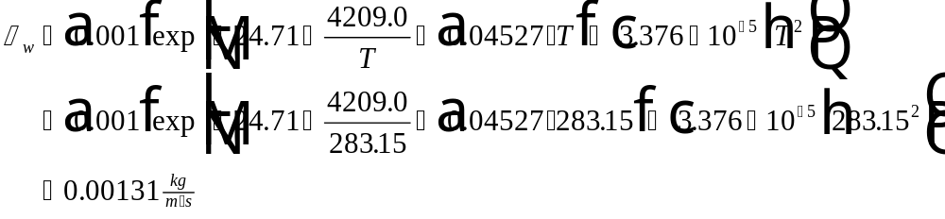

Water Surface Tension

Sources Available and Hierarchy
The water surface tension is available in StEPP™ from:
- Correlation developed by Cummins and Westrick (1983)

Reference
Cummins, M.D. and J.J. Westrick, "Proceedings ASCE Environmental Engineering Conference," Boulder, Colorado, 442-449 (July 1983).

Detailed Information on the Source Available
The correlation used to calculate water surface tension is shown below:
where:
= Water surface tension (N/m)
= Temperature (°C)
Sample Calculation at 10° C
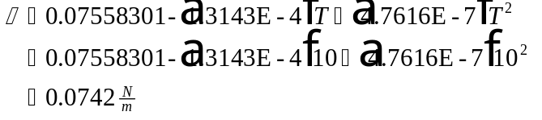

Air Density

Sources Available and Hierarchy
Air density is estimated in StEPP™ from the following method
- Ideal gas law

Reference
Any general chemistry book

Detailed Information on the Sources Available
The ideal gas law is shown below:
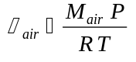
where:
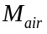 = Molecular weight of air = 28.95
= Pressure (atm)
= Universal gas constant (L atm/mol K) = 0.08205
= Temperature (K)
Sample Calculation at 10° C and 101325 Pa (1 atm)

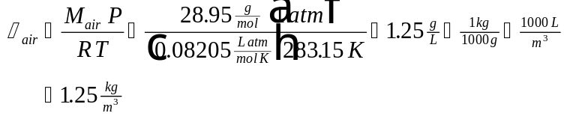

Air Viscosity

Sources Available and Hierarchy
The air viscosity is available in StEPP™ from:
- Correlation developed by Cummins and Westrick (1983)

Reference
Cummins, M.D. and J.J. Westrick, "Proceedings ASCE Environmental Engineering Conference," Boulder, Colorado, 442-449 (July 1983).

Detailed Information on the Source Available
The correlation used to calculate air viscosity is shown below:
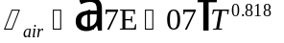
where:
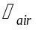 = Air viscosity (kg/m/s)
= Temperature (K)

Sample Calculation at 10° C
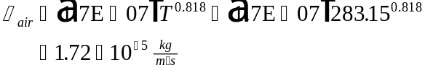

Sample Run of StEPP™

Running StEPP™
To run StEPP™, load Windows and click twice on the StEPP™ icon in Program Manager. The program will initialize and the window shown in Figure 4 will appear on the screen:

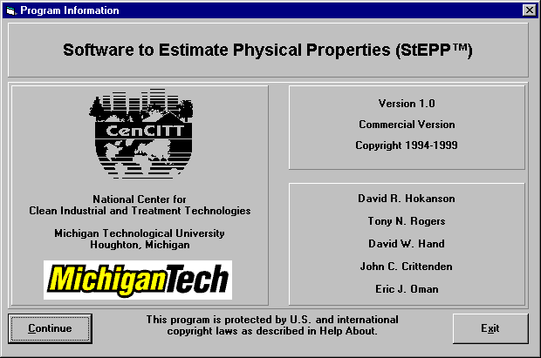
Figure 4 - Title Window in StEPP™
Click on the Continue command button shown in Figure 4 and a user agreement will appear. Click on I Agree then the StEPP™ main window will appear, as shown in Figure 5:

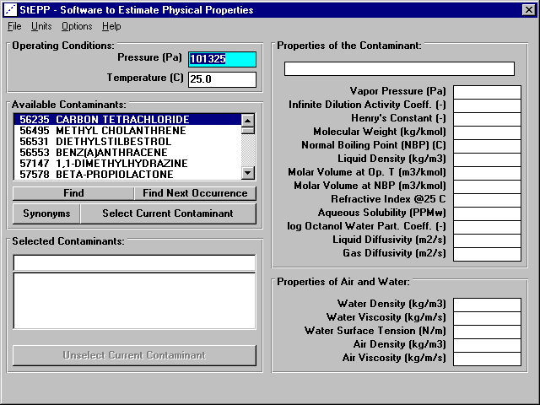
Figure 5 - StEPP Main™ Window
From the StEPP main™ window shown in Figure 5, it is possible to manipulate StEPP™ in order to gain information about various contaminants. To demonstrate the capabilities of StEPP™, a sample program run will be made by selecting trichloroethylene at an operating temperature of 10° C (50 F) and an operating pressure of 101325 Pa (14.696 psi). The ability of StEPP™ to show values in both SI and English units will be illustrated in the sample program run. The sample program run is not intended to provide a comprehensive description of StEPP™’s features, but to give a brief demonstration of the look-and-feel of the software. More detail on StEPP™’s features will be provided later in this report.

Sample Program Run
When the program is started, the default units are SI units so this is the system of units in which the sample program run begins. In the StEPP main™ window (see Figure 5), a value of 101325 is entered into the Operating Pressure field and a value of 10 is entered in the Operating Temperature field. Then in the Available Contaminants list box, trichloroethylene is chosen. To find trichloroethylene in the list, click on the Find button and search for trichloroethylene (there is also a Synonyms feature to aid in finding chemicals, as described in Appendix A). Once this is done, the main window will appear as shown in Figure 6.

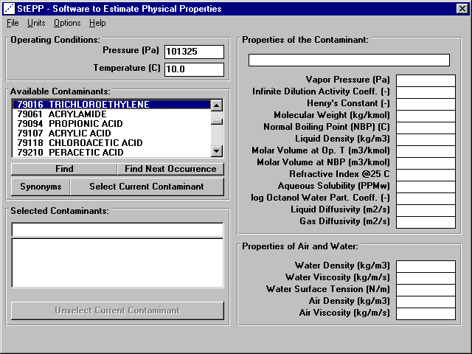
Figure 6 - StEPP™ Main Window for Trichloroethylene at 10° C before Selection

Once trichloroethylene is selected in the Available Contaminants list box, it is necessary to have StEPP™ perform calculations of properties for this compound at the desired operating pressure and temperature. The desired operating pressure (101325 Pa) and temperature (10° C) have already been entered. The screen now appears as shown in Figure 6. In order to calculate properties, the Select Current Contaminant command button shown in Figure 6 is clicked. Once this is done, the StEPP main™ window updates to reflect the property values for trichloroethylene and the properties of air and water at 10° C and 101325 Pa. The updated StEPP main™ window is shown in Figure 7.

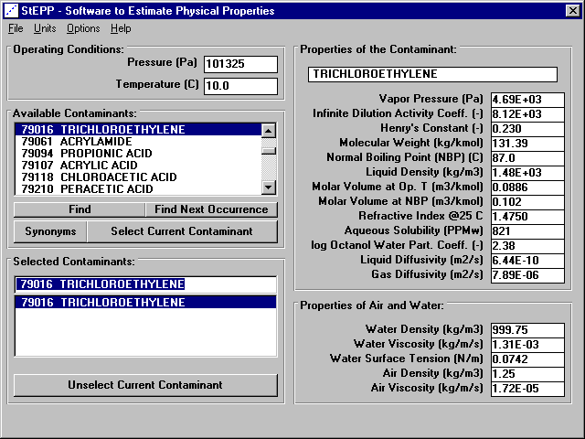
Figure 7 - StEPP Main™ Window for Trichloroethylene at 101325 Pa and 10° C

The values that appear in the StEPP main™ window for each property are chosen initially according to a hierarchy. For each individual property available in StEPP™, there may be more than one source of data values, not just the value chosen according to the hierarchy. For this reason, StEPP™ contains an individual property window for each property available in StEPP™ in which the user may choose to select a different value of a particular property to appear in the StEPP main™ window. For example, the property window for Liquid Density for the example given above is shown in Figure 8.

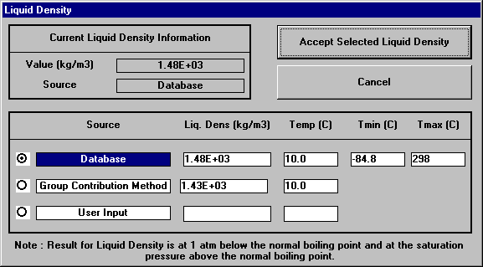
Figure 8 - Liquid Density Window (Trichloroethylene, 10° C, 101325 Pa)
In Figure 7, it can be seen that the value for Liquid Density that appears in the StEPP main™ window from the hierarchy is 1.48E+03. By examining the Liquid Density window in Figure 8, it is seen that the value 1.48E+03 (which has its source highlighted) comes from the source “Database”. Figure 8 also shows that there are two other potential sources of Liquid Density available in StEPP™, namely “Group Contribution Method” and “User Input”. The user may select either of the other choices (if they have values available) in a manner that will be described later.

StEPP™ has the capability to display its results in English units, as opposed to the SI units shown in Figure 7 and in Figure 8. English units can be selected in the Units menu on the StEPP main™ window. After doing this, Figure 9 shows the StEPP™ Main Window for the previous example when English units are selected.

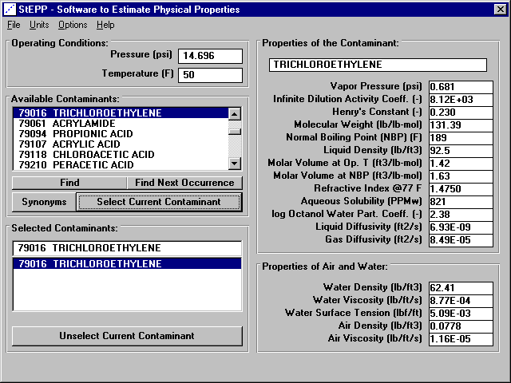
Figure 9 -StEPP main™ Window (Trichloroethylene, 14.696 psi, 50° F)

Figure 10 shows the liquid density window for the previous example when English units are selected.

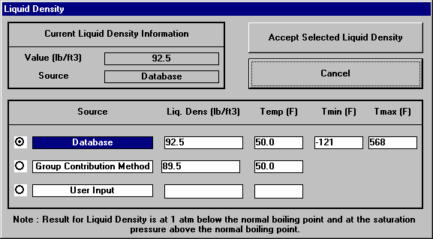
Figure 10 - Liquid Density Window (Trichloroethylene, 14.696 psi, 50° F)

Windows in StEPP™
StEPP™ is designed for the Microsoft Windows interface. As such, there are several windows contained in StEPP™. The major windows will be described in detail here. The major windows in StEPP™ that will be described are:
- StEPP main™ Window
- Vapor Pressure Window
- Infinite Dilution Activity Coefficient Window
- Henry’s Constant Window
- Molecular Weight Window
- Normal Boiling Point Window
- Liquid Density Window
- Molar Volume at the Operating Temperature Window
- Molar Volume at the Normal Boiling Point Window
- Refractive Index Window
- Aqueous Solubility Window
- Octanol Water Partition Coefficient Window
- Liquid Diffusivity Window
- Gas Diffusivity Window
- Water Density Window
- Water Viscosity Window
- Water Surface Tension Window
- Air Density Window
- Air Viscosity Window

Main StEPP™
The user has the option of viewing the StEPP main™ window either in the SI system of units or in the English system of units. To toggle between English and SI units, click on the appropriate choice in the Units menu on the StEPP main™ window. Figure 11 shows the StEPP main™ window in SI units for TCE as the selected contaminant at 10° C and 101325 Pa.

Figure 11 - StEPP™ Main Window (Trichloroethylene Selected, 10° C, 101325 Pa)

Figure 12 shows the StEPP™ main window in English units for TCE as the selected contaminant at an operating pressure of 14.696 psi and an operating temperature of 50° F.

Figure 12 - StEPP™ Main Window (Trichloroethylene Selected, 14.696 psi, 50° F)

Vapor Pressure

StEPP™ has the capability to predict vapor pressure at the temperature of interest. To activate the Vapor Pressure window, click the left mouse button on the vapor pressure label or the vapor pressure value in the StEPP main™ window. The Vapor Pressure window for trichloroethylene at 101325 Pa and 10 C is shown in Figure 13.

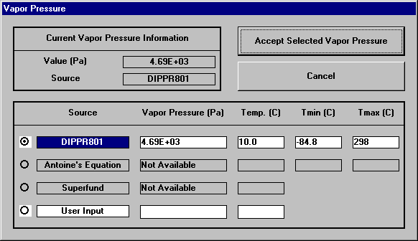
Figure 13 - Vapor Pressure Window (Trichloroethylene, 101325 Pa, 10° C)

Figure 14 shows the vapor pressure window for English units (Trichloroethylene, 14.696 psi, 50° F).

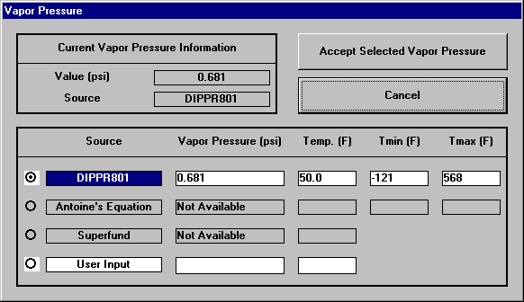
Figure 14 - Vapor Pressure Window (Trichloroethylene, 14.696 psi, 50° F)

Infinite Dilution Activity Coefficient

StEPP™ has the capability to predict infinite dilution activity coefficient at the temperature of interest. To activate the Activity Coefficient window, click the left mouse button on the activity coefficient label or the activity coefficient value in the StEPP main™ window. The Activity Coefficient window for trichloroethylene at 101325 Pa and 10° C is shown in Figure 15.

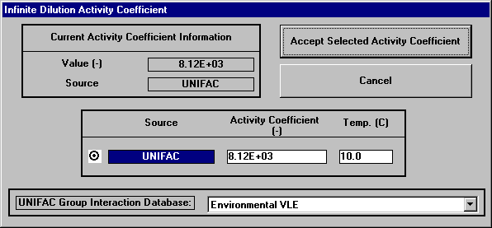
Figure 15 - Activity Coefficient Window (Trichloroethylene, 101325 Pa, 10° C)

Figure 16 shows the activity coefficient window for English units (Trichloroethylene, 14.696 psi, 50° F).

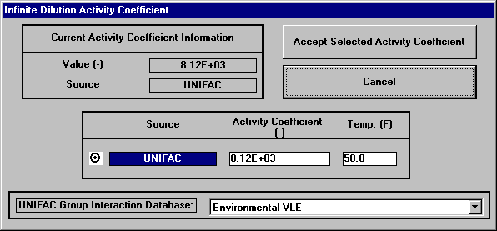
Figure 16 - Activity Coefficient Window (Trichloroethylene, 14.696 psi, 50° F)

Henry’s Constant

StEPP™ has the capability to predict Henry’s constant at the temperature of interest. To activate the Henry’s Constant window, click the left mouse button on the Henry’s constant label or the Henry’s constant value in the StEPP main™ window. The Henry’s constant window for trichloroethylene at 101325 Pa and 10° C is shown in Figure 17.

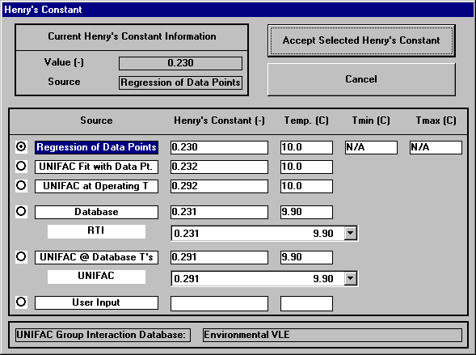
Figure 17 - Henry’s Constant Window (Trichloroethylene, 101325 Pa, 10° C)

Figure 18 shows the Henry’s constant window for English units (Trichloroethylene, 14.696 psi, 50° F).

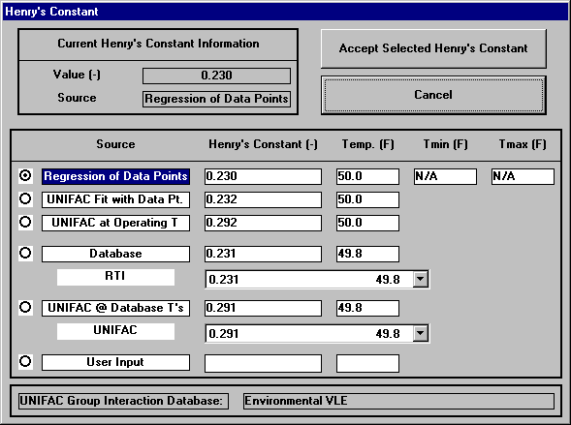
Figure 18 - Henry’s Constant Window (Trichloroethylene, 14.696 psi, 50° F)

Molecular Weight

StEPP™ has the capability to determine a contaminant’s molecular weight. To activate the Molecular Weight window, click the left mouse button on the molecular weight label or the molecular weight value in the StEPP main™ window. The molecular weight window for trichloroethylene for SI units is shown in Figure 19.

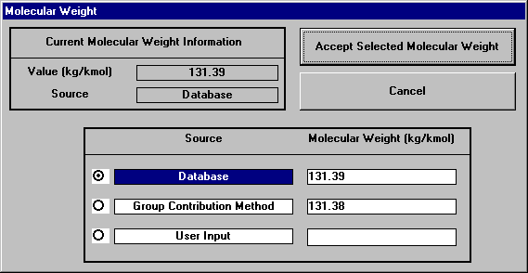
Figure 19 - Molecular Weight Window (Trichloroethylene, SI Units)

Figure 20 shows the molecular weight window for English units (Trichloroethylene).

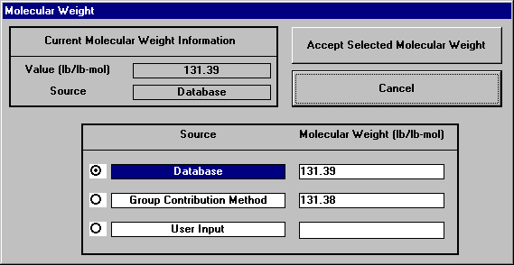
Figure 20 - Molecular Weight Window (Trichloroethylene, English Units)

Normal Boiling Point

StEPP™ has the capability to determine a contaminant’s normal boiling point. To activate the Normal Boiling Point window, click the left mouse button on the normal boiling point label or the normal boiling point value in the StEPP main™ window. The normal boiling point window for trichloroethylene is shown in Figure 21 for SI units.

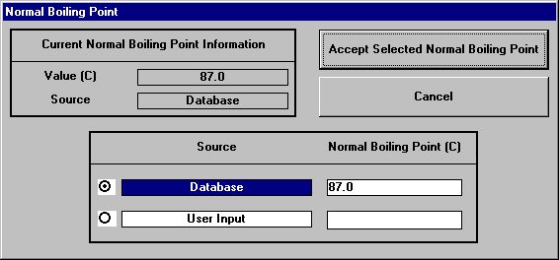
Figure 21 - Normal Boiling Point Window (Trichloroethylene, SI Units)

Figure 22 shows the normal boiling point window for English units (Trichloroethylene).

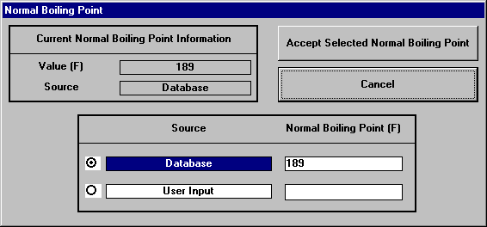
Figure 22 - Normal Boiling Point Window (Trichloroethylene, English Units)

Liquid Density

StEPP™ has the capability to predict a contaminant’s liquid density. To activate the Liquid Density window, click the left mouse button on the liquid density label or the liquid density value in the StEPP main™ window. The liquid density window for trichloroethylene at 101325 Pa and 10° C is shown in Figure 23.

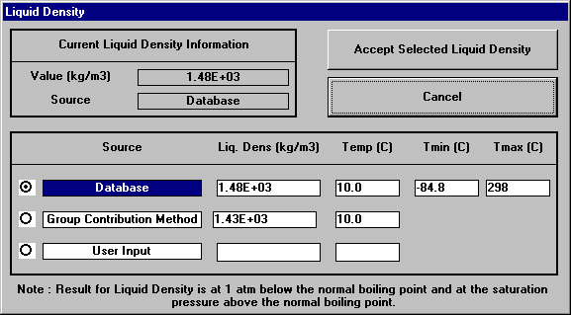
Figure 23 - Liquid Density Window (Trichloroethylene, 101325 Pa, 10° C)

Figure 24 shows the liquid density window for English units (Trichloroethylene, 14.696 psi, 50° F).

Figure 24 - Liquid Density Window (Trichloroethylene, 14.696 psi, 50° F)

Molar Volume at the Operating Temperature

StEPP™ has the capability to predict a contaminant’s molar volume at the operating temperature. To activate the Molar Volume at the Operating Temperature window, click the left mouse button on the molar volume at the operating temperature label or the molar volume at the operating temperature value in the StEPP main™ window. The molar volume at the operating temperature window for trichloroethylene at 101325 Pa and 10° C is shown in Figure 25.

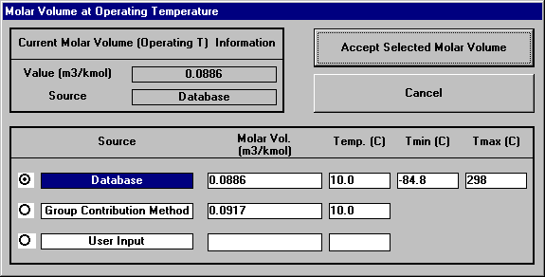
Figure 25 - Molar Volume at Operating Temperature Window
(Trichloroethylene, 101325 Pa, 10° C)

Figure 26 shows the molar volume at the operating temperature window for English units (Trichloroethylene, 14.696 psi, 50° F).

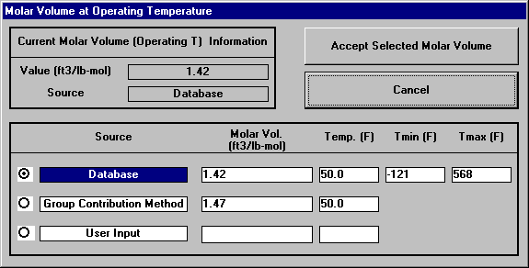
Figure 26 - Molar Volume at Operating Temperature Window (Trichloroethylene, 14.696 psi, 50° F)

Molar Volume at the Normal Boiling Point

StEPP™ has the capability to predict a contaminant’s molar volume at the operating temperature. To activate the Molar Volume at the Normal Boiling Point window, click the left mouse button on the molar volume at the normal boiling point label or the molar volume at the normal boiling point value in the StEPP main™ window. The molar volume at the normal boiling point window for trichloroethylene is shown in Figure 27 for SI units. Note that the temperature is 76.6° C, which is the normal boiling point for trichloroethylene in SI units (see Figure 21).

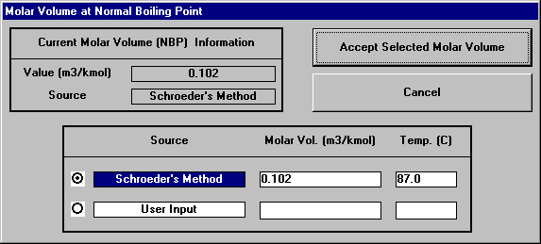
Figure 27 - Molar Volume at Normal Boiling Point Window (Trichloroethylene, 101325 Pa, 76.6° C)

Figure 28 shows the molar volume at the normal boiling point window for English units (Trichloroethylene, 14.696 psi, 170° F). Note that the temperature is 170° F, which is the normal boiling point for trichloroethylene in English units (see Figure 22).

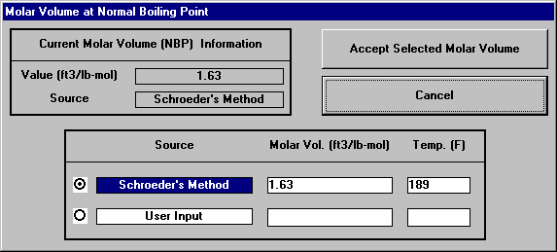
Figure 28 - Molar Volume at Normal Boiling Point Window (Trichloroethylene, 14.696 psi, 170° F)

Refractive Index

StEPP™ has the capability to estimate a contaminant’s refractive index. To activate the Refractive Index window, click the left mouse button on the refractive index label or the refractive index value in the StEPP main™ window. The refractive index window for trichloroethylene in SI units is shown in Figure 29.

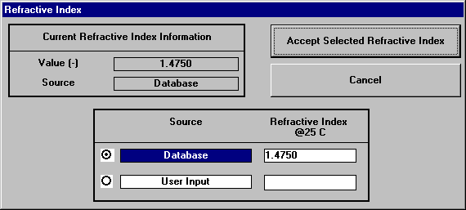
Figure 29 - Refractive Index Window for Trichloroethylene

The refractive index window for trichloroethylene in English units is shown in Figure 30.

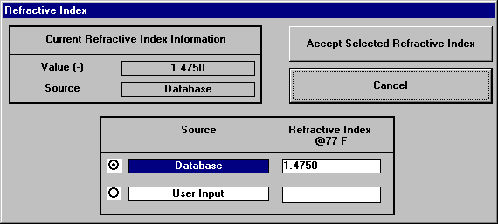
Figure 30 - Refractive Index Window for Trichloroethylene

Aqueous Solubility

StEPP™ has the capability to predict a contaminant’s aqueous solubility. To activate the Aqueous Solubility window, click the left mouse button on the aqueous solubility label or the aqueous solubility value in the StEPP main™ window. The aqueous solubility window for trichloroethylene at 101325 Pa and 10° C is shown in Figure 31.

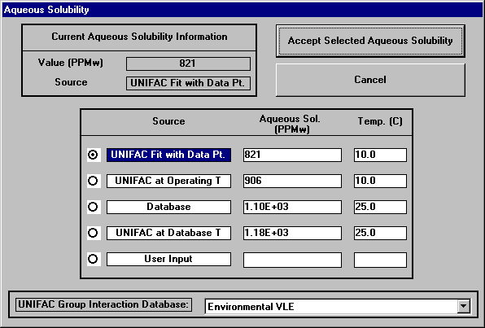
Figure 31 - Aqueous Solubility Window (Trichloroethylene, 101325 Pa, 10° C)

Figure 32 shows the aqueous solubility window for English units (Trichloroethylene, 14.696 psi, 50° F).
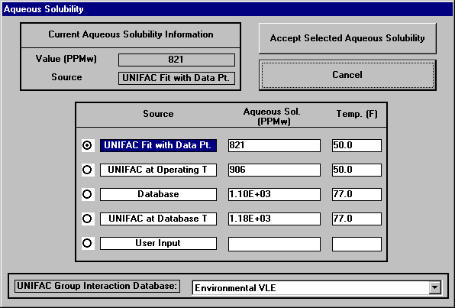
Figure 32 - Aqueous Solubility Window (Trichloroethylene, 14.696 psi, 50° F)

Octanol Water Partition Coefficient

StEPP™ has the capability to predict a contaminant’s octanol water partition coefficient. To activate the Octanol Water Partition Coefficient window, click the left mouse button on the octanol water partition coefficient label or the octanol water partition coefficient value in the StEPP main™ window. The octanol water partition coefficient window for trichloroethylene at 101325 Pa and 10° C is shown in Figure 33.

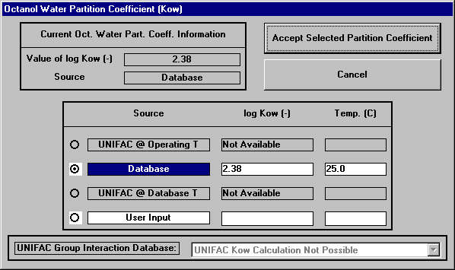
Figure 33 - Octanol Water Partition Coefficient Window (Trichloroethylene, 101325 Pa, 10° C)

Figure 34 shows the octanol water partition coefficient window for English units (Trichloroethylene, 14.696 psi, 50° F).

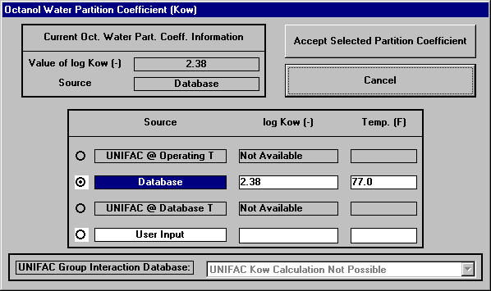
Figure 34 - Octanol Water Partition Coefficient Window
(Trichloroethylene, 14.696 psi, 50° F)

Liquid Diffusivity

StEPP™ has the capability to predict a contaminant’s liquid diffusivity. To activate the Liquid Diffusivity window, click the left mouse button on the liquid diffusivity label or the liquid diffusivity value in the StEPP main™ window. The liquid diffusivity window for trichloroethylene at 101325 Pa and 10° C is shown in Figure 35.

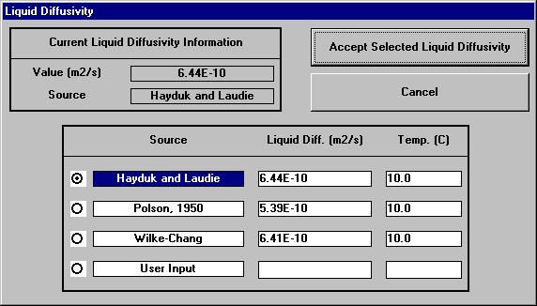
Figure 35 - Liquid Diffusivity Window (Trichloroethylene, 101325 Pa, 10° C)

Figure 36 shows the liquid diffusivity window for English units (Trichloroethylene, 14.696 psi, 50° F).

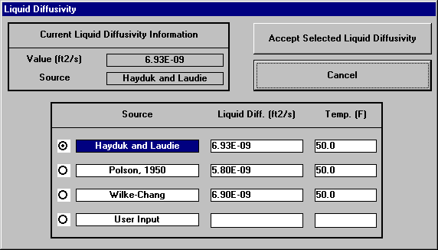
Figure 36 - Liquid Diffusivity Window (Trichloroethylene, 14.696 psi, 50° F)

Gas Diffusivity

StEPP™ has the capability to predict a contaminant’s gas diffusivity. To activate the Gas Diffusivity window, click the left mouse button on the gas diffusivity label or the gas diffusivity value in the StEPP main™ window. The gas diffusivity window for trichloroethylene at 101325 Pa and 10° C is shown in Figure 37.

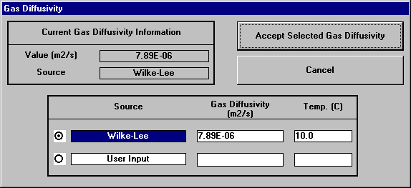
Figure 37 - Gas Diffusivity Window (Trichloroethylene, 101325 Pa, 10° C)

Figure 38 shows the gas diffusivity window for English units (Trichloroethylene, 14.696 psi, 50° F).

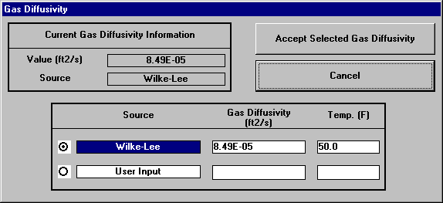
Figure 38 - Gas Diffusivity Window (Trichloroethylene, 14.696 psi, 50° F)

Water Density

StEPP™ has the capability to predict water density. To activate the water density window, click the left mouse button on the water density label or the water density value in the StEPP main™ window. The water density window at 101325 Pa and 10° C is shown in Figure 39.

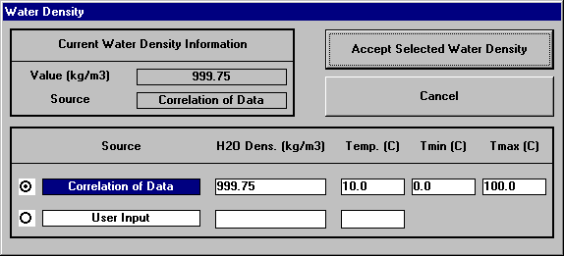
Figure 39 - Water Density Window (101325 Pa, 10° C)

Figure 40 shows the water density window for English units (14.696 psi, 50° F).

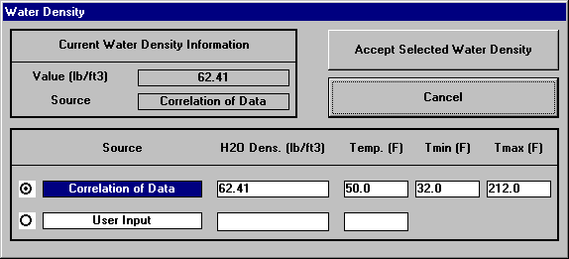
Figure 40 - Water Density Window (14.696 psi, 50° F)

Water Viscosity

StEPP™ has the capability to predict water viscosity. To activate the water viscosity window, click the left mouse button on the water viscosity label or the water viscosity value in the StEPP main™ window. The water viscosity window at 101325 Pa and 10° C is shown in Figure 41.

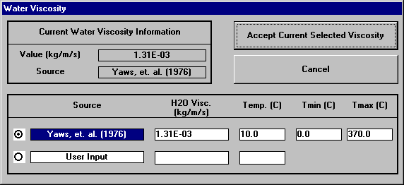
Figure 41 - Water Viscosity Window (101325 Pa, 10° C)

Figure 42 shows the water viscosity window for English units (14.696 psi, 50° F).

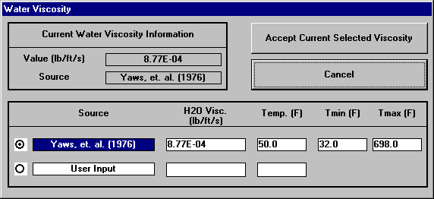
Figure 42 - Water Viscosity Window (14.696 psi, 50° F)

Water Surface Tension

StEPP™ has the capability to predict water surface tension. To activate the water surface tension window, click the left mouse button on the water surface tension label or the water surface tension value in the StEPP main™ window. The water surface tension window at 101325 Pa and 10° C is shown in Figure 43.

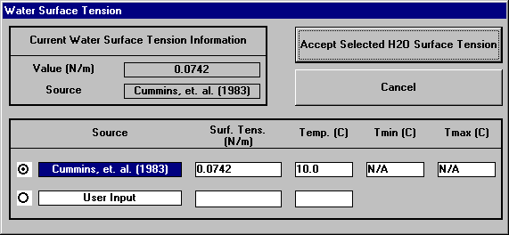
Figure 43 - Water Surface Tension Window (101325 Pa, 10° C)

Figure 44 shows the water surface tension window for English units (14.696 psi, 50° F).

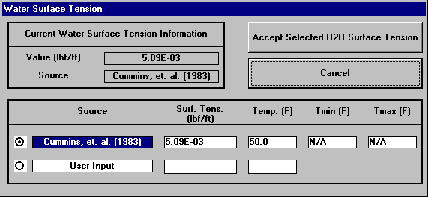
Figure 44 - Water Surface Tension Window (14.696 psi, 50° F)

Air Density

StEPP™ has the capability to predict air density. To activate the air density window, click the left mouse button on the air density label or the air density value in the StEPP main™ window. The air density window at 101325 Pa and 10° C is shown in Figure 45.

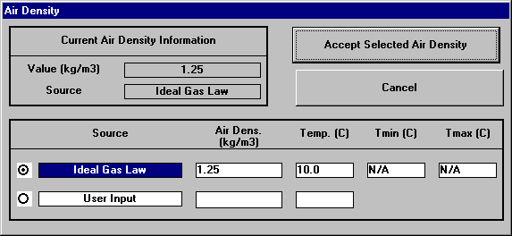
Figure 45 - Air Density Window (101325 Pa, 10° C)

Figure 46 shows the air density window for English units (14.696 psi, 50° F).

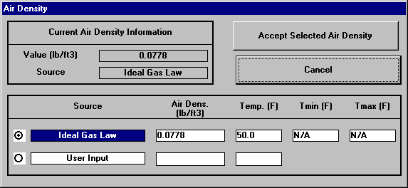
Figure 46 - Air Density Window (14.696 psi, 50° F)

Air Viscosity

StEPP™ has the capability to predict air viscosity. To activate the air viscosity window, click the left mouse button on the air viscosity label or the air viscosity value in the StEPP main™ window. The air viscosity window at 101325 Pa and 10° C is shown in Figure 47.

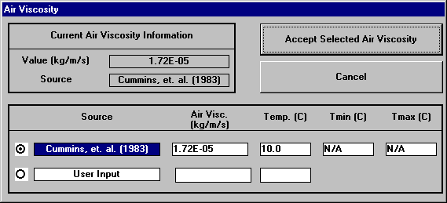
Figure 47 - Air Viscosity Window (101325 Pa, 10° C)

Figure 48 shows the air viscosity window for English units (14.696 psi, 50° F).

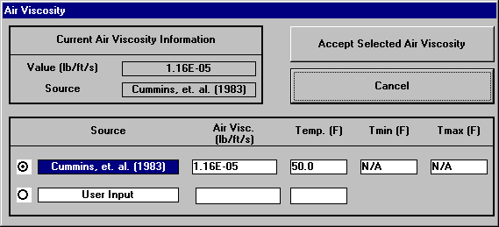
Figure 48 - Air Viscosity Window (14.696 psi, 50° F)

Exporting StEPP™ Data to Other ETDOT Applications

It is possible to export chemical properties from StEPP™ into other ETDOT applications, such as Adsorption Design Software (AdDesignS™) and Aeration System Analysis Program (ASAP™). There are two methods for performing the export, both of which are available in the Options menu (see Figure 49): (1) Create Export File for AdDesignS/ASAP and (2) Copy to Clipboard for AdDesignS/ASAP.

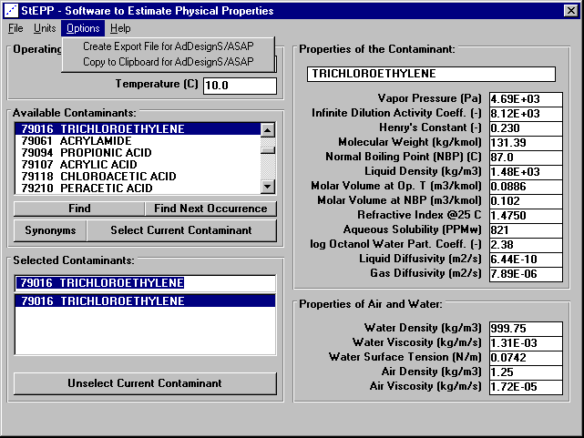
Figure 49 –StEPP™ Main Window Showing Options Menu
(TCE; 10 °C; 101,325 Pa)

Export Method 1: Create Export File for AdDesignS/ASAP

In this method, data is passed from StEPP™ to another ETDOT application by writing the appropriate data to a file in StEPP™ and then reading the data from the file into another ETDOT application. To generate the export file in StEPP™, click on the Create Export File for AdDesignS™/ASAP™ choice in the Options menu. The Save StEPP™ Export File window shown in Figure 49 will appear.

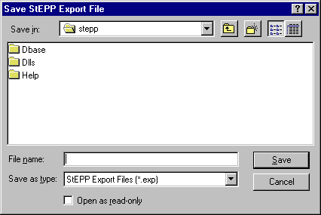
Figure 50 – Save StEPP™ Export File Window

In the File Name field shown in Figure 50, give the export file a name (the default file extension for StEPP™ export files is .exp). For this sample case of exporting the properties of TCE, which is the only chemical selected for this example (see Figure 49), the export file will be given the name: tce.exp. Figure 51 shows the Save StEPP™ Export File Window for this sample file name. Note that the user may also select a folder in which to save the file in the Save In field shown in Figure 51.

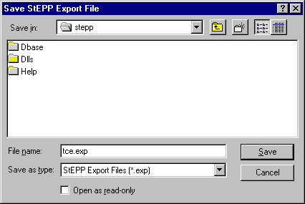
Figure 51 – Save StEPP™ Export File Window Showing Sample File Name

To save the export file, click on the Save button shown in Figure 51. The message box shown in Figure 52 appears indicating that the StEPP™ export file has been generated successfully.

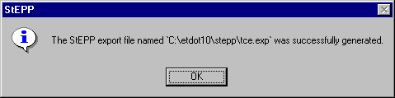
Figure 52 – Message Box Indicating Status of the Save StEPP™ Export File Process

Within other ETDOT applications (e.g. ASAP™, AdDesignS™), it is possible to import the StEPP™ export file created here. The process of importing StEPP™ properties in this fashion is described in the other ETDOT manuals.

Export Method 2: Copy to Clipboard for AdDesignS/ASAP

In this method, data is passed from StEPP™ to another ETDOT application by copying the appropriate data from StEPP™ into the Windows clipboard and then pasting the data from the Windows clipboard into another ETDOT application. To copy the data from StEPP™ into the Windows clipboard, click on the Copy to Clipboard for AdDesignS™/ASAP™ choice in the Options menu. The message box shown in Figure 53 will appear, indicating the StEPP™ properties have been successfully copied to the clipboard.

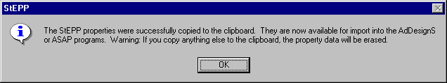
Figure 53 - Message Box Indicating Status of the Copy to Clipboard Process

Within other ETDOT applications (e.g. ASAP™, AdDesignS™), it is possible to import the StEPP™ properties from the clipboard. The process of copying StEPP™ properties from the clipboard in this fashion is described in the other ETDOT manuals.

Appendix A – Description of Chemical Name Synonyms Feature in StEPP™

StEPP™ contains a feature allowing the user to have access to common synonyms for chemical names contained in the StEPP™ database. The reference for the synonyms contained in StEPP™ is:

Howard, P.H. and M. Neal. Dictionary of Chemical Names and Synonyms, Lewis Publishers: New York, 2544 pp. (1992).

An example of how to make use of the synonyms feature in StEPP™ is provided. Load StEPP™ and click on the Continue button on the StEPP™ title window. The StEPP™ main window appears as shown in Figure A.1 below.

Figure A.1 –StEPP™ Main Window

Click on the Synonyms button in the Available Contaminants frame shown in Figure A.1. Once this is done, the Synonyms window will appear, as shown in Figure A.2.

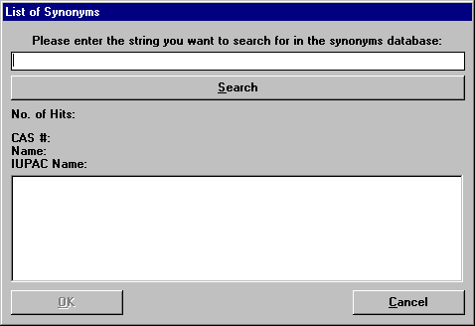
Figure A.2 – Synonyms Window

As an example, type in Trichloroethene, a synonym for the IUPAC chemical name Trichloroethylene, on the Synonyms window (see Figure A.2) as the string to search for in the synonyms database. Then click the Search button on the Synonyms window to execute the search for Trichloroethene in the synonyms database. Once this is done, the Synonyms window appears as shown in Figure A.3, presenting the results for this synonym search.

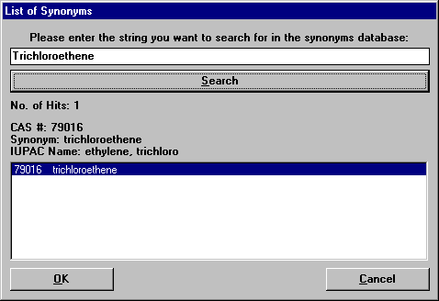
Figure A.3 – Synonyms Window Showing Result of Search for Trichloroethene

The search found Trichloroethene to be a synonym for a chemical with CAS number 79016 and IUPAC name ethylene, trichloro. This is the expected result. For the user to select this chemical in StEPP™, simply click on the OK button at the bottom of the Synonyms window. To exit the Synonyms window without selecting the chemical found by the search, click the Cancel button.

Research Engineer I, Dept. of Civil and Environmental Engineering, Michigan Tech. Univ.
Asst. Professor, Dept. of Chemical Engineering, Michigan Tech. Univ.
Assoc. Prof., Dept. of Civil and Environmental Engineering, Michigan Tech. Univ.
Project Engineer, Hyprotech, Inc., Calgary, Alberta
Presidential Professor, Dept. of Civil and Environmental Engineering, Michigan Tech. Univ. * Author to whom correspondence should be directed

