Surface Aeration - Design Mode
The following problem will be used to show sample calculations for surface aeration. In addition, a sample program run of ASAP™ will be used to verify that the program is correctly duplicating the results of the sample calculations.

Problem Statement
The city of Anytown, USA recently discovered that one of its wells was contaminated with the compounds listed in Table 1. In order for them to continue using the well, they were required to remove these compounds below their MCLs, also shown in Table 1. During normal pumping operations, the well produces about 2000 gpm, the water temperature is 10°C, and the barometric pressure is 1 atm.
Design a surface aeration system consisting of three tanks in series using TCE as the design contaminant. Obtain physical and chemical properties for the design from StEPP™. The power input to the system is assumed to have 80 percent efficiency and a power input per unit volume of 65.0 W/m³.
Present a sample calculation of the volume of an individual tank in the system. Also show sample calculations for total tank volume, hydraulic retention time of each tank, and the total hydraulic retention time for all tanks.
Table 1 – Contaminant Influent Concentrations and Treatment Objectives (MCLs)
Compound | Concentration Discharged, C₀ | MCL, C_{TO}
 | (μg/L) | (μg/L)
Trichloroethylene | 200.0 | 5.0
Tetrachloroethylene | 150.0 | 5.0
Vinyl Chloride | 60.0 | 1.0
Ethylbenzene | 30.0 | 5.0
Toluene | 80.0 | 5.0
1,1-Dichloroethene | 85.0 | 7.0

Properties Needed to Perform Sample Calculations and Program Run
Table 2 shows the chemical properties retrieved from StEPP™ and ASAP™ required for surface aeration at 10°C and 1 atm.
Table 2 - Chemical Properties from StEPP™ and ASAP™ at 10° C and 1 atm
Compound | MW | H | V_{b} | T_{NBP} | D_{l} | D_{g}
 | (kg/kmol) | (-) | (m³/kmol) | (°C) | (m²/s) | (m²/s)
Trichloroethylene | 131.39 | 0.230 | 0.1020 | 87.0 | 6.44E-10 | 7.89E-06
Tetrachloroethylene | 165.84 | 0.361 | 0.1190 | 121.0 | 5.86 E-10 | 7.13 E-06
Vinyl Chloride | 62.50 | 0.546 | 0.0665 | -13.9 | 8.26 E-10 | 1.08E-05
Ethylbenzene | 106.17 | 0.170 | 0.1400 | 136.0 | 5.33 E-10 | 6.88 E-06
Toluene | 92.15 | 0.167 | 0.1190 | 111.0 | 5.86 E-10 | 7.57 E-06
1,1-Dichloroethene | 96.95 | 0.680 | 0.0840 | 31.6 | 7.20 E-10 | 9.05 E-06

Note Regarding Comparison of Sample Calculation Values to Sample Program Run
In certain cases, the numbers that appear in the sample calculations are slightly different from the values displayed in the sample program run. These variations can be attributed to rounding.

Sample Design Mode Calculation of Tank Volume for Trichloroethylene as the Design Compound Including Supplementary Parameter Calculations

Total Volume
The total volume of the system, 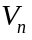, is calculated using the following relationship:
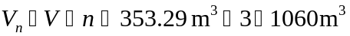
Eq. 1
The parameters required to calculate in Eq. 1 can be found as follows:
Parameter Location
Eq. 2
Given in problem statement

Tank Volume
The calculation of the volume for each tank, , in the series is shown in Eq. 2.
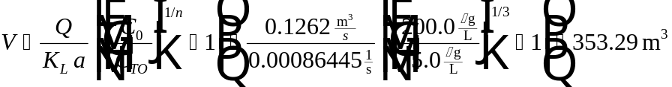
Eq. 2
The parameters required to calculate in Eq. 2 can be found as follows:
Parameter Location
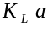 Eq. 3
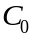 Table 1
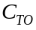 Table 1
Given in problem statement
Given in problem statement

Mass Transfer Coefficient
For surface aeration, it is difficult to determine the overall mass transfer coefficient, , for a compound with the method utilized in aeration pack tower design due to variations in each system. In order to determine the overall mass transfer coefficient of a compound for these systems, it is necessary to relate the mass transfer coefficient of a given compound, 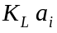, to the mass transfer coefficient of a reference compound, 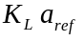 as shown in Eq. 3. For the purposes of this design, oxygen will be used as the reference compound.
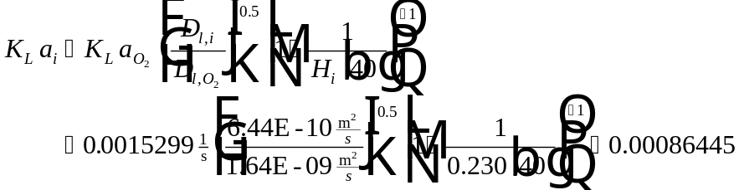
Eq. 3
The parameters required to calculate in Eq. 3 can be found as follows:
Parameter Location
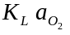 Eq. 4
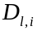 Table 2
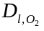 Eq. 5
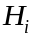 Table 2
Mass Transfer Coefficient of Oxygen
The mass transfer coefficient of oxygen, , can be estimated using Eq. 4.
Eq. 4
The parameters required to calculate in Eq. 4 can be found as follows:
Parameter Location
Given in problem statement
Liquid Diffusivity of Oxygen
The liquid diffusivity of oxygen, 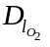, is calculated in the following equation:
Eq. 5
The parameters required to calculate in Eq. 5 can be found as follows:
Parameter Location
Table 3
Table 3
Given in problem statement

Hydraulic Retention Time
The hydraulic retention time, , can be calculated using the following relationship:
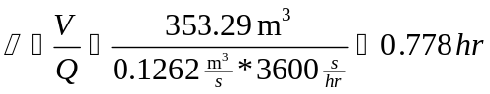
Eq. 6
The parameters required to calculate in Eq. 6 can be found as follows:
Parameter Location
Eq. 2
Given in problem statement
Total Hydraulic Retention Time
The total hydraulic retention time of the system, 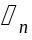, can be found using the following equation:
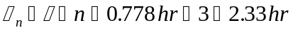
Eq. 7
The parameters required to calculate in Eq. 7 can be found as follows:
Parameter Location
Eq. 6
Given in problem statement

Liquid Phase Effluent Concentration from Tank Number i
The liquid phase effluent concentration from tank number i, 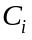, can be calculated using the following relationships:
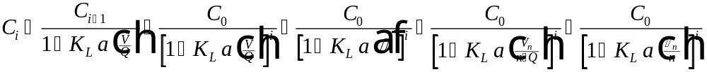
Eq. 8
The parameters required to calculate in Eq. 8 can be found as follows:
Parameter Location
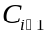 Calculated value
Eq. 3
Eq. 2
Given in problem statement
Table 1
User-specified
Eq. 6
Eq. 1
Given in problem statement
Eq. 7

Liquid Phase Effluent Concentration from Tank Number 1
The liquid phase effluent concentration from tank number 1, 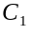, can be found using Eq. 9.
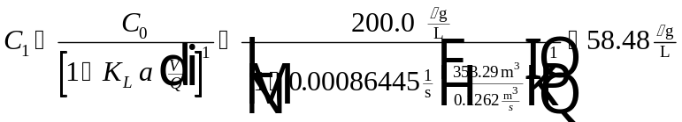
Eq. 9
The parameters required to calculate in Eq. 9 can be found as follows:
Parameter Location
Eq. 3
Table 1
Given in problem statement
Eq. 3

Liquid Phase Effluent Concentration from Tank Number 2
The liquid phase effluent concentration from tank number 2, 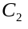, can be found using Eq. 10:

Eq. 10
The parameters required to calculate in Eq. 10 can be found as follows:
Parameter Location
Eq. 3
Table 1
Given in problem statement
Eq. 2

Liquid Phase Effluent Concentration from Tank Number 3
The liquid phase effluent concentration from tank number 3,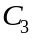, can be found using Eq. 11:
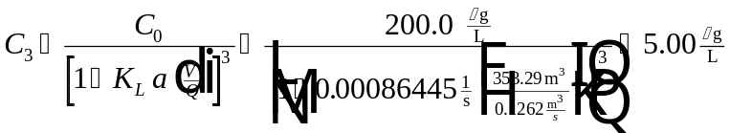
Eq. 11
The parameters required to calculate in Eq. 11 can be found as follows:
Parameter Location
Eq. 3
Table 1
Given in problem statement
Eq. 2

Power Calculations

Total Power Input
The total power input to the system, , can be found using the relationship shown in Eq. 12:
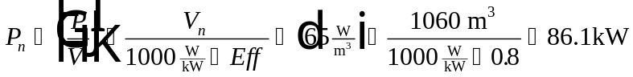
Eq. 12
The parameters required to calculate in Eq. 12 can be found as follows:
Parameter Location
 Given in problem statement
Eq. 1
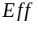 Given in problem statement

Power Input per Tank
The power input per tank, , is calculated by the following:
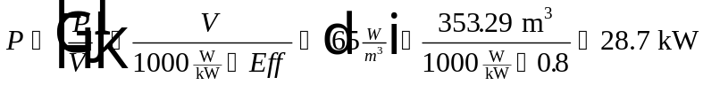
Eq. 13
The parameters required to calculate in Eq. 13 can be found as follows:
Parameter Location
Given in problem statement
Eq. 2
Given in problem statement

Sample Program Run of ASAP™ to Verify Sample Calculations for Surface Aeration in Design Mode
To start the ASAP™ program, double click on the ASAP™ icon in the ETDOT Programs group in windows. The screen shown in Figure 1 will appear.
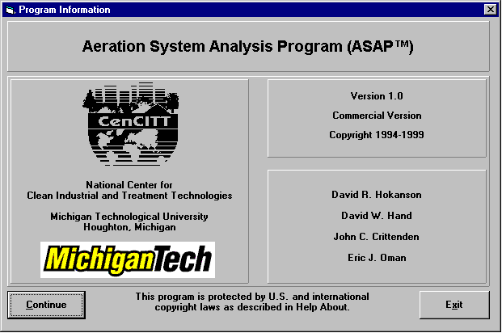
Figure 1 - ASAP™ Title Window
Click on the Continue button on the screen shown in Figure 1 and the menu shown in Figure 2 will appear.
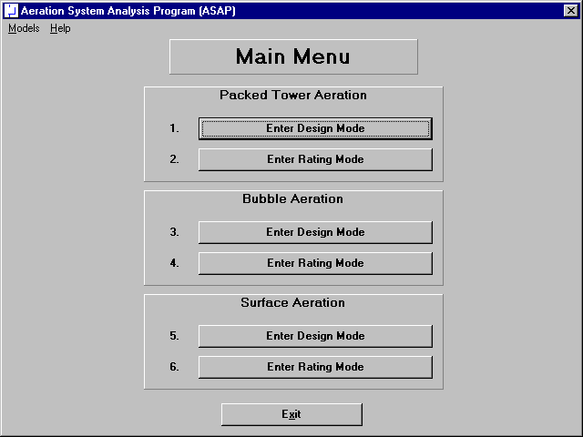
Figure 2 - Main Menu Window in ASAP™
Click on the Enter Design Mode button for Surface Aeration (option 5 in Figure 2) and the design mode screen for surface aeration shown in Figure 3 will appear.
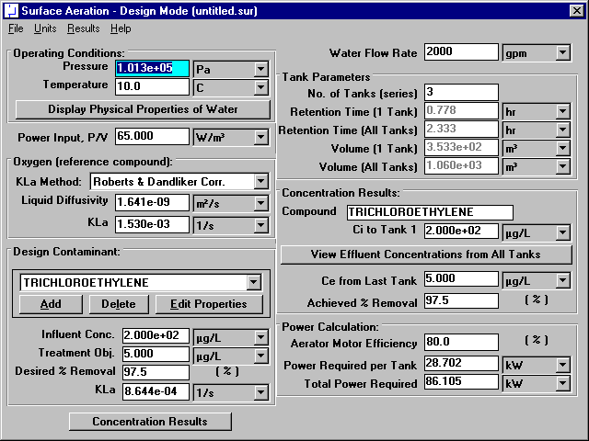
Figure 3 - Design Mode Window for Surface Aeration

Physical Properties of Water
Specify pressure and temperature in the upper left-hand corner of the window shown in Figure 3. This portion of the surface aeration design mode window is shown in Figure 4.
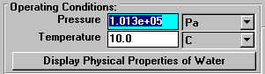
Figure 4 - Operating Conditions Portion of Design Mode Window
Click on the Display Physical Properties of Water button in Figure 3 (and highlighted in Figure 4) to show the properties of water at the specified temperature and pressure (101325 Pa and 10°C). Figure 5 shows the water properties window for this case.
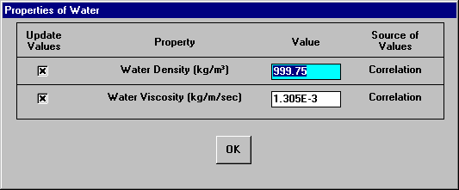
Figure 5 - Water Properties Window
The properties shown in Figure 5 are by default calculated from correlations so the user should not have to change his values. In the rare case that the user would like to enter a value for any of these properties instead of using the correlations, it is possible to do so on the window shown in Figure 5. Click on the OK button shown in Figure 5 to close the window.

Oxygen (reference compound)
The mass transfer coefficient for the design contaminant is calculated using its relationship to the mass transfer coefficient of oxygen under similar conditions. The mass transfer coefficient of oxygen is estimated using the Roberts & Dandlike Correlation. This portion of the design mode window is shown in Figure 3 (and highlighted in Figure 6).
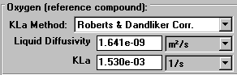
Figure 6 - Oxygen Section of Design Mode Window
The mass transfer coefficient of oxygen at 10°C is calculated by the program as 1.530E-03 1/s. This agrees with the value from the sample calculations section (see Eq. 4).

Chemical Properties
Chemical properties for each of the six components can be retrieved from StEPP™. When the screen shown in Figure 3 loads, the properties of the six contaminants load as a default design case. Before retrieving the chemical properties of the six chemicals required in the current design, it is necessary to delete the six default chemicals shown in the Design Contaminant list box on the bottom of the left-hand column shown in Figure 3. This portion of the design mode window is in Figure 3 (and highlighted in Figure 7).
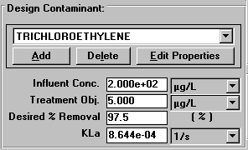
Figure 7 - Contaminant Selection Portion of Design Mode Window
It can be seen that the value for the mass transfer coefficient of trichloroethylene calculated by the program, 8.644E-04 1/s, agrees with the sample calculations (see Eq. 3).
To delete each chemical click on the Delete button located in between the Add and Edit Properties buttons shown in Figure 3 (and highlighted in Figure 7). Click the Delete button once for each chemical until all chemicals have been deleted.

Transferring Properties from StEPP™ to ASAP™
ASAP™ has the capability of transferring the physical properties of contaminants from Software to Estimate Physical Properties (StEPP™). There are two choices available in the Options menu within StEPP for transferring data from StEPP into ASAP: (a) Create Export File for AdDesignS/ASAP and (b) Copy to Clipboard for AdDesignS/ASAP. The StEPP™ main window highlighting the Options menu is shown in Figure 8 (refer to StEPP manual for more information on selecting compounds within StEPP). Figure 8 shows the main StEPP™ window after the chemicals for this design have been selected at 10°C.
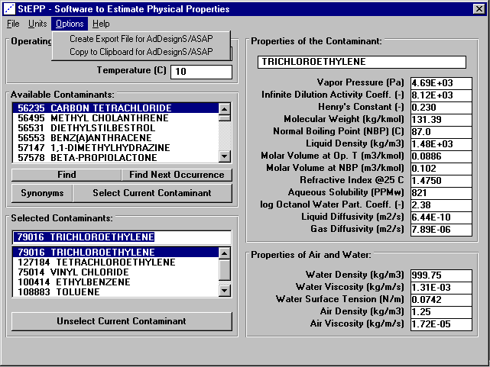
Figure 8 - StEPP™ Main Window for This Design

Transferring Chemical Properties from StEPP™ to ASAP™ Using the Create Export File for AdDesignS/ASAP Option
To create an export file within StEPP™ for use in ASAP™, click on the Create Export File for AdDesginS™/ASAP™ in the StEPP™ Options menu. This option is shown in Figure 8. After clicking this option, the Save StEPP™ Export File window shown in Figure 9 appears. Give the export file a .exp extension (the default), such as surf10.exp, and the file will be readily importable into ASAP™, as described below.
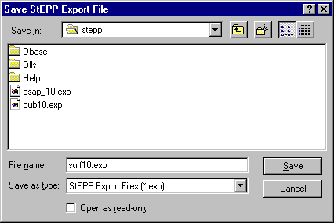
Figure 9 - Save StEPP™ Export File Window
To import the StEPP™ export file described above (surf10.exp), click on the Add button shown on the bottom left-hand corner of the window shown in Figure 3 (and highlighted in Figure 7). Figure 10 shows the window that will appear.
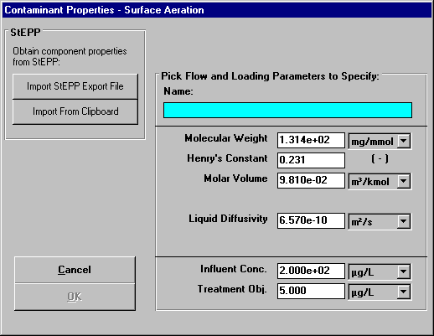
Figure 10 - Contaminant Properties Input Window
Click on the Import StEPP™ Export File button shown in Figure 10. The window shown in Figure 11 will appear.
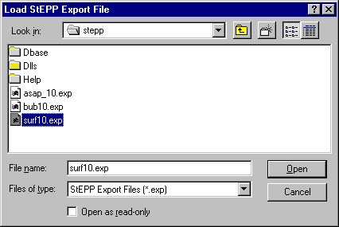
Figure 11 - Load StEPP™ Export File Window

Select the file surf10.exp that was created earlier and the chemicals selected in StEPP™ for the given design will be imported into ASAP™. Figure 12 appears after the import and shows a successful import was achieved.

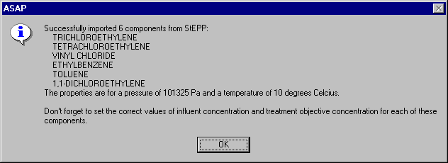
Figure 12 - Successful StEPP™ Property Retrieval Indication Window

Transferring Chemical Properties from StEPP™ to ASAP™ Using the Copy to Clipboard for AdDesignS/ASAP Option

To copy selected StEPP™ data to the Windows clipboard for export into ASAP™, select Copy to Clipboard for AdDesignS/ASAP from the Options menu within StEPP™. The message box shown in Figure 13 will appear, verifying that all of the StEPP™ data is now stored in the Windows clipboard.
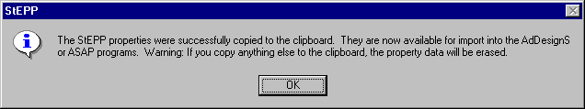
Figure 13 – Successful Copy to Clipboard from StEPP™ Message Box
To import the chemicals and their physical properties to ASAP™ from the data on the clipboard, click on the Add button in the Component Properties block of the ASAP™ main window. The Component Properties window shown in Figure 14 will appear.
Figure 14 - Component Properties window (adding new components)
To import the StEPP™ data from the Windows clipboard, click the Import from Clipboard button on the Component Properties window. The window shown in Figure 15 will appear, showing that the properties have been successfully transferred into ASAP.
Figure 15 – Successful Import from StEPP™ Window

Manipulation of Data Required after Transferring Properties from StEPP™ to ASAP™
Click on the OK button to continue. Figure 3 appears. As shown in Figure 12 or Figure 15, it is necessary to input influent concentrations and treatment objectives for each of the six components retrieved. To do so, select each contaminant one at a time in the Design Contaminant list box shown in the lower left-hand corner of Figure 3. Then click on the Edit Properties button. Figure 16 shows the window that appears for trichloroethylene.
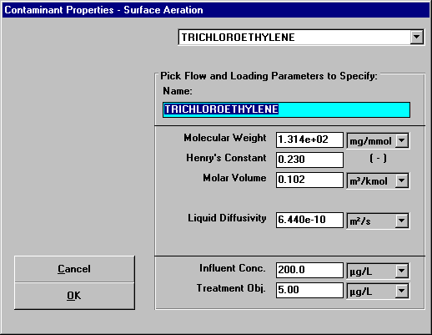
Figure 16 - Specify Contaminant Properties Window for Trichloroethylene
The properties molecular weight, Henry’s constant, molar volume, and liquid diffusivity are already correct since they were retrieved from StEPP™. The influent concentration and treatment objective shown at the bottom of the screen must be input since they will vary from case to case. These properties shown in Figure 16 already reflect the values for the current design case. It is seen that the properties shown in Figure 16 agree with the trichloroethylene properties shown in Tables 1 and 2.
Figure 17 shows the Specify Contaminant Properties window for tetrachloroethylene. It can be seen that the properties shown in Figure 17 agree with the properties of tetrachloroethylene shown in Tables 1 and 2.
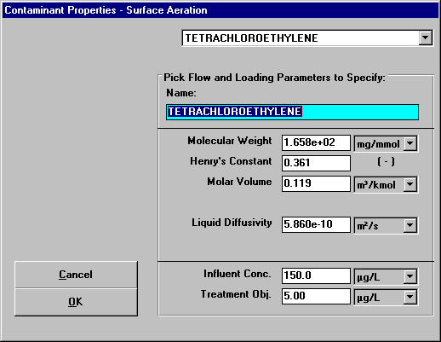
Figure 17 - Specify Contaminant Properties Window for Tetrachloroethylene
Figure 18 shows the Specify Contaminant Properties window for vinyl chloride. It can be seen that the properties shown in Figure 18 agree with the properties of vinyl chloride shown in Tables 1 and 2.
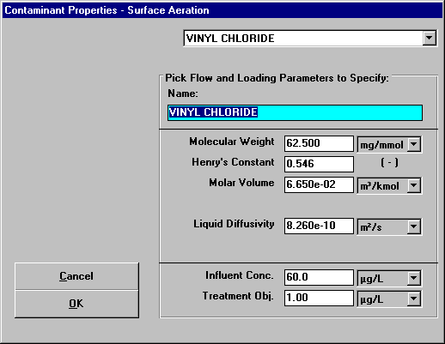
Figure 18 - Specify Contaminant Properties Window for Vinyl Chloride
Figure 19 shows the Specify Contaminant Properties window for ethylbenzene. It can be seen that the properties shown in Figure 19 agree with the properties of ethylbenzene shown in Tables 1 and 2.
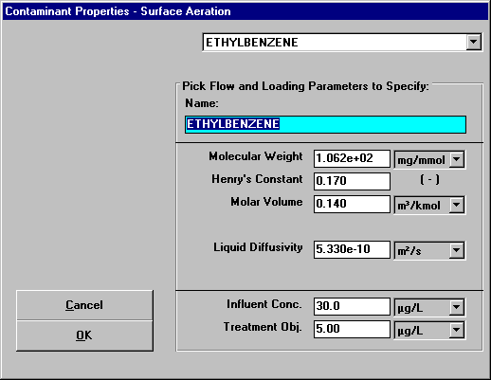
Figure 19 - Specify Contaminant Properties Window for Ethylbenzene
Figure 20 shows the Specify Contaminant Properties window for toluene. It can be seen that the properties shown in Figure 20 agree with the properties of toluene shown in Tables 1 and 2.
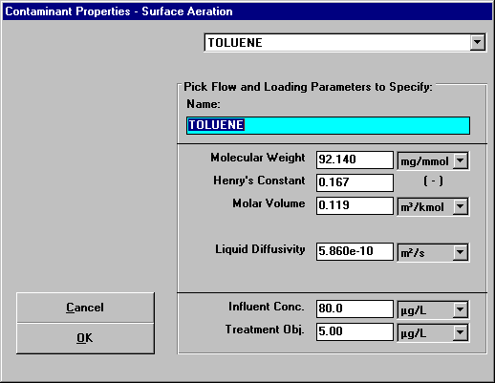
Figure 20 - Specify Contaminant Properties Window for Toluene
Figure 21 shows the Specify Contaminant Properties window for 1,1-dichloroethene. It can be seen that the properties shown in Figure 21 agree with the properties of 1,1-dichloroethene shown in Tables 1 and 2.
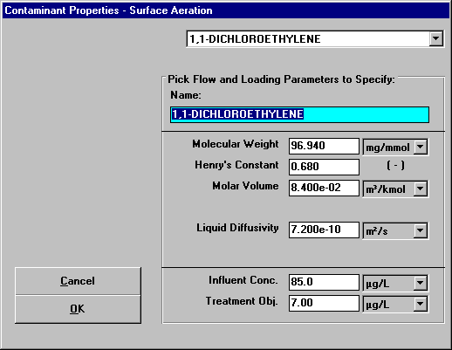
Figure 21 - Specify Contaminant Properties Window for 1,1-Dichloroethene

Flow Parameters
The flow is shown in the upper right-hand side of Figure 3. This portion of Figure 3 is reproduced here as Figure 22.

Figure 22 - Flow Rate in Design Mode Window
The water flow rate of 2000 gpm is given in the problem statement.

Tank Parameters
The tank parameters are shown in the middle of the right-hand column of the design mode window shown in Figure 3. This portion of the window is highlighted as Figure 23.
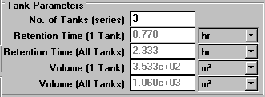
Figure 23 - Tank Parameters Section of Design Mode Window
The values of the tank parameters shown in Figure 3 (and highlighted in Figure 23) agree with the sample calculations section. The number of tanks in the series is given in the problem statement. The retention time of 0.778 hr calculated by the program agrees with the sample calculations performed previously (see Eq. 6). The total retention time for the system determined by the program to be 2.333 hr corresponds to the value calculated in the sample calculations (see Eq. 7). The volume of 353.3 m³ calculated by the program agrees with the sample calculations performed previously (see Eq. 2). The volume of the entire system shown to be 1.060E+03 m³ reflects the sample calculations provided (see Eq. 1).

Concentration Results
The effluent concentrations of the liquid phase and the achieved percent removal are found in the lower right-hand corner of the design mode window as shown in Figure 3 (and highlighted in Figure 24).
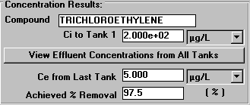
Figure 24 - Concentration Results Portion of Design Mode Window
Click on the View Effluent Concentrations from All Tanks button shown in Figure 3 (and highlighted in Figure 24) to see the effluent concentrations of the liquid of the contaminant from each tank. The window that appears is shown in Figure 25.
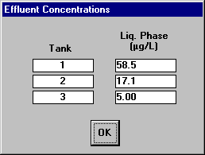
Figure 25 - Effluent Concentrations from Each Tank

It can be seen that the values calculated by the program for the liquid phase effluent concentrations; 58.5 μg/L from tank 1 (see Eq. 9), 17.1 μg/L from tank 2 (see Eq. 10), and 5.00 μg/L from tank 3 (see Eq. 11), match the values shown in the sample calculations.
Click the OK button shown in Figure 25 to return to the design mode window shown in Figure 3.

Power Input
The power input to the system is displayed in middle of the left-hand column of the design mode window as shown in Figure 3 (and highlighted in Figure 26). This value is chosen to suit design purposes. Typical values range from 10 to 200 W/m³.
Figure 26 - Power Input Portion of Design Mode Window

Power Calculations
Other power parameters can be viewed in the lower right-hand corner of the design mode window as shown in Figure 3 (and highlighted in Figure 27). The value for the aerator motor efficiency is input by the user. The power required per tank is determined by the program to be 28.702 kW which agrees with the sample calculations (see Eq. 13). The total power required is calculated to be 86.105 kW which also agrees with the sample calculations (see Eq. 12).
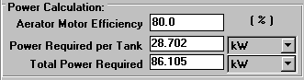
Figure 27 - Power Calculation Section of Design Mode Window

Viewing Effluent Concentration Results for Contaminants Other than the Design Contaminant
For a given design, it is useful to see what the effluent concentrations of contaminants other than the design contaminant would be. ASAP provides a convenient method for seeing these results without having to switch to rating mode. (of course, the user will have to switch to rating mode to investigate commercially available packed tower sizes).
By clicking on the Concentration Results button in the lower left-hand corner of the surface aeration – design mode window shown in Figure 3, the user will see the concentration results for all contaminants using the given design.
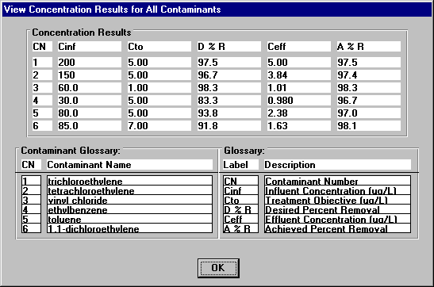
Figure 28 – View Concentration Results for All Contaminants Window
This window provides a quick method to see whether the given design will meet the treatment objectives for all contaminants.

Switching to Rating Mode
Once the surface aeration system has been specified in design mode, the user can take the established properties and switch to rating mode in order to examine the effect of modifications of various properties. The procedure for switching to rating mode is described here.
Figure 29 shows the File menu for surface aeration, design mode.

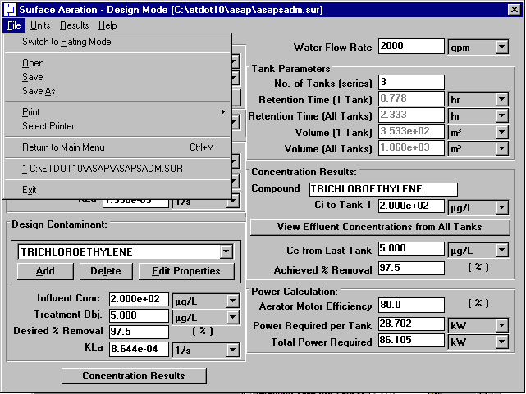
Figure 29 – File Menu for Surface Aeration – Design Mode
Click on the menu option called Switch to Rating Mode in Figure 29. The surface aeration – rating mode window will appear, as shown in Figure 30.

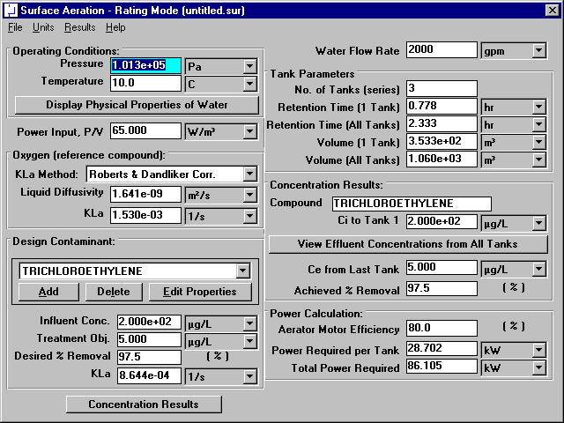
Figure 30 – Surface Aeration – Rating Mode Window
Use of Surface Aeration – Rating Mode will be described in the next section.

