Surface Aeration - Nomenclature

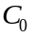 Liquid phase influent concentration of contaminant, (g/L)
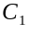 Liquid phase effluent concentration from tank number 1, (g/L)
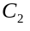 Liquid phase effluent concentration from tank number 2, (g/L)
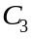 Liquid phase effluent concentration from tank number 3, (g/L)
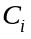 Liquid phase effluent concentration from tank number i, (g/L)
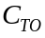 Treatment objective concentration of contaminant, (g/L)
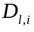 Liquid diffusivity of contaminant at 10°C, (m²/s)
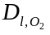 Diffusivity of Oxygen at 10°C, (m²/s)
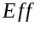 Motor efficiency (dimensionless)
Henry’s constant, (dimensionless)
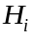 Henry’s constant of the contaminant, (dimensionless)
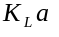 Design mass transfer coefficient, (1/s)
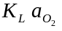 Mass transfer coefficient of Oxygen at 10°C, (1/s)
Number of tanks operating in series, (dimensionless)
Power input per tank, (W/m³)
Total power input to the system, (W/m³)
Water flowrate, (m³/s)
Volume of each tank in series, (m³)
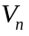 Total volume of system, (m³)
Greek Letters
Hydraulic retention time, (hr)
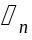 Hydraulic retention time, (hr)

