Estimating the Mass Transfer Coefficient for Surface Aeration

Development
It was shown previously that the general formula for estimating the mass transfer coefficient of a compound in an air stripping process is:
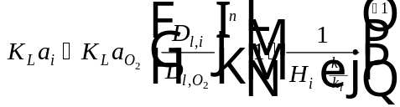
Eq. 1
Methods for obtaining each of the parameters in Eq. 1 are described below:
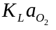 For surface aeration, the overall mass transfer coefficient for oxygen can be estimated using a correlation developed by Roberts and Dändliker (1983): 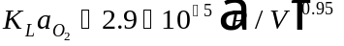, where 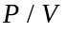, the power input, is in the range 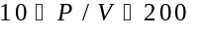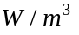.
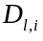 Liquid diffusivity of compound i (L²/T). This parameter can be calculated by the Hayduk & Laudie correlation (1974) for small molecules in water.
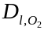 Diffusivity of oxygen (L²/T). This parameter can be determined from a correlation presented by Holmén and Liss (1984). The correlation was obtained from a best fit of literature values.
Munz and Roberts (1989) report that should be set equal to 0.5 for mechanical surface aeration.
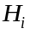 Henry’s constant of compound, i (dimensionless). This value is available from StEPP™ and from various literature sources (Ashworth, et al, 1988; Gossett, 1987)
Munz and Roberts (1989) recommend a value of equal to 40 in mechanical surface aeration.
Therefore, the equation used to estimate the mass transfer coefficient of a compound, i, in surface aeration is given below:
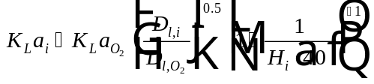
Eq. 2

Nomenclature
Liquid diffusivity of compound (L²/T)
Liquid diffusivity of oxygen (L²/T)
Henry’s constant for component (dimensionless)
Ratio that tends to be relatively constant for a surface aeration system and is not compound dependent. It is set equal to 40 for surface aeration.
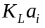 Overall mass transfer coefficient of compound in surface aeration (1/T)
Overall mass transfer coefficient of compound in surface aeration (1/T)
Diffusivity exponent (dimensionless)
Power input per unit volume (W/m³)

References
Ashworth, R. A., G. B. Howe, M. E. Mullins, and T. N. Rogers, “Air--Water Partitioning Coefficients of Organics in Dilute Aqueous Solutions,” Journal of Hazardous Materials, 18, 25-36 (1988).
Gossett, J. M., “Measurement of Henry’s Law Constants for C₁ and C₂ Chlorinated Hydrocarbons,” Environ. Sci. Technol., 21, 202-208 (1987).
Hayduk, W. and H. Laudie, “Prediction of Diffusion Coefficients for Non-electrolytes in Dilute Aqueous Solutions,” Jour. AIChE, 28, 611 (1974).
Holmén, Kim, and Peter Liss, “Models for Air-Water Gas Transfer: An Experimental Investigation,” Tellus, 36B, 92-100 (1984).
Munz, C. and P. V. Roberts, “Gas- and Liquid-Phase Mass Transfer Resistances of Organic Compounds during Mechanical Surface Aeration,” Water Research, 23, 5, 589-601 (1989).
Roberts, P. V. and P. G. Dändliker, “Mass Transfer of Volatile Organic Contaminants from Aqueous Solution to the Atmosphere during Surface Aeration,” Environ. Sci. Technol., 17, 8, 484-489 (1983).

