Power Requirements in Surface Aeration

Development
The total operating power for surface aeration is equal to the power requirement for each tank times the number of tanks. The power requirement for each tank is determined from the following relationship:
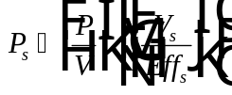
Eq. 1

Nomenclature
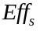 Surface aerator motor efficiency (expressed as decimal)
Power input required for each surface aeration tank (M L² / T³)
Power input per unit volume in surface aeration (M L² / T³/L³)
Volume of a surface aeration tank (L³)

