

Manual

Ion Exchange Design Software (IonExDesignS™)

Copyright © 1995-2004
Michigan Technological University
All Rights Reserved

David R. Hokanson
David W. Hand *
John C. Crittenden

Michigan Technological University
1400 Townsend Drive
Houghton, MI 49931

Copyright © 1995-2004 Michigan Technological University

All rights reserved.

No part of this publication may be reproduced, stored in a retrieval system, or transmitted, in any form or by any means, electronic, mechanical, photocopying, recording, or otherwise, without written permission of the author.

Table of Contents

I. Getting Started 1
A. System Requirements 1
B. Installing IonExDesignS™ 1
II. Introduction to IonExDesignS™ 2
III. Description of the Model 4
A. The Pore Diffusion Model (PDM) 4
B. Mass Transfer Parameters 5
C. Equilibrium Parameters: Separation Factors 5
1. Equilibrium Isotherm Database Error! Bookmark not defined.
IV. Input Data 6
A. IonExDesignS™ Main Window 6
B. Liquid and Gas Phase Selection Error! Bookmark not defined.
C. Water and Air Properties 6
D. Fixed Bed Ion exchanger Properties 7
E. Resin Properties 7
F. Component Properties 8
1. Physical Properties and StEPP™ 8
2. Influent Concentrations - Fixed and Variable 13
a. Manipulating cells in the grid 15
b. Cut, Copy, and Paste 16
c. Loading and Saving Files for Influent Concentrations 16
3. Selecting Freundlich Isotherm Parameters 16
a. Obtaining Freundlich Isotherm Parameters from the Isotherm Database 17
b. Obtaining Freundlich Isotherm Parameters from Parameter Estimation Techniques 19
4. Kinetic Parameters 21
G. Simulation Parameters 22
H. Fouling of GAC 23
I. Saving and Printing Input Parameters 25
V. Running a Simulation 29
VI. Results 31
A. Displaying Results 31
1. Equilibrium Column Model Results 31
2. Constant Pattern Homogeneous Surface Diffusion Model 32
3. Pore and Surface Diffusion Model Results 34
B. Transferring Results to Excel 36
C. Comparing Model Predictions to Data 37
1. Manipulating Cells in the Grid 38
2. Cut, Copy, and Paste 38
3. Loading and Saving Files for Effluent Concentrations 39
VII. Databases 41
A. Isotherm Database 41
1. Manipulating Chemical Names 43
2. Manipulating Isotherms 45
B. Ion exchanger Database 47
C. Resin Database 47
1. Manipulating Manufacturers 48
2. Manipulating Resins 49
VIII. Example GAC Usage Rate Calculations 51
A. Problem Statement 51
B. Using StEPP™ with IonExDesignS™ 51
1. Operating Conditions 51
2. Selecting Contaminants in StEPP™ 52
3. Creating a StEPP™ Export File 53
C. Specifying Ion exchanger, Resin, and Water Properties 54
1. Liquid Phase Selection 56
2. Entering Water Properties 56
3. Entering Fixed Bed Properties 57
4. Entering Resin Properties 58
D. Importing Physical Properties from StEPP™ to IonExDesignS™ 59
E. Entering Initial Concentrations 62
F. Selecting Freundlich Isotherm Parameters 64
1. Obtaining Freundlich Isotherm Parameters from Database 65
2. Obtaining Freundlich Isotherm Parameters by Estimation 67
G. Running ECM and Viewing the Simulation Results 69
H. Running PSDM and Viewing the Simulation Results 71
1. Further Information for PSDM 71
a. Entering Kinetic Information 71
b. Entering Simulation Parameters 72
c. Running the PSDM and Viewing Results 72
I. Running PSDM with NOM Fouling and Viewing Results 75
1. Selecting Water Type and Chemical Correlation Type for NOM Fouling 75
2. Setting Simulation Parameters for PSDM with NOM Fouling 77
3. Editing Kinetic Parameters for PSDM with NOM Fouling 77
4. Running the PSDM with GAC Fouling by NOM and Viewing Results 78
J. Running CPHSDM and Viewing the Simulation Results 80
1. Reducing Freundlich K Value 80
2. Running CPHSDM and Viewing Results 81
K. Comparison of Liquid Phase Model Results 82
L. Gas Phase Ion exchange Simulation with IonExDesignS™ 82
1. ASAP™ and StEPP™ 83
2. IonExDesignS™ Inputs 86
a. Gas Phase Selection 86
b. Entering Air Properties 87
c. Entering Fixed Bed Properties 88
d. Entering Resin Properties 88
e. Importing Contaminants and Physical Properties from StEPP™ to IonExDesignS™ 90
f. Editing Contaminant Properties and Entering Initial Concentrations 92
g. Selecting Freundlich Isotherm Parameters 93
h. Entering Kinetic Information 96
3. Running the Gas Phase ECM 97
4. Running the Gas Phase CPHSDM 99
5. PSDM Gas Phase model 101
M. Comparison of Liquid and Gas Phase Ion exchange Model Results 101
Appendix A: ECM Equations 103
Appendix B: CPHSDM Equations 106
Appendix C: PSDM Equations 111
Appendix D: Fouling of GAC 113
Appendix E: Air and Water Property Correlations 115
1. Water Property Correlations 115
2. Air Property Correlations 115
Appendix F: Kinetic Coefficients 116
1. Description of the Mechanisms Involved 116
a. Film Transfer Resistance 116
b. Surface and Pore Diffusion Mechanisms 116
2. Correlations for the Film Transfer Diffusion Coefficient 117
3. Estimation of the Pore Diffusion Coefficient 119
4. Estimation of the Surface Diffusion Coefficient 119
Appendix G: Polanyi Ion exchange Potential Models 121
Appendix H: References for the Isotherm Database 124
Appendix I: References 127
Appendix J: Input and Output for Example Calculations 131
List of Figures and Tables

Figure 1: Representation of concentrations of component k in ECM Error! Bookmark not defined.
Figure 2: Default IonExDesignS™ Main window Error! Bookmark not defined.
Figure 3: Selection of Gas Phase Error! Bookmark not defined.
Figure 4: Water Properties window Error! Bookmark not defined.
Figure 5: Ion exchanger Database Screen Error! Bookmark not defined.
Figure 6: Resin Database window Error! Bookmark not defined.
Figure 7: StEPP™ Main window 10
Figure 8: Save StEPP™ Export File window 10
Figure 9: Default Component Properties window (adding new components) Error! Bookmark not defined.
Figure 10: Load StEPP™ Export File window 12
Figure 11: Import Confirmation window 12
Figure 12: Successful Import of Components from StEPP™ window 13
Figure 13: Component Properties window 14
Figure 14: Variable Influent Concentrations Window 15
Figure 15: Freundlich Isotherm Parameters window 17
Figure 16: Freundlich Isotherm Parameter Database window 18
Figure 17: Isotherm Parameter Estimation Warning message 19
Figure 18: Freundlich Isotherm Parameter Estimation window 19
Figure 19: Freundlich Isotherm Parameters Estimation Results window 20
Figure 20: Kinetic Parameters Window 22
Figure 21: Fouling of GAC window 24
Figure 22: Kinetic Parameters with NOM Fouling window 25
Figure 23: Print window 26
Figure 24: IonExDesignS™ Main window 29
Figure 25: Results for the Equilibrium Column Model 31
Figure 26: Results for the CPHSDM 33
Figure 27: Treatment Objectives window 34
Figure 28: Results for the Pore and Surface Diffusion Model 35
Figure 29: Results for the Pore and Surface Diffusion Model 36
Figure 30: Transfer Results to Excel window 37
Figure 31: Effluent Concentrations window 38
Figure 32: Comparison of PSDM Results with Effluent Data window 40
Figure 33: Editing the Isotherm Database window 42
Figure 34: Creating a New Chemical for the Isotherm Database window 43
Figure 35: Editing a Chemical in the Isotherm Database window 44
Figure 36: Deleting a Chemical from the Isotherm Database window 44
Figure 37: Creating a New Isotherm window 45
Figure 38: Editing an Isotherm window 46
Figure 39: Creating a New Manufacturer in the Resin Database 48
Figure 40: Editing a Manufacturer Name in the Resin Database 48
Figure 41: Creating a New Resin window 49
Figure 42: Editing a resin window 50
Figure 43: Default StEPP™ Main window 52
Figure 44: Completed StEPP™ Main window 53
Figure 45: Save StEPP™ Export File window 54
Figure 46: Default IonExDesignS™ Main window 55
Figure 47: Completed Liquid Phase IonExDesignS™ Main window 56
Figure 48: Water Properties window 57
Figure 49: Resin Database window 59
Figure 50: Component Properties window (adding new components) 60
Figure 51: Load StEPP™ Export File window 61
Figure 52: Import Confirmation window 61
Figure 53: Successful Import of Components from StEPP™ window 62
Figure 54: Component Properties window 63
Figure 55: Variable Influent Concentrations window 64
Figure 56: Freundlich Isotherm Parameters window 65
Figure 57: Freundlich Isotherm Parameters for TCE window 66
Figure 58: Freundlich Isotherm Parameters for PCE window 67
Figure 59: Isotherm Parameter Estimation Warning window 68
Figure 60: Freundlich Isotherm Parameters for Toluene window 68
Figure 61: Freundlich IPES Results for Toluene 69
Figure 62: Liquid Phase ECM Results window 70
Figure 63: Liquid Phase Kinetic Parameters window 71
Figure 64: PSDM Completed window 72
Figure 65: Liquid Phase PSDM Results window 73
Figure 66: Liquid Phase PSDM Results window 74
Figure 67: Treatment Objective window 75
Figure 68: Fouling of GAC window with the Water Type menu open 76
Figure 69: Fouling of GAC window with Type of correlation menu open 76
Figure 70: Kinetic Parameters window (TCE with NOM Fouling) 77
Figure 71: PSDM Completed window 78
Figure 72: PSDM with NOM Fouling Results window 79
Figure 73: Liquid Phase CPHSDM Results window 81
Figure 74: Air Stripper with GAC Off-Gas Treatment 83
Figure 75: Selection of Gas Phase 86
Figure 76: Completed Gas Phase IonExDesignS™ Main window 87
Figure 77: Air Properties window 88
Figure 78: Resin Database window 89
Figure 79: Component Properties window (adding new components) 90
Figure 80: Load StEPP™ Export File window 91
Figure 81: Import Confirmation window 91
Figure 82: Successful Import of Components from StEPP™ window 92
Figure 83: Component Properties window 93
Figure 84: Freundlich Isotherm Parameters window 94
Figure 85: Isotherm Parameter Estimation Warning message 94
Figure 86: Freundlich Isotherm Parameters for TCE window 95
Figure 87: Freundlich IPES Results for TCE 96
Figure 88: Gas Phase Kinetic Parameters window 97
Figure 89: Gas Phase ECM Results 98
Figure 90: Gas Phase CPHSDM Results 100

Table 1: Estimation methodology to simulate NOM fouling of GAC Error! Bookmark not defined.
Table 2: Single-solute IPES estimation options for gas and liquid phase Error! Bookmark not defined.
Table 3: Liquid Phase Freundlich K Reduction 80
Table 4: Comparison of Liquid Phase Model Results 82
Table 5: ASAP™ Inputs 84
Table 6: ASAP™ Air Stripping Tower Design Results 84
Table 7: Treatment Stream Concentrations 85
Table 8: Gas Phase Freundlich Parameter Estimation Results 96
Table 9: Gas Phase Freundlich K Reduction 99
Table 10: Comparison of Gas Phase Model Results 101
Table 11: Comparison of Liquid and Gas Phase Model Results 102
Table B1: Minimum Stanton Number 107
Table B2: HSDM Solution for Fixed Bed Reactor 108
Table D1: Empirical Kinetic Characterization of Different Water Sources 113
Table D2: Empirical Capacity Reduction for Different Compound Classes 114

Listing J1: Liquid-Phase ECM Example (VIII.G) 131
Listing J2: Liquid-Phase PSDM Example (VIII 8.H) 132
Listing J3: Liquid-Phase PSDM with NOM Fouling Example (VIII.I) 134
Listing J4: Liquid-Phase CPHSDM Example (VIII.J) 136
Listing J5: Gas-Phase ECM Example (VIII.L.3) 137
Listing J6: Gas-Phase CPHSDM Example (VIII.L.4) 138

I. Getting Started

A. System Requirements

To use Ion Exchange Design Software (IonExDesignS™), you need:

- An English-language version of Windows 95, Windows 98, Windows NT 4.0, Windows 2000, or Windows XP. In the case of Windows NT 4.0, Service Pack 3 or more recent is required.
- At least 50 megabytes of hard drive space
- At least 32 megabytes of RAM is recommended
- A graphic VGA or more recent video display
- A CD-ROM drive, which is used to install the software
- A Pentium or more recent processor is recommended.
- A Windows compatible mouse (or any compatible point device) is recommended

B. Installing IonExDesignS™

To install IonExDesignS™ on your computer, you must have the CD-ROM installation disk labeled “ETDOT Programs”. The installation program will copy files from the installation disk to your hard drive. The installation program will cancel the process if you do not have sufficient hard drive space. If anything goes wrong during the installation, you will always be able to quit the install program and run it again. If a previous release of IonExDesignS ™ was installed, you should install the new version on top of the old version; this is done by installing to the same directory that the original version was installed to.

1. Log in to Windows normally.
2. Insert the CD-ROM labeled “ETDOT Programs” in the CD-ROM drive.
3. From the Start menu, choose Run.
4. Type z:\setup (replace z with the letter of the CD-ROM drive).
5. Press ENTER.
6. Follow the setup instructions on the screen.

Note: Steps 3, 4 and 5 are equivalent to double-clicking on the setup.exe program icon in Explorer or File Manager.

If the software does not work correctly after the installation, you can reach Dr. David W. Hand at (906) 487-2777.

II. Introduction to IonExDesignS™

Ion exchange is one of the most effective processes for removing ionic species from liquid mixtures. However, this treatment process can be expensive if it is not properly designed. Proper design of ion exchange processes usually results from carefully controlled laboratory and/or pilot plant studies which are used to determine important design variables such the type of resin, empty bed contact time (EBCT), and bed configuration. These studies can be time consuming and expensive if they are not properly planned. A complementary approach is the use of mathematical models that effectively simulate the dynamic behavior of an ion exchanger and can select the optimum process design. Mathematical models can be used:

- To assess the preliminary design and economic feasibility of using ion exchange processes by estimating resin usage rates
- To plan the scope of laboratory and/or pilot plant studies
- To interpret laboratory and pilot plant results
- Directly for process design if site-specific model parameters are available.

However, the major drawbacks in using mathematical models as a design tool include the lack of model software availability and compiled databases of kinetic and equilibrium properties required for model calculations.

Ion Exchange Design Software (IonExDesignS™) was developed as a part of the Clean Process Advisory System (CPAS) to aid design engineers in performing ion exchange design calculations for pollution prevention (Radecki, et al, 1994). IonExDesignS™ will assist CPAS in evaluating the technical and economic feasibility of source reduction versus end-of-pipe treatment using ion exchange processes. Although IonExDesignS™ was developed for CPAS, it is also a valuable tool for evaluating the application of ion exchange in drinking and wastewater treatment.

IonExDesignS™ was designed to:

- Make the model easy to use
- Provide databases and estimation methods for obtaining model parameters

IonExDesignS™ consists of a mass transfer model, which can be used to simulate multicomponent ion exchange in fixed bed ion exchangers for both strong acid cation (SAC) and strong base anion (SBA) exchange resins. IonExDesignS™ is linked with several databases, which include resin properties, ion exchange equilibrium properties, and kinetic properties. These databases enable the engineer to perform a wide range of ion exchange design calculations in an efficient manner in the absence of external input.

The IonExDesignS™ software is designed for the Microsoft Windows™ environment with a graphical user interface (GUI) in order to maximize user-friendliness. Making use of the Microsoft Windows interface, with its built-in file and hardware control features, frees the engineer from concerns over printer drivers and other “machine” issues and allows the user to give more attention to the computational algorithms. The GUI consists of a front-end shell written in Visual Basic™ that calls FORTRAN subroutines to perform the calculations.

This manual presents a description of the IonExDesignS™ software capabilities including model development, model databases and parameter estimation techniques, and model capabilities. Example program runs for both binary and multicomponent simulations of SAC and SBA exchange resins are presented.

IonExDesignS™ provides a model can be used to simulate ion exchange in fixed bed ion exchangers. This mass transfer model is the pore diffusion model (PDM).

The IonExDesignS™ Title Window, which appears when the user executes the IonExDesignS™ software, is shown in Figure 1 below. This window shows the authors and the sponsors of the software.

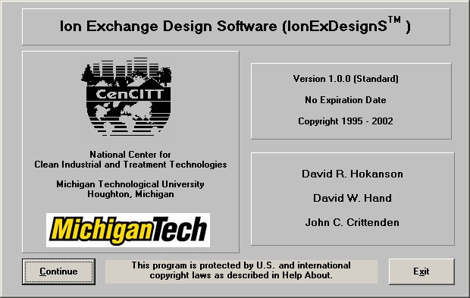
Figure 1 - IonExDesignS™ Title Window

III. Description of the Model

A. The Pore Diffusion Model (PDM)

The PDM is a dynamic fixed bed model that incorporates the following assumptions:

- The fluid is transported through the bed by advective plug flow (axial and radial dispersions are neglected)
- A linear driving force describes the liquid phase mass transfer flux at the exterior of the resin particle
- The intraparticle transport is caused by pore diffusion.
- Electrical potential effects on intraparticle transport are neglected
- There are no ion-ion interactions during the diffusion process
- The exchange rate of an ion onto the resin is much faster than the diffusion rate (i.e. local ion exchange equilibrium exists between the ion adsorbed onto the resin particle and the ion in the intraaggregate stagnant fluid)
- A Langmuir equilibrium relationship incorporating constant separation factors and total solution concentration describes the multicomponent ion exchange equilibrium between the liquid- and solid-phases
- The PDM considers the total cation or anion concentration in the system as a constant (hence, the electroneutrality condition holds) and neglects the water formation reaction and degree of ionization of weak acids and bases. Hence, the PDM is only applicable to SAC and SBA exchange resins and does not apply to mixed bed ion exchange resins.

From the mass balances on the liquid phase and resin phase, two partial differential equations are obtained for each exchanging component. A coupling equation between the liquid phase and the resin phase is obtained from assuming local equilibrium at the exterior of the resin particle. In cases where pore diffusion is present, local equilibrium is assumed along the pore walls. These equations are non-dimensionalized and solved by numerical methods. The orthogonal collocation method is used to convert the partial differential equations into a set of ordinary differential equations (Finlayson, 1972 and 1980; Villadsen, 1978). The set of ordinary differential equations is solved using the backward differentiation method formula, also known as Gear’s stiff method. The development of the PDM follows closely the development of the pore and surface diffusion model (PSDM) available in the literature (Friedman, 1984; Crittenden et al., 1986). The PDM was developed by eliminating the effects of surface diffusion from the PSDM and by modifying the coupling equation to use the Langmuir equilibrium approach appropriate for ion exchange rather than the Freundlich equilibrium expression used for adsorption processes. Hokanson (2002) and Hokanson et al. (2002) have presented the derivation of the equations and the computer algorithms that were used to solve the model equations. The PDM model equations are summarized in Appendix A.

Ion exchange calculations using this model require equilibrium and kinetic parameters combined with several physical properties of the exchanging ion(s) and the resin. These parameters and physical properties are easily obtained using the IonExDesignS™ databases. The PDM results show breakthrough curves for each compound.

B. Mass Transfer Parameters

Mass transfer parameters are required for the PDM. These parameters can be experimentally determined. However, at the design stage of a fixed bed ion exchanger, such data are often unavailable and correlations are required. IonExDesignS™ has the capability to estimate external and intraparticle mass transfer parameters using the correlations presented in Appendix C.

C. Equilibrium Parameters: Separation Factors

The PDM incorporates the Langmuir equilibrium isotherm expression to describe the ion exchange equilibrium for each ion and is used to predict multicomponent competitive interactions. The Langmuir equilibrium isotherm parameters (separation factors) can be obtained from the IonExDesignS™ isotherm database. If separation factors for particular ion/resin systems are not available in the IonExDesignS™ isotherm database, then the user may provide them.

The user should be aware that the ion exchange characteristics of a given commercial resin can vary slightly from lot to lot. In addition, improvements on resins in IonExDesignS™ may have been recently made by resin manufacturers. Resin manufacturers can be contacted for information on improvements in their resin products. New or updated ion/resin system information obtained from the manufacturers can easily be inserted into the IonExDesignS™ isotherm database, and new or updated resin information can easily be inserted into the IonExDesignS™ resin database.

IV. Input Data

A. IonExDesignS™ Main Window

When IonExDesignS™ is run a default IonExDesignS™ Main window is opened. This window is presented in Figure 2.

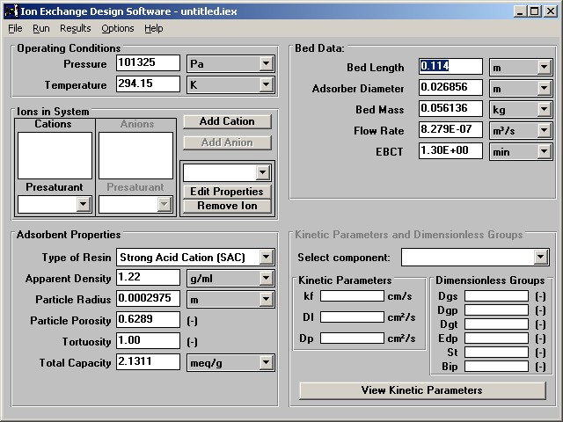
Figure 2 - Default IonExDesignS™ Main window

C. Temperature and Pressure

The operating water temperature and pressure must be specified in the IonExDesignS™ main window. To change the default temperature or pressure, highlight the corresponding textbox and type in the new value.

The values of density and viscosity of water are calculated from correlations as a function of temperature. Liquid density is determined from a correlation developed from a polynomial fit of liquid density data from McCabe and Smith (1976). Liquid viscosity is calculated with a correlation presented in Yaws et al. (1976).

D. Fixed Bed Ion Exchanger Properties

IonExDesignS™ requires the user to specify the following fixed bed ion exchanger data which can be input in a variety of units:

- Bed length (m, cm, ft, in)
- Ion exchanger diameter (m, cm, ft, in)
- Mass of resin in the bed (kg, g, lb)
- Inlet flowrate (m³/s, m³/d, cm³/s, mL/min, ft³/s, ft³/d, gpm, gpd)

OR
- Empty Bed Contact Time (EBCT) (s, min, hr, d, yr)

The EBCT is defined as follows:

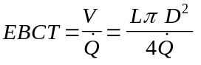

where: D is the diameter of the ion exchanger (m)
L is the length of the bed (m)
is the volumetric inlet flowrate (m³/s)
V is the volume of the bed (m³)
EBCT is the Empty Bed Contact Time (s).

These values are entered in the IonExDesignS™ main window. A built-in check warns the user if the bed dimensions specified do not accommodate the mass of resin specified. Enter the required information by highlighting the proper field, entering the number, and then pressing Enter or Tab. Note that the pull-down menu tab to the right of each field allows the user to specify the units used. Make sure the proper units are selected before entering the data. IonExDesignS™ also calculates the bed porosity, which is printed when the Print option is chosen from the File menu.

E. Resin Properties

The user must specify the following resin properties (default units in parentheses) in the main window:

- Type of Resin: Choices are (1) Strong Acid Cation (SAC) or (2) Strong Base Anion (SBA)
- Apparent density of the resin (including the pore volume) (g/mL); also called the resin density or particle density
- Average particle radius (m)
- Resin porosity (the volume fraction occupied by pores in the resin particle)
- Tortuosity, or particle shape factor (1.0 for perfectly spherical particles)

In the Resin Properties frame of the IonExDesignS™ main window a value can be entered for the Particle Shape Factor (PSF), or Tortuosity. The PSF is a dimensionless quantity and is the ratio of the actual surface area of a resin particle to the surface area of an equivalent-volume sphere. The default PSF value of 1.0 indicates that the resin particle is spherical.

F. Ion Properties

One of the first steps in setting up a simulation is entering the ion properties. The program can keep in memory up to ten ions and their properties. The user must first specify the Type of Resin in the Resin Properties frame, as described above. If a strong acid cation (SAC) exchange resin is chosen, the user must enter cation properties and the anion data entry options will be disabled. If a strong base anion (SBA) exchange resin is chosen, the user must enter anion properties and the cation data entry options will be disabled.

Four command buttons are available in the main window for this purpose:

- Add Cation
- Add Anion
- Edit Properties
- Remove Ion

The Add Cation button will open an Add Cation window and add a new cation to the list of Cations. The Add Anion button will open an Add Anion window and add a new anion to the list of Anions. To delete an ion from the list, select its name from the pull down list and click on the Remove Ion button. To edit the properties of a given ion, select an ion in the pull down list and click on the Edit Properties button. The Remove Anion and Edit Properties buttons are disabled if there are no ions in the list. The Add Cation or Add Anion button is disabled if the maximum number of ions has been reached in the list. The Add Cation window is shown in Figure 3. The Add Anion window is shown in Figure 4.

1. Ion Physical Properties

After clicking on the Add Cation, Add Anion or Edit Properties button in the main window, the user must enter ion properties in the window shown in Figure 3 for cations or Figure 4 for anions.

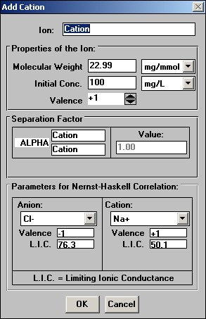
Figure 3 - Default Add Cation window (adding new cations)

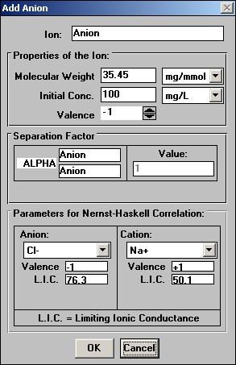
Figure 4 - Default Add Anion window (adding new anions)

The following properties (with their default units in parentheses) are required for each component:

- Ion Name
- Molecular weight (mg/mmol)
- Initial (influent) concentration (meq/L)
- Valence (-)
- Separation factor (-)
- Parameters required by Nernst-Haskell correlation used to calculate liquid diffusivity
- Ion / Counter Ion
- Valence of Ion / Valence of Counter Ion
- Limiting Ionic Conductance of Ion / Limiting Ionic Conductance of Counter Ion

The user can input data by first selecting the appropriate units (if it is a dimensioned value) and then by clicking on a text box and typing in the corresponding value. By pressing the Enter key, the Tab key, or clicking on another text box or button, the data is updated. (Units are changed in the pull-down menus to the right of each text box.). Each ion must be given a unique name other than the default values of “Cation” or “Anion.”

The separation factor is input with respect to the presaturant ion. It is suggested that the user enter the presaturant ion data first such that the separation factors can be properly input. The separation factor for the presaturant ion is equal to 1.0.

The parameters required for the Nernst-Haskell correlation are entered as follows. For a strong acid cation (SAC) exchange resin, in the “Parameters for Nernst-Haskell Correlation” frame within the Add Cation window (see Figure 3), select the current cation name within the Cation combo box. Choose an appropriate counter anion based on the ions present in the system of study (perhaps Chloride) within the Anion combo box. Selection of these ions within the combo boxes will automatically generate within the “Parameters for Nernst-Haskell Correlation” frame, the values of Valence and the Limiting Ionic Conductance for the cation and the counter anion selected. For a strong base anion (SBA) exchange resin, in the “Parameters for Nernst-Haskell Correlation” frame within the Add Anion window (see Figure 4), select the current anion name within the Anion combo box. Choose an appropriate counter cation based on the ions present in the system of study (perhaps Sodium) within the Cation combo box. Selection of these ions within the combo boxes will automatically generate within the “Parameters for Nernst-Haskell Correlation” frame, the values of Valence and the Limiting Ionic Conductance for the anion and the counter cation selected.

2. Influent Concentrations - Fixed and Variable

To edit the ion properties, or enter the influent concentration, use the pull-down tab in the field above the Edit Properties button on the IonExDesignS™ main window to select an ion, and click Edit Properties to enter the Edit Ion Properties (Edit Cation or Edit Anion) window. It is necessary to return to the IonExDesignS™ main window to edit the properties of multiple ions.

Initial concentrations are specified in the Ion Properties window. The pull-down tab adjacent to this field allows the user to select the units to be used. To enter a constant influent concentration, highlight the text box and type in the concentration.

IonExDesignS™ is also able to handle variable influent concentrations. For each component, it is possible to simulate variable influent concentration by resetting the value of this concentration at different times. The values of concentrations and times can be entered by the user. By selecting Influent Concentrations in the Options menu (see Figure 2), the window shown in Figure 5 will appear. The variable influent concentrations are also plotted by the Compare PDM Results to Data command on the Results menu.

To enter variable concentrations, enter the value of time on the left-hand side column. Then for each component enter the value of its inlet concentration at the corresponding time. The concentrations must be in mg/L. Once this is done, click on OK to validate the influent concentrations shown in the grid. If the Cancel button is clicked, no changes will be implemented.

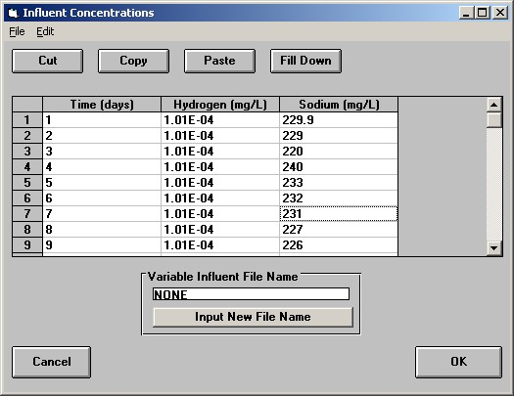
Figure 5 - Variable Influent Concentrations Window

The same number of points must be entered for each ion. Otherwise, the program will detect an error and return to the grid. The maximum number of points that can be entered is 400 for each ion. For times between variable influent data points, the program linearly interpolates the surrounding two time-concentration data points in order to determine the concentration at those times.

a. Manipulating cells in the grid

The grid on the Influent Concentrations window works like a standard spreadsheet. To enter a value in a cell, click on the cell and type in the desired value. To update it, press Enter, the Up Arrow or the Down Arrow. If you press any other control key or click somewhere else with the mouse, the number will be lost.

It is possible to select several cells to use the options in the Edit menu. Click on the first cell of the area you want to select, keep the left mouse button pressed and drag over the entire area. The selected area will be highlighted.

b. Cut, Copy, and Paste

Three commands are available in the Edit menu to manipulate data in the influent concentrations grid. They are Cut, Copy, and Paste.

The Cut command will clear the content of the selected cells and put the contents in memory. The Copy command will copy into memory the content of the selected cells. The Paste command duplicates the data from memory to the selected cells. The data in memory are from a previous cut or copy command.

c. Loading and Saving Files for Influent Concentrations

From the File menu, click on Open… or Save to manipulate the files containing the data for influent concentrations.

The Save or Save As… commands from the File menu will save the data currently displayed in the grid in a text file (CSV Format) with the following format:

n number of points in the file
t1, c11 ,c21 time, concentration: 1st ion, 2nd ion ...
t2, c12, c22 time, concentration: 1st ion, 2nd ion ...

3. Kinetic Parameters

For the PDM, kinetic parameters are required for each ion are:
- k_{f}, the film mass-transfer coefficient (cm/s)
- D_{p}, the pore diffusion coefficient (cm²/s)

The user can edit these values by clicking on the View Kinetic Parameters button within the Kinetic Parmameters and Dimensionless Groups frame on the main IonExDesignS window (see Figure 2). The Kinetic Parameters window shown in Figure 20 will appear. If the user does not edit the values, they are automatically calculated using correlations and the value of the Surface to Pore Diffusion Flux Ratio displayed in the Kinetic Parameters window.

By clicking onto the appropriate option buttons in this window, the user can select whether k_{f}, D_{s}, and D_{p} are determined from correlations or user input. For example, in Figure 20, the film diffusivity is calculated using a correlation and the two other coefficients are user inputs.

Values for SPDFR and tortuosity are also entered in this window. To enter a value, highlight the corresponding text box and type in the new value. When NOM fouling is being considered the pore diffusion correlation should be used for tortuosity; this is done by marking the box labeled Use Pore Diffusion Correlation for Tortuosity. By pressing the OK button, the data are updated. By pressing the Cancel button, no changes are implemented.

The correlations used for each kinetic parameter are described in Appendix F.

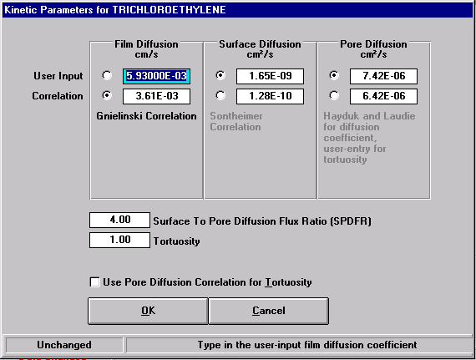

Figure 20: Kinetic Parameters Window

G. Simulation Parameters

Before running a PSDM simulation, the user needs to specify the following collocation parameters which are only used by the PSDM:

- Number of axial collocation points
- Number of radial collocation points
- Number of axial elements

The following time parameters also need to be specified, again only for the PSDM:

- Total simulation time (days)
- Time at which the first point is to be displayed (days)
- Time step between two consecutive points of a breakthrough curve (days)

This can be done by editing the appropriate text boxes in the Simulation Parameters for PSDM Only frame of the IonExDesignS™ main window.

Default values for the collocation parameters are set automatically. The number of collocation points is set to three in the radial direction and to eight in the axial direction. These default values give good results for many cases in liquid phase simulation. However, there are situations when the mass transfer zone length is small compared to the fixed-bed length and the number of axial collocation points needs to be increased. In cases where NOM fouling is important and in some multicomponent systems, the intraparticle concentration gradient for a component may be sharp and require a larger number of radial collocation points to accurately describe the intraparticle concentration profile. This is especially true for gas phase calculations because the mass transfer zone lengths are very short, and for liquid phase applications in which long EBCTs are used. The values can be changed by clicking on the corresponding small arrows near the number’s text box or via direct entry into the text boxes.

The time parameters can be changed to display only a given portion of the breakthrough curves. The maximum number of points for a breakthrough curve is 400. Therefore, the value of the time step must be greater than (T_{t} -T_{i})/400 where T_{i} is the time for the first point of the curve and T_{f} is the final point of the curve. These values can be changed by highlighting the corresponding text box and typing in a new value.

H. Fouling of GAC

The PSDM is able to account for the fouling of GAC by Natural Organic Matter (NOM). Once all the chemicals have been entered, the user can specify which fouling correlation to use for each chemical. By clicking on Fouling of GAC in the Options menu, the window shown in Figure 21 will appear.

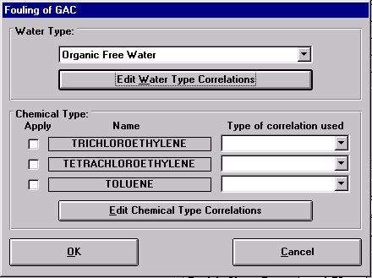

Figure 21: Fouling of GAC window

To allow the PSDM to take account of the fouling of GAC by NOM, the user needs to perform the following data entry tasks:

- Select a correlation to model the type of water (other than Organic Free).
- For each chemical, select whether or not fouling is to be taken into account, and, if so, select a correlation to model the type of chemical.
- For each chemical, if fouling is to be taken into account, the pore diffusion correlation for tortuosity must be selected (see below).

These data entry tasks must be performed before the PSDM is run in order to account for fouling. Note that of the IonExDesignS™ ion exchange models currently available, only the PSDM accounts for fouling.

By clicking on the Water Type pull-down menu, the user can select the type of water. The default water type is Organic Free water in which no fouling occurs. Each type of water is described in Appendix D.

The user must also specify which correlation to use for each chemical to account for the difference between this chemical and the chemical that was used to establish the correlations for water. This is done by clicking on a chemical’s Type of correlation used pull-down menu and selecting the applicable correlation. For these correlations to be applied, the user must also check the chemical’s Apply check-box. If a chemical’s check-box is not checked, no fouling will be taken into account for that chemical.

The kinetic parameters of the chemicals must also be modified. With a chemical selected in the pull-down menu on the Component Properties screen, click on the Kinetics button. Mark the box labeled Use Pore Diffusion Correlation for Tortuosity. The Kinetic Parameters with NOM Fouling window is shown in Figure 22.

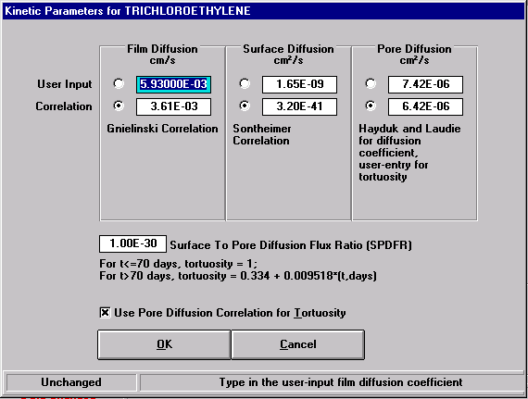

Figure 22: Kinetic Parameters with NOM Fouling window

I. Saving and Printing Input Parameters

The Save and Save As... commands will save into a file all the parameters needed for a simulation: phase, bed data, component properties, GAC properties, kinetic parameters, variable influent concentrations, number of collocation points and simulation time. To save the data click on Save As... or Save in the File menu. Save As... will open a dialog box where the user is required to enter the name of the file where the data will be saved. The Save command will save the current data by overwriting the file last opened. To load a file to start a simulation, click on Open in the File menu and select the file. All the parameters will be updated automatically. Any kinetic coefficients or fluid properties not input by the user are automatically calculated.

To print the current input parameters, click on Print… in the File menu. It is possible to print either to a printer or a file. If the To Printer option is selected, the data will be sent to the printer. To select the printer, choose Select Printer from the File menu. If the To a File option is selected, the user must specify a filename where the data is to be saved. The window shown in Figure 23 will appear. Any or all of the following information can be printed by marking the appropriate check box:

- Component properties
- Bed data
- Carbon properties
- Kinetic parameters
- Fouling correlations
- Variable influent data
- Effluent data

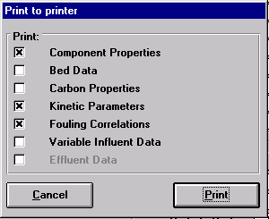

Figure 23: Print window

The results of printing all of the available input data to a printer or a file are shown below:

Component Properties

Component K* 1/n C0 MW Vm NBP
- mg/L g/mol cm³/mol C
Trichlororethylene 60.100 0.416 0.20 1.31E+02 1.02E+02 87.00
Tetrachloroethylene 245.900 0.458 0.20 1.66E+02 1.19E+02 1.21E+02
Toluene 84.820 0.384 0.20 92.14 1.19E+02 1.11E+02

* K in (mg/g)*(L/mg)^(1/n) - Vm = Molar Volume at NBP

Bed Data

Bed Length: 1.800E+00 m
Bed Diameter: 3.658E+00 m
Weight of GAC: 8.500E+03 kg
Inlet Flowrate: 3.156E-02 m³/s
EBCT: 9.990E+00 mn
Bed Density: 0.449 g/cm3
Bed Porosity: 0.440
Superficial Velocity: 1.08E+01 m/hr
Interstitial Velocity: 2.45E+01 m/hr

Temperature: 10.00 C
Water Density: 0.9998 g/cm³
Water Viscosity: 1.31E-2 g/cm.s

Carbon Properties

Name: Calgon F400 (12x40)
Apparent Density: 0.803 g/cm³
Particle Radius: 0.05130 cm
Porosity: 0.641
Shape Factor: 1.500

Kinetic Parameters

Component kf Ds Dp St Eds Edp SPDFR
cm/s cm²/s cm²/s - - - -
Trichloroethylene 3.61E-03 1.33E-10 6.42E-06 23.58 2.10 0.52 4.00
Tetrachloroethylene 3.38E-03 3.18E-11 5.86E-06 22.13 1.92 0.48 4.00
Toluene 3.38E-03 8.19E-11 5.86E-06 22.13 1.92 0.48 4.00

Variable Influent Data

Time(days),C of Trichloroethylene, C of Tetrachloroethylene, C of Toluene: (All C in mg/L)
1,.2,.2,.2
10,.2,.2,.2
20,.2,.2,.2
30,.2,.2,.2
40,.2,.2,.2
50,.2,.2,.2
60,.2,.2,.2
70,.2,.2,.2
80,.2,.2,.2
90,.2,.2,.2
100,.2,.2,.2
110,.2,.2,.2
120,.2,.2,.2
130,.2,.2,.2
140,.2,.2,.2
150,.2,.2,.2
160,.2,.2,.2
170,.2,.2,.2
180,.2,.2,.2
190,.2,.2,.2
200,.2,.2,.2
210,.2,.2,.2
220,.2,.2,.2
230,.2,.2,.2
240,.2,.2,.2
250,.2,.2,.2
260,.2,.2,.2
270,.2,.2,.2
280,.2,.2,.2

Effluent Data

Time(days),C/C0 of Trichloroethylene, C/C0 of Tetrachloroethylene, C/C0 of Toluene:
(All C/C0 are dimensionless and normalized)
0,.01,.01,.01
225,.03,.01,.01
250,.04,.01,.01
275,.05,.01,.01
300,.5,.01,.01
325,.95,.01,.01
350,1.4,.01,.01
375,1.6,.01,.01
400,1.8,.01,.03
500,1.65,.01,.05
550,1.4,.01,.5
600,1.1,.01,.95
650,1,.01,1.05
700,1,.01,1.15
800,1,.04,1.2
850,1,.05,1.18
900,1,.1,1.17
1000,1,.2,1.15

V. Running a Simulation

Once all the input data have been entered, it is possible to run any of the three models available: ECM, CPHSDM or PSDM. To run a simulation the user must first select from the component list on the IonExDesignS™ main window the component(s) which should be used for the simulation. To select a component, the user must click on its name in the list. The user can select one component for CPHSDM, up to ten components for the ECM and up to six components for the PSDM. For example in Figure 24, TCE is selected because its name is highlighted.

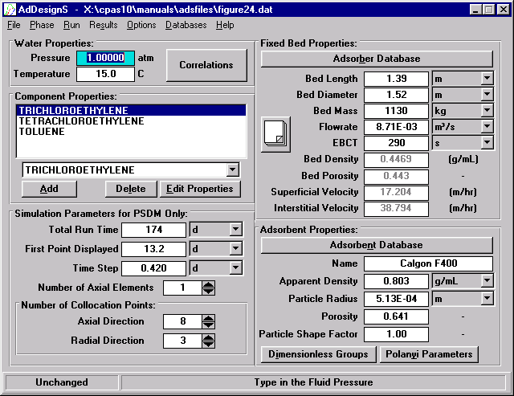

Figure 24: IonExDesignS™ Main window

Once the components have been selected, select one of the models available in the Run menu. Depending on the number of components selected, the calculation time may be lengthy, especially for PSDM.

If the PSDM fails to converge or if the breakthrough curves show oscillations, it is recommended to try another run after increasing the number of radial and/or axial collocation points. For example, increase the number of axial collocation from 8 to 9, 10 or 11, and the number of radial collocation points from 3 to 4 or 5. Increasing the number of collocation points is a good method to solve convergence problems when the breakthrough curves occupy a small fraction of the fixed-bed. The user can also increase the number of axial elements instead of increasing the number of axial collocation points. For example, increasing the number of axial elements from 1 to 2 will divide the bed in half and perform the calculations using the specified number of radial and axial collocation points. This will effectively double the number of axial collocation points used for a given bed length. Common convergence problems will occur when the rate of mass transfer by film diffusion and intraparticle diffusion are much more important than the rate of transfer by advection. In such a case mass transfer diffusion can be neglected. However, increasing the number of collocation points may create a stiff system of equations. In such a case, the numerical algorithm will be unable to solve the set of differential equations.

To identify which mass transfer mechanism is controlling the ion exchange process, the magnitude of the dimensionless groups can be compared as outlined by Sontheimer, et al (1988). The value of the dimensionless groups can be related such that equivalent amounts of spreading occur in the mass transfer zone due to each of the various transport mechanisms as shown by the following equation:

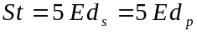

From this equation, we can say that for a linear isotherm, a Biot number of 5 (Bi=St/Ed) means that film transfer and surface diffusion have the same impact on the breakthrough curve. For example, if the Stanton number (St) is equal to 30, the surface diffusion modulus (Ed_{s}) to 1 and the pore diffusion modulus (Ed_{p}) to 0.1, the following conclusions can be made:

- Since the surface Biot number is 30, the intraparticle diffusion mechanism is the controlling mechanism.
- The surface diffusion is about ten times faster than the pore diffusion and is the controlling diffusion mechanism inside the particle since these transport steps act in parallel.

VI. Results

Once a simulation has been successfully completed, it is possible to display the results and save them selecting one of the sub-menus in the Results menu in the IonExDesignS™ main window.

A. Displaying Results

To display the results from a previous simulation, select a model in the Results menu on the main screen. A window will appear displaying the results for the selected model.

1. Equilibrium Column Model Results

After running an ECM simulation, click on ECM Results in the Results menu and the window shown in Figure 25 will appear, displaying the results for this model.

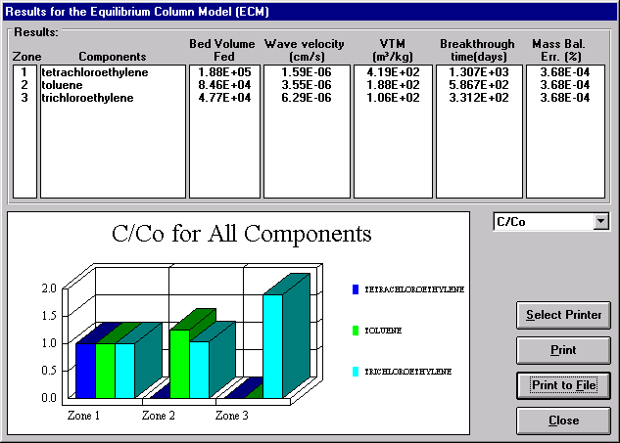

Figure 25: Results for the Equilibrium Column Model

In Figure 25, the following data are displayed for each chemical:

- Bed volumes fed before breakthrough
- Wave velocity (cm/s)
- Volume treated per mass of resin, VTM (m³/kg)
- Time before breakthrough (days)

By default, the reduced concentrations (C/C_{o}) for each chemical in each zone are displayed. To display the liquid phase concentration or the solid phase concentration, click on the combo box on the right of the window.

To select a printer, click on Select Printer. To print the results, click on the Print button. The results can also be printed to a file by clicking on Print to File. To exit this window, click on the Close button.

2. Constant Pattern Homogeneous Surface Diffusion Model

After running the CPHSDM, it is possible to display the corresponding results by clicking on CPHSDM Results in the Results menu. The window shown in Figure 26 will appear.

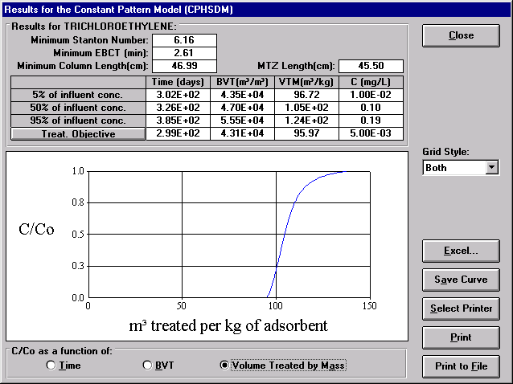

Figure 26: Results for the CPHSDM

By choosing an option at the bottom of the graph, the breakthrough curve displayed on the window can be viewed in one of three ways: C/C_{o} vs time, C/C_{o} vs Bed Volumes Treated (BVT), or C/C_{o} vs Volume Treated per Mass of Resin (VTM). Additionally, the breakthrough time, BVT, VTM and effluent concentrations for the treatment objective and 5%, 50%, and 95% of the influent concentration are listed in the table at the top of the window. To specify the treatment objective, click on the Treatment Objective button. The treatment objective window shown in Figure 27 will appear. To enter the treatment objective, highlight the text box and type the new value. It should be noted that the treatment objective units are in mg/L. The length of the mass transfer zone (MTZ) is also displayed. If the contaminant breakthrough curve is longer than the run time specified, the values may not be available and N/A will be displayed in the table.
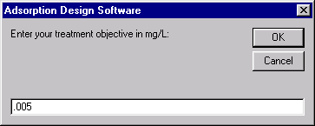

Figure 27: Treatment Objectives window

To save the points from the breakthrough curve in a text file, click on the Save Curve button. The reduced concentration will be saved as a function of time, BVT and treatment capacity. This text file will be readable by any spreadsheet software. To select a printer, click on Select Printer. To print the results, click on the Print button. The results can also be printed to a file by clicking on Print to File. To exit this window, click on the Exit button.

3. Pore and Surface Diffusion Model Results

When the Pore and Surface Diffusion Model simulation has been successfully completed, the user can display the results by clicking on PSDM Results in the Results menu. The window shown in Figure 28 will appear. The plots of each contaminant in this window are a different color; in order to present the reader with a graph they can interpret in a black-and-white document, an Excel plot (created using data transferred to Excel from IonExDesignS™) is presented as Figure 29.

By choosing an option at the bottom of the graph, the breakthrough curve displayed on the window can be viewed in one of three ways: C/C_{o} vs time, C/C_{o} vs Bed Volumes Treated (BVT), or C/C_{o} vs Volume Treated per Mass of Resin (VTM). Additionally, the breakthrough time, BVT, VTM and effluent concentrations for the treatment objective and 5%, 50%, and 95% of the influent concentration are listed in the table at the top of the window. The length of the mass transfer zone (MTZ) is also given. If the contaminant breakthrough curve is longer than the run time specified, the values may not be available and N/A will be displayed in the table.

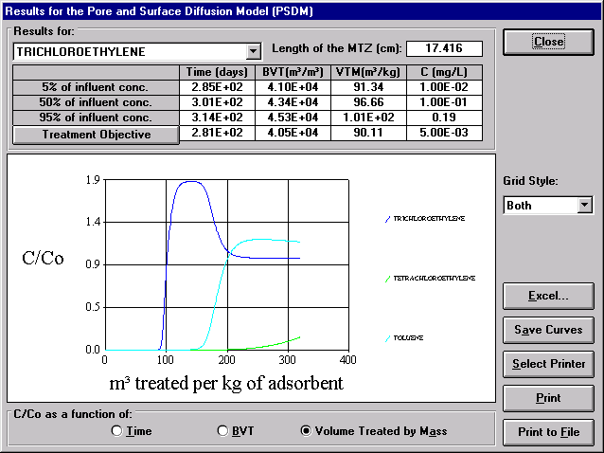

Figure 28: Results for the Pore and Surface Diffusion Model

To save the points from the breakthrough curve in a text file, click on the Save Curve button. The reduced concentration will be saved as a function of time, BVT and treatment capacity. This text file will be readable by any spreadsheet software. To select a printer, click on Select Printer. To print the results, click on the Print button. The results can also be printed to a file by clicking on Print to File. To exit this window, click on the Exit button.
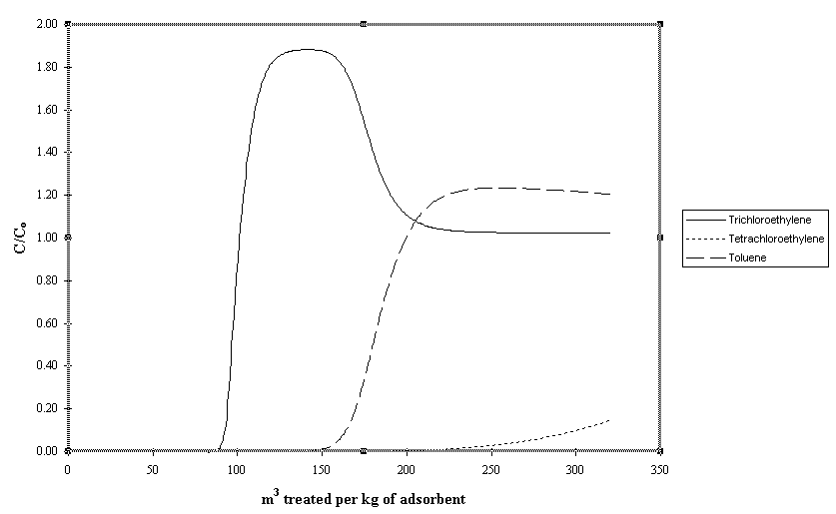

Figure 29: Results for the Pore and Surface Diffusion Model

B. Transferring Results to Excel

The PSDM and CPHSDM results can be transferred from IonExDesignS™ to applications such as Microsoft Excel via an Excel-format file or via the clipboard. To do so from the results window, the first step is to click on the Excel… button. The window shown in Figure 30 will appear. To transfer the entire set of data to an Excel file, select Save As … from the File menu, specify a filename, and then click OK; the resulting file can be loaded into any version of Microsoft Excel 5.0 or more recent. To print the entire set of data to a printer, select Print (Current Sheet Only) … from the File menu. To copy part of the set of data to the clipboard (for pasting into an application such as Microsoft Excel), select the range of data on the grid, then select Copy from the Edit menu.

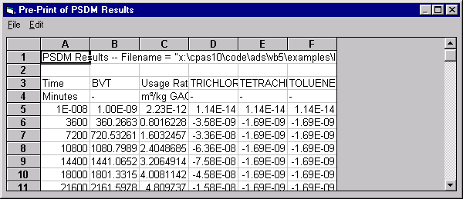

Figure 30: Transfer Results to Excel window

C. Comparing Model Predictions to Data

It is possible to compare the results from a CPHSDM or PSDM simulation to actual field/pilot data within IonExDesignS™. After running a CPHSDM or PSDM simulation, select Effluent Concentrations from the Options menu. The window shown in Figure 31 will appear where the user may type in the data. Data may also be loaded from a file.

To enter effluent concentrations, enter the value of time (in days) on the left-hand side column. Then for each component enter the value of its effluent concentration at the corresponding time. The concentrations must be entered as reduced concentration (C_{i}/C_{0i}). Once this is done, click on OK to validate the effluent concentrations shown in the grid. If the Cancel button is clicked, no changes will be implemented.

The same number of points must be entered for each component. Otherwise, the program will detect an error and return to the grid. The maximum number of points that can be entered is 400 for each component. For times between effluent data points, the program linearly interpolates the surrounding two time-concentration data points in order to determine the concentration at those times.

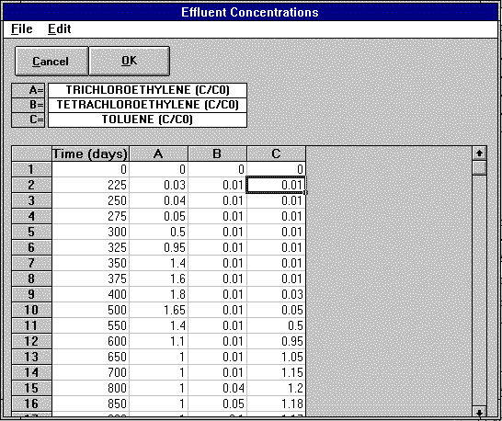

Figure 31: Effluent Concentrations window

1. Manipulating Cells in the Grid

The grid on the Effluent Concentrations window works like a standard spreadsheet. To enter a value in a cell, click on the cell and type in the desired value. To update it, press Enter, the Up Arrow or the Down Arrow. If you press any other control key or click somewhere else with the mouse, the number will be lost.

It is possible to select several cells to use the options in the Edit menu. Click on the first cell of the area you want to select, keep the left mouse button pressed and drag over the entire area. The selected area will be highlighted.

2. Cut, Copy, and Paste

Three commands are available in the Edit menu to manipulate data in the effluent concentrations grid. They are Cut, Copy, and Paste.

The Cut command will clear the content of the selected cells and put the contents in memory. The Copy command will copy into memory the content of the selected cells. The Paste command duplicates the data from memory to the selected cells. The data in memory are from a previous Cut or Copy command.

3. Loading and Saving Files for Effluent Concentrations

The data can be saved to or loaded from a file by using the File menu. From the File menu, click on Open… or Save to manipulate the files containing the data for effluent concentrations.

To load data from a file, the file must have the following format (example given is for two components):

10 ←Number of data points
1100,0.1,0.34 ← Time, C₁/C₀₁,C₂/C₀₂
1200,0.2,0.35 ← Time, C₁/C₀₁,C₂/C₀₂
. .
. .
. .
10000,0.5,0.42 ←Time, C₁/C₀₁,C₂/C₀₂

The values must be delimited by commas and the file must be an ASCII text file. It is possible to create such a file manually or from a spreadsheet by using the command Save As.... In Excel, save the file as a CSV file (Comma Delimited) to obtain such a file.

Once all the data are in the grid, click OK to return to the IonExDesignS™ main window. To return to the IonExDesignS™ main window without updating the data, click on Cancel. To compare the data, select either Compare CPHSDM Results to Data or Compare PSDM Results to Data from the Results menu in the IonExDesignS™ main window. The window shown in Figure 32 will appear.

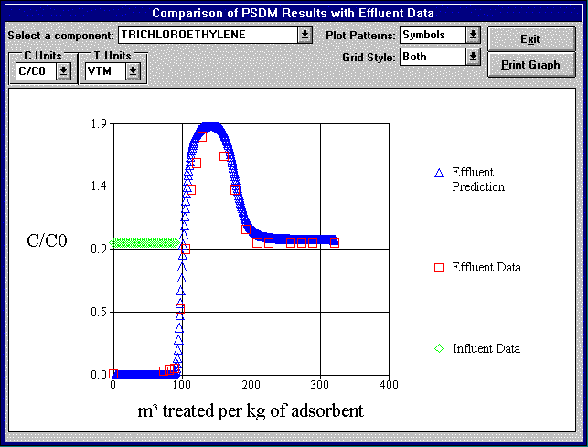

Figure 32: Comparison of PSDM Results with Effluent Data window

Concentration can be presented as reduced concentration (C/C_{o}), mg/L, or μg/L and treatment can be presented as days, BVF, or VTM by selecting the desired units from the pull-down menus in the upper left corner of the window. The user can select either symbols or lines for the plot pattern. If influent concentrations were specified in the Influent Concentrations window, those values will be plotted along with the specified effluent concentrations and the simulation results. To view the comparison plot for a different contaminant, select a contaminant from the pull-down menu at the top of the window.

VII. Databases

Three databases are used by IonExDesignS™. One database is a Freundlich isotherm database. This database contains 650 isotherms for more than 300 chemical species for various ranges of pH and concentrations. The second is an ion exchanger database which contains the properties of various commercially available ion exchangers. The third database is a resin database where physical properties of various resins are available. All databases can be accessed and edited from within the IonExDesignS™ program.

A. Isotherm Database

The isotherm database was designed to provide the user with values of the Freundlich parameters for a large number of chemicals. This database was created from data available in various publications summarized in Appendix I.

This database can be accessed from the Component Properties window by clicking the Freundlich K and 1/n button. The user also has the capability of adding new isotherm data to the database. To edit the database, click on Isotherm Database in the Databases menu on the main window. The window shown in Figure 33 will appear.

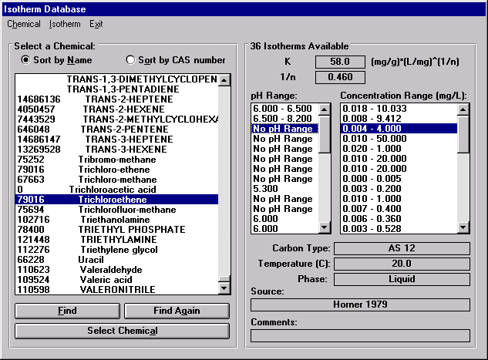

Figure 33: Editing the Isotherm Database window

From this window, it is possible to edit an isotherm, create a new isotherm for an existing chemical or create a new chemical and add new isotherms.

The list of available chemicals is displayed in the left-hand part of the window. The chemicals can be sorted by name or by CAS number (Chemical Abstract Number) by clicking on one of the two buttons on the top of the list. By default, they are sorted by name. For almost all chemicals, a CAS number is available. The same chemical may appear in the list under different names but with the same CAS number. If the user selects a chemical in the list, all of the isotherms for the selected chemical will be displayed in the right hand side of the window. To select a chemical, highlight its name in the list, and double-click on it, or else click on the Select Chemical button. All the isotherms for this chemical will be displayed.

To exit this window and go back to the main window, click on Exit in the menu bar.

1. Manipulating Chemical Names

From the menu of the Editing Database window, it is possible to manipulate the chemical names and CAS numbers. The capabilities are the following:

- Create a new chemical
- Modify an existing chemical
- Delete the selected chemical

To create a new chemical, select New… in the Chemical menu. The window shown in Figure 34 will appear.

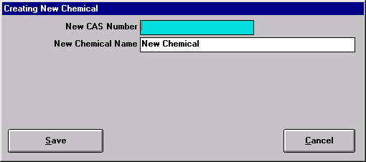

Figure 34: Creating a New Chemical for the Isotherm Database window

In this window the user can type a new CAS number (without spaces or hyphens) and the name of the new chemical. The CAS number can be a CAS number that is already in the chemical list. To save the new chemical in the list, click on the Save button. To exit the window without updating the chemical list, click on Cancel. If no CAS number is provided, the chemical will be stored in the database without a CAS number.

To modify the name or the CAS number of an existing chemical, select Edit current in the Chemical menu. The window shown in Figure 35 will appear.

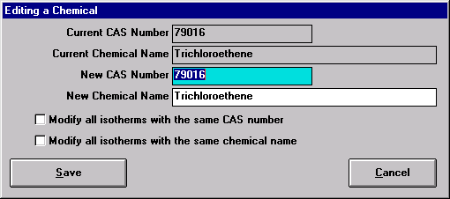

Figure 35: Editing a Chemical in the Isotherm Database window

To change the name or CAS number, type in the new name or CAS number in the New Name or New CAS number text box. If the CAS number is changed, all the isotherms that refer to this chemical can be changed to refer to the new chemical. To update all the isotherms that refer to this CAS number and chemical name, click on the two check boxes at the bottom of the window.

Click on Save to update the chemical list or Cancel to exit the window without updating the database.

To delete a chemical from the list, click on Delete current in the Chemical menu. The window shown in Figure 36 will appear.

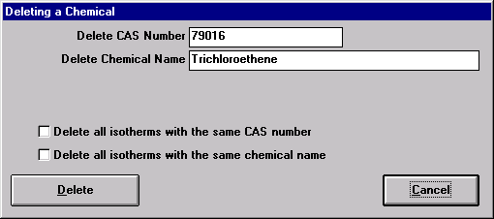

Figure 36: Deleting a Chemical from the Isotherm Database window

When a chemical is deleted, only its name is deleted from the database, not the corresponding isotherms, unless the user has clicked in the two check boxes at the bottom of the window. If the user deletes a chemical without deleting its isotherms and creates a new chemical with the same CAS number, these isotherms will be linked to the new chemical.

2. Manipulating Isotherms

Once a chemical has been selected by double-clicking on its name or by clicking on the Select Chemical button, it is possible to edit the isotherms for this chemical or create a new isotherm from the Editing the Isotherm Database window.

To create a new isotherm for the selected chemical, click on New… in the Isotherm menu. The window shown in Figure 37 will appear.

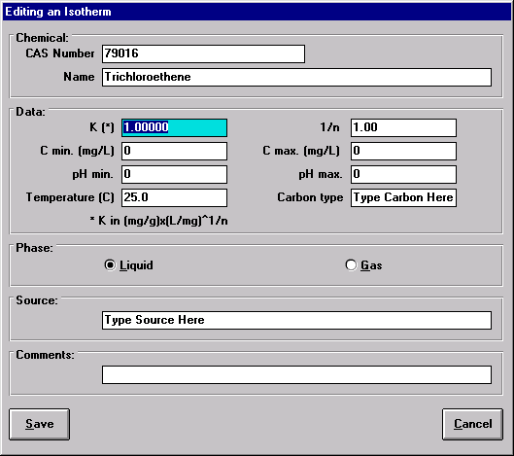

Figure 37: Creating a New Isotherm window

In this window, the user can specify which chemical the isotherm will be linked to by specifying the CAS number and the chemical name. Then the user must at least type in new values of K and 1/n and the phase in which the isotherm is valid (liquid or gas). All other information is optional. To update the database with these new values, click on Save. Click on Cancel to exit the window without updating the database.

To edit an existing isotherm, the process is similar. Select an isotherm by highlighting it and click on Edit current in the Isotherm menu. The window in Figure 38 will appear.

From this window, the user can modify any information and save modifications.

To delete an existing isotherm, select an isotherm by highlighting it and select Delete current in the Isotherm menu. To delete all of the isotherms for a selected chemical select Delete All in the Isotherm menu. A window asking for confirmation of the deletion will appear. Click Yes to delete the isotherm(s) or No to cancel the deletion.

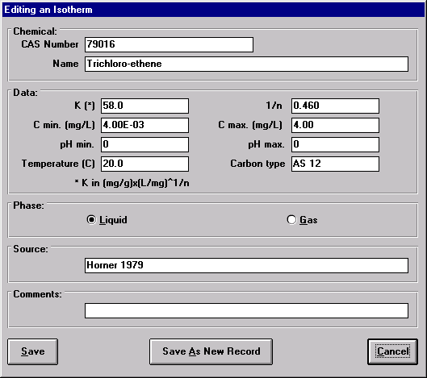

Figure 38: Editing an Isotherm window

Ion exchanger Database

An ion exchanger database is also included in IonExDesignS™. Ion exchanger types are sorted by manufacturers. The following data is available in the database for a given resin:

- Internal Area
- Maximum Capacity
- Outside Diameter
- Design Pressure
- Design Flow Range
- Default Flow Rate
- Default Bulk Density
- Notes

This database can be opened from the main window (1) for importation purposes by clicking on the Ion exchanger Database button or (2) for editing purposes by selecting Ion exchanger Database from the Databases menu. When opened for importation purposes, the user is unable to edit the database. When opened for editing, a manufacturer must first be highlighted before it can be edited, and an ion exchanger must first be highlighted before it can be edited. The Ion exchanger Database window is shown in Figure 5.

C. Resin Database

A resin database is also included in Ion Exchange Design Software. Resin types are sorted by manufacturer. The following data is available in the database for a given resin:

- Particle density
- Average particle radius
- Particle porosity (volume fraction occupied by pores in the resin particle)
- Resin type
- Polanyi parameters

This database can be opened from the main window by selecting Resin Database from the Databases menu. When editing the database, the user is able to modify the property of any existing resin, add new resins to the database, and delete existing resins from the database. The window shown in Figure 6 is the window used to edit the resin database.

To select a carbon in this window, first click on the name of a manufacturer, then select in which phase the carbon is used and finally, click on a carbon name to display its properties. From the menu in this window, it is possible to modify any record in the database. To exit this window, click on Exit in the menu bar.

1. Manipulating Manufacturers

From the menu, it is possible to:

- Add a new manufacturer
- Edit the name of an existing manufacturer
- Delete a manufacturer

To add a new manufacturer name to the list, click on New in the Manufacturer menu (in Figure 6). The window shown in Figure 39 will then appear. Type in the name of the new manufacturer and click on Save to update the database. The name of the new manufacturer will then appear in the manufacturer list.

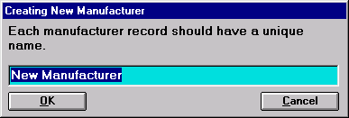

Figure 39: Creating a New Manufacturer in the Resin Database

To edit the name of an existing manufacturer, highlight the name of the manufacturer and click on Edit Current in the Manufacturer menu. As shown in Figure 40, the user is prompted to type in the new manufacturer name. Click on OK to update the database.

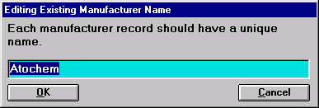

Figure 40: Editing a Manufacturer Name in the Resin Database

To delete a manufacturer, click on the name and click on Delete Current in the Manufacturer menu. A warning window will then ask for a confirmation. Click on Yes to delete the selected manufacturer and all corresponding carbons.

At any time, the user can click on the Cancel button to exit the window without updating the database.

2. Manipulating Resins

To create a new resin, select a manufacturer name, select a phase by selecting Liquid Phase or Gas Phase and click on New in the Resin menu. The window shown in Figure 41 will appear.

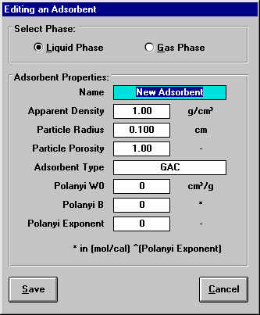

Figure 41: Creating a New Resin window

To edit the properties of an existing resin, select the resin and click on Edit Current in the Resin menu. The window shown in Figure 42 will appear.

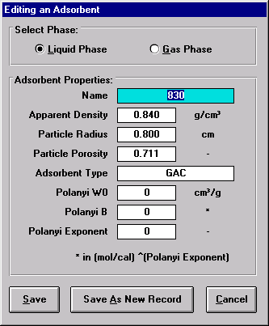

Figure 42: Editing a resin window

To update the database with the changes, click on Save. To exit the window without updating the database, click on Cancel.

To delete a resin, click on its name in the resin list and click on Delete in the Resin menu. A warning window will appear asking for confirmation. Click on Yes to delete the selected carbon or on No to cancel the deletion.

VIII. Example GAC Usage Rate Calculations

This example problem demonstrates the use of IonExDesignS™ to calculate and compare GAC usage rates for two different systems in conjunction with Software to Estimate Physical Properties (StEPP™) and the Aeration System Analysis Program (ASAP™). In this example, the physical properties of three Volatile Organic Compounds (VOCs) are imported from StEPP™ into IonExDesignS™ and ASAP™, and liquid and gas phase carbon usage rates are calculated using IonExDesignS™. For the liquid phase, usage rates are calculated for these cases: ECM calculation assuming NOM fouling is not important; PSDM calculation assuming NOM fouling is not important; single component PSDM calculation assuming NOM fouling is important; and a combined ECM and CPHSDM calculation assuming NOM fouling is not important. For the gas phase, ASAP™ is used to estimate off gas concentrations and gas flow rates from an air stripper. These values are then used in IonExDesignS™ to calculate gas phase carbon usage rates for these cases: an ECM calculation and a combined ECM and CPHSDM calculation. The results of the liquid and gas phase calculations are also compared. These example calculations demonstrate the utility of the software to aid the user in determining the resin usage rates that will lead to selection of the most economical treatment option for a given contaminated water.

A step-by-step demonstration of the software is provided below as a tutorial to familiarize the user with the software operation.

A. Problem Statement

A groundwater remediation project includes a well producing 1500 gpm of water contaminated with 200 μg/L trichloroethylene (TCE), 200 μg/L tetrachloroethylene (PCE) and 200 μg/L toluene, which all need to be removed to concentrations of 5 μg/L or less. The water temperature is 10ºC at a pressure of 1 atmosphere (absolute).

B. Using StEPP™ with IonExDesignS™

The physical properties of the contaminants of interest can be selected in StEPP™ and saved for export to IonExDesignS™ and ASAP™. The default main StEPP™ window is shown as Figure 43.

1. Operating Conditions

The operating temperature (°C) and pressure (Pa) must be entered in the main StEPP™ window. Enter 10°C and 101325 Pa for this portion of the sample calculation.

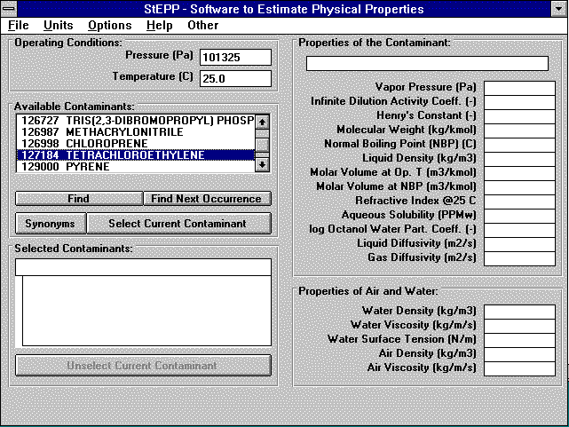

Figure 43: Default StEPP™ Main window

2. Selecting Contaminants in StEPP™

Using the scroll bar on the Available Contaminants frame (or the Find, Find Next Occurrence, or Synonyms buttons), highlight each contaminant of interest and click on the Select Current Contaminant button in StEPP™. Repeat this process for all of the contaminants. Figure 44 shows the main StEPP™ window with all three contaminants selected and the StEPP™-calculated properties of the highlighted compound, PCE, at the proper temperature and pressure.

After the contaminants have been selected in StEPP™ and their properties calculated at the proper temperature and pressure, they can be saved for export to IonExDesignS™ and ASAP™.
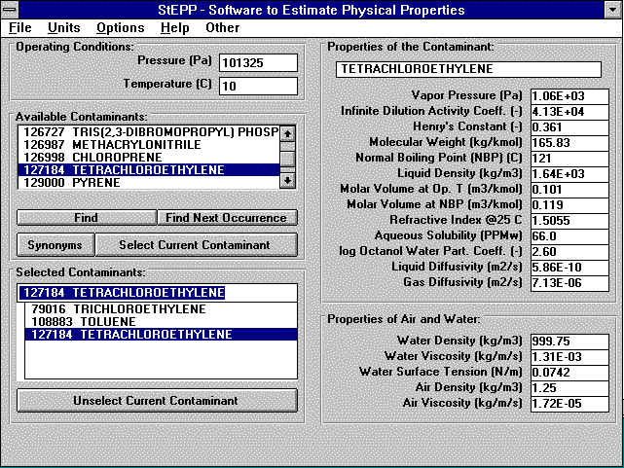

Figure 44: Completed StEPP™ Main window

3. Creating a StEPP™ Export File

To create a StEPP™ export file, select Create Export File for IonExDesignS™/ASAP™ from the Options menu (Figure 43). The window shown in Figure 45 will appear. Enter a file name (liquid.exp) in which to save the export file. This file will be available for use in both IonExDesignS™ and ASAP™.

There is an alternate method for communicating property data from the StEPP™ program to either IonExDesignS™ or ASAP™. For this alternate method, select Copy to Clipboard for IonExDesignS™/ASAP™ from the Options menu (Figure 43). Next, click on the Clipboard button within the IonExDesignS™ window named “Component Properties” in order to import the StEPP properties from the clipboard. This method does not generate a persistent StEPP export file (.exp) on your hard drive, but requires fewer steps.

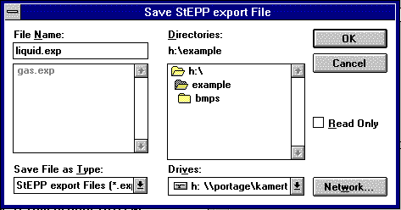

Figure 45: Save StEPP™ Export File window

C. Specifying Ion exchanger, Resin, and Water Properties

The fixed bed ion exchanger properties, resin properties and water properties must be specified in the IonExDesignS™ main window. The default IonExDesignS™ main window is shown in Figure 46; a completed liquid phase IonExDesignS™ main window for this simulation is shown in Figure 47.

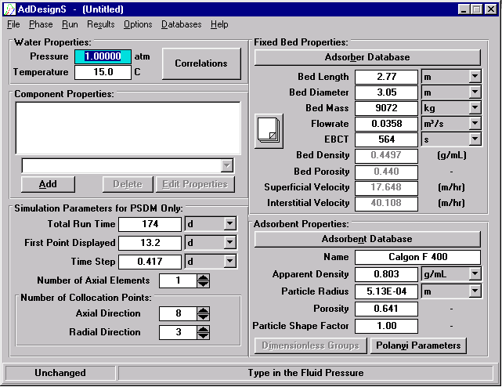

Figure 46: Default IonExDesignS™ Main window

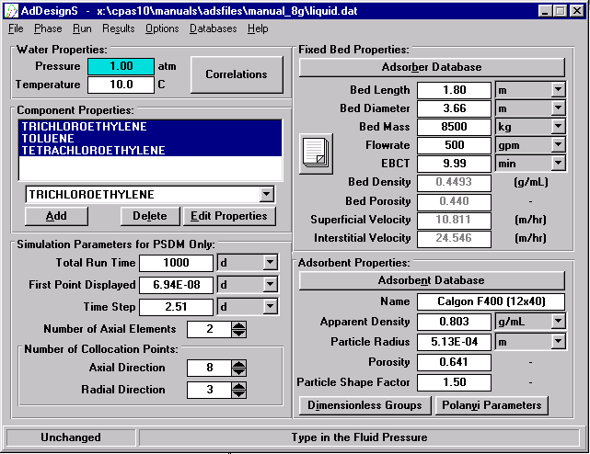

Figure 47: Completed Liquid Phase IonExDesignS™ Main window

1. Liquid Phase Selection

The default setting for IonExDesignS™ is liquid phase ion exchange (in order to simulate gas phase ion exchange, select Gas Phase from the Phase menu at the top of the window). This portion of the sample calculation is concerned with liquid phase ion exchange; thus no changes are required to this setting.

2. Entering Water Properties

In the Water Properties frame in the IonExDesignS™ main window the operating temperature and pressure can be entered. Enter 10ºC and 1 atm for this example. As a default, IonExDesignS™ uses correlations to calculate the water density and water viscosity for the given temperature and pressure. To override the default correlations and input values for water density and water viscosity, click on the Correlations button to open the Water Properties window shown in Figure 48 and unclick the Density and Viscosity boxes and input values for these parameters. For this example, use the correlations for water density and viscosity. Click OK to return to the IonExDesignS™ main window.

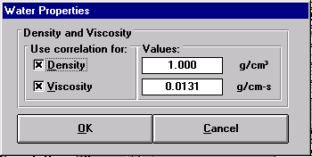

Figure 48: Water Properties window

3. Entering Fixed Bed Properties

IonExDesignS™ requires the user to specify the following information about the fixed bed: length, diameter, mass of carbon present and flow rate entering the bed. The empty bed contact time (EBCT) is calculated from the given dimensions and flow rate. A built-in check warns the user if the bed dimensions specified do not accommodate the mass of carbon specified.

Typical commercial ion exchangers are available in diameters of 1.219, 2.438, 3.048, and 3.658 m (4, 8, 10, and 12 ft). Typical bed densities range from 0.35 g/ml to 0.55 g/ml, typical bed porosities from 0.38 to 0.55, typical superficial velocities from 5 m/hr to 15 m/hr and typical EBCTs from 10 to 15 minutes. To design a system with these characteristics, three 3.658 m diameter ion exchangers with flowrates of 500 gpm each were placed in parallel. This system has the following properties:

Ion exchange System Properties (for typical commercially available ion exchanger)

- Bed Length 1.800 m
- Bed Diameter 3.658 m
- Resin Calgon F400 GAC
- Bed Mass 8500 kg
- Flowrate 500 gpm
- Number of ion exchangers 3

Enter the required information onto the main window by highlighting the proper field, entering the number, and pressing enter. Note that the pull-down menu tab to the right of each field allows the user to specify the units to be used. Make sure the proper units are selected before entering the data.

The Fixed Bed Properties frame also calculates and displays the bed density and porosity as well as the superficial and interstitial velocities. The user does not have the option to specify these values. These values can be used to check whether the fixed-bed properties entered correspond to typical values reported in the field. If they are out of this range then the user should check to see if the values were entered properly.

Figure 47 shows the fixed bed properties that were entered.

4. Entering Resin Properties

In the Resin Properties frame, click on the Resin Database button to select the resin to use. Figure 49 shows the Resin Database window that will appear. Note that when selecting a resin type, the Liquid Phase or Gas Phase button must be selected. This portion of the sample calculation is concerned with the liquid phase and uses Calgon F400 carbon as the resin. Select the manufacturer (Calgon) and the resin (F-400 (12x40)) on the left side of the Resin Database window. The physical properties and Polanyi parameters of the carbon resin selected are shown in the Resin Properties frame. After clicking OK, the physical properties of the carbon resin will appear in the IonExDesignS™ main window.

In the Resin Properties frame of the IonExDesignS™ main window enter a value of 1.5 for the Particle Shape Factor (PSF). The PSF is a dimensionless quantity and is the ratio of the actual surface area of a resin particle to the surface area of an equivalent-volume sphere. A PSF value of 1.0 indicates that the resin particle is spherical.

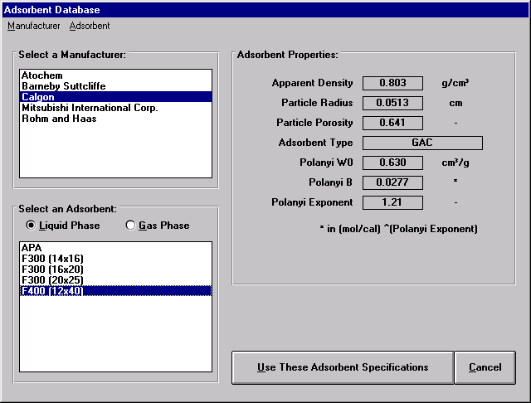

Figure 49: Resin Database window

D. Importing Physical Properties from StEPP™ to IonExDesignS™

To import contaminants (components) and their physical properties to IonExDesignS™ from a StEPP™ export file, click the Add button in the Component Properties frame of the IonExDesignS™ main window. The Component Properties window shown in Figure 50 will appear.
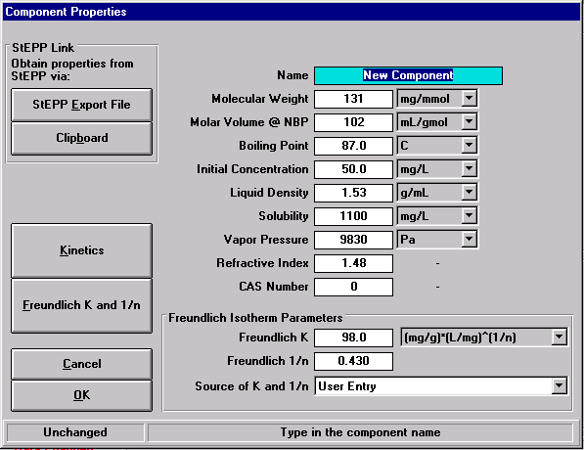

Figure 50: Component Properties window (adding new components)

To open the StEPP™ export file, click the StEPP™ Export File button on the Component Properties window. The Load StEPP™ Export File window shown in Figure 51 will appear.

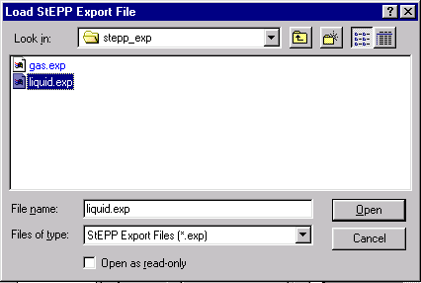

Figure 51: Load StEPP™ Export File window

Select the file which was previously saved in StEPP™. The import confirmation window with the pressure and temperature of the imported data shown in Figure 52 will appear.

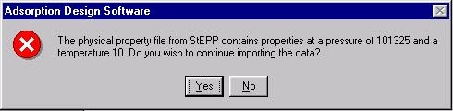

Figure 52: Import Confirmation window

Make sure that these pressure and temperature values are the same as the IonExDesignS™ operating conditions. Click Yes to complete data import. The window shown in Figure 53 announcing the successful import of the components will appear. Click OK to return to the IonExDesignS™ main window.

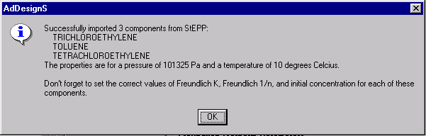

Figure 53: Successful Import of Components from StEPP™ window

E. Entering Initial Concentrations

To edit the contaminant properties, or enter the influent concentration, use the pull-down tab in the field above the Edit Properties button on the IonExDesignS™ main window to select a contaminant, and click Edit Properties to enter the Component Properties window. It is not necessary to return to the IonExDesignS™ main window to edit the properties of multiple components. To switch components in the Component Properties window, use the pull-down menu at the top of the screen as shown in Figure 54.
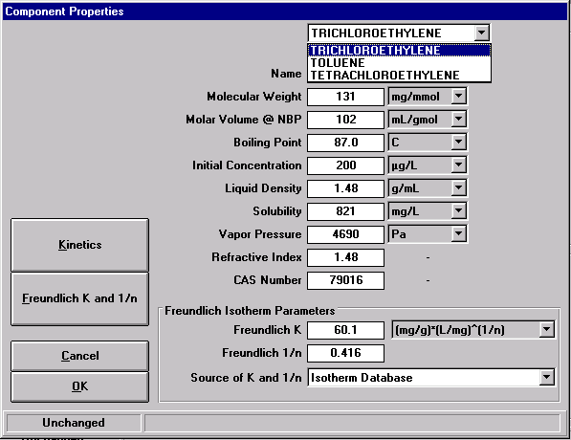

Figure 54: Component Properties window

Initial concentrations are specified in the Component Properties window. The pull-down tab adjacent to this field allows the user to select the units to be used. For this example, all three contaminants have a constant influent concentration of 200 μg/L.

IonExDesignS™ also has the capability to accommodate variable influent concentrations. Click on the Options button on the top menu in the IonExDesignS™ main window and select Influent concentrations. In the Influent Concentrations window shown in Figure 55, the user can enter the concentration data. It is not necessary to enter more than one time if the concentration is constant, however Figure 55 illustrates how a variable concentration can be accommodated (notice that the units of concentration are mg/L). NOTE: For times between variable influent data points, the program linearly interpolates the surrounding two time-concentration data points in order to determine the concentration at those times.

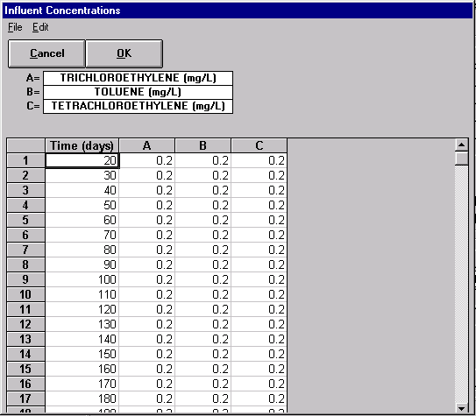

Figure 55: Variable Influent Concentrations window

F. Selecting Freundlich Isotherm Parameters

To edit the contaminant properties and select Freundlich isotherm parameters, click on the Edit Properties button (in Figure 47) to open the Component Properties window. The contaminant properties imported from StEPP™ can be edited in this window, but for this example they will be left as they were in StEPP™.

Freundlich parameters can be obtained from databases, predicted from correlations, or input by the user. The user may select the data source by marking the corresponding option under Source of K and 1/n. For this example, the Freundlich isotherm data for TCE and PCE will be taken from isotherm databases and the isotherm data for toluene will be estimated by the 3-Parameter Polanyi Correlation. In the Component Properties window, click on the Freundlich K and 1/n button to open the Freundlich Isotherm Parameters for Contaminant-X window, as shown in Figure 56.

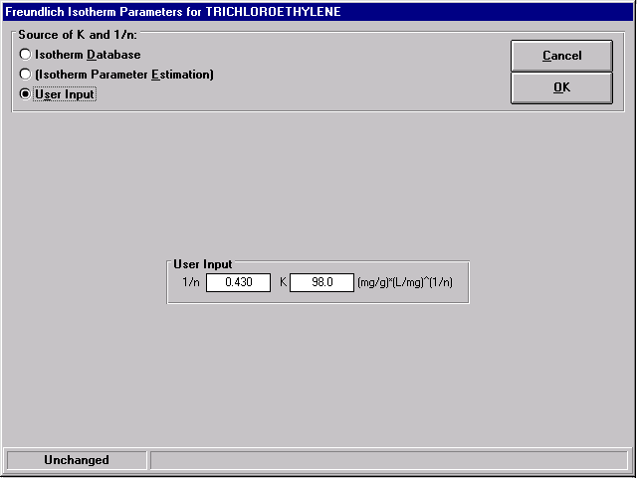

Figure 56: Freundlich Isotherm Parameters window

1. Obtaining Freundlich Isotherm Parameters from Database

To obtain Freundlich isotherm parameters from the isotherm database, mark the Isotherm Database option under Source of K and 1/n on the Freundlich Isotherm Parameters for Contaminant-X window. The Freundlich Isotherm Parameters window will be updated as shown in Figure 57. The contaminant of interest will automatically be selected if the contaminant’s CAS number, which was transferred from StEPP™, matches the CAS number of a contaminant in the isotherm database. The isotherms for the selected chemical are displayed on the right hand side of the window. If the contaminant of interest is not selected it must be found using the scroll bar or the Find button. Pressing the Find Again button will resume the search from the current highlighted name in the list. Click the Select Chemical button to select the highlighted contaminant.

Depending on the contaminant, the isotherm database has different numbers of isotherms available, at various temperatures and pH levels for various resins. The number of isotherms available to choose from are listed in the heading at the top of the frame; in Figure 57, for example, this line reads: “36 Liquid-Phase isotherm(s) for Trichloroethene”. For each set of data, the reference source and the values of K, 1/n, pH range, and concentration range are displayed. If no data is available for the pH range or the concentration range, “No range available” will be displayed instead of numerical values. NOTE: Be sure to use an isotherm for the resin type, operating temperature, and phase you have selected.

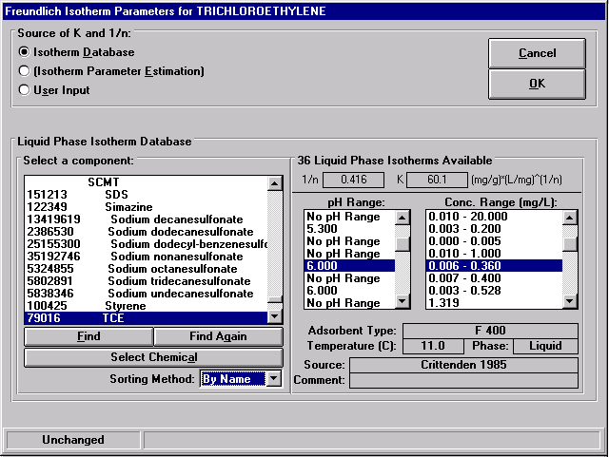

Figure 57: Freundlich Isotherm Parameters for TCE window

To select a pH range or a concentration range, click on one item in the pH or concentration range list. If you click on a pH range, the corresponding concentration range will be highlighted in the concentrations range list.

After the desired isotherm has been selected, click on the OK button to return to the Component Properties window. Select OK to return to the IonExDesignS™ main window. All the contaminant and isotherm properties for TCE that were specified are stored in the active IonExDesignS™ data file. Repeat this process for PCE, selecting the appropriate isotherm as shown in Figure 58.

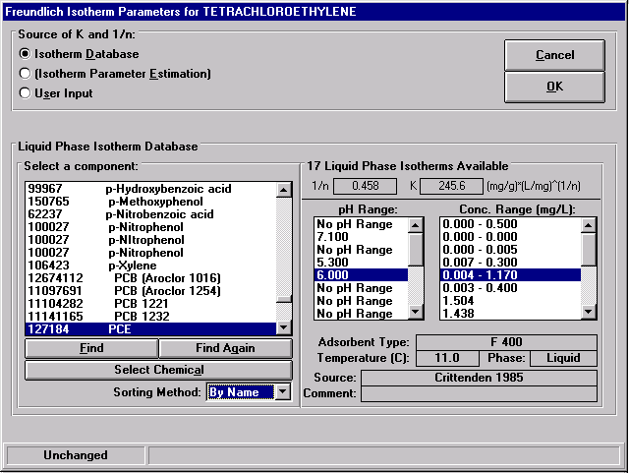

Figure 58: Freundlich Isotherm Parameters for PCE window

2. Obtaining Freundlich Isotherm Parameters by Estimation

Another method of obtaining Freundlich parameters is by using the isotherm parameter estimation (IPE) software. The Freundlich parameters for toluene will be obtained by using the 3-Parameter Polanyi Isotherm Correlation. Select toluene in the Component Properties window (in Figure 54) and open the Freundlich Isotherm Parameters for Contaminant-X window by clicking on the Freundlich K and 1/n button. To obtain Freundlich isotherm parameters using the isotherm parameter estimation techniques, mark the Isotherm Parameter Estimation option under Source of K and 1/n on the Freundlich Isotherm Parameters for Contaminant-X window. The warning message shown in Figure 59 will appear cautioning the user that if Freundlich parameters are not calculated, the values will revert back to the default user input values. The Freundlich Isotherm Parameters window will then be updated as shown in Figure 60.

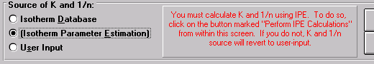

Figure 59: Isotherm Parameter Estimation Warning window

In the Isotherm Parameter Estimation frame, use the pull down tab to select the 3-Parameter Polanyi Isotherm Correlation. Then click the Perform IPE Calculations button to calculate the parameters. The Freundlich Parameters Estimation Results window will then appear as shown in Figure 61. This window displays the input data, the parameters estimated and statistical information pertaining to the correlation. Click Close to return to the previous window. Click on the OK button to return to the Component Properties window. Select OK to return to the main window.

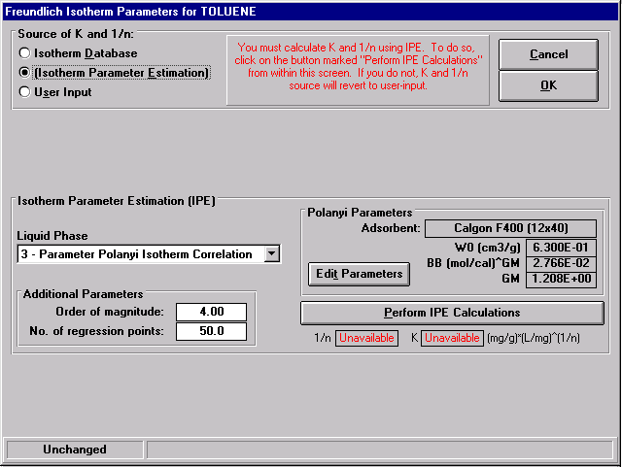

Figure 60: Freundlich Isotherm Parameters for Toluene window

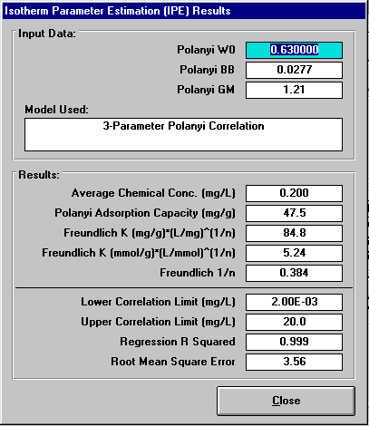

Figure 61: Freundlich IPES Results for Toluene

The simulation is now prepared, with all of the required input data correctly specified to predict carbon usage rates using the Equilibrium Column Model (ECM).

G. Running ECM and Viewing the Simulation Results

Carbon usage rates and breakthrough times can be predicted using the ECM. To run the ECM, highlight the three components in the Component Properties frame of the IonExDesignS™ main window and using the pull-down menu under the Run option on the menu select ECM. A message indicating that the run is complete will appear. To view the results, choose ECM Results under the Results option on the main menu bar. Figure 62 shows the ECM Results window. By choosing an option to the right of the graph, the results can be displayed in one of three ways: C/C_{o} (reduced liquid phase concentration), C (liquid phase concentration in μg/L), or Q (resin phase concentration in μg/g) of the components in all zones in which they are present. Additionally, the bed volumes treated (BVT), volume treated per kg of carbon (VTM), wave velocity, breakthrough time, and mass balance error of each zone are listed in the table at the top of the window. The results can be printed by selecting the appropriate button to the right of the graph.

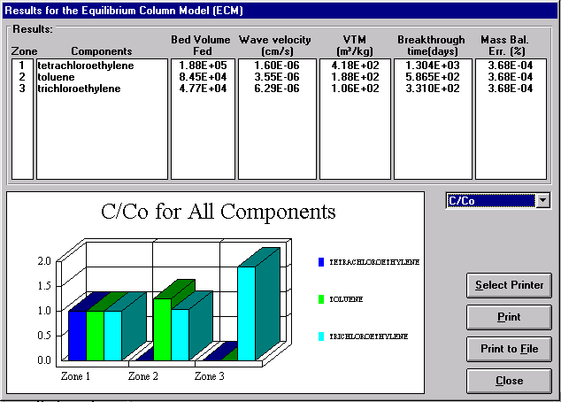

Figure 62: Liquid Phase ECM Results window

From the results for the three contaminants simulated in this example, it is obvious that TCE is the controlling component as it is present in all three zones and has the shortest breakthrough time. Thus TCE should be used for the remainder of the calculations.

The ECM does not take into account mass transfer and, accordingly, serves as an example of the best an ion exchanger can perform for a multi-component system. The model calculates the greatest possible breakthrough times and bed volumes treated, and therefore the highest possible GAC usage rate (volume of water treated per unit mass of resin). The breakthrough time for this system is 331.1 days. The GAC usage rate is the VTM. Therefore, for the ECM a GAC usage rate of 106 m³ water treated per kg GAC was calculated.

H. Running PSDM and Viewing the Simulation Results

1. Further Information for PSDM

In order to use the PSDM to predict carbon usage rates and breakthrough curves, further information must be specified. This includes kinetic parameters (film, surface, and pore diffusion coefficients) as well as simulation parameters.

a. Entering Kinetic Information

In the Component Properties window (Figure 54), ensure TCE is selected and then click on the Kinetics button to open the Kinetic Parameters window, which is shown in Figure 63. Mark the Correlation option for the film diffusion, surface diffusion and pore diffusion coefficients to allow IonExDesignS™ to use correlations to estimate these three parameters for this example. Set the Surface to Pore Diffusion Flux Ratio (SPDFR) to 4.0 and the Tortuosity to 1.0 for this example. Click OK to return to the Component Properties window. Repeat this procedure for the other 2 components.

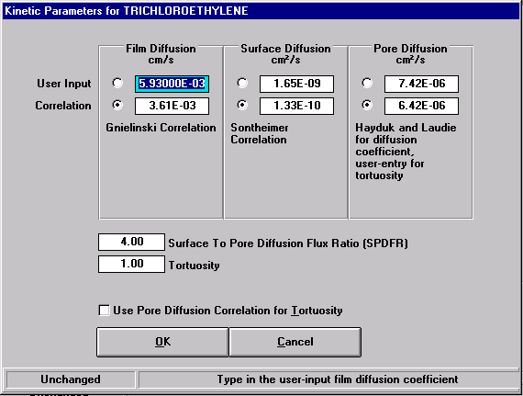

Figure 63: Liquid Phase Kinetic Parameters window

b. Entering Simulation Parameters

The Simulation Parameters frame in the IonExDesignS™ main window requires the user to input the number of axial elements and axial and radial collocation points and the run time, time step and time of first data point to be displayed in the output. Usually, selecting the default values of 8 axial and 3 radial collocation points and 1 axial element will give good results for cases where EBCTs are small (<5 minutes) or pollutant concentrations are large (>1 mg/L). Use the default values for the number of axial and radial collocation points for this example. Increase the number of axial elements to 2.

The user can first perform the ECM calculations to determine the total run time required for PSDM calculations. A common estimate of the total run time is three times the breakthrough time from ECM calculations. For this example, a time step of 2.51 days and a run time of 1000 days will be used. Input these values in the appropriate fields in the Simulation Parameters for PSDM Only frame of the IonExDesignS™ main window. It should be noted that a maximum of 400 data points may be specified and the time step and run time should be set accordingly.

c. Running the PSDM and Viewing Results

To run the PSDM, highlight the three components in the Component Properties frame of the IonExDesignS™ main window and using the pull-down menu under the Run option on the menu bar select PSDM. A window will appear displaying the start and end time of the run and a message indicating that the run is complete, as shown in Figure 64. To view the results, choose PSDM Results under the Results option on the main menu bar. Figure 65 shows the PSDM Results window. The plots of each contaminant in this window are a different color; in order to present a plot which can be interpreted within a black-and-white document, an Excel plot (created using data transferred to Excel from IonExDesignS™) is presented as Figure 66.

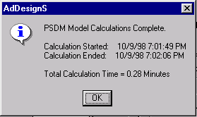

Figure 64: PSDM Completed window

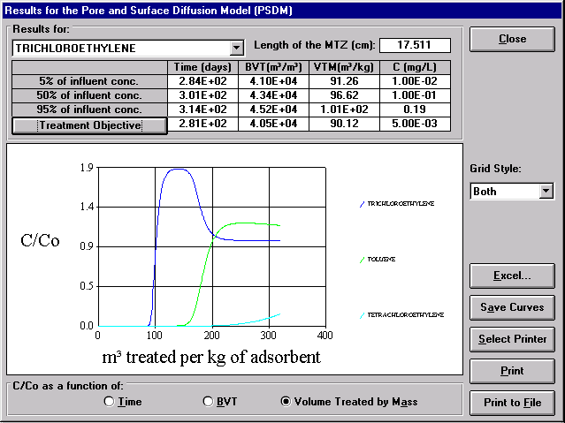

Figure 65: Liquid Phase PSDM Results window

Figure 66: Liquid Phase PSDM Results window

Using the pull-down menu in the Results for frame, the user can select a contaminant for which to see the results. By choosing an option at the bottom of the graph, the breakthrough curves displayed on the window can be displayed three ways: C/C_{o} vs time, C/C_{o} vs Bed Volumes Treated (BVT), or C/C_{o} vs Volume treated per kg carbon (VTM). Additionally, the time to breakthrough, the BVT, VTM and effluent concentration for the treatment objective and 5%, 50% and 95% of the influent concentration are listed in the table at the top of the window. To specify the treatment objective, click on the Treatment Objective button. The treatment objective window shown in Figure 67 will appear. Enter the treatment objective in the highlighted frame. Note that the treatment objective units are in mg/L. Click OK to return to the PSDM Results window. The length of the mass transfer zone (MTZ) is also given. If the contaminant breakthrough curve is longer than the run time specified, the values may not be available and N/A will be displayed in the table.

The results can be saved, exported to Excel or printed, by selecting the appropriate button to the right of the graph.

From the breakthrough curves for the three contaminants simulated in this example, it is obvious that TCE is the controlling component since it is the first component to break through. The breakthrough occurs after 281 days. The GAC usage rate is the VTM. Therefore, for the PSDM a GAC usage rate of 90.11 m³ water treated per kg GAC is calculated for the treatment objective of 5 μg/L or less for all three contaminants. This is the highest GAC usage rate that can be achieved for this example with mass transfer in the absence of NOM fouling.

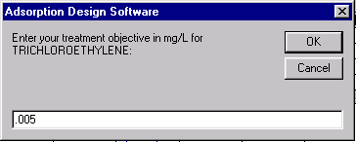

Figure 67: Treatment Objective window

I. Running PSDM with NOM Fouling and Viewing Results

The capacity and kinetics of synthetic organic compound (SOC) ion exchange in fixed beds can be strongly impacted by the presence of natural organic matter (NOM) in surface and ground waters. The presence of NOM effectively shortens the bed life by causing faster propagation of the mass transfer zone through the bed and an overall reduction in bed capacity. IonExDesignS™ provides correlations which can be used to evaluate the impact of NOM on fixed bed ion exchange. IonExDesignS™ allows the user to select from several different water sources. The user has the option of applying an existing NOM correlation or entering their own NOM correlation. For groundwater sources, the recommended default correlation is Karlsruhe groundwater. For surface water sources, the recommended default correlation is Rhine River water (Sontheimer, et al, 1988).

Fouling calculations are only performed on a single component. Consequently, for these calculations the weakest adsorbing component is usually used. Thus, in this example fouling calculations were run on TCE as it was previously determined to be the weakest adsorbing component.

1. Selecting Water Type and Chemical Correlation Type for NOM Fouling

To access the Fouling of GAC window, select Fouling of GAC under Options in the IonExDesignS™ main window. Figure 68 shows the Fouling of GAC window with the opened Water Type pull-down menu. The user can edit the water type list, but for this example it will be assumed that the contaminated well water is similar to Karlsruhe groundwater.
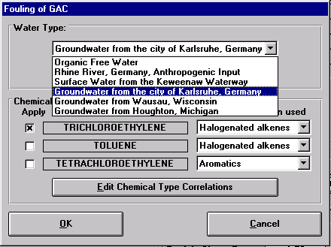

Figure 68: Fouling of GAC window with the Water Type menu open

Figure 69 shows the Type of Correlation pull-down menu used to select which correlation should be used to relate the chemical’s fouling behavior to the reference chemical (TCE).

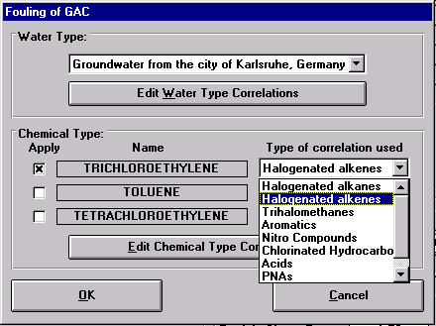

Figure 69: Fouling of GAC window with Type of correlation menu open

2. Setting Simulation Parameters for PSDM with NOM Fouling

For fouling calculations, the simulation parameters in the IonExDesignS™ main window need to be modified. A minimum of 5 radial collocation points are usually required for fouling calculations to prevent numerical error. If numerical error persists, the number of radial collocation points can be increased to 8, or further as needed. For this example, set the number of axial and radial collocation points at 10 and 8, respectively, and the number of axial elements at 1.

3. Editing Kinetic Parameters for PSDM with NOM Fouling

The kinetic parameters of the weakest adsorbing component must also be edited. With TCE selected in the pull-down menu on the Component Properties screen (Figure 54), click on the Kinetics button. Mark the box labeled Use Pore Diffusion Correlation for Tortuosity. The Kinetic Parameters window for TCE is shown in Figure 70.

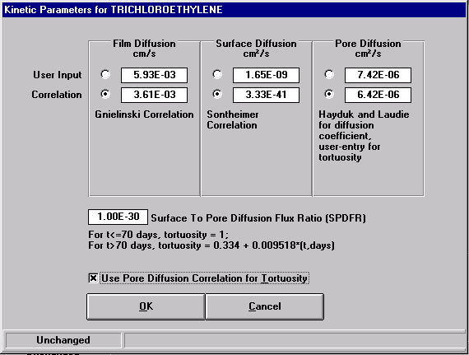

Figure 70: Kinetic Parameters window (TCE with NOM Fouling)

4. Running the PSDM with GAC Fouling by NOM and Viewing Results

To run the PSDM, highlight TCE in the Component Properties frame of the IonExDesignS™ main window and using the pull-down menu under the Run option on the menu bar select PSDM. A window will appear displaying the start and end time of the run and a message indicating that the run is complete, as shown in Figure 71. To view the results, choose PSDM Results under the Results option on the main menu bar. Figure 72 shows the PSDM with NOM Fouling Results window.

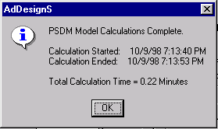

Figure 71: PSDM Completed window

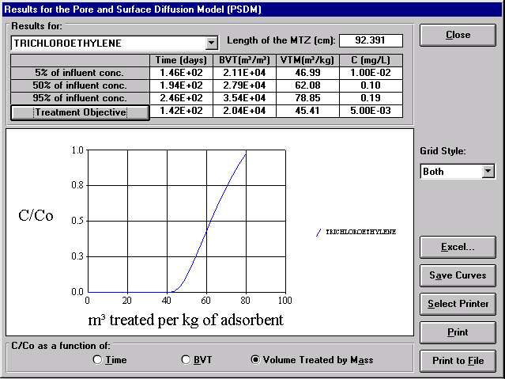

Figure 72: PSDM with NOM Fouling Results window

By choosing an option at the bottom of the graph, the breakthrough curve can be displayed three ways: C/C_{o} vs time, C/C_{o} vs Bed Volumes Treated (BVT), or C/C_{o} vs Volume treated per kg carbon (VTM). Additionally, the time to breakthrough, the BVT, VTM and effluent concentration for the treatment objective and 5%, 50% and 95% of the influent concentration are listed in the table at the top of the window. The treatment objective is specified as described in Section H.1.c. The length of the mass transfer zone (MTZ) is also given. If the contaminant breakthrough curve is longer than the run time specified, the values may not be available and N/A will be displayed in the table.

By selecting the appropriate button to the right of the graph, the results can be exported to Excel or printed.

TCE breakthrough occurs after 142 days. The GAC usage rate is the VTM. Therefore, for the PSDM with NOM fouling, a GAC usage rate of 45.43 m³ water treated per kg GAC is calculated for the treatment objective of 5 μg/L or less for all three contaminants.

J. Running CPHSDM and Viewing the Simulation Results

The Constant Pattern Homogenous Surface Diffusion Model (CPHSDM) is a single component, fixed bed ion exchanger model. For a multi-component system, ECM calculations must first be made to determine the component which breaks through first. The system can then be reduced to a single compound to use in CPHSDM calculations. For this example, ECM calculations found the weakest adsorbing compound to be TCE.

1. Reducing Freundlich K Value

Before running the CPHSDM on the weakest adsorbing component, the Freundlich K value for this component must be reduced until the bed volumes treated (BVT) for single component ECM calculations with the reduced Freundlich K is the same as for the multi-component ECM calculations with the original Freundlich K. Before changing the Freundlich K value, first note the BVT from the results of the multi-component ECM. Then, turn off all fouling correlations that were used in the PSDM model (first, change water type to organic free and uncheck TCE in the Fouling of GAC window (Figure 68); then uncheck the Use Pore Diffusion Correlation for Tortuosity in the Kinetic Parameters window (Figure 70).

To change the Freundlich K value for a component, select the component in the pull-down menu in the Component Properties frame of the IonExDesignS™ main window and click the Edit Properties button. Make a note of the values of K and 1/n in the Freundlich Isotherm Parameters frame. Use the pull-down tab to change the Source of K and 1/n to User Entry. Enter the original value for 1/n and a lower value of K. Click OK to return to the IonExDesignS™ main window. Highlight the weakest adsorbing component (TCE in this example) and run ECM calculations. View the ECM results and compare the BVT value with that of the multi-component system. Decrease the Freundlich K value for the weakest adsorbing component until the value of BVT equals the original BVT in the multi-component ECM results. Table 3 details the trial and error process of obtaining the reduced Freundlich K value. For this example the values used for K and 1/n are 41.5 and 0.416, respectively.

 | Freundlich K | BVT
ECM | 60.1 | 47,700
Reduction #1 | 45 | 51,800
Reduction #2 | 42 | 48,300
Reduction #3 | 41 | 47,200
Reduction #4 (CPSHDM) | 41.5 | 47,700

Table 3: Liquid Phase Freundlich K Reduction

2. Running CPHSDM and Viewing Results

To run the CPHSDM calculations, highlight TCE in the Component Properties frame of the IonExDesignS™ main window and using the pull-down menu under the run option on the menu bar select CPHSDM. A message indicating that the run is complete will appear. To view the results, choose CPHSDM Results under the Results option on the main menu bar. Figure 73 shows the CPHSDM Results window.

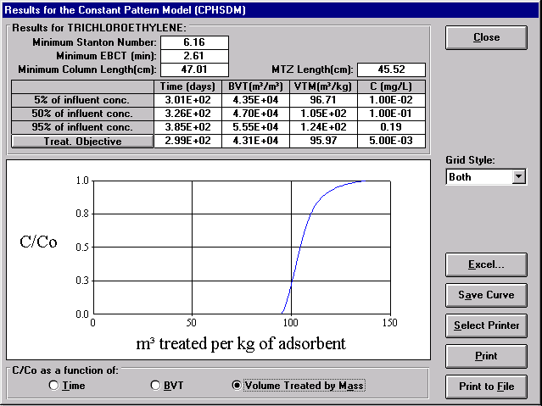

Figure 73: Liquid Phase CPHSDM Results window

By choosing an option at the bottom of the graph, the breakthrough curve displayed on the window can be viewed in one of three ways: C/C_{o} vs time, C/C_{o} vs Bed Volumes Treated (BVT), or C/C_{o} vs Volume water treated per kg carbon (VTM). Additionally, the breakthrough time, BVT, VTM and effluent concentrations for the treatment objective and 5%, 50% and 95% of the influent concentration are listed in the table at the top of the window. The treatment objective is specified as described in Section H.1.c. The length of the mass transfer zone (MTZ) is also displayed. If the contaminant breakthrough curve is longer than the run time specified, the values may not be available and N/A will be displayed in the table.

By selecting the appropriate button to the right of the graph, the results can be saved, exported to Excel or printed.

TCE breakthrough occurs after 299 days. The GAC usage rate is the VTM. Therefore, for the CPHSDM, a GAC usage rate of 95.97 m³ water treated per kg GAC is calculated for the treatment objective of 5 μg/L or less for all three contaminants. This model provides a quick estimate of the GAC usage rate that can be achieved with mass transfer in the absence of NOM fouling.

K. Comparison of Liquid Phase Model Results

Table 4 provides a comparison of the results from the four models run: ECM, CPHSDM, PSDM, and PSDM with NOM fouling. Note that taking into account mass transfer (i.e., using the PSDM) results in an approximately 15 percent reduction in the breakthrough time and GAC usage rate calculated using the ECM. This shows that mass transfer effects on TCE due to PCE and toluene are small. Taking into account both mass transfer and NOM fouling (i.e., using the PSDM with NOM fouling) results in an approximately 57 percent reduction in breakthrough time and GAC usage rate calculated using the ECM. Consequently, it appears that for this case NOM fouling is the major factor controlling GAC usage rates. The PSDM with NOM fouling calculations give the lowest GAC usage rate that can be achieved for this liquid phase example.

Model | Breakthrough time (days) | GAC usage rate (m³ water/kg)
ECM | 331.2 | 106
CPHSDM | 299 | 95.97
PSDM | 281 | 90.11
PSDM with NOM Fouling | 142 | 45.43

Table 4: Comparison of Liquid Phase Model Results

L. Gas Phase Ion exchange Simulation with IonExDesignS™

Air stripping can be used to remove VOCs from contaminated water. Concerns have been raised that the VOC removal may result in air pollution. The off-gas of air strippers can be treated using gas phase GAC ion exchange to remove VOCs. Figure 74 provides a schematic of air stripping followed by gas phase GAC ion exchange.

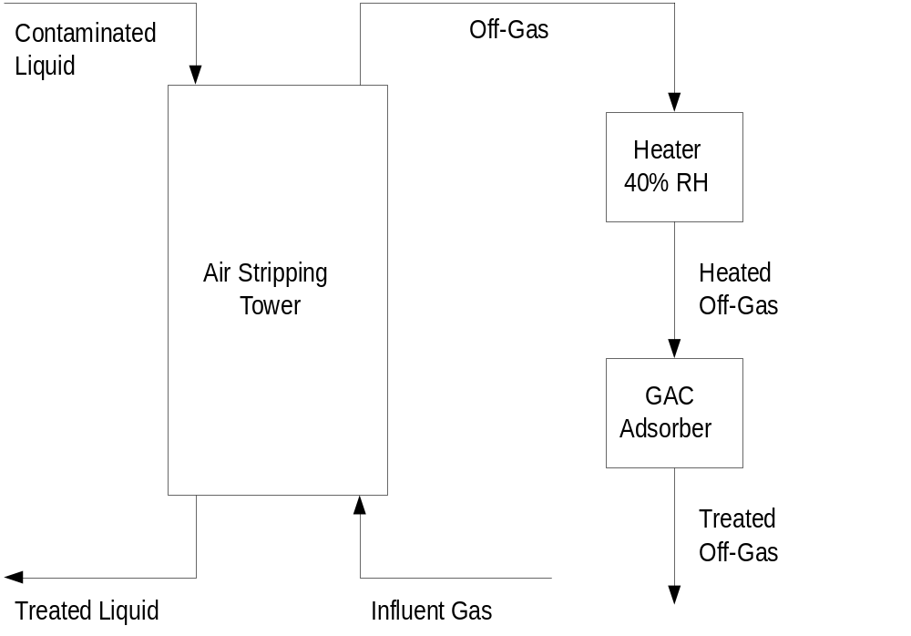

Figure 74: Air Stripper with GAC Off-Gas Treatment

1. ASAP™ and StEPP™

ASAP™ is used to design the air stripping tower used prior to gas phase ion exchange. The program provides the user with the tower area, diameter, and height as well as the liquid effluent concentrations and the off gas flow rate. Information on the use of ASAP™ is provided in the ASAP™ manual.

To obtain the above mentioned information from ASAP™, run ASAP™ in the Packed Aeration Tower Design Mode. The information in Table 5 must be entered to generate the desired results.

TCE, PCE and toluene are imported from StEPP™ by clicking on the Add button and opening a previously created StEPP™ export file. Before importing contaminants from StEPP™ the user should first delete all chemicals from the ASAP™ contaminant box. Influent concentrations and treatment objectives must be specified for each contaminant. Click on Edit Properties in the Design Contaminant frame of the ASAP™ main window. Enter the influent concentration (200 μg/L) and treatment objective (5 μg/L) in the appropriate text boxes.

Operating Conditions
Pressure (Pa) | 101325.00
Temperature (°C) | 10.0
Packing Type | Tri-Packs No. 1
Design Contaminants | Trichloroethylene  Tetrachloroethylene  Toluene
Water flow rate (gpm) | 1500
Air to water ratio (vol/vol) | 29.7
Kla Safety Factor | 0.8

Table 5: ASAP™ Inputs

Select toluene as the design contaminant using the pull-down menu in the Design Contaminant frame. ASAP™ calculates the aeration tower design properties, presented in table 6.

Design Properties:
Air flow rate (m³/s) | 2.81
Tower area (m²) | 4.755
Tower diameter (m) | 2.461
Tower height (m) | 8.025

Table 6: ASAP™ Air Stripping Tower Design Results

To view the concentration results click on the Concentration Results button. ASAP™ provides the user with the liquid effluent concentrations (C_{eff}) of the contaminants. These values are presented in Table 7. The user must then calculate the off-gas concentrations. A sample calculation for toluene is presented below.

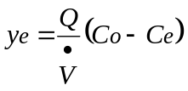
where:
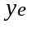 is the off-gas concentration
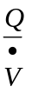 is the air to water ratio
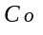 is the liquid influent concentration
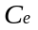 is the liquid effluent concentration

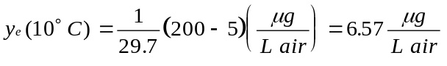

For gas phase ion exchange calculations the influent gas must be at a relative humidity of less than 50% or water vapor will impact GAC capacity. For air stripping off-gases the relative humidity is usually 100% and must be reduced. This can be done by heating the air stream prior to entering the ion exchanger. For this example, the relative humidity will be reduced to 40%. A psychrometric chart is used to determine the temperature of the air stream after heating. The air stream temperature was found to be 24°C at 40% relative humidity. Having determined the air stream temperature, the concentration of the air stream must be corrected according to the following equation. A sample calculation for toluene is presented.

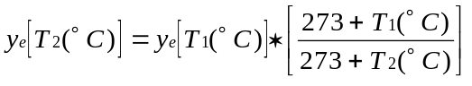
where:
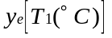 is the off-gas concentration
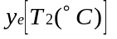 is the heated air stream concentration
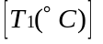 is the off-gas temperature
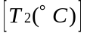 is the heated air stream temperature

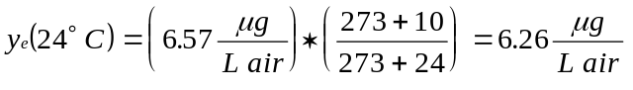

The results of these calculations for all three contaminants are presented in Table 7.

 | Concentration (μg/L)
 | TCE | PCE | Toluene
Stripping tower influent (liquid) | 200 | 200 | 200
Stripping tower effluent (liquid) | 2.98 | 2.51 | 5.00
Stripping tower off-gas | 6.63 | 6.65 | 6.57
GAC ion exchanger influent (gas) | 6.32 | 6.34 | 6.26

Table 7: Treatment Stream Concentrations

The values for GAC ion exchanger influent concentrations are the initial concentrations which should be entered in IonExDesignS™.

2. IonExDesignS™ Inputs

The following steps must be followed to prepare IonExDesignS™ to run the gas phase ion exchange models.

a. Gas Phase Selection

The default setting for IonExDesignS™ is liquid phase ion exchange. In order to simulate gas phase ion exchange, the phase setting must be changed. To change to the gas phase, click on the Phase button on the top menu in the IonExDesignS™ main window and select Gas Phase, as shown in Figure 75.

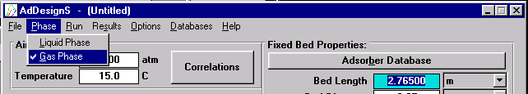

Figure 75: Selection of Gas Phase

The completed IonExDesignS™ main window for this gas phase simulation is presented as Figure 76.

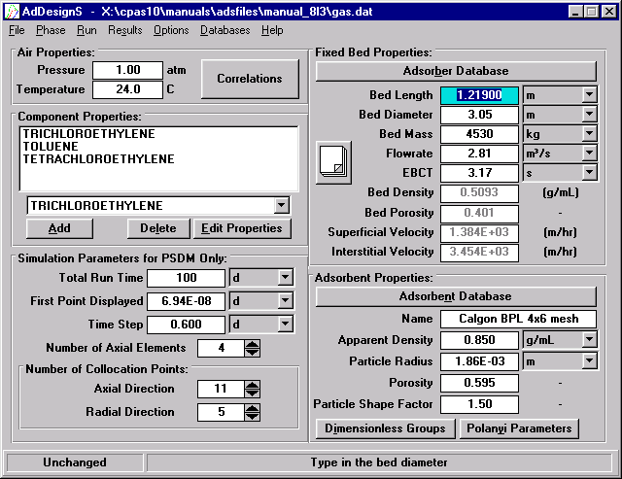

Figure 76: Completed Gas Phase IonExDesignS™ Main window

b. Entering Air Properties

In the Air Properties frame in the IonExDesignS™ main window the operating temperature and pressure can be entered. Enter 24ºC and 1 atm for this example. As a default, IonExDesignS™ uses correlations to calculate the air density and air viscosity for the given temperature and pressure. To override the default correlations and input values for air density and air viscosity, click on the Correlations button to open the Air Properties window shown in Figure 77 and unclick the Density and Viscosity boxes and input values for these parameters. For this example, use the correlations for air density and viscosity. Click OK to return to the IonExDesignS™ main window.

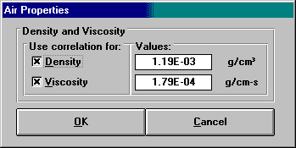

Figure 77: Air Properties window

c. Entering Fixed Bed Properties

IonExDesignS™ requires the user to specify the following information about the fixed bed: length, diameter, mass of carbon present and flow rate entering the bed. The EBCT is calculated from the given dimensions and flow rate. A built-in check warns the user if the bed dimensions specified do not accommodate the mass of carbon specified. Enter the required information in the fixed bed properties frame (Figure 76) by highlighting the proper field, entering the number and pressing enter. Note that the pull-down menu tab to the right of each field allows the user to specify the units to be used. Make sure the proper units are selected before entering the data.

The Fixed Bed Properties frame (Figure 76) also calculates and displays the bed density and porosity as well as the superficial and interstitial velocities.

Ion exchange System Properties (for typical commercially available ion exchanger)

- Bed Length 1.219 m
- Bed Diameter 3.048 m
- Resin Calgon BPL GAC (4x6 mesh)
- Bed Mass 4530 kg
- Flowrate 2.81 m³/s

These values result in an EBCT of 3.17 seconds and a superficial velocity of 1,386 m/hr (0.385 m/s). Typical EBCTs for gas phase ion exchange range from 1.5 to 5 seconds. Superficial velocities range from 0.25 to 0.50 m/s.

d. Entering Resin Properties

In the Resin Properties frame (Figure 76), click on the Resin Database button to select the resin to use. Figure 78 shows the Resin Database window that will appear. Note that when selecting a resin type, the Liquid Phase or Gas Phase button must be selected. This portion of the sample calculations is concerned with the gas phase and uses Calgon BPL 4x6 mesh carbon as the resin. Select the manufacturer (Calgon) and the resin (BPL 4x6 mesh). The physical properties and Polanyi parameters of the carbon resin selected are shown in the Resin Properties frame. After clicking Use These Resin Specifications, the physical properties of the carbon resin will appear in the IonExDesignS™ main window.

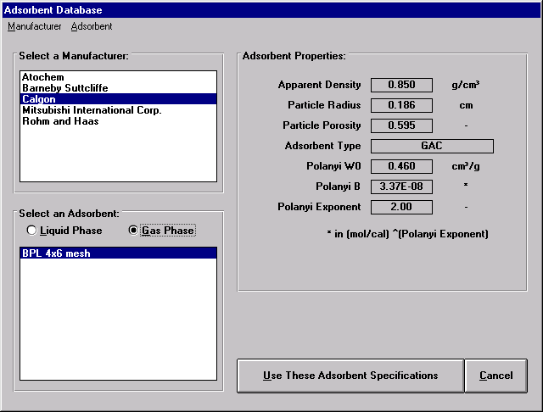

Figure 78: Resin Database window

In the Resin Properties frame of the IonExDesignS™ main window enter a value of 1.5 for the Particle Shape Factor (PSF). The PSF is a dimensionless quantity and is the ratio of the actual surface area of a resin particle to the surface area of an equivalent-volume sphere. A PSF value of 1.0 indicates that the resin particle is spherical.

e. Importing Contaminants and Physical Properties from StEPP™ to IonExDesignS™

Create a StEPP™ export file as described in Section A. Enter 24°C and 101325 Pa as the operating conditions for this portion of the sample calculation. Select the contaminants and save the data to an export file (gas.exp). To import contaminants (components) and their physical properties to IonExDesignS™ from a StEPP™ export file, click the Add button in the Component Properties frame of the IonExDesignS™ main window. The Component Properties window shown in Figure 79 will appear.

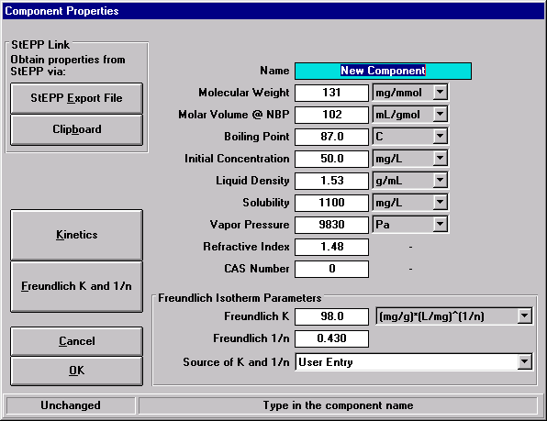

Figure 79: Component Properties window (adding new components)

To open the StEPP™ export file, click the StEPP™ Export File button on the Component Properties window. The Load StEPP™ Export File window shown in Figure 80 will appear.
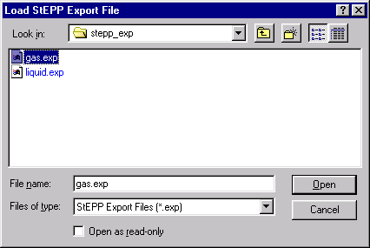

Figure 80: Load StEPP™ Export File window

Select the file which was previously saved in StEPP™. The import confirmation window with the pressure and temperature of the imported data shown in Figure 81 will appear.

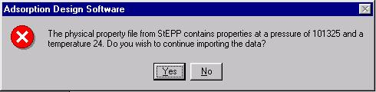

Figure 81: Import Confirmation window

Make sure that these pressure and temperature values are the same as the IonExDesignS™ operating conditions. Click Yes to complete data import. The window shown in Figure 82 announcing the successful import of the components will appear. Click OK to return to the IonExDesignS™ main window.

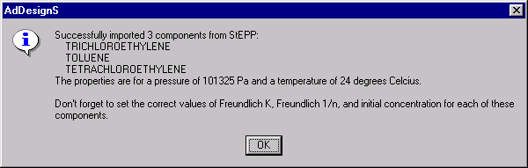

Figure 82: Successful Import of Components from StEPP™ window

f. Editing Contaminant Properties and Entering Initial Concentrations

To edit the contaminant properties, or enter the influent concentration, use the pull-down tab in the field above the Edit Properties button on the IonExDesignS™ main window to select a contaminant, and click Edit Properties to enter the Component Properties window. It is not necessary to return to the IonExDesignS™ main window to edit the properties of multiple components. To switch components in the Component Properties window, use the pull-down menu at the top of the screen as shown in Figure 83.

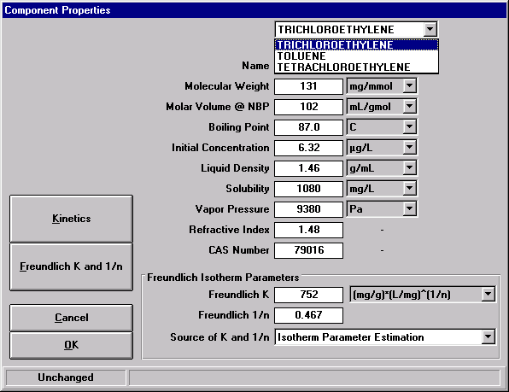

Figure 83: Component Properties window

Initial concentrations are specified in the Component Properties window. The pull-down tab adjacent to this field allows the user to select the units to be used. For this example, enter the GAC ion exchanger influent concentrations listed in Table 7 as the initial concentration for each of the contaminants.

g. Selecting Freundlich Isotherm Parameters

To edit the contaminant properties and select Freundlich isotherm parameters, click on the Edit Properties button (Figure 76) to open the Component Properties window. The contaminant properties imported from StEPP™ can be edited in this window, but for this example they will be left as they were in StEPP™.

Freundlich parameters can be obtained from databases, predicted from correlations, or input by the user. The user may select the data source by marking the corresponding option under Source of K and 1/n. For this example, the Freundlich isotherm parameters for all three contaminants will be estimated using the D-R Based on Spreading Pressure Evaluation. In the Component Properties window, click on the Freundlich K and 1/n button to open the Freundlich Isotherm Parameters for Contaminant-X window, as shown in Figure 84.

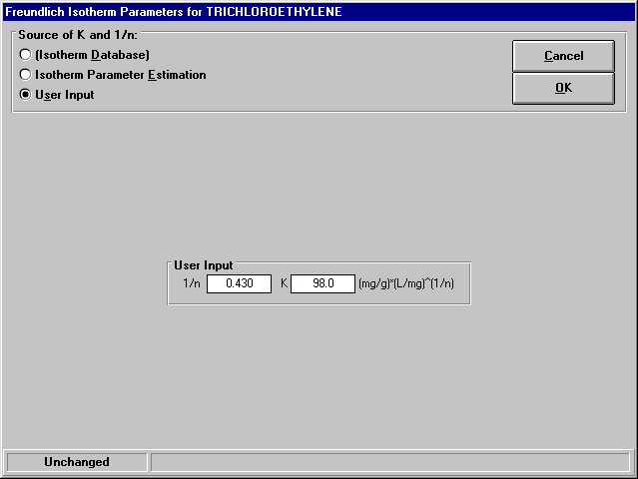

Figure 84: Freundlich Isotherm Parameters window

To obtain Freundlich isotherm parameters using the isotherm parameter estimation techniques, mark the Isotherm Parameter Estimation option under Source of K and 1/n on the Freundlich Isotherm Parameters for Contaminant-X window. The warning message shown in Figure 85 will appear cautioning the user that if Freundlich parameters are not calculated, the values will revert back to the default user input values. The Freundlich Isotherm Parameters window will then be updated as shown in Figure 86.

Figure 85: Isotherm Parameter Estimation Warning message

In the Isotherm Parameter frame D-R Based on Spreading Pressure Evaluation will be selected, as shown in Figure 86. Click the Perform IPE Calculations button to calculate the parameters. The Freundlich Parameters Estimation Results window will then appear as shown in Figure 87. This window displays the input data, the parameters estimated and statistical information pertaining to the correlation. Click Close to return to the previous window. Click on the OK button to return to the Component Properties window. Select OK to return to the main window. Table 8 summarizes the results of Freundlich isotherm parameter estimation.

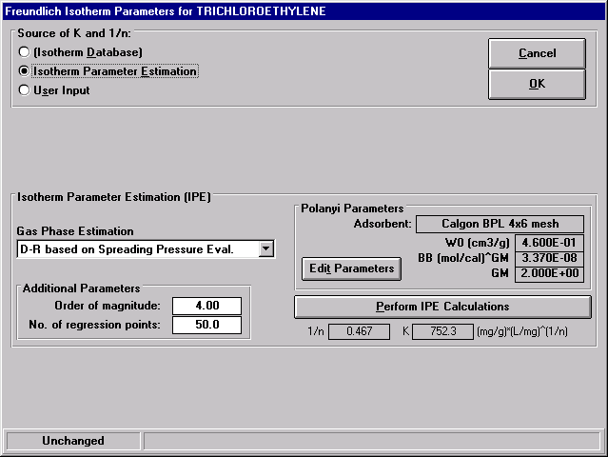

Figure 86: Freundlich Isotherm Parameters for TCE window

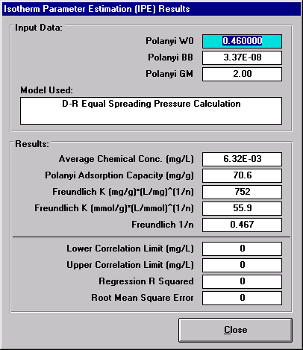

Figure 87: Freundlich IPES Results for TCE

Contaminant | Freundlich K (mg/g)(L/mg)^{1/n} | Freundlich 1/n
TCE | 752 | 0.467
PCE | 1038 | 0.313
Toluene | 570 | 0.303

Table 8: Gas Phase Freundlich Parameter Estimation Results

h. Entering Kinetic Information

In the Component Properties window (Figure 79), click on the Kinetics button to open the Kinetic Parameters window, shown in Figure 88. Mark the Correlation option for the film diffusion, surface diffusion and pore diffusion coefficients to allow IonExDesignS™ to use correlations to estimate these three parameters for this example. Set the Surface to Pore Diffusion Flux Ration (SPDFR) to 16.000 and the tortuosity to 1.000 for this example. Click OK to return to the Component Properties window. Repeat this procedure for all three components.

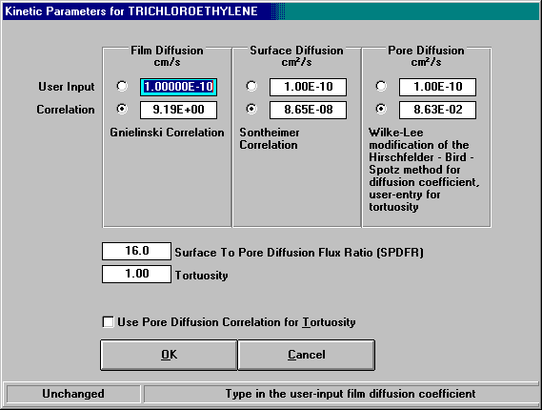

Figure 88: Gas Phase Kinetic Parameters window

3. Running the Gas Phase ECM

Carbon usage rates and breakthrough times can be predicted using the ECM. The gas phase ECM is run in the same manner as the liquid phase ECM. To run the ECM, highlight the three components in the Component Properties frame of the IonExDesignS™ main window and using the pull-down menu under the Run option on the menu bar select ECM. A message indicating that the run is complete will appear. To view the results, choose ECM Results under the Results option on the main menu bar. Figure 89 shows the results of the gas phase ECM calculations. By choosing an option to the right of the graph, the results can be displayed in one of three ways: C/C_{o} (reduced liquid phase concentration), C (liquid phase concentration in μg/L), or Q (resin phase concentration in μg/g) of the components in all zones in which they are present. Additionally, the bed volumes treated (BVT), volume treated per kg of carbon (VTM), wave velocity, breakthrough time, and mass balance error of each zone are listed in the table at the top of the window. The results can be printed by selecting the appropriate button to the right of the graph.

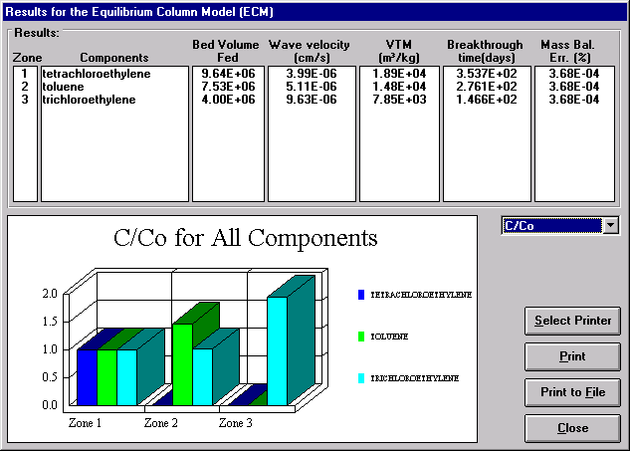

Figure 89: Gas Phase ECM Results

From the results for the three contaminants simulated in this example, it is obvious that TCE is the controlling component as it is present in all three zones and has the shortest breakthrough time.

The ECM does not take into account mass transfer and, accordingly, serves as an example of the best an ion exchanger can perform for a multi-component system. The model calculates the greatest possible breakthrough times and bed volumes treated, and therefore the highest possible GAC usage rate. The breakthrough time for this system is 146.6 days. The GAC usage rate is the volume treated per mass of resin (VTM); for the gas phase ECM, a GAC usage rate of 7850 m³ air treated per kg GAC was calculated.

4. Running the Gas Phase CPHSDM

The CPHSDM is a single component, fixed bed ion exchanger model. The gas phase CPHSDM is run in the same manner as the liquid phase CPHSDM. For a multi-component system, ECM calculations must first be made to determine the component which breaks through first. The system can then be reduced to a single compound to use in CPHSDM calculations. For this example, ECM calculations found the weakest adsorbing compound to be TCE.

Before running the CPHSDM on the weakest adsorbing component, the Freundlich K value for this component must be reduced until the bed volumes treated (BVT) for single component ECM calculations is the same as for the multi-component ECM calculations. Before changing the Freundlich K value, note the BVT from the results of the multi-component ECM. To change the Freundlich K value for a component, select the component in the pull-down menu in the Component Properties frame of the IonExDesignS™ main window and click the Edit Properties button. Make a note of the values of K and 1/n in the Freundlich Isotherm Parameters frame. Use the pull-down tab to change the Source of K and 1/n to User Entry. Enter the original value for 1/n and a lower value of K. Click OK to return to the IonExDesignS™ main window. Highlight the weakest adsorbing component (TCE in this example) and run ECM calculations. View the ECM results and compare the BVT value with that of the multi-component system. Decrease the Freundlich K value for the weakest adsorbing component until the BVT values are equal. Table 9 details the trial and error process of obtaining the reduced Freundlich K value. The reduced values of K and 1/n used for this example were 529 and 0.467, respectively.

 | Freundlich K (mg/g)(L/mg)^{1/n} | BVT
ECM | 752.3 | 4,000,000
Reduction #1 | 650 | 4,920,000
Reduction #2 | 500 | 3,780,000
Reduction #3 | 528 | 3,990,000
Reduction #4 (CPSHDM) | 529 | 4,000,000

Table 9: Gas Phase Freundlich K Reduction

To run the CPHSDM calculations, highlight TCE in the Component Properties frame of the IonExDesignS™ main window and using the pull-down menu under the Run option on the menu bar select CPHSDM. A message indicating that the run is complete will appear. To view the results, choose CPHSDM Results under the Results option on the main menu bar. Figure 90 shows the CPHSDM Results window.

By choosing an option at the bottom of the graph, the breakthrough curve displayed on the window can be viewed in one of three ways: C/C_{o} vs time, C/C_{o} vs Bed Volumes Treated (BVT), or C/C_{o} vs Volume air treated per kg carbon (VTM). Additionally, the breakthrough time, BVT, VTM and effluent concentrations for the treatment objective and 5%, 50% and 95% of the influent concentration are listed in the table at the top of the window. The treatment objective is specified as described in Section H.1.c. The length of the mass transfer zone (MTZ) is also given. If the contaminant breakthrough curve is longer than the run time specified, the values may not be available and N/A will be displayed in the table.

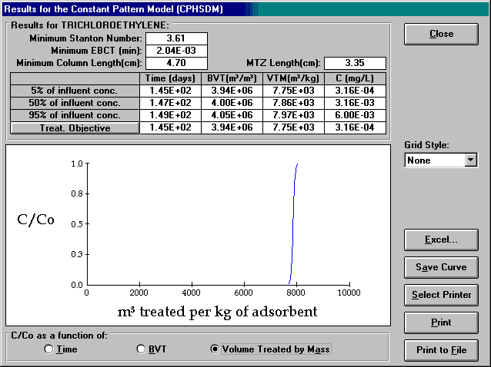

Figure 90: Gas Phase CPHSDM Results

By selecting the appropriate button to the right of the graph, the results can be saved, exported to Excel, or printed.

TCE breakthrough occurs after 145 days. The GAC usage rate is the volume treated per mass of resin (VTM); for the gas phase CPHSDM, a GAC usage rate of 7750 m³ air treated per kg GAC is calculated for the default treatment objective of 0.316 μg/L or less for all three contaminants.

5. PSDM Gas Phase model

The PSDM gas phase model can be run on systems in which the mass transfer zone occupies a relatively large portion of the bed length. However, for this system the mass transfer zone occupies only 3.35 cm (as calculated by the CPHSDM) of the 121.9 cm (4 ft) bed or 2.75%. This results in a stiff system of ordinary differential equations which the PSDM cannot solve. A comparison of the results of the gas phase ECM and CPHSDM shown in Table 10 indicates that taking into account mass transfer has little effect on the results. Therefore, the ECM results can be used in place of PSDM results for this example.

Model | Breakthrough time (days) | GAC usage rate (m³air/kg)
ECM | 146.6 | 7850
CPHSDM | 145 | 7750

Table 10: Comparison of Gas Phase Model Results

M. Comparison of Liquid and Gas Phase Ion exchange Model Results

In order to compare the liquid and gas phase results, the gas phase GAC usage rates must be converted to liquid phase GAC usage rates. This is done by dividing the gas phase usage rates by the air to water ratio as follows:

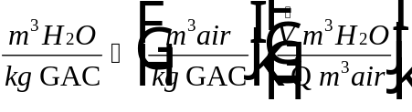

For this example = 29.7, therefore 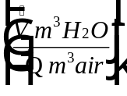= 0.0337. Using this value, the gas phase GAC usage rates were converted to liquid phase GAC usage rates. Table 11 provides a comparison of the GAC usage rates for the liquid and gas phase models presented in m³ water treated per kg GAC.

Model | GAC Usage Rate (m³ water treated per kg GAC)
Liquid phase ECM | 106
Liquid phase CPHSDM | 96.71
Liquid phase PSDM | 91.26
Liquid phase PSDM w/ NOM Fouling | 46.99
Gas phase ECM | 290.45
Gas phase CPHSDM | 286.5

Table 11: Comparison of Liquid and Gas Phase Model Results

The lowest GAC usage rate for liquid phase is 46.99 m³ water treated per kg GAC, as calculated using the liquid phase PSDM with NOM fouling. By comparison, the lowest GAC usage rate for gas phase is 286.5 m³ water treated per kg GAC, calculated using the gas phase CPHSDM. When selecting a treatment method the added cost of air stripping and humidity reduction must be taken into account for gas phase ion exchange.

Appendix A: ECM Equations

Following Crittenden, et al (1987), let us consider the interface between zones k-1 and k. The following equation is obtained from the mass balance at front k-1 for component i in zone k:

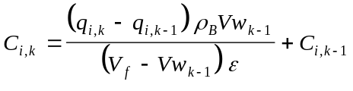 (A-1)

where : 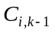 is the liquid-phase concentration of component i in zone k-1 (mg/L)
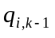 is the solid-phase concentration of component i in zone k-1 (mg/L)
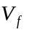 is the interstitial fluid velocity (m/s)
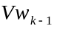 is the velocity of the wave front k-1(m/s)
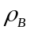 is the bulk density of the column
ε is the bed void fraction.

Equation A-1 is valid for components which are present in zone k, i.e. components k through N. This equation can be applied only for k greater than 1. In zone 1, the liquid phase concentrations in the mixture are equal to the initial inlet concentrations.

The wave velocity 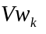 is determined from a mass balance over the entire bed length when zone k breaks through. The mass balance is made for component k, which is present from zone 1 through zone k. The following expression results from rearrangement of that equation:

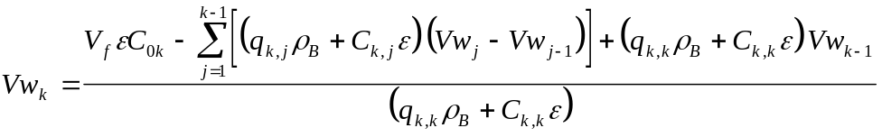 (A-2)

in which 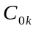 is the influent concentration of component k (mg/L). Equation A-2 is valid for k > 1.

The velocity of the wave front of zone 1 is obtained from the following equation:

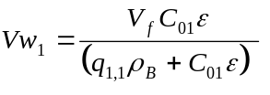 (A-3)

where 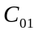 is the initial concentration for component 1 (mg/L) and 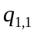 is the solid phase concentration of component 1 in zone 1 (mg/g).

Ideal adsorbed solution theory (IAST) describes the competitive interactions between the components in a mixture and is derived from single component isotherms. The IAST equation for zone k and component i is given by the following expression:

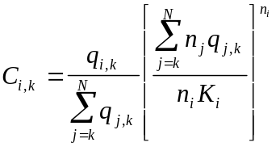 (A-4)

Equation A-5 was developed from the Freundlich isotherm equation which represents the single component equilibria of solute i:

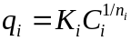 (A-5)

in which K_{i} is the Freundlich ion exchange capacity parameter of component i [(mg/g)(L/mg)^{1/n}] and 1/n_{i} is Freundlich ion exchange intensity parameter for component i (dimensionless).

Equation A-1, A-2 and A-4 defined above can be applied for all components in zones greater than one. All the concentrations and the front velocities are determined starting from zone 1 and progressing to the end of the bed. In zone 1, the liquid phase concentrations are known and equal to the influent concentrations. Only the solid phase concentrations are unknown. They can be calculated using IAST (i.e. equation A-4). N equations are solved in the first zone where the N unknowns are the solid phase concentrations. Once zones 1 through k-1 has been solved, 2N-2k+2 equations are solved in zone k. The unknowns are the solid and liquid phase concentrations for components k through N. Components 1 through k-1, which are the k-1 most strongly adsorbed components, are already adsorbed in zones 1 through k-1. To solve these equations, equations A-1 and A-2 are combined since both Ci,k and qi,k are unknown. This leads to the following set of N-k+1 equations :

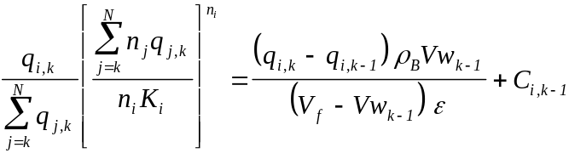 (A-6)

with i=k, ..., N.

Once the solid phase concentrations (qi,k‘s) are known, the liquid phase concentrations (Ci,k's) are calculated from equation A-3. Then, the velocity of the wave front k is calculated from equation A-2.

Once all the liquid and solid phase concentrations have been determined, the number of bed volumes treated to breakthrough and the carbon usage rate for component i can be calculated using the following equations:

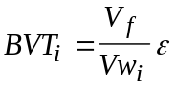 (A-7)

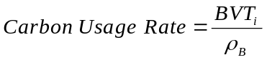 (A-8)

where i refers to component number i.

BVTi is the bed volumes of feed that may be treated before breakthrough. Since the mass transfer resistance is ignored, the value of the Bed Volumes Treated is the largest that could be obtained. Similarly, the Carbon Usage Rate is the largest value possible. The carbon usage rate (in m³ of water treated per kg GAC) is very useful in quickly determining the mass of GAC needed for a given treatment objective.

Nomenclature

BVT_{i} Bed Volume Treated -
C_{i,j} liquid--phase concentration of component i in zone j M/L³
C_{0k} influent liquid-phase concentration of component k M/L³
K_{i} Freundlich capacity parameter for component i (M/M)×(L³/M)^{1/ni}
N number of components -
1/n_{i} Freundlich parameters for component i --
Q flow rate L³/T
q_{i,j} solid-phase concentration of component i in zone j M/M
t time T
Vf interstitial fluid velocity L/T
Vw_{k} velocity of front k L/T
ε bed void fraction -
ρ_{B} bulk density of bed M/L³

Appendix B: CPHSDM Equations

The CPHSDM solutions were obtained by generating all possible solutions to the HSDM numerical model (Hand, et al, 1984). A sensitivity analysis was performed to reduce the model solutions to a reasonable number without sacrificing the model’s predictive capability. Tables B1 and B2 display the solutions to the CPHSDM that use simple algebraic equations. Three dimensionless parameters: 1/n, Bi and St_{min} are required to obtain model solutions. St_{min} is the minimum Stanton number required to obtain constant pattern. Table B1 also provides solutions for St_{min} values for constant pattern calculations which are within 10 percent error of calculated breakthrough times. For given Bi and 1/n values, the following equation can be used in conjunction with Table B2 to obtain the constant pattern solution in terms of mass throughput, , as a function of reduced concentration, C/C₀:

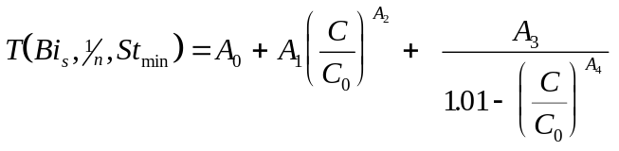 (B-1)
In order to convert mass throughput into time, St_{min} and the minimum empty bed contact time required for constant pattern, EBCT_{min}, or the packed bed contact time, τ_{min}, are first calculated. St_{min} is obtained from Table B1 and EBCT_{min} or τ_{min} is calculated using the following equation:

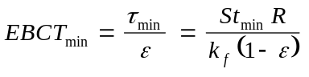 (B-2)

in which ε is the bed void fraction, k_{f} is the film or external mass transfer coefficient, and R is the resin particle radius. Accordingly, mass throughput is converted into elapsed time according to the following equation:

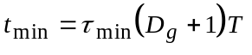 (B-3)

in which, D_{g} is the solute distribution parameter. The constant pattern solution is then scaled to the EBCT of interest using the following equation:

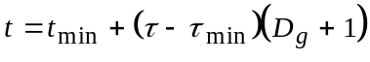 (B-4)

in which, t is the elapsed time which corresponds to τ, the packed bed contact time of interest.

Table B1: Minimum Stanton Number
- Minimum Stanton Number Required to Achieve Constant Pattern Conditions as Function of Bi for Various 1/n Values
- Minimum Stanton Number Required to be Within 10% of Constant Pattern
Freundlich  Isotherm | (a) MINIMUM STANTON NUMBER  REQUIRED FOR CONSTANT PATTERN |  |  |  | (b) MINIMUM STANTON NUMBER REQUIRED  TO BE WITHIN 10% OF CONSTANT PATTERN
Exponent | Empirical Equation 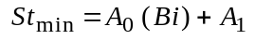 |  |  |  | Empirical Equation 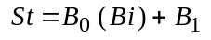
Parameter | 0.5 ≤ Bi ≤ 10 |  | 10 ≤ Bi ≤ ∞ |  | 0.5 ≤ Bi ≤ 10 |  | 10 ≤ Bi ≤ ∞
1/n  (1) | 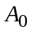  (2) | 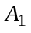  (3) | (4) | (5) | 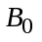  (6) | 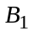  (7) | (8) | (9)
0.05 | 2.10526 × 10⁻² | 1.98947 | 0.22 | - | 1.05263 × 10⁻² | 1.39474 | 1.278 × 10⁻¹ | 0.22
0.10 | 2.10526 × 10⁻² | 2.18947 | 0.24 | - | 3.15789 × 10⁻² | 1.38421 | 1.367 × 10⁻¹ | 0.33
0.20 | 4.21053 × 10⁻² | 2.37895 | 0.28 | - | 6.31578 × 10⁻² | 1.36842 | 1.625 × 10⁻¹ | 0.38
0.30 | 1.05263 × 10⁻¹ | 2.54737 | 0.36 | - | 9.47368 × 10⁻² | 1.35263 | 1.80 × 10⁻¹ | 0.50
0.40 | 2.31579 × 10⁻¹ | 2.68421 | 0.50 | - | 1.68421 × 10⁻¹ | 1.41579 | 2.475 × 10⁻¹ | 0.63
0.50 | 5.26316 × 10⁻¹ | 2.73684 | 0.80 | - | 2.78947 × 10⁻¹ | 1.46053 | 3.438 × 10⁻¹ | 0.81
0.60 | 1.15789 × 10⁰ | 3.42105 | 1.50 | - | 4.52631 × 10⁻¹ | 1.97368 | 5.056 × 10⁻¹ | 1.40
0.70 | 1.78947 × 10⁰ | 7.10526 | 2.50 | - | 6.84211 × 10⁻¹ | 3.65789 | 7.722 × 10⁻¹ | 2.80
0.80 | 3.68421 × 10⁰ | 13.1579 | 5.00 | - | 1.21053 × 10⁰ | 5.89474 | 1.355 × 10⁰ | 4.40
0.90 | 6.31579 × 10⁰ | 56.8421 | 12.00 | - | 2.84211 × 10⁰ | 15.5789 | 3.122 × 10⁰ | 12.80
Table B2: HSDM Solution for Fixed Bed Reactor
Parameters Used for Empirical Equation that Describes Solution to HSDM for Fixed Bed Reactor; note 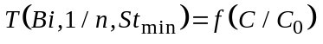
Freundlich  Isotherm  Exponent  Parameter | Biot  Number | Empirical Equation  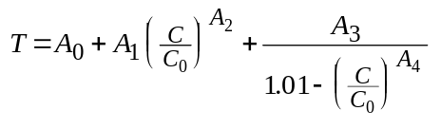 |  |  |  |  | Equations Valid  for 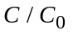 Values  Between  Following Limits
1/n  (1) | Bi  (2) | (3) | (4) | 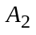  (5) | 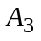  (6) | 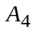  (7) | Lower  (8) | Upper  (9)
0.05 | 0.5 | -5.447214 | 6.598598 | 0.026569 | 0.019384 | 20.450470 | 0.01 | 0.99
0.05 | 2.0 | -5.465811 | 6.592484 | 0.02529 | 0.004988 | 0.503250 | 0.01 | 0.99
0.05 | 4.0 | -5.531155 | 6.584935 | 0.023580 | 0.009019 | 0.273076 | 0.02 | 0.99
0.05 | 6.0 | -5.606508 | 6.582188 | 0.022088 | 0.013126 | 0.214246 | 0.02 | 0.99
0.05 | 8.0 | -5.606500 | 6.504701 | 0.020872 | 0.017083 | 0.189537 | 0.02 | 0.99
0.05 | 10.0 | -5.664173 | 6.456597 | 0.018157 | 0.019935 | 0.149314 | 0.02 | 0.98
0.05 | 14.0 | -0.662780 | 1.411252 | 0.060709 | 0.020229 | 0.143293 | 0.02 | 0.99
0.05 | 25.0 | -0.662783 | 1.350940 | 0.031070 | 0.020350 | 0.129998 | 0.01 | 0.99
0.05 | ≥100.0 | 0.665879 | 0.711310 | 2.987309 | 0.016783 | 0.361023 | 0.01 | 0.99
0.10 | 0.5 | -1.919873 | 3.055368 | 0.055488 | 0.024284 | 15.311766 | 0.02 | 0.99
0.10 | 2.0 | -2.278950 | 3.393925 | 0.046838 | 0.004751 | 0.384675 | 0.02 | 0.99
0.10 | 4.0 | -2.337178 | 3.379926 | 0.043994 | 0.008650 | 0.243412 | 0.02 | 0.99
0.10 | 6.0 | -2.407407 | 3.374131 | 0.041322 | 0.012552 | 0.196565 | 0.02 | 0.99
0.10 | 8.0 | -2.477819 | 3.370954 | 0.038993 | 0.016275 | 0.176437 | 0.02 | 0.99
0.10 | 10.0 | -2.566414 | 3.370950 | 0.035003 | 0.019386 | 0.150788 | 0.02 | 0.98
0.10 | 16.0 | -2.567201 | 3.306341 | 0.020940 | 0.019483 | 0.136813 | 0.01 | 0.98
0.10 | 30.0 | -2.568618 | 3.241783 | 0.009595 | 0.019610 | 0.121746 | 0.01 | 0.98
0.10 | ≥100.0 | -2.568360 | 3.191482 | 0.001555 | 0.019682 | 0.110113 | 0.01 | 0.98
0.20 | 0.5 | -1.441000 | 2.569000 | 0.060920 | 0.002333 | 0.371100 | 0.01 | 0.99
0.20 | 2.0 | -1.474313 | 2.558300 | 0.058480 | 0.005026 | 0.241265 | 0.01 | 0.99
0.20 | 4.0 | -1.506696 | 2.519259 | 0.055525 | 0.008797 | 0.187510 | 0.01 | 0.99
0.20 | 6.0 | -1.035395 | 1.983018 | 0.069283 | 0.012302 | 0.167924 | 0.01 | 0.99
0.20 | 8.0 | -0.169192 | 1.077521 | 0.144879 | 0.015500 | 0.168083 | 0.02 | 0.99

Table B2 (continued)
(1) | (2) | (3) | (4) | (5) | (6) | (7) | (8) | (9)
0.20 | 10.0 | -1.402932 | 2.188339 | 0.052191 | 0.018422 | 0.133574 | 0.01 | 0.98
0.20 | 13.0 | -1.369220 | 2.118545 | 0.039492 | 0.018453 | 0.127565 | 0.01 | 0.98
0.20 | 25.0 | -1.514159 | 2.209450 | 0.017937 | 0.018510 | 0.118517 | 0.01 | 0.99
0.20 | ≥100.0 | 0.680346 | 0.649006 | 2.570086 | 0.014947 | 0.369818 | 0.01 | 0.99
0.30 | 0.5 | -1.758696 | 2.846576 | 0.049530 | 0.003022 | 0.156816 | 0.01 | 0.99
0.30 | 2.0 | -1.657862 | 2.688895 | 0.048409 | 0.005612 | 0.140937 | 0.01 | 0.99
0.30 | 4.0 | -0.565664 | 1.537833 | 0.084451 | 0.008808 | 0.139086 | 0.01 | 0.99
0.30 | 6.0 | -0.197077 | 1.118564 | 0.117894 | 0.011527 | 0.135874 | 0.01 | 0.99
0.30 | 8.0 | -0.197070 | 1.069216 | 0.119760 | 0.013925 | 0.132691 | 0.01 | 0.99
0.30 | 10.0 | -0.173358 | 1.000000 | 0.120311 | 0.015940 | 0.133973 | 0.01 | 0.99
0.30 | 15.0 | -0.173350 | 0.919411 | 0.071768 | 0.014156 | 0.086270 | 0.01 | 0.98
0.30 | 35.0 | 0.666471 | 0.484570 | 1.719440 | 0.013444 | 0.259545 | 0.02 | 0.99
0.30 | ≥100.0 | 0.696161 | 0.516951 | 2.054587 | 0.012961 | 0.303218 | 0.01 | 0.99
0.40 | 0.5 | -0.534251 | 1.603834 | 0.094055 | 0.004141 | 0.137797 | 0.01 | 0.99
0.40 | 2.0 | -0.166270 | 1.190897 | 0.122280 | 0.006261 | 0.134278 | 0.01 | 0.99
0.40 | 4.0 | -0.166270 | 1.131946 | 0.115513 | 0.008634 | 0.126813 | 0.01 | 0.99
0.40 | 6.0 | -0.166270 | 1.089789 | 0.112284 | 0.010463 | 0.124307 | 0.01 | 0.99
0.40 | 9.0 | 0.491912 | 0.491833 | 0.487414 | 0.011371 | 0.147747 | 0.02 | 0.98
0.40 | 12.0 | 0.564119 | 0.419196 | 0.639819 | 0.011543 | 0.149005 | 0.02 | 0.99
0.40 | 15.0 | 0.640669 | 0.432466 | 1.048056 | 0.011616 | 0.212726 | 0.02 | 0.99
0.40 | 25.0 | 0.672353 | 0.397007 | 1.153169 | 0.011280 | 0.216883 | 0.01 | 0.99
0.40 | ≥100.0 | 0.741435 | 0.448054 | 1.929879 | 0.010152 | 0.306448 | 0.01 | 0.99
0.50 | 0.5 | -0.040800 | 1.099652 | 0.158995 | 0.005467 | 0.139116 | 0.01 | 0.99
0.50 | 4.0 | -0.040800 | 0.982757 | 0.111618 | 0.008072 | 0.111404 | 0.01 | 0.99
0.50 | 10.0 | 0.094602 | 0.754878 | 0.092069 | 0.009877 | 0.090763 | 0.01 | 0.99
0.50 | 14.0 | 0.023000 | 0.802068 | 0.057545 | 0.009662 | 0.084532 | 0.01 | 0.99
0.50 | 25.0 | 0.023000 | 0.793673 | 0.039324 | 0.009326 | 0.082751 | 0.01 | 0.99
0.50 | ≥100.0 | 0.529213 | 0.291801 | 0.082428 | 0.008317 | 0.075461 | 0.01 | 0.99
0.60 | 0.5 | 0.352536 | 0.692114 | 0.263134 | 0.005482 | 0.121775 | 0.01 | 0.99
0.60 | 2.0 | 0.521979 | 0.504220 | 0.327290 | 0.005612 | 0.128679 | 0.01 | 0.99
0.60 | 6.0 | 0.676253 | 0.334583 | 0.482297 | 0.005898 | 0.138946 | 0.01 | 0.99

Table B2 (continued)
(1) | (2) | (3) | (4) | (5) | (6) | (7) | (8) | (9)
0.60 | 14.0 | 0.769531 | 0.259497 | 0.774068 | 0.005600 | 0.165513 | 0.01 | 0.99
0.60 | 50.0 | 0.849057 | 0.215799 | 1.343183 | 0.004725 | 0.223759 | 0.01 | 0.99
0.60 | ≥100.0 | 0.831231 | 0.227304 | 1.174756 | 0.004961 | 0.212109 | 0.01 | 0.99
0.70 | 0.5 | 0.575024 | 0.449062 | 0.278452 | 0.004122 | 0.121682 | 0.01 | 0.99
0.70 | 4.0 | 0.715269 | 0.307172 | 0.442104 | 0.004371 | 0.138351 | 0.01 | 0.99
0.70 | 12.0 | 0.787940 | 0.243548 | 0.661599 | 0.004403 | 0.162595 | 0.01 | 0.99
0.70 | 25.0 | 0.829492 | 0.204078 | 0.784529 | 0.004050 | 0.179003 | 0.01 | 0.99
0.70 | ≥100.0 | 0.847012 | 0.190678 | 0.931686 | 0.003849 | 0.183239 | 0.01 | 0.99
0.80 | 0.5 | 0.708905 | 0.314101 | 0.357499 | 0.003276 | 0.119300 | 0.01 | 0.99
0.80 | 4.0 | 0.784576 | 0.239663 | 0.484422 | 0.003206 | 0.134987 | 0.01 | 0.99
0.80 | 14.0 | 0.839439 | 0.188966 | 0.648124 | 0.003006 | 0.157697 | 0.01 | 0.99
0.80 | ≥100.0 | 0.882747 | 0.146229 | 0.807987 | 0.002537 | 0.174543 | 0.01 | 0.99
0.90 | 0.5 | 0.865453 | 0.157618 | 0.444973 | 0.001650 | 0.148084 | 0.01 | 0.99
0.90 | 4.0 | 0.854768 | 0.171434 | 0.495042 | 0.001910 | 0.142251 | 0.01 | 0.99
0.90 | 16.0 | 0.866180 | 0.163992 | 0.573946 | 0.001987 | 0.157594 | 0.01 | 0.99
0.90 | ≥100.0 | 0.893192 | 0.133039 | 0.624100 | 0.001740 | 0.164248 | 0.01 | 0.99

Appendix C: PSDM Equations

The partial differential equations describing the ion exchanger dynamics in a fixed-bed ion exchanger is given below. The detailed derivation of these equations is given by Friedman (1984).

The liquid phase mass balance for component i is given by:

(C-1)

The initial condition for equation C-1 is:

(C-2)

The boundary condition for equation C-1 is:

(C-3)

The intraparticle phase mass balance for component i is given by:

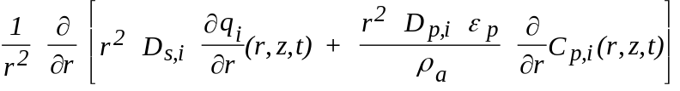
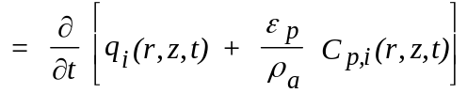 (C-4)

The initial condition for equation C-4 is:
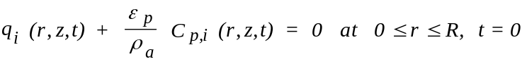 (C-5)

The first boundary condition for equation C-4 is:

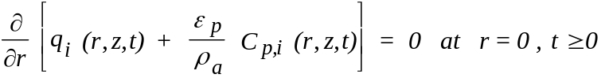 (C-6)

The second boundary condition for equation C-4 is:

(C-7)

The equation coupling the aqueous phase concentration of component i within the resin pores to the resin phase concentration of component i is given by:

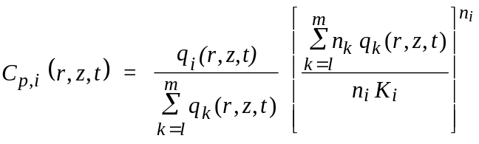 (C-8)

The above equation is derived assuming that the ion exchange reaction rate is much faster than the mass transfer rate (assumption of local equilibrium).

Nomenclature:

C_{0,i}i initial concentration M/L³
C_{i}(z,t) resin concentration in bulk phase M/L³
C_{p,i}(r,z,t) adsorbate concentration in resin pores M/L³
D_{p,i} pore diffusivity L²/T
D_{s,i} surface diffusivity L²/T
k_{f,i} film transfer coefficient L/T
L bed length L
m number of components -
q_{i}(r,z,t) resin phase concentration M/M
R average resin particle radius L
V loading rate L/T

Greek letters

ε_{P} particle void fraction (porosity) -
ρ_{A} apparent resin density M/L³

Index i refers to component number i.

Appendix D: Fouling of GAC

Correlations were established to evaluate the fouling of GAC for the following water sources:

- Surface water (with significant anthropogenic input) from the Rhine River in Germany, (F100 GAC)
- Surface water (with little anthropogenic input) from the Keweenaw Waterway (Portage Lake) which is connected to Lake Superior in Houghton, Michigan (F400 GAC)
- Groundwater from the city of Karlsruhe, Germany (F100 GAC)
- Groundwater from Wausau, Wisconsin (F400 GAC)
- Groundwater from Houghton, Michigan (F400 GAC)

The empirical kinetic constants used in Equation 1 for each of these water sources is presented in Table D1.

 | Empirical Kinetic Constants
Background Water Source | A1 |  | A2 | A3 | A4
 | (-) |  | (min⁻¹) | (-) | (min⁻¹)
Surface water with significant anthropogenic input.  (Rhine River, Germany)¹ | 35.0 | -6.15x10⁻⁸ |  | 65.0 | -8.93x10⁻⁵
Surface water with a small amount of anthropogenic input. (Portage Lake, Michigan)² | 51.0 | -9.21x10⁻⁷ |  | 49.0 | -2.80x10⁻⁵
Ground water in Germany that caused reduction in capacity similar to six other German ground waters.  (Karlsruhe, Germany)¹ | 65.0 | -6.71x10⁻⁷ |  | 35.0 | -1.00x10⁻⁴
Rural Midwestern ground water (Wausau, Wisconsin)² | 83.0 | -9.12x10⁻⁷ |  | 17.0 | -2.65x10⁻⁴
Rural Northern ground water (Houghton, Michigan)² | 66.0 | -1.55x10⁻⁷ |  | 34.0 | -1.04x10⁻⁴
¹Calgon F100 GAC
²Calgon F400 GAC

Table D1: Empirical Kinetic Characterization of Different Water Sources

All of the water types above can be specified in IonExDesignS™ from the Fouling of GAC window.

It should be noted that the pre-loading effect of Houghton groundwater and Karlsruhe groundwater are very similar to each other. For more details about these equations, refer to Bhuvendralingham (1992). Table D2 shows the corrected capacity reduction equations to be employed to estimate the capacity reduction of GAC for SOCs other than TCE.

The equations shown in Table D2 are also available in the Fouling of GAC window.

Class | Group | Surrogate Compound | Equation relative to a Standard Compound (TCE)
 | Halogenated alkanes | 1,1,1-TCA | 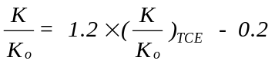
 | Halogenated | TCE | 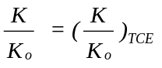
Purgeables | Trihalo methanes | Chloroform
 | Aromatics | Toluene | 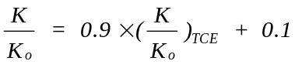
Base Neutrals | Nitro compounds | 3,4-Dinitro toluene | 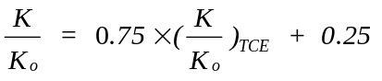
 | Chlorinated Hydrocarbons | 1,4- Dichloro benzene | 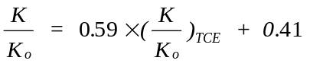
Acids | Phenols | 2,4-Dichloro benzene | 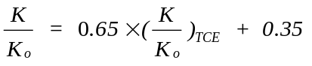
PNAs | - | Methylene blue | 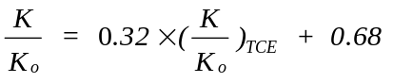
Pesticides | - | Atrazine | 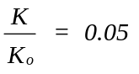

Table D2: Empirical Capacity Reduction for Different Compound Classes
(Based on pre-loading data for groundwater from Karlsruhe on F100)

Appendix E: Air and Water Property Correlations

The correlations used to estimate air and water properties are described below.

1. Water Property Correlations

The water density is calculated using a correlation developed at Michigan Technological University. This correlation has the following form:

(E-1)

where ρ_{L} is the water density (g/cm³)
T_{A} is equal to 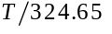
T is the temperature (Kelvin)

The water viscosity is calculated using a correlation shown by Reid, et al (1987), and from Yaws (1976). This correlation has the following form:

(E-2)

where μ_{L} is the water viscosity in cP
T is the temperature in Kelvins

2. Air Property Correlations

Air density is calculated using the ideal gas law (PV=nRT). The air viscosity is calculated using the following correlation:

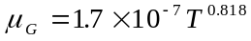 (E-3)

where μ_{G} is the gas viscosity (kg/m.s)
T is the temperature (Kelvin)

Appendix F: Kinetic Coefficients

1. Description of the Mechanisms Involved

a. Film Transfer Resistance

Adsorbate molecules, which migrate from bulk solution to the inside of the particle, are transferred from the bulk to the outer surface of the resin by liquid phase diffusion. A linear concentration gradient may be used to describe the mass transfer resistance within the boundary layer. The following equation describes this mechanism:

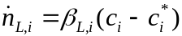 (F-1)

where: 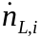 is the mass transfer rate per unit of surface area (mol/m2⋅s)
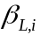 film diffusion coefficient (m/s)
is the adsorbate concentration on the external surface of the resin (mol/m3)
is the adsorbate concentration in the bulk (mol/m3)
index i refers to component number i

b. Surface and Pore Diffusion Mechanisms

Adsorbates can diffuse into a resin particle by two kinetic mechanisms; they travel along the surface walls or within the fluid void space contained within the pore. These mechanisms are known as surface diffusion and pore diffusion, respectively. For strongly adsorbed species, surface diffusion flux is many times stronger than pore diffusion flux. However, if the bulk contains both weak and strong adsorbing solutes, both mechanisms will occur. Surface diffusion will not allow the weaker adsorbing components to adsorb, but pore diffusion will allow ion exchange in the pore void space. A model that includes both pore and surface diffusion should allow for a better description of the ion exchange of many types of components.

The surface diffusion model assumes that the resin grain is a spherical particle of homogeneous structure. It implies that the solid-phase concentration, resin density, and surface area depend only on the radial location in the particle.

The surface diffusion mechanism follows Fick's first law of diffusion:

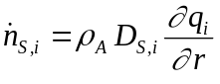 (F-2)

where: 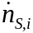 is the pore diffusion flux (mol/m²⋅s)
qi is the solid-phase concentration in the pores (mol/kg)
D_{S,i} is the pore diffusion coefficient (m²/s)
ρ_{A} is particle density of the resin (kg/m³)

From Fick's first law, the following equation may be written for the pore diffusion flux:

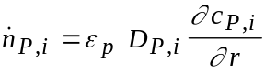 (F-3)

where: 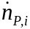 is the pore diffusion flux (mol/m²⋅s)
cp,i is the adsorbate concentration in the pores (mol/m3)
DP,i is the pore diffusion coefficient (m²/s)

For the pore diffusion model, it is assumed that the pore fluid concentration, cp,i, is in equilibrium with the local solid-phase concentration.

2. Correlations for the Film Transfer Diffusion Coefficient

The gas and liquid phase film transfer diffusion coefficient, k_{f} (m/s), is calculated using the Gnielinski correlation (Sontheimer, et al, 1988):

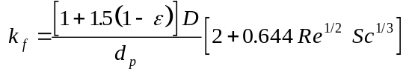 (F-4)

in which 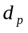 is the resin particle diameter (m), 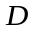 is the adsorbate gas or liquid phase diffusivity (m²/s), and is the bed void fraction. The Reynolds (Re) and Schmidt (Sc) numbers are calculated as follows:

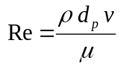 (F-5)
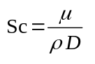 (F-6)

in which is the gas or liquid phase density (kg/m³), is the gas or liquid phase interstitial velocity (m/s), and 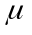 is the gas or liquid phase viscosity (kg/m/s).

The liquid diffusivity was determined from a correlation given by Hayduk and Laudie (1974):

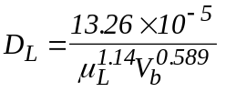 (F-7)

where D_{L} is the liquid diffusivity (cm²/s)
V_{b} is the molar volume of the chemical at the normal boiling point (cm³/mol)
μ_{L} is the water viscosity (centipoise)

The gas diffusivity, D_{G}, is calculated using the Wilke-Lee modification of the Hirschfelder-Bird-Spotz method (see Reid, et al, 1987).

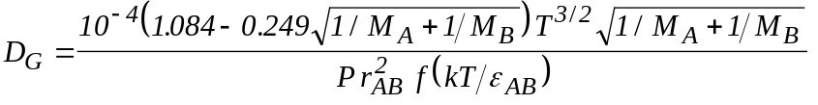 (F-8)

where D_{G} is the gas diffusivity of compound B in air (A) (m²/s)
T is the absolute temperature (K)
M_{A} is the molecular weight of A (air)(g/mol)
M_{B} is the molecular weight of B (g/mol)
P absolute pressure (Pa)
r_{AB} is the molecular separation at collision (=(r_{A}+r_{B})/2)
ε_{AB} is the energy of molecular attraction (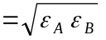)
k is the Boltzmann’s constant
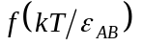 is the collision function

r and ε can be calculated as follows:

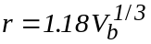 (F-9)

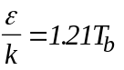 (F-10)

where V_{b} is the molar volume of liquid at normal boiling point(m³/kmol)
T_{b} is the normal boiling point in Kelvin

The collision function is calculated by:

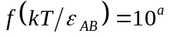 (F-11)

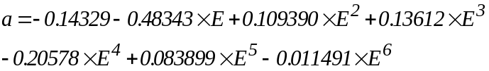 (F-12)

where 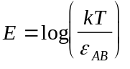

All the calculations for the gas diffusivity come from Treybal (1980).

3. Estimation of the Pore Diffusion Coefficient

The pore diffusion coefficient is related to the adsorbate diffusivity and the intraparticle physical properties as shown in the following equation (Sontheimer, et al, 1988):

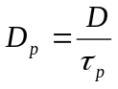 (F-13)

where: D is the adsorbate gas or liquid phase diffusivity (cm²/s)
τ_{p} is the resin tortuosity (-)
D_{p} is the pore diffusion coefficient (cm²/s)

4. Estimation of the Surface Diffusion Coefficient

The surface diffusion coefficient is obtained by relating the surface diffusion flux to the pore diffusion flux by a correlation factor, the surface to pore diffusion flux ratio (SPDFR). This results in the following correlation which is used to calculate the surface diffusion coefficient (Sontheimer, et al, 1988):

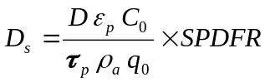 (F-14)
where:
C₀ is the initial inlet concentration (mg/L)
D is the adsorbate gas or liquid phase diffusivity (cm²/s)
D_{s} is the surface diffusion coefficient (cm²/s)
q_{o} is the solid phase concentration in equilibrium with C_{o} for a single-solute equilibrium (mg/g)
ε_{p} is the void fraction (porosity) of the carbon (-)
ρ_{A} is the apparent resin density (which includes pore volume) (g/L)
τ_{p} is the resin tortuosity (-).

The SPDFR and 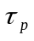 can be chosen by the user. Tortuosity can also be determined using a correlation provided by IonExDesignS™. The following guidelines are provided for estimating the SPDFR and . For liquid phase cases where there is little or no background organic matter (such as many industrial by-product streams) and a single or multiple components are present, an SPDFR between 2.0 and 8.0 can be used (Dobrezelewski, et al, 1985; Hand, et al, 1989). For this reason, IonExDesignS™ defaults to a SPDFR value of 5.0. For gas phase applications, the impact of pore diffusion on the intraparticle ion exchange rate is negligible and surface diffusion is predominant (Crittenden, et al, 1988). An 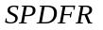 of 16.0 or greater is typically used.
For cases when the ion exchange process is controlled by competitive interactions between NOM and SOCs, pore diffusion is the predominant intraparticle mass transfer mechanism and the correlation presented in Equation F-15 is used. When the ion exchanger operation time is less than about 70 days, is equal to 1.0. This implies that there is some surface diffusion flux incorporated into the pore diffusion model. After 70 days of ion exchanger operation, is assumed to increase linearly with time and the following equation is used (Sontheimer, et al, 1988):

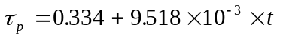 (F-15)

in which is in days. Equation F-15 was developed to describe the breakthrough of micropollutants from groundwater for six different cities in Germany. This equation is recommended for use when contaminant concentrations are less than or equal to 1.0 mg/L.

Appendix G: Polanyi Ion exchange Potential Models

The ion exchange potential concept views ion exchange onto activated carbon as a gradual concentration of adsorbate molecules toward the solid surface due to a potential field. The empirical relationship between the potential field and the adsorbed volume above the surface is called the characteristic curve (e.g., "universal" isotherm). Such a curve is analogous to a cumulative pore-size distribution in which the pores are characterized by energy rather than dimensions. According to Polanyi (1920), the characteristic curve is independent of temperature because ion exchange occurs by temperature-invariant dispersion (i.e., van der Waals) forces.

Correcting for polarizability relative to that of a reference chemical shifts the isotherms for all adsorbates onto a reference isotherm (e.g., characteristic curve) for a given resin. This "scale factor", in addition to any temperature difference, changes the value of the ion exchange potential used to obtain adsorbate loadings from the reference isotherm. Isotherms derived from the potential theory are useful for describing ion exchange by pore filling, and apply specifically to microporous resins such as activated carbon. For both liquid and vapor phase ion exchange, the adsorbed chemical is assumed to exist in the liquid state, so the volume adsorbed is related to the mass adsorbed through the liquid density.

Theoretically, a general ion exchange isotherm derived from experimental data for a single reference compound can be applied to any other compound of interest at any temperature. For example, the Dubinin-Radushkevich (D-R) equation for gas-phase ion exchange is based on the potential field theory of Polanyi (1920). In the D-R procedure, a logarithmic plot of adsorbate loading versus the square of the ion exchange potential gives a linear reference isotherm for that resin that can be generalized to other adsorbates and temperatures. A variation of the D-R equation, with a third adjustable parameter, has been used successfully to model aqueous ion exchange. The ion exchange potential for a given bulk chemical concentration is computed relative to the aqueous solubility limit.

As noted above, Polanyi ion exchange potential theory (Polanyi, 1920) may be used to define a single correlation curve for a specific granular activated carbon (GAC) and single solute ion exchange isotherm data. It may also be used to correct for the effects of temperature on the ion exchange capacity of chemicals on GAC (Kuennen, et al, 1988; Speth, et al, 1989). A more detailed description of Polanyi uniform adsorbate theory is given by Greenbank and Manes (1981).

The three parameter uniform adsorbate isotherm (Crittenden, et al, 1987; Kuennen, et al, 1988) used in IPES takes on the following general form:

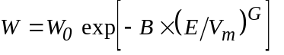

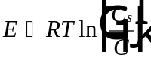 (G-1)

where:
W Volume adsorbed mL/g
W₀ Maximum pore volume for ion exchange mL/g
E Ion exchange potential cal/mol
V_{m} Liquid molar volume ml/mol
C Equilibrium liquid phase concentration mg/L
R Gas constant 1.987 cal/mol⋅K
T Absolute temperature K
C_{s} Aqueous solubility limit of adsorbate mg/L
B Fitted Polanyi parameter (mL/cal)^{G}
G Fitted Polanyi parameter -

By plotting the volume adsorbed, W, versus the ion exchange potential divided by a normalizing physical property, characteristic curves for many compounds will coincide (Speth, 1986). In many liquid phase studies (Speth, 1986; Kuennen, et al 1988), molar volume was found to provide the best correlation. Accordingly, the correlation can be described by the following linear equation:

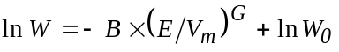 (G-2)

This correlation is used for hydrophobic compounds and considers ion exchange resulting from physical Van der Waals forces. Hence, the correlation may not be applicable where dipole-dipole, dipole-dipole induced dipole and Lewis acid-base interactions between solutes and resin take place.

The Manes-Hofer correlation (1969) is used to obtain aqueous phase ion exchange isotherms for partially miscible and immiscible organic liquids and solids on resins using the Dubinin-Radushkevich equation for gas phase isotherms (see Equation 3.23, section G-3). This correlation assumes the resin pores are initially filled with water which is displaced when the adsorbate moves into the resin pores.

For aqueous phase applications, it is suggested the three parameter Polanyi correlation be used for compounds except phenols and pesticides. For these compounds, it is suggested that the Manes-Hofer correlation be used if they are immiscible or partially miscible. For a range of aqueous phase concentrations, these correlations are used to calculate values of W which are converted to values of q by multiplying by the density of the compound.

For gas phase ion exchange, the Dubinin-Radushkevich correlation (D-R) (1966) is used and takes on the following general form:

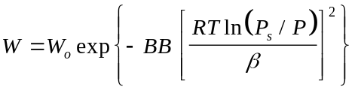 (G-3)

where: 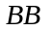 is the microporosity constant (mol/cal)²
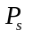 is the liquid adsorbate vapor pressure Pa
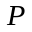 is the partial pressure of the adsorbate in the bulk gas phase Pa
is the affinity coefficient of the adsorbate -

Instead of molar volume, the normalization factor is , the ratio of the adsorbate polarizability to that of a reference adsorbate. Polarizability may be estimated from the Lorentz-Lorenz equation, which is a function of the liquid refractive index. Equation G-3 can correlate isotherm data on activated carbon for compounds with dipole moments less than 2 debyes (Reucroft, et al, 1971). In the special case of the gas-phase application of the Dubinin-Radushkevich equation, G is assumed to have a value of 2 because such a form has been empirically successful for data correlation.

One important limitation of gas-phase application of the D-R equation is that it does not describe equilibria at high relative pressures (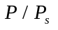>0.2) because of capillary condensation effects at these concentrations. However, the low relative pressures ( between 10⁻⁶ and 10⁻³) typical of VOCs in air stripping off-gas allow the D-R equation to describe VOC ion exchange equilibria. For gas phase applications, the D-R correlation can be used for relative humidities less than about 50 percent.

The detailed mathematical development and the FORTRAN code for the D-R IPE calculations based on a spreading pressure evaluation was first presented in Cortright (1986). Although the FORTRAN code for this calculation has been modified since then to improve the numerical techniques, the calculation is fundamentally the same.

For a range of gas phase concentrations, W is calculated from Equation G-3 and converted to solid phase concentrations by multiplying by the density of the compound. The Freundlich isotherm parameters are then obtained by fitting Equation 3 (on page 12) to the empirical gas and solid phase data.

Appendix H: References for the Isotherm Database

The following articles or books were used to create the isotherm database. The abbreviations in parenthesis are the ones used in the database.

Abe, H., K. Hayashi, M. Kitagawa, and T. Urahata, “Adsorptive Mechanism on Activated Carbon in the Liquid Phase. I. Free Energy Change for Ion exchange of Organic Compounds from Aqueous Solution on Activated Carbon,” Bull. Soc. Chem. Japan, 1979, 52, 1899. (ABE)

Baldauf, G., Untersuchungen uber die konkurrierende Ion exchange von Aweistoffgemischen an Aktivkohle, Dissertation, Univ. Karlsruhe, 1978. (Baldauf 1978 and Baldauf 1978-80)

Brauch, H.J., Ion exchange von naturlichen organischen Wasserinhaltsstoffen an Aktivkohle, Dissertation, Univ. Karlsruhe, 1984. (Brauch 1984)

Cal, M.P., S.M. Larson, and M.J. Rood, “Ion exchange of Acetone and Benzene onto Activated Carbon Fibers: Comparison of Experimental and Modeled Isotherms”. (Cal 1993)

Cal, M.P., M.J. Rood, and S.M. Larson, “Experimental and Modeled Results Describing the Ion exchange of Acetone and Benzene onto Activated Carbon Fibers,” Environmental Progress, February 1994, 13:1. (Cal 1994)

Crittenden, J.C., R.D. Cortright, B. Rick, S. Tang, and D. Perram, “Using GAC to Remove VOCs from Air Stripper Off-Gas,” Journal AWWA, May 1988. (Crittenden 1988)

Crittenden, J.C., D.W. Hand, H. Arora, and B.W. Lykins Jr., “Design Considerations for GAC Treatment of Organic Treatment of Organic Chemicals,” Journal AWWA, January 1987. (Crittenden, et al 1987)

Crittenden, J.C., P. Luft, and D.W. Hand, “Prediction of Multicomponent Ion exchange Equilibria in Background Mixtures of Unknown Composition,” Wat. Res., 1985, 19:12, 1537-1548. (Crittenden, et al 1985)

Crittenden, J.C., P. Luft, D.W. Hand, J.L. Oravitz, S.W. Loper, and M. Ari, “Prediction of Multicomponent Ion exchange Equilibria Using Ideal Adsorbed Solution Theory,” Environ. Sci. Technol., 1985, 19:11, 1307-1043. (Crittenden 1985)

Dobbs, R.A. and Cohen, J.M., “Carbon Ion exchange Isotherms for Toxic Organics”, EPA-600/8-80-023, U.S. Environmental Protection Agency, Cincinnati, Ohio, 1980. (Dobbs, et al 1980)

Frick, B., Ion exchangesgleichgewichte zwischen Aktivkohle und organischen Wasserinhaltsstoffen in Mehrstoffgemischen bekannter und unbekannter Zusammensetzung, Dissertation, Univ. Karlsruhe, 1980. (Frick 1980)

Fritz, W., Konkurrierende Ion exchange von zwei organischen Wasserinhaltsstoffen an Aktivkohlekornern, Dissertation, Univ. Karlsruhe, 1978. (Fritz 1978)

Haist-Gulde, B., Zur Ion exchange von Spurenverunreinigungen aus Oberflachenwassern, Dissertation, Univ. Karlsruhe, 1991. (Haist 1988)

Personal communication: Dr. David W. Hand, Environmental Engineering Center, Michigan Technological University, Houghton, MI 49931. (MTU)

Hand, D.W., J.C. Crittenden and, J.L. Bulloch, “Development of a Rational Modeling Approach for the Design, and Optimization of Liquid Phase Ion exchange Systems,” prepared for NASA/Ames, December 1994, NAG 2-820. (NASA/Ames)

Horner, G., Zimmer, G., Sontheimer, H. and Bachle, A., Aktivkohleregeneration mittels Desorption, DVGW-Schriftenreihe Wasser, 1984. (Horner 1984)

Love, O.T., Jr., et al, “Treatment of Volatile Organic Compounds in Drinking Water,” EPA-600/8-83-019, U.S. Environmental Protection Agency, Cincinnati, Ohio, 1983.

McKay, G., M.J. Bingo, and A.R. Altanemi, “The Ion exchange of Various Pollutants from Aqueous Solutions on to Activated Carbon,” Wat. Res., 1985, 19:4, 491-495. (G. McKay, et al 1985)

Merk, W., Konkurrierende Ion exchange verschiedener organischer Wasserinhaltsstoffe in Aktivkohlefiltern, Dissertation, Univ. Karlsruhe, 1978. (Merk 1978)

Sakoda, A., M. Suzuki, R. Hirai, and K. Kowazoe, “Trihalomethane Ion exchange of Activated Carbon Fibers,” Wat. Res., 1991, 25:2, 219-225. (Sakoda, et al 1991)

Speth, T.F. and R.J. Miltner, “Technical Note: Ion exchange Capacity of GAC for Synthetic Organics,” Journal AWWA, Research and Technology, February 1990, 72-75. (Westvaco Isotherms and Speth 1990)

Speth, T.F., Miltner, R., Crittenden, J.C., and Hand, D.W., “An Evaluation of GAC Ion exchange Capacities for SOCs,” submitted to Journal AWWA, 1988. (Speth, et al 1988)

Suzuki, M., Ion exchange Engineering: Chemical Engineering Monographs 25, Kodansha Ltd., 1990, 84. (M. Suzuki 1990)

van Lier, W.C., Mass Transfer to Activated Carbon in Aqueous Solutions, 1989, 102-104. (W.C. Van Lier 1989)

Vidic, R.D., M.T. Suidan, U.K. Traegner, and G.F. Nakhla, “Ion exchange Isotherms: Illusive Capacity and Role of Oxygen,” Wat. Res., 1990, 24:10, 1187-1195. (Vidic, et al 1990)

Weber, W., Jr. and M. Pirbazari, “Ion exchange of Toxic and Carcinogenic Compounds from Water,” Journal AWWA, Research and Technology, April 1982, 203-208. (Weber Jr. 1982)

Weber, W.J., Jr. and B.M. Van Vliet, “Synthetic Resins and Activated Carbons for Water Treatment: Overview and Experimental Comparisons,” Journal AWWA, August 1981. (Weber, Jr. 1981)

Weber, W.J., Jr., Pirbazari, M., Herbert, M., and Thompson, R., “Effectiveness of activated carbon for removal of volatile halogenated hydrocarbons from drinking water”, In: Viruses and Trace Contaminants in Water and Wasterwater, Ann Arbor Science, Ann Arbor, Michigan, 1977. (Weber, et al 1977 and Weber 1977)

Yaws, C.L., et al, “Ion exchange-Capacity Data for 283 Organic Compounds,” Environmental Engineering Work, May-June 1995. (Yaws 1995)

Yonge, D.R., T.M. Keinath, K. Poznanska, and Z.P. Jiang, “Single-Solute Irreversible Ion exchange on Granular Activated Carbon,” Envrin. Sci. Technol., 1985, 19:8, 690-694. (Yonge 1985)

Zimmer, G., J.C. Crittenden, and H. Sontheimer, “Design Considerations for Fixed-Beds Ion exchangers that Remove Synthetic Organic Chemicals in the Presence of Natural Organic Matter”, Proc. of the Annual AWWA Conf., Orlando, FL, 1988. (Zimmer 1988)

Appendix I: References

Arora, H., (1988) “Modeling of Fixed-Bed Ion exchangers for Multicomponent Mixtures of Known and Unknown Components,” Ph.D. Dissertation, Michigan Technological University.

Benz, M., (1989) Untersuchungen zum Ion exchangesverhalten von Vielstoffgemischen unbekannter Zusammensetzung, Dissertation, Univ. Karlsruhe.

Bhuvendralingham S., (1992) “A Decision Algorithm for Optimizing Granular Activated Carbon Ion exchange Process Design,” Ph.D. Dissertation, Michigan Technological University.

Cortright, R., (1986) “Gas-phase Ion exchange of Volatile Organic Compounds from Air Stripping Off-gas onto Granulated Activated Carbon,” Masters Thesis, Michigan Technological University.

Crittenden, J.C., et al, (1985) “Prediction of Multicomponent Ion exchange Equilibria Using Ideal Adsorbed Solution Theory,” Environ. Sci. Technol., Vol. 19, No. 11.

Crittenden, J.C., N.J. Hutzler, D.G. Geyer, J.L. Oravitz, and G. Friedman, (1986) “Transport of Organic Compounds with Saturated Groundwater Flow: Model Development and Parameter Sensitivity,” Wat. Res. Research, Vol. 22, No.3.

Crittenden J.C., T.F. Speth, D.W. Hand, P.J. Luft and B.W. Lykins, (1987), “Evaluating Multicomponent Competitive Ion exchange in Fixed Beds,” Jour. Environ. Eng., Vol. 113, No. 6, December.

Crittenden, J.C., D.W. Hand, H. Arora, J.M. Miller, G. Zimmer, and H. Sontheimer, (1987b) “Adequacy of Mathematical Models for Designing Full Scale Ion exchange Facilities which Remove Synthetic Organic Chemicals,” Proc. of the Annual AWWA Conf., Kansas City, Missouri.

Crittenden, J.C., P.S. Reddy, H. Arora, J. Trynoski, D.W. Hand, D.L. Perram, and R.S. Summers, (1991) “Predicting GAC Performance with Rapid Small-Scale Column Tests,” Jour. AWWA, 83:1:77.

Dobrezelewski, M., et al, (1985) “Determination and Prediction of Surface Diffusivities of Volatile Organic Compounds Found in Drinking Water,” Nat. Tech. Info. Svc., Springfield, Virginia.

El-Behlil, M., (1990) “An Investigation of the Impact of Natural Organic Matter on the Design of Fixed-Bed Ion exchangers that Remove Synthetic Organic Chemicals from Drinking Water Supplies,” Ph.D. Dissertation, Michigan Technological University.

Finlayson, B.A., (1972) The Method of Weighted Residuals and Variational Principles, Academic Press Inc., New York.

Finlayson, B.A., (1980) Non Linear Analysis in Chemical Engineering, McGraw-Hill, New-York.

Friedman, G., (1984) “Mathematical Modeling of Multicomponent Ion exchange in Batch and Fixed-Bed Reactors,” Masters Thesis, Michigan Technological University.

Fritz, W. and E.U. Schundler, (1981) “Competitive Ion exchange of Two Dissolved Organics onto Activated Carbon,” Chem. Engrg. Sci., Vol. 36, No. 3.

Greenbank, M., (1981) “Ion exchange of Mixed Liquids and Solids From Water Solution onto Activated Carbon,” Diss., Kent State University, Ohio.

Greenbank, M., and M. Manes, (1981) “Application of the Polanyi Ion exchange Potential Theory to Ion exchange from Solution on Activated Carbon, 11. Ion exchange of Organic Liquid Mixtures from Water solution,” J. Phys. Chem., Vol. 85, 3050.

Haist-Gulde, B., (1991) Zur Ion exchange von Spurenverunreinigungen aus Oberflachenwassern, Dissertation, Univ. Karlsruhe.

Hand, D.W., J.C. Crittenden and W.E. Thacker, (1984) “Simplified Models for Design of Fixed-Bed Ion exchange Systems,” Jour. of Env. Eng., Vol. 110, No. 2.

Hand, D.W., J.C. Crittenden, H. Arora, J.M. Miller, and B.W. Lykins, Jr. (1989) “Designing Fixed-Bed Ion exchangers to Remove Mixtures of Organics,” J. AWWA, 81:67.

Hayduk, W., and H. Laudie, (1974) “Prediction of Diffusion Coefficients for Non-Electrolytes in Dilute Aqueous Solutions,” AIChE J., Vol. 28, p.611.

Hokanson, D.R., T.N. Rogers, D.W. Hand, F. Gobin, M.D. Miller, J.C. Crittenden, and J.E. Finn, (1997) “A Physical Property Resource Tool for Air and Water Treatment Unit Operations,” In preparation: AIChE Journal of Environmental Progress.

Hokanson, D.R., (1996) “Development of Software Design Tools for Physical Property Estimation, Aeration, and Ion exchange,” Masters Thesis, Michigan Technological University.

Hokanson, D.R., T.N. Rogers, D.W. Hand, F. Gobin, M.D. Miller, J.C. Crittenden, and J.E. Finn, (1995) “A Physical Property Resource Tool for Water Treatment Unit Operations,” AWWA Annual Conference Proceedings, 411-422.

Hokanson, D.R., D.W. Hand and J.C. Crittenden, (2002) “Development of a Multicomponent Mass Transfer Model for Ion Exchange,” manuscript in preparation for submission to Water Environment Research.

Hokanson, D.R. (2002) “Multifiltration Bed Model (MFBMODEL™) Development for the International Space Station Water Processor: Ion Exchange Models and Overall Model,” Ph.D. Dissertation, Michigan Technological University, Dept. of Civil and Environmental Engineering, in preparation.

Kuennen, R., K. Van dyke, J.C. Crittenden, and D.W. Hand, (1989) “Predicting the Multi-Component Removal of Surrogate Compounds by a Fixed-Bed Ion exchanger,” J. AWWA, Vol. 81, No. 12.

Manes, M., and L.J.E. Hofer, (1969), “Ion exchange on Activated Carbon from Solvents of Different Refractive Index,” J. Phys. Chem., Vol. 73, 584.

McCabe, W.L. and J.C. Smith, (1976) Unit Operations of Chemical Engineering, 3rd ed., New York: McGraw-Hill Book Company.

Polanyi, M,. (1920) Z. Physik, Vol. 2, 111.

Radecki, P.P., D.W. Hertz, and C. Vinton, (August 1994) “Build Pollution Prevention into System Design,” Hydrocarbon Processing.

Reid, R.C., J.M. Prausnitz and B.E. Poling, (1987) The Properties of Gases and Liquids, 4th Edition - McGraw Hill.

Reucroft, et al, (1971) “Sorption Properties of Activated Carbon,” Jour. Phys. Chem., Vol. 75, 3526.

Sontheimer, H., J.C. Crittenden, and R.S. Summers, (1988) Activated Carbon for Water Treatment, DVGW-Forschungsstelle, Engler-Bunte-Institut, Univ. of Karlsruhe, Fed. Rep. of Germany.

Speth, T.F., (1986) “Predicting Equilibria for Single and Multi-component Aqueous-Phase Ion exchange Onto Activated Carbon,” Master Dissertation, Michigan Technological University.

Speth, T.F., and R.J. Miltner, (1989) “Effect of Preloading on the Scale Up of GAC Micro Columns,” J.AWWA, 81:141.

Speth, T.F., (1991) “Evaluating Capacities of GAC Preloaded with Natural Water,” Jour. of Envir. Engrg., ASCE, 117:1:66.

Summers, R.S., B. Haist, J. Koehler, J. Ritz, G. Zimmer, and H. Sontheimer, (1989) “The Influence of Background Organic Matter on GAC Ion exchange,” J. AWWA, 81:5:66.

Summers, R.S., D. DiCarlo, and S. Palepu, (1990) “GAC Ion exchange in the Presence of Background Organic Matter: Pretreatment Approaches and Attenuation of Shock Loadings,” Proc. of the Annual AWWA Conf., Cincinatti, Ohio.

Treybal, R.E., (1980) Mass-Transfer Operations, 3rd Edition - Mc Graw-Hill.

Villadsen, J. and M.L. Michelsen, (1978) Solution of Differential Equation Models by Polynomial Approximation, Prentice-Hall, Englewood Cliffs, N.J.

Wakao R. and T. Funazakri, (1978) “Effects of fluid dispersion on particle to fluid mass transfer coefficients in packed beds,” Chem. Eng. Sci., 33, 1375-1384.

Yaws, C.L., J.W. Miller, P.N. Shah, G.R. Schorr and P.M. Patel, (1976) “Correlation Constants for Chemical Compounds,” Chem. Eng., 83(25):153.

Zimmer, G., J.C. Crittenden, and H. Sontheimer, (1988) “Design Considerations for Fixed-Beds Ion exchangers that Remove Synthetic Organic Chemicals in the Presence of Natural Organic Matter,” Proc. of the Annual AWWA Conf., Orlando, FL.

Appendix J: Input and Output for Example Calculations

This appendix contains the Print-to-File output for each of the example calculations which were performed in the following sections of this document: VIII.G, VIII.H, VIII.I, VIII.J, VIII.L.3, and VIII.L.4.

Listing J1: Liquid-Phase ECM Example (VIII.G)

Input data for the Equilibrium Column Model

From Data File : x:\cpas10\manuals\adsfiles\manual_8g\liquid.dat
Date/time stamp: 10-09-1998 18:57:44

Component K* 1/n Init. Conc. MW
- mg/L g/mol
TETRACHLOROETHYLENE 245.600 0.458 0.20 165.83
TOLUENE 84.820 0.384 0.20 92.14
TRICHLOROETHYLENE 60.100 0.416 0.20 131.39

* K in (mg/g)*(L/mg)^(1/n)

Bed Data:
Bed Length: 1.800E+00 m
Bed Diameter: 3.658E+00 m
Weight of GAC: 8.500E+03 kg
Inlet Flowrate: 3.156E-02 m³/s
EBCT: 9.990E+00 mn

Temperature: 10.00 C
Water Density: 0.9998 g/cm³
Water Viscosity: 1.31E-02 g/cm.s

Carbon Properties:
Name: Calgon F400 (12x40)
Apparent Density: 0.803 g/cm³
Particle Radius: 0.051300 cm
Porosity: 0.641
Shape Factor: 1.500

Results for the Equilibrium Column Model

Zone Component BVF Wave Vel. TC Breakthrough
cm/s m3/kg days
Zone 1 TETRACHLOROETHYLENE 1.88E+05 1.60E-06 4.18E+02 1.30E+03
Zone 2 TOLUENE 8.45E+04 3.55E-06 1.88E+02 5.86E+02
Zone 3 TRICHLOROETHYLENE 4.77E+04 6.29E-06 1.06E+02 3.31E+02

TC (Treatment Capacity) is in m³ / kg of GAC

TETRACHLOROETHYLENE
Zone C/Co C (mg/L) Q (mg/L)
Zone 1 1.00 0.20 83.68
Zone 2 0.00E+00 0.00E+00 0.00E+00
Zone 3 0.00E+00 0.00E+00 0.00E+00

TOLUENE
Zone C/Co C (mg/L) Q (mg/L)
Zone 1 1.00 0.20 26.32
Zone 2 1.25 0.25 46.88
Zone 3 0.00E+00 0.00E+00 0.00E+00

TRICHLOROETHYLENE
Zone C/Co C (mg/L) Q (mg/L)
Zone 1 1.00 0.20 5.54
Zone 2 1.03 0.21 7.67
Zone 3 1.89 0.38 40.05

Mass Balance Results

Component Percent Err.
(%)
TETRACHLOROETHYLENE 3.679E-04
TOLUENE 3.679E-04
TRICHLOROETHYLENE 3.679E-04

Listing J2: Liquid-Phase PSDM Example (VIII 8.H)

Input data for the Plug-Flow Pore And Surface Diffusion Model

From Data File : x:\cpas10\manuals\adsfiles\manual_8h\liquid.dat

Component K* 1/n C0 MW Vm NBP
- mg/L g/mol cm³/mol C
TRICHLOROETHYLENE 60.100 0.416 0.20 1.31E+02 1.02E+02 87.00
TOLUENE 84.820 0.384 0.20 92.14 1.19E+02 1.11E+02
TETRACHLOROETHYLENE 245.600 0.458 0.20 1.66E+02 1.19E+02 1.21E+02

* K in (mg/g)*(L/mg)^(1/n) - Vm = Molar Volume at NBP

Bed Data:
Bed Length: 1.800E+00 m
Bed Diameter: 3.658E+00 m
Weight of GAC: 8.500E+03 kg
Inlet Flowrate: 3.156E-02 m³/s
EBCT: 9.990E+00 mn

Temperature: 10.00 C
Water Density: 0.9998 g/cm³
Water Viscosity: 1.31E-02 g/cm.s

Carbon Properties:
Name: Calgon F400 (12x40)
Apparent Density: 0.803 g/cm³
Particle Radius: 0.051300 cm
Porosity: 0.641
Shape Factor: 1.500

Kinetic parameters:

Component kf Ds Dp St Eds Edp SPDFR
cm/s cm²/s cm²/s - - - -
TRICHLOROETHYLENE 3.61E-03 1.33E-10 6.42E-06 23.58 2.10 0.52 4.00
TOLUENE 3.38E-03 8.19E-11 5.86E-06 22.13 1.92 0.48 4.00
TETRACHLOROETHYLENE 3.38E-03 3.19E-11 5.86E-06 22.13 1.92 0.48 4.00

Fouling correlations:

Water type : Organic Free Water
K(t)/K0 = 1.00
(t in minutes)

TRICHLOROETHYLENE:
Correlation type:

K/K0 = K/K0

TOLUENE:
Correlation type:

K/K0 = K/K0

TETRACHLOROETHYLENE:
Correlation type:

K/K0 = K/K0

Results for the Plug-Flow Pore And Surface Diffusion Model

TRICHLOROETHYLENE
Time(days)BVT TC C (mg/L)
5% of the influent conc. 2.84E+02 4.10E+04 91.26 1.00E-02
50% of the influent conc. 3.01E+02 4.34E+04 96.62 1.00E-01
95% of the influent conc. 3.14E+02 4.52E+04 1.01E+02 0.19

Treatment Objective: 5.00E-03 mg/L

Time (days): 2.81E+02
BVT: 4.05E+04
Tr. Capacity: 90.12

TOLUENE
Time(days)BVT TC C (mg/L)
5% of the influent conc. 4.97E+02 7.16E+04 1.59E+02 1.00E-02
50% of the influent conc. 5.61E+02 8.08E+04 1.80E+02 0.10
95% of the influent conc. 6.13E+02 8.84E+04 1.97E+02 0.19

Treatment Objective: 1.00E-02 mg/L

Time (days): 4.97E+02
BVT: 7.16E+04
Tr. Capacity: 1.59E+02

TETRACHLOROETHYLENE
Time(days)BVT TC C (mg/L)
5% of the influent conc. 8.41E+02 1.21E+05 2.70E+02 1.00E-02
50% of the influent conc. N/A N/A N/A N/A
95% of the influent conc. N/A N/A N/A N/A

Treatment Objective: 1.00E-02 mg/L

Time (days): 8.41E+02
BVT: 1.21E+05
Tr. Capacity: 2.70E+02

TC (Treatment Capacity) is in m³ / kg of GAC

PSDM Module Input Variables
Note: * designates a variable calculated in Visual BASIC

Number of radial collocation points, NC = 3
Number of axial collocation points, MC = 8
Total no. of differential equations, NEQ = 93
Radius of resin particle, RAD (cm) = 5.1300E-02
Apparent particle density, RHOP (g/cm^3) = 8.0300E-01
Void fraction of carbon, EPOR (-) = 6.4100E-01
Void fraction of bed, EBED (-) = 4.4043E-01
*Surface loading, SF (gpm/ft^2) = 4.4221E+00
Packed bed contact time, TAU (sec) = 1.3200E+02
Empty bed contact time, EBCT (min) = 4.9950E+00
*Reynolds number, RE (-) = 5.3580E+00
*Fluid density, DW (g/cm^3) = 9.9975E-01
*Fluid viscosity, VW (g/cm-s) = 1.3053E-02
Error flag, NFLAG = 0

TRICHLOROETHYLENE
Molal volume at the boiling pt., VB (cm^3/gmol) = 1.0200E+02
Molecular weight of compound, XWT (g/gmol) = 1.3139E+02
Initial bulk liquid-phase conc., CBO (umol/L) = 1.5222E+00
Freundlich iso. cap., XK (umol/g)*(L/umol)^(1/n) = 1.9650E+02
Freundlich isotherm constant, XN (-) = 4.1630E-01
*Liquid diffusivity, DIFL (cm^2/sec) = 6.4204E-06
Film transfer coefficient, KF (cm/sec) = 3.6060E-03
Surface diffusion coefficient, DS (cm^2/s) = 1.3332E-10
Stanton number, ST (-) = 1.1788E+01
Solute distribution parameter, DGS (-) = 1.5688E+05
Biot number, BIS (-) = 1.1237E+01
Diffusivity modulus, EDS (-) = 1.0490E+00
Pore solute dist. parameter, DGP (-) = 8.1439E-01
Pore diffusion coefficient, DP (cm^2/s) = 6.4204E-06
Pore Biot number, BIP (-) = 4.4949E+01
Pore diffusion modulus, EDP (-) = 2.6226E-01
Surface to pore diffusivity ratio, D (-) = 2.0765E-05
*Schmidt number, SC (-) = 2.0336E+03
*SPDFR (-) = 4.0000E+00

TOLUENE
Molal volume at the boiling pt., VB (cm^3/gmol) = 1.1900E+02
Molecular weight of compound, XWT (g/gmol) = 9.2140E+01
Initial bulk liquid-phase conc., CBO (umol/L) = 2.1706E+00
Freundlich iso. cap., XK (umol/g)*(L/umol)^(1/n) = 3.6820E+02
Freundlich isotherm constant, XN (-) = 3.8430E-01
*Liquid diffusivity, DIFL (cm^2/sec) = 5.8632E-06
Film transfer coefficient, KF (cm/sec) = 3.3845E-03
Surface diffusion coefficient, DS (cm^2/s) = 8.1938E-11
Stanton number, ST (-) = 1.1064E+01
Solute distribution parameter, DGS (-) = 2.3310E+05
Biot number, BIS (-) = 1.1550E+01
Diffusivity modulus, EDS (-) = 9.5798E-01
Pore solute dist. parameter, DGP (-) = 8.1439E-01
Pore diffusion coefficient, DP (cm^2/s) = 5.8632E-06
Pore Biot number, BIP (-) = 4.6198E+01
Pore diffusion modulus, EDP (-) = 2.3949E-01
Surface to pore diffusivity ratio, D (-) = 1.3975E-05
*Schmidt number, SC (-) = 2.2268E+03
*SPDFR (-) = 4.0000E+00

TETRACHLOROETHYLENE
Molal volume at the boiling pt., VB (cm^3/gmol) = 1.1900E+02
Molecular weight of compound, XWT (g/gmol) = 1.6583E+02
Initial bulk liquid-phase conc., CBO (umol/L) = 1.2061E+00
Freundlich iso. cap., XK (umol/g)*(L/umol)^(1/n) = 6.5050E+02
Freundlich isotherm constant, XN (-) = 4.5790E-01
*Liquid diffusivity, DIFL (cm^2/sec) = 5.8632E-06
Film transfer coefficient, KF (cm/sec) = 3.3845E-03
Surface diffusion coefficient, DS (cm^2/s) = 3.1856E-11
Stanton number, ST (-) = 1.1064E+01
Solute distribution parameter, DGS (-) = 5.9956E+05
Biot number, BIS (-) = 1.1550E+01
Diffusivity modulus, EDS (-) = 9.5798E-01
Pore solute dist. parameter, DGP (-) = 8.1439E-01
Pore diffusion coefficient, DP (cm^2/s) = 5.8632E-06
Pore Biot number, BIP (-) = 4.6198E+01
Pore diffusion modulus, EDP (-) = 2.3949E-01
Surface to pore diffusivity ratio, D (-) = 5.4333E-06
*Schmidt number, SC (-) = 2.2268E+03
*SPDFR (-) = 4.0000E+00

Listing J3: Liquid-Phase PSDM with NOM Fouling Example (VIII.I)

Input data for the Plug-Flow Pore And Surface Diffusion Model

From Data File : x:\cpas10\manuals\adsfiles\manual_8i\liquid.dat

Component K* 1/n C0 MW Vm NBP
- mg/L g/mol cm³/mol C
TRICHLOROETHYLENE 60.100 0.416 0.20 1.31E+02 1.02E+02 87.00

* K in (mg/g)*(L/mg)^(1/n) - Vm = Molar Volume at NBP

Bed Data:
Bed Length: 1.800E+00 m
Bed Diameter: 3.658E+00 m
Weight of GAC: 8.500E+03 kg
Inlet Flowrate: 3.156E-02 m³/s
EBCT: 9.990E+00 mn

Temperature: 10.00 C
Water Density: 0.9998 g/cm³
Water Viscosity: 1.31E-02 g/cm.s

Carbon Properties:
Name: Calgon F400 (12x40)
Apparent Density: 0.803 g/cm³
Particle Radius: 0.051300 cm
Porosity: 0.641
Shape Factor: 1.500

Kinetic parameters:

Component kf Ds Dp St Eds Edp SPDFR
cm/s cm²/s cm²/s - - - -
TRICHLOROETHYLENE 3.61E-03 3.33E-41 6.42E-06 23.58 5.25E-31
0.52 1.00E-30

Fouling correlations:

Water type : Groundwater from the city of Karlsruhe, Germany
K(t)/K0 = 0.65 - 6.71E-07* t + 0.35* EXP(-1.00E-04* t)
(t in minutes)

TRICHLOROETHYLENE:

Correlation type: Halogenated alkenes
K/K0 = (K/K0)
Correlation used when NOM fouling is important:
Tortuosity = 1.0 if t< 70 days
Tortuosity = 0.334 + 6.610E-06 * EBCT

Results for the Plug-Flow Pore And Surface Diffusion Model

TRICHLOROETHYLENE
Time(days)BVT TC C (mg/L)
5% of the influent conc. 1.46E+02 2.11E+04 46.99 1.00E-02
50% of the influent conc. 1.94E+02 2.79E+04 62.08 0.10
95% of the influent conc. 2.46E+02 3.54E+04 78.85 0.19

Treatment Objective: 5.00E-03 mg/L

Time (days): 1.42E+02
BVT: 2.04E+04
Tr. Capacity: 45.41

TC (Treatment Capacity) is in m³ / kg of GAC

PSDM Module Input Variables
Note: * designates a variable calculated in Visual BASIC

Number of radial collocation points, NC = 8
Number of axial collocation points, MC = 10
Total no. of differential equations, NEQ = 89
Radius of resin particle, RAD (cm) = 5.1300E-02
Apparent particle density, RHOP (g/cm^3) = 8.0300E-01
Void fraction of carbon, EPOR (-) = 6.4100E-01
Void fraction of bed, EBED (-) = 4.4043E-01
*Surface loading, SF (gpm/ft^2) = 4.4221E+00
Packed bed contact time, TAU (sec) = 2.6399E+02
Empty bed contact time, EBCT (min) = 9.9900E+00
*Reynolds number, RE (-) = 5.3580E+00
*Fluid density, DW (g/cm^3) = 9.9975E-01
*Fluid viscosity, VW (g/cm-s) = 1.3053E-02
Error flag, NFLAG = 0

TRICHLOROETHYLENE
Molal volume at the boiling pt., VB (cm^3/gmol) = 1.0200E+02
Molecular weight of compound, XWT (g/gmol) = 1.3139E+02
Initial bulk liquid-phase conc., CBO (umol/L) = 1.5222E+00
Freundlich iso. cap., XK (umol/g)*(L/umol)^(1/n) = 1.9650E+02
Freundlich isotherm constant, XN (-) = 4.1630E-01
*Liquid diffusivity, DIFL (cm^2/sec) = 6.4204E-06
Film transfer coefficient, KF (cm/sec) = 3.6060E-03
Surface diffusion coefficient, DS (cm^2/s) = 3.3331E-41
Stanton number, ST (-) = 2.3577E+01
Solute distribution parameter, DGS (-) = 1.5688E+05
Biot number, BIS (-) = 4.4949E+31
Diffusivity modulus, EDS (-) = 5.2451E-31
Pore solute dist. parameter, DGP (-) = 8.1439E-01
Pore diffusion coefficient, DP (cm^2/s) = 6.4204E-06
Pore Biot number, BIP (-) = 4.4949E+01
Pore diffusion modulus, EDP (-) = 5.2451E-01
Surface to pore diffusivity ratio, D (-) = 5.1913E-36
*Schmidt number, SC (-) = 2.0336E+03
*SPDFR (-) = 1.0000E-30

Listing J4: Liquid-Phase CPHSDM Example (VIII.J)

Input data for the Constant Pattern Model

From Data File : x:\cpas10\manuals\adsfiles\manual_8j\liquid.dat

Chemical:TRICHLOROETHYLENE
Molecular weight: 131.39 g/mol
Normal Boiling Point: 87.00 C
Molar Volume @ NBP: 1.02E+02 cm³/mol
Initial Concentration: 0.20 mg/L
K: 41.500 (mg/g)(L/mg)^(1/n)
1/n: 0.416

Bed Data:
Bed Length: 1.800E+00 m
Bed Diameter: 3.658E+00 m
Weight of GAC: 8.500E+03 kg
Inlet Flowrate: 3.156E-02 m³/s
EBCT: 9.990E+00 mn

Temperature: 10.00 C
Water Density: 0.9998 g/cm³
Water Viscosity: 1.31E-02 g/cm.s

Carbon Properties:
Name: Calgon F400 (12x40)
Apparent Density: 0.803 g/cm³
Particle Radius: 0.051300 cm
Porosity: 0.641
Shape Factor: 1.500

Kinetic parameters:
kf 3.61E-03 cm/s
Ds 1.93E-10 cm²/s
SPDFR 4.00
St 23.58
Eds 2.10

Fouling correlations:

Water type : Organic Free Water
K(t)/K0 = 1.00
(t in minutes)

TRICHLOROETHYLENE:

Correlation type: Halogenated alkenes
K/K0 = (K/K0)

Constant Pattern Model Results for TRICHLOROETHYLENE:

Minimum Stanton number: 6.16
Minimum EBCT: 2.61 min
Minimum Column Length: 47.01 cm
Throughput at 95% of the MTZ:1.63
Throughput at 5% of the MTZ: 0.66
EBCT of the MTZ: 2.53 min
Length of the MTZ: 45.52 cm

Time(days)BVT TC C (mg/L)
5% of the influent conc. 3.01E+02 4.35E+04 96.71 1.00E-02
50% of the influent conc. 3.26E+02 4.70E+04 1.05E+02 1.00E-01
95% of the influent conc. 3.85E+02 5.55E+04 1.24E+02 0.19

TC (Treatment Capacity) is in m³ / kg of GAC

Treatment Objective: 5.00E-03 mg/L

Time (days): 2.99E+02
BVT: 4.31E+04
Tr. Capacity: 95.97

Listing J5: Gas-Phase ECM Example (VIII.L.3)

Input data for the Equilibrium Colum Model

From Data File : x:\cpas10\manuals\adsfiles\manual_8l3\gas.dat
Date/time stamp: 10-09-1998 21:13:10

Component K* 1/n Init. Conc. MW
- mg/L g/mol
TETRACHLOROETHYLENE 1,038.206
0.313 6.34E-03 165.83
TOLUENE 570.479 0.303 6.26E-03 92.14
TRICHLOROETHYLENE 752.285 0.467 6.32E-03 131.39

* K in (mg/g)*(L/mg)^(1/n)

Bed Data:
Bed Length: 1.219E+00 m
Bed Diameter: 3.048E+00 m
Weight of GAC: 4.530E+03 kg
Inlet Flowrate: 2.806E+00 m³/s
EBCT: 5.283E-02 mn

Temperature: 24.00 C
Pressure: 1.00000 atm
Air Density: 0.0000 g/cm³
Air Viscosity: 1.79E-04 g/cm.s

Carbon Properties:
Name: Calgon BPL 4x6 mesh
Apparent Density: 0.850 g/cm³
Particle Radius: 0.186000 cm
Porosity: 0.595
Shape Factor: 1.500

Results for the Equilibrium Column Model

Zone Component BVF Wave Vel. TC Breakthrough
cm/s m3/kg days
Zone 1 TETRACHLOROETHYLENE 9.64E+06 3.99E-06 1.89E+04 3.54E+02
Zone 2 TOLUENE 7.53E+06 5.11E-06 1.48E+04 2.76E+02
Zone 3 TRICHLOROETHYLENE 4.00E+06 9.63E-06 7.85E+03 1.47E+02

TC (Treatment Capacity) is in m³ / kg of GAC

TETRACHLOROETHYLENE
Zone C/Co C (mg/L) Q (mg/L)
Zone 1 1.00 6.34E-03 1.20E+02
Zone 2 0.00E+00 0.00E+00 0.00E+00
Zone 3 0.00E+00 0.00E+00 0.00E+00

TOLUENE
Zone C/Co C (mg/L) Q (mg/L)
Zone 1 1.00 6.26E-03 80.48
Zone 2 1.46 9.16E-03 1.35E+02
Zone 3 0.00E+00 0.00E+00 0.00E+00

TRICHLOROETHYLENE
Zone C/Co C (mg/L) Q (mg/L)
Zone 1 1.00 6.32E-03 8.19
Zone 2 1.00 6.35E-03 8.77
Zone 3 1.94 1.23E-02 96.27

Mass Balance Results

Component Percent Err.
(%)
TETRACHLOROETHYLENE 3.679E-04
TOLUENE 3.679E-04
TRICHLOROETHYLENE 3.679E-04

Listing J6: Gas-Phase CPHSDM Example (VIII.L.4)

Input data for the Constant Pattern Model

From Data File : x:\cpas10\manuals\adsfiles\manual_8l4\gas.dat

Chemical:TRICHLOROETHYLENE
Molecular weight: 131.39 g/mol
Normal Boiling Point: 87.00 C
Molar Volume @ NBP: 1.02E+02 cm³/mol
Initial Concentration: 6.32E-03 mg/L
K: 529.000 (mg/g)(L/mg)^(1/n)
1/n: 0.467

Bed Data:
Bed Length: 1.219E+00 m
Bed Diameter: 3.048E+00 m
Weight of GAC: 4.530E+03 kg
Inlet Flowrate: 2.806E+00 m³/s
EBCT: 5.283E-02 mn

Temperature: 24.00 C
Pressure: 1.00000 atm
Air Density: 0.0000 g/cm³
Air Viscosity: 1.79E-04 g/cm.s

Carbon Properties:
Name: Calgon BPL 4x6 mesh
Apparent Density: 0.850 g/cm³
Particle Radius: 0.186000 cm
Porosity: 0.595
Shape Factor: 1.500

Kinetic parameters:
kf 3.81 cm/s
Ds 1.23E-07 cm²/s
SPDFR 16.00
St 38.95
Eds 45.10

Fouling correlations:

Water type : Organic Free Water
K(t)/K0 = 1.00
(t in minutes)

TRICHLOROETHYLENE:
Correlation type:

K/K0 = K/K0

Constant Pattern Model Results for TRICHLOROETHYLENE:

Minimum Stanton number: 3.09
Minimum EBCT: 4.19E-03 min
Minimum Column Length: 9.67 cm
Throughput at 95% of the MTZ:1.37
Throughput at 5% of the MTZ: 0.66
EBCT of the MTZ: 2.98E-03 min
Length of the MTZ: 6.88 cm

Time(days)BVT TC C (mg/L)
5% of the influent conc. 1.43E+02 3.89E+06 7.64E+03 3.16E-04
50% of the influent conc. 1.47E+02 4.00E+06 7.85E+03 3.16E-03
95% of the influent conc. 1.51E+02 4.12E+06 8.09E+03 6.00E-03

TC (Treatment Capacity) is in m³ / kg of GAC

Treatment Objective: 3.16E-04 mg/L

Time (days): 1.43E+02
BVT: 3.89E+06
Tr. Capacity: 7.64E+03

Research Engineer, Dept. of Civil and Environmental Engineering, Michigan Tech. Univ.
Assoc. Prof., Dept. of Civil and Environmental Engineering, Michigan Tech. Univ.
Presidential Professor, Dept. of Civil and Environmental Engineering, Michigan Tech. Univ. * Author to whom correspondence should be directed

