

Manual

Advanced Oxidation Process Simulation Software (AdOx™)

Version 1.0
Copyright © 1998-2002
Michigan Technological University
All Rights Reserved

Ke Li
John C. Crittenden
David W. Hand *
David R. Hokanson

Michigan Technological University
1400 Townsend Drive
Houghton, MI 49931

Copyright © 1998-2002 Michigan Technological University

All rights reserved.

No part of this publication may be reproduced, stored in a retrieval system, or transmitted, in any form or by any means, electronic, mechanical, photocopying, recording, or otherwise, without written permission of the author.

I. Getting Started 1
A. Getting Started 1
B. Installing AdOx™ 1
II. Introduction to Advanced Oxidation Process Software 2
III. Description of the Models 3
A. The Advanced Oxidation Kinetic Model (background) 3
B. The Mechanism of the H₂O₂/UV Oxidation Process 4
C. The Elementary Reactions of H₂O₂ Photolysis 5
D. Influence of Radical Scavengers and UV Light Absorption by the Water Matrix 6
E. Modeling equations 9
1. Photolysis Rate Expressions 9
2. Kinetic Rate Expressions 13
3. Reactor Specific Equations 15
4. Kinetic Parameters 16
IV. Working with AdOx ™ 17
A. Input Data 19
1. Reactor Properties 19
2. Dye Study Model 21
3. Water Quality Properties 23
4. Numerical Simulation Parameters 24
5. Photochemical Parameters 24
a) Light Source-related Parameters 25
b) Target Compound Related Photochemical Parameters 28
6. Target Compound Properties 30
a) Add a Target Compound 30
b) Delete an Existing Target Compound 33
c) Edit the Information of an Existing Target Compound 33
d) Rename an Existing Target Compound 34
B. Saving and Printing Input Parameters 35
C. Run a Simulation 37
D. Results 38
1. Viewing Input Data 38
2. Viewing Simulation Results 38
3. Results Analysis 38
a) Print Results to Excel 38
b) Plot Results 38
c) Change the Units for Plot 39
d) Plot the Concentration Profile for a Single Species 40
e) Combining Plots 40
V. Sample Run for Determining Optimum Operational Parameters by AdOx 42
A. Problem Statement 42
B. Solution Scenario 43
1. Determine the Hydraulic Retention Time and Effective Optical Path Length 43
2. Light Power 44
3. H₂O₂ Dosage 44
C. Running AdOx to Obtain the Result for Calculating EE/O 46
1. Input Data 47
a) Reactor Properties 47
b) Water Quality Properties 47
c) Numerical Simulation Parameters 48
d) Photochemical Parameters 48
e) Target Compound Properties 50
2. Running a Simulation 55
3. Viewing Results 55
D. Calculate the EE/O 56
E. The Optimum H₂O₂ Dosage and Light Power 56
F. Conclusion 57
Appendix A. References 58
Appendix B. Low-level Results for Example Calculations 60
Appendix C. Information on the Spectral Energy Distribution of Typically-Used Mercury Lamps 62
Appendix D: Effective Optical Path Length Determination 64
Appendix E. An Example Run of Dye Study Model 68
A. Problem Statement 68
B. Running Dye Study Model 69
C. Conclusion 74
Appendix F. Photochemical Properties and the Rate Constant Toward HO Radical of DOC Isolates (pH = 7.5, DOC =0.23±0.02mM) (Based on Westerhoff et. al, 1999) 75
Acknowledgments 77

Figure IV-1. AdOx Title Window 17
Figure IV-2. The Main Window of AdOx 18
Figure IV-3. Selection of Reactor Type 19
Figure IV-4. Reactor Properties for CMBR 20
Figure IV-5. Reaction Properties for CMFR 21
Figure IV-6. Main Window of Dye Study Model 22
Figure IV-7. The Spreadsheet for Input Dye Study Data 22
Figure IV-8. Pull-down Window for Choosing Result Plots 23
Figure IV-9. Water Quality Properties Dialogue Box. 24
Figure IV-10. The Numerical Simulation Parameters Dialogue Box 24
Figure IV-11. Pop-up Window for Editing Photochemical Parameters 25
Figure IV-12. Light Intensity Input Methods 26
Figure IV-13. Edit the Wavelength Property 27
Figure IV-14. Dialogue Box of Adding a New Wavelength 27
Figure IV-15. The Result after Adding a New Wavelength 27
Figure IV-16. Change an Existing Wavelength 27
Figure IV-17. Warning Message for Deleting a Wavelength 28
Figure IV-18. Target Compound Related Photochemical Parameters 29
Figure IV-19. Warning Message for Adding New Compound 30
Figure IV-20. Window for Adding a New Target Compound 31
Figure IV-21. The Database Window 32
Figure IV-22. The Window for Specifying the Rate Constant with CO₃^{*-} and HPO₄^{*-} 33
Figure IV-23. Warning Message before a Run 37
Figure IV-24. Running Status of Sample Simulation 37
Figure IV-25. The "Result" Menu 38
Figure IV-26. The Result Plotting Window 39
Figure IV-27. Change Time Units for Plotting 39
Figure IV-28. Window for Changing The Units of Species Concentration 40
Figure IV-29. Combination Plot of DBCP and H₂O₂ 41
Figure V-1. The Cross-Section Sketch of the Reactor 43
Figure V-2. AdOx Title Window 46
Figure V-3. The Main Window of AdOx 47
Figure V-4. Reactor Type Portion of the Main Window 47
Figure V-5. Water Quality Properties Portion of the Main Window 48
Figure V-6. Numerical Simulation Parameters Portion of Main Window 48
Figure V-7. Window for Editing Photochemical Parameters 49
Figure V-8. Lamp Parameters Portion of Photochemical Parameters Window 49
Figure V-9. Specify UV Light Intensity 50
Figure V-10. Compound Related Photochemical Parameters 50
Figure V-11. NOM and Target Compound Portion of Main Window 51
Figure V-12. Information Message for Adding New Compound 51
Figure V-13. Window for Adding a New Target Compound 52
Figure V-14. The Chemical Database Window 53
Figure V-15. The Search Result for TCE 53
Figure V-16. The Compound Properties of TCE 54
Figure V-17. The Content in the Target Compound Portion 54
Figure V-18. Running Status of Sample Simulation 55
Figure V-19. The Energy Requirement for Removing PCE under MCL in Different Operational Condition (4 tanks-in-series, 5000 liters each, total hydraulic retention time 10min) 57

Getting Started

Getting Started

To use Advanced Oxidation Process Simulation (AdOx ™), you need:

- At least a Pentium processor.
- An English-language version of Windows 95, Windows 98, or Windows NT 4.0. In the case of Windows NT 4.0, Service Pack 3 or more recent is required.
- At least 50 megabytes of hard drive space.
- At least 64 megabytes of RAM is recommended.
- A graphic VGA or more recent video display.
- A CD-ROM drive, which is used to install the software.
- A Windows compatible mouse (or any compatible point device) is recommended.

Installing AdOx™

To install AdOx™ on your computer, you must have the CD-ROM installation disk labeled “ETDOT Programs”. The installation program will copy files from the installation disk to your hard drive. The installation program will cancel the process if you do not have sufficient hard drive space. If anything goes wrong during the installation, you will always be able to quit the install program and run it again. If a previous release of StEPP™ was installed, you should install the new version to the same directory over the original version. AdOx is installed using the following steps:

- Log in to Windows.
- Insert the CD-ROM labeled “ETDOT Programs” in the CD-ROM drive.
- From the Start menu, choose Run.
- Type z:\setup (replace z with the letter of the CD-ROM drive).
- Press ENTER.
- Follow the setup instructions on the screen.

Note: Steps 3, 4 and 5 are equivalent to double-clicking on the setup.exe program icon in Explorer or File Manager.

If the software does not work correctly after the installation, please contact Dr. David W. Hand at (906) 487-2777 or by email at dwhand@mtu.edu.

Introduction to Advanced Oxidation Process Software

The H₂O₂/UV advanced oxidation process (AOP) is an attractive alternative to traditional non-destructive water treatment processes (e.g. air stripping, adsorption, membranes) because it can mineralize toxic organic compounds to harmless compounds as opposed merely transporting them from one phase to another. Commercial applications of the H₂O₂/UV process have been able to destroy a wide range of chemical pollutants in many field applications. (Lewis et al., 1990; Zeff et al., 1994; Froelich, 1990, 1994; Miller, 1994) Designing a least cost H₂O₂/UV process for commercial applications requires the determination of important design and operational variables such as reactor type, optical path length and the optimum oxidant and irradiation dosages within the reactor. Carefully controlled laboratory and/or pilot plant studies can be used to design advanced oxidation processes. However, these studies can be time consuming and expensive if they are not properly planned. A complementary approach is taking advantage of the predictive capabilities of mathematical models that can effectively simulate the dynamics of H₂O₂/UV oxidation system.
According to Peyton (1990), AOPs can be mathematically modeled at several different levels, depending on the amount of known kinetic information, computer resources available and motivation for the application. Compared to other types of mathematical models, a kinetic model gives the most information and provides the best check of the model against actual laboratory data, because all defined or proposed reactions in the system are considered and the rate equations are written for all the main species in solution.
In the last decade, several models are developed to describe the kinetics of free radical species in AOPs system (Lay, 1989; Glaze et al., 1992; Weir et al., 1993; De Laat et al., 1994; Glaze et al., 1995; Hong et al.,1996). These kinetic models were able to predict concentration of some contaminants as a function of time using various hydrogen peroxide dosages. Although most of them have been applied to laboratory scale reactors with different levels of success, their widespread application is limited for one or more of the following reasons. Most of these models invoked pseudo-steady state assumption to simplify the governmental equations with the expense of losing accuracy. Many of the models assumed constant pH though studies demonstrated that change of solution pH has an important impact on the process efficiency. Some of the models considered only partial reactions due to the lack of understanding on process mechanism. Some of them don’t include the influence of reactor type to the process.
AdOxTM was developed to aid design engineers in the design of AOPs. Compared to most of the previous models, AdOxTM does not invoke the pseudo-steady-state and constant pH assumptions and thus provides a more accurate simulation of real systems. AdOxTM includes the following capabilities:

- AdOxTM provides a comprehensive understanding of the impact of key design and operational variables on process performance. For example, AdOxTM can be used to determine the optimum reactor type, optical path length and the optimum oxidant and irradiation dosages.
- AdOxTM can dynamically simulate parent organic compound destruction and hydrogen peroxide consumption in both completely mixed batch reactors, completely mixed flow reactors in series and plug flow reactors. (Steady state solutions are also provided.)
- AdOxTM can analyze dye study results to determine the number of tanks that are required in the tanks in series model to simulate non-ideal mixing in the photochemical reactor.
- AdOxTM includes all identified and reasonably proposed photochemical and chemical reactions with regard to the degradation of parent organic compounds so it is the most comprehensive model to date.
- AdOxTM can simulate the destruction of all of the target compounds whose reaction mechanism and corresponding rate constants are known.

The AdOxTM software is designed for the Microsoft Windows™ environment with a graphical user interface (GUI) in order to maximize user-friendliness. Making use of the Microsoft Windows interface, with its built-in file and hardware control features, frees the engineer from concerns over printer drivers and other “machine” issues and allows you to give more attention to the computational algorithms. The GUI consists of a front-end shell written in Visual Basic™ that calls FORTRAN subroutines to perform the calculations.
This manual presents a description of the AdOxTM software capabilities including theoretical development, model descriptions and sample calculations where applicable. The manual also presents a description of the windows in the software and an example problem in order to aid the user.
References to specific commercial product, processes, or services by trademark, manufacturer, or otherwise does not necessarily constitute or imply endorsement/recommendation by the authors or the respective organizations under which the software was developed.

Description of the Models

The Advanced Oxidation Kinetic Model (background)

In the last two decades, AOPs that utilize hydroxyl radical mediated reactions were developed. The highly reactive hydroxyl radicals produced in AOPs have been shown to attack undesirable compounds (contaminants) very rapidly, leading to a process in which the contaminants are essentially mineralized to carbon dioxide and mineral acids. In conventional technologies such as GAC adsorption and stripping, the contaminants are just transferred from one phase to another, and the pollutants must undergo another treatment step before they are destroyed. In order to make this technology commercially attractive, it is important to properly design the reactor and determine the optimum oxidant, and irradiation dosages within the reactor.
In applying the kinetic model to date, most researchers have applied the pseudo-steady-state approximation for the kinetic description of free radical species in the system. To invoke the pseudo-steady-state approximation, the net formation rates of free radical species are assumed to be zero. Glaze and Lay (1989, 1995) developed one of the most comprehensive kinetic models for H₂O₂/UV employing this assumption for completely mixed batch reactor (CMBR) systems. Their model was able to predict the contaminant and oxidant concentrations as a function of time for several operating conditions.
Stefan et al. (1996) presented the most comprehensive kinetic model developed to date. In the their model, all known kinetic degradation pathways for the breakdown of acetone to carbon dioxide were considered and the degradation of acetone (the parent chemical compound) and by-products were predicted by invoking the pseudo-steady-state assumption for the formation of radical species.
Yao et al. (1992) developed a kinetic model for the H₂O₂/UV process using the ACUCHEM software (Braun et al., 1988) supplied by the National Institute of Standards and Technology (NIST). The kinetic model does not utilize the pseudo-steady-state assumption; however, ACUCHEM does have these significant limitations: (1) acid-base equilibrium and variable photolysis rates are not easily considered and (2) complex flow reactor kinetics cannot be considered.
Liao et al. (1993, 1995) developed a kinetic model for a completely mixed flow reactor (CMFR) and they were also able to consider the influence of background organic matter (BOM) on the reactor performance. For a CMFR which is fed with a constant influent concentration, steady-state exists and it is possible to invoke the psuedo-steady-state assumption for the formation of radical species. However, the CMFR model which was developed by Liao et al. (1993, 1995) only considers steady-state operation and can not be used for other reactor types or the reactor dynamics which are created by time variable influent concentration.
Although most of the previous kinetic models for the AOPs were applied to full and laboratory scale reactors with different levels of success, the disadvantages that are discussed above do limit their widespread application. Consequently, AdOxTM was developed which has the following improvements: (1) all identified and reasonably proposed photochemical and chemical reactions with regard to the degradation of parent organic compounds are considered; (2) the process kinetics does not employ the pseudo-steady-state assumption to simplify the rate expressions; and, (3) a powerful ordinary differential equation (ODE) solver was utilized to solve the kinetic modeling equations which is a set of very stiff ODEs.
AdOxTM is capable of predicting the degradation of organic pollutants and the consumption of hydrogen peroxide under various operating conditions, including initial hydrogen peroxide concentration, light intensity, alkalinity, pH, and humic substances. In this version, only the simulation of H₂O₂/UV process is available.

The Mechanism of the H₂O₂/UV Oxidation Process

The two primary reaction steps by which hydroxyl radical attacks an organic compound are abstraction of a hydrogen atom from the organic molecule or addition to a double bond. Both reaction pathways produce a very reactive organic radical that rapidly undergoes subsequent oxidation.
Table 1 summarizes all the photochemical and chemical reactions together with literature reported rate constants for those reactions that are common in any H₂O₂/UV process. All photochemical and chemical kinetic parameters as well as rate laws were obtained from independent research reported in the literature (Baxendal et al., 1957, Mallard et al. 1992, Buxton et al. 1988). The derivation of the photolysis rate expressions for reactions 1, 34, 35 given in Table 1 can be found in section E "Modeling Equation". The absorption of UV-light by several components is considered in the rate expressions. The photolysis rate expressions given in Table 1 is for monochromatic UV-light. If the output of the UV-lamps have a spectral distribution of output, then the photolysis rate can be calculated using the approach shown in section E. AdOx enables simulating of up to 100 wavelengths.

The Elementary Reactions of H₂O₂ Photolysis

Early investigations of hydrogen peroxide photolysis (Heidt, 1932; Hunt et al., 1952; Baxendale et al., 1957; Volman et al., 1959) as well as more recent studies (Schested, et al., 1968; Bielski et al., 1977, 1985) indicate that the following radical chain reactions occur in a hydrogen peroxide solution with UV-light irradiation.
Initiation Reaction: (primary photolysis of H₂O₂ or HO₂⁻)
H₂O₂/HO₂⁻ + hv → 2HO•
Propagation:
H₂O₂/HO₂⁻ + HO• → H₂O/OH⁻ + HO₂•
H₂O₂ + HO₂•/O₂•⁻ → HO• + H₂O/OH⁻ + O₂
Termination:
HO• + HO• → H₂O₂
HO• + HO₂•/O₂•⁻ → H₂O/OH⁻ + O₂
HO₂• + HO₂•/O₂•⁻ → H₂O₂/HO₂⁻ + O₂
The overall quantum yield (Φ_{T}) of hydrogen peroxide in this reaction chain is unity at the UV-light wavelength of 254 nm, while the primary quantum yield (Φ_{P}) of the primary photolysis reaction of hydrogen peroxide at the same wavelength is 0.5.
In the H₂O₂/UV process, hydroxyl radicals produced by the photolysis of hydrogen peroxide quickly attack the organic compounds contained in the solution (reactions 21, 24 in Table 1). AdOx has the capability of simulating the competition of hydroxyl radicals by multiple contaminants. That is, it is able to model the degradation of multiple contaminants (up to ten) at one run. Compounds may exist in acidic forms (R₁H and R₂H) and conjugate base forms (R₁⁻ and R₂⁻). In addition, some organic pollutants may be subject to direct photolysis under UV irradiation (reactions 34, 35 in Table 1); and, in some cases, the organic pollutants may be oxidized by superoxide radicals (reactions 30, 33 in Table 1), or carbonate and phosphate radicals (reactions 26, 29 in Table 1). Those reactions are included in the model and simulation of them are applicable if we can get the rate constants for the reactions.

Influence of Radical Scavengers and UV Light Absorption by the Water Matrix

In natural waters, various inorganic substances and background organic matter (BOM) usually reduce the oxidation efficiency of target pollutants by consuming significant amounts of hydroxyl radicals in the H₂O₂/UV system (reactions 6, 9 and 25 in Table 1). These substances are called hydroxyl radical scavengers since in most cases their reactions with hydroxyl radicals do not yield species that propagate the reaction chain. Carbonate and bicarbonate ions are the most common inorganic hydroxyl radical scavengers in natural waters, while humic substances (represented by “S” in the reaction pathways) are the most common organic hydroxyl radical scavengers. The effects of BOM and inorganic substances on the H₂O₂/UV process are extremely complex because of the formation of free radicals.
The mechanism of carbonate species scavenging hydroxyl radicals has been investigated by several researchers (Glaze et al., 1988, 1989, Peyton et al., 1988). Carbonate and bicarbonate ions (CO₃²⁻/HCO₃⁻) react with hydroxyl radicals to produce carbonate radicals, CO₃•⁻ and HCO₃• (reactions 6, 7 in Table 1), which are reported to be similarly active and therefore can be referred to as one term, CO₃•⁻ (Chen et al., 1975; Larson et al., 1988). In general, the most significant reaction of CO₃•⁻ is to react with hydrogen peroxide forming superoxide radicals, HO₂• (reactions 10, 11 in Table 1, Peyton et al.,1988). CO₃•⁻ also reacts with hydroxyl radicals and other free radicals (reactions 18, 20 in Table 1). Since CO₃•⁻ is a weak oxidant, it may react with some target organic compounds (reactions 26 and 27). But for the treatment of most organic pollutants, these reactions are ignored because this reaction is insignificant. The role of phosphate ions in the H₂O₂/UV process is similar to that of carbonate ions (Peyton et al., 1987, reactions 8, 9 and 12 in Table 1). The scavenging of hydroxyl radical by carbonate species and phosphate ions are included in the modeling equations as we can see in Table 1.

The influence of humic substances on hydroxyl radicals scavenging and adsorption of UV light are considered in the model as we could see in the reaction 36 and 25 in Table 1. However, we didn’t consider the influence of the photolysis of humic acid and the formation of byproducts by humic degradation.

Table 1. The Elementary Reactions in the H₂O₂/UV AOP System

No. | Reactions | Rate Constants, M⁻¹ s⁻¹  (or Reaction Rates for Photolysis Reactions, and Equilibrium Constants for Equilibrium Reactions) | rEF*
 | H₂O₂/HO₂⁻ + hv = 2 HO• | k₁ (measured for the specific system, s⁻¹)  or  r_{UV,} _{H2O2} = -r_{HO}/2 = -Φ_{H2O2} I₀ f_{H2O2} (1-e^{-A})  A=2.303b(ε_{H2O2}C_{H2O2}+ε_{R1}C_{R1}+ε_{R2}C_{R2}+ε_{S}C_{S}+ε_{HO2-}C_{HO2-})  f_{H2O2} = 2.303 b (ε_{H2O2} C_{H2O2} + ε_{HO2-} C_{HO2-}) /A  ε_{H2O2} = 17.9 ~19.6 M⁻¹cm⁻¹, ε_{HO2-} = 228 M⁻¹cm⁻¹  Φ_{H2O2} = Φ_{HO2-} = 0.5 | a
 | H₂O₂ + HO• = H₂O + HO₂• | k₂ = 2.7 × 10⁷ | b
 | HO• + HO₂⁻ = HO₂• + OH⁻ | k₃ = 7.5× 10⁹ | c
 | H₂O₂ + HO₂• = HO• +H₂O + O₂ | k₄ = 3.0 | d
 | H₂O₂ + O₂•⁻ = HO• + O₂ + OH⁻ | k₅ = 0.13 | e
 | HO• + CO₃²⁻ = CO₃•⁻ + OH⁻ | k₆ = 3.9 × 10⁸ | b
 | HO• + HCO₃⁻ = CO₃•⁻ + H₂O | k₇ = 8.5 × 10⁶ | b
 | HO• + HPO₄²⁻ = HPO₄•⁻ + OH⁻ | k₈ = 1.5 × 10⁵ | f
 | HO• + H₂PO₄⁻ = HPO₄•⁻ + H₂O | k₉ = 2.0 × 10⁴ | f
 | H₂O₂ + CO₃•⁻ = HCO₃⁻ + HO₂• | k₁₀ = 4.3 × 10⁵ | g
 | HO₂⁻ + CO₃•⁻ = CO₃²⁻ + HO₂• | k₁₁ = 3.0 × 10⁷ | g
 | H₂O₂+ HPO₄•⁻ = H₂PO₄⁻ + HO₂• | k₁₂ = 2.7 × 10⁷ | h
 | HO• + HO•= H₂O₂ | k₁₃ = 5.5 × 10⁹ | b
 | HO• + HO₂• = H₂O + O₂ | k₁₄ = 6.6× 10⁹ | i
 | HO₂• + HO₂• = H₂O₂ + O₂ | k₁₅ = 8.3 × 10⁵ | j
 | HO₂• + O₂•⁻ = HO₂⁻ + O₂ | k₁₆ = 9.7 × 10⁷ | j
 | HO• + O₂•⁻ = O₂ + OH⁻ | k₁₇ = 7.0 × 10⁹ | k
 | HO• + CO₃•⁻ = ? | k₁₈ = 3.0 × 10⁹ | l
 | CO₃•⁻ + O₂•⁻ = CO₃²⁻ + O₂ | k₁₉ = 6.0 × 10⁸ | m
 | CO₃•⁻ + CO₃•⁻ = ? | k₂₀ = 3.0 × 10⁷ | n
 | HO• + R₁ = ? | k₂₁ | o
 | HO• + R₂ = ? | k₂₂ | o
 | HO• + R₁H = ? | k₂₃ | o
 | HO• + R₂H = ? | k₂₄ | o
 | HO• + S = ? | k₂₅ | o
 | CO₃•⁻ + R₁ = ? | k₂₆ | o
 | CO₃•⁻ + R₂ = ? | k₂₇ | o
 | HPO₄•⁻ + R₁ = ? | k₂₈ | o
 | HPO₄•⁻ + R₂ = ? | k₂₉ | o
 | O₂•⁻ + R₁ = ? | k₃₀ | o
 | O₂•⁻ + R₂ = ? | k₃₁ | o
 | HO₂• + R₁ = ? | k₃₂ | o
 | HO₂• + R₂ = ? | k₃₃ | o
 | R₁ + hv = ? | k₃₄, (measured for the specific system, s⁻¹)  or  r_{UV,} _{R1} = -Φ_{R1}I₀ f_{R1}(1-e^{-A})  f_{R1} = 2.303 b ε_{R1}c_{R1}/A | a
 | R₂ + hv = ? | k₃₅, (measured for the specific system, s⁻¹)  or  r_{UV,} _{R2} = -Φ_{R2}I₀ f_{R2}(1-e^{-A})  f_{R2} = 2.303 b ε_{R2}c_{R2}/A | a
 | S + hv = ? | k₃₆ = 0, (measured for the specific system, s⁻¹)  or  r _{UV, S}= -Φ_{S}I₀ f_{S}(1-e^{-A}) = 0 | p
 | H₂CO₃* ⇔ H⁺ + HCO₃⁻ | pK_{a1} = 6.3 | q
 | HCO₃⁻ ⇔ H⁺ + CO₃²⁻ | pK_{a2} = 10.3 | q
 | H₃PO₄ ⇔ H⁺ + H₂PO₄⁻ | pK_{a3} = 2.1 | q
 | H₂PO₄⁻ ⇔ H⁺ + HPO₄²⁻ | pK_{a4} = 7.2 | q
 | H₂O₂ ⇔ H⁺ + HO₂⁻ | pK_{a5} = 11.75 | r
 | HO₂• ⇔ H⁺ + O₂•⁻ | pK_{a6} = 4.8 | r
 | R₁H ⇔ H⁺ + R₁ | pK_{a7} | o
 | R₂H ⇔ H⁺ + R₂ | pK_{a8} | o

* References:
a. See the derivation in section “Modeling Equations”.
b. Buxton, G.V.; Greenstock C.L.;Helman W.P.; and Ross A.B. (1988) Critical Review of Rate Constants for Reactions of Hydrated Dlectrons, Hydrogen Atoms and Hydroxyl Radicals (OH/O⁻) in Aqueous Solution. J. Phys. Chem. Ref. Data, 17 (2), 513-886
c. Christensen, H.S.; Sehested K. and Corftizan H., (1982) Reaction of hydroxyl radicals with hydrogen peroxide at ambient temperatures. Journal of Physical Chemistry, 86, 15-88.
d. Koppenol, W. H.; Butler, J.; Van, Leeuwen; Johan W.L., (1978) The Haber-Weiss Cycle, Photochem. Photobiol., 28, 655-60.
e. Judith, Weinstein; Bielski B.H.J. (1979) Kinetics of the interaction of HO₂ and O₂⁻ radicals with hydrogen peroxide. The Haber-Weiss reaction, J. Am. Chem. Soc., 101, 58-62.
f. Maruthamuthu, P.; Neta, P. (1978) Phosphate radicals. Spectra, acid-base equilibria, and reactions with inorganic compounds. J. Phys. Chem. 82: 710-3
g. Draganic, Z.D.; Negron-mendoza, A.; Sehested, K.; Vujosevic, S.I.; Navarro-Gonzales, R.; Albarran-Sanchez, M.G.; Draganic, I.G., (1991) Radiolysis of aqueous solutions of ammonium bicarbonate over a large dose range. Radiat. Phys.Chem., 38(3), 317-21.
h. Nakashima, M.; Hayon, E., (1970), Rates of reaction of inorganic phosphate radicals in solution, J. Phys. Chem. 74(17), 3290-1.
i. Sehested, K.; Rasmussen, O.L.; Fricke, H. (1968) Rate constants of OH with HO₂, O₂⁻and H₂O₂⁺ from hydrogen peroxide formation in pulse-irradiated oxygenated water, J. Phys. Chem., 72, 626-31.
j. Bielski, B. H. J.; Cabelli, D. E.; Arudi, R. L.; Ross, A. B. (1985) Reactivity of perhydroxyl/superoxide radicals in aqueous solution J. Phys. Chem. Ref. Data, 14(4), 1041-100
k. Beck, G. (1969), Detection of charged intermediate of pulse radiolysis by electrical conductivity measurements, Int. J. Radiat. Phys. Chem., 1(3), 361-71
l. Holcman, J.; Bjergbakke, E.; Sehested, K. (1987) The importance of radical-radical reactions in pulse radiolysis of aqueous carbonate/bicarbonate. Proc. Tihany Symp. Radiat. Chem., 6th(1), 149-53
m. Eriksen, T. E.; Lind, J.; Merenyi, G. (1985), On the acid-base equilibrium of the carbonate radical, Radiat. Phys. Chem., 26(2), 197-9.
n. Huie, R. E.; Clifton, C. L. (1990), Temperature dependence of the rate constants for reactions of the sulfate radical, SO₄⁻, with anions. J. Phys. Chem., 94(23), 8561-7.
o. Unspecified.
p. Depending on the NOM characteristics.
q. Stumm, W. and Morgan J.J.(1972) Aquatic chemistry, Prentice-Hall, Engelwood, New Jersey.
r. Perry, R.H., Green D.W.; Maloney J.D. (1981) Chemical Engineer’s Handbook, 5th edn, McGraw-Hill, New York.

Modeling equations

Photolysis Rate Expressions

Modeling the H₂O₂/UV process requires a fundamental understanding of the photo-physical and photochemical behavior of the system. This section reviews the fundamental relationships of absorbency and photolysis and how they are incorporated into the AdOx model.
Two empirical laws are used to describe the absorption of light in aqueous solution. Lambert’s law says that the fraction of radiation absorbed by the system is independent of the intensity of that radiation. Beer’s law says that the quantity of radiation absorbed by the system is proportional to the number of radiation absorbing molecules. Beer’s law is valid when there are no significant interactions between the molecules. When these laws are combined, the Beer-Lambert law is used to relate the light intensity emerging from solution to the incident light intensity as shown:

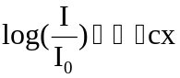

where I is equal to the incident UV light intensity (einstein•cm⁻²•sec⁻¹) through a solution of path length “x” for a given wavelength, I₀ is the incident light intensity for a given wavelength (einstein•cm⁻²•sec⁻¹ ), ε is the molar absorptivity or extinction coefficient of a compound at a given wavelength (L•mol⁻¹•cm⁻¹), C is the concentration of a compound in solution (mol•L⁻¹) and x is the path length of the UV light in the solution (cm). Neglecting the absorptivity of the medium, Eq. 8 states that the absorbance of a solution is directly proportional to the distance x that the UV light has traveled through the solution, and the concentration C of the absorbing species in solution. When the log base e is used then Eq. 8 will be written as:

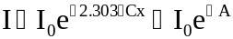

where A is sometimes used to denote the exponent term 2.303εCx.
The photo-physical phenomena of light behavior as described by the Beer-Lambert law can be related to the photochemical behavior to arrive at an general expression that describes the photolysis rate for a single chromophore (e.g. H₂O₂, R₁, R₂ and S) in solution. The quantum yield denoted as , is the number of reactions divided by the number of photons absorbed by the molecule:
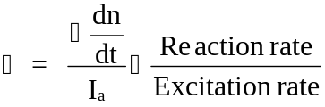
where 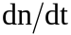 is the change in the number of molecules reacted per unit time, or the rate of photo-physical or photochemical process under consideration. The quantum yield is defined for a monochromatic radiation, and may depend on the wavelength of excitation as well as on the incident photon flux, I₀. The reaction rate, dn/dt, usually assumes a constant volume system so that it can be substituted with, dC/dt, but it is important to keep in mind the definition, since in many scientific articles, is actually taken in account as the molar rate.
Rewriting Eq. 9 in terms of a local reaction rate for a reactant in solution as the only absorbing species over a small distance in solution yields:
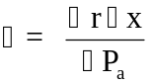
or
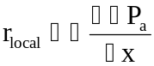
where 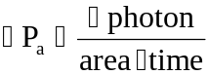 is the number of photons absorbed per area per time and  is the local reactant rate per unit path length of incident UV light. The UV light absorbed by a reactant in solution is also equal to:
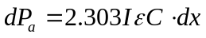
Substitution of Eq. 11 into Eq. 10 yields the following expression for the local photolysis rate:
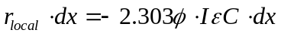
or
The overall or average photolysis rate of a reactant in solution over the whole reactor is obtained by integrating Eq. 13 over the whole solution volume where “b” is the effective optical path length of UV light regardless of the shape of the reactor (cm). This is just an example derivation for the flat plate source of light in a Cartesian coordinate, similar results would occur for line source or point source of light in a cylindrical or spherical coordinate. In addition, it was assumed in the model that the reaction zone is completely mixed so that the concentrations of substances are uniform along the direction of light.
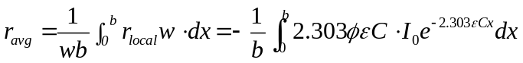
where w is the width of the reactor (cm). Integration of the above equation gives:
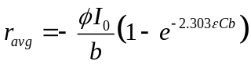
Sometimes the UV light intensity is expressed in the units of moles of photons per volume – time rather than area as shown:
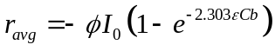
or
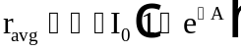

If the photolytic decomposition of H₂O₂ is considered:

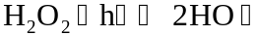

the photolysis rate is:

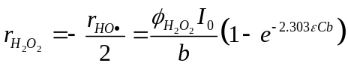

where 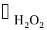is the quantum yield of hydrogen peroxide. When the primary quantum yield  of H₂O₂ is used, 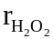is the primary photolysis rate of H₂O₂ and if the overall quantum yield 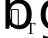 is used, is the overall photolysis rate of H₂O₂. Similar expressions are developed for R1, R2 and S as shown in Table 1.
Equation 18 can also be developed for chromophore mixtures in solution if there is no interaction among the species in solution. The total absorbency for a multi-component system with n different chromophore species (e.g. H₂O₂, organic compounds R1, R2 and S) in solution is given as the sum of their absorbency. Consequently the Beer-Lambert law can be written for a two component chromophore system as:
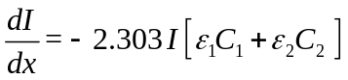
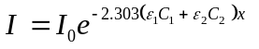
The total UV light absorbed by the solution can be determined by rewriting Eq. 11 for a multi-component system as:

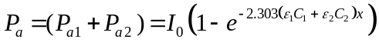

or
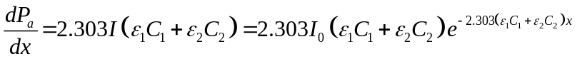

P_{a1} and P_{a2} can be written individually as:

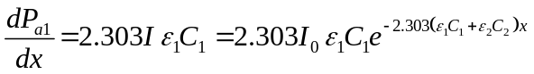

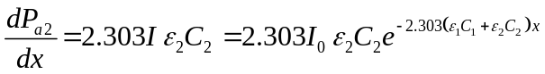

The local photolysis rate expression for P_{a1} and P_{a2} can be determined for the multi-component case by rewriting Eq. 10 as:

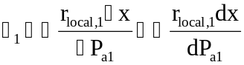
and
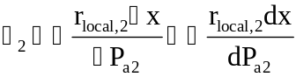
Substitution of Equations 24 and 25 into Equations 26 and 27, respectively, will yield the following local rate expressions:
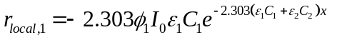
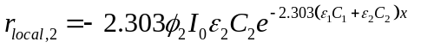
Similar to Equation 14, the following two expressions can be written for the average rate of photolysis for components 1 and 2:
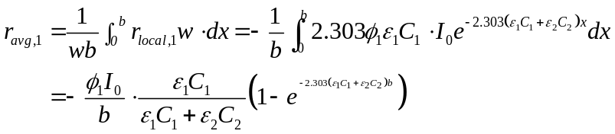
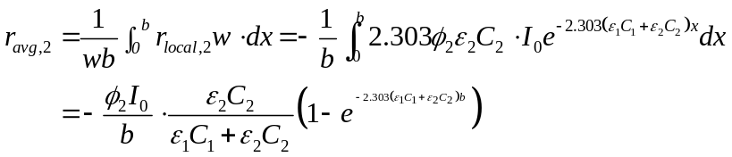

The fractions of absorbed UV light may be expressed using the following equations:

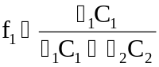
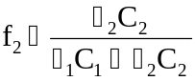

Similar to equation 15, the following average photolysis expressions can be obtained if I₀ is expressed in mole photons per volume-time:

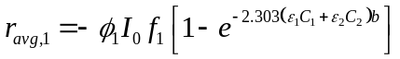

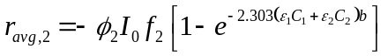

The general expression for the average photolysis rate of component “j” in a solution of “n” components is given as:

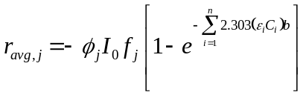
where f_{j} is written as:

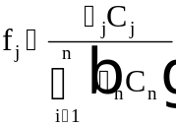

If UV lamps other than low-pressure mercury lamps are used in the photo-oxidation process, (e.g., medium-pressure mercury lamps) the spectral distribution of the lamp must be considered. Usually the incident UV light intensity is measured at specific wavelength intervals (e.g., 5nm) within the effective UV radiation range. The UV-light intensity can be assumed to be monochromatic within such as small wavelength band. The quantum yield and the molar extinction coefficient of a chromophore changes for different wavelengths, and requires measurement as a function of wavelength. Knowing the UV-light intensity, I₀₁, I₀₂, I₀₃, ⋅⋅⋅, I_{0k}, at every k^{th} wavelength band (represented as λ₁, λ₂, λ₃, ⋅⋅⋅, λ_{k}), as well as Φ₁, Φ₂, Φ₃, ⋅⋅⋅, Φ_{k}, and ε₁, εα₂, ε₃, ⋅⋅⋅, ε_{k}, the photolysis rate can be calculated as following:
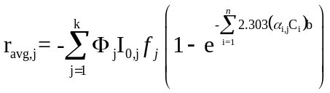
The AdOx software can simulate up to 100 of wavelengths.

Kinetic Rate Expressions

Based on the reactions in Table 1, the overall kinetic rate expressions can be written for inclusion in equations 57 and 58 (see below). These species include: H₂O₂/HO₂⁻, HO•, HO₂•/O₂•⁻, CO₃•⁻, HCO₃⁻/CO₃²⁻, HPO₄•⁻, H₂PO₄⁻/HPO₄²⁻, R₁ (or R₁⁻/R₁H), R₂ (or R₂⁻/R₂H), and S.
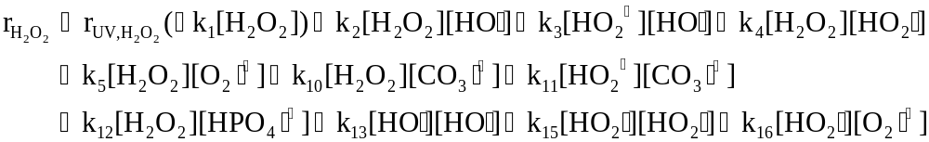 (III.39)
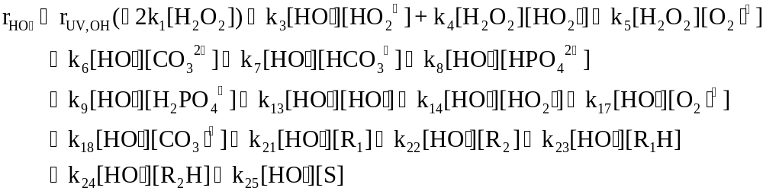 (III.40)
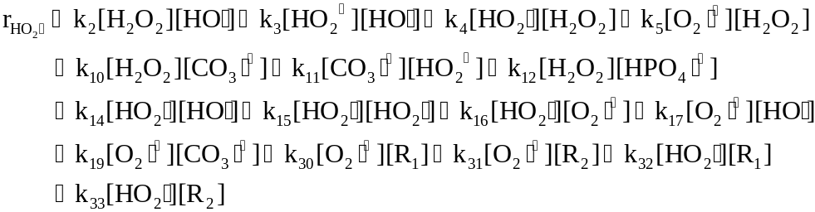 (III.41)
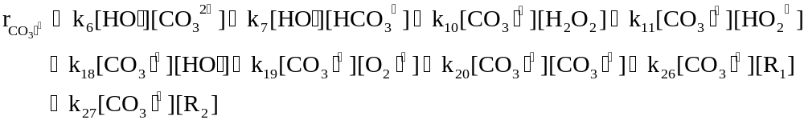 (III.42)
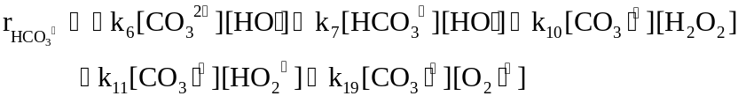 (III.43)
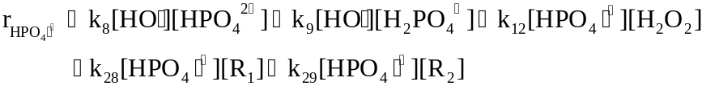 (III.44)
(III.45)
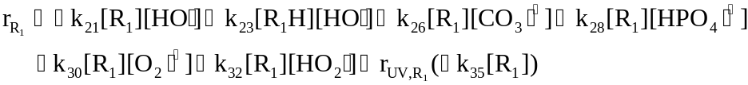 (III.46)
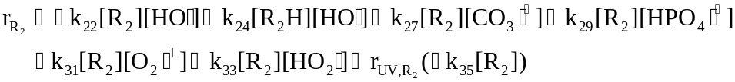 (III.47)
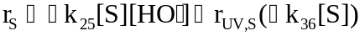 (III.48)
The following equilibrium relationships are considered:

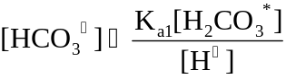 (III.49)
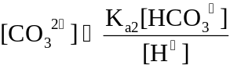 (III.50)
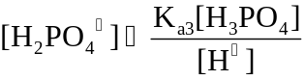 (III.51)
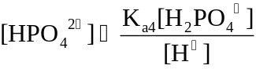 (III.52)
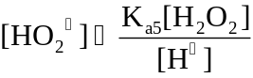 (III.53)
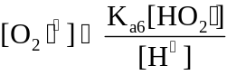 (III.54)
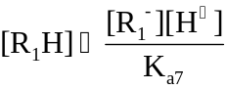 (III.55)
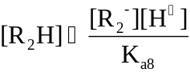 (III.56)
In equations 39 through 48, [R₁] and [R₂] represent [R₁⁻] and [R₂⁻] for acidic compounds. The ordinary differential equations resulting from the substitution of above rate expressions into the mass balances are solved using a backward differentiation formula method (Gear's method) called DGEAR. DGEAR and the associated nuclei are adaptations of a package designed by A. C. Hindmarsh based on C. W. Gear's subroutine DIFSUB (Hindmarsh, 1974).

Reactor Specific Equations

The mass balance for a species, “A”, in a completely mixed batch reactor (CMBR) or a completely mixed flow reactor (CMFR) yields following two ordinary differential equations:
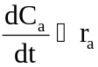 (CMBR) (III.57)
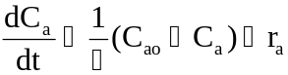 (CMFR) (III.58)
Where C_{ao} is the influent concentration of species A, C_{a} is the concentration of A at time t, τ is the hydraulic retention time of the reactor, and r_{a} is the overall kinetic rate expression of the species A in the reaction system.
Model equations for a plug flow reactor (PFR) and a real flow reactor (RFR) which has mixing characteristics somewhere between CMFR and PFR, can also be solved using the DGEAR algorithm using a Tanks-in-Series model. The same rate expressions [Equations 39, 48] describing the kinetics of the H₂O₂/UV process can also be used for modeling a PFR or RFR. The program can determine how many tanks are needed for modeling PFR or RFR according to dye study data provided by you.

Kinetic Parameters

The use of the AdOx software requires kinetic information and physicochemical properties of the target compounds. AdOxTM contains a database in which you can get information for more than 600 types of compounds. Kinetics parameters needed for the modeling are listed below.

- Extinction coefficient of each compound as a function of specific wavelength of the UV light (normally about 254nm for mercury lamp). This parameter determines the direct hydrolysis reaction rate.
- Quantum yield of the compound under the wavelength of the light from light source (normally about 250nm for mercury lamp). The default value is 0.
- Dissociation constant(s) of the compound if dissociation(s) of that compound exists.
- Rate constants of the reaction between target compounds with OH., HO₂., O₂., radicals.
- Rate constants of the reaction between the dissociated formats of target compound with OH., HO₂., O₂. radicals (default as 0 if not applicable).

Generally, we could ignore the direct photolysis of the target compounds because it is usually insignificant comparing to the reaction with hydroxyl radicals. So, the molar extinction coefficient and quantum yield of the target compound can be ignored. The simulation results will be conservative in this case.

Working with AdOx ™

To start AdOxTM, click on the AdOx icon in the ETDOT programs in the start menu. The screen shown in Figure IV-1 will appear.

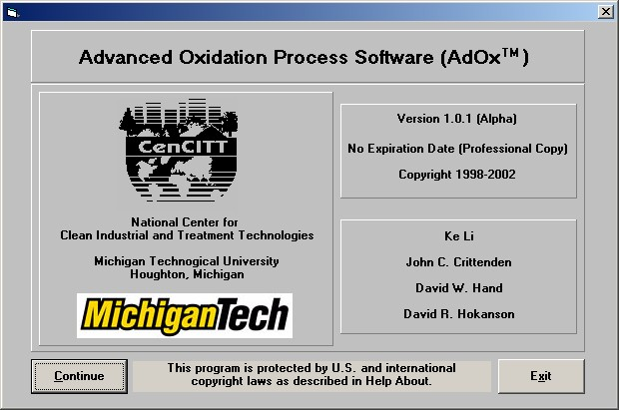

Figure IV-1. AdOx Title Window

Click on the Continue button on the screen shown in Figure IV-1 and the main window of AdOx will appear.

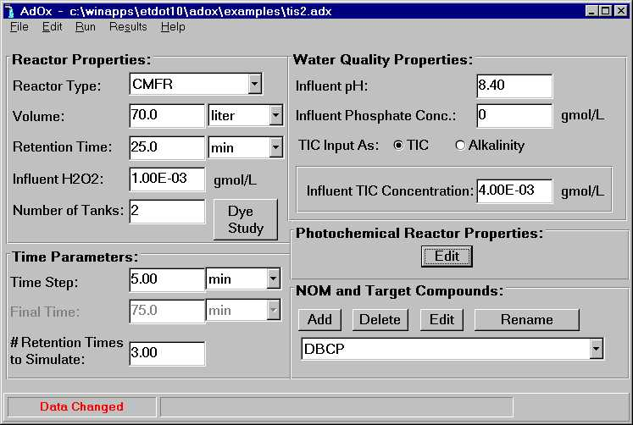

Figure IV-2. The Main Window of AdOx

The main window contains information in five categories as listed below.

- Reactor Properties
- Water Quality Properties
- Time Parameters
- Photochemical Reactor Parameters
- NOM and Target Compounds.

In the following sections, we will discuss the categories in detail.

Input Data

To run a simulation, requires that that all the properties or operational parameters in the five categories above be specified. The property and parameter information can be input for modeling by entering the data directly on the screen in the appropriate windows. You can then save the information into a “.adx” project file for later use. The following discussion will elaborate on how to enter the parameters and information necessary for a model simulation run. In the last section of this chapter, we will briefly cover the data flow.
AdOx ™ provides three sample project files which are located in the "~\adox\examples" subdirectory and named "batch1.adx", "batch2.adx" and "tis2.adx" separately (subject to change). To open them, simply use "open" item in "File" menu from the main window and choose one of the files. We will use "tis2.adx" as our sample in this manual.

Reactor Properties

Reactor properties considered in AdOx ™ include the type, volume and number of tank(s), the retention time in the reactor and the influent H₂O₂ concentration. Among these properties, you should select the flow type first.

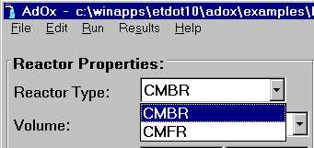

Figure IV-3. Selection of Reactor Type

AdOx ™ can simulate either completely mixed batch reactor (CMBR) or completely mixed flow reactor (CMFR). We can also simulate a plug flow reactor (PFR) or a real reactor by CMFRs in series. Given the removal efficiency, the tanks required for simulating a plug flow reactor can be calculated as below.
For a pseudo first order reaction, the removal efficiencies of a PFR and NTIS are separately:
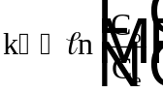
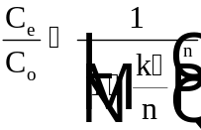
where k is the pseudo first order reaction rate constant,  is the hydraulic retention time. Considering 5% conversion error, we can get the n value from the following equation.
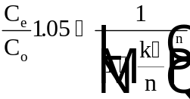
For a real reactor, tracer study analysis should be used to determine the number of tanks required for simulating the reactor.
When using the model as a design aid, both reactor types can be chosen and compared in terms of treatment efficiency. To select the flow type of the reactor, simply choose CMFR or CMBR in the pull down list as shown in Figure IV-3. AdOx ™ provides default parameters for both flow types.

Figure IV-4 displays the reactor property dialogue box for the CMBR option. For the CMBR, the reactor volume and initial H₂O₂ concentration in gmol/L need to be specified. The unit for reactor volume can be m³, cm³, ft³, liter or gal. You can use the one of your convenience.

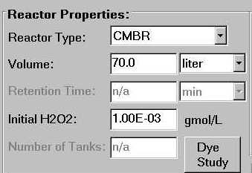
Figure IV-4. Reactor Properties for CMBR

For CMFR, you need to specify the reactor volume, influent H₂O₂ concentration and hydraulic retention time as shown in Figure IV-5. When simulating tanks-in-series (NTIS) process, you must input number of tanks as shown in Figure IV-5. The maximum number of tanks that can be used in AdOx ™ is set at 25. The volume and hydraulic retention time shown in Figure IV-5 are for a single tank, which is simply calculated by taking the volume of the reactor divided by the flow rate into the reactor. The values for these parameters in the tis2.adx sample data file are illustrated in Figure IV-5. These values will be used in the example throughout this chapter.

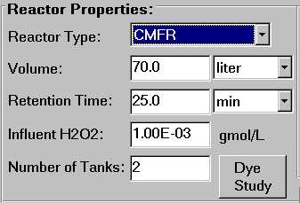

Figure IV-5. Reaction Properties for CMFR

Real reactors can be simulated by matching the exit age distributions that are observed from the dye study of the real reactors and the number of tanks is adjusted to get the spread that occurring in the exit age distribution.

Dye Study Model

The dye study model was integrated in AdOx to analyze dye study data of real reactor systems and provide flow information in the system. Please see Appendix E for an example run of dye study model.

Click on the Dye Study button or select “Edit – Edit Dye Study” menu item in the main window will bring up the dye study screen as shown in Figure IV-6.

You can input your data in the following way.

- Click on Edit Dye Study Data, a window will pop up as shown in Figure IV-7.
- Click on Reset to Empty button in the pop up window
- Choose either of the following options (A) or (B):
(A) Enter your concentration vs. Time data manually by typing it directly into the window
(B) Prepare experimental data in Excel, copy to clipboard, then click on Paste from Excel button in the pop-up window
- Exit the window and save the data file by selecting "File -- Save As" item.

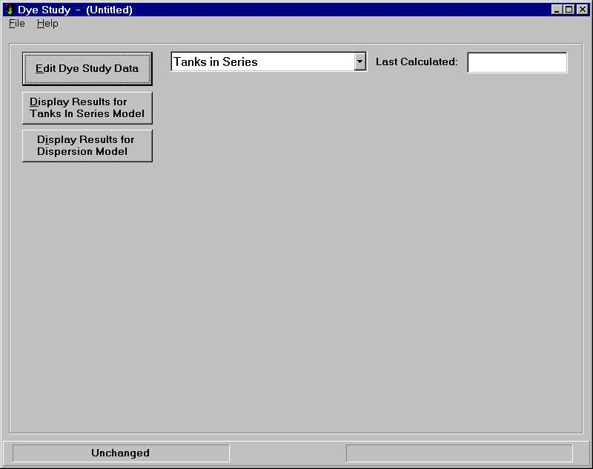

Figure IV-6. Main Window of Dye Study Model

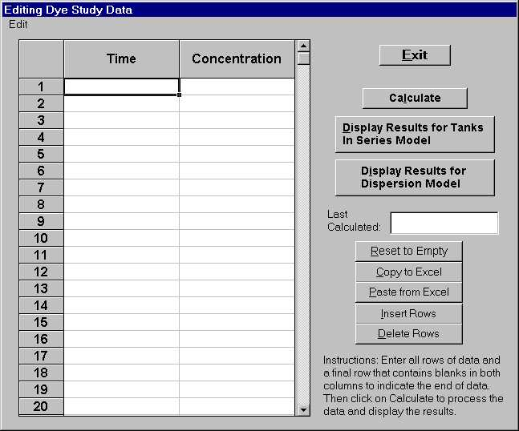
Figure IV-7. The Spreadsheet for Input Dye Study Data

You can edit the data by clicking on Insert Rows or Delete Rows. To perform dye study analysis, click on Calculate button. The model will automatically fit the dye study data by NTIS model. After the calculation, exit the editing window to the main window. Choose from the two Display result… buttons to display modeled results for NTIS or dispersion model according to your requirement. The low-level calculation results window will appear. It includes information for number of tanks that needed for simulating the system and Peclect number of the system. Exit the window by clicking on the Exit button. You can display the exit age distribution plot of the experimental data and NTIS model results. The dispersion models are features of the dye study model and not used in AdOx.

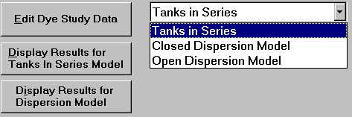

Figure IV-8. Pull-down Window for Choosing Result Plots

Water Quality Properties

Figure IV-9 displays the water quality properties considered in AdOx ™ which include pH, phosphate concentration and total inorganic carbonate (TIC). Because alkalinity is a water quality parameter more frequently measured than TIC, two ways for TIC input are provided. One is by gmol/L of TIC, the other is by alkalinity as mg/L CaCO₃. Please be advised that the two ways in the front-end is not interchangeable. That is, you need to select the input method before you input the value. You have to re-enter in the appropriate value anytime you select the other input method by click on it. The calculation of TIC from alkalinity is based on the assumption that there is no other ions causes alkalinity except carbonate species. The assumption is not always true, such as in the cases when excess phosphate ions or organic matters exist. In those cases, one should calculate the TIC by hand and should not rely on the conversion by the front-end. Below is the derivation of conversion performed by the front-end.
A = Alkalinity (mol/L) = Alkalinity (eqv g/LCaCO3) /50 (g eqv)
A = [OH⁻]+[HCO₃⁻]+2*[CO₃²⁻]-[H⁺]
TIC = [H₂CO₃*] + [HCO₃⁻]+[CO₃²⁻]
[H₂CO₃*] =10^{pKa1-pH} [HCO₃⁻]
[CO₃²⁻] = 10^{pH-pKa2} [HCO₃⁻]
Incorporate into , we got
[HCO₃⁻] = (A+10^{-pH}-10^{pH-14})/(1+2*10^{pH-pKa2})
TIC = [HCO₃⁻] *(1+10^{pKa1-pH} + 10^{pH-pKa2} )

In this example, a pH of 8.4, no phosphate and TIC of 4*10⁻³ gmol/L is used.

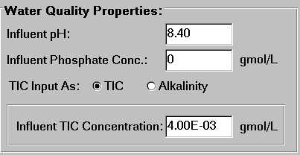

Figure IV-9. Water Quality Properties Dialogue Box.

Numerical Simulation Parameters

In Figure IV-10, AdOx enables you to easily change some numerical parameters for different requirements. You can decrease the time step to get more data for plotting or increase it to decrease run time. AdOx ™ has an upper limit of time steps that is high enough for the possible simulation steps required. Most PC systems can run AdOx ™ efficiently with a wide range of time steps. A value of 5 minutes was used in this sample.

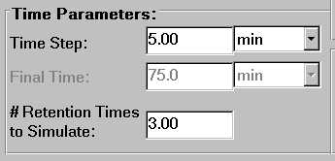

Figure IV-10. The Numerical Simulation Parameters Dialogue Box

The other numerical parameter that can be adjusted is the total time of simulation. You need to specify a long enough time to obtain the steady state result. For a CMBR, you can directly provide a fixed time in the gray area in Figure IV-10. For a CMFR simulation, the total retention time is the number of tanks times the retention time for a single tank. For NTIS model, you should specify a “# Retention times” equal or larger than the number of tanks. In this example, a number 3.00 is used.

Photochemical Parameters

The photochemical parameters within AdOx™ can be adjusted by single clicking the Edit button under Photochemical Reactor Properties label in the main window. A pop-up window will appear, as shown in Figure IV-11, that contains the entire light source and compound related photochemical parameters.
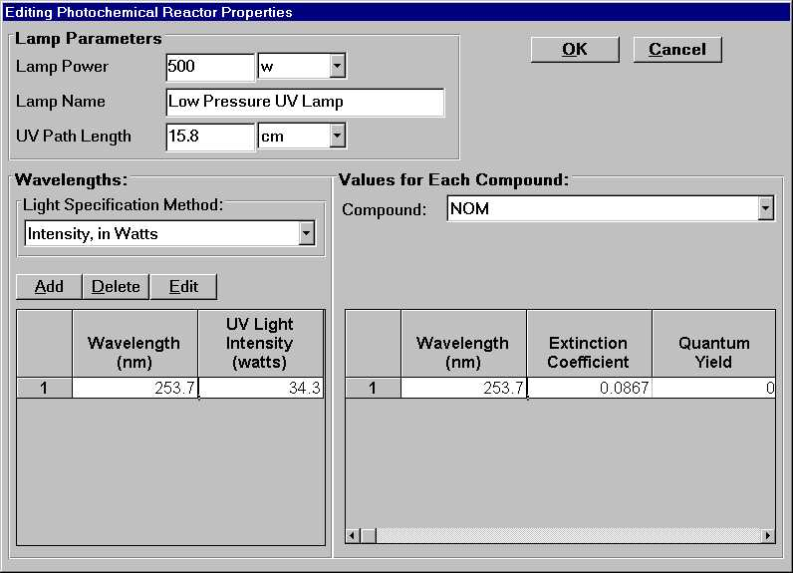

Figure IV-11. Pop-up Window for Editing Photochemical Parameters

Light Source-related Parameters

There are two kinds of light source-related parameters, the lamp parameters and the light source wavelength properties. Appendix C provides some information of generally used mercury lamps.
There are two types of lamp power, the lamp power and the effective UV path length. The lamp power should be input as watts or kilowatts and the UV path length can be input as cm, m or other units. In case of a design phase simulation, any reasonable path length can be used. However, when the simulation of an existing system is being evaluated, the UV path length should be measured by actinometric experiments. Appendix D provides information on how to carry on the experiment and determine the UV path length. As shown in Figure IV-12, in our example, a 500 W low pressure UV lamp and 15.8cm UV path length are used. Notice that when NTIS model is used, the lamp power here refers to the power in one tank so that the total power of the whole reactor system is the lamp power times the number of tanks.
Light intensity as a function of wavelength can be input using any of these three units: Watts, Einsteins/L-s and dimensionless efficiency. This information can be found in the lamp manual of the manufacturer. Once entered, these units can be changed using the pull down unit menu illustrated in Figure IV-12.

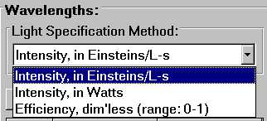

Figure IV-12. Light Intensity Input Methods

The relationship among these three units of expression is given in the following equations.

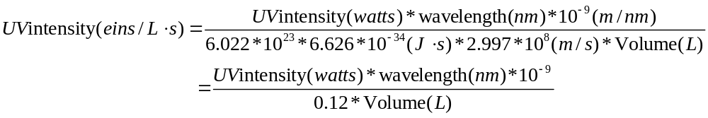
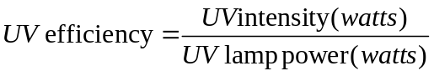
AdOx™ can incorporate multiple wavelengths into the light model calculations. To add a certain wavelength, click on the Add button in the middle of left side of Editing Photochemical Parameters section as shown in Figure IV-13. A pop up dialogue box will appear and inform you to enter the unit of wavelength (Figure IV-1). Simply enter the wavelength in the highlighted area and click on "OK" button, a new wavelength will be added to AdOx™ with a default light intensity. Figure IV-15 shows the results after adding a new wavelength. The new wavelength will appear in the table in ascendant order. The light intensity of the formal record was set to the default wavelength. At the same time, an item is added to the compound related photochemical parameter table, as illustrated in the right part of Figure IV-15. The maximum number of wavelengths permitted by AdOx ™ is 100.

The UV light intensity for various wavelength(s) can be changed by clicking the Edit button. Click on the wavelength you are going to change, the corresponding area will be highlighted as shown. Then click on the Edit button, a pop up dialogue box will appear as Figure IV-16 to enable the change.

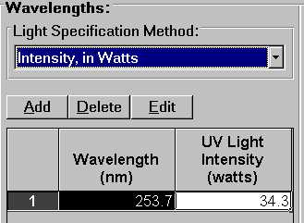

Figure IV-13. Edit the Wavelength Property

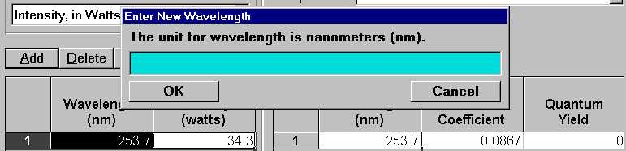

Figure IV-14. Dialogue Box of Adding a New Wavelength

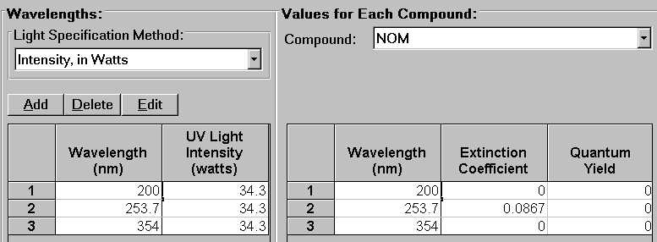

Figure IV-15. The Result after Adding a New Wavelength

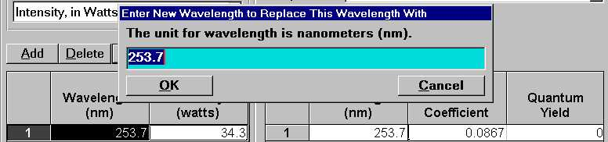

Figure IV-16. Change an Existing Wavelength

You can also delete a wavelength from current table by clicking on the Delete button after clicking on a highlighted item. A warning message will appear, as shown in Figure IV-17, to confirm the operation. Click on the Yes button will delete the wavelength permanently. The only way to recover it is to use the add option.



Figure IV-17. Warning Message for Deleting a Wavelength

Target Compound Related Photochemical Parameters

The compound-related photochemical parameters for each compound are the extinction coefficient and quantum yield.
The extinction coefficients of H₂O₂ were built in the model and can be viewed by click on the "view table of H2O2 Extinction Coefficient" bar as shown in Figure IV-15. A fixed number 0.5 can be used for the quantum yield for H₂O₂ at all wavelengths (Volman D.H., 1959;Vaghjiani G. L. et al., 1992; Zellner R., 1990). Since the pKa of H₂O₂ is 11.75, for most cases where the pH is neutral, the molar concentration of HO₂⁻ is quite low. As a result, AdOx considers the photolysis of HO₂⁻ only at 254nm and the quantum yield is taken as 0.5 (Baxendale J.H. et al., 1957).
For most target compounds, direct photolysis can be ignored, i.e. the quantum yields are 0. However, for those have strong absorption in the UV range, the extinction coefficient should be included in the model to account for the UV interference by these compounds. Some of the extinction coefficients for common aqueous species were listed in Table 2 and Table 3. Appendix F concludes properties of NOM.
For those compounds that degrade via photolysis, both quantum yield and molar extinction coefficient needs to be specified for each specified wavelength. The pull down menu shown in Figure IV-18 is used to select each compound and enter the parameters. For target compounds and hydrogen peroxide, the units of the extinction coefficient is (mole/L)⁻¹(cm)⁻¹. For NOM, the unit is (mg/L)⁻¹(cm)⁻¹. These data should be obtained either from prior experimental values obtained from literature or by performing experiments.

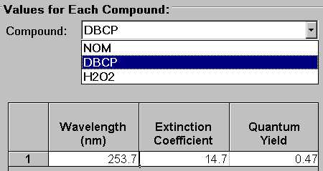

Figure IV-18. Target Compound Related Photochemical Parameters

The table below lists three common inorganic ions in the water and wastewater stream. This enables simulation of the UV interference and scavenging effect of these species. The hydroxyl rate constants of these ions can be found in reference 5 and 8.

Table 2. Molar Extinction Coefficients for Ultraviolet Radiation for Liquid Hydrogen Peroxide-Water Mixtures and Some Common Inorganic Species

Wavelength | Molar Extinction Coefficient (L/mol⁻¹.cm⁻¹)
Wavelength | H₂O₂& | Fe(III)@ | Fe(II)@ | Nitrate*
200 | 140. | 4032 | 642 | 9623.5
210 | 98.0 | 4336 | 650 | 7943.3
220 | 76. | 4517 | 551 | 3744.0
230 | 62 | 4361 | 494 | 788.25
240 | 35 | 3933 | 584 | 92.6
250 | 21.5 | 3135 | 518 | 8.6
254 | 19.6±0.3 | 2798 | 444 | 3.4
260 | 13. | 2304 | 354 | 1.4
270 | 6.4 | 1991 | 313 | 1.4
280 | 4.2 | 1934 | 288 | 3.4
290 | 3.3 | 2041 | 255 | 5.0
300 | 1.0 | 2172 | 255 | 6.7
304 | 0.58 | 2197 | 255 | 6.6
310 | 0.36 | 2164 | 255 | 6.0
320 | 0.22 | 1876 | 247 | 3.2
& Schumb, W.C; Satterfield, C.N.; Wentworth, R.L. "Hydrogen Peroxide", Reinhold Pub. Corp., New York, 1955.
@ Frank A.H.; Roesch W.C. "Radiation Dosimetry (2nd Ed.)", Academic Press, 1966.
* Meyerstein D.; Treinin A. "Absorption Spectra of NO₃⁻ in Solution", Trans. Faraday Soc., 57, 2104-2112, 1961.

Table 3 provides additional information of the molar extinction coefficient of two contaminants.

Table 3. Molar Extinction Coefficients of DBCP and EDB

Compound | Wavelength  (nm) | Molecular Extinction Coefficient (liters/mole•cm)
 |  | Distilled Water (DW) | 4mM HCO₃⁻ DW
DBCP | 310 | 2.8 | 2.1
 | 254 | 14.8 | 19.7
 | 240 | 69.8 | 86.8
 | 210 | 395 | 683
EDB | 310 | 0.0 | 0.3
 | 254 | 7.1 | 9.3
 | 240 | 39.1 | 56.2
 | 210 | 360 | 834

Target Compound Properties

AdOx ™ is capable of simulating the destruction of up to 10 compounds.

Add a Target Compound

The current version of AdOxTM includes a database containing the second order hydroxyl radical rate constants of more than 600 compounds. The database is built in the model and very easy to use. Just click on the Add button under the NOM and Target Compound display label in the lower right corner of the main window and a message will appear to tell you that there are two ways to add a compound. It can be entered on the screen manually or from the database. The message is as shown in .

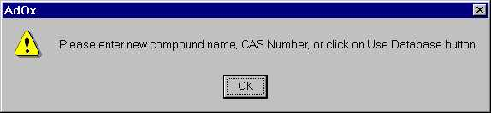

Figure IV-19. Warning Message for Adding New Compound

Clicking on “OK” in the message window above will display the following window shown in Figure IV-20.
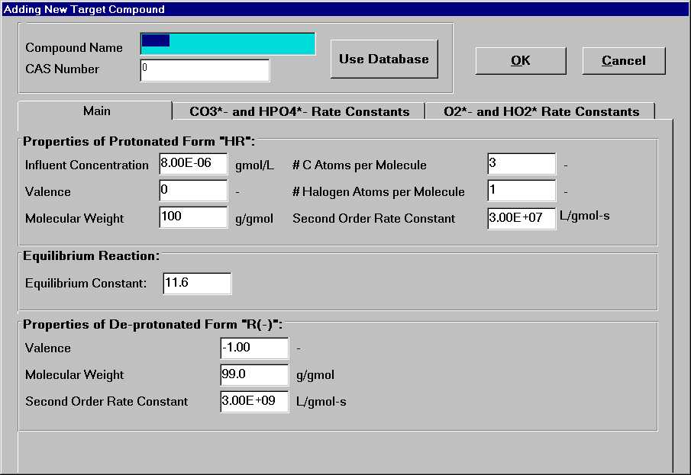

Figure IV-20. Window for Adding a New Target Compound

The recommended method is to use the database as the window is shown below in Figure IV-21 below.

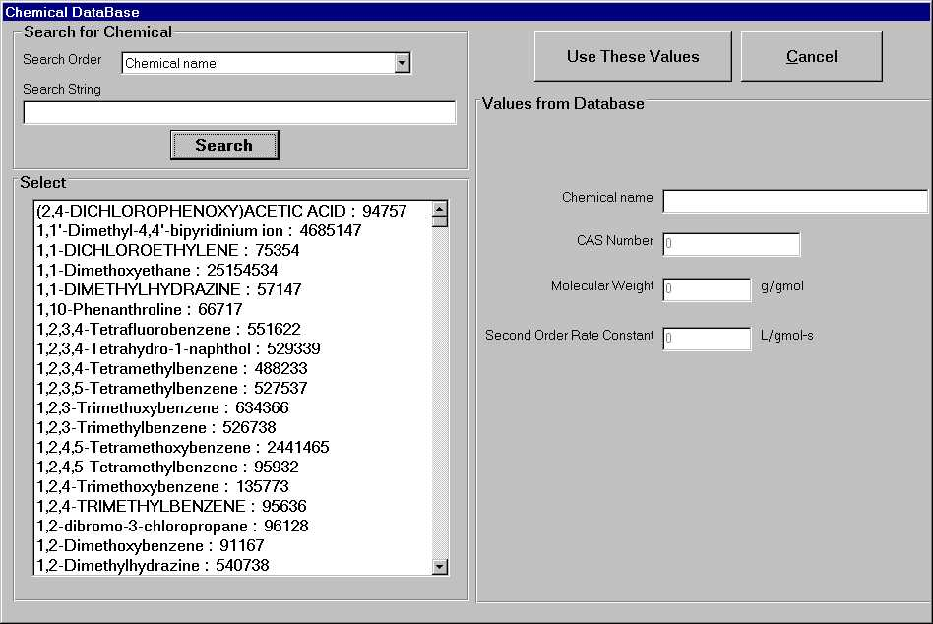

Figure IV-21. The Database Window
The AdOx™ database enables searching by compound name, synonyms or CAS number. The synonym database includes most of the currently used synonyms for the selected compounds. Once the search method is selected, the search keyword or Cas number can be entered and then click on the search button. All the compounds that contain the search keyword will appear in the “Select” window in the lower left part. The format is “name: CAS number”. The appropriate compound can then be selected for the results of the key word search by clicking on the “Use These Value” button. The hydroxyl radical rate constant and the molecular weight of the compound will automatically be transferred to the screen.
Adding a compound without using the database requires the name of the compound to be typed in the first input box in the window shown in Figure IV-20. If the CAS number of the compound is all that is known, the database can be searched to see if it is available. If not, then both the molecular weight and second order hydroxyl radical rate constant must be entered by hand. Please refer to Figure IV-20 for the section.
Other physical-chemical of the target compound include
- the valence of the protonated form
- the number of the carbon atoms in the compound
- the number of the halogen number of the compound
- the equilibrium constant for the deprotonation of the compound
- properties of the deprotonated form
- reaction constant for reaction with other radicals
The valence of the protonated form and the numbers of carbon and halogen atoms in a compound molecule are used for calculating the pH change. Assuming the degraded compounds are completely mineralized, the CO₂ and anion ions produced can be calculated according to stoichiometry. The new pH for the system can then be calculated based on the charge balance in the reactor. Because the advanced oxidation process is normally a dilute solution system, the ionic strength effects can be neglected. The equilibrium constant can be calculated by concentration instead of activity of the species while the equilibrium constant remains dimensionless. The default value of equilibrium constant 100 means the compound doesn’t dissociate in water.

The properties of the deprotonated form "R(-)" include the following three:
- the valence of de-protonated target compound, (normally is 1, that is, only consider the first order dissociation of target compound);
- molecular weight of de-protonated compound;
- second order rate constant of the reaction between hydroxyl radical and de-protonated target compound.

AdOx TM considers the reaction between the target compound with radicals other than the hydroxyl radical. Four radicals that normally exist in the advanced oxidation process are CO₃*⁻ , HPO₄*⁻, O₂*⁻and HO₂*. The corresponding rate constant for the reaction can be entered to account for the influence of those radicals. Normally, you can ignore the reactions of those radicals. But if you want to consider the influence of these radicals and have the rate constant information, you can specify the rate constants by clicking on the proper tag in the window shown in Figure IV-20. For example, clicking on the “CO₃*⁻ and HPO₄*⁻ Rate Constant” will bring up the window for specifying rate constants with the CO₃*⁻ and HPO₄*⁻ radicals as shown in Figure IV-22. The specification of the rate constant for the O₂*⁻and HO₂* radicals is the same.
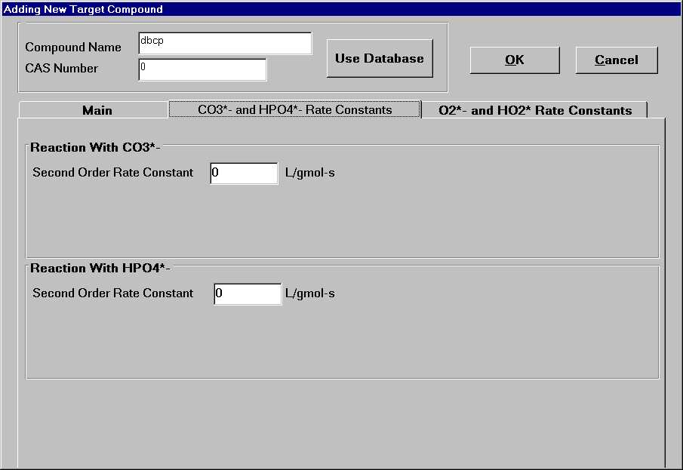

Figure IV-22. The Window for Specifying the Rate Constant with CO₃^{*-} and HPO₄^{*-}

After entering all information for the reaction pathway, click on the "OK" button and the compound is successfully added.

Delete an Existing Target Compound

To delete a target compound, select the compound in the pull-down window below the “NOM and Target Compounds” label in the main window. Then click on the delete button. A warning message will appear to confirm the deleting. Click yes will permanently delete the compound from the simulation.

Edit the Information of an Existing Target Compound

After adding a compound, the properties can be changed by using the "Edit" button under the "NOM and Target Compounds:" label in Figure IV-20.

Rename an Existing Target Compound

Using the "rename" button under the "NOM and Target Compounds:" bar in the main window, will enable the change of a name of an existing compound. The pop up window is the same as that shown Figure V-48.

Saving and Printing Input Parameters

The "Save" and "Save As" items in the "File " menu of the main window can be used to save a file for a simulation. To save the data click on Save As... or Save in the File menu. Selecting the “Save As...” menu item will open a dialog box where the file name can be entered and the data will be saved. The Save command will save the current data by overwriting the previous file last opened. To load a file to start a simulation, click on Open in the File menu and select the file. All the parameters will be updated automatically. Any kinetic coefficients or fluid properties not input during an edit session are automatically calculated.
To print the current input parameters, select the Print to Excel item in the File menu. It will print all input parameters and simulation results into an Excel workbook. The input worksheet includes all the input parameters.
- Reactor properties
- Numerical Simulation Parameters
- Water Quality properties
- Target Compound property
- Photochemical parameters
(Note: When you choose File...Print to Excel, there is simulation result even you didn’t run the model. This is not the result for current input data but for the last run of AdOx. )

The results of printing all of the available input data to a printer or a file are shown below:
Filename: C:\CPAS10\adox\examples\tis2.adx
Unused: Unused
Printed: 5/3/99 2:30:40 AM

Reactor Properties.

Reactor Type: CMFR
Volume: 70.0 liters
Retention Time: 25.0 minutes
Influent H2O2: 1.00E-03 gmol/L
Number of Tanks: 2.00 tanks

Numerical Simulation Parameters.

Time Step: 5.00 minutes
Final Time: n/a minutes
# Retention Times to Simulate: 3.00 -

Water Quality Properties.

Influent pH: 8.40 -
Influent Phosphate Conc.: 0 gmol/L
TIC Input As: TIC
Influent TIC Concentration: 4.00E-03 gmol/L

Target Compounds : Properties of Protonated Form.
Name | Influent Conc. gmol/L | Valence | Molec. Wt. g/gmol | # C toms per molec | # hal. toms per molec | 2nd order rate const.  (*)
NOM | 0 | n/a | 200 | n/a | n/a | 20000
DBCP | 1.83E-06 | 0 | 100 | 3.00 | 3.00 | 150000000
(*): For NOM, units are 1/(mg-L)-s; for all other compounds, units are L/gmol-s.
Target Compounds : Equilibrium Reaction, Properties of the De-protonated Form.
Name | Equilibrium Constant gmol/L | Valence | Molec. Wt.  g/gmol | 2nd order rate const.  L/gmol-s
NOM | n/a | n/a | n/a | n/a
DBCP | 14.0 | -1.00 | 99.0 | 3.00E+09

Target Compounds : Other Reactions.
Name | Rxn. With CO3*-  L/gmol-s | Rxn. With H₂PO₄*- L/gmol-s | Rxn. With  O2*-  L/gmol-s | Rxn. With  HO2⁻*  L/gmol-s
NOM | n/a | n/a | n/a | n/a
DBCP | 0 | 0 | 0 | 0

Photochemical Parameters:

Lamp Power: 500 watts
Lamp Name: Low Pressure UV Lamp
UV Path Length: 15.8 cm
Light Specification Method: Intensity, in Watts

Photochemical Parameters: Light Intensities.
Wavelength nm | UV Light Intensity watts
254 | 34.3

Photochemical Parameters : Values for Each Compound.
Name | Wavelength  nm | Extinction Coefficient | Quantum Yield
NOM | 254 | 0.0867 | 0
DBCP | 254 | 14.7 | 0.470
H2O2 | 254 | 19.0 | 0.500

Run a Simulation

Once all of the input data have been entered, a model simulation can be performed. To run a simulation, select the Run...Run Simulation menu item from the main menu or use short key "ctrl + R". A warning message will appear and tell you the time variance of simulation as shown in Figure IV-23. Most simulations can be performed in a couple of minutes on PC with a 80486 or higher processor. After each run, a message box like the one in Figure IV-24 will appear to inform you of the simulation status.

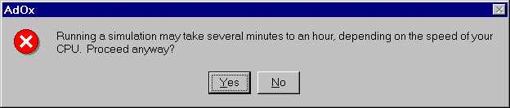

Figure IV-23. Warning Message before a Run

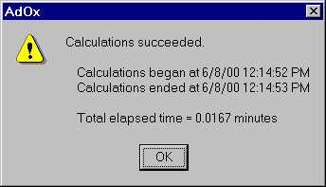

Figure IV-24. Running Status of Sample Simulation

Results

Once a simulation has been successfully completed, the results can be displayed and saved by selecting the "Result" menu at the top of the main menu as shown in Figure IV-25. AdOx ™ provides a way to view all of the input information and simulation results in text format. It also provides methods to analyze the results. These functions are discussed below.

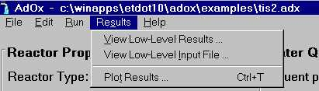

Figure IV-25. The "Result" Menu

Viewing Input Data

Selecting the "View Low-Level Input File…" will open a Notepad window that contains all of the input information as well as the explanation of input data. It is helpful for understanding the model.

Viewing Simulation Results

Select "View Low-Level Results File…" will open a Notepad window which contains all of the simulation results in each time step. As can be seen in Appendix B, the low-level results file includes the concentration profile of all of the compounds and intermediate radicals. The results can be saved in a file in .txt format for later use.

Results Analysis

Print Results to Excel

Select File...Print to EXCEL... menu item to print both the input information and simulation results to an Excel workbook. You can then save the .xls file and work on the file using Excel.

Plot Results

You can select Results...Plot Results menu item to plot the concentration profiles of species in the last tank of the system as shown in Figure IV-26. The concentration profile of the main species of common interest such as NOM, target compound (DBCP in our sample simulation), H₂O₂ and pH can be viewed.
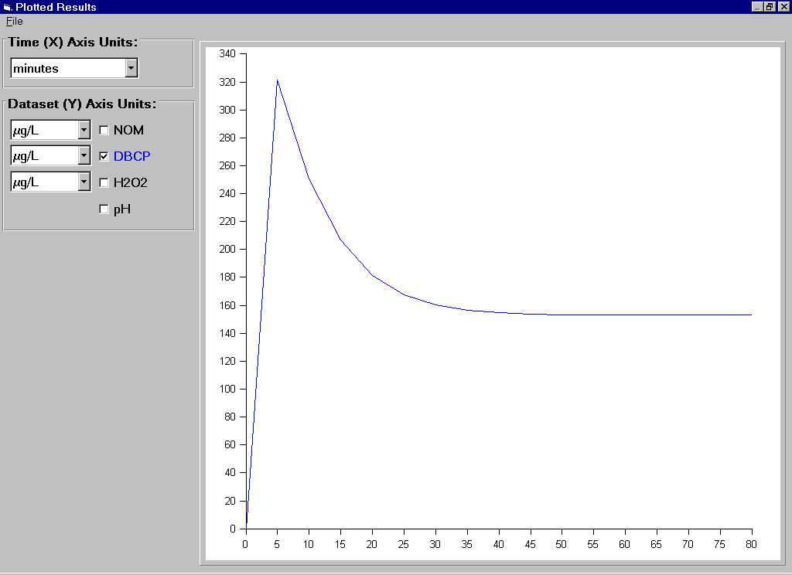

Figure IV-26. The Result Plotting Window

Change the Units for Plot

As can see in Figure IV-26, the units can be changed in the plot. For the x-axis, the units of seconds, minutes, hours and years can be used. Choosing the appropriate unit will depend upon on the simulation run time. Using the pull-down window shown in Figure IV-27 the units can easily be changed. The simulation time of the sample calculation is 80 minutes, so the appropriate units for the x-axis are minutes. To select a certain unit, click on the arrow to bring up the units list, then click on the one you want to use to make it highlighted. In a similar way, the concentration units on the y-axis can also be changed as shown in Figure IV-28.

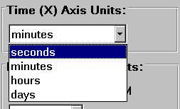
Figure IV-27. Change Time Units for Plotting

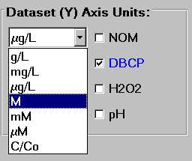

Figure IV-28. Window for Changing The Units of Species Concentration

Plot the Concentration Profile for a Single Species

To plot concentration profile of a species, simply check the box for each compound. If more than one kind of target compound is considered in the simulation, the target option of all of the compounds will appear in the left part of the window (see Figure IV-29).

Combining Plots

A plot of several compounds in one figure can be obtained by checking the option labeled “all of the species”. The concentration curves for different species are shown in different colors and easily distinguishable. As illustrated in Figure IV-29, DBCP and H2O2 were both checked and their curves are shown in one plot in the right part of the window.

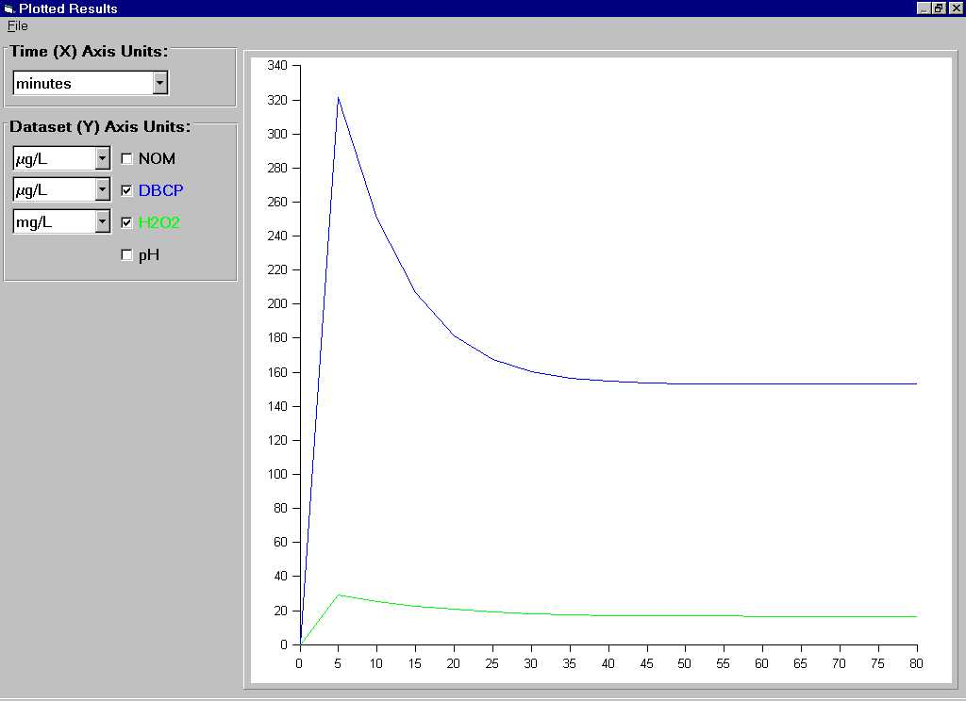

Figure IV-29. Combination Plot of DBCP and H₂O₂

Sample Run for Determining Optimum Operational Parameters by AdOx

Due to the many factors that affect the AOP process, electrical energy per order (EE/O) was proposed as a figure of merit to evaluate the efficiency of AOPs. The definition of EE/O is the electrical energy (in kilowatts) required to reduce the concentration of a pollutant by one order of magnitude in 1000 U.S. gallons (3785L) of water. Though full economic analysis should be made when considering the use of advanced oxidation, it is simple to use EE/O to compare the efficiency of the AOP under different operational conditions and thus determine the optimum operational parameters.
The following example illustrates how to determine the optimum EE/O of a H₂O₂/UV system using AdOx.

Problem Statement

The city of Anytown, USA recently discovered that one of its wells was contaminated with the compounds listed in Table 1. In order to continue using the well as drinking water resource, the compounds shown in Table 1 need to be removed below their MCLs. During normal pumping operations, the well produces about 500 gallon per minute. The pH and alkalinity are 6.8 and 400 mg/L as CaCO₃, respectively.
In this example, we will design a H₂O₂/UV system that can remove all the VOCs below their MCLs and determine the optimum operational parameters including H₂O₂ dosage, light power and hydraulic retention time. The solution is only a conceptual design and not based on the commercially available reactor.

Table 1. Contaminants – Influent Concentrations and Treatment Objectives

Compound | Concentration Discharged, C₀ |  | MCL, C_{TO}
 | (μg/L) | (μmol/L) | (μg/L) | (μmol/L)
Trichloroethylene (TCE) | 200.0 | 1.53 | 5.0 | 3.8e-2
Tetrachloroethylene (PCE) | 150.0 | 0.90 | 5.0 | 3.0e-2
Vinyl Chloride | 60.0 | 0.97 | 1.0 | 1.6e-2
Toluene | 80.0 | 0.87 | 5.0 | 5.43e-2

Table 2. Physico-Chemical Properties of the Contaminants

Compound | MW  (g/mol) | pKa | OH radical rate constant (L/mol.s) | CAS
Trichloroethylene | 131 | N/A | 4.2E+9 | 79-01-6
Tetrachloroethylene | 166 | N/A | 2.6E+9 | 127-18-4
Vinyl Chloride | 62 | N/A | 1.2E+10 | 593-60-2
Toluene | 92 | N/A | 3.0E+9 | 108-88-3

Solution Scenario

A four tanks-in-series system will be designed. For simplicity, we are going to use a fixed hydraulic retention time in this example. However, in practice, you can model different hydraulic retention times and determine the optimum value by comparing the EE/O for each retention time.
In order to determine the optimum operational parameters, different light power and dosage will be calculated. For each light power, the optimum H₂O₂ dosage will be determined by comparing the EE/O for different H₂O₂ dosage. Then the EE/O of different light powers in the optimum H₂O₂ dosage will be compared to obtain the optimum light power. The following is the way of determining of key parameters required by the model.

Determine the Hydraulic Retention Time and Effective Optical Path Length

For the simplicity of the example, we will use a fixed hydraulic time 10 minutes. Of course it can be changed and an optimum value could be obtained whenever it is interested.
With a hydraulic time of 10 min and flow rate of 500 gpm, the volume of the tank is given by
(B.1)
where Q is the flow rate and τ is the hydraulic retention time.
For our case, we use 20000 liter as our reactor volume. Considering the large capacity, we are going to use 4 reactors in series. Then the volume and hydraulic retention time of each tank are 5000 liter and 2.5 minutes separately. Using an effective depth of 1.5 m, the diameter of the tank can be calculated as below.

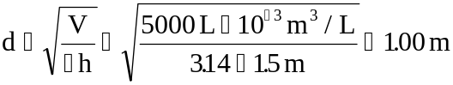 (B.2)
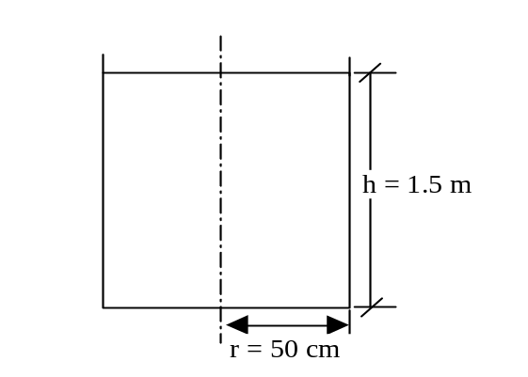
Figure V-30. The Cross-Section Sketch of the Reactor

Then the effective optical path length can be reasonably estimated to be around 50 cm. In this example, we use an effective optical path length of 50 cm.

Light Power

To determine the optimum light power we are going to run the model with different light intensities and H₂O₂ dosages and compare the EE/Os. We will model the UV intensity ranging from 0.5×10⁻⁶ eins./(L.S) to 2×10⁻⁶ eins./(L.S) with an interval of 0.5×10⁻⁶ eins./(L.S). The light power is related to the UV intensity by the equation below.

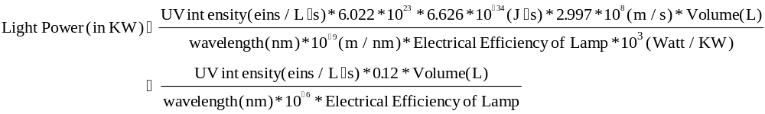(B.3)

The type of lamp to be used determines the lamp efficiency. There are two major options for UV lamp, the low and medium-pressure mercury lamps which have the electrical efficiency of 30% and 5~20% respectively. Some new generation medium-pressure mercury lamps, called proprietary lamps, have a higher efficiency around 30%. You can get the information on lamp efficiency from the product manual. In addition, since the efficiency of the UV lamp drops at low temperatures, it is important to insulate the lamp from the fluid. The disadvantage of low-pressure lamps is that the power input is low, around 20~120W. A large system may require a large number of lamps. This will increase the capital cost and lamp replacement cost. The drawback of medium-pressure lamps is that their low efficiency means high electrical cost. We use low-pressure mercury lamps as light source in the example. Considering a safe factor of 1.5, we use the electrical efficiency of 30%/1.5 = 20%.

According to the equation, we can calculate the light powers corresponding to each UV intensity as shown in Table 3.

Table 3. The Light Intensity Required for Various UV Intensities

UV Intensity  (10⁻⁶eins./L.S) | Lamp Power for Each Tank (KW) | Total Light Power for Four Tanks (KW)
0.5 | 6 | 24
1.0 | 12 | 48
1.5 | 18 | 72
2.0 | 24 | 96

H₂O₂ Dosage

Table 4 shows the parameters we used for variable modeling. For each light power, H₂O₂ dosages ranging from 0.5 mM to 1.5 mM in 0.1 mM increments are used to determine the optimum H₂O₂ dosage.

Table 4. The Scenario for Running the Model to Determine Optimum Operational Parameters *

Run NO | Tank Volume (L) | Number of Tanks | Tau (min) | Light Power  (KW) | Light Intensity  (10⁻⁶enis./L.S) | H₂O₂ Dosage (mM)
1 | 5000 | 4 | 2.5 | 6 | 0.5 | 0.5
2 |  |  |  |  |  | 0.6
3 |  |  |  |  |  | 0.7
4 |  |  |  |  |  | 0.8
5 |  |  |  |  |  | 0.9
6 |  |  |  |  |  | 1
7 |  |  |  |  |  | 1.1
8 |  |  |  |  |  | 1.2
9 |  |  |  |  |  | 1.3
10 |  |  |  |  |  | 1.4
11 |  |  |  |  |  | 1.5
12 | 5000 | 4 | 2.5 | 12 | 1.0 | 0.5
13 |  |  |  |  |  | 0.6
14 |  |  |  |  |  | 0.7
15 |  |  |  |  |  | 0.8
16 |  |  |  |  |  | 0.9
17 |  |  |  |  |  | 1.0
18 |  |  |  |  |  | 1.1
19 | 5000 | 4 | 2.5 | 12 | 1.0 | 1.2
20 |  |  |  |  |  | 1.3
21 |  |  |  |  |  | 1.4
22 |  |  |  |  |  | 1.5
23 | 5000 | 4 | 2.5 | 18 | 1.5 | 0.5
24 |  |  |  |  |  | 0.6
25 |  |  |  |  |  | 0.7
26 |  |  |  |  |  | 0.8
27 |  |  |  |  |  | 0.9
28 |  |  |  |  |  | 1
29 |  |  |  |  |  | 1.1
30 |  |  |  |  |  | 1.2
31 |  |  |  |  |  | 1.3
32 |  |  |  |  |  | 1.4
33 |  |  |  |  |  | 1.5
34 | 5000 |  | 2.5 | 24 | 2.0 | 0.5
35 |  |  |  |  |  | 0.6
36 |  |  |  |  |  | 0.7
37 |  |  |  |  |  | 0.8
38 |  |  |  |  |  | 0.9
39 |  |  |  |  |  | 1
40 |  |  |  |  |  | 1.1
41 |  |  |  |  |  | 1.2
42 |  |  |  |  |  | 1.3
43 |  |  |  |  |  | 1.4
44 |  |  |  |  |  | 1.5
* The tank volume, lamp power and light intensity are for one tank. The H₂O₂ dosage are for the whole system.

Now that we have the necessary information for the required parameters, we need to run AdOx to get the results and calculate the EE/O for each run. We will use run NO 17 shown in table 4 as an example in the following section.

Running AdOx to Obtain the Result for Calculating EE/O

To start AdOxTM, click on the AdOx icon in the ETDOT programs in the start menu. The screen shown in Figure 2 will appear.

Figure V-31. AdOx Title Window

Click on the Continue button on the screen shown in Figure V-31 and the main window of AdOx will appear. We will use the parameters listed in the table for run NO. 17.
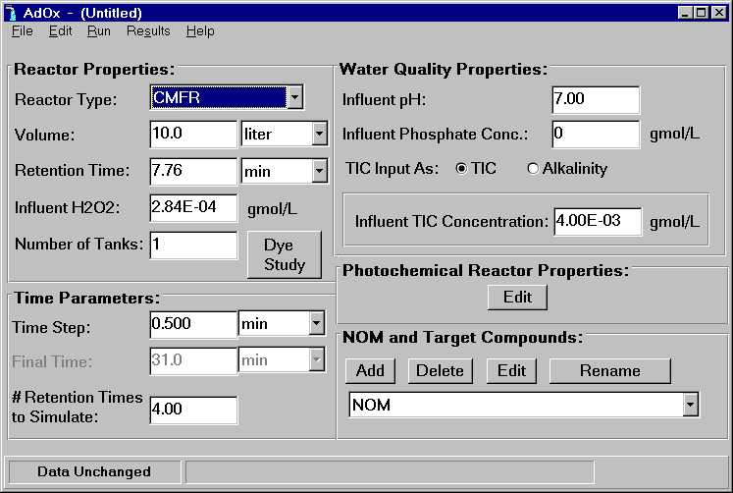
Figure V-32. The Main Window of AdOx

Input Data

Reactor Properties

Specify reactor properties in the upper left corner of the main window shown in Figure V-33. The system is a two tanks-in-series. The single tank volume is 5000 liters and the hydraulic retention time is 2.5min. The dosage of H₂O₂ is 1mM.

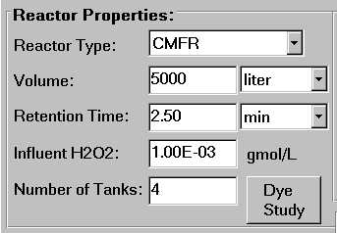
Figure V-33. Reactor Type Portion of the Main Window

Water Quality Properties

Specify the water quality at the upper right corner as shown in Figure V-34. The pH of the source water is 6.8, total phosphate concentration is 0 and alkalinity is 400 mg/L as CaCO₃.

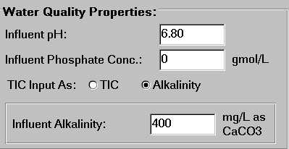

Figure V-34. Water Quality Properties Portion of the Main Window

Numerical Simulation Parameters

The lower left part of the main window is the numerical simulation parameters portion. Because the retention time in the example is not long, we use 1min as the simulation time step and totally simulate 5 times of retention time (5*2.5 = 12.5min). We could adjust the parameters according to the requirement of viewing results.

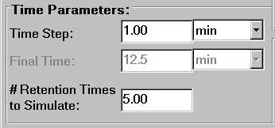

Figure V-35. Numerical Simulation Parameters Portion of Main Window

Photochemical Parameters

Click on the Edit button under Photochemical Reactor Properties label in the main window, a pop-up window will appear, as shown in Figure V-36. We can edit the photochemical parameters for the reactor and the chemical in this window.

Figure V-36. Window for Editing Photochemical Parameters

Light Source-related Parameters

Specify the total lamp power in a tank in the upper left portion of the editing window as shown in Figure V-37. The light power for a single tank is 12KW and the optical length is 50cm.

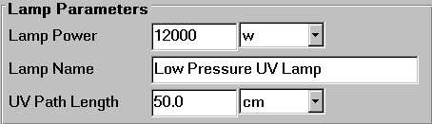

Figure V-37. Lamp Parameters Portion of Photochemical Parameters Window

Since we use low-pressure mercury lamp, the irradiation wavelength is 253.7 nm. The simulated UV intensity is 1*10⁻⁶ eins./(L.S). Select the specification method as Intensity, in Einsteins/L-S as shown in and change the numbers under UV Light Intensity to 1e-6.

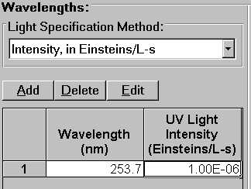

Figure V-38. Specify UV Light Intensity

Target Compound Related Photochemical Parameters

The UV-light absorption and direct photolysis of the four target compounds are ignored due to the lack of photochemical parameters. In addition, there is no NOM in the source water. So we only need to specify the extinction coefficient and quantum yield for H₂O₂ as shown in Figure V-39.

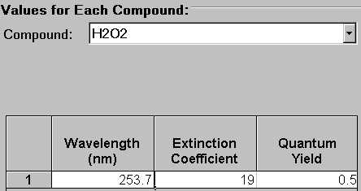

Figure V-39. Compound Related Photochemical Parameters

Target Compound Properties

Target compounds can be added and their properties can be edited in the lower right portion of the main window as shown in . We are going to model the destruction of four compounds that are TCE, PCE, vinyl chloride and toluene. We need to add them one by one. We will add TCE step by step in the following section.

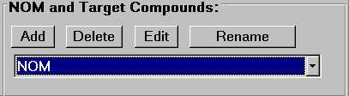

Figure V-40. NOM and Target Compound Portion of Main Window

Click on the Add button and a message will appear to tell you that there are two ways to add a compound. It can be entered on the screen manually or from the database. The message is as shown in .

Figure V-41. Information Message for Adding New Compound

Clicking on “OK” in the message window above and the adding new compound window will appear in Figure V-42.
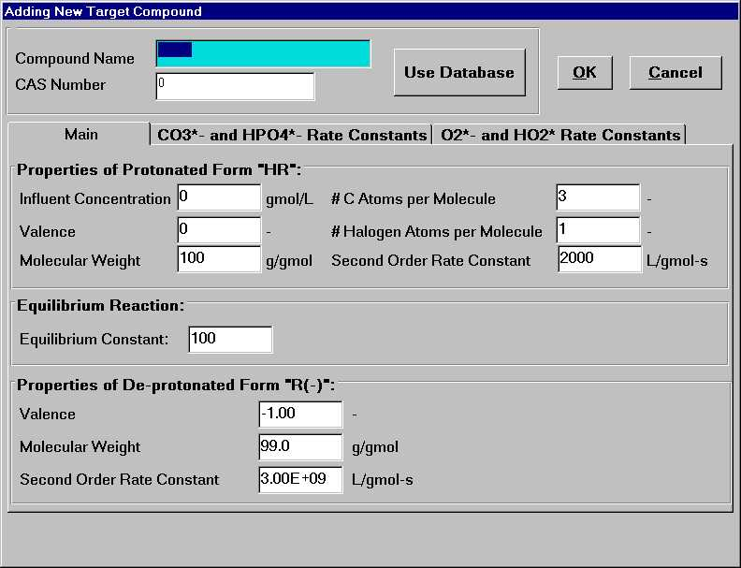

Figure V-42. Window for Adding a New Target Compound

Click on Use Database button in the above window, the chemical database window will appear as Figure V-43 shown.

Figure V-43. The Chemical Database Window

The AdOx™ database enables searching by compound name, synonyms or CAS number. The synonym database includes most of the currently used synonyms for the selected compounds. Select the Synonyms search order and enter TCE as the search string and click on search. Click on the appeared search result, the required compound properties will appear in gray in the right part of the window as shown in Figure V-44.

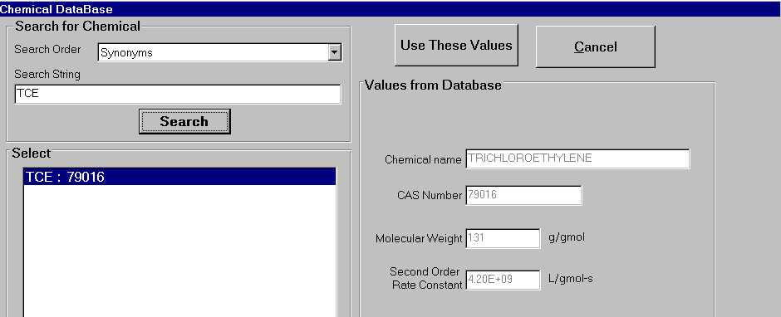

Figure V-44. The Search Result for TCE

Click on the Use These Values button on the screen above, the search results will automatically filled in the adding compound window. We could then specify other information as shown in Figure V-45.
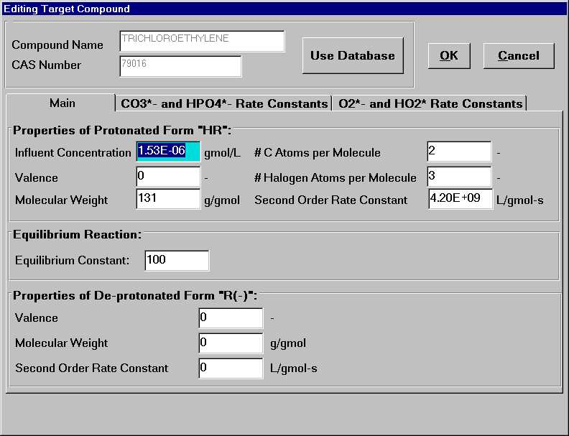
Figure V-45. The Compound Properties of TCE

The influent concentration of TCE is 1.53 gmol/L. Because TCE doesn’t dissociate in water, the equilibrium constant remains the default value 100, which means the compound doesn’t dissociate. Click on the OK button in the screen that shown in Figure V-45, the target compound is successfully added in. Add other three compounds in the same way and delete the default compound R1. Figure V-45 shows the content in the drop-down window of the NOM and Target Compound portion.

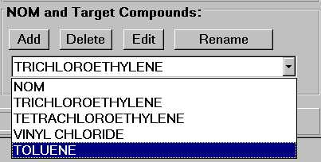

Figure V-46. The Content in the Target Compound Portion
After added all target compounds, we can save our input by selecting File...Save or File...Save As menu item.

Running a Simulation

To run a simulation, select the Run...Run Simulation menu item from the main menu or use short key "ctrl + R". Click Yes on the appeared message box to run the simulation. After each run, a message box as shown in will appear to inform you of the simulation status.

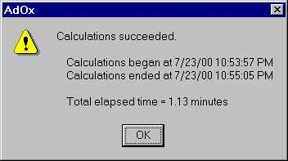

Figure V-47. Running Status of Sample Simulation

Viewing Results

As we know from the Chapter IV of this manual, we could plot the concentration profiles of the target compounds. We can also see the low-level output results by selecting the Results...View Low-Level Results menu item to obtain the low-level simulation. For calculation of the EE/O, we only need the effluent concentration. We can obtain the effluent concentrations for the 4 compounds by viewing the low-level simulation results. The following are the low-level simulation results for the effluent from the fourth tank. From the model calculations, the effluent concentration of TCE, PCE, vinyl chloride and toluene are respectively 0.852E-10 M, 0.277E-9 M, 0.102E-11 M and 0.162E-9 M. Referring to Table 1 we can see that the effluent concentrations for all four compounds are below their MCLs.
#TANK TIME(SEC) TIME(MIN) H2O2 TRICHLOROETHTETRACHLOROEVINYL CHLORITOLUENE
4 0. 0.0 0.000E+00 0.000E+00 0.000E+00 0.000E+00 0.000E+00
4 60. 1.0 0.968E-03 0.335E-07 0.844E-07 0.186E-10 0.567E-07
4 120. 2.0 0.937E-03 0.605E-09 0.660E-08 0.110E-11 0.302E-08
4 180. 3.0 0.907E-03 0.977E-10 0.748E-09 0.108E-11 0.310E-09
4 240. 4.0 0.878E-03 0.890E-10 0.321E-09 0.106E-11 0.176E-09
4 300. 5.0 0.850E-03 0.878E-10 0.288E-09 0.105E-11 0.168E-09
4 360. 6.0 0.825E-03 0.870E-10 0.284E-09 0.104E-11 0.166E-09
4 420. 7.0 0.803E-03 0.865E-10 0.282E-09 0.104E-11 0.165E-09
4 480. 8.0 0.784E-03 0.860E-10 0.280E-09 0.103E-11 0.164E-09
4 540. 9.0 0.767E-03 0.857E-10 0.279E-09 0.103E-11 0.164E-09
4 600. 10.0 0.753E-03 0.855E-10 0.279E-09 0.102E-11 0.163E-09
4 660. 11.0 0.742E-03 0.854E-10 0.278E-09 0.102E-11 0.163E-09
4 720. 12.0 0.733E-03 0.853E-10 0.278E-09 0.102E-11 0.163E-09
4 780. 13.0 0.725E-03 0.852E-10 0.277E-09 0.102E-11 0.162E-09

Change the parameters according to the scenario in Table 4 and run the model, we can then obtain the effluent concentration for each case.

Calculate the EE/O

The EE/O of flow system can be calculated from the equation below.

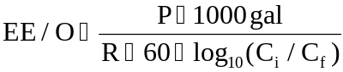
where P is the lamp power (in KW), R is the flow rate (in gallons per minute) and C_{i} and C_{f} are influent and effluent concentration separately.

Table 5 shows the energy requirement for each compound in case 17.

Table 5. The EE/O for the Removal of the Four Target Compound for Run NO 17

Compound | Volume(L)* | Tau  (min)* | Light Power  (KW)* | UV Intensity  (eins./L-S) | H₂O₂ Dosage  (M) | C_{i}  (M) | C_{f}  (M) | log(C_{i}/C_{f}) | Flow Rate  (gpm) | Light Power  (KW)# | EE/O
TCE | 5000 | 2.5 | 12 | 1.00E-06 | 0.001 | 1.53E-06 | 8.52E-11 | 4.2543 | 500 | 48 | 0.38
PCE |  |  |  |  |  | 9E-07 | 2.77E-10 | 3.5118 | 500 | 48 | 0.46
Vinyl Chloride |  |  |  |  |  | 9.7E-07 | 1.02E-12 | 5.9782 | 500 | 48 | 0.27
Toluene |  |  |  |  |  | 8.7E-07 | 1.62E-10 | 3.73 | 500 | 48 | 0.43
(Note: The unit of the EE/O is Kw-hour/Kgallon-conversion.
* The values in this column are for a single tank.
# The values in this column are the total value for the whole system. )

Because the second order hydroxyl radical rate constant of PCE is the smallest among the four compounds, we can assume that the EE/O for PCE is the largest at certain operation condition. The calculation in Table 5 proves this. We will compare the EE/O for PCE removal in each case to determine the optimum operational parameters (EE/O results of all other cases also prove the assumption).

The Optimum H₂O₂ Dosage and Light Power

Calculate the EE/O for PCE removal for all cases in the same way we used above. We can then compare the EE/Os to get the optimum H₂O₂ dosages and light power. The energy requirement for all cases is plotted as Figure V-48. It seems that the EE/O increase as the light power increases. We could run the model in lower light power to find a better solution. But since the EE/O is already very low, we didn’t try lower light powers in this example. From Figure V-48, we can see that the minimum EE/O is achieved when light power is 24 KW and the H₂O₂ dosage is 0.8mM. This could be considered as the optimum operation condition. However, the EE/Os for other cases are also low. None of them exceeds 2 Kwh/KGallon while the EE/Os less than 10 Kwh/KGallon are considered very favorable (J. R. Bolton & S. R. Cater, 1994). In addition, as you increase power, you could increase removal. Therefore you will be able to increase the power and allow more flexibility in the design which is an important consideration.

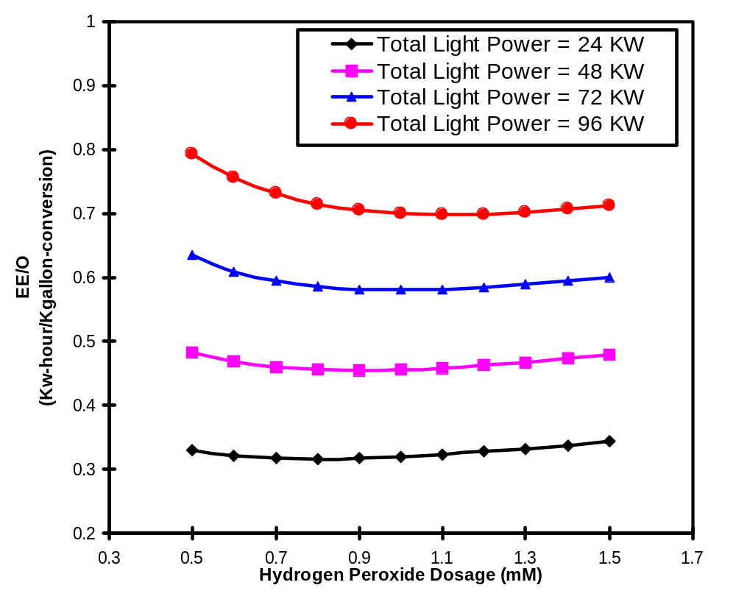
Figure V-48. The Energy Requirement for Removing PCE under MCL in Different Operational Condition (4 tanks-in-series, 5000 liters each, total hydraulic retention time 10min)

Conclusion

A four tanks-in-series system could meet the treatment requirement for the well in AnyTown. The design parameters are as below.

Number of tanks: 4
Single tank volume: 5000 Liter (diameter 1.00m, valid depth 1.50m)
Flow rate: 500 gpm
Single tank hydraulic retention time: 2.5 min
Total hydraulic retention time: 10min
Light source: low-pressure mercury lamp
Total light power: 12 KW *4 = 48 KW
H₂O₂ dosage: 0.8 mM (27.2mg/L)

Appendix A. References

- Baxendale, J.H. and Wilson J.A. The Photolysis of Hydrogen Peroxide at High Light Intensities. Trans. Faraday Soc., 53, 344-356, 1957.
- Bielski, B.H.J.; Cabelli, D.E.; Ravindra, L.A. and Alberta, A.B.Reactivity of perhydroxyl/superoxide radicals in aqueous solution J. Phys. Chem. Ref. Data, 14(4), 1041-100, 1985.
- Bolton, J. R. and Cater, D. R. Homogeneous Photodegradation of Pollutants in Contaminated Water: An Introduction. Chapter 33 in Aquatic & Surface Photochemistry, Helz G. R., ED.; CRC Press:Boca Raton, 467-490, 1994.
- Braun, W.; Herron, J.T. and Kahanner, D.K. Auchem: A Computer Program for Modeling Complex Chemical Reaction Systems International Journal of Chemical Kinetics, 20, 51-62, 1988.
- Buxton, G.V.; Greenstock C.L.; Helman W.P. and Ross A.B. Critical Review of Rate Constants for Reactions of Hydrated Dlectrons, Hydrogen Atoms and Hydroxyl Radicals (OH/O⁻) in Aqueous Solution. J. Phys. Chem. Ref. Data, 17 (2), 513-886, 1988.
- Chen, S.N. and Hoffman, M.Z. Effect of pH on the Reactivity if the Carbonate Radical in Aqueous Solutions Radiat. Res., 62, 18-27, 1975.
- De Laat, J. and Dore, M. Degradation of Chloroethanes in Dilute Aqueous Solution by H₂O₂/ UV Wat. Res., 28 (12), 2507-2519, 1994.
- Farhataziz and Ross A.B. Selected Specific Rates of Reactions of Transients from Water in Aqueous Solution III. Hydroxyl Radical and Perhydroxyl Radical and their Radical Ions, NSRDS-NBS NO.59, 1977.
- Froelich, E.M. The Perox-PureTM Oxidation System, A Comparative Summary. A Symposium on Advanced Oxidation Processes for the Treatment of Contaminated Water and Air, Proceedings, June 4 and 5, 1990.
- Froelich, E.M. Advanced Chemical Oxidation of Contaminated Water Using the perox-pureTM Oxidation System. Chemical Oxidation: Technologies for th Nineties, ED. Eckenfelder, W.W., 1994.
- Glaze, W.H. and Kang J.W. Advanced Oxidation Processes for Treating Groundwater Contaminated with TCE and PCE: Laboratory Studies J. AWWA, May, 57-63, 1988.
- Glaze, W.H. and Kang J. W. Advanced Oxidation Processes. Description of a Kinetic Model for the Oxidation of Hazardous Materials in Aqueous Media with Ozone and Hydrogen Peroxide in the Semibatch Reactor Ind. Eng. Chem. Res., 28, 1573-1580, 1989a.
- Glaze, W.H. and Kang J. W. Advanced Oxidation Processes. Test of a Kinetic Model for the Oxidation of Organic Compounds with Ozone and Hydrogen Peroxide in a Semibatch Reactor Ind. Eng. Chem. Res., 28, 1580-1587, 1989b.
- Glaze, W.H.; Lay Y. and Kang J. W. Advanced Oxidation Processes. A Kinetic Model for the Oxidation of 1,2-Dibromo-3-chloropropane in Water by the Combination of Hydrogen Peroxide and UV Radiation Ind. Eng. Chem. Res., 34, 2314-2323, 1995.
- Glaze, W.H.; Beltran F.; Tuhkanen T. and Kang J. W. Chemical Models of Advanced Oxidation Processes Water Poll. Res. J. Canada, 27 (1), 23-42, 1992.
- Hong, A.; Zappi, M.E.; Kuo C. H., and Hill D. Modeling Kinetics of Illuminated and Dark Advanced Oxidation Processes Journal of Environmental Engineering, Jan., 58-62, 1996.
- Hunt, J.P. and Taube H. The Photochemical Decomposition of Hydrogen Peroxide. Quantum Yields, Tracer and Fractionation Effects J. Ame. Chem. Soc., 74, 5999-6002, 1952.
- Larson, R.A. and Zepp R. G. Reactivity of the Carbonate Radical with Aniline Derivatives Environ, Toxicology and Chemistry, 7, 265-274, 1988.
- Lay, Y.S. Oxidation of 1,2-Dibromo-3-Chloropropane in Groundwater Using Advanced Oxidation Processes. Ph.D. dissertation, University of California, Los Angeles, 1989.
- Lewis, N., Topuduti K. and Foster R. A Field Evaluation of the UV/Oxidation Technology to Treat Contaminated Groundwater. HMC, March/April, 42-55, 1990.
- Liao C.H. (1993) The Investigation of Hydrogen Peroxide Photolysis as a Water Treatment Process. Ph.D. Dissertation, Drexel University.
- Liao, C.H. and Gurol M.D. Chemical Oxidation by Photolytic Decomposition of Hydrogen Peroxide. Environ. Sci. Technol., 29, 3007-3014, 1995.
- Mallard, W.G., Ross A.B., and Helman W.P. NIST Standard Reference Database 40, NDRL/NIST Solution Kinetics Database Version 1.0. Data compiled and evaluated, 1992.
- Miller, W.L. Recent Advances in the Photochemistry of Natural Dissolved Organic Matter. Aquatic and Surface Photochemistry, 111-128, 1994.
- Peyton, G.R.; Smith M.A. and Peyton B.M. Photolytic Ozonation for Protection and Rehabilitation of Groundwater Resources; A Mechanistic Study. UILU-WRC-87-206 Research Report, 1987.
- Peyton, G.R. and Glaze W. H. Destruction of Pollutants in Water with Ozone in Combination with Ultraviolet Radiation. 3. Photolysis of Aqueous Ozone. Environ. Sci. Technol., 22, 761-767, 1988.
- Peyton, G.R. Guidelines for the Selection of a Chemical Model for Advanced Oxidation Processes. A symposium on advanced oxidation processes for the treatment of contaminated water and air (proceedings) June 4&5, 1990, Toronto.
- Schumb, W.C;Satterfield, C.N.; Wentworth, R.L. "Hydrogen Peroxide", Reinhold Pub. Corp., New York, 1955.
- Sehested, K.; Rasmussen O.L. and Fricke H. Rate constants of OH with HO₂, O₂⁻and H₂O₂⁺ from hydrogen peroxide formation in pulse-irradiated oxygenated water, J. Phys. Chem., 72, 626-31, 1968.
- Stefan, M.I.; Hoy A.R. and Bolton J.R. Kinetics and Mechanism of the Degradation and Mineralization of Acetone in Dilute Aqueous Solution Sensitized by the UV Photolysis of Hydrogen Peroxide. Environ. Sci. Technol., 30, 2382-2390, 1996.
- Symons, J. M.; Prengle, H. W.; Dannelle B. Use of Ultraviolet Irradiation and Hydrogen Peroxide for the Control of Solvent Contamination in small Water Utilities, Proc.-Annu. Conf., Am. Water Works Assoc., (Pt. 2), 1403-18, 1989.
- Vaghjiani G.L.,Turnipseed A.A., Warren R.F. and Racishankara A.R. Photodissociation of H2O2 at 193 and 222nm: Products and Quantum Yields, J. Chem. Phys. 96(8), 15, pp5878, April, 1992.
- Volman, D.H. and Chen, J. C. The Photochemical Decomposition of Hydrogen Peroxide in Aqueous Solutions of Allyl Alcohol at 253.7Å, J. Am. Chem. Soc. 81, 4141-4144, 1959.
- Weir, B.A. and Sundstrom D.W. Destruction of Trichloroethylene by UV Light-catalyzed Oxidation with Hydrogen Peroxide. Chemosphere, 27 (7), 1279-1291, 1993.
- Westerhoff P.; Aiken G.; Amy G.; Debroux J. Relationship between the Structure of Natural Organic Matter and Its Reactivity towards Molecular Ozone and Hydroxyl Radicals. Wat. Res. Vol. 33, No. 10, pp. 2265-2276, 1999.
- Yao, C.D.; Haag W.R.; and Mill T. Kinetic Features of Advanced Oxidation Processes for Treating Aqueous Chemical Mixtures. Chemical Oxidation: Technology for the Nineties, Nashville, TN, 19-21 Feb. 1992.
- Zeff, J.D. and Bull R. A. Hydrogen Peroxide in Advanced Oxidation Processes for Treatment of Industrial Process and Contaminated Groundwater. Chemical Oxidation: Technologies for the Nineties, ED. Eckenfelder W.W., 1992.
- Zellner R.; Exner M. and Herrmann H Absolute OH Quantum Yields in the Laser Photolysis of Nitrate, Nitrite and Dissolved H₂O₂ at 308and 351nm in the Temperature Range 278-353K, J. of Atmospheric Chemistry 10, pp411-425, 1990.

Appendix B. Low-level Results for Example Calculations

#TANK TIME(S) TIME(M) H2O2 DBCP HO2* HCO3- H2PO4-
1 0. .0 .100E-02 .183E-05 .000E+00 .400E-02 .000E+00
1 300. 5.0 .883E-03 .143E-05 .114E-05 .400E-02 .000E+00
1 600. 10.0 .812E-03 .124E-05 .103E-05 .400E-02 .000E+00
1 900. 15.0 .770E-03 .115E-05 .959E-06 .400E-02 .000E+00
1 1200. 20.0 .744E-03 .110E-05 .919E-06 .400E-02 .000E+00
1 1500. 25.0 .729E-03 .108E-05 .896E-06 .400E-02 .000E+00
1 1800. 30.0 .720E-03 .107E-05 .882E-06 .400E-02 .000E+00
1 2100. 35.0 .715E-03 .107E-05 .874E-06 .400E-02 .000E+00
1 2400. 40.0 .712E-03 .107E-05 .869E-06 .400E-02 .000E+00
1 2700. 45.0 .710E-03 .107E-05 .866E-06 .400E-02 .000E+00
1 3000. 50.0 .709E-03 .107E-05 .864E-06 .400E-02 .000E+00
1 3300. 55.0 .708E-03 .107E-05 .863E-06 .400E-02 .000E+00
1 3600. 60.0 .708E-03 .107E-05 .862E-06 .400E-02 .000E+00
1 3900. 65.0 .707E-03 .107E-05 .862E-06 .400E-02 .000E+00
1 4200. 70.0 .707E-03 .107E-05 .862E-06 .400E-02 .000E+00
1 4500. 75.0 .707E-03 .107E-05 .862E-06 .400E-02 .000E+00
1 4800. 80.0 .707E-03 .107E-05 .862E-06 .400E-02 .000E+00
#TANK TIME(S) TIME(M) NOM CO3*- HPO4*- HO*
1 0. .0 .000E+00 .000E+00 .000E+00 .000E+00
1 300. 5.0 .000E+00 .259E-09 .000E+00 .538E-11
1 600. 10.0 .000E+00 .278E-09 .000E+00 .525E-11
1 900. 15.0 .000E+00 .290E-09 .000E+00 .516E-11
1 1200. 20.0 .000E+00 .298E-09 .000E+00 .510E-11
1 1500. 25.0 .000E+00 .302E-09 .000E+00 .506E-11
1 1800. 30.0 .000E+00 .305E-09 .000E+00 .504E-11
1 2100. 35.0 .000E+00 .307E-09 .000E+00 .503E-11
1 2400. 40.0 .000E+00 .308E-09 .000E+00 .502E-11
1 2700. 45.0 .000E+00 .309E-09 .000E+00 .501E-11
1 3000. 50.0 .000E+00 .309E-09 .000E+00 .501E-11
1 3300. 55.0 .000E+00 .309E-09 .000E+00 .501E-11
1 3600. 60.0 .000E+00 .309E-09 .000E+00 .501E-11
1 3900. 65.0 .000E+00 .310E-09 .000E+00 .500E-11
1 4200. 70.0 .000E+00 .310E-09 .000E+00 .500E-11
1 4500. 75.0 .000E+00 .310E-09 .000E+00 .500E-11
1 4800. 80.0 .000E+00 .310E-09 .000E+00 .500E-11
#TANK TIME(S) TIME(M) H2O2 DBCP HO2* HCO3- H2PO4-
2 0. .0 .000E+00 .000E+00 .000E+00 .000E+00 .000E+00
2 300. 5.0 .862E-03 .136E-05 .110E-05 .400E-02 .000E+00
2 600. 10.0 .750E-03 .106E-05 .927E-06 .400E-02 .000E+00
2 900. 15.0 .666E-03 .874E-06 .798E-06 .400E-02 .000E+00
2 1200. 20.0 .607E-03 .768E-06 .708E-06 .400E-02 .000E+00
2 1500. 25.0 .566E-03 .710E-06 .647E-06 .400E-02 .000E+00
2 1800. 30.0 .538E-03 .678E-06 .607E-06 .400E-02 .000E+00
2 2100. 35.0 .520E-03 .662E-06 .581E-06 .400E-02 .000E+00
2 2400. 40.0 .508E-03 .654E-06 .564E-06 .400E-02 .000E+00
2 2700. 45.0 .501E-03 .651E-06 .553E-06 .400E-02 .000E+00
2 3000. 50.0 .496E-03 .649E-06 .546E-06 .400E-02 .000E+00
2 3300. 55.0 .493E-03 .649E-06 .542E-06 .400E-02 .000E+00
2 3600. 60.0 .491E-03 .649E-06 .539E-06 .400E-02 .000E+00
2 3900. 65.0 .490E-03 .649E-06 .538E-06 .400E-02 .000E+00
2 4200. 70.0 .489E-03 .649E-06 .537E-06 .400E-02 .000E+00
2 4500. 75.0 .488E-03 .649E-06 .536E-06 .400E-02 .000E+00
2 4800. 80.0 .488E-03 .649E-06 .536E-06 .400E-02 .000E+00
#TANK TIME(S) TIME(M) NOM CO3*- HPO4*- HO*
2 0. .0 .000E+00 .000E+00 .000E+00 .000E+00
2 300. 5.0 .000E+00 .264E-09 .000E+00 .535E-11
2 600. 10.0 .000E+00 .296E-09 .000E+00 .512E-11
2 900. 15.0 .000E+00 .324E-09 .000E+00 .490E-11
2 1200. 20.0 .000E+00 .346E-09 .000E+00 .471E-11
2 1500. 25.0 .000E+00 .364E-09 .000E+00 .456E-11
2 1800. 30.0 .000E+00 .376E-09 .000E+00 .445E-11
2 2100. 35.0 .000E+00 .384E-09 .000E+00 .437E-11
2 2400. 40.0 .000E+00 .390E-09 .000E+00 .432E-11
2 2700. 45.0 .000E+00 .393E-09 .000E+00 .428E-11
2 3000. 50.0 .000E+00 .396E-09 .000E+00 .426E-11
2 3300. 55.0 .000E+00 .397E-09 .000E+00 .424E-11
2 3600. 60.0 .000E+00 .398E-09 .000E+00 .423E-11
2 3900. 65.0 .000E+00 .399E-09 .000E+00 .423E-11
2 4200. 70.0 .000E+00 .399E-09 .000E+00 .422E-11
2 4500. 75.0 .000E+00 .400E-09 .000E+00 .422E-11
2 4800. 80.0 .000E+00 .400E-09 .000E+00 .422E-11
#TANK TIME(S) TIME(M) pH
1 0. .0 8.40
1 300. 5.0 8.38
1 600. 10.0 8.38
1 900. 15.0 8.38
1 1200. 20.0 8.38
1 1500. 25.0 8.38
1 1800. 30.0 8.38
1 2100. 35.0 8.38
1 2400. 40.0 8.38
1 2700. 45.0 8.38
1 3000. 50.0 8.38
1 3300. 55.0 8.38
1 3600. 60.0 8.38
1 3900. 65.0 8.38
1 4200. 70.0 8.38
1 4500. 75.0 8.38
1 4800. 80.0 8.38
2 0. .0 8.40
2 300. 5.0 8.38
2 600. 10.0 8.38
2 900. 15.0 8.37
2 1200. 20.0 8.37
2 1500. 25.0 8.37
2 1800. 30.0 8.37
2 2100. 35.0 8.37
2 2400. 40.0 8.37
2 2700. 45.0 8.37
2 3000. 50.0 8.37
2 3300. 55.0 8.37
2 3600. 60.0 8.37
2 3900. 65.0 8.37
2 4200. 70.0 8.37
2 4500. 75.0 8.37
2 4800. 80.0 8.37

Appendix C. Information on the Spectral Energy Distribution of Typically-Used Mercury Lamps

Table C-1. Relative Spectral Energy Distribution of Low Pressure Mercury Lamps

Wavelength /nm | Hanovia SC-2537 | Rayonet RPR-2537Å
248.2 | 0.01 | -
253.7 | 100 | 100
265.2-265.5 | 0.05 | 3
275.3 | 0.03 | -
280.4 | 0.02 | 0.1
289.4 | 0.04 | 0.1
296.7 | 0.20 | 0.5
302.2-302.8 | 0.06 | 0.3
312.6-313.2 | 0.60 | 2
334.1 | 0.03 | -
365.0-366.3 | 0.54 | 2
404.5-407.8 | 0.39 | 2
435.8 | 1.00 | 6
546.1 | 0.88 | 3
577.0-579.0 | 10.14 | 0.7

Table C-2. Spectral Energy Distribution of Hanovia Medium* Pressure Mercury Lamps

Wavelength (nm) | Radiated Energy (watts)
222.4 | 0.04 | 0.03 | 3.7 | 4.2
232.0 | 0.02 | 0.03 | 1.5 | 2.4
236.0 | 0.02 | 0.08 | 2.3 | 1.8
238.0 | 0.03 | 0.12 | 2.3 | 2.6
240.0 | 0.05 | 0.20 | 1.9 | 2.2
248.2 | 0.10 | 0.20 | 2.3 | 2.6
253.7 | 0.34 | 1.10 | 5.8 | 5.0
257.1 | 0.11 | 0.20 | 1.5 | 1.8
265.2 | 0.30 | 0.64 | 4.0 | 4.6
270.0 | 0.07 | 0.14 | 1.0 | 1.2
275.3 | 0.06 | 0.14 | 0.7 | 0.8
280.4 | 0.12 | 0.30 | 2.4 | 2.8
289.4 | 0.10 | 0.20 | 1.6 | 1.8
296.7 | 0.32 | 0.48 | 4.3 | 5.0
302.5 | 0.41 | 0.86 | 7.2 | 8.2
313.0 | 1.02 | 2.3 | 13.2 | 15.0
334.1 | 0.13 | 0.36 | 2.4 | 2.8
366.0 | 1.40 | 3.1 | 25.6 | 30.1
404.5 | 0.75 | 1.6 | 11.0 | 12.7

Table C-2. Spectral Energy Distribution for Hanovia Medium* Pressure Mercury amps (continued)

Wavelength (nm) | Radiated Energy (watts)
435.8 | 1.08 | 2.6 | 20.2 | 23.3
546.1 | 1.35 | 3.0 | 24.5 | 28.2
578.0 | 1.55 | 3.4 | 20.2 | 23.0
1014.0 | 0.85 | 1.8 | 10.5 | 12.2
1128.7 | 0.62 | 1.3 | 3.3 | 3.8
1367.3 | 0.65 | 1.0 | 2.6 | 4.6
Total Watts | 11.49 | 25.18 | 175.8 | 202.7
Lamp Code | SOL | S | L | A
Lamp Cat. No. | 608A | 654A | 679A | 673A
Lamp Watts | 100 | 200 | 450 | 550
Lamp Volts | 100 | 125 | 135 | 145
Current Amps | 1.2 | 1.9 | 3.6 | 4.4
Arc-length (inch) | 2.9 | 4.5 | 4.5 | 4.5

*termed "high" pressure by Hanovia.

Appendix D: Effective Optical Path Length Determination

For design purpose, we suggested using the radius of the reactor as the effective path length. For most of the drinking water treatment practice, this would result in a conservative but safe design. For more accurate prediction or mechanism research, the following sections describe the rationale and the methods for the determination of effective path length.
There are two experimental methods to determine the effective optical path length of a UV/H₂O₂ system. The first method involves adding sufficient HO• scavengers to the solution to consume the HO• produced by primary photolysis of H₂O₂ and to eliminate the consumption of H₂O₂ by HO•. This method measures the primary photolysis rate. Normally, allyl alcohol is used as HO• scavenger (Volman and Chen, 1959). To ensure the concentration of HO• scavengers is sufficient, different concentrations of allyl alcohol need to be tested until the effluent concentration of H₂O₂ remain constant as the allyl alcohol concentration is increased.
The second method doesn’t involve HO• radical scavengers. In this situation, the H₂O₂ degrades both by direct photolysis and reaction with HO•. This process measures the overall photolysis rate. Normally, distilled water can be used as scavenger free water. In this method, one should use a proper H₂O₂ dosage to obtain accurate estimation of the effective optical path length. If the dosage is too high, the light cannot penetrate the whole path length. If it is too low, the absorption of light is not enough for effective photolysis of H₂O₂ so that the optical path length would be underestimated. To determine the proper H₂O₂ concentration, you should increase the H₂O₂ concentration gradually until the maximum degradation rate is observed. The maximum degradation rate can then be used to calculate the effective optical path length.
We can estimate the proper H₂O₂ dosage range according to Beer-Lambert law. The dosage used needs to ensure the reaction occurs over the entire path length. The maximum of dosage that can be used in the experiment is the dosage that can absorb almost all (99%) incident light over the entire path length. According to Beer-Lambert law, we can obtain the equation below.

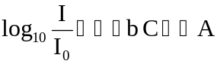
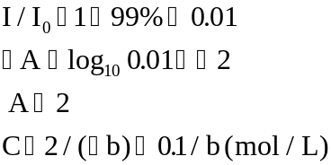

Using the minimum H₂O₂ dosage is the dosage that could absorb at least 10% of incident light, we can calculate the minimum H₂O₂ dosage range similarly.

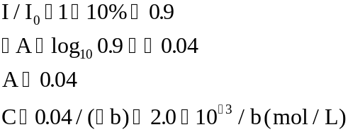

So, the dosage of H₂O₂ should be in the range from 0.002/b to 0.1/b. Before we carry on the experiment, we could estimate the dosage range by taking the radius of the reactor as effective optical path length. Please note that if the reactor has a mirrored inner surface, the effective path length will be much longer due to the reflection. After we obtain an effective path length, we can check the validity of the dosage used in the experiment by the calculation above using the obtained path length.
If the reactor is a nearly completely mixed flow reactor, we can estimate the effective optical path length by the following equations.

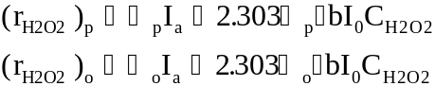

where r means photolysis rate, I₀ and I_{a} are the incident UV light intensity and the light intensity absorbed by H₂O₂ respectively, ε is the extinction coefficient of H₂O₂, and b is the effective optical path length. The subscript p means primary and o means overall. Theoretically, these two methods are equivalent, but in practice the overall photolysis rate determines the more accurate effective optical path length.

The equations above can be used only for ideal or nearly ideal situations. AdOx provides a mechanism to fit experiment data to determine the effective path length for both ideal and non-ideal system. The procedure is described below:
1) Run the Dye Study model to determine the number of tanks needed for simulating the reactor
2) Select an appropriate object function
3) Use the number obtained from step 1) to simulate the reactor by AdOxTM
4) Set the simulation variables according to the experimental configuration
5) Assume an effective optical path length and run the model
6) Compare the simulation result with the experiment data according to the object function
7) Change the value of the effective optical path length till the object function reaches its minimum value. This effective optical path length that achieve the minimum of the objective function should be used in the modeling.

The following is an example of fitting the experiment data by Glaze et al. (1995). To fit the experimental data, we use the following object function.
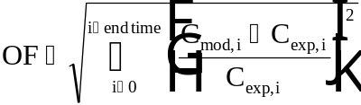, if the concentration profile is known;
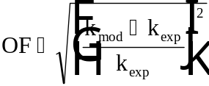, if only the photolysis rate constant is known.
Where C is the concentration of H₂O₂; k is the photolysis rate constant of H₂O₂, k = dln[H₂O₂]/dt; subscribe i represents time step, “mod” and “exp” means modeled and experimental results respectively.

In Glaze et al.’s (1995) experiment, they measured the overall photolysis rate of hydrogen peroxide with the initial concentration of 0.054mM. The measured photolysis rate constant is 6.76 × 10⁻⁴ s⁻¹. To fit the data, run AdOx in the following way:
- Use CMBR as reactor type
- Use the initial concentration of the hydrogen peroxide as indicated in the experiment
- Set the pH of the solution to 7
- Set the TIC concentration to 0
- Set the NOM concentration and the target compound concentration to 0
- Set all other parameters as specified in the experiment documentation

Run AdOx with different path lengths while keep all other parameters unchanged. After each run, analyze the concentration vs. time data of hydrogen peroxide. Repeat the steps until the object function is minimal or is less than a given accuracy.

Table D-1. The Change of the Hydrogen Peroxide Photolysis Rate Constant and the
Objective Function as the Change of the Effective Optical Path Length Used

Effective Optical Path Length(cm) | k_{H2O2} (*10⁻⁴ s⁻¹) | OF
15.8 | 6.2781 | 0.071287
16 | 6.3618 | 0.0589053
16.5 | 6.5878 | 0.0254734
16.8 | 6.7223 | 0.0055769
17 | 6.807 | 0.0069527
16.9 | 6.7602 | 2.959E-05
17.1 | 6.8501 | 0.0133284

Table D-1 summarizes the path length used during the fitting process and corresponding photolysis rate constant and objective function.
Figure D-1plots the OF vs. path length. The effective path length obtained by fitting data is 16.9 cm, which is close to the calculation results by Glaze et al. There is 1.1cm difference between the fitted and the calculated data.
It is not clear why there is difference between what the AdOx calculation and Glaze’s calculation. The possible reasons may be the concentration of H₂O₂ used in the experiment is not high enough. According to the calculation in equation [5], the H₂O₂ dosage should be larger than 0.002/b = 0.002/16.9 = 11.8 mM. The used dosage, 0.054mM, is much lower than the calculated minimum dosage. Another possible reason is the impurity in the experiment solution caused the absorption of UV light by H₂O₂ was over estimated. Since the error of the calculated degradation rate is only 8%, it is appropriate to use the calculated path length for prediction purpose.

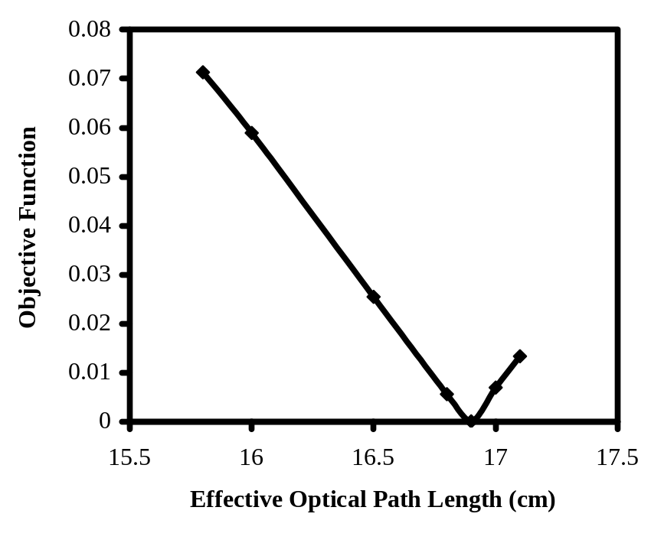
Figure D-1. The Change of the Objective Function as the Effective Optical Path Length Change

Appendix E. An Example Run of Dye Study Model

Problem Statement

The drinking water treatment plant of Anytown in USA is going to apply a UV-H₂O₂ reactor into their current drinking water treatment system to improve the removal of organic contaminants. The tracer study data of the reactor they measured is listed in the table below. Please use the dye study model in the AdOx to determine how many tanks should be used to simulate the real tank so that we could use AdOx to estimate the feasibility of using this tank.

Table E-1. The Tracer Study Data for UV/H₂O₂ Reactor of Anytown Water Plant

Time (hr) | Conc. (mM) | Time (hr) | Conc. (mM) | Time (hr) | Conc. (mM) | Time (hr) | Conc. (mM)
0.000 | 1.2 | 0.410 | 28.7 | 0.761 | 37.1 | 1.131 | 6.4
0.020 | 1.2 | 0.421 | 29.1 | 0.770 | 34.8 | 1.141 | 5.6
0.030 | 1.2 | 0.430 | 30.1 | 0.801 | 35.1 | 1.150 | 5.1
0.040 | 1.3 | 0.440 | 32.6 | 0.810 | 32.2 | 1.160 | 5.1
0.050 | 1.4 | 0.450 | 32.1 | 0.820 | 32.6 | 1.170 | 4.1
0.061 | 1.4 | 0.460 | 30.8 | 0.831 | 31.4 | 1.180 | 3.5
0.071 | 1.5 | 0.471 | 34.1 | 0.841 | 31.8 | 1.190 | 3.6
0.091 | 1.5 | 0.480 | 32.6 | 0.850 | 31.1 | 1.200 | 3.3
0.111 | 1.4 | 0.490 | 33.7 | 0.861 | 29.6 | 1.210 | 3.1
0.121 | 1.5 | 0.500 | 31.3 | 0.871 | 27.6 | 1.220 | 3
0.141 | 1.6 | 0.510 | 37.1 | 0.881 | 28.1 | 1.231 | 2.3
0.160 | 1.6 | 0.521 | 38.8 | 0.891 | 26.1 | 1.240 | 2.1
0.180 | 1.5 | 0.531 | 38.9 | 0.901 | 25.7 | 1.250 | 2.1
0.201 | 1.5 | 0.541 | 36.6 | 0.910 | 23.9 | 1.260 | 1.7
0.210 | 1.4 | 0.550 | 42.6 | 0.920 | 22.3 | 1.270 | 1.8
0.220 | 1.6 | 0.561 | 41.9 | 0.931 | 22.6 | 1.291 | 1.6
0.231 | 1.4 | 0.571 | 43.2 | 0.940 | 21.1 | 1.300 | 1.1
0.241 | 1.3 | 0.581 | 43.8 | 0.951 | 18.5 | 1.310 | 1.1
0.261 | 1.3 | 0.591 | 44.6 | 0.961 | 19.6 | 1.311 | 1.2
0.271 | 1.1 | 0.601 | 44.6 | 0.970 | 15 | 1.331 | 1.1
0.281 | 1.3 | 0.611 | 45.7 | 0.980 | 14.8 | 1.340 | 1.1
0.290 | 1.8 | 0.621 | 47.6 | 0.990 | 16.4 | 1.351 | 1
0.301 | 3.3 | 0.631 | 46.6 | 1.000 | 15.5 | 1.360 | 0.8
0.311 | 5.1 | 0.641 | 46.6 | 1.010 | 15 | 1.381 | 0.9
0.320 | 6.8 | 0.650 | 45.7 | 1.020 | 14.3 | 1.390 | 0.8
0.330 | 10.1 | 0.661 | 45.1 | 1.030 | 12.8 | 1.421 | 0.6
0.340 | 12.5 | 0.671 | 44.1 | 1.040 | 11.4 | 1.431 | 0.7
0.350 | 16.4 | 0.680 | 45.2 | 1.051 | 12.1 | 1.441 | 0.4
0.361 | 18.8 | 0.701 | 41.1 | 1.071 | 9.9 | 1.451 | 0.4
0.371 | 22.2 | 0.710 | 43.9 | 1.081 | 9.4 | 1.460 | 0.4
0.381 | 24.3 | 0.731 | 40.7 | 1.091 | 8.4 | 1.490 | 0.4
0.391 | 26.6 | 0.740 | 40.3 | 1.111 | 7.6
0.401 | 27.6 | 0.751 | 38.9 | 1.120 | 7.1

Running Dye Study Model

You can run the dye study model either by clicking on the Dye Study button in the AdOx main window or by selecting Edit—Edit Dye Study menu item. The dye study model main window as Figure IV-6 in Chapter IV will pop up.

In the dye study main window, click on the Edit Dye Study Data, a window will pop up as shown in Figure IV-7 in Chapter IV.

Click on Reset to Empty button in the pop up window if there were some data in the spreadsheet. Edit the tracer study data by Excel, copy the data into clipboard and click the Paste from Excel button. The data will be input into the spreadsheet as shown in Figure E-1.

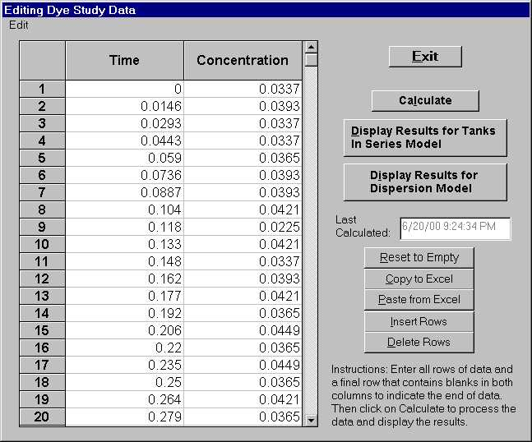
Figure E-1. The Data Edit Window for the Dye Study Model

Click on the Calculate button, the model will fit the dye study data by NTIS model. After the calculation, exit the edit window. You can select to view the plot for the NTIS from the option window.

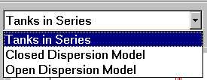

Figure E-2. The Option Window for Viewing Result Plot

Select Tanks in Series item from the small window, the plot of Tanks In Series model will appear as shown in Figure E-3.

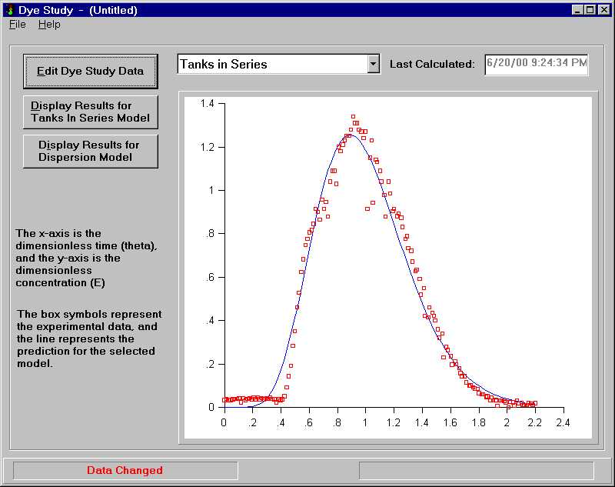
Figure E-3. The Plot of Fitting Dye Study by Tank In Series Model

To view the low-level results of dye study model, click on the Display Results for Tanks In Series Model. The low-level results include the peclect number of the analyzed system, the number of tanks needed to simulate the system and the exit age distributing of the system. Please refer to a chemical engineering textbook for details on tracer study. You can save the data for later reviewing or editing by select File — Save or File —Save as menu item. The following is the low-level result for our sample run.
From the results we know that 9 tanks in series should be used to simulate this system. There are also some other results that are useful for understanding the hydraulics with the system.

Mean Residence Time (Tbar) (user-defined units) .999852E+00
Number of tanks (dimensionless) : 9
Peclet Number for close system(dimensionless)* .183624E+02
Peclet Number for open system(dimensionless)* : .228235E+02
(* These Peclect numbers are printed out but not used in AdOx. It is one of the features useful for trace study analysis.)

Experimental E(theta) results :

THETA E(theta)
.000000E+00 .337365E-01
.146022E-01 .393426E-01
.293043E-01 .337365E-01
.443065E-01 .337365E-01
.590087E-01 .365396E-01
.736109E-01 .393426E-01
.887131E-01 .393426E-01
.104015E+00 .421456E-01
.118017E+00 .225244E-01
.133020E+00 .421456E-01
.148022E+00 .337365E-01
.162024E+00 .393426E-01
.177026E+00 .421456E-01
.192028E+00 .365396E-01
.206030E+00 .449487E-01
.220032E+00 .365396E-01
.235035E+00 .449487E-01
.250037E+00 .365396E-01
.264039E+00 .421456E-01
.279041E+00 .365396E-01
.295044E+00 .421456E-01
.308045E+00 .393426E-01
.323048E+00 .449487E-01
.338050E+00 .393426E-01
.353052E+00 .365396E-01
.367054E+00 .225244E-01
.382056E+00 .365396E-01
.396058E+00 .309335E-01
.411061E+00 .365396E-01
.425063E+00 .505547E-01
.441065E+00 .927004E-01
.455067E+00 .143155E+00
.469069E+00 .191207E+00
.483071E+00 .284308E+00
.498073E+00 .351381E+00
.513076E+00 .460499E+00
.528078E+00 .528572E+00
.543080E+00 .623675E+00
.558082E+00 .682739E+00
.572084E+00 .747810E+00
.587087E+00 .775840E+00
.601089E+00 .806874E+00
.616091E+00 .817886E+00
.630093E+00 .845916E+00
.645095E+00 .915992E+00
.660097E+00 .901977E+00
.674100E+00 .865938E+00
.690102E+00 .958037E+00
.703104E+00 .915992E+00
.718106E+00 .947026E+00
.732108E+00 .879953E+00
.747110E+00 .104113E+01
.763113E+00 .109118E+01
.777115E+00 .109118E+01
.792117E+00 .103112E+01
.806119E+00 .120130E+01
.821121E+00 .118128E+01
.836123E+00 .121131E+01
.850125E+00 .123133E+01
.865128E+00 .125136E+01
.880130E+00 .125136E+01
.894132E+00 .128139E+01
.909134E+00 .134145E+01
.924136E+00 .131142E+01
.938138E+00 .131142E+01
.952141E+00 .128139E+01
.968143E+00 .127138E+01
.983145E+00 .124134E+01
.996147E+00 .127138E+01
.101015E+01 .915992E+00
.103015E+01 .115125E+01
.104015E+01 .123133E+01
.105015E+01 .944022E+00
.107016E+01 .114124E+01
.108016E+01 .113122E+01
.110016E+01 .109118E+01
.111016E+01 .104113E+01
.113017E+01 .978059E+00
.114017E+01 .879953E+00
.116017E+01 .104113E+01
.117017E+01 .986068E+00
.119018E+01 .904980E+00
.120018E+01 .915992E+00
.122018E+01 .881955E+00
.123018E+01 .893968E+00
.125018E+01 .873946E+00
.126019E+01 .831901E+00
.128019E+01 .775840E+00
.129019E+01 .789855E+00
.130019E+01 .733795E+00
.132019E+01 .721782E+00
.133020E+01 .671727E+00
.135020E+01 .626679E+00
.136020E+01 .634687E+00
.138020E+01 .592642E+00
.139021E+01 .519563E+00
.141021E+01 .550596E+00
.142021E+01 .421456E+00
.144021E+01 .415450E+00
.145021E+01 .460499E+00
.147022E+01 .435472E+00
.148022E+01 .421456E+00
.149022E+01 .401435E+00
.151022E+01 .359389E+00
.152022E+01 .320347E+00
.154023E+01 .340369E+00
.155023E+01 .230249E+00
.157023E+01 .278301E+00
.158023E+01 .264286E+00
.160024E+01 .236256E+00
.161024E+01 .197214E+00
.163024E+01 .213231E+00
.164024E+01 .199216E+00
.166024E+01 .180195E+00
.167025E+01 .157170E+00
.168025E+01 .143155E+00
.170025E+01 .143155E+00
.171025E+01 .115125E+00
.173026E+01 .984066E-01
.174026E+01 .101109E+00
.176026E+01 .927004E-01
.177026E+01 .870943E-01
.179026E+01 .842913E-01
.180027E+01 .646700E-01
.182027E+01 .590640E-01
.183027E+01 .590640E-01
.185027E+01 .477517E-01
.186027E+01 .505547E-01
.188028E+01 .309335E-01
.189028E+01 .449487E-01
.190028E+01 .309335E-01
.192028E+01 .309335E-01
.192028E+01 .337365E-01
.193028E+01 .561608E-02
.195029E+01 .309335E-01
.196029E+01 .309335E-01
.198029E+01 .281305E-01
.199029E+01 .225244E-01
.201030E+01 .000000E+00
.202030E+01 .253274E-01
.204030E+01 .225244E-01
.205030E+01 .842913E-02
.207031E+01 .309335E-01
.208031E+01 .168182E-01
.210031E+01 .197214E-01
.211031E+01 .112121E-01
.212031E+01 .112121E-01
.214032E+01 .112121E-01
.215032E+01 .197214E-01
.217032E+01 .168182E-01
.218032E+01 .112121E-01
.220032E+01 .197214E-01

Predictions of E(theta) for nTIS model:

THETA E(theta)
.000000E+00 .000000E+00
.146022E-01 .174150E-10
.293043E-01 .401398E-08
.443065E-01 .957692E-07
.590087E-01 .830513E-06
.736109E-01 .427050E-05
.887131E-01 .165888E-04
.104015E+00 .516276E-04
.118017E+00 .125009E-03
.133020E+00 .284486E-03
.148022E+00 .584390E-03
.162024E+00 .106170E-02
.177026E+00 .188377E-02
.192028E+00 .315510E-02
.206030E+00 .488441E-02
.220032E+00 .728662E-02
.235035E+00 .107907E-01
.250037E+00 .154664E-01
.264039E+00 .210848E-01
.279041E+00 .286638E-01
.295044E+00 .387729E-01
.308045E+00 .487011E-01
.323048E+00 .622465E-01
.338050E+00 .781969E-01
.353052E+00 .966975E-01
.367054E+00 .116364E+00
.382056E+00 .140074E+00
.396058E+00 .164696E+00
.411061E+00 .193739E+00
.425063E+00 .223288E+00
.441065E+00 .259845E+00
.455067E+00 .294149E+00
.469069E+00 .330468E+00
.483071E+00 .368634E+00
.498073E+00 .411353E+00
.513076E+00 .455701E+00
.528078E+00 .501388E+00
.543080E+00 .548104E+00
.558082E+00 .595525E+00
.572084E+00 .640125E+00
.587087E+00 .687960E+00
.601089E+00 .732361E+00
.616091E+00 .779357E+00
.630093E+00 .822406E+00
.645095E+00 .867363E+00
.660097E+00 .910828E+00
.674100E+00 .949806E+00
.690102E+00 .992204E+00
.703104E+00 .102478E+01
.718106E+00 .106010E+01
.732108E+00 .109071E+01
.747110E+00 .112085E+01
.763113E+00 .114982E+01
.777115E+00 .117239E+01
.792117E+00 .119363E+01
.806119E+00 .121065E+01
.821121E+00 .122587E+01
.836123E+00 .123797E+01
.850125E+00 .124647E+01
.865128E+00 .125263E+01
.880130E+00 .125579E+01
.894132E+00 .125610E+01
.909134E+00 .125371E+01
.924136E+00 .124860E+01
.938138E+00 .124149E+01
.952141E+00 .123221E+01
.968143E+00 .121912E+01
.983145E+00 .120457E+01
.996147E+00 .119031E+01
.101015E+01 .117335E+01
.103015E+01 .114649E+01
.104015E+01 .113200E+01
.105015E+01 .111686E+01
.107016E+01 .108486E+01
.108016E+01 .106807E+01
.110016E+01 .103316E+01
.111016E+01 .101512E+01
.113017E+01 .978083E+00
.114017E+01 .959168E+00
.116017E+01 .920736E+00
.117017E+01 .901293E+00
.119018E+01 .862125E+00
.120018E+01 .842465E+00
.122018E+01 .803149E+00
.123018E+01 .783549E+00
.125018E+01 .744596E+00
.126019E+01 .725292E+00
.128019E+01 .687138E+00
.129019E+01 .668328E+00
.130019E+01 .649720E+00
.132019E+01 .613178E+00
.133020E+01 .595272E+00
.135020E+01 .560258E+00
.136020E+01 .543172E+00
.138020E+01 .509887E+00
.139021E+01 .493705E+00
.141021E+01 .462293E+00
.142021E+01 .447074E+00
.144021E+01 .417626E+00
.145021E+01 .403403E+00
.147022E+01 .375967E+00
.148022E+01 .362754E+00
.149022E+01 .349878E+00
.151022E+01 .325130E+00
.152022E+01 .313255E+00
.154023E+01 .290490E+00
.155023E+01 .279593E+00
.157023E+01 .258753E+00
.158023E+01 .248801E+00
.160024E+01 .229811E+00
.161024E+01 .220763E+00
.163024E+01 .203533E+00
.164024E+01 .195341E+00
.166024E+01 .179772E+00
.167025E+01 .172384E+00
.168025E+01 .165252E+00
.170025E+01 .151733E+00
.171025E+01 .145333E+00
.173026E+01 .133223E+00
.174026E+01 .127501E+00
.176026E+01 .116691E+00
.177026E+01 .111591E+00
.179026E+01 .101972E+00
.180027E+01 .974419E-01
.182027E+01 .889104E-01
.183027E+01 .848980E-01
.185027E+01 .773532E-01
.186027E+01 .738101E-01
.188028E+01 .671568E-01
.189028E+01 .640368E-01
.190028E+01 .610480E-01
.192028E+01 .554458E-01
.192028E+01 .554458E-01
.193028E+01 .528232E-01
.195029E+01 .479136E-01
.196029E+01 .456182E-01
.198029E+01 .413263E-01
.199029E+01 .393221E-01
.201030E+01 .355792E-01
.202030E+01 .338335E-01
.204030E+01 .305768E-01
.205030E+01 .290596E-01
.207031E+01 .262323E-01
.208031E+01 .249166E-01
.210031E+01 .224674E-01
.211031E+01 .213287E-01
.212031E+01 .202442E-01
.214032E+01 .182280E-01
.215032E+01 .172919E-01
.217032E+01 .155536E-01
.218032E+01 .147472E-01
.220032E+01 .132512E-01

Conclusion

Nine tanks in series should be used to simulate the hydraulic condition in the tank. The modeled tanks volume is (real tank volume / 9) and the hydraulic retention time is (real tank retention time / 9).

Appendix F. Photochemical Properties and the Rate Constant Toward HO Radical of DOC Isolates (pH = 7.5, DOC =0.230.02mM) (Based on Westerhoff et. al, 1999)
Geographic location | SUVA a 254nm | SUVA b 280nm | MW c | C d | H d | O d | N d | K_{HO,DOC} | molC/  mol DOC | K_{HO, DOC} | K_{HO, DOC} | SUVA a 254nm | SUVA b 280nm | SUVA a 254nm | SUVA b 280nm
 | (L/mg C -cm) | (L/mg C -cm) |  |  |  |  |  | (x10⁸ L/ molC-s) |  | (x10¹⁰ L/mol DOC-s) | (x10⁷ L/g  DOC-s) | (L/mol DOC-cm) | (L/mol DOC -cm) | (L/g DOC -cm) | (L/g DOC -cm)
Coal Creek, CO | 0.051 | 0.038 | 2230 | 52.8 | 4.5 | 38.4 | 0.95 | 4.3 | 98.1 | 4.2 | 1.9 | 60049 | 44743 | 27 | 20
Groundwater sample near Lake Shingobee, MN | 0.013 | 0.009 | 1000 | 52.7 | 5.7 | 40.6 | 0.7 | 2.6 | 43.9 | 1.1 | 1.1 | 6851 | 4743 | 7 | 5
Lake Fryxell, Antarctica | 0.019 | 0.014 | 1080 | 55 | 5.5 | 34.9 | 3.1 | 3.5 | 49.5 | 1.7 | 1.6 | 11286 | 8316 | 10 | 8
Yakima River at Kiona, WA | 0.035 | 0.027 | 1690 | 56.1 | 5 | 35.5 | 2.2 | 3.6 | 79.0 | 2.8 | 1.7 | 33183 | 25598 | 20 | 15
Lake Michigan, IL | 0.018 | 0.012 | 1060 | 48.5 | 5.3 | 35.5 | 1.4 | 3 | 42.8 | 1.3 | 1.2 | 9254 | 6169 | 9 | 6
Missouri River, IA | 0.029 | 0.02 | 1460 | 55.4 | 5.3 | 35 | 1.3 | 3.5 | 67.4 | 2.4 | 1.6 | 23456 | 16177 | 16 | 11
Ogeechee River, GA | 0.045 | 0.034 | 2000 | 54 | 4 | 38.5 | 1.4 | 4.5 | 90.0 | 4.1 | 2.0 | 48600 | 36720 | 24 | 18
Ohio River, OH | 0.042 | 0.032 | 1330 | 55.5 | 5.4 | 35.9 | 1.5 | 4.1 | 61.5 | 2.5 | 1.9 | 31002 | 23621 | 23 | 18
Calif. State Project water, CA | 0.04 | 0.03 | 1940 | 48.1 | 5.1 | 34.3 | 2.4 | 4 | 77.8 | 3.1 | 1.6 | 37326 | 27994 | 19 | 14
Shingobee River, MN(1992) | 0.032 | 0.024 | 1910 | 51.1 | 5.7 | 40.7 | 1.6 | 3.35 | 81.3 | 2.7 | 1.4 | 31232 | 23424 | 16 | 12
Shingobee River, MN(1993) | 0.049 | 0.039 | 2660 | 50.6 | 5.1 | 41.8 | 1.7 | 4.5 | 112.2 | 5.0 | 1.9 | 65952 | 52492 | 25 | 20
Lake Shingobee, MN | 0.028 | 0.021 | 1730 | 51.1 | 5.9 | 40.7 | 1.6 | 3.4 | 73.7 | 2.5 | 1.4 | 24753 | 18565 | 14 | 11
Suwannee River, GA | 0.042 | 0.033 | 2310 | 53.5 | 4.2 | 41.3 | 0.69 | 3.7 | 103.0 | 3.8 | 1.6 | 51906 | 40783 | 22 | 18
Suwannee River, GA | 0.107 | 0.087 | 3320 | 54.3 | 4.1 | 39.4 | 1.1 | 8.1 | 150.2 | 12.2 | 3.7 | 192895 | 156840 | 58 | 47
Willians Lake, MN | 0.017 | 0.012 | 1020 | 51.8 | 6.3 | 37.7 | 1.6 | 3.5 | 44.0 | 1.5 | 1.5 | 8982 | 6340 | 9 | 6
Yakima River at CleElum, WA | 0.039 | 0.03 | 1560 | 57.2 | 4.9 | 35.9 | 1 | 4 | 74.4 | 3.0 | 1.9 | 34800 | 26770 | 22 | 17

a. Specific UV absorption ((mg C/L)⁻¹ cm⁻¹
b. Specific fluorescence excitation wavelength of 320 nm and emission wavelength of 430 nm (intensity/(mg C/L))
c. Weight averaged molecular weight (Mw) by size exclusion chromatography (Da)
d. Weight percentage of elemental species: C = carbon, H = hydrogen, O = oxygen, N = nitrogen

Please note that some of the units used in the table are based on the amount of C instead of DOC. The numbers with a DOC-based unit should be used in AdOx.

Reference:
Westerhoff P.; Aiken G.; Amy G. and Debroux J. Relationship between the Structure of Natural Organic Matter and Its Reactivity towards Molecular Ozone and Hydroxyl Radicals Wat. Res. Vol. 33, No. 10, pp. 2265~2276, 1999.

Acknowledgments

The authors are grateful to Michigan Tech Masters Graduate Shumin Hu, former Michigan Tech Research Engineer Eric J. Oman, and former Michigan Tech Computer Programmer Karen A. Mansfeldt for their contributions toward the development of this product.

Ph.D. candidate, Dept. of Civil and Environmental Engineering, Michigan Tech Univ.
Presidential Professor, Dept. of Civil and Environmental Engineering, Michigan Tech Univ.
Assoc. Professor, Dept. of Civil and Environmental Engineering, Michigan Tech Univ.
⁴Research Engineer, Dept. of Civil and Environmental Engineering, Michigan Tech Univ.

