Sample Calculations and Program Runs for ASAP™

Packed Tower Aeration - Design Mode
The following problem will be used to show sample calculations for packed tower aeration in design mode. In addition, a sample program run of ASAP™ will be used to verify that the program is correctly duplicating the results of the sample calculations.

Problem Statement
The city of Anytown, USA recently discovered that one of its wells was contaminated with the compounds listed in Table 1. In order for them to continue using the well, they are required to remove these compounds below their MCLs also shown in Table 1. During normal pumping operations, the well produces about 2000 gpm and the water temperature is 10°C.
Design a packed tower aeration system that can remove all the VOCs below their MCLs. Physical and chemical properties should be retrieved from StEPP™. Make use of the following packing material: 3.5 inch plastic tri-packs. The design air to water ratio should be set to 3.5 times the minimum air to water ratio. The pressure drop per unit length should be specified as 50 N/m²/m. A safety factor of 0.6 (Design K_{L}a / Onda K_{L}a) should be applied to the mass transfer coefficient calculated from the Onda correlations.
Also calculate the total power requirement (blower and pump brake power) for this design. Assume a blower efficiency of 35% and a pump efficiency of 80%.
Table 1 - Contaminants - Influent Concentrations and Treatment Objectives
Compound | Concentration Discharged, C₀  (μg/L) | MCL, C_{TO}  (μg/L)
Trichloroethylene | 200.0 | 5.0
Tetrachloroethylene | 150.0 | 5.0
Vinyl Chloride | 60.0 | 1.0
Ethylbenzene | 30.0 | 5.0
Toluene | 80.0 | 5.0
1,1-Dichloroethene | 85.0 | 7.0

Properties Needed to Perform Sample Calculations and Program Run
Table 2 shows the chemical properties retrieved from StEPP™ required for packed tower aeration at 10°C and 1 atm.
Table 2 - Chemical Properties from StEPP™ at 10°C and 1 atm
Compound | MW  (kg/kmol) | H  (-) | V_{b}  (m³/kmol) | T_{NBP}  (°C) | D_{l}  (m²/s) | D_{g}  (m²/s)
Trichloroethylene | 131.39 | 0.230 | 0.1020 | 87.0 | 6.44E-10 | 7.89E-06
Tetrachloroethylene | 165.84 | 0.361 | 0.1190 | 121.0 | 5.86E-10 | 7.13E-06
Vinyl Chloride | 62.50 | 0.546 | 0.0665 | -13.9 | 8.26E-10 | 1.08E-05
Ethylbenzene | 106.17 | 0.170 | 0.1400 | 136.0 | 5.33E-10 | 6.88E-06
Toluene | 92.15 | 0.167 | 0.1190 | 111.0 | 5.86E-10 | 7.57E-06
1,1-Dichloroethene | 96.95 | 0.680 | 0.0840 | 31.6 | 7.20E-10 | 9.05E-06

Table 3 shows the physical properties of air and water retrieved from StEPP™ at 10°C and 1 atm.
Table 3 - Properties of Air and Water
Property | Units | Value
Water Density, ρ_{l} | kg/m³ | 999.75
Water Viscosity, μ_{l} | kg/m/s | 0.00131
Water Surface Tension, σ | N/m | 0.0742
Air Density, ρ_{g} | kg/m³ | 1.25
Air Viscosity, μ_{g} | kg/m/s | 1.72E-05

Table 4 shows the packing properties for 3.5 inch plastic tri-packs.
Table 4 - Packing Properties
Property | Units | Value
Nominal Diameter of Packing, d_{p} | m | 0.0889
Packing Factor, C_{f} | (-) | 12.0
Specific Surface Area of Packing, a_{t} | m²/m³ | 124.7
Critical Surface Tension of Packing, σ_{c} | N/m | 0.033

Note Regarding Comparison of Sample Calculation Values to Sample Program Run
In certain cases, the numbers that appear in the sample calculations are slightly different from the values displayed in the sample program run. These variations can be attributed to rounding.

Sample Design Mode Calculation of Tower Length for Trichloroethylene as the Design Compound Including Supplementary Parameter Calculations

Packing Height
Calculation of packing height, L, for the case described above is shown in Eq. 1:
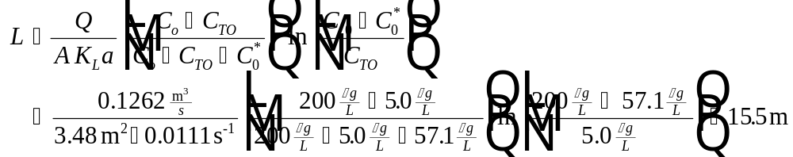
Eq. 1
Note that a 15.5 m (equals 50.9 ft) packing height may not be practical. This manual was written to illustrate the use of the software. In order to design a practical tower size, the user may want to increase the air to water ratio (or air flow rate), but that activity is beyond the scope of this manual.
The parameters required to determine in Eq. 1 can be found as follows:
Parameter Location
Given and see Eq. 2
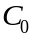 Table 1
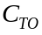 Table 1
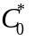 Eq. 3
Eq. 11
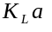 Eq. 20

Water Flowrate
The water flowrate, Q, is given in the problem statement as 2000 gpm. Conversion to the units shown in Eq. 1 is as follows:
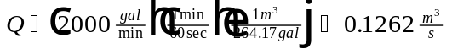
Eq. 2

Liquid Phase Concentration in Equilibrium with Exiting Gas
Calculation of required in Eq. 1 is given in Eq. 3:
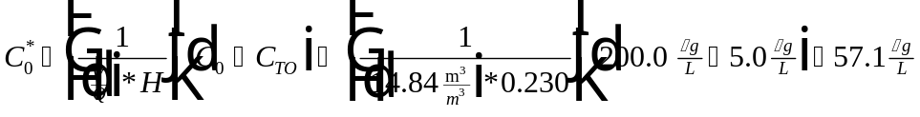
Eq. 3
The parameters required to find in Eq. 3 can be found as follows:
Parameter Location
Table 1
Table 1
Eq. 4
Table 2

Air to Water Ratio
The calculation of air to water ratio for this design case is shown in Eq. 4. In packed tower aeration design, it is possible to specify either , , or with the other two parameters calculated. In this design case, the user specifies and and are calculated in Eq. 4 and Eq. 6, respectively.
Case 1: Specify , Calculate and
Air to Water Ratio
The air to water ratio, , is found from the following equation:
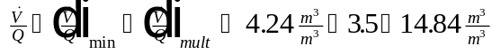
Eq. 4
The parameters required to calculate in Eq. 4 can be found as follows:
Parameter Location
 Eq. 5
Specified in problem statement
Minimum Air to Water Ratio
The minimum air to water ratio, , is found from the following:
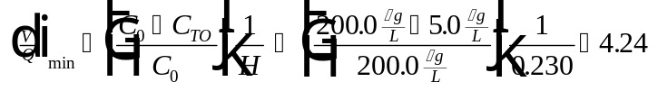
Eq. 5
The parameters required to calculate in Eq. 5 can be found as follows:
Parameter Location
Table 1
Table 1
Table 2
Air Flow Rate
The air flow rate, , through the tower is found by the following relationship:
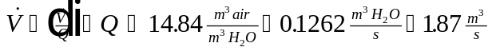
Eq. 6
The parameters required to calculate in Eq. 6 can be found as follows:
Parameter Location
Eq. 4
Given and see Eq. 2
Case 2: Specify , Calculate and
Multiple of Minimum Air to Water Ratio
The multiple of minimum air to water ratio, , can be calculated using the following relationship.
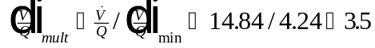
Eq. 7
The parameters required to calculate in Eq. 7 can be found as follows:
Parameter Location
User-specified
Eq. 5
Air Flow Rate
The air flow rate, , through the tower can be calculated by the following relationship:
Eq. 8
The parameters required to calculate in Eq. 8 can be found as follows:
Parameter Location
User-specified
Given and see Eq. 2
Case 3: Specify , Calculate and
Air to Water Ratio
The air to water ratio, , can be calculated using the following relationship.
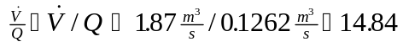
Eq. 9
The parameters required to calculate in Eq. 9 can be found as follows:
Parameter Location
User-specified
Given and see Eq. 2
Multiple of Minimum Air to Water Ratio
The multiple of minimum air to water ratio, , can be calculated using the following relationship.
Eq. 10
The parameters required to calculate in Eq. 7 can be found as follows:
Parameter Location
User-specified
Eq. 9

Tower Area
The tower cross-sectional area, , required in Eq. 1 can be found using the following relationship (Eq. 11).
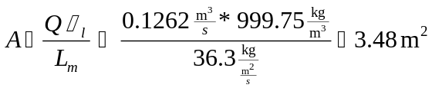
Eq. 11
The parameters required to calculate in Eq. 11 can be found as follows:
Parameter Location
Given and see Eq. 2
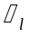 Table 3
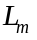 Eq. 12

Liquid Mass Loading Rate
The liquid mass loading rate, , required in Eq. 11 can be estimated by the following:
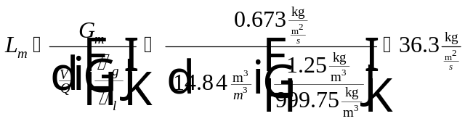
Eq. 12
The parameters required to calculate in Eq. 12 can be found as follows:
Parameter Location
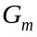 Eq. 13
Eq. 4
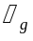 Table 3
Table 3
Gas Mass Loading Rate
The gas mass loading rate, , needed in Eq. 12 can be found using Eq. 13:
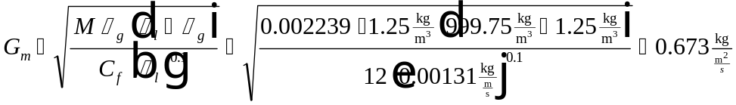
Eq. 13
The parameters required to calculate in Eq. 13 can be found as follows:
Parameter Location
Eq. 14
Table 3
Table 3
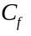 Table 4
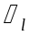 Table 3
Empirical Parameter, M
The empirical parameter M in Eq. 13 is defined by the following relationship:
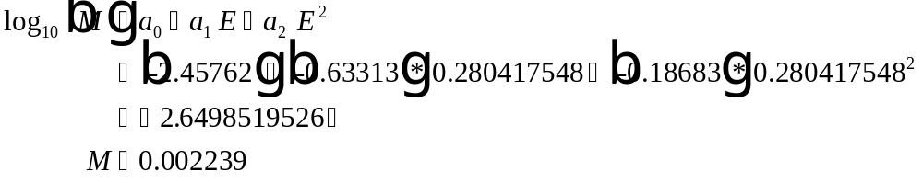
Eq. 14
The parameters required to calculate in Eq. 14 can be found as follows:
Parameter Location
Eq. 15
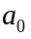 Eq. 16
Eq. 17
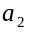 Eq. 18
Parameter, E
The parameter E needed in Eq. 14 is defined in Eq. 15 below:
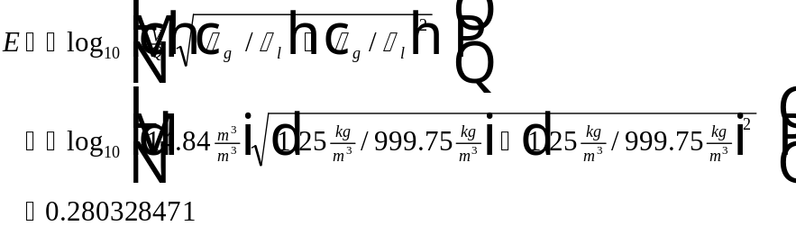
Eq. 15
The parameters required to calculate in Eq. 15 can be found as follows:
Parameter Location
Eq. 4
Table 3
Table 3
Empirical Parameters a₀, a₁, and a₂
The parameters , , and in Eq. 13 are given in the following three equations:
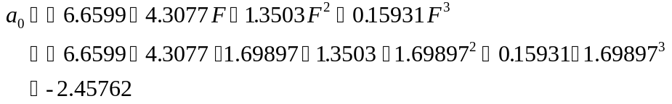
Eq. 16
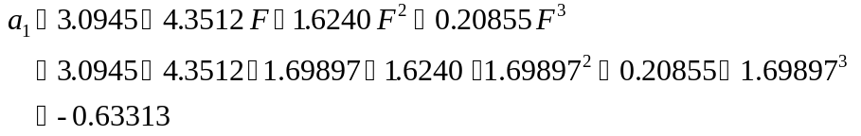
Eq. 17
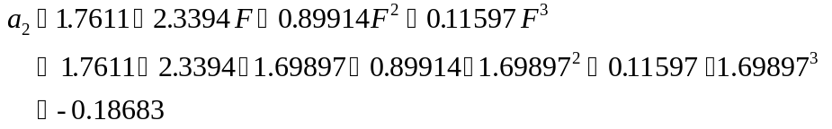
Eq. 18
The parameters required to calculate , , and in Eq. 16 through Eq. 18 can be found as follows:
Parameter Location
Eq. 19
Parameter, F
The parameter that appears in Eq. 16 through Eq. 18 is defined below (note that 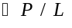 was specified in the problem statement as 50.0 N/m²/m and that the units of in Eq. 19 must be N/m²/m):
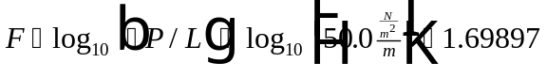
Eq. 19
The parameters required to calculate in Eq. 19 can be found as follows:
Parameter Location
Given in problem statement

Design Mass Transfer Coefficient
Design mass transfer coefficient, , in Eq. 1 is calculated as follows:
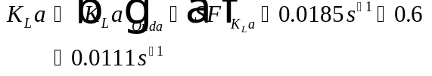
Eq. 20
The parameters required to calculate in Eq. 20 can be found as follows:
Parameter Location
 Eq. 21
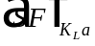 Given in problem statement

Overall Mass Transfer Coefficient from Onda Correlation
The Onda mass transfer coefficient, , required in Eq. 1 was estimated by the following equation:
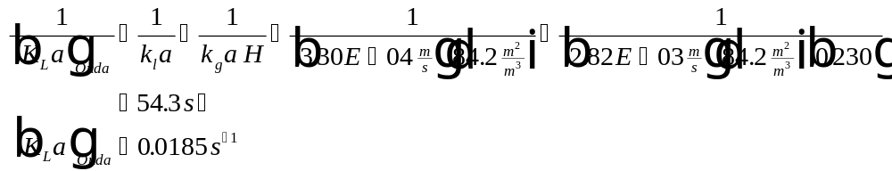
Eq. 21
The parameters required to calculate in Eq. 21 can be found as follows:
Parameter Location
Eq. 22
Eq. 23
Eq. 27
Table 2
Liquid Phase Mass Transfer Coefficient
The liquid phase mass transfer coefficient, , required in Eq. 21 can be calculated using the following equation:
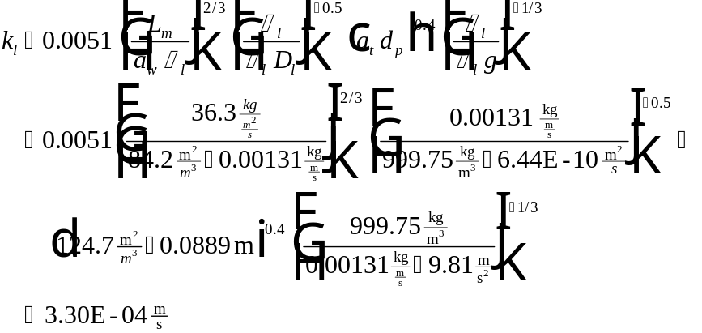
Eq. 22
The parameters required to calculate in Eq. 22 can be found as follows:
Parameter Location
Eq. 12
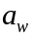 Eq. 23
Table 3
Table 3
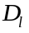 Table 2
Table 4
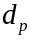 Table 4
Constant - Known = 9.8 m/s²
Area Available for Mass Transfer Divided by Vessel Volume
The area available for mass transfer divided by the vessel volume, , required in Eq. 21 is shown by the following relationship:
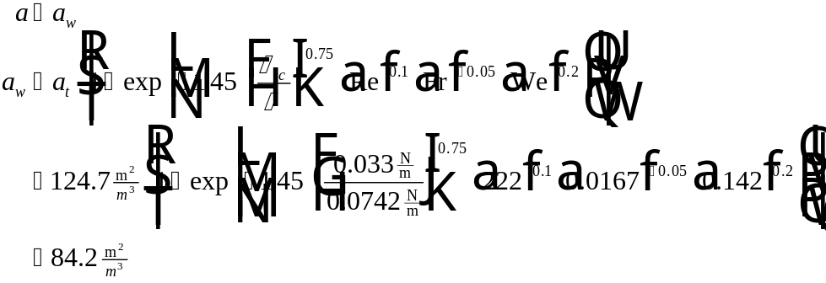
Eq. 23
The parameters needed to find in Eq. 23 can be found as shown below:
Parameter Location
Table 4
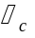 Table 4
Table 3
Eq. 24
Eq. 25
Eq. 26
Reynolds Number
Reynolds Number, Re, needed for the calculation of in Eq. 23 is defined by:
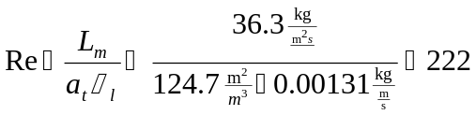
Eq. 24
The parameters required to calculate Re in Eq. 24 can be found as follows:
Parameter Location
Eq. 12
Table 4
Table 3
Froude Number
The Froude Number, Fr, used to calculate in Eq. 23 is found by the following relationship:
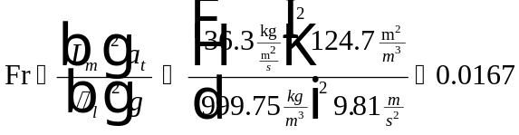
Eq. 25
The parameters required to calculate Fr in Eq. 25 can be found as follows:
Parameter Location
Eq. 12
Table 4
Table 3
Constant - Known = 9.8 m/s²
Weber Number
The Weber Number, We, used to find in Eq. 23 is found by the following:
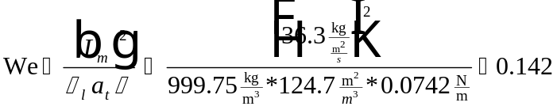
Eq. 26
The parameters required to calculate We in Eq. 26 can be found as follows:
Parameter Location
Eq. 12
Table 3
Table 4
Table 3
Gas Phase Mass Transfer Coefficient
The gas phase mass transfer coefficient, , required in Eq. 21 is calculated from:
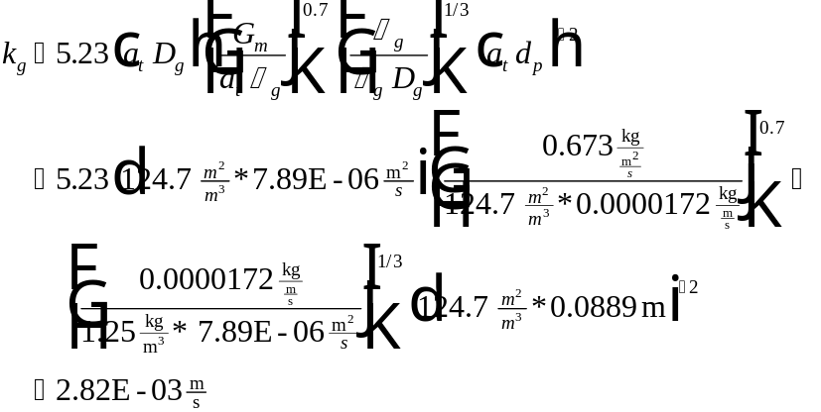
Eq. 27
The parameters required to calculate in Eq. 27 can be found as follows:
Parameter Location
Table 4
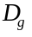 Table 2
Eq. 13
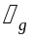 Table 3
Table 3
Table 4

Tower Diameter
The tower diameter, , is calculated knowing the tower area, , from Eq. 11.
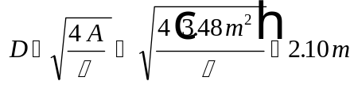
Eq. 28
The parameters required to calculate in Eq. 28 can be found as follows:
Parameter Location
Eq. 11

Tower Volume
The tower volume, , is calculated as follows.
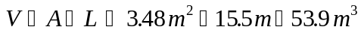
Eq. 29
The parameters required to calculate in Eq. 29 can be found as follows:
Parameter Location
Eq. 11
Eq. 1

Total Power Requirement
The total power requirement for packed tower aeration, 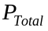, is calculated as the sum of the blower brake power and the pump brake power:
Eq. 30
The parameters required to calculate in Eq. 30 can be found as follows:
Parameter Location
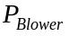 Eq. 31
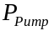 Eq. 35

Blower Brake Power
The blower brake power, , is calculated below:
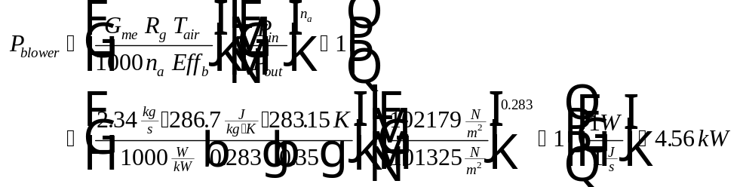
Eq. 31
The parameters required to calculate in Eq. 31 can be found as follows:
Parameter Location
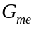 Eq. 32
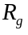 Universal gas constant
Given in problem statement
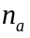 Constant (see nomenclature)
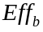 Given in problem statement
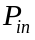 Eq. 33
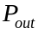 Assumed equal to 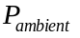

Air Mass Flow Rate
The air mass flow rate, , is calculated below:
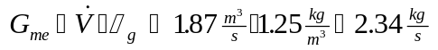
Eq. 32
The parameters required to find in Eq. 32 can be found:
Parameter Location
Eq. 6
Table 3

Inlet Air Pressure to Packed Tower
refers to the pressure at the bottom of the tower, which is the inlet for the gas stream. is calculated as the sum of the ambient pressure and the pressure drop caused by the packing media, demister, packing support plate, duct work, inlet and outlet of the tower. The equation used to find is:
Eq. 33
The parameters required to calculate in Eq. 33 can be found as follows:
Parameter Location
Given in problem statement
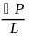 Given in problem statement
Eq. 1
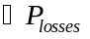 Eq. 34
Pressure Drop due to Losses at the Ends of the Tower
represents the pressure drop through the demister, packing support plate, duct work, inlet and outlet of the tower. It is assumed that turbulent flow conditions prevail and most of the losses occur in the tower (i.e., in the packing support plate and the demister). 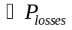 is found from the following:
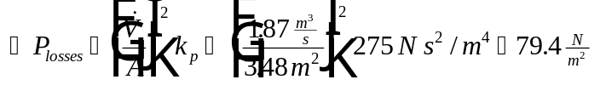
Eq. 34
The parameters required to calculate in Eq. 34 can be found as follows:
Parameter Location
Eq. 6
Eq. 11
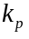 Constant (see nomenclature)

Pump Brake Power
The pump brake power, , is calculated below:
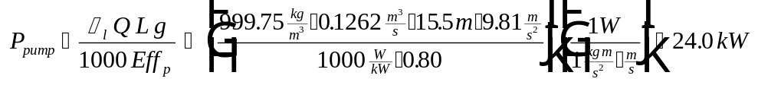
Eq. 35
The parameters required to calculate in Eq. 35 can be found as follows:
Parameter Location
Table 3
Given in problem statement
Eq. 1
Acceleration due to gravity
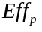 Given in problem statement

Sample Program Run of ASAP™ to Verify Sample Calculations for Packed Tower Aeration in Design Mode
To start the ASAP™ program, double click on the ASAP™ icon in the ETDOT Programs group icon in windows. The screen shown in Figure 1 will appear.
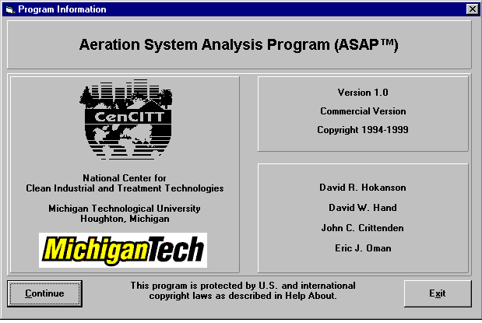
Figure 1 - ASAP™ Title Window
Click on the Continue button on the screen shown in Figure 1 and the menu shown in Figure 2 will appear.

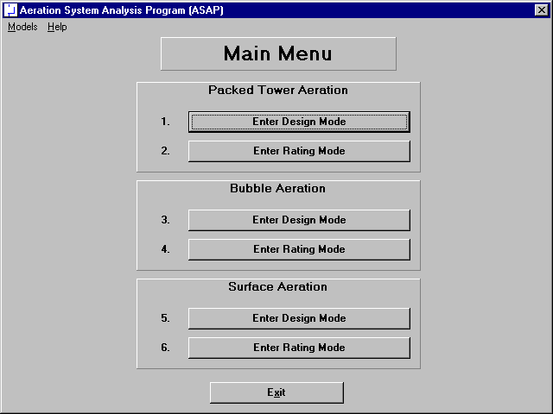
Figure 2 - Main Menu Window in ASAP™
Click on the Enter Design Mode button for Packed Tower Aeration (option 1 in Figure 2) and the design mode screen for packed tower aeration shown in Figure 3 will appear.
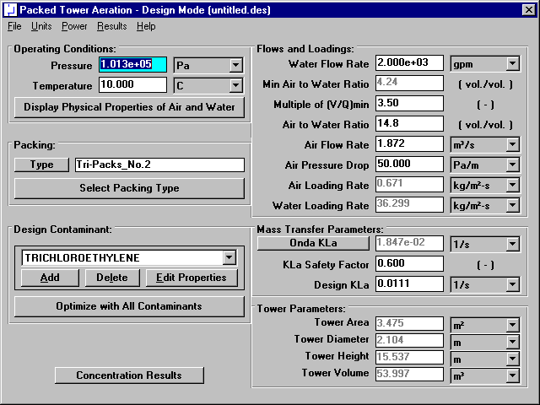
Figure 3 - Design Mode Window for Packed Tower Aeration

Physical Properties of Air and Water
Specify pressure and temperature in the upper left-hand corner of the window shown in Figure 3. This portion of the packed tower aeration design mode window is shown in Figure 4.
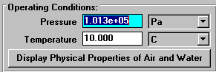
Figure 4 - Operating Conditions Portion of Design Mode Window
Click on the Display Physical Properties of Air and Water button in Figure 3 (and highlighted in Figure 4) to show the properties of air and water at the specified temperature and pressure (101325 Pa and 10°C). Figure 5 shows the air and water properties window for this case.
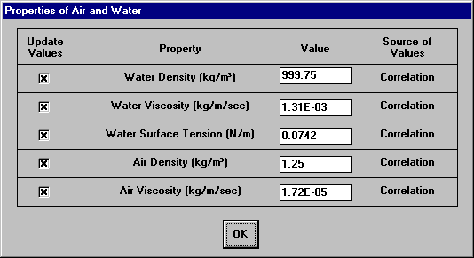
Figure 5 - Air and Water Properties Window
The properties shown in Figure 5 are by default calculated from correlations so the user should not have to change their values. In the rare case that the user would like to enter a value for any of these properties instead of using the correlations, it is possible to do so on the window shown in Figure 5. Click on the OK button shown in Figure 5 to close the window.
It can be seen that the air and water properties shown in Figure 3 agree with the properties shown in Table 3.

Packing Properties
The next step is to choose the appropriate packing. Packing selection is located in the middle of the left-hand side of the design mode window shown in Figure 3. This portion of Figure 3 is highlighted in Figure 6.
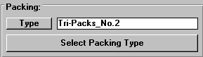
Figure 6 - Packing Selection Portion of Design Mode Window
Click on the Select Packing Type button shown in Figure 3 (and highlighted in Figure 6). The packing database window shown in Figure 7 will appear.
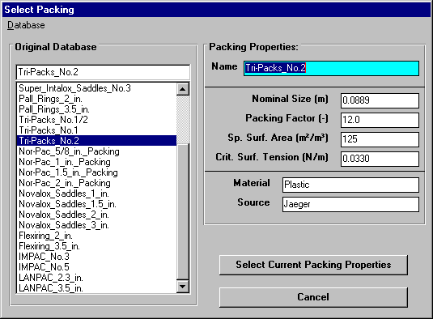
Figure 7 - Select Packing Type Window
ASAP™ contains a database of packing properties available from vendor data. The packing properties used in development of the product are shown in Figure 7. The left-hand side of the packing database window shown in Figure 8 contains a listing of available packings. The item called “Tri-packs No. 2” in the list is the 3.5 inch plastic tri-packs requested in the problem statement. Click on this item in the list as shown in Figure 7 so that this item is selected. Then select the properties of this packing for use in the design by clicking on the Select Current Packing Properties button shown in Figure 7.
It should be noted that it is also possible for the user to enter properties of additional packings. It is not possible for the user to modify the list of packings from vendor data supplied with the program (called the “Original Database”). However, there is a separate database of packing properties from user input available with the software. An alternative method to enter the properties of 3.5 inch plastic tri-packs is as follows. Click on the Select Packing Type button in the window shown in Figure 3 (and highlighted in Figure 6). The window shown in Figure 7 will appear again. In the Database menu shown in Figure 8, it is seen that currently the “Original Database” option is selected.
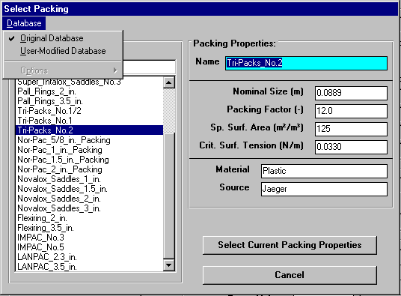
Figure 8 - Database Menu in Select Packing Type Window
To input data, the user must click on the “User Modified Database” item in the menu shown in Figure 8. Then the Select Packing Type window will show a database of user input packing parameters, as shown in Figure 9.
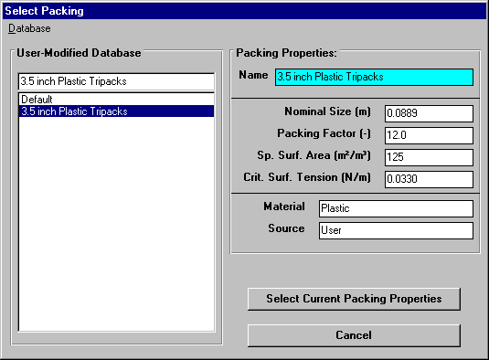
Figure 9 - User Modified Database in Select Packing Type Window
On the screen shown in Figure 9, it is possible to input values for all packing properties. Figure 9 shows the screen after the properties of 3.5 inch plastic tri-packs have been input. To select these properties for use in the current design, click on the Select Current Packing Properties button shown in Figure 9.
It can be seen that the packing properties shown in both Figure 7 and Figure 9 agree with the properties shown in Table 4.

Chemical Properties
Chemical properties for each of the six components can be retrieved from StEPP™. When the screen shown in Figure 3 loads, the properties of six contaminants load as a default design case. Before retrieving the chemical properties of the six chemicals required in the current design, it is necessary to delete the six default chemicals shown in the Design Contaminant list box on the bottom of the left-hand column shown in Figure 3. This portion of the design mode window is highlighted in Figure 10.
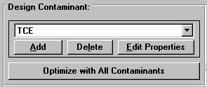
Figure 10 - Contaminant Selection Portion of Design Mode Window
To delete each chemical click on the Delete button located in between the Add and Edit Properties buttons shown in Figure 3 (and highlighted in Figure 10). Click the Delete button once for each chemical until all chemicals have been deleted from the Design Contaminant list box.
It is now possible to add the chemicals required for the current design. To do so, click on the Add button shown on the bottom left-hand corner of the window shown in Figure 3 (and highlighted in Figure 10). Figure 11 shows the window that will appear.
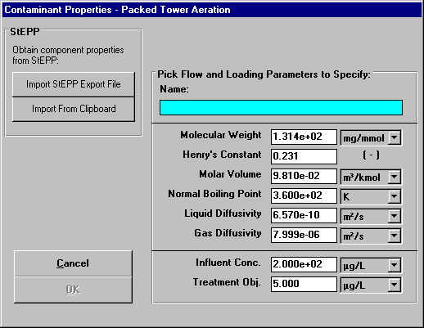
Figure 11 - Contaminant Properties Input Window
The following properties (with their default units in parentheses) are required for each component:
- Name
- Molecular weight (mg/mmol)
- Henry’s constant (dimensionless)
- Molar volume at the normal boiling point temperature (m³/kmol)
- Normal boiling point (K)
- Liquid diffusivity (m²/s)
- Gas diffusivity (m²/s)
- Initial (influent) concentration (mg/L)
- Treatment objective (mg/L)
The user can input data by clicking on a text box and typing in the corresponding value. By pressing the Enter key, the Tab key or clicking on another text box or button, the data is updated. The default units can be changed in the pull-down menus to the right of the text boxes.

Transferring Properties from StEPP™ to ASAP™
ASAP™ has the capability of transferring the physical properties of contaminants from Software to Estimate Physical Properties (StEPP™). There are two options for transferring data from StEPP™ into ASAP™: (a) Create Export File for AdDesignS/ASAP and (b) Copy to Clipboard for AdDesignS/ASAP. Both choices are available in the Options menu within StEPP™. The StEPP™ main window highlighting the Options menu is shown in Figure 12.

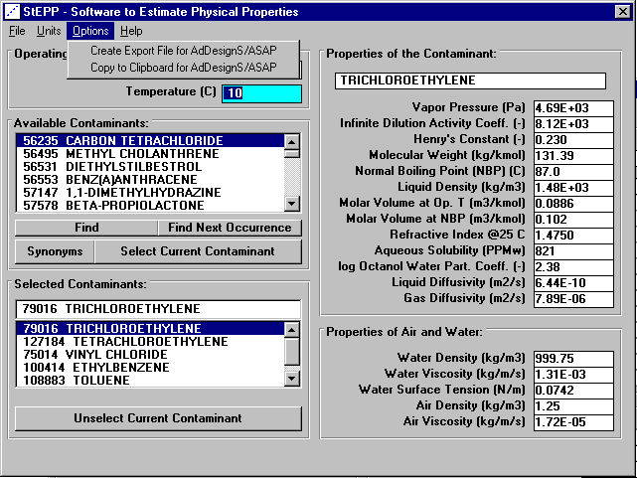
Figure 12 - StEPP™ Main window
The operating temperature and pressure, with units of degrees Celsius and Pascals respectively, must be entered. Chemicals can be selected using the scroll bar on the Available Contaminants block or the Find, Find Next Occurrence, or Synonyms buttons, highlighting the chemical, and clicking on the Select Current Contaminant button. Repeat this process for all contaminants of interest. After the contaminants have been selected in StEPP™ and their properties calculated at the proper temperature and pressure, they can be transferred from StEPP to ASAP using either of two options, which are described below: (a) Create Export File for AdDesignS/ASAP and (b) Copy to Clipboard for AdDesignS/ASAP.

Transferring Chemical Properties from StEPP™ to ASAP™ Using the Create Export File for AdDesignS/ASAP Option
To create a StEPP™ export file, select Create Export File for AdDesignS/ASAP™ from the Options menu. The window shown in Figure 13 will appear. Enter a file name to save the export file. This file will be available for use in ASAP™.
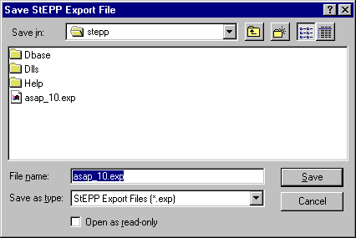
Figure 13 - Save StEPP™ Export File window
To import the chemicals and their physical properties to ASAP™ from the StEPP™ export file, click on the Add button in the Component Properties block of the ASAP™ main window. The Component Properties window shown in Figure 14 will appear.

Figure 14 - Component Properties window (adding new components)
To open the StEPP™ export file, click the Import StEPP™ export file button on the Component Properties window. The Load StEPP™ Export File window shown in Figure 15 will appear.
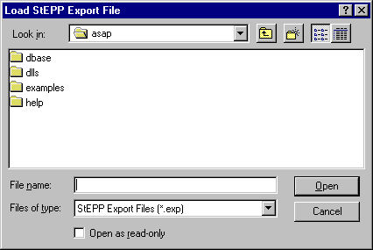
Figure 15 - Load StEPP™ Export File window
The file which was previously saved in StEPP™ can be selected in this window. The window shown in Figure 16 announcing the successful import of the components will appear. To return to the ASAP™ main window, click on OK.
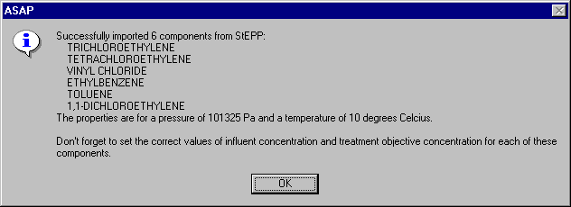
Figure 16 - Successful Import of Components from StEPP™ window

Transferring Chemical Properties from StEPP™ to ASAP™ Using the Copy to Clipboard for AdDesignS/ASAP Option
To copy selected StEPP™ data to the Windows clipboard for export into ASAP, select Copy to Clipboard for AdDesignS/ASAP from the Options menu within StEPP. The message box shown in Figure 17 will appear, verifying that all of the StEPP data is now stored in the Windows clipboard.
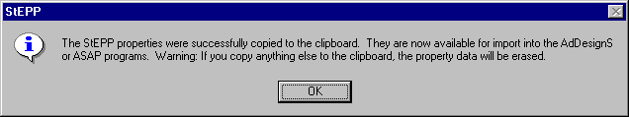
Figure 17 – Successful Copy to Clipboard from StEPP™ Message Box
To import the chemicals and their physical properties to ASAP™ from the data on the clipboard, click on the Add button in the Component Properties block of the ASAP™ main window. The Component Properties window shown in Figure 18 will appear.
Figure 18 - Component Properties window (adding new components)
To import the StEPP™ data from the Windows clipboard, click the Import from Clipboard button on the Component Properties window. The window shown in Figure 19 will appear, showing that the properties have been successfully transferred into ASAP.
Figure 19 – Successful Import from StEPP™ Window

Manipulation of Data Required after Transferring Properties from StEPP™ to ASAP™
The following properties will be transferred to ASAP™ from StEPP™, unless these are not available:
- Molecular weight (mg/mmol)
- Henry’s constant (dimensionless)
- Molar volume at the normal boiling point temperature (mL/gmol)
- Normal boiling point (Celsius)
- Liquid diffusivity (m²/s)
- Gas diffusivity (m²/s)
The name of the chemical will also be transferred. If any of the properties above are not available in StEPP™ for a selected chemical, the chemical with missing properties will not be imported and a warning message will be displayed.
Click on the OK button to continue. Figure 3 appears. As shown in Figure 16 or Figure 19, it is necessary to input influent concentrations and treatment objectives for each of the six components retrieved. To do so, select each contaminant one at a time in the Design Contaminant list box shown in the lower left-hand corner of Figure 3. Then click on the Edit Properties button. Figure 20 shows the window that appears for trichloroethylene.
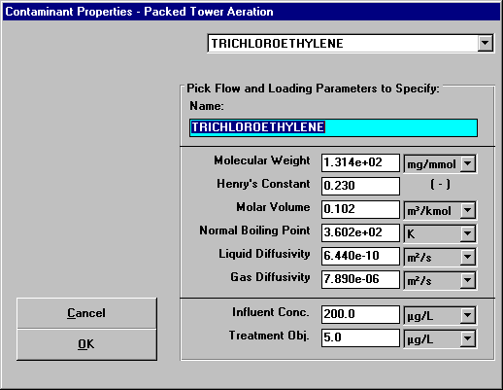
Figure 20 - Specify Contaminant Properties Window for Trichloroethylene
The properties molecular weight, Henry’s constant, molar volume, normal boiling point, liquid diffusivity, and gas diffusivity are already correct since they were retrieved from StEPP™. The influent concentration and treatment objective shown at the bottom of the screen must be input since they will vary from case to case. These properties shown in Figure 20 already reflect the values for the current design case. It is seen that the properties shown in Figure 20 agree with the trichloroethylene properties shown in Tables 1 and 2.
Figure 21 shows the Specify Contaminant Properties window for tetrachloroethylene. It can be seen that the properties shown in Figure 21 agree with the properties of tetrachloroethylene shown in Tables 1 and 2.

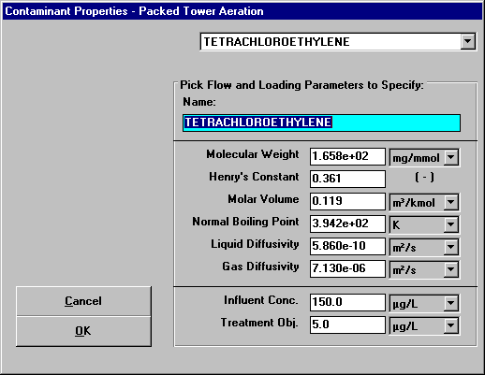
Figure 21 - Specify Contaminant Properties Window for Tetrachloroethylene
Figure 22 shows the Specify Contaminant Properties window for vinyl chloride. It can be seen that the properties shown in Figure 22 agree with the properties of vinyl chloride shown in Tables 1 and 2.

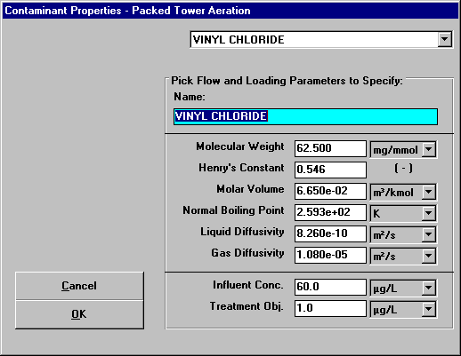
Figure 22 - Specify Contaminant Properties Window for Vinyl Chloride
Figure 23 shows the Specify Contaminant Properties window for ethylbenzene. It can be seen that the properties shown in Figure 22 agree with the properties of ethylbenzene shown in Tables 1 and 2.
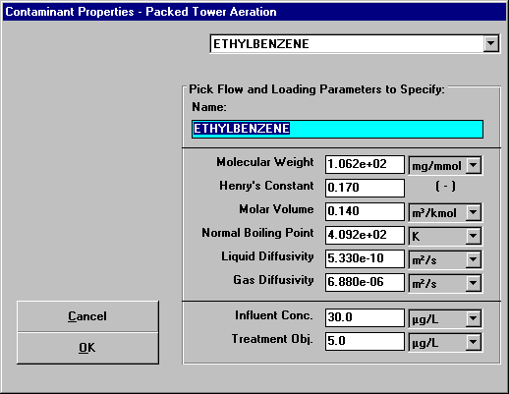
Figure 23 - Specify Contaminant Properties Window for Ethylbenzene
Figure 24 shows the Specify Contaminant Properties window for toluene. It can be seen that the properties shown in Figure 22 agree with the properties of toluene shown in Tables 1 and 2.
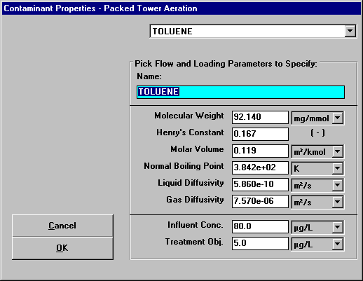
Figure 24 - Specify Contaminant Properties Window for Toluene
Figure 25 shows the Specify Contaminant Properties window for 1,1-dichloroethene. It can be seen that the properties shown in Figure 22 agree with the properties of 1,1-dichloroethene shown in Tables 1 and 2.
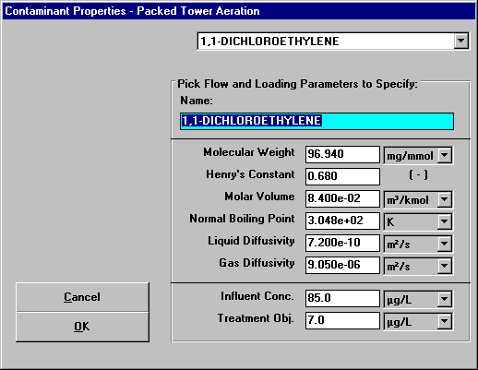
Figure 25 - Specify Contaminant Properties Window for 1,1-Dichloroethene

Flow, Loading, and Pressure Drop Parameters
Flow, loading, and pressure drop parameters are shown in the upper right-hand side of Figure 3. This portion of Figure 3 is reproduced here as Figure 26.
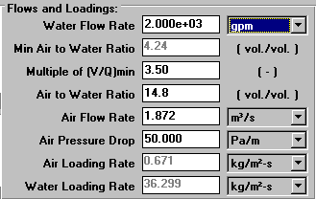
Figure 26 - Flow, Loading, and Pressure Drop Parameters
Explanation of the origin of the values for the properties shown in Figure 26 is provided here. The water flow rate of 2000 gpm was specified in the problem statement. The minimum air to water ratio of 4.24 was calculated by the program. This value agrees with the value calculated in the sample calculation for this design case (see Eq. 5 in the sample calculations section). The multiple of minimum air to water ratio was specified in the problem statement as 3.5. The air to water ratio was calculated by the program as 14.8. This value agrees with the sample calculations (see Eq. 4 in sample calculations section). The air flow rate was calculated in the program as 1.87 m³/s. This value agrees with the sample calculations section (see Eq. 6). The air pressure drop was user-specified as 50 N/m²/m. The air loading rate was calculated by the program as 0.67 kg/m²/s. This value agrees with the sample calculations section (see Eq. 13). The water loading rate was calculated by the program as 36.3 kg/m²/s. This number agrees with the sample calculations section (see Eq. 12).

Mass Transfer Parameters
The mass transfer parameters are shown on the middle of the right-hand column of the design mode window shown in Figure 3. This portion of the window is highlighted in Figure 27.
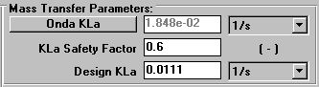
Figure 27 - Mass Transfer Parameters Section of Design Mode Window
The mass transfer coefficient from the Onda correlations is calculated by the program as 0.0185 1/s. This agrees with the value from the sample calculations section (see Eq. 21). Supplementary properties in the calculation of Onda mass transfer coefficient can be viewed by clicking on the Onda KLa label shown in Figure 3 (and highlighted in Figure 27). After the click, the following window appears:

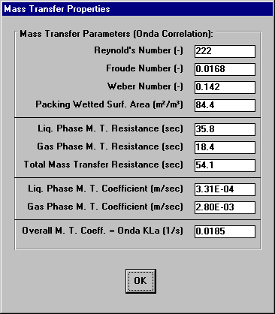
Figure 28 - Supplementary Onda KLa Properties Window
The values shown in Figure 28 agree with the values shown previously in the sample calculations. Reynolds number calculated by the program is 223, which agrees with the sample calculations (see Eq. 24). Froude number calculated in the program is 0.0168, which is in agreement with the sample calculations (see Eq. 25). Weber number is calculated by the program as 0.142, which matches the value given in the sample calculations (see Eq. 26). Packing wetted surface area is determined in the program as 84.3 m²/m³, which agrees with the sample calculations (see Eq. 23). Liquid phase mass transfer coefficient is calculated by the program as 3.31E-04 m/s, which matches the sample calculations (see Eq. 22). Gas phase mass transfer coefficient is determined by the program as 2.82E-03 m/s, which agrees with the sample calculations (see Eq. 27).
The KLa safety factor shown in Figure 3 (and highlighted in Figure 27) is specified in the problem statement. The design KLa was calculated by the program as 0.0111 1/s (see Figure 3 and Figure 27) and this value agrees with the sample calculations shown earlier (Eq. 20).

Tower Parameters
The tower parameters are shown on the bottom of the right-hand column of the design mode window shown in Figure 3. This portion of the window is highlighted in Figure 29.
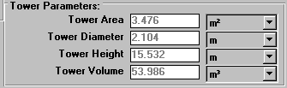
Figure 29 - Tower Parameters Section of Design Mode Window
The values of the tower parameters shown in Figure 3 (and highlighted in Figure 29) agree with the sample calculations section. Tower cross-sectional area was calculated in the program as 3.48 m², which agrees with the sample calculations (see Eq. 11). Tower diameter was determined in the program as 2.10 m, which matches the sample calculations (see Eq. 28). The tower height calculated by the program is 15.5 m, which is in agreement with the sample calculations (see Eq. 1). The tower volume was determined by the program as 54.0 m³, which agrees with the sample calculations (see Eq. 29).

Power Parameters
By clicking on the Perform Power Calculations option in the Brake Power menu shown in Figure 3, the power window for packed tower aeration appears. This power window is shown below in Figure 30.
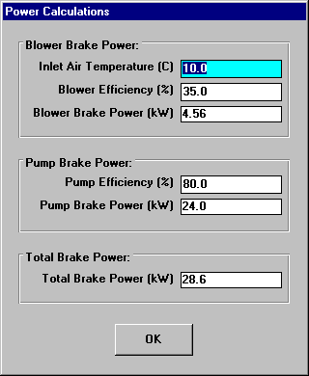
Figure 30 - Power Window for Packed Tower Aeration
The values of the power parameters shown in Figure 30 agree with the sample calculations shown earlier. The blower brake power was calculated in the program as 4.56 kW, which agrees with the sample calculations (see Eq. 31). Pump brake power was calculated in the program as 24.0 kW, which matches Eq. 35 in the sample calculations. Total brake power was determined by the program as 28.6 kW, which is in agreement with the sample calculations (see Eq. 30).

Viewing Effluent Concentration Results for Contaminants Other than the Design Contaminant
For a given design, it is useful to see what the effluent concentrations of contaminants other than the design contaminant would be. ASAP provides a convenient method for seeing these results without having to switch to rating mode. (of course, the user will have to switch to rating mode to investigate commercially available packed tower sizes).
By clicking on the Concentration Results button in the lower left-hand corner of the packed tower aeration – design mode window shown in Figure 3, the user will see the concentration results for all contaminants using the given design.
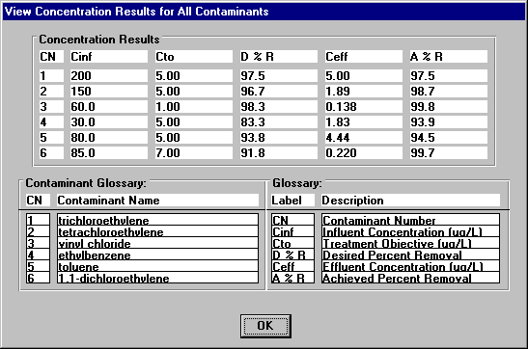
Figure 31 – View Concentration Results for All Contaminants Window
This window provides a quick method to see whether the given design will meet the treatment objectives for all contaminants.

Example of Optimize with All Contaminants Feature
For packed tower aeration in design mode, ASAP contains an optimization routine to attempt to determine an appropriate design contaminant for the given problem statement. This feature is described in detail in the Theoretical Development section of the manual (see section III.D. Optimization Routine for Packed Tower Aeration (Design Mode). In order to demonstrate the feature, run ASAP and choose packed tower aeration, design mode from the main menu. The packed tower aeration , design mode window appears as shown previously in Figure 3. Change the design contaminant to Toluene. The packed tower aeration, design mode window now appears as shown in Figure 32.
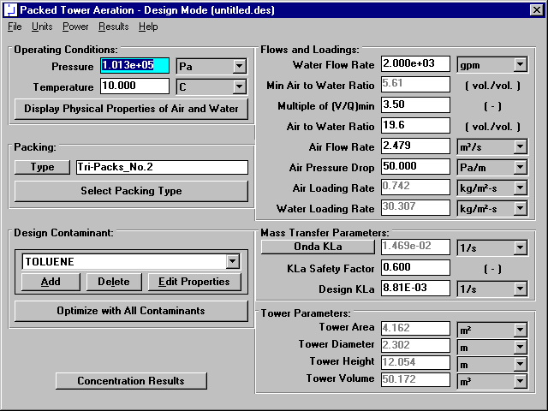
Figure 32 – Packed Tower Aeration, Design Mode Window with Toluene as the Design Contaminant
Click the Concentration Results button. The Concentration Results window for this case with toluene as the design contaminant is shown in Figure 33.
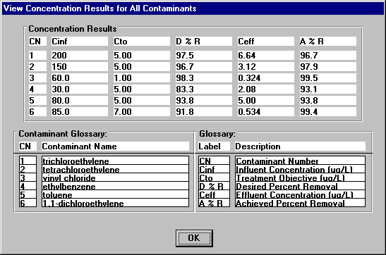
Figure 33 – Concentration Results Window with Toluene Selected as the Design Contaminant
From Figure 33, it is clear that trichloroethylene fails to meet its treatment objective with toluene chosen as the design contaminant. Hence, toluene is not the proper design contaminant and it is expected that trichloroethylene is the appropriate design contaminant. Clicking on the Optimize with All Contaminants button should produce this result, choosing the proper design contaminant. Click the Optimize with All Contaminants button. Figure 34 shows the Optimize with All Contaminants window that appears, which shows that the optimization routine has chosen trichloroethylene as the design contaminant, which is expected. Click Ok to close this window and then click the Concentration Results button. Figure 35 shows the Concentration Results window with trichloroethylene as the design contaminant, which clearly demonstrates that all compounds meet their treatment objectives for this design case. This shows that trichloroethylene is the proper design contaminant, suggesting that the optimization routine has functioned properly in this case.
Important Note: There are situations where the optimization routine will be unable to determine the proper design contaminant. This is described in the theoretical section of this manual (see section III.D). The user should pay close attention to the results of using the Optimize with All Contaminants feature to assure that a proper design is developed, which meets all design specifications.
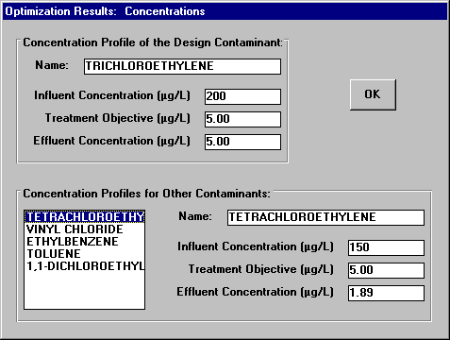
Figure 34 – Optimize with All Contaminants Window
Figure 35 - Concentration Results Window with Trichloroethylene Selected as the Design Contaminant

Switching to Rating Mode
Once the packed tower has been specified in design mode, the user can take the established properties and switch to rating mode in order to see the effect of modifications of various properties. The procedure for switching to rating mode is described here.
Figure 36 shows the File menu for packed tower aeration, design mode.

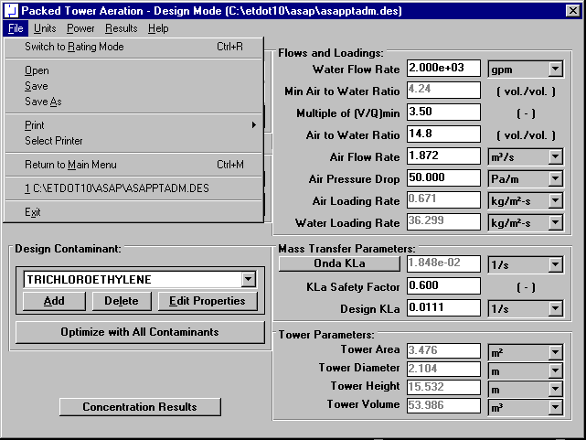
Figure 36 – File Menu for Packed Tower Aeration – Design Mode
Click on the menu option called Switch to Rating Mode in Figure 36. The packed tower aeration – rating mode window will appear, as shown in Figure 37.
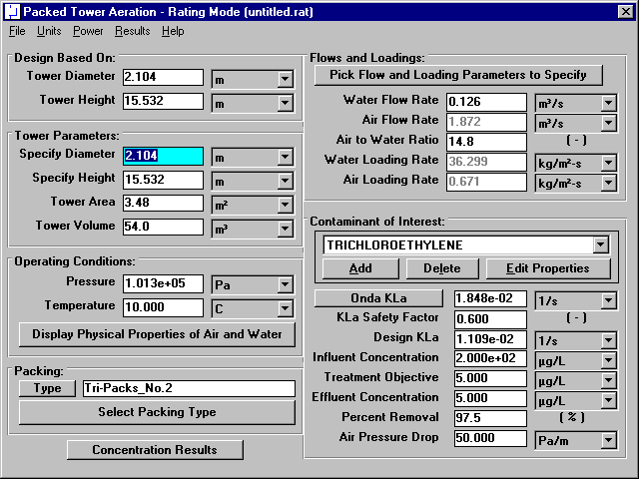
Figure 37 – Packed Tower Aeration – Rating Mode Window
Use of Packed Tower Aeration – Rating Mode will be described in the next section.

